IEEE P802.19
Wireless Coexistence
Reduction of Co-channel Interference in WLAN BSSs
Date: 2012-10-30
Author(s):
Name | Company | Address | Phone | email
Xiao Ying Lei | Kwangwoon University | 26 Kwangwoon-Gil, Seoul 139-701, Korea | +82-2-940-5441 | wodeying21@kw.ac.kr
Jeong-Ho Kim | Kwangwoon University | 26 Kwangwoon-Gil, Seoul 139-701, Korea | +82-2-940-5441 | jeongho@k2w.ac.kr
Seung Hyong Rhee | Kwangwoon University | 26 Kwangwoon-Gil, Seoul 139-701, Korea | +82-2-940-5441 | rhee@kw.ac.kr
Abstract
In a densely deployed infrastructure WLAN, the closely located BSSs (Basic service set) which operating at the same channel could interfere with each other. This kind of co-channel interference may degrade the whole network performance severely. In this document, we consider the scenario which APs in two overlapped BSSs are far from each other that only sations at the boundary area of BSS are possible interfering sources. We propose a scheme objecting to improve the whole performance through tuning transmission power of AP in order to leave the boundary interfering nodes out of AP’s transmission range. We do amounts of simulation which shows that our protocol can reduce the co-channel interference in certain level and improve the whole performance of network.

Notice: This document has been prepared to assist IEEE 802.19. It is offered as a basis for discussion and is not binding on the contributing individual(s) or organization(s). The material in this document is subject to change in form and content after further study. The contributor(s) reserve(s) the right to add, amend or withdraw material contained herein.

1. Co-channel interference

Considering overlapped coverage area between closely deployed BSSs, we describe three representative scenarios in fig.1, namely, scenario A, B and C.
In scenario A, the coverage area of the two BSSs is not overlapped, so there is no co-channel interference.
In scenario B, two APs are in each other’s transmission range, they can sense the transmission ofeach other also the transmission from some nodes belonged neighbor BSS, so there is no co-channel interference in this scenario.
In scenario C, the two BSS overlapped in certain degree, and some nodes located at boundary can overhear the transmission of AP belongs to other BSS, but two AP cannot sense each other, therefore co-channel interference happen. In this paper we only discuss about this situation.
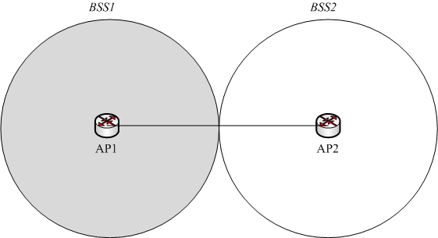
Scenario A
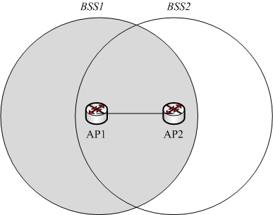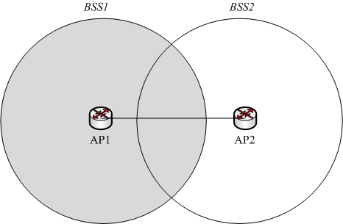
Scenario B
Scenario C

Figure 1 Scenarios for co-channel interference

2. Proposed mechanism

We assume the number of interfering nodes which located at the boundary of BSSs is relatively small comparing with the total number of stations in each BSS. Since reducing the transmission power can shorten the transmission range, we suggest tune AP’s tansmission power so as to leave the interfering nodes out of AP’s transmission range. Through this way although the interferring nodes cann not transmit with AP the whole performance can be improved.
STEP1. In infrastructure network, beacon frames are transmitted by AP periodically to announce the presence of a WLAN. When a node receives the beacon frame from another different BSS, it gets to know that itself is in some other AP’s transmission range, so it responses this situation to AP. To do this, a new one-bit field called node type is added into the control field of MAC head, interference node sends packets in basis DCF way to AP with this field equals to ‘1’. The normal node sets this new field as ‘0’.
STEP2. In proposed shechem every AP keeps a power table which recording the nodes power information. After AP gathering all nodes’ power information, it assesses these values and then calculates a new transmission power that if holding power to this value transmission range does not reach out to the interfering nodes located at boundary. Then AP reduces its transmission power level to this new value. The proposed scheme is illustrated in fig.3.
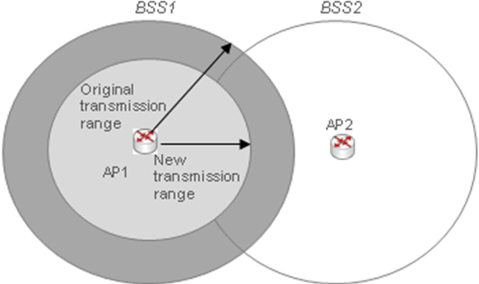
Figure 2. Reduce transmission power of AP

3. Simulation and Results

We use OPNET 14.5 to simulate our proposed scheme, two BSSs consisting of one AP and 10 nodes respectively overlap to each other. Two kinds of traffic VoIP and FTP are simulated. Network deployed as fig.3 shown, the parameters used in this simulation are the same as table1.
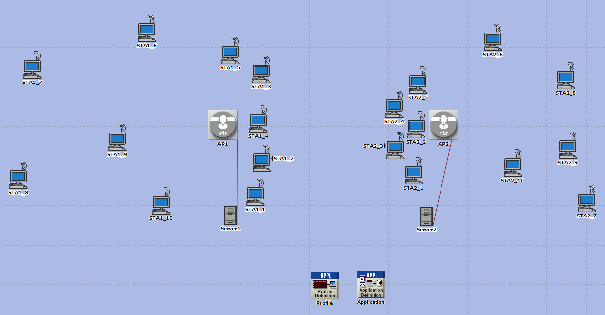
Figure 3. Simulation topology
Table 1. Simulation parameters
Parameter | Value
Number of station | 20
VoIP | Voice over IP Call ( PCM Quality )
FTP traffic | FTP file size | 10Mbyte
FTP traffic | Inter request time | 30sec
Simulation time | 600sec

Through fig.4 we can see compared to IEEE 802.11, through keeping AP’s transmitssion power in a proper level, our propoed sheme can improve the whole network throughput.
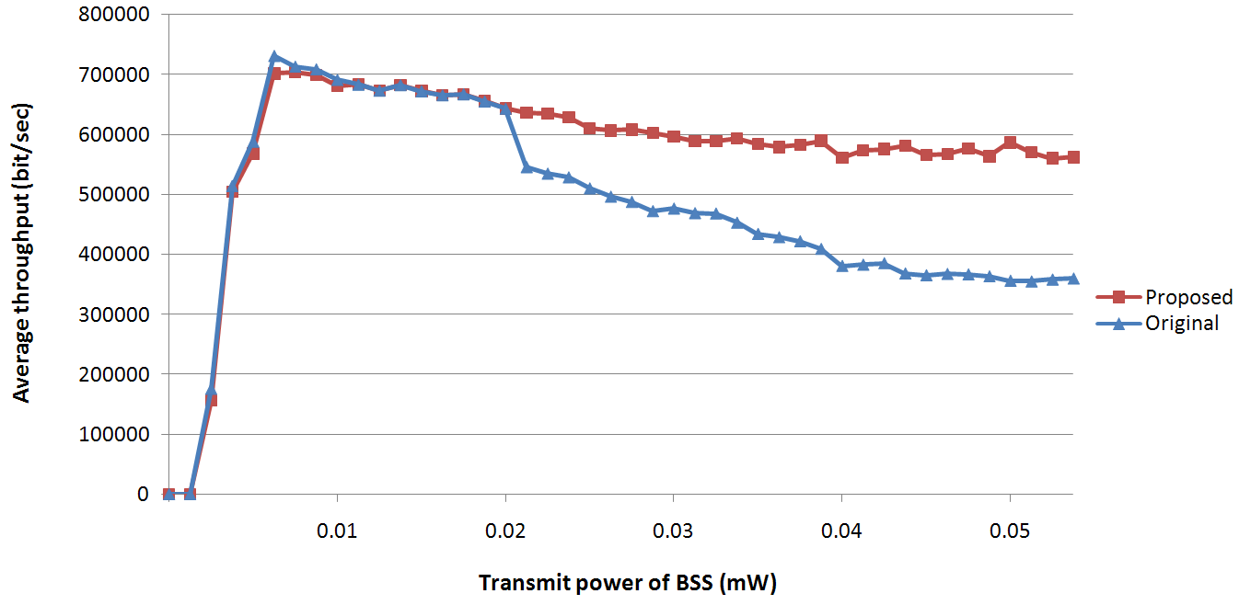
Figure 4. Average throughput
Through fig.5 we can see when transmit VoIP packets, using our proposed scheme can get higher MOS score.
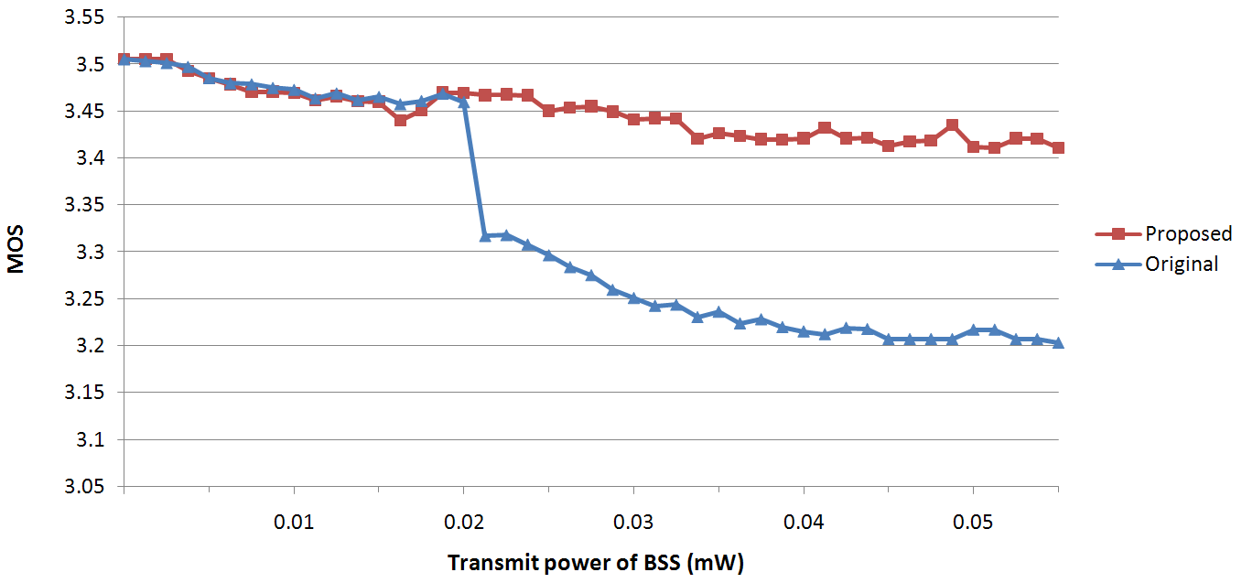
Figure 5. MOS

