IEEE P802.19
Wireless Coexistence
Comment Resolution on the Monitoring Scheme of Session Aliveness among Coexistence System Entities
Date: 2012-07-16
Author(s):
Name | Company | Address | Phone | Email
Jinho Kim | LGE | LG R&D Complex 533, Hogye-1dong, Dongan-Gu, Anyang-Shi, Kyungki-Do, 431-749, Korea | +82-31-450-1867 | boiler4.kim@lge.com
Jinyoung Chun | LGE | LG R&D Complex 533, Hogye-1dong, Dongan-Gu, Anyang-Shi, Kyungki-Do, 431-749, Korea | +82-31-450-1856 | jiny.chun@lge.com
Suhwook Kim | LGE | LG R&D Complex 533, Hogye-1dong, Dongan-Gu, Anyang-Shi, Kyungki-Do, 431-749, Korea
Wookbong Lee | LGE
Jinsam Kwak | LGE
Abstract

This document provides normative text related to a connection (aliveness of a session) monitoring scheme among Coexistence System entities such as CE, CM, and CDIS.

CID | Clause | Subclause | Page | Line | Type | Comment | Suggested Remedy | Response
69 |  | 5.2.1.1 |  |  |  | In the procedure of WSO authentication, what would be happen if the CM is powered off suddenly without any notification?  Furthermore, before sending "Authentication Request", how does the CE expect that the CM is powered on and will work normally ? | In order to keep real-time robustness of the system, we suggest an keepalive message exchange and timeout rule.

[Note- Underlined blue text is new text as below.]

Discussion

Problem
Question 1: In the procedure of WSO de-authentication (Fig. 9 in the section 5.2.1.2 ), what would be happen if the CM is powered off suddenly without any notification?
- Answer : Because the CE doesnot know that the CM is gone, CE just sends any request to the CM and waits for its response for some time. (This is wasting time I think.)
Question 2: Furthermore, before sending "Deauthentication Request", how does the CE expect that the CM is still powered on and will work normally?
- Answer: When the CM is powered off suddenly in any reason, this fact should be notice to the related CEs and the CDIS as soon as possible in order to avoid meaningless requests and responses. So we suggest KeepAlive Request and Response messages between CDIS and CM, and between CM and CE. These messages will make the system more robust.

Propose
Editor’s note: Insert the following text into the end of 5.2.13 Coexistence Set Element Reconfiguration Procedure.

5.2.14 Session Aliveness Monitoring Procedure
5.2.14.1. Session Aliveness Monitoring between a CDIS and a CM
This procedure, illustrated in Figure xx, is started when a CM is registered to the CDIS.

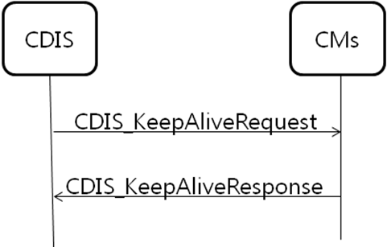
Figure xx. Periodic session monitoring between a CDIS and CMs

5.2.14.2. Session Aliveness Monitoring between a CM and a CE
This procedure, illustrated in Figure xx, is started when a CE is registered to the CM.

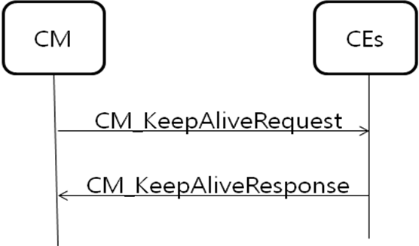
Figure xx. Periodic session monitoring between a CM and CEs

Propose
Editor’s note: Add four parameters into CxPayload message in the section 5.3 as below:

CxPayload ::= CHOICE {
authenticationRequest AuthenticationRequest,
…
…
eventConfirm EventConfirm,
cm_KeepAliveRequest CM_KeepAliveRequest,
cm_KeepAliveResponse CM_KeepAliveResponse,
cdis_KeepAliveRequest CDIS_KeepAliveRequest,
cdis_KeepAliveResponse CDIS_KeepAliveResponse
}

Propose
Editor’s note: Insert the following text in the end of section 5.3

-- Enumerate definition of StatusOfAliveness of CDIS
CDIS_StatusOfAliveness ::= ENUMERATED {
alive,
terminating,
outOfService
}

-- Enumerate definition of StatusOfAliveness of CM
CM_StatusOfAliveness ::= ENUMERATED {
alive,
terminating,
outOfService
}

--Sending KeepAliveRequest from CM to CE
CM_KeepAliveRequest ::= SEQUENCE {
Period INTEGER
CDIS_StatusOfAliveness cdis_cdis_StatusOfAliveness
}

--Sending KeepAliveResponse from CE to CM
CM_KeepAliveResponse ::= SEQUENCE {
Status INTERGER
}

--Sending KeepAliveRequest from CDIS to CM
CDIS_KeepAliveRequest ::= SEQUENCE {
Period INTEGER
CM_StatusOfAliveness cm_cm_StatusOfAliveness
}

--Sending KeepAliveResponse from CM to CDIS
CDIS_KeepAliveRequest ::= SEQUENCE {
Status INTERGER
}

