IEEE P802.19
Wireless Coexistence
Comment Resolution on Master CM Selection
Date: 2011-11-07
Author(s):
Name | Company | Address | Phone | Email
Yunjung Yi | LGE | LG R&D Complex 533, Hogye-1dong, Dongan-Gu, Anyang-Shi, Kyungki-Do, 431-749, Korea | +82-31-450-1911 | yunjung.yi@lge.com
Jihyun Lee
Suhwook Kim
Boenghoe Kim
Abstract

This document provides normative text related to master CM selection process.

CID | Clause | Subclause | Page | Line | Type | Comment | Suggested Remedy | Response
 |  | 9.5.3 |  |  |  | The subclause needs to be filled. | add master CM selection algorithm

Discussion

Propose
Editor’s note: Insert the following text in Master CM selection (9.5.3).

The figure xxx shows an illustrative system overview of coexistence system consisting of CDIS, CMs, CEs and TVBD networks or devices.

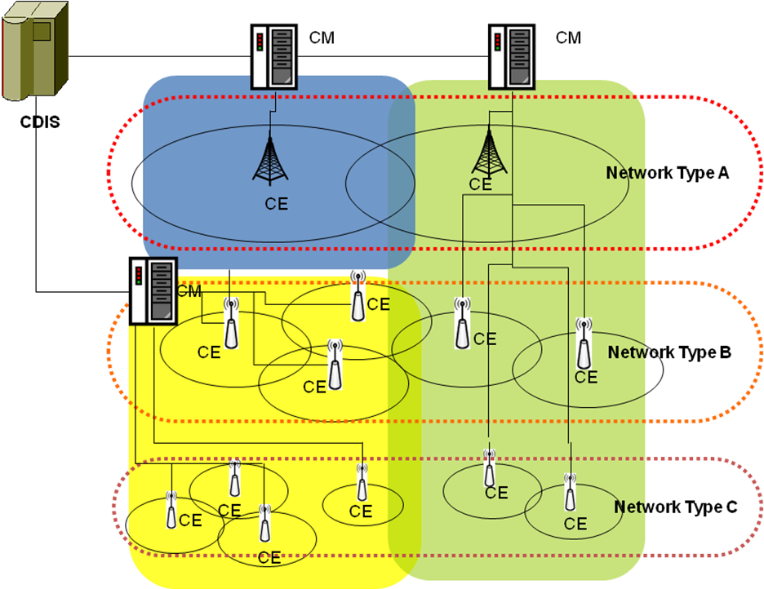
Figure xxx. An illustrative coexistence system

As described in 3.3.3, a CDIS performs calculation of neighboring relationship among registered TVBD networks or devices to one of CMs which are authenticated by the CDIS. CMs are not required to go through registration separate from authentication. Once it is authenticated by a CDIS, it is assumed that CM is successfully connected to a CDIS. A CM is authenticated by only one CDIS, in other words, a CM can be connected to only one CDIS at one time. There could be one or more CDISs in the system. However, a TVBD network or device can be registered to only one CDIS at one time. Moreover, it is recommended that CMs have inter-CM neighbors (i.e., interfering each other) are connected to the same CDIS for a better interference management.

Master CM selection is used to reconfigure the coexistence topology.
Figure xxx illustrates an example where a coexistence topology shows potentially poor performance, which can be improved by merging CMs covering small interference coverage to a CM covering larger interference coverage by selecting a master CM.

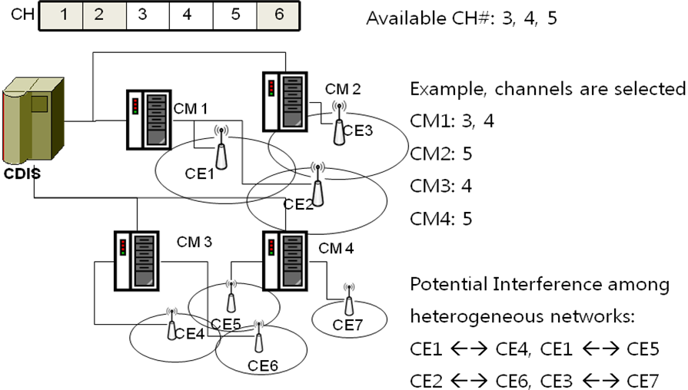
Figure xxx. An example -- Initial coexistence topology

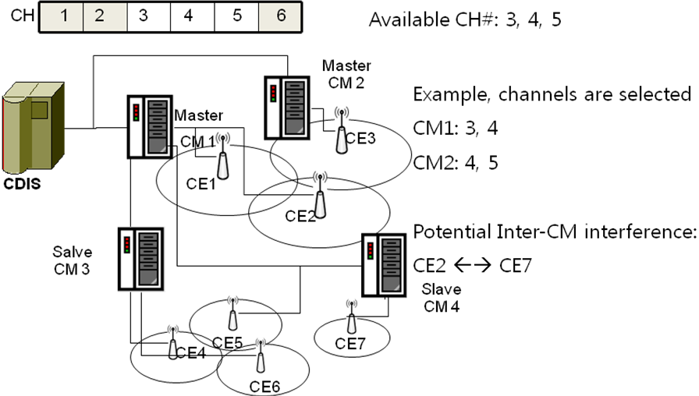
Figure xxx. An example -- Coexistence decision topology after master CM selection process

Master/Slave CM selection algorithm is focused on providing a method to re-organize CMs autonomously.
A few expected benefits from selecting master CM and making slave CMs are to (1) reduce communication overhead among CMs; (2) load balancing among CMs; (3) potentially reduce interference due to inter-CM neighbours.

In terms of master CM selection process, the process can be triggered by a CM or a CDIS. When the process is initiated, a CDIS is making the decision to select the master CM and slave CMs. When a CM becomes the slave CM, the master CM performs coexistence decision making process for the TVBD networks or devices registered to the slave CM. The result of coexistence decision making process will be forwarded to the slave CM who will distribute the resources to its management serviced TVBD networks or devices.
Moreover, a master CM may disable or enable the slave CMs. When it is disabled, the slave CM is no longer a CM. Thus, all the registered TVBD networks or devices should be re-associated with the master CM, which will be done by performing hand-off between the slave CM and master CM. Once, all the registered information of TVBD networks or devices have been transferred from the slave CM to the master CM, master CM informs TVBD networks or devices a new CM address. This process is an optional feature that a master CM and slave CMs can employ.

9.5.3.1 Load-balancing focused Master/Slave CM Selection
Define a load of a CM (Load(CM_{i})) is a number of associated TVBD network or device to the CM. Define a number of available channels to the CM as NumAvailChannel(CM_{i}). A CM (CM_{i}) which is at Independent Operation Substate (as described in CH 9.xx) requests its CDIS to initiate master/slave CM process when Load(CM_{i}) >= Trigger_Threshold * NumAvailChannel(CM_{i}) where Trigger_Threshold is a configurable parameter.
A CDIS selects a master CM among candidate CMs as the following:

9.5.3.2 Geological coverage based Master/Slave CM Selection

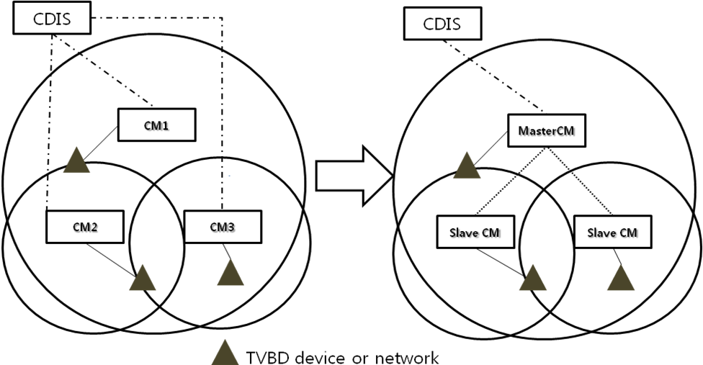
Figure xxx. An Example of Master/Slave CM Selection based on Coverage

The diagram shows an example of how Master CM and slave CMs can be selected based on geographical coverage of each CM. The geographical coverage of a CM is calculated as the following:

GEO_COV(CM) = U { GEO_INT_RANGE (registered TVBD Network or Device)}

The geographical coverage of a CM is summation/union of all the interference range/coverage of each TVBD network or device which has registered to the CM.

When either CDIS or CM receives a request to select a master, it uses geo-location of TVBD networks or devices that each CM has registrations to select a master CM. It may be possible that a CDIS periodically check the coverage of each CM and see whether there are candidate slave CMs whose coverage contour is covered by another CM’s coverage contour. For example, as shown in Figure xxx, CM2 and CM3 can be covered by CM1. The CDIS can initiate master/slave CM selection process to change the status of each CM as shown in the right diagram in Figure xxx.

9.5.3.3 Interference-level based Master/Slave CM Selection

The trigger mechanism utilizes (1) interference level that each CM experiences and (2) the ratio of inter-CM neighbors compared to number of TVBD networks or devices registered to CM.
The first metric uses ANPI (Average Noise Power Indicator) defined in 802.11REVmb [ref]. “ANPI is set to the average noise plus interference power value measured during the indicated measurement duration while the indicated channel is idle as described in carrier sensing mechanism”
The first metric (A_ANPI) is calculated as follows
A_ANPI = Avg{ANPI(registered TVBD network or device)}

The second metric (INF_RATIO) can be calculated as follows:
# of inter-CM neighboring TVBD networks or devices
INF_RATIO = ------------------------------------------------------------------
# of registered TVBD networks or devices

A CM can request the CDIS to select a master CM when either A_ANPI is higher than a threshold or INF_RATIO is greater than a threshold. It is assumed that two threshold values are vendor specific. Upon receiving a request to initiate master CM selection process, CDIS can use geographical coverage of each CM to decide a master CM as described in 9.5.3.2.

Editor’s note: Change 5.1.10.1 as the follows:
5.2.10.1 Master CM selection by CDIS
This procedure, illustrated in Figure 39, is performed when a CM intends to become a slave CM and
requests the CDIS to select a master CM. Moreover, it is possible that a CDIS initiate a master CM selection process as it may detect overlapped CMs where coverage contours of CMs are overlapped each other.
After receiving such request or detect a condition where master CM selection is required, CDIS selects candidate master CM and sends MasterCM_Request to the selected CM. If confirm message is negative from the selected CM,
CDIS selects next candidate master CM. If confirm message is positive, CDIS indicates selected master CM
to the salve CM by sending MasterCM_Confirm message.

Editor’s note: Change Figure 39 as the follows: (change solid line to dotted line between Slave CM and CDIS, add solid line named MasterSlaveCMConfiguration_Announcement between CDIS and SalveCM, add dotted line named MasterSlaveCMConfiguration_Announcement between CDIS and SalveCM )

