IEEE P802.19
Wireless Coexistence
Comment Resolution on Two Service Type (Information and Management)
Date: 2011-11-09
Author(s):
Name | Company | Address | Phone | Email
Yunjung Yi | LGE | LG R&D Complex 533, Hogye-1dong, Dongan-Gu, Anyang-Shi, Kyungki-Do, 431-749, Korea | +82-31-450-1911 | yunjung.yi@lge.com
Jihyun Lee
Suhwook Kim
Boenghoe Kim
Abstract

This document provides proposed resolutions for comments related to information and management services that a CM provides.

CID | Clause | Subclause | Page | Comment | Suggested Remedy | Response
40 |  | 3.5.3 | 8 | It is not clear whether CM can have both information and management serviced TVBD networks and devices. Moreover, the functionality that each service provides is not clearly stated. | Add "functionality per each service" ; add necessary procedures and messages to support both information and management services by a CM at one time

Discussion
Current draft does not clearly state what functionalities that each information or management service provides. Moreover, the draft does not specify how coexistence algorithm is performed when there are both information serviced and management serviced TVBD networks or devices.

Propose

Editor: Insert the following at the end of 3.5.3 Services for TVBD networks or devices:

A CM provides the following listed functions for a TVBD network or device subscribed to either information or management service.

(1) Information Service
- Authentication/de-authentication: a CM performs authentication/deauthentication of a TVBD network or device
- Registration/de-registration: a CM performs registration/de-registration of a TVBD network or device to CDIS.
- NeighborReport: a CM responds with a set of neighboring TVBD networks or devices upon NeighborReport request from a CE. The response includes neighboring CM IDs and information of neighboring TVBD networks or devices registered to those neighboring CMs.
- Obtain available channel list: a CM may obtain the list of available channels that each TVBD network or device has received from TVWS database.
- Event indication from CE: a CE may send indication to a CM to notify an event occurred. An event includes SINR threshold reached, QoS degradation occurred, MisLocatedTVBD detected, etc
- Channel Classification: a CM provides or updates channel classification information to a CE.

(2) Management Service:
- Authentication/de-authentication: a CM performs authentication/deauthentication of a TVBD network or device
- Registration/de-registration: a CM performs registration/de-registration of a TVBD network or device to CDIS.
- Obtain available channel list: a CM may obtain the list of available channels that each TVBD network or device has received from TVWS database.
- Obtain information: a CM may request the information regarding desired bandwidth, desired occupancy, desired QoS, desired covered, or etc to a CE. The obtained information can be used in coexistence decision making process.
- Requesting and obtaining measurements: a CM may request a TVBD network or device (registered to it) to obtain measurement report. It can also request TVBD network or device to perform measurements.
- Reconfiguration request to CE: a CM may request a TVBD network or device to change operating frequency, transmission power limit, or transmission schedule, etc.
- Resource allocation request from CE: a CE may request to allocate resources (e.g., channel number, start/end frequency, maximum power level, expected throughput, etc).
- Channel Classification: a CM provides or update channel classification information to a CE.
- Event indication from CE: a CE may send indication to a CM to notify an event occurred. An event includes SINR threshold reached, QoS degradation occurred, MisLocatedTVBD detected, etc.

Editor: Replace the sentence in 5.2.2.3 with the following

This procedure, illustrated in Figure 14, is performed by a CM to CDIS to subscribe to either interCMNeighbors discovery service or allNeighbors discovery. In interCMNeighbors discovery service mode, a CDIS sends the list of neighbors which are inter-CM neighbors of the requesting CM. In allNeighbors discovery mode, a CDIS sends the list of neighbors which are either inter-CM neighbors or intra-CM neighbors of the requesting CM.
This procedure is also performed by a CM to CDIS to change its discovery service between two options.

Editor: Remove 5.1.2.4 as it is redundant to 5.1.2.3
Description on subscription update is addressed in the proposed text for 5.1.2.3.

Editor: Add the following procedures and message formats accordingly based on sub-clause number

5.2.2.6 Obtain occupied channel list of TVBD network or device
This procedure, illustrated in Figure xxx, is performed when a CM wants to obtain the list of [occupied channel ID, occupancy] from a TVBD network or device for the channels that it has selected to use. The response message includes the list of occupied channels and occupancy of each occupied channel.
Occupancy may be estimated or measured by a TVBD network or device.

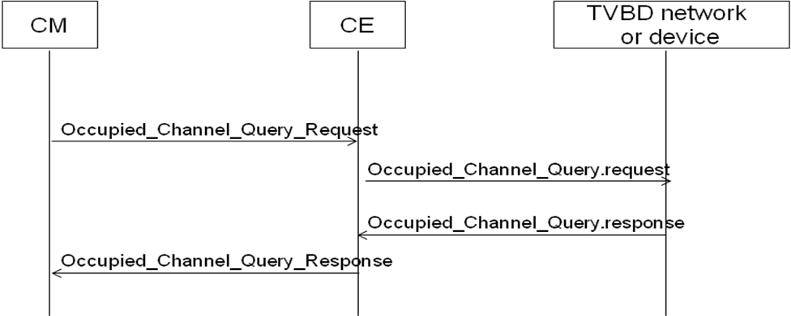
Figure xxx. Occupied Channel Query Procedure

5.3.2.5 Occupied_Channel_Query_Request
This message is sent from a CM to a CE to request the list of [occupied channel ID, occupancy] from a TVBD network or device.

The sourceIdentifier shall be set to CM_ID. The destinationIdentifier shall be set to CE_ID. The message payload is defined in Table xx.

Table xx – Occupied Channel Query Request
Information element | Data Type | Description
CID | Integer | CoexistenceDeviceID (A unique ID allocated by the CDIS which the TVBD network or device has registered)
Measurement Duration | Integer | Measurement duration to obtain occupancy measurement by a TVBD network or device in TUs. If the value is 0, no measurement is rquested.

5.3.2.6 Occupied_Channel_Query_Response
This message is sent from a CE to a CM to send the list of [occupied channel ID, occupancy] of occupied channels by a TVBD network or device.

The sourceIdentifier shall be set to CE_ID. The destinationIdentifier shall be set to CM_ID. The message payload is defined in Table xx.

Table xx – Occupied Channel Query Response
Information element | Data Type | Description
CID | Integer | CoexistenceDeviceID (A unique ID allocated by the CDIS which the TVBD network or device has registered)
numOfOccupiedChannelNumbers | Char | Number of occupied channel numbers in listOfOccupiedChannelNumber
listOfOccupiedChannelNumber | ListOfSupportedChannelNumber optional | List of occupied channel number
listOfMaxPower | ListOfMaxPower | List of maximum power of each channel
listOfOccupancy | ListOfOccupancy | List of occupancy of each channel

Editor -- Change MeasurementDescription in subclause 5.4 as the following :

MeasurementDescription ::= sequence of sequence{
measDescr enumeration{SINR, PER, SensingLevel, PrimaryDetection,
TVBDDetection, ChannelLoadMeasurement, Occupancy…},
measSchedule MeasSchedule,
measFreq MeasFreq
}

MeasurementResult ::= sequence of sequence{
reqInfoDescr ReqInfoDescr,
reqInfoValue choice{SINRValue real, BERValue FERValue real,
SensingLevelValue real,
PrimaryDetection boolean,
TVBDDetection boolean,
ChannelLoadMeasurement real,
Occupancy, integer,
otherValue ANY}
}

