IEEE P802.11
Wireless LANs
Comment Resolutions regarding to Intra-CM and Inter-CM Neighbor Definitions
Date: 2011-09-22
Author(s):
Name | Company | Address | Phone | Email
Yunjung Yi | LGE | LG R&D Complex 533, Hogye-1dong, Dongan-Gu, Anyang-Shi, Kyungki-Do, 431-749, Korea | +82-31-450-1911 | yunjung.yi@lge.com
Jihyun Lee
Suhwook Kim
Boenghoe Kim
Abstract

This document provides proposed resolutions for comments 41, 47, 94, 239, 243 received in the 1st TG review of Draft P802.19.1/DF0.

CID | Clause | Subclause | Page | Line | Type | Comment | Suggested Remedy | Response
41 | 9 | 9.4.7 | 182 | 44 | T | The draft has no description on master / slave CM selection. Such description needs to be provided in order to have unified manner to run such a procedure. We need to also agree on what's mandatory and what's optional from this procedure perspective. | Add a new subclause to this clause of "Other algorithms of coexistence management" to address master/slave selection and management. One possibility is to have a subclause to deal with "Topology management" in general and have master/slave selection as one item within. | As suggested, add one Master selection algorithm (new subclause 9.4.7.3).  Content:TBD

Discussion CID 47 points out that there is no sufficient description on master/slave CM selection mechanism. We propose a simple master/slave CM selection algorithm based on geographical coverage.

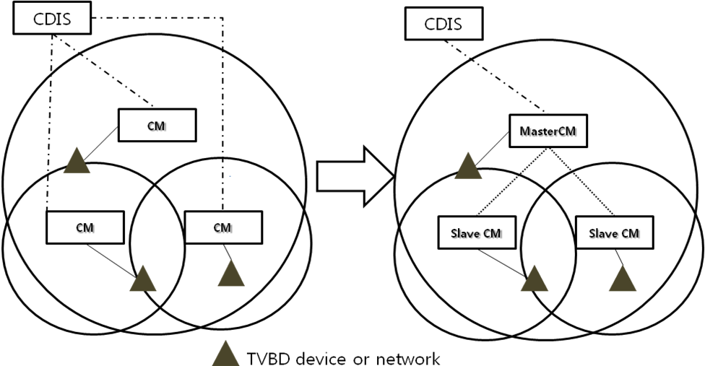

The diagram shows an example of how Master CM and slave CMs can be selected based on geographical coverage of each CM. When either CDIS or CM receives a request to select a master, it uses geo-location of TVBD networks or devices that each CM has registrations to select a master CM.

The master CM selection algorithm will consist of the following main functions:
- Initiation of master CM selection process: when to trigger master CM selection request. One example is when a CM notices that there are too many interfering inter-CM neighbors.
- Master CM selection algorithm by CDIS: selection of the CM to be a master CM among candidate CMs based on geographical coverage.
- Master CM selection algorithm by CM: selection of a CM to request becoming the master CM based on inter-CM neighbor list
- Enabling/disabling slave CM (OPTIONAL): mechanism to control a slave CM to disable or enable its CM function. See an example in below.

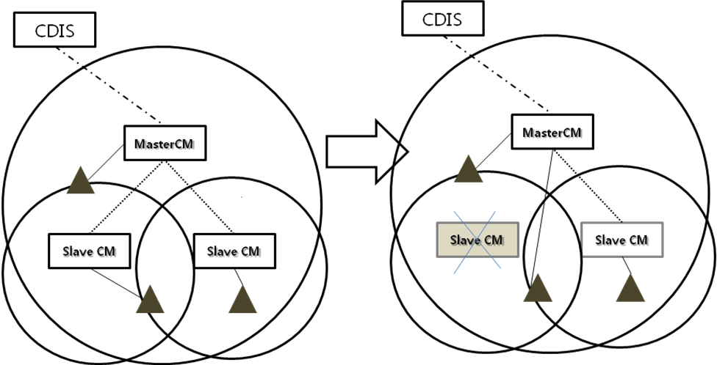

Propose add new subclause to describe master CM selection mechanism (9.4.7.3). Leave the content as “TBD”.

CID | Clause | Subclause | Page | Line | Type | Comment | Suggested Remedy | Response
47 | 4 | 4.2.2.5.1 | 31 | 15 | T | I would challenge the current description that states that a CM can request a TVBD to perform measurements. At the end there will be typically measurements done in the TVBDs but more precise wording here would be to require measurement reports. | Revise the description to state that one requires measurement reports. | Reject
Propose

Change line 15 of page 31 from
This primitive is used by a CE to request the TVBD network or device to perform measurements.

to:

This primitive is used by a CE to request the TVBD network or device to report measurements.

Reject

Delete line 33of page 31 as it is redundant

This primitive is generated by the CE to request the TVBD network or device to perform measurements.

CID | Clause | Subclause | Page | Line | Type | Comment | Suggested Remedy | Response
94 | 9 |  |  |  | T | Nowhere is specified a decision making algorithm in distributed topology, where the fairness is taken into account, when considering amount of requested resources and also how to minimize the rate of resource changes. | Specify an algorithm | OPEN

Discussion:

Propose:

CID | Clause | Subclause | Page | Line | Type | Comment | Suggested Remedy | Response
239 |  | 7.2.1.1 |  |  | T | I think two messages from CM should be added: CM_Reconfiguration_Request, CM_Reconfiguration_Response as those messages can be exchange between CMs regardless of its status | Please add two messages and add description sections as well | withdraw

CID | Clause | Subclause | Page | Line | Type | Comment | Suggested Remedy | Response
243 |  |  |  |  | T | It will be very helpful if we can add some flow diagram at least for initial system setup (e.g., how TVBD joins CE & CM, how CM joins CDIS, etc) in appendix |  | Put “Informative” Appendix A. Use case.  Content: in below

Discussion

Propose: Put “Informative” Appendix A. Use case. Content: in below
Use case 1: TVBD network or device registration to CM

When a TVBD device or network wants to use CM, it can initiate the registration process through CE. First, it starts CE if it is not already running. When CE receives the initiation request, it starts the registration process which consists of (1) authentication, (2) service subscription, and (3) registration. The flow diagram is shown in the following:

