IEEE P802.11
Wireless LANs
Comment Resolutions regarding to Intra-CM and Inter-CM Neighbor Definitions
Date: 2011-09-19
Author(s):
Name | Company | Address | Phone | Email
Hyunduk Kang | ETRI | 138 Gajeong-Ro, Yuseong-Gu, Daejeon, 305-700, South Korea | +82-42-860-1074 | henry@etri.re.kr
Donghoon Lee | ETRI | 138 Gajeong-Ro, Yuseong-Gu, Daejeon, 305-700, South Korea | +82-42-860-0865 | mmdang@etri.re.kr
Byung-Jang Jeong | ETRI | 138 Gajeong-Ro, Yuseong-Gu, Daejeon, 305-700, South Korea | +82-42-860-6765 | bjjeong@etri.re.kr
Abstract

This document provides proposed resolutions for comments 6, 127 received in the 1st TG review of Draft P802.19.1/DF0.

CID | Clause | Subclause | Page | Line | Type | Comment | Suggested Remedy | Response
6 | 3 | 3.3.2 | 5 | 28 | T | What does an intra-CM neighbor mean? | Specify it
127 | 3 | 3.5.3 | 9 | 8 | T | the inter-CM and intra-CM neighbor shall be clarified.

Discussion CIDs 6 and 127 point out the missing definitions of intra-CM and inter-CM neighbors for TVBDs. These two terms are related to TVBD neighbors. Note that the definition of TVBD neighbors is still open to discuss. The below figure describes intra-CM TVBD neighbor and inter-CM TVBD neighbor as an example.

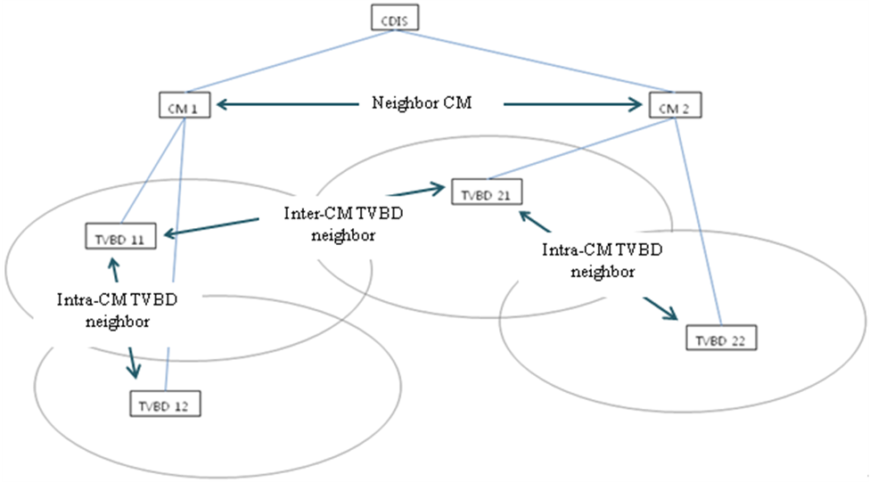

Propose clarified the definitions of intra-CM and inter-CM neighbors for TVBDs, added it in subclause 2.1 in page 2

Editing instructions:

2.1 Definitions
TG1 Editor: Insert the following two definitions as shown

Intra-CM neighbor: TVBD neighbors registered to the same CM.

Inter-CM neighbor: TVBD neighbors registered to the different CM.

