IEEE P802.19
Wireless Coexistence Working Group

Project | IEEE 802.19 Wireless Coexistence Working Group (WG)
Title | Coexistence Procedures and Protocols
Date Submitted | January 17, 2011
Source | Jihyun Lee, Yongho Seok, Junho Jo, Bonghoe Kim, byounghoon Kim  LG R&D Complex 533, Hogye-1dong, Dongan-Gu, Anyang-Shi, Kyungki-Do, 431-749, Korea  jihyun1220.lee@lge.com, yongho.seok@lge.com, junho.jo@lge.com, bonghoe.kim@lge.com, bh.kim@lge.com  Hyunduk Kang, Donghun Lee, Kyu-Min Kang, Heonjin Hong, Chang-Joo Kim, Jaeick Choi  138 Gajeong-Ro, Yuseong-Gu, Daejeon, 305-700, South Korea  henry@etri.re.kr, mmdang@etri.re.kr, kmkang@etri.re.kr, hjhong@etri.re.kr, cjkim@etri.re.kr, jichoi@etri.re.kr  Stanislav Filin, Junyi Wang, Aziz Rahaman, Chunyi Song, Yohannes D. Alemseged, Chen Sun, Ha Nguyen Tran,  Zhou Lan, Sum Chin Sean, Gabiel Villardi, Pyo-Chang Woo, Hiroshi Harada  NICT, 3-4 Hikarino-oka, Yokosuka, Kanagawa, Japan, 239-0847  sfilin@nict.go.jp, junyi.wang@nict.go.jp, aziz@nict.go.jp, songe@nist.go.jp, yohannes@nict.go.jp, sun@nict.go.jp, haguen@nict.go.jp, harada@nict.go.jp
Re:
Abstract | Proposal for Coexistence Procedures and Protocols clause
Purpose
Notice | This document has been prepared to assist the IEEE P802.19. It is offered as a basis for discussion and is not binding on the contributing individual(s) or organization(s). The material in this document is subject to change in form and content after further study. The contributor(s) reserve(s) the right to add, amend or withdraw material contained herein.
Release | The contributor acknowledges and accepts that this contribution becomes the property of IEEE and may be made publicly available by P802.19.
CONTENTS
1 Overview 1
1.1 Scope 1
1.2 Purpose 1
2 Normative references 1
3 Definitions, abbreviations, and acronyms 1
3.1 Definitions 1
3.2 Abbreviations and acronyms 1
4 System description 1
4.1 Architecture 2
4.2 Entities 2
4.3 Interfaces 2
4.4 Coexistence scenarios 2
4.5 Coexistence services 2
5 Reference model 2
5.1 General description 2
5.2 Service access points 2
5.3 Data type definition 2
6 Procedures and protocols 2
6.1 General description 2
6.2 Procedures 2
6.3 Messages 34
6.4 Data type definition 73

TV White Space Coexistence Methods
- Overview
  - Scope
The standard specifies radio technology independent methods for coexistence among dissimilar or independently operated TV Band Device (TVBD) networks and dissimilar TV Band Devices
  - Purpose
The purpose of the standard is to enable the family of IEEE 802 Wireless Standards to most effectively use TV White Space by providing standard coexistence methods among dissimilar or independently operated TVBD networks and dissimilar TVBDs. This standard addresses coexistence for IEEE 802 networks and devices and will also be useful for non IEEE 802 networks and TVBDs.
- Normative references
The following referenced documents are indispensable for the application of this document. For dated references, only the edition cited applies. For undated references, the latest edition of the referenced document (including any amendments or corrigenda) applies.
TBD
- Definitions, abbreviations, and acronyms
  - Definitions
For the purposes of this draft standard, the following terms and definitions apply. The Authoritative Dictionary of IEEE Standards, Seventh Edition, should be referenced for terms not defined in this clause.
  - Abbreviations and acronyms
- System description
  - Architecture
  - Entities
  - Interfaces
  - Coexistence scenarios
  - Coexistence services
- Reference model
  - General description
  - Service access points
  - Data type definition

- Procedures and protocols
  - General description
TBD
  - Procedures
Procedures are categorizaed as the followings;
- Interface setup
- Registration/Deregistration
- Coexistence information gathering
- Neighbor discovery
- Channel classification
- Coexistence decision making
- Reconfiguration
- Measurement
- Event
- Registration
- Neighbor discovery
- Get available channel list
- Channel list update
- Measurement
- Information collection
- Event
- Reconfiguration
- Session activity check
- Connection Setup
- Coexistence Resource Allocation
- Coexistence Command
- Coexistence Measurement
- Neighbor Discovery
- Master Selection

    - Interface setup
      - Interface between CM and CE
The CM state machine for interface between CM and CE consists of the following 4 states as depicted in figure 1:
- Inactive
- Active
- Engaged
- Request sent

State transition shall be occurred as follows:
- The active state goes to the engaged state if CM receives connection request from CE and sends connection response to CE.
- The engaged state goes to the request sent state if CM sends request for context information (CI) or measurement (ME) or reconfiguration (RC) to CE. After CM receives corresponding response from CE it goes back to the engaged state.
- CM receives event indication from CE and sends event acknowledgement to CE at the engaged state.
- CM stays the engaged state if it periodically receives being-engagement request from CE.
- The engaged state goes to the active state if CM receives disconnection request from CE, or fails to receive being-engagement request from CE periodically.

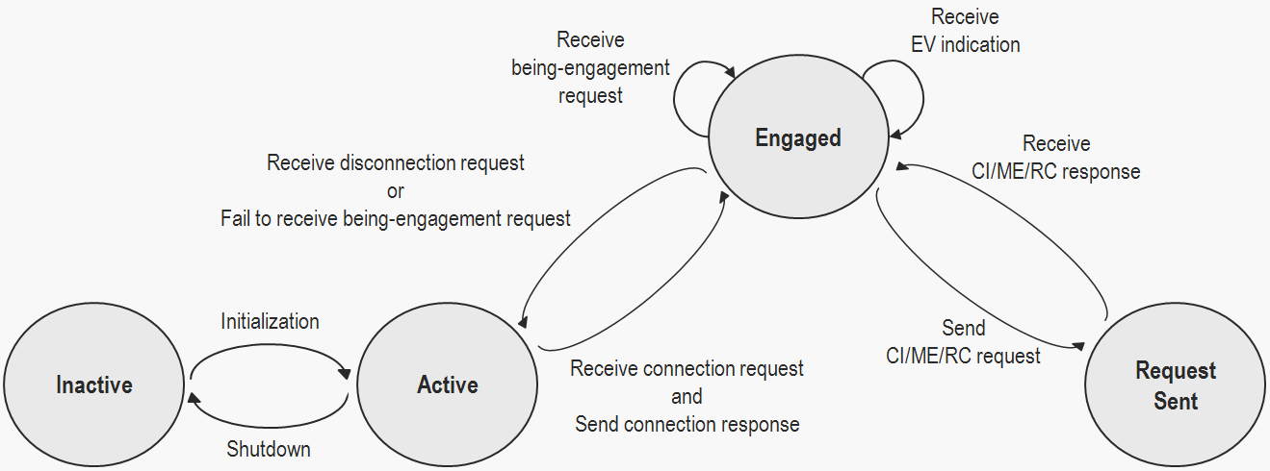
- CM state diagram for interface between CM and CE

The CE state machine for interface between CM and CE consists of the following 5 states as depicted in figure 2:
- Inactive
- Active
- Waiting engagement
- Engaged
- Request received

State transition shall be occurred as follows:
- The active state goes to the waiting engagement state if CE sends connection request to CM.
- The waiting engagement state goes to the engaged state if CE receives connection response from CM within time limit. If not, it goes back to the active state.
- The engaged state goes to the request received state if CE receives request for context information or measurement or reconfiguration from CM. After CE sends corresponding response to CM it goes back to the engaged state.
- CE sends event indication to CM and receives event acknowledgement from CM at the engaged state.
- CE stays the engaged state if it periodically sends being-engagement request to CM.
- The engaged state goes to the active state if CE sends disconnection request to CM.

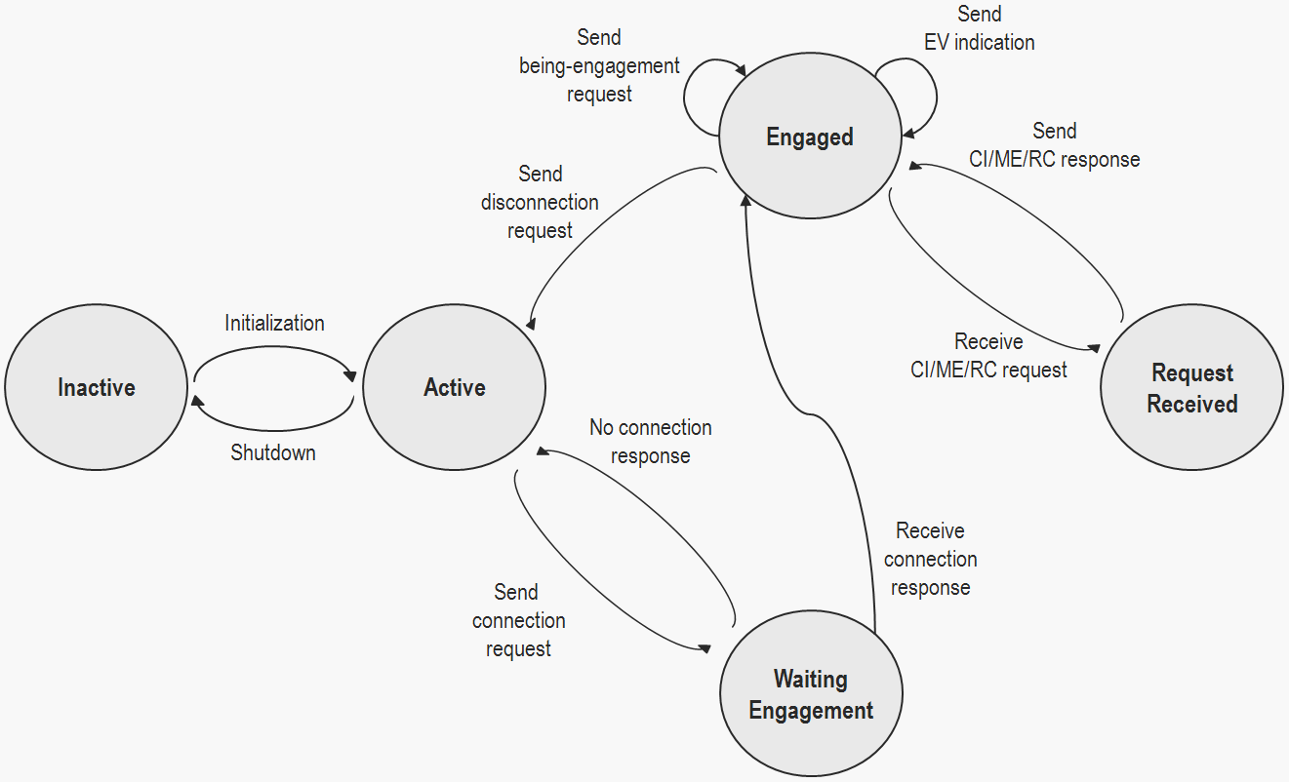
- CE state diagram for interface between CM and CE

      - Interface between CM and CDIS
The CM state machine for interface between CM and CDIS consists of the following 6 states as depicted in figure 3:
- Inactive
- Active
- Waiting engagement
- Engaged
- Request sent
- Request received

State transition shall be occurred as follows:
- The active state goes to the waiting engagement state if CM sends connection request to CDIS.
- The waiting engagement state goes to the engaged state if CM receives connection response from CM within time limit. If not, it goes back to the active state.
- The engaged state goes to the request received state if CM receives request for context information from CDIS. After CM sends corresponding response to CDIS it goes back to the engaged state.
- CM receives event indication from CDIS and sends event acknowledgement to CDIS at the engaged state.
- CM sends event indication to CDIS and receives event acknowledgement from CDIS at the engaged state.
- The engaged state goes to the request sent state if CM sends request for context information to CDIS. After CM receives corresponding response from CDIS it goes back to the engaged state.
- CM stays the engaged state if it periodically sends being-engagement request to CDIS.
- The engaged state goes to the active state if CM sends disconnection request to CDIS.

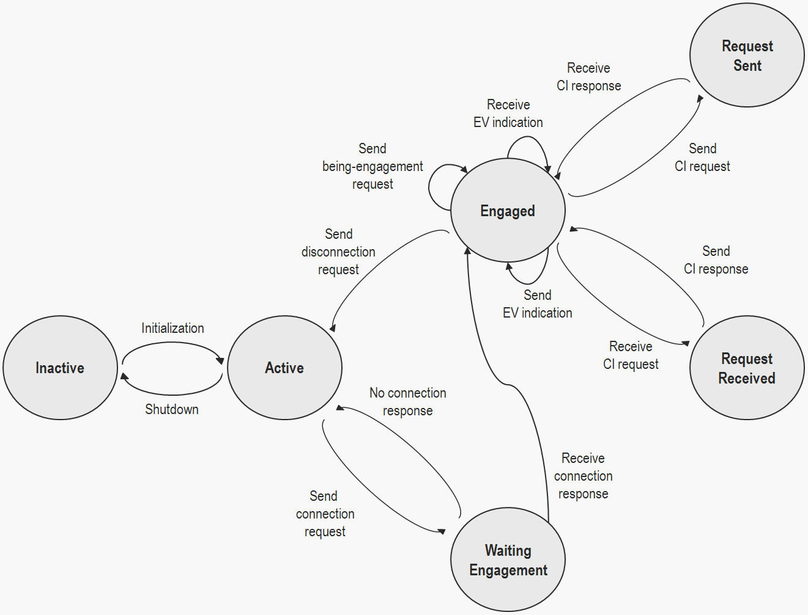
- CM state diagram for interface between CM and CDIS

The CDIS state machine for interface between CM and CDIS consists of the following 5 states as depicted in figure 4:
- Inactive
- Active
- Engaged
- Request sent
- Request received

State transition shall be occurred as follows:
- The active state goes to the engaged state if CDIS receives connection request from CM and sends connection response to CM.
- The engaged state goes to the request sent state if CDIS sends request for context information or event to CM. After CDIS receives corresponding response from CM it goes back to the engaged state.
- CDIS receives event indication from CM and sends event acknowledgement to CM at the engaged state.
- CDIS sends event indication to CM and receives event acknowledgement from CM at the engaged state.
- The engaged state goes to the request received state if CDIS receives request for context information from CM. After CDIS sends corresponding response to CM it goes back to the engaged state.
- CDIS stays the engaged state if it periodically receives being-engagement request from CM.
- The engaged state goes to the active state if CDIS receives disconnection request from CM, or fails to receive being-engagement request from CM periodically.

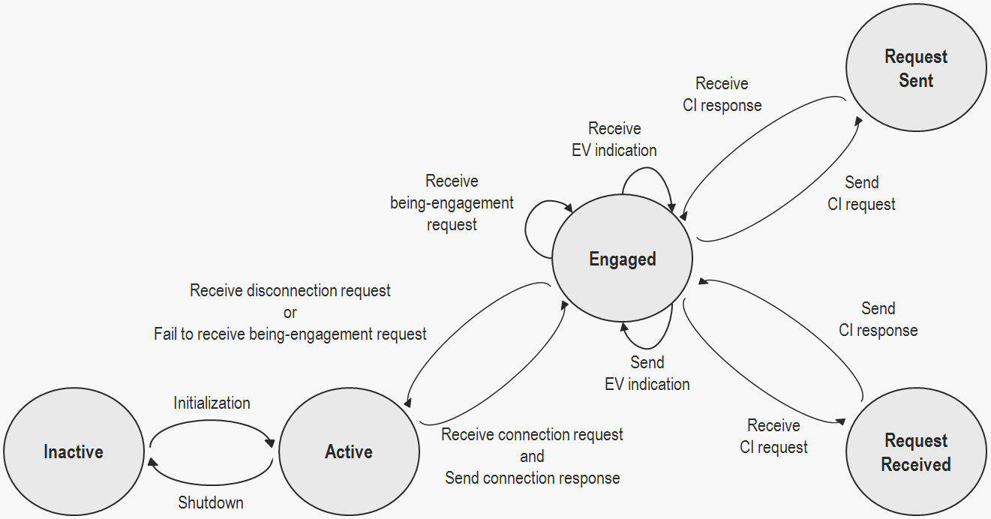
- CDIS state diagram for interface between CM and CDIS

      - Interface between CM and neighbor CM
        - Centralized topology
In centralized topology, there is one master CM which has a number of slave CMs. The master CM performs coexistence decision making and slave CMs follows it.

The master CM state machine for interface between master CM and slave CM consists of the following 5 states as depicted in figure 5:
- Inactive
- Active
- Engaged
- Request sent
- Request received

State transition shall be occurred as follows:
- The active state goes to the engaged state if master CM receives connection request from slave CM and sends connection response to slave CM.
- The engaged state goes to the request sent state if master CM sends request for context information or measurement or reconfiguration to slave CM. After master CM receives corresponding response from slave CM it goes back to the engaged state.
- Master CM receives event indication from slave CM and sends event acknowledgement to slave CM at the engaged state.
- The engaged state goes to the request received state if master CM receives request for context information from slave CM. After master CM sends corresponding response to slave CM it goes back to the engaged state.
- Master CM stays the engaged state if it periodically receives being-engagement request from slave CM.
- The engaged state goes to the active state if master CM receives disconnection request from slave CM, or fails to receive being-engagement request from slave CM periodically.

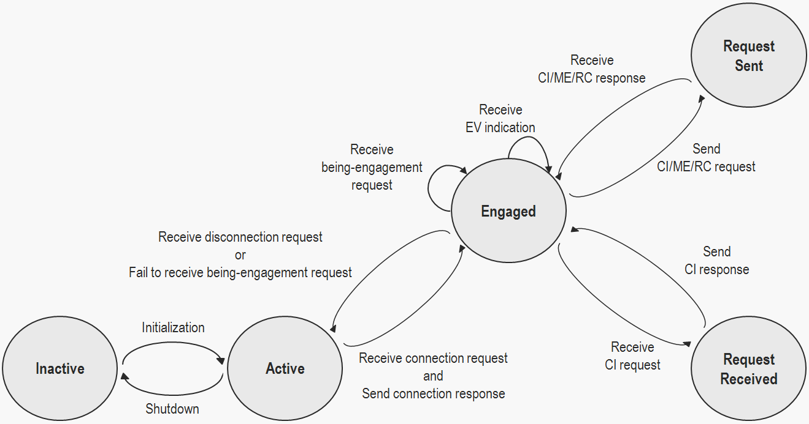
- Master CM state diagram for interface between master CM and slave CM

The slave CM state machine for interface between master CM and slave CM consists of the following 6 states as depicted in figure 6:
- Inactive
- Active
- Waiting engagement
- Engaged
- Request sent
- Request received

State transition shall be occurred as follows:
- The active state goes to the waiting engagement state if slave CM sends connection request to master CM.
- The waiting engagement state goes to the engaged state if slave CM receives connection response from master CM within time limit. If not, it goes back to the active state.
- The engaged state goes to the request received state if slave CM receives request for context information or measurement or reconfiguration from master CM. After slave CM sends corresponding response to master CM it goes back to the engaged state.
- Slave CM sends event indication to master CM and receives event acknowledgement from master CM at the engaged state.
- The engaged state goes to the request sent state if slave CM sends request for context information to master CM. After slave CM receives corresponding response from master CM it goes back to the engaged state.
- Slave CM stays the engaged state if it periodically sends being-engagement request to master CM.
- The engaged state goes to the active state if slave CM sends disconnection request to master CM.

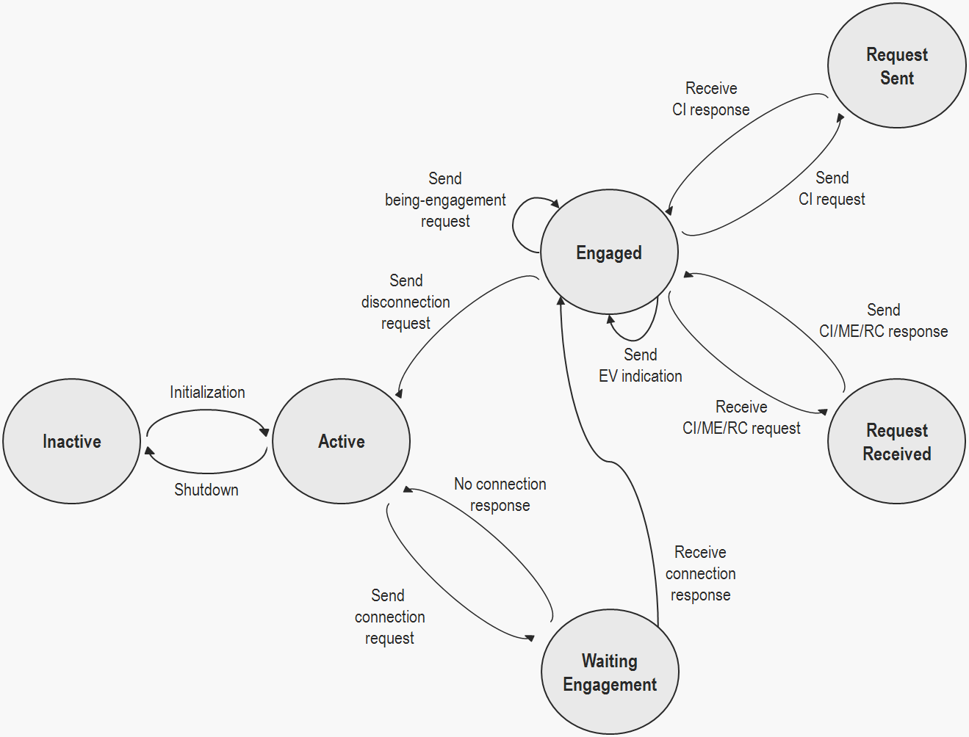
- Slave CM state diagram for interface between master CM and slave CM

        - Distributed topology
In distributed topology, a CM pair, one CM and its neighbor CM, is connected each other. Any two CMs could be connected each other. Each CM performs coexistence decision making by negotiation with neighbor CMs.

The CM state machine for interface between CM and neighbor CM consists of the following 6 states as depicted in figure 7:
- Inactive
- Active
- Waiting engagement
- Engaged
- Request sent
- Request received

State transition shall be occurred as follows:
- If CM sends connection request to neighbor CM,
  - The active state goes to the waiting engagement state if CM sends connection request to neighbor CM.
  - The waiting engagement state goes to the engaged state if CM receives connection response from neighbor CM within time limit. If not, it goes back to the active state.
- If CM receives connection request from neighbor CM,
  - The active state goes to the engaged state if CM receives connection request from neighbor CM and sends connection response to neighbor CM.
- The engaged state goes to the request sent state if CM sends request for context information or measurement or negotiation to neighbor CM. After CM receives corresponding response from neighbor CM it goes back to the engaged state.
- CM receives event indication from neighbor CM and sends event acknowledgement to neighbor CM at the engaged state.
- CM sends event indication to neighbor CM and receives evnt acknowledgement from neighbor CM at the engaged state.
- The engaged state goes to the request received state if CM receives request for context information or measurement or negotiation from neighbor CM. After CM sends corresponding response to neighbor CM it goes back to the engaged state.
- If CM sends connection request to neighbor CM,
  - CM stays the engaged state if it periodically sends being-engagement request to neighbor CM.
  - The engaged state goes to the active state if CM sends disconnection request to neighbor CM.
- If CM receives connection request from neighbor CM,
  - CM stays the engaged state if it periodically receives being-engagement request from neighbor CM.
  - The engaged state goes to the active state if CM receives disconnection request from neighbor CM, or fails to receive being-engagement request from neighbor CM periodically.

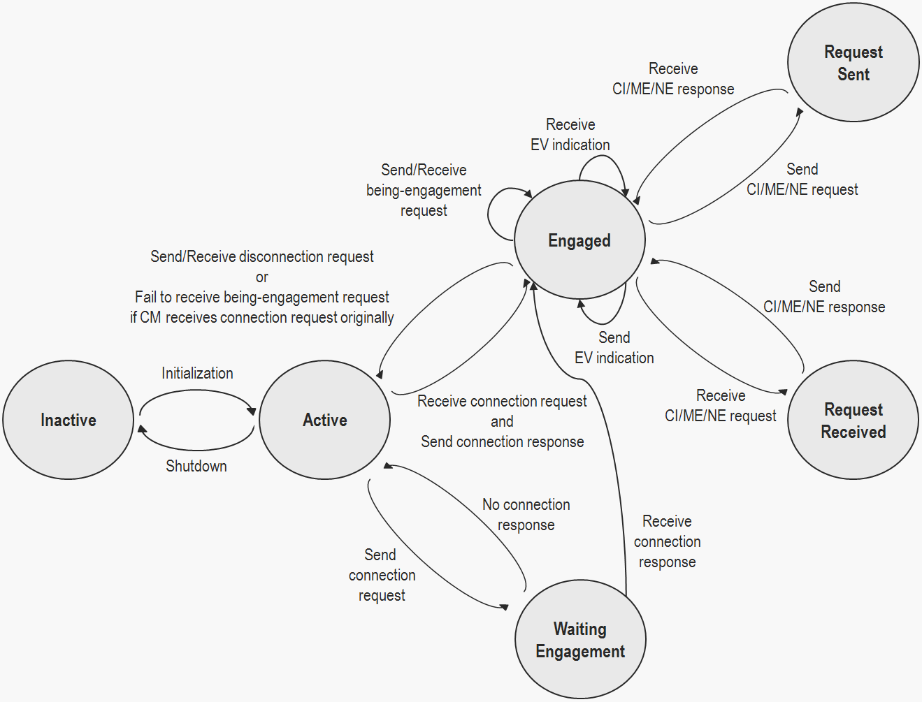
- CM state diagram for interface between CM and neighbor CM

    - Registration procedure

6.2.2.1 CE connection to CM
This procedure is used by CE to check connection with CM. The procedure is shown in the following Figure.
- 10CE connection to CM procedure

6.2.2.2 CE authentication
This procedure is used by CE to authenticate itself to CM. The procedure is shown in the following Figure.
- 10CE authentication procedure

6.2.2.3 CE registration update
This procedure is used by CE to update information of its TVBD network or device to CM. The procedure is shown in the following Figure.
- 10 CE registration update procedure

6.2.2.4 CE deregistration
This procedure is used by CE to deregister its TVBD network or device from CM. The procedure is shown in the following Figure.
- 11 CE deregistration procedure

6.2.2.5 CE deauthentication
This procedure is used by CE to deauthenticate itself from CM. The procedure is shown in the following Figure.
- 11 CE deauthentication procedure

6.2.2.6 CM connection to CDIS
Before connecting to CDIS, CM has list of candidate CDISs. This procedure is used by CM to find the first CDIS from the list that can serve this CM. The procedure is shown in the following Figure.
- 11 CM connection to CDIS procedure

6.2.2.7 CM authentication
This procedure is used by CM to authenticate itself to CDIS. The procedure is shown in the following Figure.
- 12 CM authentication procedure

6.2.2.8 CM registration
This procedure is used by CM to register information of its TVBD networks and devices to CDIS. The procedure is shown in the following Figure.
- 12CM registration procedure

6.2.2.9 CM registration update
This procedure is used by CM to update information of its TVBD networks and devices to CDIS. The procedure is shown in the following Figure.
- 12 CM registration update procedure

6.2.2.10 CM deregistration and deauthentication
This procedure is used by CM to deregister its TVBD networks and devices from CDIS. The procedure is shown in the following Figure.
- 13 CM deregistration procedure

6.2.2.11 CM deauthentication
This procedure is used by CM to deregister its TVBD networks and devices from CDIS and to deauthenticate itself from CDIS. The procedure is shown in the following Figure.
- 13 CM deauthentication procedure

This procedure is used for registration between entities.

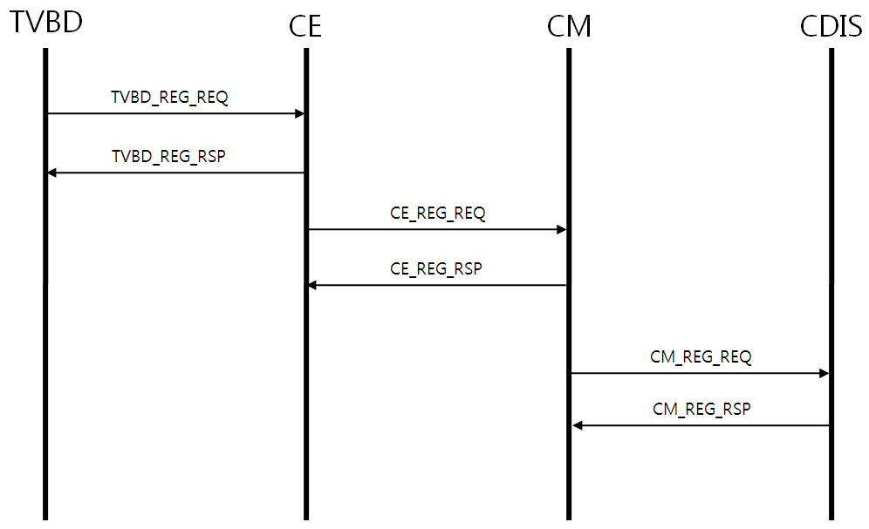
- Registration between entities

This procedure is used for deregistration between entities.

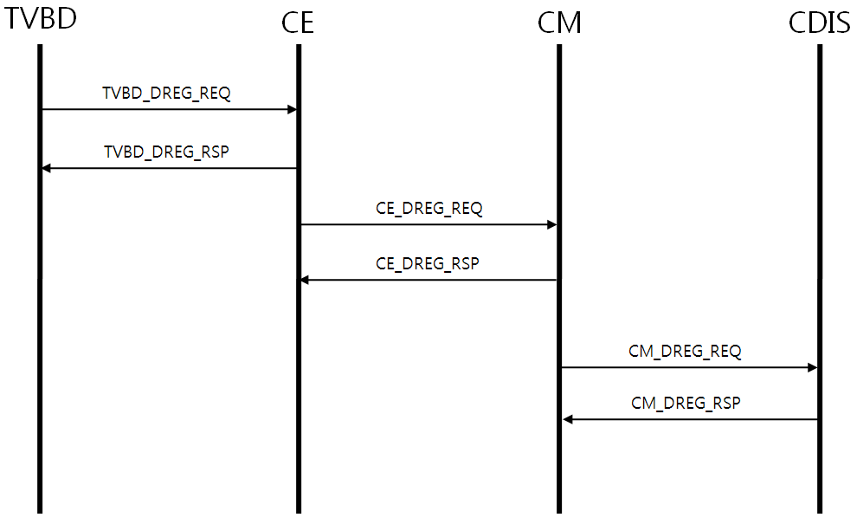
- Deregistration between entities

This procedure is used for registration between neighbor CMs based on topologies (centralized vs. distributed). A centeralized topology consists of one master CM (MCM) and one or more slave CMs (SCMs). A distributed topology consists of two or more neighbor CMs (NCMs).

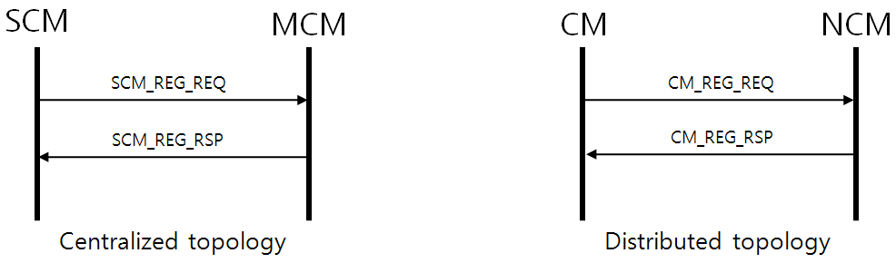
- Registration between entities based on topologies

This procedure is used for deregistration between neighbor CMs based on topologies (centralized vs. distributed).

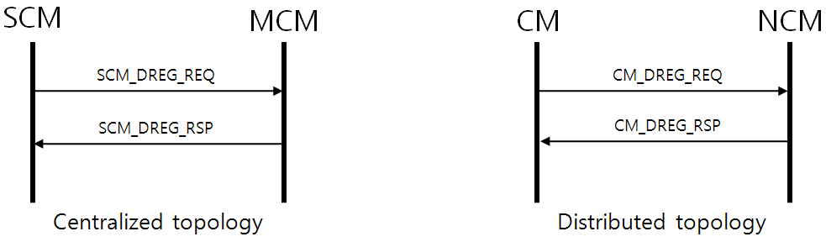
- Deregistration between entities based on topologies

This procedure is used by CE to set up a connection with CM

- registration between CM and CE

This procedure is used by CM to set up a connection with CDIS or another CM.

- CM registration

    - Resource allocation procedures
This procedure is used by CE to obtain channel list on which it can operate from CM

- Coexistence resource allocation
    - Get available channel list procedures

6.2.4.1 CM acquires available channel list from CDIS or TV WS database
This procedure is used by CM to obtain available channel list from CDIS or TV WS database. The procedure is shown in the following Figure.
- 16 CM acquires available channel list from CDIS or TV WS database

6.2.4.2 CM acquires available channel list from CE
This procedure is used by CM to obtain available channel list from CE. The procedure is shown in the following Figure.
- 16 CM acquires available channel list from CE
    - Channel list update procedures

6.2.5.1 CDIS announces the available channel list to CM
This procedure is used by CDIS to update the provided available channel list CM. The procedure is shown in the following Figure.
- 17 CDIS announces the available channel list to CM

6.2.5.2 CM announces the available channel list to CE
This procedure is used by CM to update the provided available channel list CE. The procedure is shown in the following Figure.
- 17 CM announces the available channel list to CE
    - Coexistence Information Gathering/Information collection
This procedure is used for coexistence information gathering by CE.

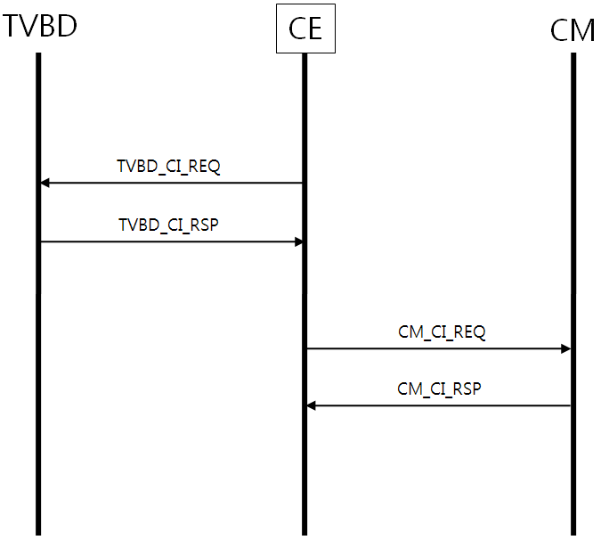
- Coexistence information gathering by CE

This procedure is used for coexistence information gathering by CM.

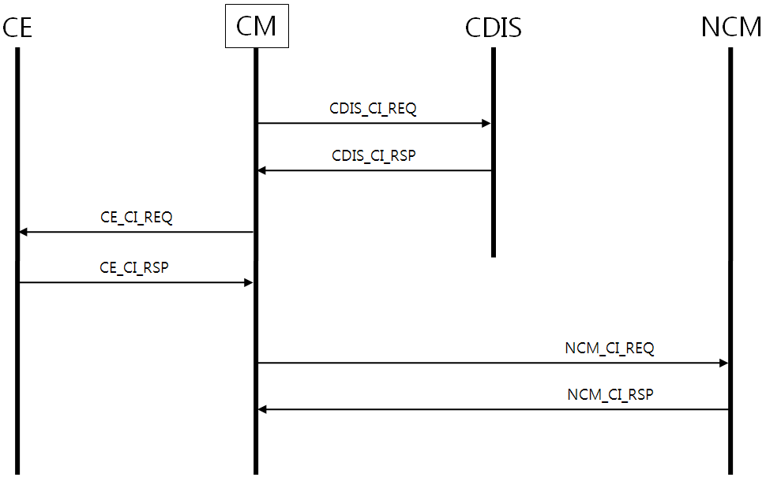
- Coexistence information gathering by CM

This procedure is used for coexistence information gathering by CDIS.

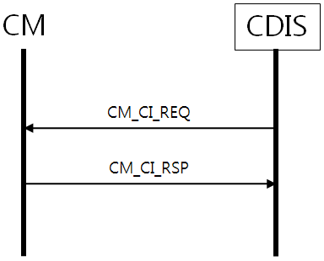
- Coexistence information gathering by CDIS

6.2.4.1 CE information collection
This procedure is used by CE to collect information from CM. The procedure is shown in the following Figure.
- 19 CE information collection procedure

6.2.4.2 CM information collection
This procedure is used by CM to collect information from CE, another CM, or CDIS. The procedure is shown in the following Figure.
- 19 CM information collection procedure

    - Neighbor Discovery
This procedure is used by CM to get the neighbour list. Note that the neighbour list contains intra and inter CM neighbour relationship between registered CEs and TVBDs of each CM.
- Neighbor discovery

This procedure is used for neighbor discovery between TVBDs registered to the same CM. Two or more intra-CM TVBD neighbor if they registered to the same CM as well as interfere each other with the same operating channel due to their geo-location, transmission range, interference range, and etc.

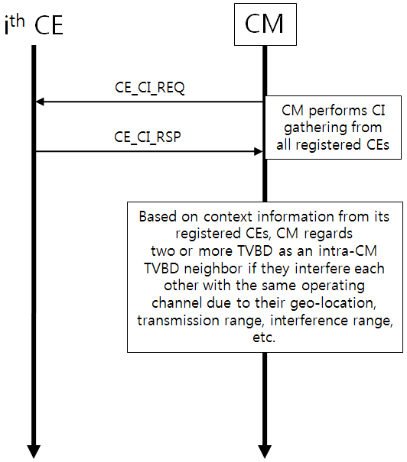
- Intra-CM TVBD neighbor discovery

This procedure depicted in the following figure is used for neighbor discovery between TVBDs registered to the different CM. Two or more inter-CM TVBD neighbor if they registered to the different CM as well as interfere with each other with the same operating channel due to their geo-location, transmission range, interference range, and etc.

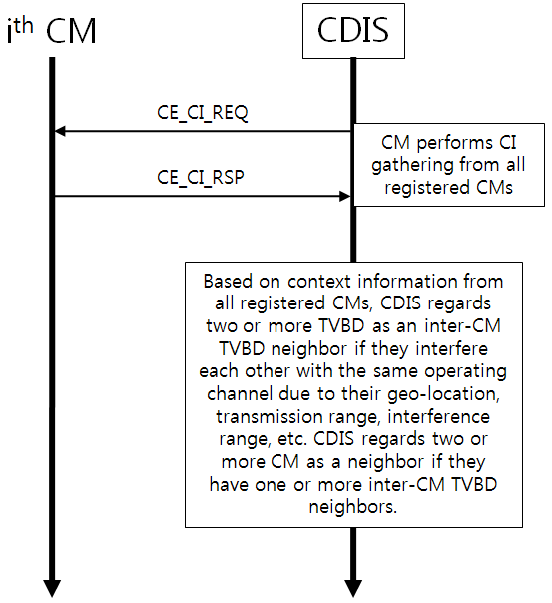
- Inter-CM TVBD neighbor discovery

This procedure is used for neighbor CM discovery.

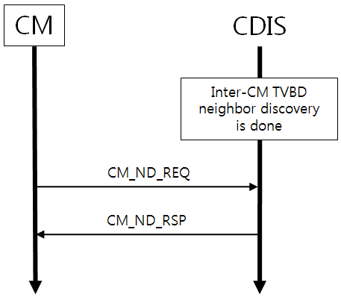
- Neighbor CM discovery

This procedure is used for neighbor TVBD discovery.

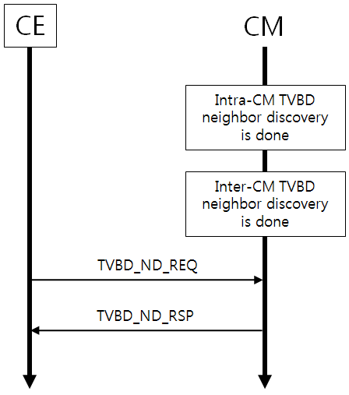
- Neighbor TVBD discovery

6.2.5.1 CE neighbour discovery
This procedure is used by CE to obtain information on neighbours for TVBD network or device served by this CE. The procedure is shown in the following Figure.
- 22 CE neighbour discovery procedure

6.2.5.2 CM neighbour discovery
This procedure is used by CM to obtain information on neighbours for one TVBD network or device served by this CM. The procedure is shown in the following Figure.
- 23 CM neighbour discovery procedure

    - Channel Classification
This procedure is used for channel classification by CM.

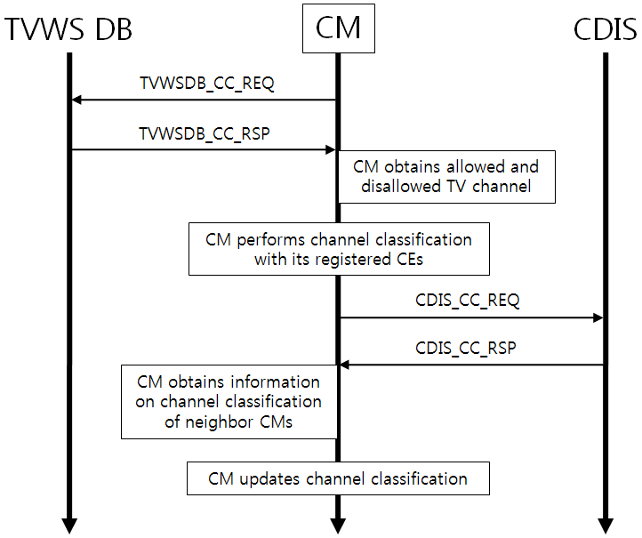
- Channel classification by CM

This procedure is used for channel classification by CE.

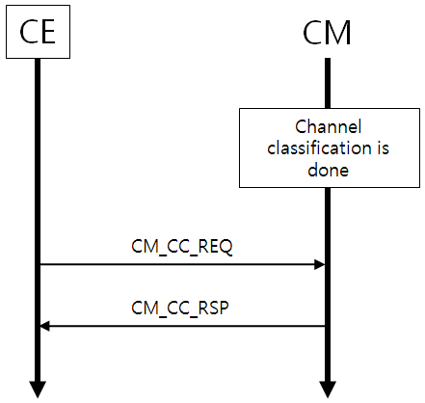
- Channel classification by CE

This procedure is used for channel classification by CDIS.

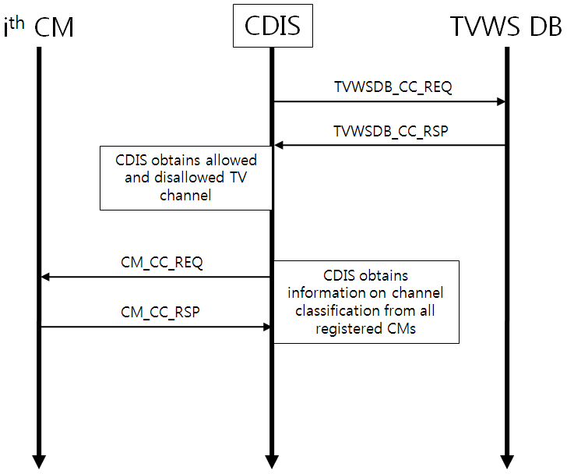
- Channel classification by CDIS

    - Coexistence decision making
This procedure is used for coexistence decision making by master CM (MCM) for centralized topology. MCM commands its slave CMs (SCMs).

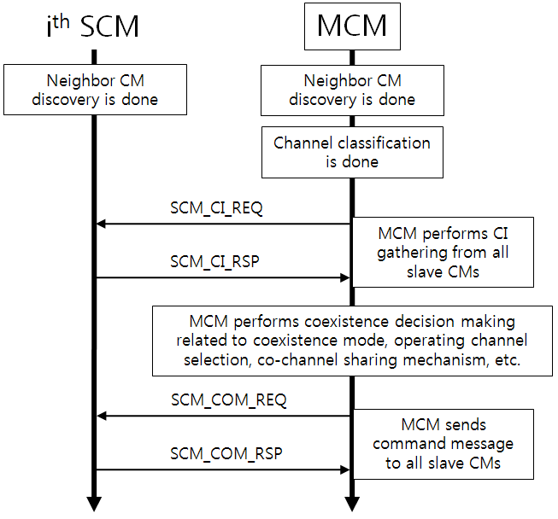
- Coexistence decision making: Command by MCM for centralized topology

This procedure is used for coexistence decision making by each CM for distributed topology. Negotiation shall be needed between neighbor CMs.

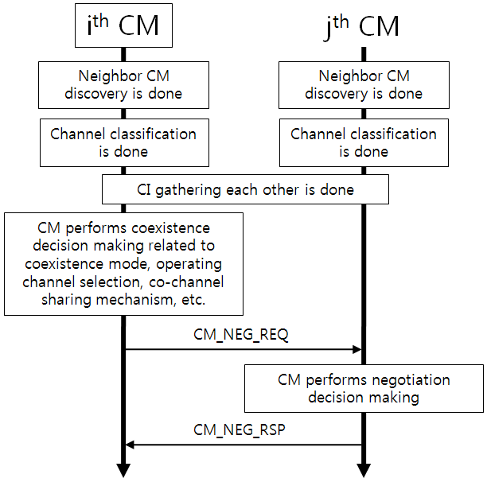
- Coexistence decision making: Negotiation by CM for distributed topology

    - Reconfiguration/Command
This procedure is used by CM to command its registered CE or TVBD to be configured as requested.

- Coexistence command

This procedure is used for reconfiguration by CM.

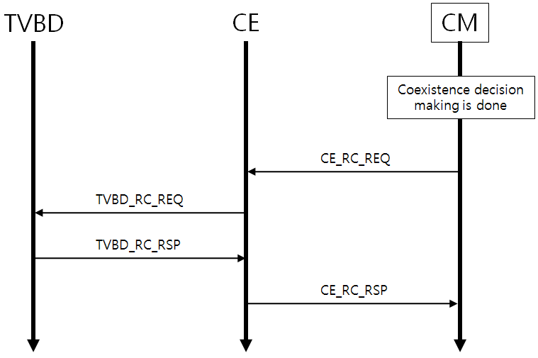
- Reconfiguration for management mode

6.2.8.1 CE reconfiguration
This procedure is used by CM to request reconfiguration of one of its TVBD network or device.
- 27 CE reconfiguration procedure

    - Measurement

6.2.9.1 Measurement request and report
This procedure is used by CM to request CE to perform measurements and to obtain measurement results from CE. The procedure is shown in the following Figure.
- 27 Measurement and report procedure
When report type is set to on-demand value, the measurement results are collected from CE by using CE information collection procedure.

This procedure is used for measurement between entities.

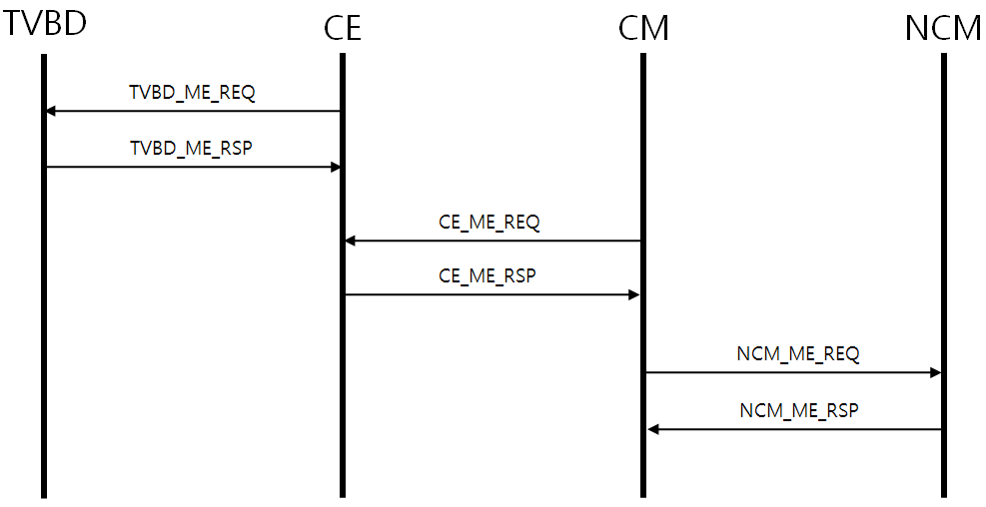
- Measurement between entities

This procedure is used by CM to request CE to perform measurements.

- CE Measurement
    - Event
This procedure is used for event between entities.

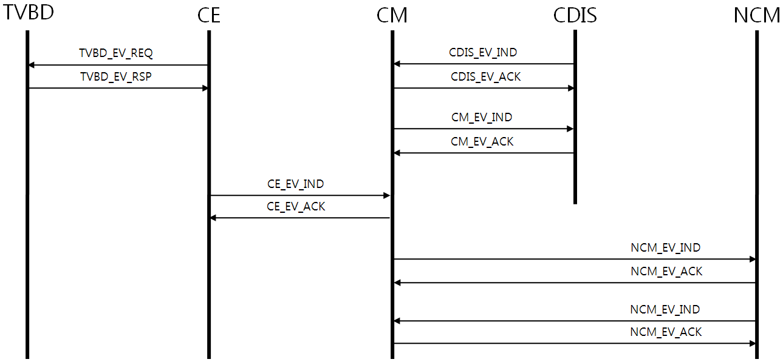
- Event between entities

6.2.10.1 Event from CE to CM
This procedure is used by CE to indicate an event to CM. The procedure is shown in the following Figure.
- 29 Event from CE to CM procedure

6.2.10.2 Event from CM to CE
This procedure is used by CM to indicate an event to CE. The procedure is shown in the following Figure.
- 29 Event from CM to CE procedure

6.2.10.3 Event from CM to CM
This procedure is used by CM to indicate an event to another CM. The procedure is shown in the following Figure.
- 30 Event from CM to CM procedure

6.2.10.4 Event from CM to CDIS
This procedure is used by CM to indicate an event to CDIS. The procedure is shown in the following Figure.
- 30 Event from CM to CDIS procedure

6.2.10.5 Event from CDIS to CM
This procedure is used by CDIS to indicate an event to CM. The procedure is shown in the following Figure.
- 30 Event from CDIS to CM procedure
    - Master selection procedure
This procedure is to support more flexible and efficient coexistence architecture. This is used by CM to hand over its role to another CM.

- Master CM selection
This procedure is to announce CDIS that the CM takes the role of master so that CDIS can take it into account when it calculates neighbor list.

- Master CM announcement
    - Unsupported message procedure
      - MessageUnsupported_Indication
The procedure is used by CM or CDIS to indicate to CE or CM that the received message is not supported.
- 31 Unsupported message procedure

    - Examples of using procedures (informative)
      - Coexistence decisions are done by TVBD
The following Figure shows example of using the above described procedure for scenario when decisions are done by TVBD network or device.
- 32 Coexistence decisions are done by TVBD
      - Coexistence decisions are done by Coexistence System
The following Figure shows example of using the above described procedure for scenario when decisions are done by coexistence system.
- 32 Coexistence decisions are done by Coexistence System

  - Messages
The logical entities in the 802.19.1 system communicate with each other using the transmission control protocol/internet protocol (TCP/IP) over internet. This clause specifically defines messages for data transfers between 802.19.1 entities, or between 802.19.1 entity and TVWS DB.

The following sub-clauses specify different messages and contents for interface between entities ((master/slave) CM, CE and CDIS) in the 802.19.1 system. The primitives and contents for interface between TVBD and CE are already defined in the 5.2 sub-clause. Messages in the following sub-clauses are specified for centralized and distributed topologies.

All messages convey a source identifier followed by a destination identifier as the first two of the message. Any message received that does not contain the source and destination identifiers, or has an unrecognizable or invalid message shall be discarded without sending any indication to the source entity.

The messages between the 802.19.1 entities are categorized into eight kinds of procedure messages, given as

- Registration/deregistation procedure messages
- Coexistence information gathering procedure messages
- Neighbor discovery procedure messages
- Channel classification procedure messges
- Coexistence decision making procedure messages
- Reconfiguration procedure messges
- Measurement procedure messages
- Event procedure messages

Registration/deregistation procedure messges specify demends of TVBD in the registration procedure and the removal of TVBD in the deregisration procedure. These messages in the 802.19.1 system are defined for interface between CM-CE, CM-CDIS, slave CM (SCM)-master CM (MCM) for the centralized toplogy and CM-neighbor CM (NCM) for the distributed topology, respectively.

Context information procedure messages convey fundamental information of the corresponding entity for decision making on radio resource usage optimization within this standard to be possible. The context information messages in the 802.19.1 system are defined for interface between CM-CE, CM-CDIS and CM-NCM for the distributed topology, respectively.

Neighbor discovery procedure messges convey the neighbor discovery information of the corresponding entity for the optimized radio resource usage. The neighbor discovery procedure messages in the 802.19.1 system are defined for interface between CM-CE and CM-CDIS, respectively.

Channel classification procedure messages inform channel classification information of TVWS to the corresponding entity based on TVWS DB information. These procedure messages in the 802.19.1 system are defined for interface between CM-CE, CM-CDIS and TVWS DB-CM/CDIS, respectively.

Coexistence decision making procedure messages are used to give command or negotiation information to the corresponding entity. These messages in the 802.19.1 system are defined for interface between SCM-MCM for the centralized topology, CM-NCM for the distributed topology, respectively.

Reconfiguration procedure messages provide the information for setting hardware and/or software of TVBD in order to properly change its operating parameters in the physical and MAC layers, such as operating channel, transmitting power and communicating coverage. The reconfiguration message in the 802.19.1 system is defined for interface between CM and CE.

Measurement procedure messages give measurement results of TVBD the corresponding entity. These procedure messages in the 802.19.1 system are defined for interface between CM-CE, SCM-MCM for the centralized topology and CM-NCM for the distributed topology, respectively.

Event message is used for a means of notifying a change of the entity status that triggers specific procedures for maintaining system performance. The event message in the 802.19.1 system is defined for interface between CM-CE, CM-CDIS, SCM-MCM for the centralized topology and CM-NCM for the distributed toplogogy, respectively.

Brief description of all messages defined in the 802.19.1 system is given as follows:

Category | Name | Description
Registration/  Deregistration | CE_REG_REQ/CE_REG_RSP  CM_REG_REQ/CM_REG_RSP  SCM_REG_REQ/SCM_REG_RSP | Registration of the corresponding entity
Registration/  Deregistration | CE_DREG_REQ/CE_DREG_RSP  CM_DREG_REQ/CM_DREG_RSP  SCM_DREG_REQ/SCM_DREG_RSP | Deregistration of the corresponding entity
Registration/  Deregistration | Authentication_Request/Authentication_Response  Deauthentication_Request/Dequthentication_Response  CE_Registration_Request/CM_Registration_Request/Registration_Response  Deregistration_Request/Deregistration_Confirm/Deregistration_Announcement  Connection_Request/Connection_Response | TBD
Registration/  Deregistration | Registration_Request/Registration_Response | TBD
Coexistence Resource Allocation | Resource_Request/Resource_Response | TBD
Coexistence information gathering | CE_CI_REQ/CE_CI_RSP  CDIS_CI_REQ/CDIS_CI_RSP  NCM_CI_REQ/NCM_CI_RSP  CM_CI_REQ/CM_CI_RSP  SCM_CI_REQ/SCM_CI_RSP | Coexistence information of the corresponding entity
Information collection | InfoAcquiring_Request /InfoAcquiring_Response | TBD
Neighbor discovery | CM_ND_REQ/CM_ND_RSP  TVBD_ND_REQ/TVBD_ND_RSP | Neighbor discovery information of the corresponding entity
Neighbor discovery | CE_NeighbourList_Announcement  CM_ NeighbourList_Announcement | TBD
Neighbor discovery | Neighborlist_Request  /Neighborlist_Response | TBD
Get available channel list | GetAvailableChannels_Request  /GetAvailableChannels_Response | TBD
Channel list update | AvailableChannels_Announcement | TBD
Channel classification | TVWSDB_CC_REQ/TVWSDB_CC_RSP  CDIS_CC_REQ/CDIS_CC_RSP  CM_CC_REQ/CM_CC_RSP | Channel classification information of the corresponding CM
Coexistence decision making | SCM_COM_REQ/ SCM_COM_RSP  CM_NEG_REQ/CM_NEG_RSP | Command or negotiation information of the corresponding CM
Reconfiguration | CE_RC_REQ/ CE_RC_RSP | Reconfiguration information of the corresponding CE
Reconfiguration | Reconfiguration_Request  /Reconfiguration_Confirm | TBD
Reconfiguration | Command_Request  /Command_Confirm | TBD
Measurement | CE_ME_REQ/CE_ME_RSP  NCM_ME_REQ/ NCM_ME_RSP | Measurement information of the corresponding CE
Measurement | Measurement_Request  Measurement_Report  Measurement_Confrim | TBD
Measurement | Measurement_Request  /Mesurement_Report | TBD
Event | CE_EV_IND/ CE_EV_ACK  CDIS_EV_IND/CDIS_EV_ACK  CM_EV_IND/ CM_EV_ACK  NCM_EV_IND/NCM_EV_ACK | Event information of the corresponding entity
Event | Event_Indication  Event_Confirm | TBD
Master selection | MasterCM_Request/MasterCM_Reponse  /MasterCM_Announcement | TBD
Session activity check | SessionActive_Request/ SessionActive_Confirm | TBD
Unsupported message | MessageUnsupported_indication | TBD
    - Registration/Deregistration procedure messages
      - CE_REG_REQ
This message is identical to all topologies, that is, centralized and distributed topologies. This message used by CE is transmitted to (master/slave) CM to request registration of the corresponding TVBD. The contents of this message are given as follows
Header
Name | Data Type | Description
SourceID | CE ID | Source identifier
DestinationID | (Master/Slave) CM ID | Destination identifier
Payload
Name | Data Type | Description
TVBDFCCID | STRING | FCC ID of the corresponding TVBD
RequiredBandwidth | REAL | Required bandwidth of the corresponding TVBD which is a mandatory parameter
RequiredServiceDuration | INTEGER | Required service duration of the corresponding TVBD which is a mandatory parameter
RequiredServiceCoverage | REAL | Required service coverage of the corresponding TVBD which is a mandatory parameter
RegistrationOptions | COEX_REG_OPTIONS | Optional parameters:  - Desired TVWS channel number list  - Service time
      - CE_REG_RSP
This message is identical to all topologies. This message used by (master/slave) CM is transmitted to CE to give the registration results of the corresponding TVBD. The contents of this message are given as follows
Header
Name | Data Type | Description
SourceID | (Master/Slave) CM ID | Source identifier
DestinationID | CE ID | Destination identifier
Payload
Name | Data Type | Description
TVBDFCCID | STRING | FCC ID of the corresponding TVBD
RegistrationStatus | COEX_REG_STATUS | The status information of registration parameters is provided with  - accepted values of parameters when  registration is succeed.  - recommended values of parameters  when registration is failed.

      - CM_REG_REQ
This message is identical to all topologies, that is, centralized and distributed topologies. This message used by (master/slave) CM is transmitted to CDIS to request registration of the corresponding (master/slave) CM. Also, this message is sent from CM to neighbor CM for the distributed topology. The contents of this message are given as follows
Header
Name | Data Type | Description
SourceID | (Master/Slave) CM ID/ CM ID | Source identifier
DestinationID | CDIS ID/Neighbor CM ID | Destination identifier
Payload
Name | Data Type | Description
RegisteredCMID | CM ID | Registered CM ID
      - CM_REG_RSP
This message is identical to all topologies. This message used by CDIS is transmitted to (master/slave) CM to give the registration results of the corresponding (master/slave) CM. Also, this message is sent from neighbor CM to CM for the distributed topology. The contents of this message are given as follows
Header
Name | Data Type | Description
SourceID | CDIS ID/Neighbor CM ID | Source identifier
DestinationID | (Master/Slave) CM ID/ CM ID | Destination identifier
Payload
Name | Data Type | Description
RegistrationStatus | BOOLEAN | Status of registration  - True: Registration of the  corresponding CM is succeed.  - False:Registration of the  corresponding CM is failed.

      - CE_DREG_REQ
This message is identical to all topologies.This message used by CE is transmitted to (master/slave) CM to request deregistration of the corresponding TVBD. The contents of this message are given as follows
Header
Name | Data Type | Description
SourceID | CE ID | Source identifier
DestinationID | (Master/Slave) CM ID | Destination identifier
Payload
Name | Data Type | Description
TVBDFCCID | STRING | FCC ID of the corresponding TVBD
      - CE_DREG_RSP
This message is identical to all topologies. This message used by (master/slave) CM is transmitted to CE to give the deregistration results of the corresponding TVBD. The contents of this message are given as follows
Header
Name | Data Type | Description
SourceID | (Master/Slave) CM ID | Source identifier
DestinationID | CE ID | Destination identifier
Payload
Name | Data Type | Description
TVBDFCCID | STRING | FCC ID of the corresponding TVBD
DeregistrationStatus | BOOLEAN | Status of de-registration  - True: De-registration of the  corresponding TVBD is succeed.  - False:De-registration of the  corresponding TVBD is failed.
      - CM_DREG_REQ
This message is identical to all topologies. This message used by (master/slave) CM is transmitted to CDIS to request deregistration of the corresponding (master/slave) CM. Also, this message is sent from CM to neighbor CM for the distributed topology. The contents of this message are given as follows
Header
Name | Data Type | Description
SourceID | (Master/Slave) CM ID/ CM ID | Source identifier
DestinationID | CDIS ID/ Neighbor CM ID | Destination identifier
Payload
Name | Data Type | Description
RegisteredCMID | CM ID | Registered CM ID

      - CM_DREG_RSP
This message is identical to all topologies. This message used by CDIS is transmitted to (master/slave) CM to give the deregistration results of the corresponding (master/slave) CM. Also, this message is sent from neighbor CM to CM for the distributed topology. The contents of this message are given as follows
Header
Name | Data Type | Description
SourceID | CDIS ID /Neighbor CM ID | Source identifier
DestinationID | (Master/Slave) CM ID/CM ID | Destination identifier
Payload
Name | Data Type | Description
DeregistrationStatus | BOOLEAN | Status of de-registration  - True: De-registration  of the corresponding CM is succeed.  - False:De-registration  of the corresponding CM is failed.

      - SCM_REG_REQ
This message is for the centralized topology. This message used by slave CM is transmitted to master CM to request registration of the corresponding slave CM. The contents of this message are given as follows
Header
Name | Data Type | Description
SourceID | Slave CM ID | Source identifier
DestinationID | Master CM ID | Destination identifier
Payload
Name | Data Type | Description
NeighborCEIDList | SEQUENCE OF STRING | Neighbor CE ID list
The message contents below are repeated for each neighbor CE
NeighborCEID | STRING | Neighbor CE ID
RequiredBandwidth | REAL | Required bandwidth of the corresponding TVBD which is a mandatory parameter
RequiredServiceDuration | INTEGER | Required service duration of the corresponding TVBD which is a mandatory parameter
RequiredServiceCoverage | REAL | Required service coverage of the corresponding TVBD which is a mandatory parameter
RegistrationOptions | COEX_REG_OPTIONS | Optional parameters:  - Desired TVWS channel number list  - Service time
      - SCM_REG_RSP
This message is for the centralized topology. This message used by master CM is transmitted to slave CM to give the registration results of the corresponding slave CM. The contents of this message are given as follows
Header
Name | Data Type | Description
SourceID | Master CM ID | Source identifier
DestinationID | Slave CM ID | Destination identifier
Payload
Name | Data Type | Description
NeighborCEIDList | SEQUENCE OF STRING | Neighbor CE ID list
The message contents below are repeated for each neighbor CE
NeighborCEID | STRING | Neighbor CE ID
RegistrationStatus | COEX_REG_STATUS | The status information of registration parameters is provided with  - accepted values of parameters when  registration is succeed.  - recommended values of parameters  when registration is failed.

      - SCM_DREG_REQ
This message is for the centralized topology. This message used by slave CM is transmitted to master CM to request deregistration of the corresponding slave CM. The contents of this message are given as follows
Header
Name | Data Type | Description
SourceID | Slave CM ID | Source identifier
DestinationID | Master CM ID | Destination identifier
Payload
Name | Data Type | Description
NeighborCEIDList | SEQUENCE OF STRING | Neighbor CE ID list

      - SCM_DREG_RSP
This message is for the centralized topology. This message used by master CM is transmitted to slave CM to give the deregistration results of the corresponding slave CM. The contents of this message are given as follows
Header
Name | Data Type | Description
SourceID | Master CM ID | Source identifier
DestinationID | Slave CM ID | Destination identifier
Payload
Name | Data Type | Description
NeighborCEIDList | SEQUENCE OF STRING | Neighbor CE ID list
The message contents below are repeated for each neighbor CE
NeighborCEID | STRING | Neighbor CE ID
DeregistrationStatus | BOOLEAN | Status of de-registration  - True: De-registration of the  corresponding TVBD is succeed.  - False:De-registration of the  corresponding TVBD is failed.
      - Authentication_Request
This message is sent from CE to CM to login to CM. Also, this message is sent from CM to CDIS to login to CDIS.
Header
Information element | Data type | Description
SourceIdentifier = CE_ID or CM_ID | CX_ID | Source identifier
DestinationIdentifier = CM_ID or CDIS_ID | CX_ID | Destination identifier
ACKPolicy | BOOLEAN | Request to send acknowledgement of reception
Payload
Information element | Data type | Description
ClientID | IA5String | Client ID (client is CE or CM)
ClientPW | IA5String | Client password (client is CE or CM)
      - Authentication_Response
This message is sent from CM to CE to confirm or reject CE authentication. Also, this message is sent from CDIS to CM to confirm or reject CM authentication.
Header
Information element | Data type | Description
SourceIdentifier = CM_ID or CDIS_ID | CX_ID | Source identifier
DestinationIdentifier = CE_ID or CM_ID | CX_ID | Destination identifier
ACK Policy | BOOLEAN | Request to send acknowledgement of reception
Payload
Information element | Data type | Description
ServerID | IA5String | Server ID (server is CM or CDIS)
ServerPW | IA5String | Server password (server is CM or CDIS)
Status | STATUS | Status
      - Deauthentication_Request
This message is sent from CE to CM to logoff from CM. Also, this message is sent from CM to CDIS to logoff from CDIS.
Header
Information element | Data type | Description
SourceIdentifier = CE_ID or CM_ID | CX_ID | Source identifier
DestinationIdentifier = CM_ID or CDIS_ID | CX_ID | Destination identifier
ACK Policy | BOOLEAN | Request to send acknowledgement of reception
Payload
Information element | Data type | Description
ClientID | IA5String | Client ID (client is CE or CM)
ClientPW | IA5String | Client password (client is CE or CM)
Reason | REASON | Reason
      - Deauthentication_Response
This message is sent from CM to CE to confirm or reject CE deauthentication. Also, this message is sent from CDIS to CM to confirm or reject CM deauthentication.
Header
Information element | Data type | Description
SourceIdentifier = CM_ID or CDIS_ID | CX_ID | Source identifier
DestinationIdentifier = CE_ID or CM_ID | CX_ID | Destination identifier
ACK Policy | BOOLEAN | Request to send acknowledgement of reception
Payload
Information element | Data type | Description
ServerID | IA5String | Server ID (server is CM or CDIS)
ServerPW | IA5String | Server password (server is CM or CDIS)
Status | STATUS | Status
      - CE_Registration_Request
This message is sent from CE to CM to register information of TVBD network or device served by this CE to CM. This message is used for initial registration or for registration update.
Header
Information element | Data type | Description
SourceIdentifier = CE_ID | CX_ID | Source identifier
DestinationIdentifier = CM_ID | CX_ID | Destination identifier
ACK Policy | BOOLEAN | Request to send acknowledgement of reception
Payload
Information element | Data type | Description
OperationCode | OPERATION_CODE | Indicates whether this is new registration or registration update
NetworkID | NETWORK_ID | E.g., FCC ID of TVBD network or device
NetworkType | NETWORK_TYPE | E.g., 802.11af, 802.22
SubscrCoexService | SUBSCR_COEX_SERVICE | Coexistence service to which TVBD network or device served by this CE is subscribed
OperatingChannel | OPERATING_CHANNEL | Operating channels if any
ServiceAreaInfo | SERVICE_AREA | Service area related information
InterferenceAreaInfo | INTERFERENCE_AREA | Interference area related information
      - CM_Registration_Request
This message is sent from CM to CDIS to register information of TVBD networks or devices served by this CM to CDIS. This message is used for initial registration or for registration update.
Header
Information element | Data type | Description
SourceIdentifier = CM_ID | CX_ID | Source identifier
DestinationIdentifier = CDIS_ID | CX_ID | Destination identifier
ACK Policy | BOOLEAN | Request to send acknowledgement of reception
Payload
Information element | Data type | Description
Note: For each TVBD network or device, the information elements below are repeated.
OperationCode | OPERATION_CODE | Indicates whether this is new registration, adding registration, modifying registration, or removing registration
NetworkID | NETWORK_ID | E.g., FCC ID of TVBD network or device
NetworkType | NETWORK_TYPE | E.g., 802.11af, 802.22
SubscrCoexService | SUBSCR_COEX_SERVICE | Coexistence service to which TVBD network or device served by this CE is subscribed
OperatingChannel | OPERATING_CHANNEL | Operating channels if any
ServiceAreaInfo | SERVICE_AREA | Service area related information
InterferenceAreaInfo | INTERFERENCE_AREA | Interference area related information
      - Registration_Response
This message is sent from CM to CE to confirm the registration. Also, this message is sent from CDIS to CM to confirm the registration.
Header
Information element | Data type | Description
SourceIdentifier = CM_ID or CDIS_ID | CX_ID | Source identifier
DestinationIdentifier = CE_ID or CM_ID | CX_ID | Destination identifier
ACKPolicy | BOOLEAN | Request to send acknowledgement of reception
Payload
Information element | Data type | Description
Status | STATUS | Status
      - Deregistration_Announcement
This message is sent from CM to CE to announce to CE that it will start deregistration procedure. This message does not have any payload.
Header
Information element | Data type | Description
SourceIdentifier = CM_ID | CX_ID | Source identifier
DestinationIdentifier = CE_ID | CX_ID | Destination identifier
ACKPolicy | BOOLEAN | Request to send acknowledgement of reception
Payload
Information element | Data type | Description
None | None | None
      - Deregistration_Request
This message is sent from CE to CM to remove its registered record from CM. Also, this message is sent from CM to CDIS to remove its registered record from CDIS.
Header
Information element | Data type | Description
SourceIdentifier = CE_ID or CM_ID | CX_ID | Source identifier
DestinationIdentifier = CM_ID or CDIS_ID | CX_ID | Destination identifier
ACKPolicy | BOOLEAN | Request to send acknowledgement of reception
Payload
Information element | Data type | Description
Reason | REASON | Reason
      - Deregistration_Confirm
This message is sent from CM to CE to confirm deregistration. Also, this message is sent from CDIS to CM to confirm deregistration.
Header
Information element | Data type | Description
SourceIdentifier = CM_ID or CDIS_ID | CX_ID | Source identifier
DestinationIdentifier = CE_ID or CM_ID | CX_ID | Destination identifier
ACK Policy | BOOLEAN | Request to send acknowledgement of reception
Payload
Information element | Data type | Description
Status | STATUS | Status
      - Connection_Request
This message is sent from CE to CM to check CM availability. Also this message is sent from CM to CDIS to check CDIS availability. This message does not have payload.
Header
Information element | Data type | Description
SourceIdentifier = CE_ID or CM_ID | CX_ID | Source identifier
DestinationIdentifier = CM_ID or CDIS_ID | CX_ID | Destination identifier
ACK Policy | BOOLEAN | Request to send acknowledgement of reception
Payload
Information element | Data type | Description
None | None | None
      - Connection_Response
This message is sent from CM to CE to indicate CM availability to provide service for the CE. Also this message is sent from CDIS to CM to indicate CDIS availability to provide service for the CM. This message does not have payload.
Header
Information element | Data type | Description
SourceIdentifier = CDIS_ID | CX_ID | Source identifier
DestinationIdentifier = CM_ID | CX_ID | Destination identifier
ACK Policy | BOOLEAN | Request to send acknowledgement of reception
Payload
Information element | Data type | Description
None | None | None

      - Registration_Request
This message is sent from CE to CM to set up a connection to with CM. Also this message is sent from CM to CDIS or CM to CM.
.
Header
Name | Data type | Description
SourceIdentifier | COEX_ID | CE/CM identifier
DestinationIdentifier | COEX_ID | CM/CDIS identifier
InformationType | COEX_INFO_TYPE | Message type
DialogTocken | Integer | Message sequence number
Payload
Information element | Data type | Description
Geolocation (optional) | GEO_LOC | Registrer geolocation of TVBD

      - Registration_Response
This message is sent from CM to CE. This message contains the result of requested connection setup.

Header
Name | Data type | Description
SourceIdentifier | COEX_ID | CE/CM identifier
DestinationIdentifier | COEX_ID | CM/CDIS identifier
InformationType | COEX_INFO_TYPE | Message type
DialogTocken | Integer | Message sequence number
Payload
Information element | Data type | Description
StatusCode | STATUS_CODE | Status

    - Coexistence resource allocation procedure message
      - Resource_Request
This message is sent from CE to CM to request to allocate resource. This message contains each of TVBD device or network’s information including available channel list obtained from TVWS DB.

Header
Name | Data type | Description
SourceIdentifier | COEX_ID | CE identifier
DestinationIdentifier | COEX_ID | CM identifier
InformationType | COEX_INFO_TYPE | Message type
DialogTocken | Integer | Message sequence number
Payload
Information element | Data type | Description
Note: Information elements below are repeated for each TVBD device or network
TVBDType | TVBD_TYPE | TVBD device or network type
Geolocation | GEO_LOC | Registered geolocation
Note: Information elements below are repeated for each available channel of TVBD.
ChannelNumber | Integer | Channel number
MaximumPowerLevel | Real | Power limit
ChannelLoad (optional) | Real | Expected throughput

      - Resource_Response
This message is sent from CM to allocate resources to requested CE.

Header
Name | Data type | Description
SourceIdentifier | COEX_ID | CM identifier
DestinationIdentifier | COEX_ID | CE identifier
InformationType | COEX_INFO_TYPE | Message type
DialogTocken | Integer | Message sequence number
Payload
Information element | Data type | Description
Note: Information elements below are repeated for each allocated channel for CE
ChannelNumber | Integer | Channel number
MaximumPowerLevel | Real | Power limit

    - Coexistence information gathering procedure message
      - CM_CI_REQ
This message is for all topologies. This message used by CDIS is transmitted to (master/slave) CM to request coexistence information of the corresponding (master/slave) CM. Also, this message is sent from CE to (master/slave) CM. The contents of this message are given as follows
Header
Name | Data Type | Description
SourceID | CDIS ID/CE ID | Source identifier
DestinationID | (Master/Slave) CM ID | Destination identifier
Payload
Name | Data Type | Description
RegisteredCMInformationIDs | COEX_CM_INFO_IDS | Registered CM information IDs  - Registered CE ID list  - Registered CEs information  - Operating channel list  - TVBD type  - Network type  - Antenna gain  - Antenna Height  - Geolocaiton  - Coverage  - Interference range  - Reconfiguraiton options
      - CM_CI_RSP
This message is for all topologies. This message used by (master/slave) CM is transmitted to CDIS to give the coexistence information of corresponding (master/slave) CM. Also, this message is sent from (master/slave) CM to CE. The contents of this message are given as follows
Header
Name | Data Type | Description
SourceID | (Master/Slave) CM ID | Source identifier
DestinationID | CDIS ID/CE ID | Destination identifier
Payload
Name | Data Type | Description
RegisteredCEIDList | SEQUENCE OF  STRING | Registered CE ID list
The message contents below are repeated for each registered CE
RegisteredCEID | STRING | Registered CE ID
RegisteredCEOperatingChannelList | SEQUENCE OF  INTEGER | TVBD operating channe list
RegisteredCETVBDType | COEX_TVBD_TYPE | TVBD type, categorized by  - Fixed device type  - Personal/portable mode I type  - Personal/portable mode II type
RegisteredCENetworkType | COEX_TVBD_  NET_TYPE | TVBD network type such as IEEE 802.11af, IEEE 802.22 and IEEE 802.16, etc.
RegisteredCEAntennaGain | REAL | TVBD antenna gain
RegisteredCEAntennaHeight | REAL | TVBD antenna height
RegisteredCEGeolocation | COEX_TVBD_  GEOLOCATION | TVBD geolocation, including  - Latitude  - Longitude  - Altitude
RegisteredCECoverage | REAL | TVBD coverage for communications
RegisteredCEInterferenceRange | REAL | TVBD interference range
RegisteredCEReconfigurationOptions | COEX_TVBD_  RC_OPTIONS | Reconfiguration options of TVBD such as  - Reconfigurable TVWS  channel list  - Resolution of transmit  power control  - Range of transmit  power  - Reconfigurable antenna  polarization list  - Resolution of antenna  half power beam width (HPBW) control  - Range of HPBW
      - CE_CI_REQ
This message is for all topologies. This message used by (master/slave) CM is transmitted to CE to request coexistence information of the corresponding TVBD. The contents of this message are given as follows
Header
Name | Data Type | Description
SourceID | (Master/Slave) CM ID | Source identifier
DestinationID | CE ID | Destination identifier
Payload
Name | Data Type | Description
TVBDInformationIDs | COEX_TVBD_INFO_IDS | TVBD information IDs  - TVBD operating channel list  - TVBD type  - TVBD network type  - TVBD antenna gain  - TVBD antenna height  - TVBD aeolocation  - TVBD coverage  - TVBD interference range  - TVBD reconfiguration options

      - CE_CI_RSP
This message is for all topologies. This message used by CE is transmitted to (master/slave) CM to give the coexistence information of corresponding CE. The contents of this message are given as follows
Header
Name | Data Type | Description
SourceID | CE ID | Source identifier
DestinationID | (Master/Slave) CM ID | Destination identifier
Payload
Name | Data Type | Description
TVBDOperatingChannelList | SEQUENCE OF INTEGER | TVBD operating channel number list
TVBDType | COEX_TVBD_TYPE | TVBD type, categorized by  - Fixed device type  - Personal/portable mode I type  - Personal/portable mode II type
TVBDNetworkType | COEX_TVBD_NET_TYPE | TVBD network type such as IEEE 802.11af, IEEE 802.22 and IEEE 802.16, etc.
TVBDAntennaGain | REAL | TVBD antenna gain
TVBDAntennaHeight | REAL | TVBD antenna height
TVBDGeolocation | COEX_TVBD_GEOLOCATION | TVBD geolocation, including  - Latitude  - Longitude  - Altitude
TVBDCoverage | REAL | TVBD coverage for communications
TVBDInterferenceRange | REAL | TVBD interference range
TVBDReconfigurationOptions | COEX_TVBD_RC_OPTIONS | Reconfiguration options of TVBD such as  - Reconfigurable TVWS  channel list  - Resolution of transmit  power control  - Range of transmit power  - Reconfigurable antenna  polarization list  - Resolution of antenna half  power beam width (HPBW) control  - Range of HPBW

      - CDIS_CI_REQ
This message is for all topologies. This message used by (master/slave) CM is transmitted to CDIS to request coexistence information of the neighbor (master/slave) CM for neighbor discovery. The contents of this message are given as follows
Header
Name | Data Type | Description
SourceID | (Master/Slave) CM ID | Source identifier
DestinationID | CDIS ID | Destination identifier
Payload
Name | Data Type | Description
NeighborList | SEQUENCE OF STRING | Neighbor list such as  - Neighbor CM ID list  - Neighbor CE ID list
NeighborCMsInformationIDs | COEX_CM_INFO_IDS | Neighbor CMs information IDs  - Neighbor CM ID list  - Neighbor CMs information  - Neighbor CE ID list  - Neighbor CEs information

      - CDIS_CI_RSP
This message is for all topologies. This message used by CDIS is transmitted to (master/slave) CM to give coexistence information of the neighbor (master/slave) CM for neighbor discovery. The contents of this message are given as follows
Header
Name | Data Type | Description
SourceID | CDIS ID | Source identifier
DestinationID | (Master/Slave) CM ID | Destination identifier
Payload
Name | Data Type | Description
NeighborCMIDList | SEQUENCE OF  STRING | When this content is null from the (master/slave) CM message, a default value is all neighbor CM ID list
The message contents below are repeated for each neighbor CM
NeighborCMID | STRING | Neighbor CM ID
NeighborCEIDList | SEQUENCE OF  STRING | When this content is null from the (master/slave) CM message, a default value is all neighbor CE ID list
The message contents below are repeated for each neighbor CE
NeighborCEsInformation | COEX_CE_INFO | Neighbor CEs information  - Operating channel list  - TVBD type  - Network type  - Antenna gain  - Antenna height  - Geolocation  - Coverage  - Interference range  - Reconfiguration options

      - NCM_CI_REQ
This message is for the distributed topology. This message used by CM is transmitted to neighbor CM to request coexistence information of corresponding neighbor CM. The contents of this message are given as follows
Header
Name | Data Type | Description
SourceID | CM ID | Source identifier
DestinationID | Neighbor CM ID | Destination identifier
Payload
Name | Data Type | Description
NeighborCEIDList | SEQUENCE OF STRING | Neighbor CE ID list to collect context information
NeighborCEInformationIDs | COEX_CE_INFO_IDS | Neighbor CEs information  - Operating channel list  - TVBD type  - Network type  - Antenna gain  - Antenna height  - Geolocaiton  - Coverage  - Interference range  - Reconfiguration options

      - NCM_CI_RSP
This message is for the distributed topology. This message used by neighbor CM is transmitted to CM to give the coexistence information of corresponding neighbor CM. The contents of this message are given as follows
Header
Name | Data Type | Description
SourceID | Neighbor CM ID | Source identifier
DestinationID | CM ID | Destination identifier
Payload
Name | Data Type | Description
NeighborCMChannelClassificationList | COEX_CH_  CLASSIFICATION | Neighbor CM channel classification list
NeighborCEIDList | SEQUENCE OF STRING | Neighbor CE ID list
The message contents below are repeated for each neighbor CE
NeighborCEID | STRING | Neighbor CE ID
NeighborCEOperatingChannelList | COEX_CH_  CLASSIFICATION | TVBD operating channe list
NeighborCETVBDType | COEX_TVBD_TYPE | TVBD type, categorized by  - Fixed device type  - Personal/portable  mode I type  - Personal/portable mode II type
NeighborCENetworkType | COEX_TVBD_  NET_TYPE | TVBD network type such as IEEE 802.11af, IEEE 802.22 and IEEE 802.16, etc.
NeighborCEAntennaGain | REAL | TVBD antenna gain
NeighborCEAntennaHeight | REAL | TVBD antenna height
NeighborCEGeolocation | COEX_TVBD_  GEOLOCATION | TVBD geolocation, including  - Latitude  - Longitude  - Altitude
NeighborCECoverage | REAL | TVBD coverage for communications
NeighborCEInterferenceRange | REAL | TVBD interference range
NeighborCEReconfigurationOptions | COEX_TVBD_  RC_OPTIONS | Reconfiguration options of TVBD such as  - Reconfigurable  TVWS channel list  - Resolution of transmit  power control  - Range of transmit  power  - Reconfigurable  antenna polarization list  - Resolution of antenna  half power beam width (HPBW) control  - Range of HPBW

      - SCM_CI_REQ
This message is for the centralized topology. This message used by master CM is transmitted to slave CM to request coexistence information of the corresponding slave CM for the centralized topology. The contents of this message are given as follows
Header
Name | Data Type | Description
SourceID | Master CM ID | Source identifier
DestinationID | Slave CM ID | Destination identifier
Payload
Name | Data Type | Description
RegisteredCMInformationID | COEX_CM_INFO_IDS | Registered CM information IDs  - Registered CE ID list  - Registered CEs information  - Operating channel list  - TVBD type  - Network type  - Antenna gain  - Antenna Height  - Geolocaiton  - Coverage  - Interference range  - Reconfiguraiton options
NeighborCMsInformationIDs | COEX_CM_INFO_IDS | Neighbor CMs information IDs  - Neighbor CM ID list  - Neighbor CE ID list

      - SCM_CI_RSP
This message is for the centralized topology. This message used by slave CM is transmitted to master CM to give coexistence information of corresponding slave CM. The contents of this message are given as follows
Header
Name | Data Type | Description
SourceID | Slave CM ID | Source identifier
DestinationID | Master CM ID | Destination identifier
Payload
Name | Data Type | Description
RegisteredCEIDList | SEQUENCE OF  STRING | Registered CE ID list
The message contents below are repeated for each registered CE
RegisteredCEInformation | COEX_CE_INFO | Registered CE information  - Registered CE ID  - Registered CE information  - Operating channel  list  - TVBD type  - Network type  - Antenna gain  - Antenna Height  - Geolocaiton  - Coverage  - Interference range  - Reconfiguraiton  options
NeighborCMIDList | SEQUENCE OF  STRING | Neighbor CM ID list
The message contents below are repeated for each neighbor CM
NeighborCMID | STRING | Neighbor CM ID
NeighborCEIDList | SEQUENCE OF  STRING | Neighbor CE ID list
NeighborCEChannelNumberList | SEQUENCE OF  INTEGER | Neighbor CE channel number list

    - Information collection procedure message
      - InfoAcquiring_Request
This message is sent from CM to CE to request CE to obtain information from TVBD network or device. Also, this message is sent from CM to another CM to obtain information from this CM.
Header
Information element | Data type | Description
SourceIdentifier = CM_ID | CX_ID | Source identifier
DestinationIdentifier = CE_ID or CM_ID | CX_ID | Destination identifier
ACK Policy | BOOLEAN | Request to send acknowledgement of reception
Payload
Information element | Data type | Description
ReqInfoDescr | REQ_INFO_DESCR | Requested information ID
      - InfoAcquiring_Response
This message is sent from CE to CM to provide requested information to CM. Also, this message is sent from CM to another CM to provide requested information to this CM.
Header
Information element | Data type | Description
SourceIdentifier = CE_ID or CM_ID | CX_ID | Source identifier
DestinationIdentifier = CM_ID | CX_ID | Destination identifier
ACKPolicy | BOOLEAN | Request to send acknowledgement of reception
Payload
Information element | Data type | Description
ReqInfo | REQ_INFO | Requested information value

    - Neighbor discovery procedure message
      - CM_ND_REQ
This message is for all topologies. This message used by (master/slave) CM is transmitted to CDIS to request inter-CM TVBD neighbor discovery information of the corresponding (master/slave) CM. The contents of this message are given as follows
Header
Name | Data Type | Description
SourceID | (Master/Slave) CM ID | Source identifier
DestinationID | CDIS ID | Destination identifier
Payload
Name | Data Type | Description
None

      - CM_ND_RSP
This message is for all topologies. This message used by CDIS is transmitted to (master/slave) CM to give inter-CM TVBD neighbor discovery information of corresponding (master/slave) CM. The contents of this message are given as follows
Header
Name | Data Type | Description
SourceID | CDIS ID | Source identifier
DestinationID | (Master/Slave) CM ID | Destination identifier
Payload
Name | Data Type | Description
CMFunction | COEX_CM_FUNC | To command a function of corresponding CM for the centralized topology  - Master CM  - Slave CM
NeighborCMIDList | SEQUENCE OF  STRING | Neighbor CM ID list
The message contents below are repeated for each neighbor CM
NeighborCMID | STRING | Neighbor CM ID
NeighborCEIDList | SEQUENCE OF  STRING | Neighbor CE ID list
NeighborCEChannelNumberList | SEQUENCE OF  INTEGER | Neighbor CE channel number list
      - TVBD_ND_REQ
This message is for all topologies. This message used by CE is transmitted to (master/slave) CM to request intra/inter-CM neighbor discovery information of the corresponding CM. The contents of this message are given as follows
Header
Name | Data Type | Description
SourceID | CE ID | Source identifier
DestinationID | (Master/Slave) CM ID | Destination identifier
Payload
Name | Data Type | Description
None
      - TVBD_ND_RSP
This message is for all topologies. This message used by (master/slave) CM is transmitted to CE to give inter/intra-CM neighbor discovery information of corresponding CM. The contents of this message are given as follows
Header
Name | Data Type | Description
SourceID | (Slave/Master) CM ID | Source identifier
DestinationID | CE ID | Destination identifier
Payload
Name | Data Type | Description
NeighborCMIDList | SEQUENCE OF  STRING | Neighbor CM ID list
The message contents below are repeated for each neighbor CM
NeighborCMID | STRING | Neighbor CM ID
NeighborCEIDList | SEQUENCE OF  STRING | Neighbor CE ID list
NeighborCEChannelNumberList | SEQUENCE OF  INTEGER | Neighbor CE channel number list

      - CE_NeighbourList_Announcement
This message is sent from CM to CE for CM to provide neighbour information to CE.
Header
Information element | Data type | Description
SourceIdentifier = CM_ID | CX_ID | Source identifier
DestinationIdentifier = CE_ID | CX_ID | Destination identifier
ACK Policy | BOOLEAN | Request to send acknowledgement of reception
Payload
Information element | Data type | Description
Note: Information elements below are repeated for each neighbour network.
NetworkID | NETWORK_ID | E.g., FCC ID of TVBD network or device
NetworkType | NETWORK_TYPE | E.g., 802.11af, 802.22
OperatingChannel | OPERATING_CHANNEL | Operating channels if any
      - CM_ NeighbourList_Announcement
This message is sent from CDIS to CM for CDIS to provide neighbour information regarding TVBD network or device mentioned in the request to CM.
Header
Information element | Data type | Description
SourceIdentifier = CDIS_ID | CX_ID | Source identifier
DestinationIdentifier = CM_ID | CX_ID | Destination identifier
ACK Policy | BOOLEAN | Request to send acknowledgement of reception
Payload
Information element | Data type | Description
Note: Information elements below are repeated for each neighbour CM.
NeighbourCMID = CM_ID | CX_ID | Neighbour CM ID
Note: Information elements below are repeated for each neighbour network.
NetworkID | NETWORK_ID | E.g., FCC ID of TVBD network or device
NetworkType | NETWORK_TYPE | E.g., 802.11af, 802.22
OperatingChannel | OPERATING_CHANNEL | Operating channels if any

      - Neighbourlist_Request
This message is sent from CM to CDIS to get its candidate neighbour list.

Header
Name | Data type | Description
SourceIdentifier | COEX_ID | CM identifier
DestinationIdentifier | COEX_ID | CDIS identifier
InformationType | COEX_INFO_TYPE | Message type
DialogTocken | Integer | Message sequence number
Payload
Information element | Data type | Description
Note: Information elements below are repeated for each CM
CM identifier | COEX_ID | CM may request neighbour list of another CM it serves
Note: Information elements below are repeated for each registered CE
CE identifier | COEX_ID | Registered CE
Note: Information elements below are repeated for each TVBD device or network
TVBDType | TVBD_TYPE | TVBD device or network type
Geolocation | GEO_LOC | Registered geolocation
Note: Information elements below are repeated for each available channel of TVBD.
ChannelNumber | Integer | Channel number
MaximumPowerLevel | Real | Power limit
      - Neighbourlist_Response
This message is sent from CDIS to CM to provide candidate neighbour information.

Header
Name | Data type | Description
SourceIdentifier | COEX_ID | CM identifier
DestinationIdentifier | COEX_ID | CDIS identifier
InformationType | COEX_INFO_TYPE | Message type
DialogTocken | Integer | Message sequence number
Payload
Information element | Data type | Description
Note: Information elements below are repeated for each CM
CM identifier | COEX_ID | CM may request neighbour list of another CM it serves
Note: Information elements below are repeated for each registered CE
CE identifier | COEX_ID | Registered CE
Note: Information elements below are repeated for each TVBD device or network
TVBDAddress | OCTET(6) | MAC address of TVBD
Note: Information elements below are repeated for each channel which has neighbor TVBD
ChannelNumber | Integer | Channel number
Note: Information elements below are repeated for each neighbor TVBD device or network
NeighbourCM | COEX_ID | Neighbour CM identifier
NeighbourCE | COEX_ID | Neighbour CE identifier
NeighbourTVBDAddress | OCTET(6) | MAC address of neighbour TVBD

    - Get available channel list procedure message
      - GetAvailableChannels_Request
This message is sent from CM to CE to request available channel list from CE. Also this message is sent form CM to CDIS/TVWSDB for CM to request available channel list for a particular TVBD network or device from CDIS/TVWSDB.This message does not have payload.
Header
Information element | Data type | Description
SourceIdentifier = CM_ID | CX_ID | Source identifier
DestinationIdentifier = CE_ID or CDIS_ID or TVWSDB_ID | CX_ID | Destination identifier
ACK Policy | BOOLEAN | Request to send acknowledgement of reception
Payload
Information element | Data type | Description
None | None | None
      - GetAvailableChannels_Response
This message is sent from CE to CM to provide available channel list to CM. Also, this message is sent from CDIS/TVWSDB to CM for CDIS/TVWSDB to provide available channel list to CM.
Header
Information element | Data type | Description
SourceIdentifier = CE_ID or CDIS_ID or TVWSDB_ID | CX_ID | Source identifier
DestinationIdentifier = CM_ID | CX_ID | Destination identifier
ACK Policy | BOOLEAN | Request to send acknowledgement of reception
Payload
Information element | Data type | Description
AvailableChsNumber | INTEGER | Number of available channels
RegDomain | REG_DOMAIN | Regulatory domain
Note: Information elements below are repeated for each available channel.
ChannelNumber | INTEGER | Channel number
TransmitPowerLimit | REAL | Transmit power limit

    - Channel list update procedure message
      - AvailableChannels_Announcement
This message is sent from CDIS/TVWSDB to CM to provide available channel list to CM.
Header
Information element | Data type | Description
SourceIdentifier = CDIS_ID or TVWSDB_ID | CX_ID | Source identifier
DestinationIdentifier = CM_ID | CX_ID | Destination identifier
ACK Policy | BOOLEAN | Request to send acknowledgement of reception
Payload
Information element | Data type | Description
AvailableChsNumber | INTEGER | Number of available channels
RegDomain | REG_DOMAIN | Regulatory domain
Note: Information elements below are repeated for each available channel.
ChannelNumber | INTEGER | Channel number
TransmitPowerLimit | REAL | Transmit power limit

    - Channel classification procedure message
      - TVWSDB_CC_REQ
This message is for all topologies. This message used by (master/slave) CM or CDIS is transmitted to TVWS DB to request information of the allowed TVWS channel list. The contents of this message are given as follows
Header
Name | Data Type | Description
SourceID | (Master/Slave) CM ID/CDIS ID | Source identifier
DestinationID | TVWS DB ID | Destination identifier
Payload
Name | Data Type | Description
TVWSDBInformationIDs | COEX_TVWSDB_INFO_INS | TVWS DB information IDs  - Allowed TVWS channel list  - Channel use constraint
      - TVWSDB _CC_RSP
This message is for all topologies. This message used by TVWS DB is transmitted to (master/slave) CM or CDIS to give information of the allowed TVWS channel list. The contents of this message are given as follows
Header
Name | Data Type | Description
SourceID | TVWS DB ID | Source identifier
DestinationID | (Master/Slave) CM ID/ CDIS ID | Destination identifier
Payload
Name | Data Type | Description
AllowedTVWSChannelList | SEQUENCE OF INTEGER | Allowed TVWS channel number list
ChannelUseContraint | COEX_CH_USE_CONT | Channel use constraint
      - CDIS_CC_REQ
This message is for all topologies. This message used by (master/slave) CM is transmitted to CDIS to request channel classificaiton information of the corresponding neighbor (master/slave) CM. The contents of this message are given as follows
Header
Name | Data Type | Description
SourceID | (Master/Slave) CM ID | Source identifier
DestinationID | CDIS ID | Destination identifier
Payload
Name | Data Type | Description
ChannelClassificationInformaitonIDs | COEX_CH_INFO_IDS | Information ID such as  - Channel classification  of the registered CM  - Channel classification  of the neighbor CM
RegisteredCMID | STRING | Registered CM ID
NeighborCMIDList | SEQUENCE OF  STRING | Neighbor CM ID list

      - CDIS_CC_RSP
This message is for all topologies. This message used by CDIS is transmitted to (master/slave) CM to give channel classificaiton information of corresponding neighbor (master/slave) CM. The contents of this message are given as follows
Header
Name | Data Type | Description
SourceID | CDIS ID | Source identifier
DestinationID | (Master/Slave) CM ID | Destination identifier
Payload
Name | Data Type | Description
RegisteredCMID | STRING | Registered CM ID
RegisteredCMChannelClassificationList | COEX_CH_  CLASSIFICATION | Channel classification of registered CM such as  - Allowed channel list  - Available channel list  - Available channel list  with neighbor  - Restricted channel list  - Restricted channel list  with neighbor
NeighborCMIDList | SEQUENCE OF  STRING | Neighbor CM ID list
The message contents below are repeated for each neighbor CM
NeighborCMID | STRING | Neighbor CM ID
NeighborCMChannelClassificationList | COEX_CH_  CLASSIFICATION | Channel classification of neighbor CM such as  - Allowed channel list  - Available channel list  - Available channel list  with neighbor  - Restricted channel list  - Restricted channel list  with neighbor

      - CM_CC_REQ
This message is for all topologies. This message used by CDIS is transmitted to (master/slave) CM to request channel classificaiton information of the corresponding (master/slave) CM. Also, this message is sent from CE to (master/slave) CM. The contents of this message are given as follows
Header
Name | Data Type | Description
SourceID | CDIS ID/ CE ID | Source identifier
DestinationID | (Master/Slave) CM ID | Destination identifier
Payload
Name | Data Type | Description
None
      - CM_CC_RSP
This message is for all topologies. This message used by (master/slave) CM is transmitted to CDIS to give the channel classification information of corresponding (master/slave) CM. Also, this message is sent from (master/slave) CM to CE. The contents of this message are given as follows
Header
Name | Data Type | Description
SourceID | (Master/Slave) CM ID | Source identifier
DestinationID | CDIS ID/CE ID | Destination identifier
Payload
Name | Data Type | Description
RegisteredCMChannelClassificationList | COEX_CH_  CLASSIFICATION | Registered CM channel classification list

    - Coexistence dicision making procedure messages
      - SCM_COM_REQ
This message is for the centralized topology. This message used by master CM is transmitted to slave CM to give reconfiguration command of the corresponding slave CM. The contents of this message are given as follows
Header
Name | Data Type | Description
SourceID | Master CM ID | Source identifier
DestinationID | Slave CM ID | Destination identifier
Payload
Name | Data Type | Description
NeighborCEIDList | SEQUENCE OF  STRING | Neighbor CE ID list included in corresponding slave CM
The message contents below are repeated for each CE
NeighborCEID | STRING | Neighbor CE ID included in corresponding slave CM
CoexistenceMode | COEX_MODE | Coexistence mode such as  - Individual channel assignment  mode  - Co-channel sharing mode
ChannelClassificationList | COEX_CH_  CLASSIFICATION | Channel classification list such as  - Allowed channel list  - Available channel list  - Restricted channel list
ServiceDuration | INTEGER | Service duration
ServiceCoverage | REAL | Service coverage for communications
ReconfigurationOptions | COEX_RC_OPTIONS | Reconfiguration options of CE for  coexistence  - Transmit power  - Antenna polarization  - Antenna HPBW

      - SCM_COM_RSP
This message is for the centralized topology. This message used by slave CM is transmitted to master CM to give the reconfiguration response of corresponding slave CM. The contents of this message are given as follows
Header
Name | Data Type | Description
SourceID | Slave CM ID | Source identifier
DestinationID | Master CM ID | Destination identifier
Payload
Name | Data Type | Description
NeighborCEIDList | SEQUENCE OF  STRING | Neighbor CE ID list included in corresponding slave CM
The message contents below are repeated for each neighbor CE
NeighborCEID | STRING | Neighbor CE ID included in corresponding slave CM
ReconfigurationParameters | COEX_RC_PARAMETERS | The status information of reconfiguration parameters is provided with  - accepted values of parameters when  reconfiguration is succeed  - recommended values of parameters  when reconfiguration is failed
      - CM_NEG_REQ
This message is for the distributed topology. When CM₁ and CM₂ are neighor relation, this message used by CM₁ is transmitted to CM₂ to give negotiation information of the corresponding CM. Also, this message is sent from CM₂ to CM₁. The contents of this message are given as follows
Header
Name | Data Type | Description
SourceID | CM₁ ID/ CM₂ ID | Source identifier
DestinationID | CM₂ ID/ CM₁ ID | Destination identifier
Payload
Name | Data Type | Description
NeighborCEIDList | SEQUENCE OF  STRING | Neighbor CE ID list included in corresponding CM₁ ID/ CM₂ ID
The message contents below are repeated for each neighbor CE
NeighborCEID | STRING | Neighbor CE ID included in corresponding CM₁ ID/ CM₂ ID
ServiceChannelNumbers | SEQUENCE OF INTEGER | Selected service TVWS channel number
ServiceDuration | INTEGER | Service duration
ServiceCoverage | REAL | Service coverage for communications
      - CM_NEG_RSP
This message is for the distributed topology. When CM₂ is received CM_NEG_REQ message from CM₁, this message used by CM₂ is transmitted to CM₁ to give the negotiation response of corresponding CM₂. Also, this message is sent from CM₁ to CM₂ when CM₁ received CM_NEG_REQ message from CM₂. The contents of this message are given as follows
Header
Name | Data Type | Description
SourceID | CM₂ ID/ CM₁ ID | Source identifier
DestinationID | CM₁ ID/ CM₂ ID | Destination identifier
Payload
Name | Data Type | Description
NeighborCEIDList | SEQUENCE OF  STRING | Neighbor CE ID list included in corresponding CM₁ ID/ CM₂ ID
The message contents below are repeated for each neighbor CE
NeighborCEID | STRING | Neighbor CE ID included in corresponding CM₁ ID/ CM₂ ID
NegotiationStatus | COEX_NE_STATUS | The negotiation status of service parameters is provided with  - accepted values of parameters when  negotiation is succeed  - recommended values of parameters  when negotiaiton is failed

    - Reconfiguration procedure message/command procedure message
      - CE_RC_REQ
This message is for centralized and distributed topologies. This message used by (master/slave) CM is transmitted to CE to give reconfiguration command of the corresponding CE. The contents of this message are given as follows
Header
Name | Data Type | Description
SourceID | (Master/Slave) CM ID | Source identifier
DestinationID | CE ID | Destination identifier
Payload
Name | Data Type | Description
CoexistenceMode | COEX_MODE | Coexistence mode such as  - Individual channel assignment  mode  - Co-channel sharing mode
ChannelClassificationList | COEX_CH_CLASSIFICATION | Channel classification list such as  - Allowed channel list  - Available channel list  - Restricted channel list
ServiceDuration | INTEGER | Service duration
ServiceCoverage | REAL | Service coverage for communications
ReconfigurationOptions | COEX_RC_OPTIONS | Reconfiguration options of CE for  coexistence  - Transmit power  - Antenna polarization  - Antenna HPBW
      - CE_RC_RSP
This message is for centralized and distributed topologies. This message used by CE is transmitted to (master/slave) CM to give the reconfiguration response of corresponding CE. The contents of this message are given as follows
Header
Name | Data Type | Description
SourceID | CE ID | Source identifier
DestinationID | (Master/Slave) CM ID | Destination identifier
Payload
Name | Data Type | Description
ReconfigurationParameters | COEX_RC_PARAMETERS | The status information of reconfiguration parameters is provided with  - accepted values of parameters when  reconfiguration is succeed  - recommended values of parameters  when reconfiguration is failed
      - Reconfiguration_Request
This message is sent from CM to CE to request reconfiguration of TVBD network or device served by this CE.
Header
Information element | Data type | Description
SourceIdentifier = CM_ID | CX_ID | Source identifier
DestinationIdentifier = CE_ID | CX_ID | Destination identifier
ACKPolicy | BOOLEAN | Request to send acknowledgement of reception
Payload
Information element | Data type | Description
ReconfigRequest | RECONFIG_REQUEST | Reconfiguration request description
      - Reconfiguration_Confirm
This message is sent from CE to CM to report the result of the requested reconfiguration of TVBD network or device served by this CE.
Header
Information element | Data type | Description
SourceIdentifier = CE_ID | CX_ID | Source identifier
DestinationIdentifier = CM_ID | CX_ID | Destination identifier
ACKPolicy | BOOLEAN | Request to send acknowledgement of reception
Payload
Information element | Data type | Description
Status | STATUS | Status
      - Command_Request
This message is sent from CM to to CE to request reconfiguration of CE or TVBD devices or networks served by the CE.

Header
Name | Data type | Description
SourceIdentifier | COEX_ID | CM identifier
DestinationIdentifier | COEX_ID | CDIS identifier
InformationType | COEX_INFO_TYPE | Message type
DialogTocken | Integer | Message sequence number
Payload
Information element | Data type | Description
Note: Information elements below are repeated for each CMD_TYPE
CommandType | CMD_TYPE | Command type
CommandRequest | Defined in 6.3.10.5 | Command request description

        - CommandRequest element of TVBD deenablement
A CommandType may indicate TVBD deenablement. The corresponding CommandRequest element is as follows.

Information subelement | Data type | Description
TVBDAddress | OCTET(6) | MAC address of a TVBD to be deeanbled
Note: Information subelements below are repeated for each channel to be deenabled
ChannelNumber | INTEGER | TV channel number for which deenablement applies.

      - Command_Confirm
This message is sent from CM to CE to report the reconfiguration result.

Header
Name | Data type | Description
SourceIdentifier | COEX_ID | CE identifier
DestinationIdentifier | COEX_ID | CM identifier
InformationType | COEX_INFO_TYPE | Message type
DialogTocken | Integer | Message sequence number
Payload
Information element | Data type | Description
Note: Information elements below are repeated for each CMD_TYPE
CommandType | CMD_TYPE | Command type
StatusCode | STATUS_CODE | Status

    - Measurement procedure messages
      - CE_ME_REQ
This message is for centralized and distributed topologies. This message used by (master/slave) CM is transmitted to CE to request measurement of the corresponding CE. The contents of this message are given as follows
Header
Name | Data Type | Description
SourceID | (Master/Slave) CM ID | Source identifier
DestinationID | CE ID | Destination identifier
Payload
Name | Data Type | Description
MeasurementID | COEX_MES_ID | Measurement list such as  - TVBD QoS  - TVBD spectrum sensing
ChannelNumberList | SEQUENCE OF  INTEGER | Measuring channel number list
MeasurementOptions | COEX_MES_OPTIONS | Measurement options such as  - Measurement duration  - Measurement frequency range
      - CE_ME_RSP
This message is for centralized and distributed topologies. This message used by CE is transmitted to (master/slave) CM to give measurement results of corresponding CE. The contents of this message are given as follows
Header
Name | Data Type | Description
SourceID | CE ID | Source identifier
DestinationID | (Master/Slave) CM ID | Destination identifier
Payload
Name | Data Type | Description
MeasurementID | COEX_MES_ID | Measurement ID
ChannelNumberList | SEQUENCE OF  INTEGER | Measured channel number list
MeasurementResults | COEX_MES_RESULTS | Measurement results
MeasurementParameters | COEX_MES_OPTIONS | Actual measurement parameters such as  - Actual measurement duration  - Actual measurement frequency range
      - NCM_ME_REQ
This message is for centralized and distributed topologies. This message used by master CM is transmitted to slave CM to request measurement of the corresponding CE for the centralized topology. Also, this message is sent from CM to neighbor CM for the distributed topology. The contents of this message are given as follows
Header
Name | Data Type | Description
SourceID | Master CM ID/ CM ID | Source identifier
DestinationID | Slave CM ID/ Neighbor CM ID | Destination identifier
Payload
Name | Data Type | Description
RegisteredCEID | STRING | Registered CE ID
MeasurementID | COEX_MES_ID | Measurement list such as  - TVBD QoS  - TVBD spectrum sensing
ChannelNumberList | SEQUENCE OF  INTEGER | Measuring channel number list
MeasurementOptions | COEX_MES_OPTIONS | Measurement options such as  - Measurement duration  - Measurement frequency range

      - NCM_ME_RSP
This message is for centralized and distributed topologies. This message used by slave CM is transmitted to master CM to give measurement results of corresponding CE for the centralized topology. Also, this message is sent from neighbor CM to CM for the distributed topology. The contents of this message are given as follows
Header
Name | Data Type | Description
SourceID | Slave CM ID/ Neighbor CM ID | Source identifier
DestinationID | Master CM ID/ CM ID | Destination identifier
Payload
Name | Data Type | Description
RegisteredCEID | STRING | Registered CE ID
MeasurementID | COEX_MES_ID | Measurement ID
ChannelNumberList | SEQUENCE OF  INTEGER | Measured channel number list
MeasurementResults | COEX_MES_RESULTS | Measurement results
MeasurementParameters | COEX_MES_OPTIONS | Actual measurement parameters such as  - Actual measurement duration  - Actual measurement frequency range

      - Measurement_Request
This message is sent from CM to CE to request CE to perform measurements.
Header
Information element | Data type | Description
SourceIdentifier = CM_ID | CX_ID | Source identifier
DestinationIdentifier = CE_ID | CX_ID | Destination identifier
ACK Policy | BOOLEAN | Request to send acknowledgement of reception
Payload
Information element | Data type | Description
Note: Information elements below are repeated for each requested measurement.
ChannelNumber | INTEGER | Channel number
MeasDescr | MEAS_DESCR | Measurement description
ReportingMode | REPORTING_MODE | Reporting mode. If reporting mode is On-demand, measurement results are not reported by CE, they are collected by CM.
      - Measurement_Report
This message is sent from CE to CM to report measurement results.
Header
Information element | Data type | Description
SourceIdentifier = CE_ID | CX_ID | Source identifier
DestinationIdentifier = CM_ID | CX_ID | Destination identifier
ACKPolicy | BOOLEAN | Request to send acknowledgement of reception
Payload
Information element | Data type | Description
MeasResult | MEAS_RESULT | Measurement result
      - Measurement_Confirm
This message is sent from CE to CM to confirm reception of measurement request. This message is also sent from CM to CE to confirm reception of measurement results.
Header
Information element | Data type | Description
SourceIdentifier = CE_ID or CM_ID | CX_ID | Source identifier
DestinationIdentifier = CM_ID or CE_ID | CX_ID | Destination identifier
ACKPolicy | BOOLEAN | Request to send acknowledgement of reception
Payload
Information element | Data type | Description
Status | STATUS | Status
      - Measurement_Request
This message is sent from CM to request CE to perform measurement.

Header
Information element | Data type | Description
SourceIdentifier | COEX_ID | CM identifier
DestinationIdentifier | COEX_ID | CE identifier
InformationType | COEX_INFO_TYPE | Coexistence measurement request
DialogTocken | Integer | Message sequence number
Payload
Information element | Data type | Description
Note: Information elements below are repeated for each MEAS_TYPE
MeasurementType | MEAS_TYPE | Measurement type
MeasurementRequest | defined in 6.3.11.8 | Measurement request description

        - MeasurementRequest element of TVBD detection
A MeasurementType may indicate TVBD Detection. The MeasurementRequest element corresponding to TVBD detection request is as follows.

Information subelement | Data type | Description
MeasurementStartTime | OCTET(8) | The time at which the requested measurement starts. A value of 0 indicates it starts immediately.
MeasurementDuration | OCTET(2) | The time duration of the requested measurement
Note: Information subelements below are repeated for each channel to be measured
TVChannelNumber | INTEGER | TV channel number for which the measurement request applies.

        - MeasurementRequest element of channel load information
A MeasurementType may indicate channel load information. The MeasurementRequest element corresponding to channel load information is as follows.

Information subelement | Data type | Description
MeasurementStartTime | OCTET(8) | The time at which the requested measurement starts. A value of 0 indicates it starts immediately.
MeasurementDuration | OCTET(2) | The time duration of the requested measurement
Note: Information subelements below are repeated for each channel to be measured
TVChannelNumber | INTEGER | TV channel number for which the measurement request applies.

        - MeasurementRequest element of primary user detection
A MeasurementType may indicate primary user detection. The MeasurementRequest element corresponding to primary user detection report is as follows.

Information subelement | Data type | Description
MeasurementStartTime | OCTET(8) | The time at which the requested measurement starts. A value of 0 indicates it starts immediately.
MeasurementDuration | OCTET(2) | The time duration of the requested measurement
SpectrumSensingThreshold | OCTET(2) | The energy detection threshold for decting the primary user, expressed in dBm.
Note: Information subelements below are repeated for each channel to be measured
TVChannelNumber | INTEGER | TV channel number for which the measurement request applies.

      - Measurement_Report
This message is sent from CE to CM to provide measurement results.

Header
Information element | Data type | Description
SourceIdentifier | COEX_ID | CE identifier
DestinationIdentifier | COEX_ID | CM identifier
InformationType | COEX_INFO_TYPE | Message type
DialogTocken | Integer | Message sequence number
Payload
Information element | Data type | Description
Note: Information elements below are repeated for each MEAS_TYPE
MeasurementType | MEAS_TYPE | Measurement type
MeasruementReport | Defined in 6.3.11.9.1 and  6.3.11.9.2 | Measurement results
        - MeasurementReport element of TVBD detection
A MeasurementType may indicate TVBD Detection. The MeasurementReport element corresponding to TVBD detection report is as follows.

Information subelement | Data type | Description
ActualMeasurementStartTime | OCTET(8) | The time at which the requested measurement starts. A value of 0 indicates it starts immediately.
MeasurementDuration | OCTET(2) | The time duration of the requested measurement
Note: Information subelements below are repeated for measuring TVBD
MeasuringTVBDAddress | OCTET(6) | The MAC address of a TVBD which actually performed measurement
Note: Information subelements below are repeated for detected TVBD
DetectedTVBDAddress | OCTET(6) | The MAC address of a TVBD which are detected on the channels it measured
DetectedTVBDType | TVBD_TYPE | Type of TVBD
RCPI | OCTET | Received channel power in a dBm scale
CEIdentifierofDetectedTVBD | OCTET(6) | CE identifier
Note: Information subelements below are repeated for each channel
ChannelNumber | INTEGER | Channel numbers on which the measuring TVBD actually performs measurement. It shall be matched to the value of channel numbers field in the corresponding TVBD request.

        - Measurement Report element of channel load information
A MeasurementType may indicate channel load information. The MeasurementReport element corresponding to channel load information report is as follows.

Information subelement | Data type | Description
ActualMeasurementStartTime | OCTET(8) | The time at which the requested measurement starts. A value of 0 indicates it starts immediately.
MeasurementDuration | OCTET(2) | The time duration of the requested measurement
Note: Information subelements below are repeated for measuring TVBD
MeasuringTVBDAddress | OCTET(6) | The MAC address of a TVBD which actually performed measurement
Note: Information subelements below are repeated for each channel
ChannelNumber | INTEGER | Channel numbers on which the measuring TVBD actually performs measurement. It shall be matched to the value of channel numbers field in the corresponding TVBD request.
ChannelLoad | OCTET | An indicator which corresponds to the expected throughput. For example, the proportion of measurement duration for which the measuring STA determined  the channel to be busy.

        - Measurement Report element of primary user detection
A MeasurementType may indicate primary user detection. The MeasurementReport element corresponding to primary user detection report is as follows.

Information subelement | Data type | Description
ActualMeasurementStartTime | REAL | The time at which the requested measurement starts. A value of 0 indicates it starts immediately.
MeasurementDuration | REAL | The time duration of the requested measurement
Note: Information subelements below are repeated for each channel
TVChannelNumber | INTEGER | TV channel number for which the measurement request applies.
PrimaryUserType | PUSER_TYPE | Type of detected primary user
ReceivedPower | OCTET | Received power from detected primary users in dBm

    - Event procedure messages
      - CE_EV_IND
This message is for centralized and distributed topologies. This message used by CE is transmitted to (master/slave) CM to notify the detected event of corresponding CE. The contents of this message are given as follows
Header
Name | Data Type | Description
SourceID | CE ID | Source identifier
DestinationID | (Master/Slave) CM ID | Destination identifier
Payload
Name | Data Type | Description
RegisteredCEStatus | COEX_REG_CE_STATUS | Registered CE’s event such as  - TVBD QoS change  - TVBD geolocation change  - TVBD coverage change

      - CE_EV_ACK
This message is for centralized and distributed topologies. This message used by (master/slave) CM is transmitted to CE to give acknowledgment as a receipt. The contents of this message are given as follows
Header
Name | Data Type | Description
SourceID | (Master/Slave) CM ID | Source identifier
DestinationID | CE ID | Destination identifier
Payload
Name | Data Type | Description
EventAck | BOOLEAN | Acknowledgment of corresponding event as a receipt  - True : Event recipt is succeed  - False : Event recipt is failed

      - CDIS_EV_IND
This message is for centralized and distributed topologies. This message used by CDIS is transmitted to (master/slave) CM to notify the detected event of corresponding CDIS. The contents of this message are given as follows
Header
Name | Data Type | Description
SourceID | CDIS ID | Source identifier
DestinationID | (Master/Slave) CM ID | Destination identifier
Payload
Name | Data Type | Description
TVWSChannelStatus | COEX_TVWSCH_  STATUS | Contents of TVWS channel status, given as  - Registered CDIS ID  - TVWS channel information event  - Allowed channel list change  - Use constraint change
NeighborCMsStatus | COEX_NEI_CM_  STATUS | Contents of neighbor CMs status, given as  - Neighbor CM ID  - Neighbor CMs information event  - Channel classification list  change of neighbor CMs  - Neighbor CE ID list change  included in neighbor CMs
NeighborCEsStatus | COEX_NEI_CE_  STATUS | Contents of neighbor CEs status, given as  - Neighbor CM ID  - Neighbor CE ID  - Neighbor CEs information event  - Neighbor CEs information  change included in neighbor CMs

      - CDIS_EV_ACK
This message is for centralized and distributed topologies. This message used by (master/slave) CM is transmitted to CDIS to give acknowledgement as a receipt. The contents of this message are given as follows
Header
Name | Data Type | Description
SourceID | (Master/Slave) CM ID | Source identifier
DestinationID | CDIS ID | Destination identifier
Payload
Name | Data Type | Description
EventAck | BOOLEAN | Acknowledgment of corresponding event as a receipt  - True : Event recipt is succeed  - False : Event recipt is failed

      - CM_EV_IND
This message is for centralized and distributed topologies. This message used by (master/slave) CM is transmitted to CDIS to notify the detected event of corresponding (master/slave) CM. The contents of this message are given as follows
Header
Name | Data Type | Description
SourceID | (Master/Slave) CM ID | Source identifier
DestinationID | CDIS ID | Destination identifier
Payload
Name | Data Type | Description
RegisteredCMStatus | COEX_REG_CM_  STATUS | Contents of registered CM status, given as  - Registered CM ID  - Registered CM information event  - Channel classification list  change of registered CM  - Registered CE ID list change
RegisteredCEsStatus | COEX_REG_CE_  STATUS | Contents of registered CEs status, given as  - Registered CM ID  - Registered CE ID  - Registered CEs information event  - Operating channel number list change  - Geolocaiton change  - Service coverage change
      - CM_EV_ACK
This message is for centralized and distributed topologies. This message used by CDIS is transmitted to (master/slave) CM to give acknowledgement as a receipt. The contents of this message are given as follows
Header
Name | Data Type | Description
SourceID | CDIS ID | Source identifier
DestinationID | (Master/Slave) CM ID | Destination identifier
Payload
Name | Data Type | Description
EventAck | BOOLEAN | Acknowledgment of corresponding event as a receipt  - True : Event recipt is succeed  - False : Event recipt is failed

      - NCM_EV_IND
This message is for centralized and distributed topologies. This message used by slave CM is transmitted to master CM to notify the detected event for the centralized topology. Also, this message is sent from CM to neighbor CM or is sent from neighbor CM to CM for the distributed topology. The contents of this message are given as follows
Header
Name | Data Type | Description
SourceID | Slave CM ID/  CM ID/  Neighbor CM ID | Source identifier
DestinationID | Master CM ID/  Neighbor CM ID/  CM ID | Destination identifier
Payload
Name | Data Type | Description
RegisteredCMStatus | COEX_REG_CM_  STATUS | Contents of registered CM status, given as  - Registered CM ID  - Registered CM information event  - Channel classification list  change of registered CM  - Registered CE ID list change
RegisteredCEsStatus | COEX_REG_CE_  STATUS | Contents of registered CEs status, given as  - Registered CM ID  - Registered CE ID  - Registered CEs information event  - Operating channel number list change  - Geolocaiton change  - Service coverage change
TVWSChannelStatus | COEX_TVWSCH_  STATUS | Contents of TVWS channel status, given as  - Registered CDIS ID  - TVWS channel information event  - Allowed channel list change  - Use constraint change
NeighborCMsStatus | COEX_NEI_CM_  STATUS | Contents of neighbor CMs status, given as  - Neighbor CM ID  - Neighbor CMs information event  - Channel classification list  change of neighbor CMs  - Neighbor CE ID list change  included in neighbor CMs
NeighborCEsStatus | COEX_NEI_CE_  STATUS | Contents of neighbor CEs status, given as  - Neighbor CM ID  - Neighbor CE ID  - Neighbor CEs information event  - Neighbor CEs information  change included in neighbor CMs

      - NCM_EV_ACK
This message is for centralized and distributed topologies. This message used by master CM is transmitted to slave CM to give acknowledgement as a receipt for the centralized topology. Also, this message is sent from neighbor CM to CM or is sent from CM to neighbor CM for the distributed topology. The contents of this message are given as follows
Header
Name | Data Type | Description
SourceID | Master CM ID/  Neighbor CM ID/  CM ID | Source identifier
DestinationID | Slave CM ID/  CM ID/  Neighbor CM ID | Destination identifier
Payload
Name | Data Type | Description
EventAck | BOOLEAN | Acknowledgment of corresponding event as a receipt  - True : Event recipt is succeed  - False : Event recipt is failed
      - Event_Indication
This message is sent from CE to CM to indicate an event. Also, this message is sent from CM to CE to indicate an event. Also, this message is sent from CM to another CM to indicate an event. Also, this message is sent from CM to CDIS to indicate an event. Also, this message is sent from CDIS to CM to indicate an event.
Header
Information element | Data type | Description
SourceIdentifier = CE_ID or CM_ID or CDIS_ID | CX_ID | Source identifier
DestinationIdentifier = CM_ID or CE_ID or CDIS ID | CX_ID | Destination identifier
ACKPolicy | BOOLEAN | Request to send acknowledgement of reception
Payload
Information element | Data type | Description
EventID | EVENT_ID | Event ID
EventDescription | EVENT_DESCRIPTION | Event description
      - Event_Confirm
This message is sent from CM to CE to confirm reception of the event indication. Also, this message is sent from CE to CM to confirm reception of the event indication. Also, this message is sent from CM to another CM to confirm reception of the event indication. Also, this message is sent from CDIS to CM to confirm reception of the event indication. Also, this message is sent from CM to CDIS to confirm reception of the event indication. This message does not have any payload.
Header
Information element | Data type | Description
SourceIdentifier = CM_ID or CE_ID or CDIS_ID | CM/CE/CDIS ID | Source identifier
DestinationIdentifier = CE_ID or CM_ID or CDIS_ID | CE/CM/CDIS ID | Destination identifier
ACKPolicy | BOOLEAN | Request to send acknowledgement of reception
Payload
Information element | Data type | Description
None | None | None

    - Master selection procedure messages
      - MasterCM_Request
This message is sent from CM to request another CM to take over its role and behave as its master.

Header
Name | Data type | Description
SourceIdentifier | COEX_ID | CM identifier
DestinationIdentifier | COEX_ID | CM identifier
InformationType | COEX_INFO_TYPE | Message type
DialogTocken | Integer | Message sequence number
Payload
Information element | Data type | Description
Note: Information elements below are repeated for each registered CE
CEIdentifier | COEX_ID | Registered CE
Note: Information elements below are repeated for each TVBD device or network
TVBD type | TVBD_TYPE | TVBD device or network type
Geolocation | GEO_LOC | Registered geolocation

      - MasterCM_Response
This message is sent from CM to requested CM to indicate if the request is accepted.

Header
Name | Data type | Description
SourceIdentifier | COEX_ID | CM identifier
DestinationIdentifier | COEX_ID | CM identifier
InformationType | COEX_INFO_TYPE | Message type
DialogTocken | Integer | Message sequence number
Payload
Information element | Data type | Description
StatusCode | STATUS_CODE | Status

      - MasterCM_Announcement
This message is sent from CM to CDIS or CDIS to CM to announce selected master CM and its slaves.

Header
Name | Data type | Description
SourceIdentifier | COEX_ID | CM/CDIS identifier
DestinationIdentifier | COEX_ID | CDIS/CM identifier
InformationType | COEX_INFO_TYPE | Message type
DialogTocken | Integer | Message sequence number
Payload
Information element | Data type | Description
Note: Information elements below are repeated for each master CM
MasterCMIdentifier | COEX_ID | CM identifier
Note: Information elements below are repeated for each slave CM
SlaveCMIdentifier | COEX_ID | CM identifier

    - Session activity check procedure messages
      - SessionActive_Request
This message is sent from CM to CE to check that this CE is still active. Also, this message is sent from CDIS to CM to check that this CM is still active. This message does not have any payload.
Header
Information element | Data type | Description
SourceIdentifier = CM_ID or CDIS_ID | CX_ID | Source identifier
DestinationIdentifier = CE_ID or CM_ID | CX_ID | Destination identifier
ACK Policy | BOOLEAN | Request to send acknowledgement of reception
Payload
Information element | Data type | Description
None | None | None
      - SessionActive_Confirm
This message is sent from CE to CM to confirm that this CE is still active. Also, this message is sent from CM to CDIS to confirm that this CM is still active. This message does not have any payload.
Header
Information element | Data type | Description
SourceIdentifier = CE_ID or CM_ID | CX_ID | Source identifier
DestinationIdentifier = CM_ID or CDIS_ID | CX_ID | Destination identifier
ACKPolicy | BOOLEAN | Request to send acknowledgement of reception
Payload
Information element | Data type | Description
None | None | None

    - Unsupported message procedure messages
      - MessageUnsupported_indication
This message is sent from CM to CE, from CE to CM to indicate that the received message is not supported. Also, this message is sent from CM to CDIS, from CDIS to CM or from CM to other CM to to indicate that the received message is not supported. This message does not have any payload.
Header
Information element | Data type | Description
SourceIdentifier = CE_ID or CM_ID or CDIS_ID | CX_ID | Source identifier
DestinationIdentifier = CE_ID or CM_ID or CDIS_ID | CX_ID | Destination identifier
ACKPolicy | BOOLEAN | Request to send acknowledgement of reception
Payload
Information element | Data type | Description
None | None | None

  - Data type definition
CX_ID ::= CHOICE {
CE_ID INTEGER,
CM_ID INTEGER,
CDIS_ID INTEGER,
TVWSDB_ID INTEGER
}

STATUS ::= ENUMERATED {
Success,
Failure
}

REASON ::= ENUMERATED {
PowerOff,
TBD
}

OPERATION_CODE ::= ENUMERATED {
New,
Add,
Modify,
Remove
}

NETWORK_ID ::= ENUMERATED {
BSSID,
TBD
}

NETWORK_TYPE ::= ENUMERATED {
IEEE802.11af,
IEEE802.22,
ECMA392
}

SUBSCR_COEX_SERVICE ::= ENUMERATED {
Discovery,
Management
}

OPERATING_CHANNEL ::= SEQUENCE {
CentralFrequency REAL,
Bandwidth REAL
}

SERVICE_AREA ::= TBD

INTERFERENCE_AREA ::= TBD

REG_DOMAIN ::= ENUMERATED {
USA,
UK,
Singapore
}

MEAS_DESCR ::= TBD

REPORTING_MODE ::= ENUMERATED {
Immediate,
Scheduled,
OnDemand
}

MEAS_RESULT ::= TBD

REQ_INFO_DESCR ::= TBD

REQ_INFO ::= TBD

EVENT_ID ::= TBD

EVENT_DESCRIPTION ::= TBD

RECONFIG_REQUEST ::= SEQUENCE OF SEQUENCE {
OperatingChannel OPERATING_CHANNEL,
txPowerLimit REAL,
channelIsShared BOOLEAN,
TxSchedule SEQUENCE OF TX_SCHEDULE
}

TX_SCHEDULE ::= SEQUENCE {
scheduleStartTime REAL,
scheduleDuration REAL,
numberOfScheduleRepetitions INTEGER,
transmissionStartTime REAL,
transmissionDuration REAL
}

COEX_ID ::= CHOICE {
CE_ID INTEGER,
CM_ID INTEGER,
CDIS_ID INTEGER,
}

COEX_INFO_TYPE ::= ENUMERATED {
Registration request,
Registration response,
Resource request,
Resoure response,
Neighbourlist request,
Neighbourlist response,
Reconfiguration request,
Reconfiguratino confirm,
Measurement request,
Measurment report,
MasterCM request,
MasterCM response,
MasterCMannouncement
}

STATUS_CODE ::= ENUMERATED {
Success,
Failure
}

PUSER_TYPE ::= ENUMERATED {
TV signal,
Low power auxiliary
}

TVBD_TYPE ::= ENUMERATED {
Fixed,
Personal/portable mode
}

MEAS_TYPE ::= ENUMERATED {
Primary detection,
TVBD detection,
Channel load measurement
}

MEAS_REQ ::= SEQUENCE{
MeasurementStartTime REAL,
MeasurementDuration REAL,
ChannelNumber INTEGER
}

CMD_TYPE ::= ENUMERATED {
Deenablement
}

