IEEE P802.19
Wireless Coexistence
System description and reference model proposal
Date: 2010-09-05
Author(s):
Name | Company | Address | Phone | email
Hyunduk Kang | ETRI | 138 Gajeong-Ro, Yuseong-Gu, Daejeon, 305-700, South Korea | +82-42-860-1074 | henry@etri.re.kr
Kyu-Min Kang | ETRI | 138 Gajeong-Ro, Yuseong-Gu, Daejeon, 305-700, South Korea | +82-42-860-6703 | kmkang@etri.re.kr
Heonjin Hong | ETRI | 138 Gajeong-Ro, Yuseong-Gu, Daejeon, 305-700, South Korea | +82-42-860-4860 | hjhong@etri.re.kr
Changjoo Kim | ETRI | 138 Gajeong-Ro, Yuseong-Gu, Daejeon, 305-700, South Korea | +82-42-860-6160 | cskim@etri.re.kr
Abstract
This document is a system description and reference model proposal of 802.19 Task Group 1. The document contains system architecture, reference use cases, logical entities, interfaces, reference model, service access points, data formats and parameters of the draft of 802.19.1 standard.
1. Overview

1.1 Scope
The standard specifies radio technology independent methods for coexistence among dissimilar or independently operated TV Band Device (TVBD) networks and dissimilar TV Band Devices.

1.2 Purpose
The purpose of the standard is to enable the family of IEEE 802 Wireless Standards to most effectively use TV White Space by providing standard coexistence methods among dissimilar or independently operated TVBD networks and dissimilar TVBDs. This standard addresses coexistence for IEEE 802 networks and devices and will also be useful for non IEEE 802 networks and TVBDs.

1.3 Sample application areas
TBD

1.4 Conformance
TBD

2. Normative references
TBD

3. Definitions, acronyms and abbreviations

3.1 Definitions
TBD

3.2 Acronyms and abbreviations
TBD

4. System description

4.1 System overview

802.19.1 system has 6 logical entities and 6 logical interfaces. Each 802.19.1 logical entity is defined by its functional roles and interfaces with other 802.19.1 logical entities. 802.19.1 logical entities are composed of 3 internal entities and 3 external entities as depicted in figure 1.

The internal logical entities are as follows:
- Coexistence Manager (CM)
- Coexistence Enabler (CE)
- Coexistence Discovery and Information Server (CDIS)

The coexistence manager has a responsibility for coexistence decision making to facilitate coexistence problems between TV band device (TVBD) networks or devices. It generates and provides corresponding coexistence requests/commands and control information to coexistence enablers. It discovers/communicates with other neighbour cognitive managers to collaborate with other cognitive managers, to solve coexistence problems between multiple cognitive managers with TVBD networks or devices they are engaged. It also assists network operators in management related to TVWS coexistence. The coexistence manager is located inside or outside TVDB.

The coexistence enabler has a responsibility for the communication between coexistence manager and TVBD. It requests/obtains information required for coexistence from TVBD. It also translates reconfiguration requests/commands and control information received from the coexistence manager into TVBD-specific reconfiguration requests/commands and sends them to the TVBD. The coexistence enabler should be located inside TVBD.

The coexistence discovery and information server supports discovery of other coexistence managers and opens interfaces between coexistence managers to provide coexistence related information exchange among coexistence managers. It collects/aggregates coexistence related information from multiple coexistence managers. It also communicates with the TVWS database to obtain information on incumbents.

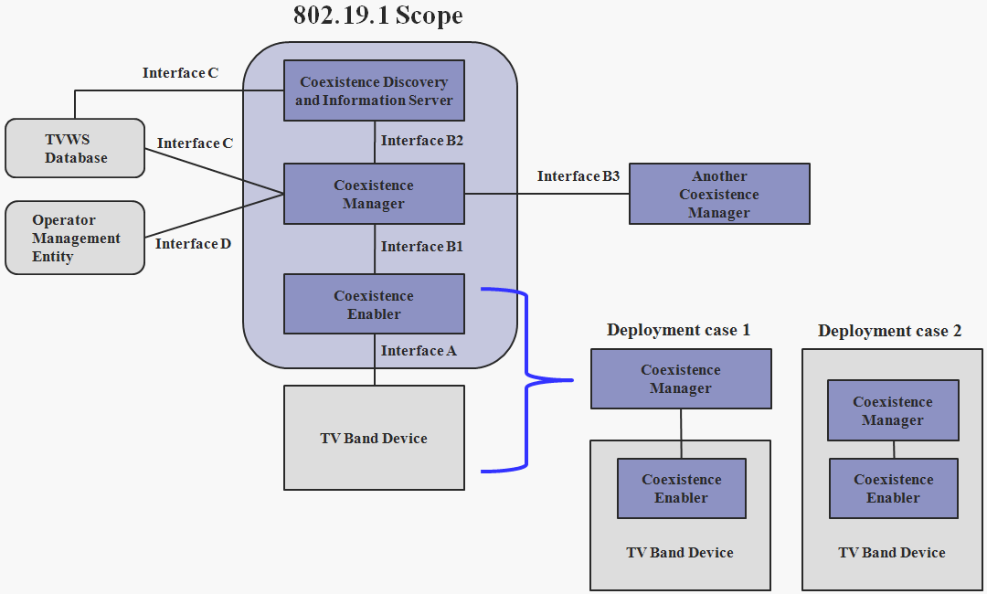

Figure 1 ─ 802.19.1 System architecture
The external logical entities are as follows:
- TVBD network or device
- TVWS database TVWS DB
- Operator management entity (OME)

TVBD or TVBD network is the device or network, which operates with unlicensed basis in the TV bands at locations where that TV bands are not being used by any incumbents, i.e., licensed services.

The TVWS database is the regulatory database which provides list of disallowed channels for TVBD networks or devices because they are occupied by incumbents.

The operator management entity provides operator related information for coexistence.

TVWS database and operator management entity are out of scope of this standard.

The six logical interfaces are:
- Interface A
- Interface B1
- Interface B2
- Interface B3
- Interface C
- Interface D

The six logical interfaces in 802.19.1 system architecture can be split into three groups:
- Interfaces between 802.19.1 entities
  - Interface B1
  - Interface B2
  - Interface B3
- Interfaces between an 802.19.1 entity and TVBD network or device
  - Interface A
- Interfaces between 802.19.1 entities and TVWD database or OME
  - Interface C
  - Interface D

Different interfaces between 802.19.1 logical entities are distinguished by their usage, types of information exchanged, and underlying protocols.

The interface A is for interaction between CE and TVBD network or device. To support this interface, a service access point (SAP) and primitives between CE and TVDB are defined (see 5.2).
- From TVBD network or device
  - Information required for coexistence
  - Configuration/information requests for coexistence
  - Configuration/measurement/information responses for coexistence
  - And other information as needed
- From CE to TVBD network or device
  - Reconfiguration requests/commands and control information (corresponding to coexistence requests/commands and control information received from CM)
  - Requests/commands related to control of measurements performed by TVBD network or device
  - And other information as needed

The interface B1 is for interaction between CE and CM.
- From CE to CM
  - Information required for coexistence (information obtained from TVBD network or device)
  - And other information as needed
- From CM to CE
  - Coexistence requests/commands and control information
  - And other information as needed

The interface B2 is for interaction between CM and CDIS.
- From CM to CDIS
  - Information required for discovery (obtained by this CM)
  - Information required for coexistence (obtained by this CM)
  - And other information as needed
- From CDIS to CM
  - Information required for discovery (obtained by other CMs)
  - Information required for coexistence (obtained by other CMs)
  - And other information as needed

The interface B3 is for interaction between CM and remote CM.
- From CM to remote CM
  - Information and message required for discovery and coexistence
  - And other information as needed

The interface C is for interaction between CM/CDIS and TVWS database. It will allow expansion to different database types.
- From TVWS database to CM/CDIS
  - Information required for coexistence (information on available TV channels)
  - And other information as needed

The interface D is for interaction between CM and OME.
- From OME to CM
  - Network operator related information e.g. spectrum policy/limitations concerning operator networks
  - And other information as needed

4.2 Reference use cases

Coexistence problems between TVBD networks or devices using same or dissimilar radio access technologies (RATs) might occur due to the disparity between the number of available channels and the number required operating channels for TVBD networks or devices over a given area.

One operating channel might consist of one or more TV channels based on the demand of each TVBD network, e.g., 10MHz channel bandwidth can be supported by two consecutive 6MHz TV channels in U.S.A.

There might be three different patterns of allocating operating channels to TVBD networks as follows;
- To allocate a free and unoccupied channel to one TVBD network
- To allocate a free and unoccupied channel to two or more TVBD networks at the same time
- To allocate a pre-occupied channel by one TVBD network to another TVBD networks

For the first case each TVBD network can use an operating channel alone. For the second and third case one TVBD network should share the same operating channel with another TVBD network.

The following two use cases are defined within this standard as depicted in figure 1:
- Individual channel assignment
- Co-channel sharing

In the individual channel assignment use case, available channels are dynamically assigned to each TVBD network which has a different operating channel. So it is possible that non-overlapped operating channel among allocated channels for TVBD networks. This guarantee co-channel-interference-free channel use and coexistence problem can be eliminated through a proper channel allocation

In co-channel sharing use case, several TVBD networks using same or dissimilar RATs share the same channel as an operating channel. The same operating channel causes co-channel interference. An operating channel sharing with the same TVBD networks; Self-coexistence mechanism might be needed to mitigate co-channel interference. An operating channel sharing with dissimilar TVBD networks; Inter-system coexistence mechanism might be needed to mitigate co-channel interference.

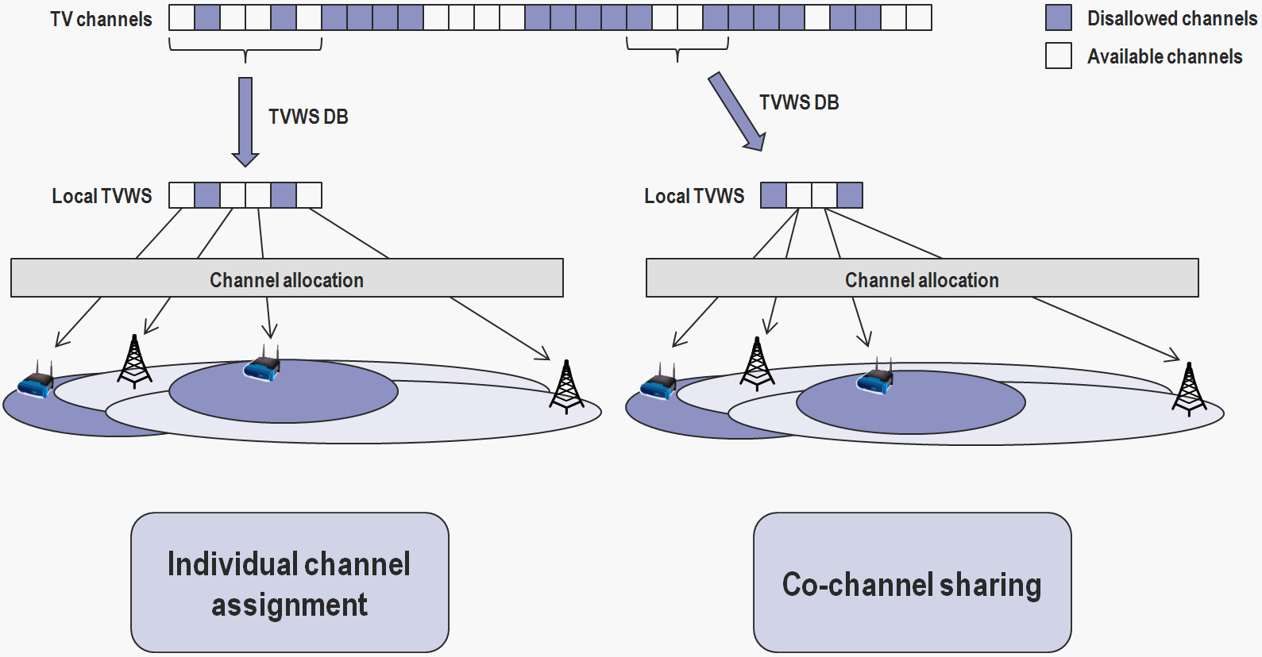

Figure 2 ─ 802.19.1 Reference use cases

4.3 Logical entities

4.3.1 Coexistence manager (CM)

4.3.1.1 General

The coexistence manager is responsible for the most important tasks such as coexistence decision making, generating and providing corresponding coexistence requests/commands and control information to coexistence enablers, discovering/communicating with other neighbour cognitive managers to collaborate with other cognitive managers, assisting network operators in management related to TVWS coexistence, and etc. The key functions of the CM are the following:
- Maintaining channel availability information
- Channel classification and selection
- Association control for CE
- Channel management
- Discovering other CMs
- Maintaining context information required for coexistence among CMs
- Assisting network operators in management related to TVWS coexistence
- Accessing the TVWS database
- Coexistence decision making

4.3.1.2 Maintaining channel availability information

The CM shall maintain the status of the TV channels available for TVBD operation at its location within a regulation according to the policies and rules established by regulation for unlicensed use of TV channels. The CM shall obtain information on the TV channel status with respect to the presence of incumbents and other neighbour CMs in its location and it shall use this information as input for its decisions for channel selection, channel management, coexistence decision making, and etc.

To maintain the status of the channels available for operation, the CM shall be able to collect and fuse information from the following sources:
- TVWS database
- CDIS
- Neighbor CMs
- Spectrum sensing report from CE

The channel availability information shall be defined during the initialization of CM and it shall be periodically updated during the operation of CM.

4.3.1.3 Channel classification and selection

In order to start operation of TVBD networks or devices, CM shall select and assign a proper operating channel for TVBD to mitigate coexistence problems among TVBDs. A proper operating channel shall be selected from one of allowed channels. Allowed channels that may be used by TVBD networks or devices at their location shall be given by TVWS database. For example, in the U.S.A. allowed channels are as depicted in figure 3.

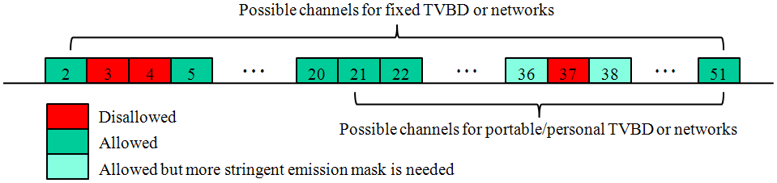

Figure 3 ─ Allowed and disallowed TV channels in U.S.A.

Status of given allowed channels will be dynamically changed based on incumbent activities, activities of other TVBD networks or devices, relocation of TVBDs, etc. To facilitate coexistence between 802.19.1 compliant TVBD networks or devices, the CM shall know status of TV channels at a given location such as:
- Which channel is available for TVBDs or networks
- Which channel is disallowed by regulation, or by the request of incumbents
- Which channel should be protected due to current incumbent activity
- Which channel should be restricted with limitations in order to use by TVBDs or networks
- Which channel is already being used by other TVBDs or networks
- Etc.

TV Channels for 802.19.1 logical entities are classified as the following 8 channels;
- Disallowed channels
- Allowed channels
- Available channels
- Protected channels
- Restricted channels
- Unclassified channels
- Operating channels
- Coexistent channels

The disallowed set is a set of channels disallowed for any TVBDs or networks by regulation, or by the request of incumbents. It should be provided by TVWS database and will be updated if necessary For example, in the U.S. TV channel 3, 4, and 37 are disallowed by regulation. Also a TV channel registered at TVWS database by a licensed wireless microphone is disallowed for any TVBDs or TVDB networks.

The allowed set is a set of channels allowed for TVBDs or networks. It should be provided by TVWS database and will be updated if necessary. All TVBDs or TVBD networks should first obtain a list of the allowed channels before their operating over TV channels.

The available set is a set of free channels available for TVBDs or TVBD networks.

The restricted set is a set of channels restricted to use with limitations due to regulation. It can be used by TVBDs or TVBD networks under limited conditions predefined by regulation. For example, in the U.S. a portable/personal TVBD can use “the first adjacent channel of the incumbent activating channel” with limited transmit power (≤ 40mW EIRP) by FCC regulation. Also in the U.S. channel 36 and 38 need more stringent emission mask to protect incumbents in channel 37 by FCC regulation.

The protected set is a set of channels occupied by current incumbents to be protected. It cannot be used by any TVBDs or TVBD networks.

The unclassified set is a set of channels has not been classified as one of listed above three sets.

The operating set is a set of operating channels being used by one TVBD or TVBD network. It can be selected from available set or restricted set only if there are no incumbent activities on it. If each TVBD or TVBD network has its own operating channel, spectrum etiquette with FDM (frequency division multiplexing) is achievable.

The coexistent set is a set of channels being shared by two or more TVBD networks. If two or more TVBDs or TVBD networks compete for the same channel, spectrum etiquette with FDM is not achievable.

Operating channels or coexistent channels shall be selected only from available channels or restricted channels.

Figure 4 shows hierarchical structure of TV channels. Allowed channels informed from TVWS database are further classified into the following categories:
- Available channels
- Restricted channels
- Protected channels
- Unclassified channels

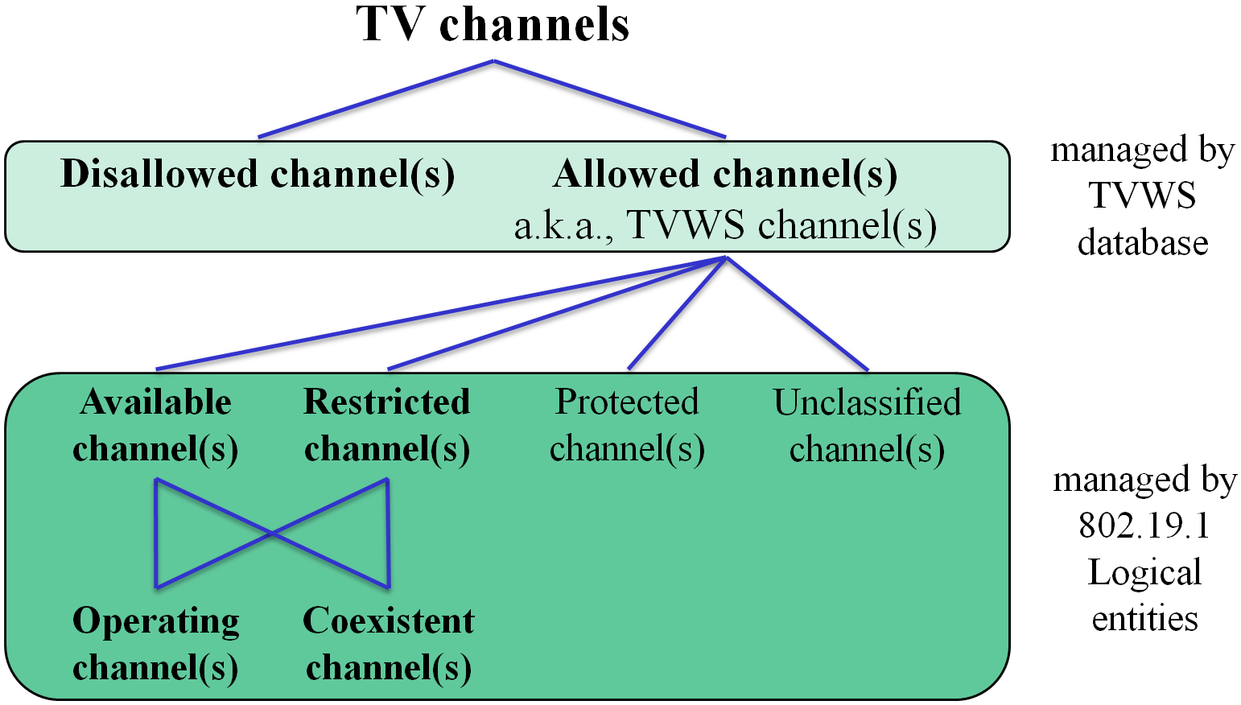

Figure 4 ─ Hierarchy of TV Channels

Figure 5 shows Venn diagram of TV channels to demonstrate relationship among TV channels. The disallowed set is a subset of a TV channel set. It is also a complementary set of the allowed set. The allowed set is a subset of a TV channel set. It is also a complementary set of the disallowed set. The Available/Restricted/Protected/Unclassified set is a subset of the allowed set. Two different channel sets are a complementary set each other. The operating set is a subset of the available set or the restricted set or union of both. It is also a subset of a complementary set of the coexistent set. The coexistent set is a subset of the operating set.

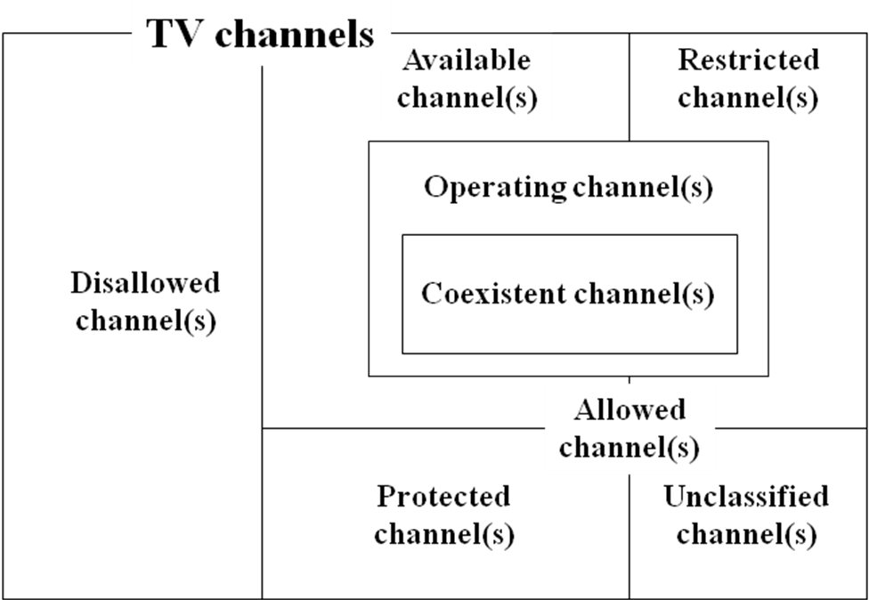

Figure 5 ─ Venn diagram of TV channels

Based on channel classification, CM shall select a proper operating channel for TVBD as depicted in figure 6.

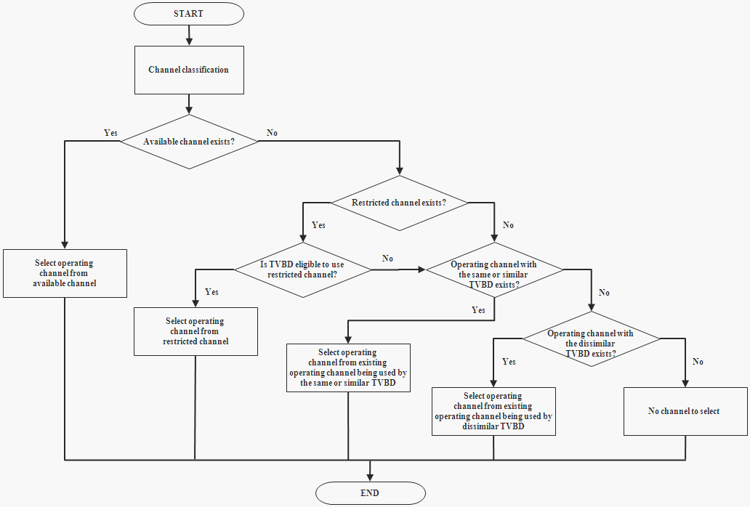

Figure 6 ─ Flowchart of channel selection

4.3.1.3.1 Channel set transition diagram

The transition diagram consists of 6 states and 11 events. The 6 states are defined in section 4.3.1.3. The disallowed and allowed channels are omitted in this transition diagram because those channels are classified by TVWS database and the sum of available, restricted, protected, unclassified, operating, and coexistent channels is equal to the allowed channels. Possible events for each state transition are defined as follows:
- Event 1: If the channel already being used by one TVWS system is assigned to other TVWS system(s) so that two or more TVWS systems use the same channel as an operating channel
- Event 2: If the channel is released by other TVWS systems so that the channel is being used by only one TVWS system
- Event 3: If the channel is released and not be used by any TVWS systems due to the completion of its usage
- Event 4: If the channel is assigned to one TVWS system and not shared by any other TVWS systems
- Event 5: If the channel is assigned to two or more TVWS systems at the same time
- Event 6: If an incumbent activity has been informed on the channel
- Event 7: If the channel temporarily satisfies the condition that requires its usage with limitations due to regulation, e.g., in the U.S. if an incumbent activity has been informed on the channel (F), the first adjacent channel (F±1) can be used by only a portable/personal TVBD with limited transmit power, say 100mW EIRP
- Event 8: If the channel is released by an incumbent due to the completion of its usage
- Event 9: If the channel is exempted from its temporary restriction and free to use without limitation, e.g., in the U.S. if the channel is released by the incumbent on the channel (F) due to the completion of its usage, the first adjacent channel (F±1) can be used by any TVBDs and networks
- Event 10: If the channel is not occupied by an incumbent or any TVWS systems
- Event 11: If the channel is not classified or updated within the predefined time expiration

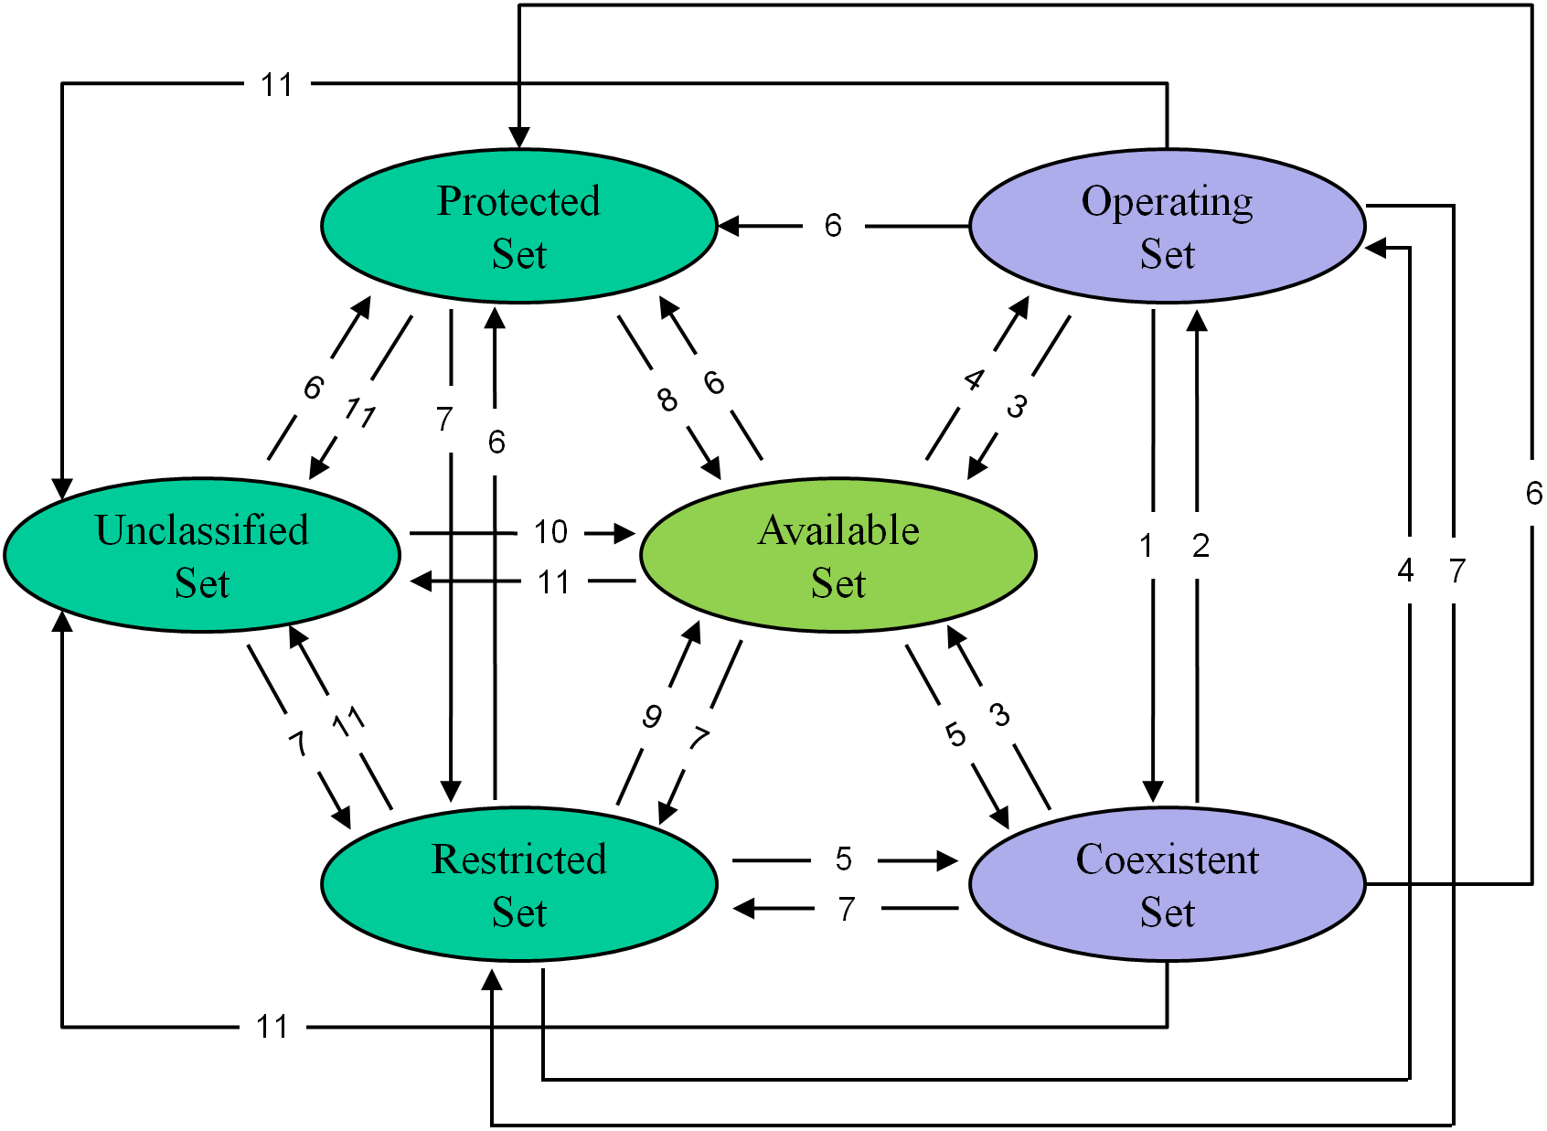

Figure 7 ─ Channel set transition diagram

The channel set transition matrix is defined as depicted in Table 1. Each row specifies the state transition due to each event. Each column specifies state transition due to the events in each row for a particular current state. A blank cell within the transition matrix implies that either the specific event cannot or should not occur within that state. And if the event does occur, the CM shall ignore it. For example, the protected channel cannot directly transit to operating channel. Therefore, there is no operating channel in the first column (i.e., operating column).

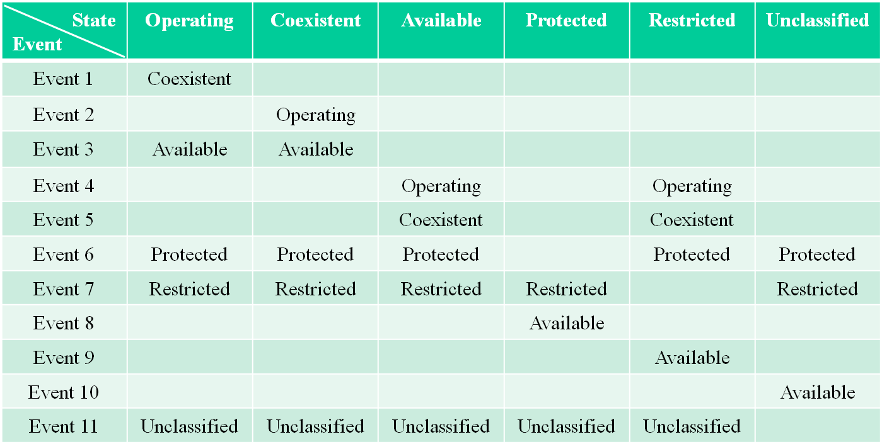

Table 1 ─ Channel set transition matrix

4.3.2 Coexistence enabler (CE)

The coexistence enabler is responsible for important tasks such as enabling communication between coexistence manager and TVBD, requesting/obtaining information required for coexistence from TVBD, translating reconfiguration requests/commands and control information received from the coexistence manager into TVBD-specific reconfiguration requests/commands, and etc. The key functions of the CE are the following:
- Accessing device management entity (DME) of TVBD
- Accessing CM
- Relaying/translating context and reconfiguration messages between CM and TVBD

4.3.3 Coexistence discovery and information server (CDIS)

The coexistence discovery and information server is responsible for important tasks such as discovering other coexistence managers, opening interfaces between coexistence managers to provide coexistence related information exchange among coexistence managers, collecting/aggregating coexistence related information from multiple coexistence managers, communicating with the TVWS database to obtain information on incumbents, and etc. The key functions of the CDIS are the following:
- Maintaining channel availability information
- Channel classification
- Association control for CM
- Supporting discovery of CMs
- Maintaining context information required for coexistence among CMs
- Accessing the TVWS database

4.4 Interfaces

4.4.1 General

There are 3 interfaces between 802.19.1 entities as follows:
- Interface B1: Interface between CE and CM
- Interface B2: Interface between CM and CDIS
- Interface B3: Interface between CM and remote CM

Each interface is defined by state machine of each entity, message exchange sequences, and message formats.

Each state machine for interface between 802.19.1 entities consists of 4 or more of the following states:
- Inactive: the state where it is impossible to set up any interfaces with other 802.19.1 entities
- Active: the state where it is possible to set up interface with other 802.19.1 entities
- Waiting engagement: the state where one entity has requested for interface setup to the other entity, and is waiting for response from it
- Engaged: the state where two entities are ready to communicate with each other
- Request sent: the state where the request related to “context information (CI)” or “event (EV)” or “reconfiguration (RC)” has been sent from home entity to remote entity, and home entity is waiting for response from the other entity
- Request received: the state where the request related to “context information (CI)” or “event (EV)” or “reconfiguration (RC)” has been received from remote entity to home entity, and home entity is waiting for the completion of the request

4.4.2 Interface between CM and CE

4.4.2.1 CM state diagram

The CM state machine for interface between CM and CE consists of the following 4 states as depicted in figure 8:
- Inactive
- Active
- Engaged
- Request sent

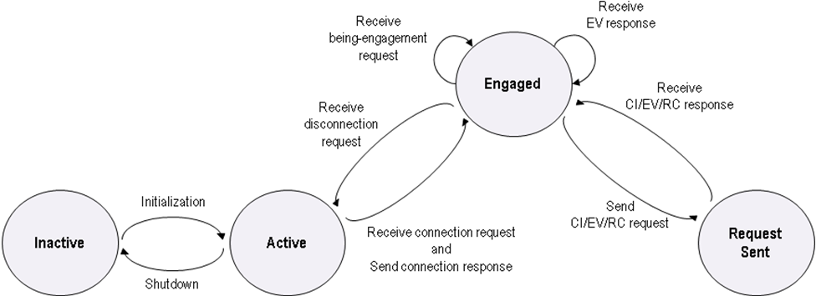

Figure 8 ─ CM state diagram for interface between CM and CE

4.4.2.2 CE state diagram

The CE state machine for interface between CM and CE consists of the following 5 states as depicted in figure 9:
- Inactive
- Active
- Waiting engagement
- Engaged
- Request sent

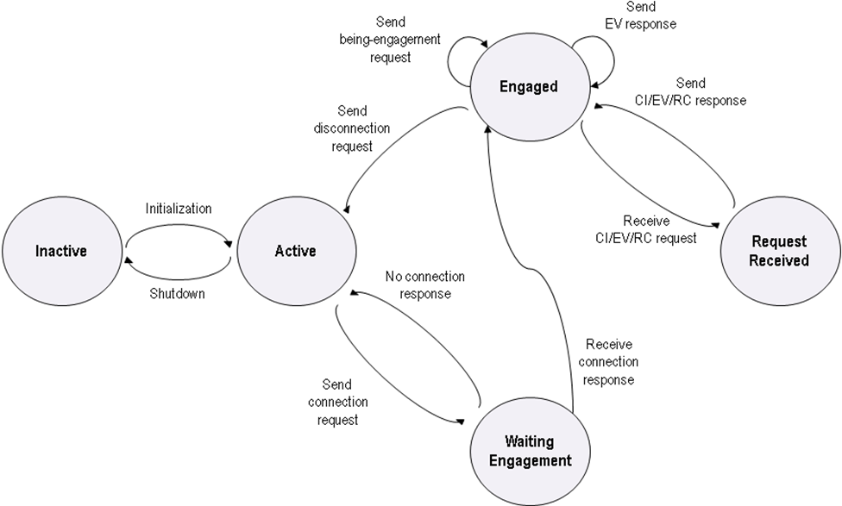

Figure 9 ─ CE state diagram for interface between CM and CE

4.4.2.3 Message exchange sequences

Figure 10 depicts an example of message exchange sequence between CM and CE.

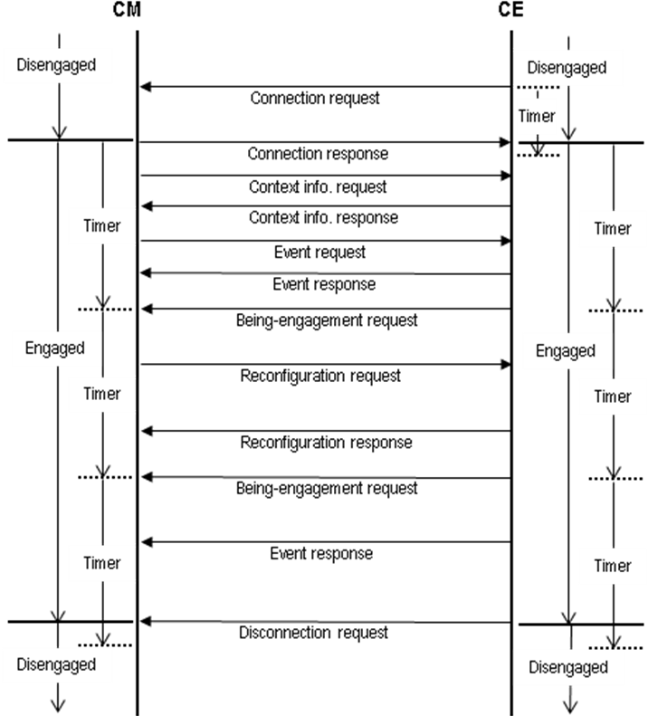

Figure 10 ─ An example of message exchange sequence between CM and CE

4.4.2.4 Message formats

Message formats for interface between CM and CE are categorized by 4 different ones as follows:
- Context.Info.Get
- Reconfiguration.Set
- Event.Set
- Event.Get

Each message is further classified into one of the following sub-categories:
- Context.Info.Get
  - TVBDID
  - TVDBType
  - RadioInterface
  - Location
  - Measurements
  - SensingThrehold
  - TransmitPowerLevel
  - CoverageArea
  - ReconfigurationOptions
- Reconfiguration.Set
  - OperatingChannelAssignment
  - TimeScheduleAssignment
  - SensingThresholdAssighment
  - TransmitPowerLevelAssighment
  - CoverageAreaAssighment
- Event.Set
  - LocationChange
  - MeasurementChange
  - IncumbentDetect
  - SecondaryUserDetect
- Event.Get
  - LocationChange
  - MeasurementChange
  - IncumbentDetect
  - SecondaryUserDetect

4.4.3 Interface between CM and CDIS

4.4.3.1 CM state diagram

The CM state machine for interface between CM and CDIS consists of the following 6 states as depicted in figure 11:
- Inactive
- Active
- Waiting engagement
- Engaged
- Request sent
- Request received

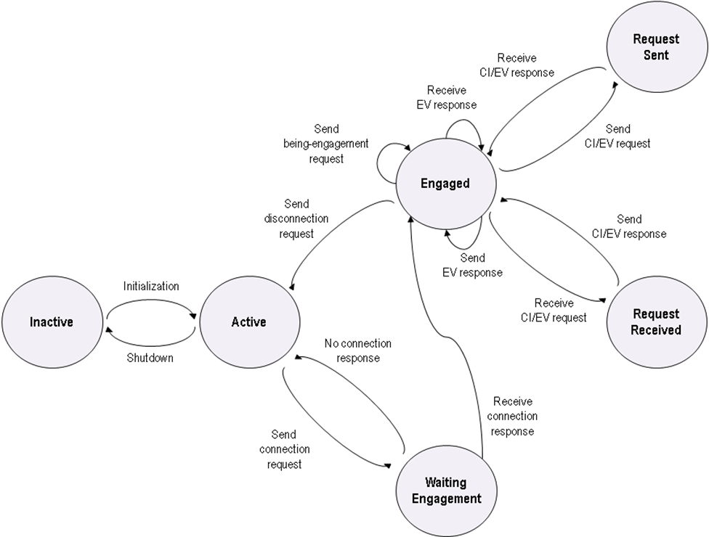

Figure 11 ─ CM state diagram for interface between CM and CDIS

4.4.3.2 CDIS state diagram

The CDIS state machine for interface between CM and CDIS consists of the following 5 states as depicted in figure 12:
- Inactive
- Active
- Engaged
- Request sent
- Request received

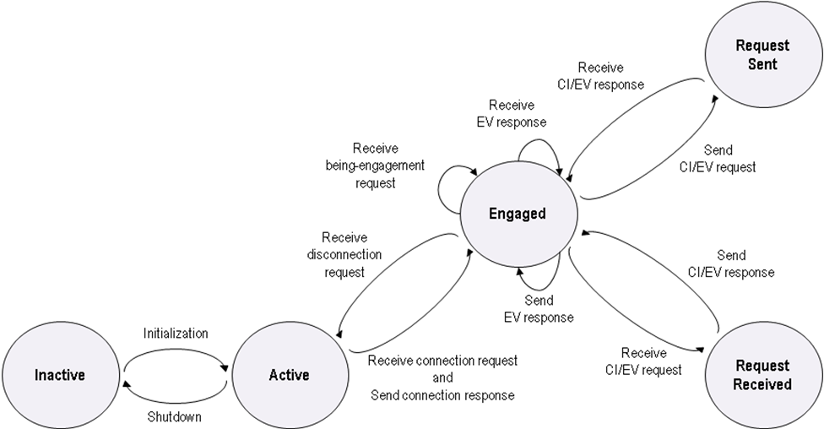

Figure 12 ─ CDIS state diagram for interface between CM and CDIS

4.4.3.3 Message exchange sequences

Figure 13 depicts an example of message exchange sequence between CM and CDIS.

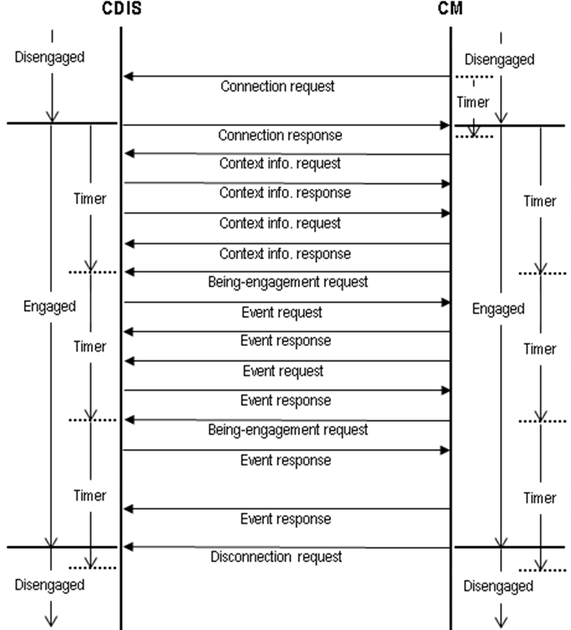

Figure 13 ─ An example of message exchange sequence between CM and CDIS

4.4.3.4 Message formats

Message formats for interface between CM and CDIS are categorized by 4 different ones as follows:
- Context.Info.Get
- Context.Info.Set
- Event.Set
- Event.Get

Each message is further classified into one of the following sub-categories:
- Context.Info.Get
  - TVWSDBContext
  - NeighborCMList
  - NeighborCMChannelClassificationList
  - NeighborCMNegotiationOption
- Context.Info.Set
  - CMID
  - CMAddress
  - ChannelClassificationList
  - NegotiationOption
- Event.Set
  - ChannelClassificationListChange
  - NegotiationOptionChange
- Event.Get
  - ChannelClassificationListChange
  - NegotiationOptionChange

4.4.4 Interface between CM and remote CM

4.4.4.1 Centralized topology

In centralized topology, there is one master CM which has a number of slave CMs. The master CM performs coexistence decision making and slave CMs follows it.

4.4.4.1.1 Master CM state diagram

The master CM state machine for interface between master CM and slave CM consists of the following 5 states as depicted in figure 14:
- Inactive
- Active
- Engaged
- Request sent
- Request received

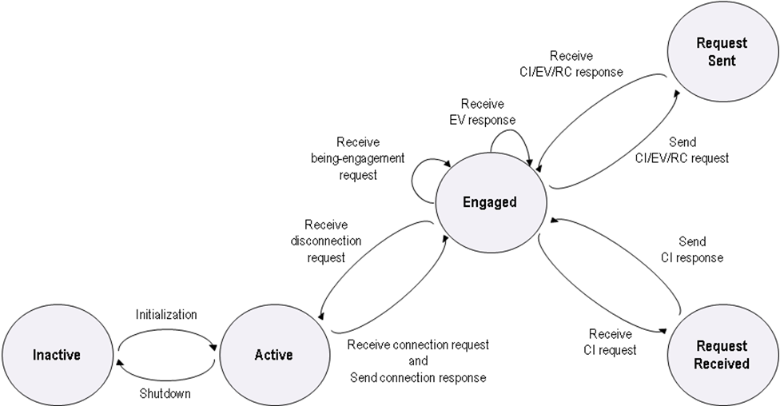

Figure 14 ─ Master CM state diagram for interface between master CM and slave CM

4.4.4.1.2 Slave CM state diagram

The slave CM state machine for interface between master CM and slave CM consists of the following 6 states as depicted in figure 15:
- Inactive
- Active
- Waiting engagement
- Engaged
- Request sent
- Request received

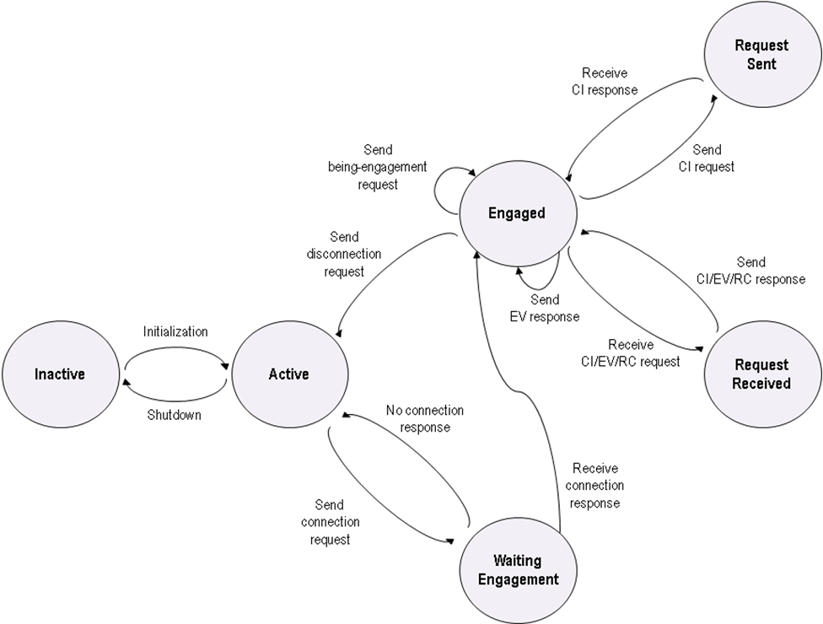

Figure 15 ─ Slave CM state diagram for interface between master CM and slave CM

4.4.4.1.3 Message exchange sequences

Figure 16 depicts an example of message exchange sequence between master CM and slave CM.

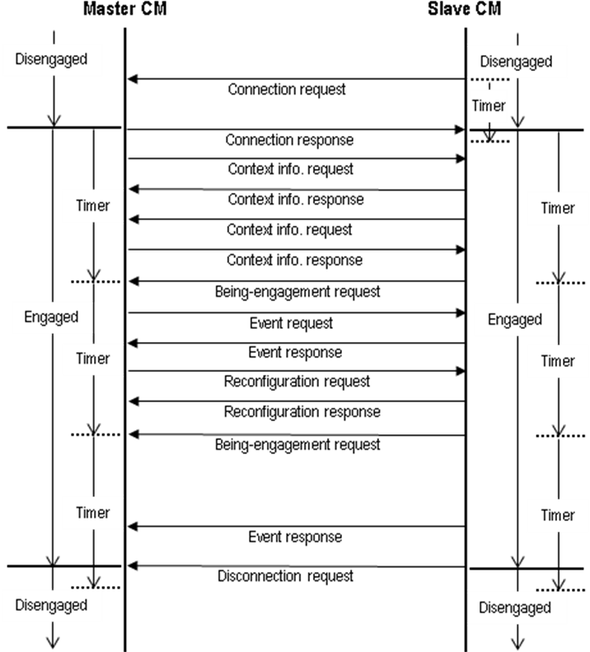

Figure 16 ─ An example of message exchange sequence between master CM and slave CM

4.4.4.1.4 Message formats

Message formats for interface between master CM and slave CM are categorized by 6 different ones as follows:
- Context.Info.Get
- Context.Info.Set
- CX.Decision.Set
- CX.Decision.Get
- Event.Set
- Event.Get

Each message is further classified into one of the following sub-categories:
- Context.Info.Get
  - NeighborCMList
  - NeighborCMChannelClassificationList
  - NeighborCMNegotiationOption
- Context.Info.Set
  - CMID
  - ChannelClassificationList
  - NegotiationOption
- CX.Decision.Set
- CX.Decision.Get
- Event.Set
  - ChannelClassificationListChange
  - NegotiationOptionChange
- Event.Get
  - ChannelClassificationListChange
  - NegotiationOptionChange

4.4.4.2 Distributed topology

In distributed topology, a CM pair, one CM and its neighbor CM, is connected each other. Any two CMs could be connected each other. Each CM performs coexistence decision making by itself.

4.4.4.2.1 CM state diagram

The CM state machine for interface between CM and neighbor CM consists of the following 6 states as depicted in figure 17:
- Inactive
- Active
- Waiting engagement
- Engaged
- Request sent
- Request received

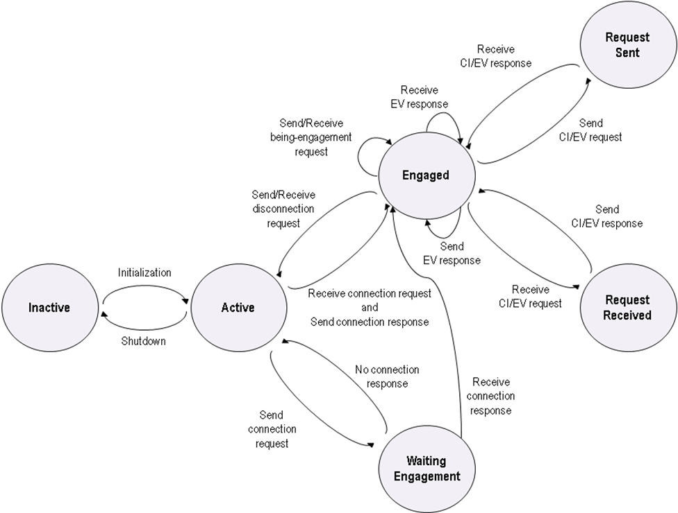

Figure 17 ─ CM state diagram for interface between CM and neighbor CM

4.4.4.2.2 Neighbor CM state diagram

The neighbor CM state machine for interface between CM and neighbor CM is identical to the CM state diagram defined in the previous section (see 4.4.2.2.1)

4.4.4.2.3 Message exchange sequences

Figure 18 depicts an example of message exchange sequence between CM and neighbor CM.

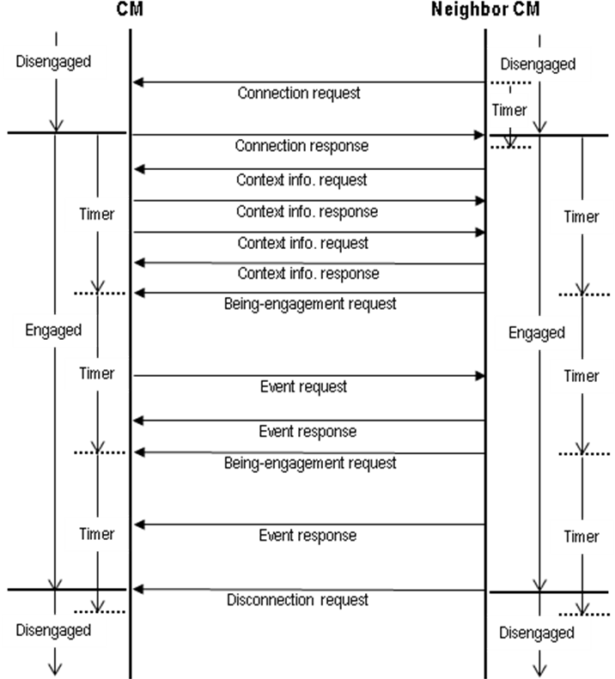

Figure 18 ─ An example of message exchange sequence between CM and neighbour CM

4.4.4.2.4 Message formats

Message formats for interface between CM and neighbor CM are categorized by 4 different ones as follows:
- Context.Info.Get
- Context.Info.Set
- Event.Set
- Event.Get

Each message is further classified into one of the following sub-categories:
- Context.Info.Get
  - NeighborCMList
  - NeighborCMChannelClassificationList
  - NeighborCMNegotiationOption
- Context.Info.Set
  - CMID
  - ChannelClassificationList
  - NegotiationOption
- Event.Set
  - ChannelClassificationListChange
  - NegotiationOptionChange
- Event.Get
  - ChannelClassificationListChange
  - NegotiationOptionChange

5. Reference model

5.1 General

Figure 19 shows 802.19.1 reference model. 802.19.1 entities are located on the application layer. Each 802.19.1 entity has one or more the following service access point (SAP).
- CX_DME_SAP (CoeXistence Device Magament Entity SAP): to communicate with 802 management entities, e.g., 802.11 SME, 802.22 NCMS
- CX_NET_SAP (CoeXistence NETwork SAP): to communicate with remote 802.19.1 logical entities or TVWS DB or OME

CXPM (coexistence primitive mapping) translates CX_DME_SAP primitives into 802 management/control primitives. 802 management entities might need CXPM (coexistence primitive mapping) service to translate CX_DME_SAP primitives into 802 management/control primitives, e.g., MIB (management information base)
- Bijection (1-to-1 mapping) might be highly desirable to fully support 802.19.1 standard, but it depends upon the degree of modification of each 802 standard
- How to implement CXPM is out of scope of this standard

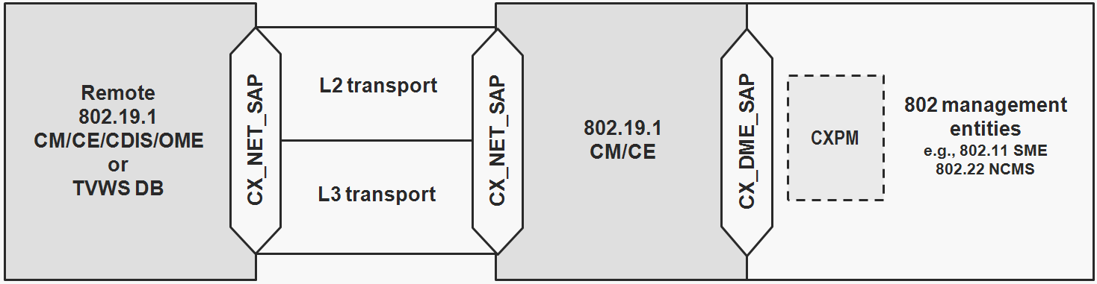

Figure 19 ─ 802.19.1 Reference model

5.2 Service Access Points (SAPs)

5.2.1 General

The SAPs are defined as a set of SAP primitives. Each primitive definition has the table of allowable parameters. Each parameter is defined using abstract data types. These types indicate the semantic value of that parameter. The parameters defined within the subclause for a particular primitive are produced or consumed by that primitive. Several of the abstract data types are used in multiple primitive definitions.

5.2.2 CX_DME_SAP

CX_DME_SAP supports interface A. It abstracts media dependent interface to communicate with 802 management entities, e.g., 802.11 SME, 802.22 NCMS. CX_DME_SAP primitives. The primitives defined for CX_DME_SAP are described in Table 2.

Table 2 ─ CX_DME_SAP primitives

Primitives | Description | Defined in
TVBD_ID | This primitive is used by the CE to obtain the ID of a particular TVBD of the TVWS. | 5.3.1
TVBD_Type | This primitive is used by the CE to obtain the device type of a particular TVBD of the TVWS. | 5.3.2
TVBD_Radio_Interface | This primitive is used by the CE to obtain the radio interface of a particular TVBD of the TVWS. | 5.3.3
TVBD_Options | This primitive is used by the CE to obtain the options of a particular TVBD of the TVWS. | 5.3.4
TVBD_Location | This primitive is used by the CE to obtain the cell location of a particular TVBD of the TVWS. | 5.3.5
TVBD_Measurements | This primitive is used by the CE to obtain the measurements of a particular TVBD of the TVWS. | 5.3.6
TVBD_Sensing_  Threshold | This primitive is used by the CE to obtain the sensing threshold level of a particular TVBD of the TVWS. | 5.3.7
TVBD_Transmit_  Power_Level | This primitive is used by the CE to obtain the transmit power level of a particular TVBD of the TVWS. | 5.3.8
TVBD_Coverage_Area | This primitive is used by the CE to obtain the cell coverage area of a particular TVBD of the TVWS. | 5.3.9
TVBD_Reconfiguration_  Options | This primitive is used by the CE to discover the reconfiguration capability of a particular TVBD of the TVWS. | 5.3.10
TVBD_Channel_  Assignment | This primitive is used by the CE to (re)configure the list of operating channel(s) of a particular TVBD of the TVWS. | 5.3.11
TVBD_Time_  Scheduling_Assignment | This primitive is used by the CE to (re)configure the time scheduling of the operating channel(s) of a particular TVBD of the TVWS. | 5.3.12
TVBD_Sensing_  Threshold_Assignment | This primitive is used by the CE to reconfigure the sensing threshold of a particular TVBD of the TVWS. | 5.3.13
TVBD_Transmit_  Power_Level_  Assignment | This primitive is used by the CE to reconfigure the transmit power level of a particular TVBD of the TVWS. | 5.3.14
TVBD_Coverage_Area_Assignment | This primitive is used by the CE to reconfigure the cell coverage area of a particular TVBD of the TVWS. | 5.3.15
TVBD_Location_Change | This primitive is used by the CE to obtain periodically the information about whether the cell location of a particular TVBD of the TVWS has been changed or not. | 5.3.16
TVBD_Measurements_  Change | This primitive is used by the CE to obtain periodically the information about whether measurements of a particular TVBD of the TVWS have been changed or not. | 5.3.17
TVBD_Incumbent_  User_Detect | This primitive is used by the CE to obtain periodically the information about whether one or more incumbent users have been detected by a particular TVBD of the TVWS or not. | 5.3.18
TVBD_Secondary_User_Detect | This primitive is used by the CE to obtain periodically the information about whether one or more secondary users have been detected by a particular TVBD of the TVWS or not. | 5.3.19

5.2.3 CX_NET_SAP

CX_NET_SAP supports interface B1, B2, B3, C, and D. It abstracts media dependent interface to communicate with remote 802.19.1 entities or TVWS DB or OME, and exchanges 802.19.1 logical entities’ information and messages with remote 802.19.1 logical entities or TVWS DB or OME. It might use L2 transport for intra-domain communications, and L3 transport for inter and intra-communications. It does not needed if CM and CE are located on the same TVBD. The primitives defined for CX_DME_SAP are described in Table 3.

Table 3 ─ CX_NET_SAP primitives

Primitives | Description | Defined in
CX_TP_Data | This primitive is used for transfer of data. | 5.4.1

5.3 CX_DME_SAP primitives

5.3.1 TVBD_ID

5.3.1.1 TVBD_ID.request

5.3.1.1.1 Function

This primitive is used by the CE to obtain the ID of a particular TVBD of the TVWS.

5.3.1.1.2 Semantics of service primitive

TVBD_ID.request()

No primitive parameters exist for this primitive.

5.3.1.1.3 When generated

This primitive is generated by the CE when it needs to receive the ID of a particular TVBD of the TVWS.

5.3.1.1.4 Effect on receipt

The recipient responds immediately with TVBD_ID.confirm primitive.

5.3.1.2 TVBD_ID.confirm

5.3.1.2.1 Function

This primitive returns the result of the query to obtain the ID of a particular TVBD of the TVWS.

5.3.1.2.2 Semantics of service primitive

TVBD_IDs.confirm(
Status,
TVBDID
)

Parameters:

Name | Data Type | Description
Status | STATUS | Status of operation.
TVBDID | TVBD_ID | ID of the TVBD of the TVWS.
5.3.1.2.3 When generated

This primitive is generated in response to a TVBD_ID.request primitive.

5.3.1.2.4 Effect on receipt

The CE examines the returned values and learns about the ID of a particular TVBD of the TVWS. However, if Status does not indicate “Success”, the CE performs appropriate error handling.

5.3.2 TVBD_Type

5.3.2.1 TVBD_Type.request

5.3.2.1.1 Function

This primitive is used by the CE to obtain the device type of a particular TVBD of the TVWS.

5.3.2.1.2 Semantics of service primitive

TVBD_Type.request(
TVBDID
)

Parameters:

Name | Data Type | Description
TVBDID | TVBD_ID | TVBD ID uniquely identifies one TVBD of the TVWS.

5.3.2.1.3 When generated

This primitive is generated by the CE when it needs to receive the device type of a particular TVBD of the TVWS.

5.3.2.1.4 Effect on receipt

The recipient responds immediately with TVBD_Type.confirm primitive.

5.3.2.2 TVBD_Type.confirm

5.3.2.2.1 Function

This primitive returns the result of the query to obtain the device type of a particular TVBD of the TVWS.

5.3.2.2.2 Semantics of service primitive

TVBD_IDs.confirm(
Status,
TVBDID,
TVBDType
)

Parameters:

Name | Data Type | Description
Status | STATUS | Status of operation.
TVBDID | TVBD_ID | TVBD ID uniquely identifies one TVBD of the TVWS.
TVBDType | TVBD_TYPE | Device type of a particular TVBD of the TVWS

5.3.2.2.3 When generated

This primitive is generated in response to a TVBD_Type.request primitive.

5.3.2.2.4 Effect on receipt

The CE examines the returned values and learns about the device type of a particular TVBD of the TVWS. However, if Status does not indicate “Success”, the CE performs appropriate error handling.

5.3.3 TVBD_Radio_Interface

5.3.3.1 TVBD_Radio_Interface.request

5.3.3.1.1 Function

This primitive is used by the CE to obtain the radio interface of a particular TVBD of the TVWS.

5.3.3.1.2 Semantics of service primitive

TVBD_Radio_Interface.request(
TVBDID
)

Parameters:

Name | Data Type | Description
TVBDID | TVBD_ID | TVBD ID uniquely identifies one TVBD of the TVWS.

5.3.3.1.3 When generated

This primitive is generated by the CE when it needs to receive the radio interface of a particular TVBD of the TVWS.

5.3.3.1.4 Effect on receipt

The recipient responds immediately with TVBD_Radio_Interface.confirm primitive.

5.3.3.2 TVBD_Radio_Interface.confirm

5.3.3.2.1 Function

This primitive returns the result of the query to obtain the radio interface of a particular TVBD of the TVWS.

5.3.3.2.2 Semantics of service primitive

TVBD_Radio_Interface.confirm(
Status,
TVBDID,
RadioInterface
)

Parameters:

Name | Data Type | Description
Status | STATUS | Status of operation.
TVBDID | TVBD_ID | TVBD ID uniquely identifies one TVBD of the TVWS.
RadioInterface | RADIO_INTERFACE | Radio Interface description of a particular TVBD of the TVWS.

5.3.3.2.3 When generated

This primitive is generated in response to a TVBD_Radio_Interface.request primitive.

5.3.3.2.4 Effect on receipt

The CE examines the returned values and learns about the radio interface of a particular TVBD of the TVWS. However, if Status does not indicate “Success”, the CE performs appropriate error handling.

5.3.4 TVBD_Options

5.3.4.1 TVBD_Options.request

5.3.4.1.1 Function

This primitive is used by the CE to obtain the options of a particular TVBD of the TVWS.

5.3.4.1.2 Semantics of service primitive

TVBD_Options.request(
TVBDID
)

Parameters:

Name | Data Type | Description
TVBDID | TVBD_ID | TVBD ID uniquely identifies one TVBD of the TVWS.

5.3.4.1.3 When generated

This primitive is generated by the CE when it needs to receive the options of a particular TVBD of the TVWS.

5.3.4.1.4 Effect on receipt

The recipient responds immediately with TVBD_Options.confirm primitive.

5.3.4.2 TVBD_Options.confirm

5.3.4.2.1 Function

This primitive returns the result of the query to obtain the options of a particular TVBD of the TVWS.

5.3.4.2.2 Semantics of service primitive

TVBD_Options.confirm(
Status,
TVBDID,
TVBDOptions
)

Parameters:

Name | Data Type | Description
Status | STATUS | Status of operation.
TVBDID | TVBD_ID | TVBD ID uniquely identifies one TVBD of the TVWS.
TVBDOptions | TVBD_OPTIONS | Description of options of a particular TVBD of the TVWS.

5.3.4.2.3 When generated

This primitive is generated in response to a TVBD_Options.request primitive.

5.3.4.2.4 Effect on receipt

The CE examines the returned values and learns about the options of a particular TVBD of the TVWS. However, if Status does not indicate “Success”, the CE performs appropriate error handling.

5.3.5 TVBD_Location

5.3.5.1 TVBD_Location.request

5.3.5.1.1 Function

This primitive is used by the CE to obtain the cell location of a particular TVBD of the TVWS.

5.3.5.1.2 Semantics of service primitive

TVBD_Location.request(
TVBDID
)

Parameters:

Name | Data Type | Description
TVBDID | TVBD_ID | TVBD ID uniquely identifies one TVBD of the TVWS.

5.3.5.1.3 When generated

This primitive is generated by the CE when it needs to receive the cell location of a particular TVBD of the TVWS.

5.3.5.1.4 Effect on receipt

The recipient responds immediately with TVBD_Location.confirm primitive.

5.3.5.2 TVBD_Location.confirm

5.3.5.2.1 Function

This primitive returns the result of the query to obtain the cell location of a particular TVBD of the TVWS.

5.3.5.2.2 Semantics of service primitive

TVBD_Location.confirm(
Status,
TVBDID,
CellLocation
)

Parameters:

Name | Data Type | Description
Status | STATUS | Status of operation.
TVBDID | TVBD_ID | TVBD ID uniquely identifies one TVBD of the TVWS.
CellLocation | CELL_LOCATION | Cell location of a particular TVBD of the TVWS.

5.3.5.2.3 When generated

This primitive is generated in response to a TVBD_Location.request primitive.

5.3.5.2.4 Effect on receipt

The CE examines the returned values and learns about the cell location of a particular TVBD of the TVWS. However, if Status does not indicate “Success”, the CE performs appropriate error handling.

5.3.6 TVBD_Measurements

5.3.6.1 TVBD_Measurements.request

5.3.6.1.1 Function

This primitive is used by the CE to obtain the measurements of a particular TVBD of the TVWS.

5.3.6.1.2 Semantics of service primitive

TVBD_Measurements.request(
TVBDID
)

Parameters:

Name | Data Type | Description
TVBDID | TVBD_ID | TVBD ID uniquely identifies one TVBD of the TVWS.

5.3.6.1.3 When generated

This primitive is generated by the CE when it needs to receive the measurements of a particular TVBD of TVWS.

5.3.6.1.4 Effect on receipt

The recipient responds immediately with TVBD_Measurements.confirm primitive.

5.3.6.2 TVBD_Measurements.confirm

5.3.6.2.1 Function

This primitive returns the result of the query to obtain the measurements of a particular TVBD of the TVWS.

5.3.6.2.2 Semantics of service primitive

TVBD_Measurements.confirm(
Status,
TVBDID,
ListOfTVBDMeasurements
)

Parameters:

Name | Data Type | Description
Status | STATUS | Status of operation.
TVBDID | TVBD_ID | TVBD ID uniquely identifies one TVBD of the TVWS.
ListOfTVBDMeasurements | LIST_OF_TVBD_  MEASUREMENTS | List of measurements of a particular TVBD of the TVWS.

5.3.6.2.3 When generated

This primitive is generated in response to a TVBD_Measurements.request primitive.

5.3.6.2.4 Effect on receipt

The CE examines the returned values and learns the measurements of a particular TVBD of the TVWS. However, if Status does not indicate “Success”, the CE performs appropriate error handling.

5.3.7 TVBD_Sensing_Threshold

5.3.7.1 TVBD_Sensing_Threshold.request

5.3.7.1.1 Function

This primitive is used by the CE to obtain the sensing threshold level of a particular TVBD of the TVWS for the detection of secondary users in a coarse acquisition mode.

5.3.7.1.2 Semantics of service primitive

TVBD_Sensing_Threshold.request(
TVBDID
)

Parameters:

Name | Data Type | Description
TVBDID | TVBD_ID | TVBD ID uniquely identifies one TVBD of the TVWS.

5.3.7.1.3 When generated

This primitive is generated by the CE when it needs to receive the sensing threshold level of a particular TVBD of TVWS for the detection of secondary users in a coarse acquisition mode.

5.3.7.1.4 Effect on receipt

The recipient responds immediately with TVBD_Sensing_Threshold.confirm primitive.

5.3.7.2 TVBD_Sensing_Threshold.confirm

5.3.7.2.1 Function

This primitive returns the result of the query to obtain the sensing threshold level of a particular TVBD of TVWS for the detection of secondary users in a coarse acquisition mode.

5.3.7.2.2 Semantics of service primitive

TVBD_Sensing_Threshold.confirm(
Status,
TVBDID,
TVBDSensingThreshold
)

Parameters:

Name | Data Type | Description
Status | STATUS | Status of operation.
TVBDID | TVBD_ID | TVBD ID uniquely identifies one TVBD of the TVWS.
TVBDSensingThreshold | TVBD_SENSING_  THRESHOLD | Sensing threshold level of a particular TVBD of the TVWS for the detection of secondary users in a coarse acquisition mode.

5.3.7.2.3 When generated

This primitive is generated in response to a TVBD_Sensing_Threshold.request primitive.

5.3.7.2.4 Effect on receipt

The CE examines the returned values and learns the sensing threshold level of a particular TVBD of the TVWS. However, if Status does not indicate “Success”, the CE performs appropriate error handling.

5.3.8 TVBD_Transmit_Power_level

5.3.8.1 TVBD_Transmit_Power_level.request

5.3.8.1.1 Function

This primitive is used by the CE to obtain the transmit power level of a particular TVBD of the TVWS.

5.3.8.1.2 Semantics of service primitive

TVBD_Transmit_Power_Level.request(
TVBDID
)

Parameters:

Name | Data Type | Description
TVBDID | TVBD_ID | TVBD ID uniquely identifies one TVBD of the TVWS.

5.3.8.1.3 When generated

This primitive is generated by the CE when it needs to receive the transmit power level of a particular TVBD of the TVWS.

5.3.8.1.4 Effect on receipt

The recipient responds immediately with TVBD_Transmit_Power_Level.confirm primitive.

5.3.8.2 TVBD_Transmit_Power_Level.confirm

5.3.8.2.1 Function

This primitive returns the result of the query to obtain the transmit power level of a particular TVBD of the TVWS.

5.3.8.2.2 Semantics of service primitive

TVBD_Transmit_Power_Level.confirm(
Status,
TVBDID,
TransmitPowerLevel
)

Parameters:

Name | Data Type | Description
Status | STATUS | Status of operation.
TVBDID | TVBD_ID | TVBD ID uniquely identifies one TVBD of the TVWS.
TransmitPowerLevel | TRANSMIT_POWER_LEVEL | Transmit power level of a particular TVBD of the TVWS

5.3.8.2.3 When generated

This primitive is generated in response to a TVBD_Transmit_Power_Level.request primitive.

5.3.8.2.4 Effect on receipt

The CE examines the returned values and learns about the transmit power level of a particular TVBD of the TVWS. However, if Status does not indicate “Success”, the CE performs appropriate error handling.

5.3.9 TVBD_Coverage_Area

5.3.9.1 TVBD_Coverage_Area.request

5.3.9.1.1 Function

This primitive is used by the CE to obtain the cell coverage area of a particular TVBD of the TVWS.

5.3.9.1.2 Semantics of service primitive

TVBD_Coverage_Area.request(
TVBDID
)

Parameters:

Name | Data Type | Description
TVBDID | TVBD_ID | TVBD ID uniquely identifies one TVBD of the TVWS.

5.3.9.1.3 When generated

This primitive is generated by the CE when it needs to receive the cell coverage area of a particular TVBD of the TVWS.

5.3.9.1.4 Effect on receipt

The recipient responds immediately with TVBD_Coverage_Area.confirm primitive.

5.3.9.2 TVBD_Coverage_Area.confirm

5.3.9.2.1 Function

This primitive returns the result of the query to obtain the cell coverage area of a particular TVBD of the TVWS.

5.3.9.2.2 Semantics of service primitive

TVBD_Coverage_Area.confirm(
Status,
TVBDID,
CoverageArea
)

Parameters:

Name | Data Type | Description
Status | STATUS | Status of operation.
TVBDID | TVBD_ID | TVBD ID uniquely identifies one TVBD of the TVWS.
CoverageArea | COVERAGE_AREA | Cell Coverage area of a particular TVBD of the TVWS.

5.3.9.2.3 When generated

This primitive is generated in response to a TVBD_Coverage_Area.request primitive.

5.3.9.2.4 Effect on receipt

The CE examines the returned values and learns about the cell coverage area of a particular TVBD of the TVWS. However, if Status does not indicate “Success”, the CE performs appropriate error handling.

5.3.10 TVBD_Reconfiguration_Options

5.3.10.1 TVBD_Recofiguration_Options.request

5.3.10.1.1 Function

This primitive is used by the CE to discover the reconfiguration capability of a particular TVBD of the TVWS.

5.3.10.1.2 Semantics of service primitive

TVBD_Reconfiguraion_Options.request(
TVBDID
)

Parameters:

Name | Data Type | Description
TVBDID | TVBD_ID | TVBD ID uniquely identifies one TVBD of the TVWS.

5.3.10.1.3 When generated

This primitive is generated by the CE when it needs to discover the reconfiguration capability of a particular TVBD of the TVWS.

5.3.10.1.4 Effect on receipt

The recipient responds immediately with TVBD_Reconfiguration_Options.confirm primitive.

5.3.10.2 TVBD_Reconfiguration_Options.confirm

5.3.10.2.1 Function

This primitive returns the result of the query to discover the reconfiguration capability of a particular TVBD of the TVWS.

5.3.10.2.2 Semantics of service primitive

TVBD_Reconfiguration_Options.confirm(
Status,
TVBDID,
ListOfSupportedReconfigurations
)

Parameters:

Name | Data Type | Description
Status | STATUS | Status of operation.
TVBDID | TVBD_ID | TVBD ID uniquely identifies one TVBD of the TVWS.
ListOfSupported  Reconfigurations | LIST_OF_SUPPORTED_  RECONFIGURATIONS | List of reconfigurations supported by a particular TVBD of the TVWS.

5.3.10.2.3 When generated

This primitive is generated in response to TVBD_Reconfiguration_Options.request primitive.

5.3.10.2.4 Effect on receipt

The CE examines the returned values and learns about the reconfiguration capability of a particular TVBD of the TVWS. However, if Status does not indicate “Success”, the CE performs appropriate error handling.

5.3.11 TVBD_Channel_Assignment

5.3.11.1 TVBD_Channel_Assignment.request

5.3.11.1.1 Function

This primitive is used by the CE to (re)configure the list of operating channel(s) of a particular TVBD of the TVWS.

5.3.11.1.2 Semantics of service primitive

TVBD_Channel_Assignment.request(
TVBDID,
NewOpertingChannels
)

Parameters:

Name | Data Type | Description
TVBDID | TVBD_ID | TVBD ID uniquely identifies one TVBD of the TVWS.
NewOperatingChannels | NEW_OPERATING_  CHANNELS | New operating channel(s) of a particular TVBD of the TVWS.

5.3.11.1.3 When generated

This primitive is generated by the CE when it needs to (re)configure the operating channel(s) of a particular TVBD of the TVWS.

5.3.11.1.4 Effect on receipt

The recipient responds immediately with TVBD_Channel_Assignment.confirm primitive.

5.3.11.2 TVBD_Channel_Assignment.confirm

5.3.11.2.1 Function

This primitive returns the result of the request to (re)configure the list of operating channel(s) of a particular TVBD of the TVWS.

5.3.11.2.2 Semantics of service primitive

TVBD_Channel_Assignment.confirm(
Status,
TVBDID
)

Parameters:

Name | Data Type | Description
Status | STATUS | Status of operation.
TVBDID | TVBD_ID | TVBD ID uniquely identifies one TVBD of the TVWS.

5.3.11.2.3 When generated

This primitive is generated in response to a TVBD_Channel_Assignment.request primitive.

5.3.11.2.4 Effect on receipt

The CE examines the returned values and learns about the result of the requested (re)configuration. However, if Status does not indicate “Success”, the CE performs appropriate error handling.

5.3.12 TVBD_Time_Scheduling_Assignment

5.3.12.1 TVBD_Time_Scheduling_Assignment.request

5.3.12.1.1 Function

This primitive is used by the CE to (re)configure time scheduling of the operating channel(s) of a particular TVBD of the TVWS.

5.3.12.1.2 Semantics of service primitive

TVBD_Time_Scheduling_Assignment.request(
TVBDID,
NewTimeScheduling
)

Parameters:

Name | Data Type | Description
TVBDID | TVBD_ID | TVBD ID uniquely identifies one TVBD of the TVWS.
NewTimeScheduling | NEW_TIME_SCHEDULING | New time scheduling of the operating channel(s) of a particular TVBD of the TVWS.

5.3.12.1.3 When generated

This primitive is generated by the CE when it needs to (re)configure time scheduling of the operating channel(s) of a particular TVBD of the TVWS.

5.3.12.1.4 Effect on receipt

The recipient responds immediately with TVBD_Time_Scheduling_Assignment.confirm primitive.

5.3.12.2 TVBD_Time_Scheduling_Assignment.confirm

5.3.12.2.1 Function

This primitive returns the result of the request to provide time scheduling of the operating channel(s) of a particular TVBD of the TVWS.

5.3.12.2.2 Semantics of service primitive

TVBD_Time_Scheduling_Assignment.confirm(
Status,
TVBDID
)

Parameters:

Name | Data Type | Description
Status | STATUS | Status of operation.
TVBDID | TVBD_ID | TVBD ID uniquely identifies one TVBD of the TVWS.

5.3.12.2.3 When generated

This primitive is generated in response to a TVBD_Time_Scheduling_Assignment.request primitive.

5.3.12.2.4 Effect on receipt

The CE examines the returned values and learns about the result of the requested (re)configuration. However, if Status does not indicate “Success”, the CE performs appropriate error handling.

5.3.13 TVBD_Sensing_Threshold_Assignment

5.3.13.1 TVBD_Sensing_Threshold_Assignment.request

5.3.13.1.1 Function

This primitive is used by the CE to reconfigure the sensing threshold level of a particular TVBD of the TVWS for the detection of secondary users in a coarse acquisition mode.

5.3.13.1.2 Semantics of service primitive

TVBD_Sensing_Threshold_Assignment.request(
TVBDID,
NewSensingThreshold
)

Parameters:

Name | Data Type | Description
TVBDID | TVBD_ID | TVBD ID uniquely identifies one TVBD of the TVWS.
NewSensingThreshold | NEW_SENSING_THRESHOLD | New sensing threshold level of a particular TVBD of the TVWS for the detection of secondary users in a coarse acquisition mode.

5.3.13.1.3 When generated

This primitive is generated by the CE when it needs to reconfigure the sensing threshold level of a particular TVBD of the TVWS for the detection of secondary users in a coarse acquisition mode.

5.3.13.1.4 Effect on receipt

The recipient responds immediately with TVBD_Sensing_Threshold.confirm primitive.

5.3.13.2 TVBD_Sensing_Threshold_Assignment.confirm

5.3.13.2.1 Function

This primitive returns the result of the request to reconfigure the sensing threshold level of a particular TVBD of the TVWS for the detection of secondary users in a coarse acquisition mode.

5.3.13.2.2 Semantics of service primitive

TVBD_Sensing_Threshold_Assignment.confirm(
Status,
TVBDID
)

Parameters:

Name | Data Type | Description
Status | STATUS | Status of operation.
TVBDID | TVBD_ID | TVBD ID uniquely identifies one TVBD of the TVWS.

5.3.13.2.3 When generated

This primitive is generated in response to a TVBD_Sensing_Threshold_Assignment.request primitive.

5.3.13.2.4 Effect on receipt

The CE examines the returned values and learns about the result of the requested reconfiguration. However, if Status does not indicate “Success”, the CE performs appropriate error handling.

5.3.14 TVBD_Transmit_Power _Level_Assignment

5.3.14.1 TVBD_Transmit_Power_Level_Assignment.request

5.3.14.1.1 Function

This primitive is used by the CE to reconfigure the transmit power level of a particular TVBD of the TVWS.

5.3.14.1.2 Semantics of service primitive

TVBD_Transmit_Power_Level_Assignment.request(
TVBDID,
NewTransmitPowerLevel
)

Parameters:

Name | Data Type | Description
TVBDID | TVBD_ID | TVBD ID uniquely identifies one TVBD of the TVWS.
NewTransmitPowerLevel | NEW_TRANSMIT_POWER_  LEVEL | New transmit power level of a particular TVBD of the TVWS.

5.3.14.1.3 When generated

This primitive is generated by the CE when it needs to reconfigure the transmit power level of a particular TVBD of the TVWS.

5.3.14.1.4 Effect on receipt

The recipient responds immediately with TVBD_Transmit_Power_Assignment.confirm primitive.

5.3.14.2 TVBD_Transmit_Power_Level_Assignment.confirm

5.3.14.2.1 Function

This primitive returns the result of the request to reconfigure the transmit power level of a particular TVBD of the TVWS.

5.3.14.2.2 Semantics of service primitive

TVBD_Transmit_Power_Level_Assignment.confirm(
Status,
TVBDID
)

Parameters:

Name | Data Type | Description
Status | STATUS | Status of operation.
TVBDID | TVBD_ID | TVBD ID uniquely identifies one TVBD of the TVWS.

5.3.14.2.3 When generated

This primitive is generated in response to a TVBD_Transmit_Power_Level_Assignment.request primitive.

5.3.14.2.4 Effect on receipt

The CE examines the returned values and learns about the result of the requested reconfiguration. However, if Status does not indicate “Success”, the CE performs appropriate error handling.

5.3.15 TVBD_Coverage_Area_Assignment

5.3.15.1 TVBD_Coverage_Area_Assignment.request

5.3.15.1.1 Function

This primitive is used by the CE to reconfigure the cell coverage area of a particular TVBD of the TVWS.

5.3.15.1.2 Semantics of service primitive

TVBD_Coverage_Area_Assignment.request(
TVBDID,
NewCoverageArea
)

Parameters:

Name | Data Type | Description
TVBDID | TVBD_ID | TVBD ID uniquely identifies one TVBD of the TVWS.
NewCoverageArea | NEW_COVERAGE_AREA | New cell coverage area of a particular TVBD of the TVWS.

5.3.15.1.3 When generated

This primitive is generated by the CE when it needs to reconfigure the cell coverage area of a particular TVBD of the TVWS.

5.3.15.1.4 Effect on receipt

The recipient responds immediately with TVBD_Coverage_Area_Assignment.confirm primitive.

5.3.15.2 TVBD_Coverage_Area_Assignment.confirm

5.3.15.2.1 Function

This primitive returns the result of the request to reconfigure the cell coverage area of a particular TVBD of the TVWS.

5.3.15.2.2 Semantics of service primitive

TVBD_Coverage_Area_Assignment.confirm(
Status,
TVBDID
)

Parameters:

Name | Data Type | Description
Status | STATUS | Status of operation.
TVBDID | TVBD_ID | TVBD ID uniquely identifies one TVBD of the TVWS.

5.3.15.2.3 When generated

This primitive is generated in response to a TVBD_Coverage_Area_Assignment.request primitive.

5.3.15.2.4 Effect on receipt

The CE examines the returned values and learns about the result of the requested reconfiguration. However, if Status does not indicate “Success”, the CE performs appropriate error handling.

5.3.16 TVBD_Location_Change

5.3.16.1 TVBD_Location_Change.request

5.3.16.1.1 Function

This primitive is used by the CE to obtain periodically the information about whether the cell location of a particular TVBD of the TVWS has been changed or not.

5.3.16.1.2 Semantics of service primitive

TVBD_Location_Change.request(
TVBDID
)

Parameters:

Name | Data Type | Description
TVBDID | TVBD_ID | TVBD ID uniquely identifies one TVBD of the TVWS.

5.3.16.1.3 When generated

This primitive is generated by the CE when it needs to receive periodically the information about whether the cell location of a particular TVBD of the TVWS has been changed or not.

5.3.16.1.4 Effect on receipt

The recipient responds immediately with TVBD_Location_Change.confirm primitive.

5.3.16.2 TVBD_Location_Change.confirm

5.3.16.2.1 Function

This primitive returns the result of the query to obtain periodically the information about whether the cell location of a particular TVBD of the TVWS has been changed or not.

5.3.16.2.2 Semantics of service primitive

TVBD_Location_Change.confirm(
Status,
TVBDID,
CellLocationChange
)

Parameters:

Name | Data Type | Description
Status | STATUS | Status of operation.
TVBDID | TVBD_ID | TVBD ID uniquely identifies one TVBD of the TVWS.
CellLocationChange | CELL_LOCATION_CHANGE | Indication about whether the cell location of a particular TVBD of the TVWS has been changed or not.

5.3.16.2.3 When generated

This primitive is generated in response to a TVBD_Location_Change.request primitive.

5.3.16.2.4 Effect on receipt

The CE examines the returned values and learns periodically about whether the cell location of a particular TVBD of the TVWS has been changed or not. However, if Status does not indicate “Success”, the CE performs appropriate error handling.

5.3.17 TVBD_Measurements_Change

5.3.17.1 TVBD_Measurements_Change.request

5.3.17.1.1 Function

This primitive is used by the CE to obtain periodically the information about whether measurements of a particular TVBD of the TVWS have been changed or not.

5.3.17.1.2 Semantics of service primitive

TVBD_Measurements_Change.request(
TVBDID
)

Parameters:

Name | Data Type | Description
TVBDID | TVBD_ID | TVBD ID uniquely identifies one TVBD of the TVWS.

5.3.17.1.3 When generated

This primitive is generated by the CE when it needs to receive periodically the information about whether measurements of a particular TVBD of the TVWS have been changed or not.

5.3.17.1.4 Effect on receipt

The recipient responds immediately with TVBD_Measurements_Change.confirm primitive.

5.3.17.2 TVBD_Measurements_Change.confirm

5.3.17.2.1 Function

This primitive returns the result of the query to obtain periodically the information about whether measurements of a particular TVBD of the TVWS have been changed or not.

5.3.17.2.2 Semantics of service primitive

TVBD_Measurements_Change.confirm(
Status,
TVBDID,
ListOfTVBDMeasurementsChange
)

Parameters:

Name | Data Type | Description
Status | STATUS | Status of operation.
TVBDID | TVBD_ID | TVBD ID uniquely identifies one TVBD of the TVWS.
ListOfTVBDMeasurements  Change | LIST_OF_TVBD_  MEASUREMENTS_CHANGE | Indication about whether the list of measurements of a particular TVBD of the TVWS has been changed or not.

5.3.17.2.3 When generated

This primitive is generated in response to a TVBD_Measurements_Change.request primitive.

5.3.17.2.4 Effect on receipt

The CE examines the returned values and learns periodically about whether measurements of a particular TVBD of the TVWS have been changed or not. However, if Status does not indicate “Success”, the CE performs appropriate error handling.

5.3.18 TVBD_Incumbent_User_Detect

5.3.18.1 TVBD_Incumbent_User_Detect.request

5.3.18.1.1 Function

This primitive is used by the CE to obtain periodically the information about whether one or more incumbent users have been detected by a particular TVBD of the TVWS or not.

5.3.18.1.2 Semantics of service primitive

TVBD_Incumbent_User_Detect.request(
TVBDID
)

Parameters:

Name | Data Type | Description
TVBDID | TVBD_ID | TVBD ID uniquely identifies one TVBD of the TVWS.

5.3.18.1.3 When generated

This primitive is generated by the CE when it needs to receive periodically the information about whether one or more incumbent users have been detected by a particular TVBD of the TVWS or not.

5.3.18.1.4 Effect on receipt

The recipient responds immediately with TVBD_Incumbent_User_Detect.confirm primitive.

5.3.18.2 TVBD_Incumbent_User_Detect.confirm

5.3.18.2.1 Function

This primitive returns the result of the query to obtain periodically the information about whether one or more incumbent users have been detected by a particular TVBD of the TVWS or not.

5.3.18.2.2 Semantics of service primitive

TVBD_Incumbent_User_Detect.confirm(
Status,
TVBDID,
IncumbentUserDetect
)

Parameters:

Name | Data Type | Description
Status | STATUS | Status of operation.
TVBDID | TVBD_ID | TVBD ID uniquely identifies one TVBD of the TVWS.
IncumbentUserDetect | INCUMBENT_USER_  DETECT | Indication about whether one or more incumbent users have been detected by a particular TVBD of the TVWS or not.

5.3.18.2.3 When generated

This primitive is generated in response to a TVBD_Incumbent_User_Detect.request primitive.

5.3.18.2.4 Effect on receipt

The CE examines the returned values and learns periodically about whether one or more incumbent users have been detected by a particular TVBD of the TVWS or not. However, if Status does not indicate “Success”, the CE performs appropriate error handling.

5.3.19 TVBD_Secondary_User_Detect

5.3.19.1 TVBD_Secondary_User_Detect.request

5.3.19.1.1 Function

This primitive is used by the CE to obtain periodically the information about whether one or more secondary users have been detected by a particular TVBD of the TVWS or not.

5.3.19.1.2 Semantics of service primitive

TVBD_Secondary_User_Detect.request(
TVBDID
)

Parameters:

Name | Data Type | Description
TVBDID | TVBD_ID | TVBD ID uniquely identifies one TVBD of the TVWS.

5.3.19.1.3 When generated

This primitive is generated by the CE when it needs to receive periodically the information about whether one or more secondary users have been detected by a particular TVBD of the TVWS or not.

5.3.19.1.4 Effect on receipt

The recipient responds immediately with TVBD_Secondary_User_Detect.confirm primitive.

5.3.19.2 TVBD_Secondary_User_Detect.confirm

5.3.19.2.1 Function

This primitive returns the result of the query to obtain periodically the information about whether one or more secondary users have been detected by a particular TVBD of the TVWS or not.

5.3.19.2.2 Semantics of service primitive

TVBD_Secondary_User_Detect.confirm(
Status,
TVBDID,
SecondaryUserDetect
)

Parameters:

Name | Data Type | Description
Status | STATUS | Status of operation.
TVBDID | TVBD_ID | TVBD ID uniquely identifies one TVBD of the TVWS.
SecondaryUserDetect | SECONDARY_USER_  DETECT | Indication about whether one or more secondary users have been detected by a particular TVBD of the TVWS or not.

5.3.19.2.3 When generated

This primitive is generated in response to a TVBD_Secondary_User_Detect.request primitive.

5.3.19.2.4 Effect on receipt

The CE examines the returned values and learns periodically about whether one or more secondary users have been detected by a particular TVBD of the TVWS or not. However, if Status does not indicate “Success”, the CE performs appropriate error handling.

5.4 CX_NET_SAP primitives

5.4.1 CX_TP_Data

The primitives associated with data transfers between 802.19.1 entities, or between 802.19.1 entity and TVWS DB are as follows:
— CX_TP_Data.request
— CX_TP_Data.confirm
— CX_TP_Data.indication

802.19.1 entities use the CX_TP_Data.request primitive to request that an CX PDU be transported. The transport service provider uses the CX_TP_Data.confirm primitive to notify the arrival of a CX PDU. CX_TP_Data.indication primitive is used to acknowledge the successful transfer of the CX PDU.

5.4.1.1 CX_TP_Data.request

5.4.1.1.1 Function

This primitive is the request for transfer of a CX PDU.

5.4.1.1.2 Semantics

CX_TP_Data.request (
TransportType,
SourceAddress,
DestinationAddress,
ReliableDeliveryFlag,
CXProtocolPDU
)
Parameters:

Name | Data Type | Description
TransportType | TRANSPORT_TYPE | Identifies the protocol layer specific transport option.
SourceAddress | TRANSPORT_ADDR | Protocol layer specific Transport Address of entity that has the Source 802.19.1 entity.
DestinationAddress | TRANSPORT_ADDR | Protocol layer specific Transport Address of entity that has the Destination 802.19.1 entity.
ReliableDeliveryFlag | BOOLEAN | Indicate that the data is sent reliably and an error is generated if delivery fails.  True: Reliable delivery is required.  False: Reliable delivery is not required.
CXProtocolPDU | OCTET_STRING | CX Protocol PDU to be transferred.

5.4.1.1.3 When generated

This primitive is used to request that a CX PDU be transported to a remote 802.19.1 entity or TVWS DB.

5.4.1.1.4 Effect on receipt

The receipt of this primitive causes the selected transport service provider to attempt to transport the CX PDU.

5.4.1.2 CX_TP_Data.confirm

5.4.1.2.1 Function

This primitive is the notification of a received CX PDU.

5.4.1.2.2 Semantics

CX_TP_Data.confirm (
TransportType,
SourceAddress,
DestinationAddress,
ReliableDeliveryFlag,
CXProtocolPDU
)
Parameters:

Name | Data Type | Description
TransportType | TRANSPORT_TYPE | Identifies the protocol layer specific transport option.
SourceAddress | TRANSPORT_ADDR | Protocol layer specific Transport Address of entity that has the Source 802.19.1 entity.
DestinationAddress | TRANSPORT_ADDR | Protocol layer specific Transport Address of entity that has the Destination 802.19.1 entity.
ReliableDeliveryFlag | BOOLEAN | Indicate that the data is sent reliably and an error is generated if delivery fails.  True: Reliable delivery is required.  False: Reliable delivery is not required.
CXProtocolPDU | OCTET_STRING | CX Protocol PDU to be transferred.

5.4.1.2.3 When generated

This primitive is used by the transport service provider to notify that a CX PDU has been received from a remote 802.19.1 entity or TVWS DB.

5.4.1.2.4 Effect on receipt

The receipt of this primitive causes the 802.19.1 entity to receive the CX PDU that was transported.

5.4.1.3 CX_TP_Data.indication

5.4.1.3.1 Function

This primitive is used to indicate an acknowledged transfer.

5.4.1.3.2 Semantics

CX_TP_Data.indication (
Status,
TransportType,
SourceAddress,
DestinationAddress
)
Parameters:

Name | Data Type | Description
Status | STATUS | Status of operation.
TransportType | TRANSPORT_TYPE | Identifies the protocol layer specific transport option.
SourceAddress | TRANSPORT_ADDR | Protocol layer specific Transport Address of entity that has the Source 802.19.1 entity.
DestinationAddress | TRANSPORT_ADDR | Protocol layer specific Transport Address of entity that has the Destination 802.19.1 entity.

5.4.1.3.3 When generated

This primitive is passed from the transport service provider to the 802.19.1 entity to indicate that a request to transfer an CX PDU succeeded.

5.4.1.3.4 Effect on receipt

Upon receipt of this primitive, the receiving 802.19.1 entity stops its retransmission timer for the corresponding request. When the 802.19.1 entity does not receive this primitive for a pre-defined time after transmitting an CX_TP_Data.request with ReliableDeliveryFlag set to TRUE, the 802.19.1 entity attempts to retransmit the CX_TP_Data.request.

5.4 CX_NET_SAP primitives

5.4.1 CX_TP_Data

The primitives associated with data transfers between 802.19.1 entities, or between 802.19.1 entity and TVWS DB are as follows:
— CX_TP_Data.request
— CX_TP_Data.confirm
— CX_TP_Data.indication

802.19.1 entities use the CX_TP_Data.request primitive to request that an CX PDU be transported. The transport service provider uses the CX_TP_Data.confirm primitive to notify the arrival of a CX PDU. CX_TP_Data.indication primitive is used to acknowledge the successful transfer of the CX PDU.

5.4.1.1 CX_TP_Data.request

5.4.1.1.1 Function

This primitive is the request for transfer of a CX PDU.

5.4.1.1.2 Semantics

CX_TP_Data.request (
TransportType,
SourceAddress,
DestinationAddress,
ReliableDeliveryFlag,
CXProtocolPDU
)
Parameters:

Name | Data Type | Description
TransportType | TRANSPORT_TYPE | Identifies the protocol layer specific transport option.
SourceAddress | TRANSPORT_ADDR | Protocol layer specific Transport Address of entity that has the Source 802.19.1 entity.
DestinationAddress | TRANSPORT_ADDR | Protocol layer specific Transport Address of entity that has the Destination 802.19.1 entity.
ReliableDeliveryFlag | BOOLEAN | Indicate that the data is sent reliably and an error is generated if delivery fails.  True: Reliable delivery is required.  False: Reliable delivery is not required.
CXProtocolPDU | OCTET_STRING | CX Protocol PDU to be transferred.

5.4.1.1.3 When generated

This primitive is used to request that a CX PDU be transported to a remote 802.19.1 entity or TVWS DB.

5.4.1.1.4 Effect on receipt

The receipt of this primitive causes the selected transport service provider to attempt to transport the CX PDU.

5.4.1.2 CX_TP_Data.confirm

5.4.1.2.1 Function

This primitive is the notification of a received CX PDU.

5.4.1.2.2 Semantics

CX_TP_Data.confirm (
TransportType,
SourceAddress,
DestinationAddress,
ReliableDeliveryFlag,
CXProtocolPDU
)
Parameters:

Name | Data Type | Description
TransportType | TRANSPORT_TYPE | Identifies the protocol layer specific transport option.
SourceAddress | TRANSPORT_ADDR | Protocol layer specific Transport Address of entity that has the Source 802.19.1 entity.
DestinationAddress | TRANSPORT_ADDR | Protocol layer specific Transport Address of entity that has the Destination 802.19.1 entity.
ReliableDeliveryFlag | BOOLEAN | Indicate that the data is sent reliably and an error is generated if delivery fails.  True: Reliable delivery is required.  False: Reliable delivery is not required.
CXProtocolPDU | OCTET_STRING | CX Protocol PDU to be transferred.

5.4.1.2.3 When generated

This primitive is used by the transport service provider to notify that a CX PDU has been received from a remote 802.19.1 entity or TVWS DB.

5.4.1.2.4 Effect on receipt

The receipt of this primitive causes the 802.19.1 entity to receive the CX PDU that was transported.

5.4.1.3 CX_TP_Data.indication

5.4.1.3.1 Function

This primitive is used to indicate an acknowledged transfer.

5.4.1.3.2 Semantics

CX_TP_Data.indication (
Status,
TransportType,
SourceAddress,
DestinationAddress
)
Parameters:

Name | Data Type | Description
Status | STATUS | Status of operation.
TransportType | TRANSPORT_TYPE | Identifies the protocol layer specific transport option.
SourceAddress | TRANSPORT_ADDR | Protocol layer specific Transport Address of entity that has the Source 802.19.1 entity.
DestinationAddress | TRANSPORT_ADDR | Protocol layer specific Transport Address of entity that has the Destination 802.19.1 entity.

5.4.1.3.3 When generated

This primitive is passed from the transport service provider to the 802.19.1 entity to indicate that a request to transfer an CX PDU succeeded.

5.4.1.3.4 Effect on receipt

Upon receipt of this primitive, the receiving 802.19.1 entity stops its retransmission timer for the corresponding request. When the 802.19.1 entity does not receive this primitive for a pre-defined time after transmitting an CX_TP_Data.request with ReliableDeliveryFlag set to TRUE, the 802.19.1 entity attempts to retransmit the CX_TP_Data.request.

