IEEE P802.19
Wireless Coexistence
[DRAFT - Meeting Minutes for Coexistence TVSG]
Date:
Author(s):
Name | Company | Address | Phone | email
Mark Austin | Ofcom | 2a Riverside House, Southwark Bridge Road, London, UK | +44 207783 4364 | Mark.austin@ofcom.org.uk
Abstract.
- During this teleconference document IEEE 802.19-09/26r1 was presented and discussed.

Notice: This document has been prepared to assist IEEE 802.19. It is offered as a basis for discussion and is not binding on the contributing individual(s) or organization(s). The material in this document is subject to change in form and content after further study. The contributor(s) reserve(s) the right to add, amend or withdraw material contained herein.

ATTENDANCE
Attendees
Name | Affiliation
Steve Shellhammer (Chairman) | Qualcomm
Mark Austin | Ofcom
Richard Paine | Self
Mimi Tan | octoScope
Ranga Reddy | US Army
Hou-Shin Chen | Thomson Inc
Wen Gao | Thomson Inc
Victor Tawil | MSTV
Herschel Stiles | Voyant International
Matthew Sherman | BAE Systems
John Stine | The Mitre Corp
Victor Hou | Broadcom Corporation
Steve Kuffner | Motorola
Ivan Reede | AmeriSys Inc
Monisha Ghosh | Philips
Alex Reznik | Interdigital
Chenyi Chiu | Panasonic
Mark Cummings | enVia
Julan Hsu | Samsung
Ariton Xhafa | TI
Neal Mellen | TDK
Apurva Mody | BAE Systems
Marianna Goldhammer | Alvarion
Gerald Chouinard | CRC
Thomas Kolze | Broadcom
Ben Rolfe | Blind Creek Associates
Joe Kwak | InterDigital Communications
Prabodh Varshney | Nokia

1.00 |  | Meeting called to order | Chair | 0 | 13.03

The meeting was called to order by the 802.19 study group on TV White Space Coexistence Chair.

2.00 |  | Attendance | Chair | 6 | 13.03

The chair required the attendees to send their name and organisation into the Secretary.

3.00 |  | REVIEW IEEE PATENT POLICY | Chair | 2 | 13.07

The patent policy slides were brought up. There is no specific requirement for them to be read word for word.

4.00 |  | Approval of agenda | Chair |  | 13:09
Agenda
- Attendance
- The IEEE patent policy is available at the following location
  - http://standards.ieee.org/board/pat/pat-slideset.pdf
- Approve minutes from previous conference call (doc 09/30r0)
- White Space Coexistence Use Cases (doc 09/26r1) (Richard Paine)
- TVWS Coexistence Use Cases - User Experience (doc 09/31r0) (Mariana Goldhamer)
- Coexistence Methods (Ranga Reddy)
- New Business

4.00 |  | Discussions | Chair |  | 13:09
Note: The following minutes are a guide to the discussion that was held not all comments have been captured and some of the following comments have been summarised.

Document IEEE 802.19-09/26r1
Abstract
This document contains a discussion of coexistence use cases, text proposal for three use cases and a discussion on the coexistence matrix.

Alex: A lot of comments were made at the last meeting and the majority are refected in this revision.

Gerard: Had sent comments on IEEE 802.19-09/26r1 to the reflector earlier both technical and editorial.

Alex then presented the document.

Alex: The use case for the wireless microphones is quite complicated and the agreement from the Interim meeting was to postpone discussions on this to the July. So work can be done in this narrow scope. The only non 802 technology that is being considered in these use cases is cellular. Gerard had put down Wireless FDD DOCSIS as an additional option.

Gerard: Indications are, especial in Canada where the RBS licences are being given, that Wireless FDD DOCSIS will be one of the first technologies going into the TV white space especial and should be considered here.

Mark: This document only looks at the US FCC, other documents should be created for other regulatory environments and then these should be merged into a final document. They feel that other similar documents should be created for other regulatory environments then merged later into this document.

Alex: This was also discussed in the Interim meeting for the high powered 802.22 mode, it is not reflected in this document.
Gerard: Wireless FDD DOCSIS may be a difficult one due to the power difference and being FDD. We may be over looking something if this is not included.

Alex: the original document did include technologies in other regions but this has been removed as the authors are not experts on different regions. And request that others whoa re to contribute for their regions.

Gerard: Can imagine a Wireless FDD DOCSIS type system being used in the US.

Marianna: will send editorial changes by email. Asked why it is only relevant to 802.11 as the content is also relevant to 802.16.

Alex: This is not an 802.11 document; there is an editorial that will change that should clarify this. For 802.11 will be changed to Wireless LAN.

Marianna: there is no difference between 802.11 and 802.16 as these will be ore likely be a fixed type deployment rather then a mobile type as that type of solution is better in a licensed environment.

Mark: Will look at her comment and reflect it in the document.

Alex: will discuss the impact of Wireless FDD DOCSIS in the US regulatory environment by email with Gerard.

Mark: Only to consider the material that has been formally published by the FCC and not to speculate on further changes.

Gerard: Assumes that Wireless FDD DOCSIS will fit in the 4W limits.

Tom: The agreement was could bring in material that was not yet a published standard that could be considered by the group.

Mark: This is correct; there is no limitation in the FCC rules that would limit anything coming into the band as long as it conformed to the rules. But the document has just started with what we can identify. Would be happy for a contribution on other technologies to see how to include them.

Tom: does not have a contribution but wanted to narrow the scope so not on a witch hunt to find this information but allowing them to bring in the information.

Mark: This correct for the standards but not going to incorporate speculation on FCC rule changes.

Ranga: ATSC or a re-transmitter as a user of these Whitespace, TV re-transmitter in the white space or cable head ends.

Alex: that was in the previous version of this document, a lot of questions about feasibility if these would fit into the FCC rules. Have taken it out similar to the removal of the wireless microphone issue until the July plenary.

Ranga: what is meant by being not being feasible.

Alex: a lot of questions on how TV Whitespace re-transmitters would be implemented asa secondary use device, within the Whitespace and still follow the FCC regulations. there were questions that we did not have answers to. The scope of this document is not to consider that protection of incumbents, so with this assumption a re-transmitter would have to be a secondary device that would have to follow the FCC rules.

Ranga: Is the same then applied to cable head ends?

Gerard: Cable head ends have a special treatment in the FCC report and order they trace a coordination area around theses cable head end. So they don’t need to be treated here as a fairly simple scenario.

Tom: procedural question how’s should the group deal with track changed documents that don’t have the author of the changes list in the front page?

Mark: there is a draft 2 of this paper containing Gerard’s comments.

Chairman: If you want to post a draft to be considered then you should follow the procedures that has been set out. Comments to a document can be accepted or rejected by the editors if these comments want to be held then should be posted.

Alex introduced section 2, which describes the 3 use cases.

Gerard: The term secondary is used which in ITU secondary can still be licnecded devices should use a term like licensed exempt instead.

Alex: the protection of the incumbent should be captured in the regulation this work should be looking at the coexistence among the licence exempt devices, this is where the regulatory environment is unclear. This will be made clearer in the text.

Mark: Could use the term protected and unprotected devices that need to give the protected devices protection.

Gerard: Ok

Chairman: Clarified that there are protection devices that are not licensed. Alternative would be to call them TV white space devices and then put in a definitions what it means.

Alex: Will add a definitions section.

Ivan: What do you mean about Licence exempt devices that protected, in the R&O the LE have to accept any interference and that they are not protected.

Chairman: There are wireless microphones in the US that are not licensed but obtain protection via sensing.

Ivan: But they are not protected by law in fact they are illegal.

Chairman: In the US they are protected.

Alex introduced the 3 use cases in section 2

- Use Case 1 – The Campus (university or suburban shopping mall)
- Use Case 2 – The Congested Apartment Complex
- Use Case 3 – The Home

Alex: Gerard’s comment ‘Added to that the possibility of interference with the neighbor’s wireless network devices, especially in the case of outdoor network devices’ was accepted.

Ivan: Why is the 802.22 type system not included?

Gerard: It has been included in the home use case as internet backhaul, but it would be better to say that it was a 4W Whitespace service provider.

Marianna: it would be better to divide this to outdoor to outdoor and outdoor to indoor, as they will contribute to different coexistence scenarios.

Alex: the WRAN roof top to roof top.

Marianna: different cell sizes due to the position of the antenna on the building, above or below the roof.

Ivan: low power indoor device has less impact then a 4W outdoor device. The conditions are different for in door LANs and outdoor WRANs. May want to consider these as sections 2.3 and 2.4.

Alex: Will consider this for the next draft.

Mimi: Is Emergency services MESH not to be included?

Mark: there are specific bands for emergency services which are protected and there is also E911 in the US. It is not considered so far that there will be a demand for Whitespace.

Mimi: Actual used a bad example more a general question on MESH systems being used by a group in a small area. Will there be an impact

Mark: this will happen in two ways one is the urban congested scenario, here it would be the apartment use case. The other would be rural where mesh is used to share expensive T1 access points and this is covered in the rural use case.

Mimi: In section 3.1.3 can interactive gaming be added as a service.

Alex: This will be added.

Alex introduced section 3.

Victor: Comment on section 2, the use cases are all for a very small service area. Isn’t the problem rather high power – low power operating in that band and the coexistence between them. And it would be better to use these then the use cases in this document. The earlier suggestion of classifying this as indoor – outdoor and outdoor – outdoor would be better.

Alex: disagrees with that approach you do need to understand the relevant differences between the powers but the other factor that you need is the environment that they are being deployed. What can you put into the coexistence space before you hit the limits where a particular use case does not support that? It does not work in a high power low power scenario as you have to understand who has control over the different technologies.

Marianna: Feels that you need to look at this more in depth as is covered in her contribution.

Mimi: Is the group interested in contributions regarding testing on the co-existence as a whole.

Chairman: There is not a lot of TV Whitespace equipment so unsure what sort of testing is being referred to.

Mimi: The FCC has carried out Phase 1 and 2 testing, there are a lot of test beds that have been set up in public. Motorola and Nokia have prototypes. These can be tested but the test scenario will be very generic and this would need to be discussed.

Chairman: Will postpone this discussion for now on test scenarios, but could review a presentation on this at a future meeting.

Alex: The professional installation of the WRAN base stations will be added.

Alex: The same structure has been adopted for all three use cases and any comments should be sent to authors on this approach.

Alex: Confirmed that personal portable is throughout three use cases and this document.

Alex introduced section 4, coexistence matrix and the changes from the matrix presented in the Interim meeting.

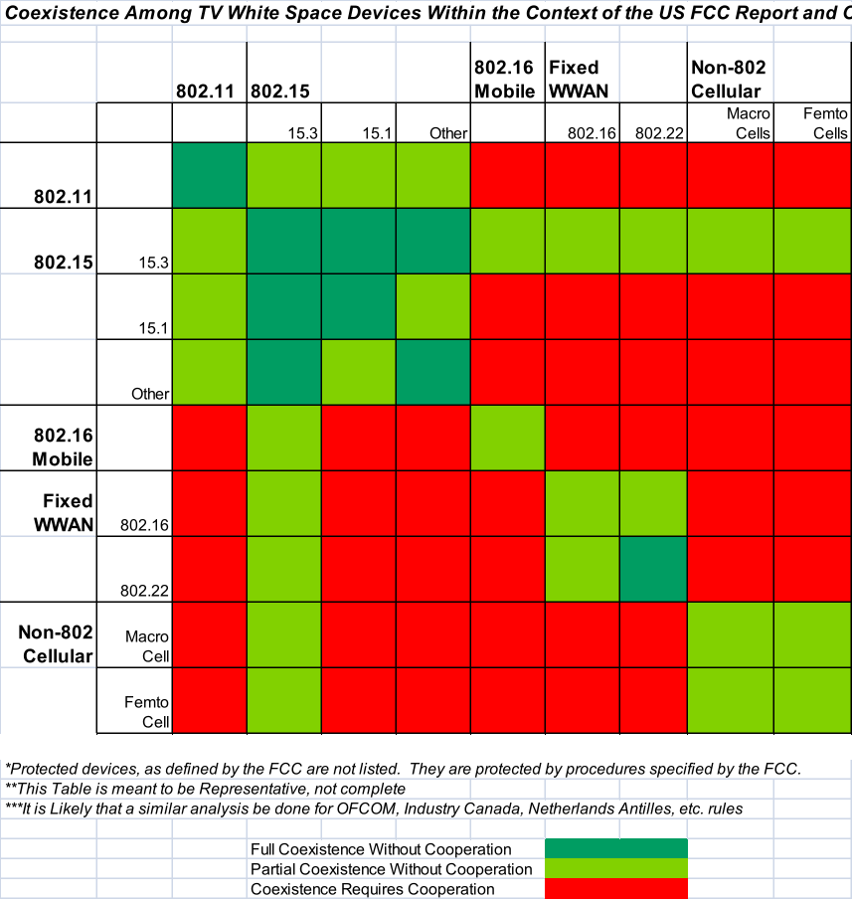

Marianna: Does coexistence between technologies mean sharing the channel between two technologies.

Alex: Yes as there is no way to avoid that if they are all secondary use devices.

Marianna: Why do you think it is different between mobile and fixed 802.16 devices? It is unlikely to be mobile more likely to be nomadic.

Alex: Queried that 802.16e and m are aimed at mobile.

Marianna: they are used for fixed applications and the band is for fixed and nomadic applications.

Alex: you can use them for fixed and for mobile so can put it in as cellular.
Marianna: What is being used for a fixed wireless MAN?

Alex: 802.22 and 802.16.

Marianna: and where is 802.16h in this matrix?

Alex: 802.16h would be depend on if it was a cellular or fixed access system i.e. it depends on deployment.

Marianna: The 802.16 2009 version should be quoted as there is no 802.16e any more. Different row and column is needed for 802.16h.

Alex: There may be coexistence of different flavours of the same standard by the same operator, it is unclear if different operators deploying a technology designed for a licensed band as 802.16 was when targeted to a cellular space and put in to the same channel.

Marianna: will coexistence if you deploy 802.16h as this is deployed over the top as thids allows 2 different 802.16 networks to work on the same channel.

Alex: Asked to discuss this with Marianna offline.

Alex: the one big issue to take away is the prevalence of the red areas in the matrix, i.e. coexistence requires cooperation. This shows that more active methods solutions to address coexistence between all of these different technologies.

Gerard: so active methods is trying to change the read to green

Alex: Yes the technologies have to actively do something; its form is up for discussion. Need to do something more then is currently being done.

Alex: Please email comments to the authors.

Tom: Would adaptive modulation be classed as passive?

Mark: 3GPP work on exchange information to allow the devices to exchange information to allow them all to have the best QoS may be an interesting way forward.

Meeting closed 14:07

5.00 |  | Other Business | Chair |  | 14:07

None

6.00 |  | Meeting closed | Chair | 0 | 14:07

References:

