IEEE 802.19
Coexistence Technical Advisory Group

Recommended Coexistence Parameters
and Test Cases

www.ieee802.org/19
Date:
November ??, 2005
Editor:
Joseph Levy
IEEE 802.19 Coexistence Technical Advisory Group
InterDigital Communications Corporation
Email: jlevy@ieee.org

Approved <approval date>
IEEE Project 802 Technical Advisory Group 802.19

Copyright (c) 2005 by the Institute of Electrical and Electronic Engineers, Inc.
3 Park Avenue, 17th Floor
New York, NY 10016-5997, USA
All rights reserved.

Contents
Contents 3
Table of Tables and Figures 4
References 5
1 Document Scope 6
2 Coexistence Systems 6
2.1 Summary 6
2.2 Part 11: Wireless LAN 6
2.2.1 Summary 6
2.2.2 Frequency Bands: 7
2.2.3 Transmission characteristics 7
2.2.4 Receiver Susceptibility 7
2.2.5 Test case and scenarios 7
2.3 Part 15 8
2.3.1 Part 15a 8
2.3.1.1 Part 15a General Description 8
2.3.1.2 Part 15a Modulation Characteristics 8
2.3.1.3 Part 15a Topology 9
2.3.1.4 Part 15a Coexistence Characteristics 9
2.3.1.5 Part 15a 9
2.4 Part 16 9
2.5 3GPP 10
2.6 3GPP2 10
3 Coexistence Test Case and Scenarios 10
3.1 Part 11 10
3.1.1 Susceptibility 10
3.1.2 Interference 10
3.2 Part 15 10
3.2.1 Susceptibility 10
3.2.2 Interference 10
3.3 Part 16 10
3.4 3GPP 10
3.5 3GPP2 10
Appendix A: Synopsis of Existing CA Documents 11
A.1 802.15.4b 11

Table of Tables and Figures
Figure 1 802.15a Modulation characteristics, GFSK 8
Figure 2 802.15a Topology 9

References
- 802.19 Coexistence Technical Advisory Group Policy and Procedures; 19-05-0010-09-0000_Coex-TAG_Operating_Rules.doc
- 802.15.1a Coexistence Characteristics; 19-05-0018-00-0000_802-15-1a_Coexistence_Characteristics.ppt
- 802.16 Overview and Coexistence Aspects;19-05-0025-00-0000_802-16_Coexistence_Aspects.ppt

Document Scope
The purpose of this document is to provide a centralized location for coexistence parameters and modeling techniques. This document was created to aid Working Groups in generating their coexistence assurance (CA) documents. There is no requirement on the Working Groups to use the information provided in this document. It is the Working Group’s responsibility to generate a CA document, the content of the CA is solely the responsibility of the Working Group who generates it.

The 802.19 Coexistence Technical Advisory Group (TAG) provides technical advice to the working groups and the IEEE 802 Sponsor Executive Committee (SEC) upon request. The 802.19 TAG is responsible for commenting on the CA documents and votes as a body on coexistence issues in wireless working group letter ballots that are accompanied by CA documents. The 802.19 TAG has no responsibility for generating CA documents. For additional information on the 802.19 TAG please see [1].

This document contains coexistence parameters and technical guidance for analyzing coexistence for various potential coexisting systems which may be address in the CA document. This document does not claim to be a complete compendium of all systems, parameters, or technical methods, it is only a compendium of those systems, parameters, and methods which have been provided over time. The document contains:
- Potential interfering systems transmissions characteristics.
- Susceptibility of systems which may be interfered with.
- Recommended test cases and scenarios for susceptibility and interference studies.

The 802.19 TAG coordinates and edits the information provided in this document. The technical information provided in this document has many sources:
- The 802.19 TAG
- Existing 802 wireless groups
- Various other wireless standards bodies (via LS)
- Working Groups who are working on coexistence documents
- Past CA documents

Coexistence Systems

Summary
This section will contain a summary of systems and top level parameters such as: Name, Frequency Bands, Description.

Paragraph | Name | Frequency Bands | Description
 | 802.11 (a, b, g) | 2.400 – 2.497 GHz  4.9 – 5.825 GHz | Wireless Local Area Networking
 | 802.15 |  | Wireless Personal Area Network
 | 802.16 |  | Wireless Metropolitan Network

Part 11: Wireless LAN

Summary

Frequency Bands:

Lower Limit | Upper limit | Regulatory range | Geography
2.402 GHz | 2.480 GHz | 2.400–2.4835 GHz | China
2.402 GHz | 2.480 GHz | 2.400–2.4835 GHz | North America
2.402 GHz | 2.480 GHz | 2.400–2.4835 GHz | Europea
2.473 GHz | 2.495 GHz | 2.471–2.497 GHz | Japan
2.447 GHz | 2.473 GHz | 2.445–2.475 GHz | Spain
2.448 GHz | 2.482 GHz | 2.4465–2.4835 GHz | France
NOTE—The frequency ranges in this table are subject to the geographic-specific regulatory authorities.

Frequency band (GHz) | USA (Maximum output power with up to 6 dBi antenna gain) (mW) | Europe (EIRP)
5.15–5.25 | 40 (2.5 mW/MHz) | 200 mW
5.25–5.35 | 200 (12.5 mW/MHz) | 200 mW
5.470–5.725 | — | 1 W
5.725–5.825 | 800 (50 mW/MHz) | —

Frequency band (GHz) | Regulatory type | Japan
4.9–5.091 | Fixed wireless access, licensed | < 250 mW EIRP, and < 50 mW/MHz EIRP for licensed access
4.9–5.091 | Nomadic access, unlicensed | < 10 mW/MHz EIRP
5.15–5.25 | Unlicensed | < 10 mW/MHz EIRP

Transmission characteristics

Receiver Susceptibility

Test case and scenarios

Part 15

Part 15a

Part 15a General Description
- Frequency Band
  - USA 2.4-2.4853 GHz (FCC 47CFR15.247)
  - Europe 2.4-2.4835 GHz (ETSI ETS 300-328)
  - Japan 2.4-2.4835 GHz (ARIB STD-T66)
- Channels
  - 79, 1 MHz
  - Non-overlap
- Spread spectrum type:
  - Frequency hopping
  - Pseudo-random hopping uses all 79 channels (exception: see Coexistence Characteristics)
  - 1600 hops / sec normal operation
  - 3200 hops / sec connection establishment
- Power -- device dependent
  - Class 1 = Max 100mW (20dBm), Min 1mW (0dBm)
  - Class 2 = Max 2.5mW (4dBm), Min 0.25mW (-6dBm)
  - Class 3 = Max 1mW (0 dBm), recommend <-30dBm Min

Part 15a Modulation Characteristics
- The Modulation is GFSK (Gaussian Frequency Shift Keying) with a bandwidth-bit period product BT=0.5. The Modulation index shall be between 0.28 and 0.35. A binary one shall be represented by a positive frequency deviation, and a binary zero shall be represented by a negative frequency deviation.

Figure 1 802.15a Modulation characteristics, GFSK

Part 15a Topology
- TDMA
- Single Master with up to 7 slaves forming an independent piconet
- Piconets are able to interact

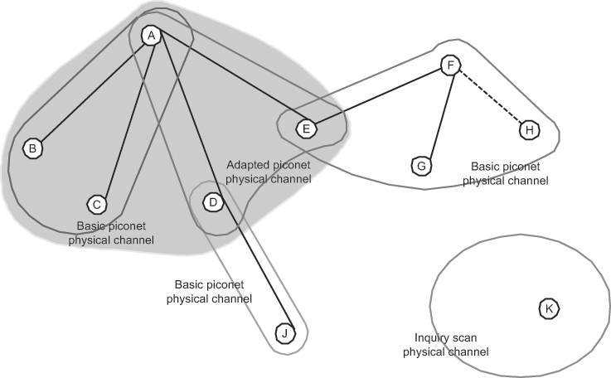
Figure 2 802.15a Topology

Part 15a Coexistence Characteristics
- Out of Band Noise Floor tolerance
Interfering Signal Frequency [Interfering Signal Power Level]
    - 30 MHz – 2000 MHz [-10 dBm]
    - 2000 – 2399 MHz [-27 dBm]
    - 2484 – 3000 MHz [-27 dBm]
    - 3000 MHz – 12.75 GHz [-10 dBm]
- Coexistence mechanism
  - Adaptive Frequency Hopping, which maps out error-prone channels
  - Number of channels may be reduced from 79 down to as low as 20 and are not required to be contiguous
  - Detection method not specified, but typical implementations:
    - Do not do Listen Before Talk (LBT)
    - Are reactive/heuristic – presence of others in band is based on repeated errors in specific channels

Part 15a

Part 16

3GPP

3GPP2

Coexistence Test Case and Scenarios
This section contains test cases and coexistence scenarios created by the various sources listed in Section 1. These test cases are meant to be used as a guideline for creating useful test cases and scenarios applicable to the creation of a CA document. It is the responsibility of the user of this material to choose and/or create meaningful test cases for the system they are proposing.

Part 11

Susceptibility

Interference

Part 15

Susceptibility

Interference

Part 16

3GPP

3GPP2
Appendix A: Synopsis of Existing CA Documents
- 802.15.4b

