IEEE P802.19
Wireless Coexistence

Project | IEEE P802.19 Coexistence TAG
Title | A Method of Curve Fitting to BER Data
Date Submitted | [November 27, 2005]
Source | [Stephen J. Shellhammer]  [Qualcomm, Inc.]  [5775 Morehouse Drive]  [San Diego, CA 92121] | Voice: [(858) 658-1874]  E-mail: [shellhammer@ieee.org]
Re: | []
Abstract | [In estimating the packet error rate using analytic techniques it is useful to have an analytic expression for the BER curve. This document describes one method of fitting the data to an analytic expression. Revision 1 includes an update for curve fitting to 802.15.4b PSSS BER data]
Purpose | []
Notice | This document has been prepared to assist the IEEE P802.19. It is offered as a basis for discussion and is not binding on the contributing individual(s) or organization(s). The material in this document is subject to change in form and content after further study. The contributor(s) reserve(s) the right to add, amend or withdraw material contained herein.
Release | The contributor acknowledges and accepts that this contribution becomes the property of IEEE and may be made publicly available by P802.19.

Table of Contents
1 Background 3
2 Functional Curve Fitting 3
3 Example – BPSK Modulation 4
4 Example – 802.15.4b PSSS in 915 MHz 6
5 Example – 802.15.4b PSSS in 868 MHz 8
6 References 10

List of Tables
Table 1: BPSK Simulation Data 5
Table 2: The 915 MHz PSSS PHY Simulation Data 7
Table 3: The 868 MHz PSSS PHY Simulation Data 9

List of Figures
Figure 1: BPSK BER Approximation 6
Figure 2: The 915 MHz PSSS BER Approximation 8
Figure 3: The 868 MHz PSSS BER Approximation 10

Background
When estimating the packet error rate (PER) using analytic techniques [1] it is useful to have an analytic expression for the bit error rate (BER). However, in modern digital communication systems it may be difficult to derive an analytic expression for the BER. Typically the BER curves are found using simulations. To simplify the PER calculations it is useful to fit a function to that BER simulation data. One method for performing that curve fitting is described in this document. If it is more convenient to deal with symbol error rate (SER) than BER the same process can be applied.

Revision 1 of this document includes an update of the 802.15.4b PSSS BER data supplied by Andreas Wolf. The curve fitting approach suggested in this document fits nicely with the new BER simulation data.

Functional Curve Fitting
We would like to find a formula for the BER that fits the simulated BER results. We begin with a series of simulated BER values for various signal-to-noise ratio (SNR) values. We would like to find a function$f(γ)$that represents a good fit to those simulation results. The parameter is the SNR on a linear scale. The SNR can vary between 0 (all noise) and infinity (all signal). We would like to select a function of a form that meets certain boundary conditions that we know to be true of any BER formula. The function should meet the following two conditions,

$$f(0)=\frac{1}{2}$$

$$\underset{γ→∞}{\text{Lim}} f(γ)=0$$

These two boundary conditions are based on laws of probability. When there is not signal and just noise the BER is one-half, the same as tossing a coin. Then there it is all signal and no noise the BER is zero. We propose the following structure of a function that meets those two boundary conditions,

$$f(γ)=\frac{1}{2}\text{exp}(g(γ))$$

Where $g(γ)$ is a polynomial in $γ$with no constant term. An example of this format is given by,

$$f(γ)=\frac{1}{2}\text{exp}(aγ+{bγ}^{2})$$

When $γ=0$ the function evaluates to one-half. And as long as we have the condition $b<0$then the function is zero in the limit to infinity. Sometime when this approach is applied the value of b is positive. Then you need to apply this approximation only over the region when the function is degreasing and set the value of the BER to zero above that limit. Usually the BER at that point is tiny and setting it to zero for higher SNR is quite reasonable. Higher order polynomials could be considered but we do not think that level of complexity is needed. It is important that there is no constant term in the exponent so as to insure that the argument of the exponent is zero for$γ=0$.

Given this structure of the function the we must then find appropriate values for the constants a and b. This can be done as follows. Assume that we are given a sequence of simulation results of the form$\left\{γ_{i},p_{i}\right\}$. It is assumed that the SNR is in a linear scale. If that is not the case you must first convert it into a linear scale. Beginning with the function for the BER,

$$p=f(γ)=\frac{1}{2}\text{exp}(aγ+{bγ}^{2})$$

We multiply both sides by two and take the natural logarithm of both sides giving,

$$\text{Log}(2p)=aγ+{bγ}^{2}$$

Now we substitute in the N sets of simulation points and we get N linear equations,

$$\text{Log}(2p_{i})={aγ}_{i}+{bγ}_{i^{2}}$$

We then solve for the two parameters a and b using a least squared technique. Several examples will be given to illustrate the approach in more detail.

Example – BPSK Modulation

The example is this section is based on a simple BPSK simulation. The simulation data is given in Table 1, where in this case the SNR is in dB and must be converted to a linear scale before solving for the parameters of the function.

SNR | BER
0.0 | 0.080400000000
1.0 | 0.061800000000
2.0 | 0.035000000000
3.0 | 0.024600000000
4.0 | 0.013950000000
5.0 | 0.005650000000
6.0 | 0.002344444444
7.0 | 0.000762962963
8.0 | 0.000187962963
9.0 | 0.000033612040
10.0 | 0.000004100000
Table 1: BPSK Simulation Data

By applying the procedure described in the previous section we obtain the following formula for the BER,

$$f(γ)=\frac{1}{2}\text{exp}(−1\text{.}\text{5136} γ+0\text{.}\text{036265} γ^{2})$$

Because in this case the constant b turned out to be positive this approximation will not work for very larger values of b. So we must limit this function to a range of the SNR. However, it works fine for values of SNR less than 20 dB. Above that value of SNR we can easily set the BER to zero.

This function and the original simulation data points are plotted in Figure 1.

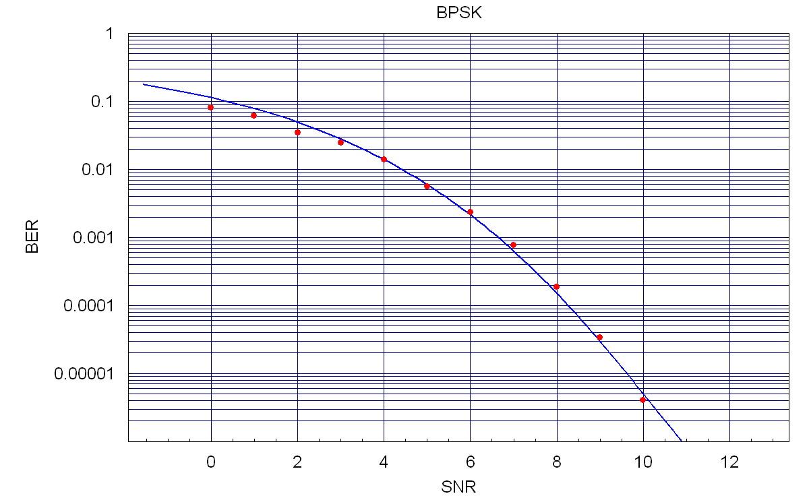
Figure 1: BPSK BER Approximation

Example – 802.15.4b PSSS in 915 MHz

The draft IEEE 802.15.4b includes a new PHY referred to at the parallel sequence spread spectrum PHY. The PHY operates in both the 915 MHz ISM band in the United States and the 868 MHz band in Europe. This section applies the procedure previously described to simulation data for the 915 MHz PSSS PHY. Simulation data for this PHY was supplied by Dr. Andreas Wolf and is given in Table 2. Once again the SNR is in dB in this data set.

SNR | BER
-8.061 | 0.19030000000000000000
-7.061 | 0.14100000000000000000
-6.061 | 0.09814000000000000000
-5.061 | 0.05431000000000000000
-4.061 | 0.02365000000000000000
-3.061 | 0.00962400000000000000
-2.061 | 0.00318200000000000000
-1.061 | 0.00063190000000000000
-0.061 | 0.00009103000000000000
0.939 | 0.00000681200000000000
1.939 | 0.00000041200000000000
2.939 | 0.00000001282000000000
3.939 | 0.00000000018120000000
4.939 | 0.00000000000091370000
Table 2: The 915 MHz PSSS PHY Simulation Data

By applying the procedure described in the previous section we obtain the following formula for the BER,

$$f(γ)=\frac{1}{2}\text{exp}(−8\text{.}\text{6613} γ−0\text{.}\text{032715} γ^{2})$$

This function and the original simulation data points are plotted in Figure 2.

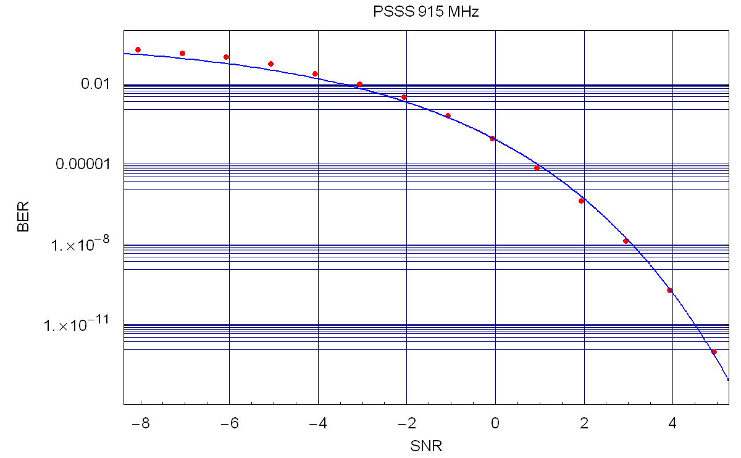
Figure 2: The 915 MHz PSSS BER Approximation

Example – 802.15.4b PSSS in 868 MHz

This section applies the procedure to the BER simulation data for the 868 MHz PSSS PHY. The simulation data is given in Table 3.

SNR | BER
-8.041 | 0.39030000000000000000
-7.041 | 0.32530000000000000000
-6.041 | 0.29430000000000000000
-5.041 | 0.23040000000000000000
-4.041 | 0.18210000000000000000
-3.041 | 0.12520000000000000000
-2.041 | 0.08090000000000000000
-1.041 | 0.04101000000000000000
-0.041 | 0.01484000000000000000
0.959 | 0.00431700000000000000
1.959 | 0.00065310000000000000
2.959 | 0.00006125000000000000
3.959 | 0.00000318200000000000
4.959 | 0.00000008713000000000
5.959 | 0.00000000090103000000
6.959 | 0.00000000000201100000
7.459 | 0.00000000000008021000
Table 3: The 868 MHz PSSS PHY Simulation Data

By applying the procedure described in the previous section we obtain the following formula for the BER,

$$f(γ)=\frac{1}{2}\text{exp}(−3\text{.}\text{8792} γ−0\text{.}\text{27578} γ^{2})$$

This function and the original simulation data points are plotted on Figure 3.

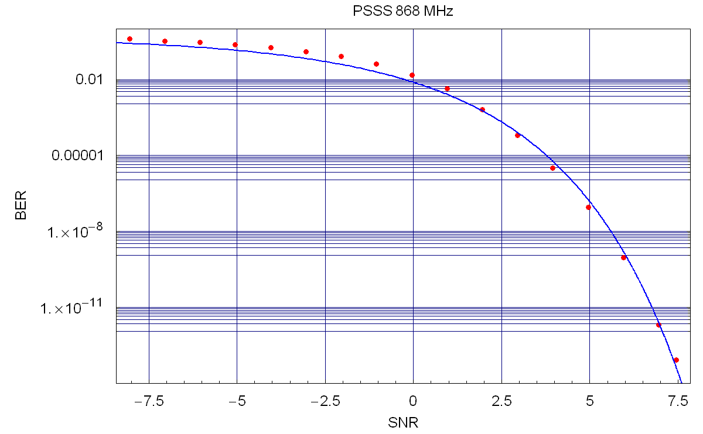
Figure 3: The 868 MHz PSSS BER Approximation

With the new PSSS simulation data the curve fitting approach suggested in this document seems to work quite well.

References
- S. J. Shellhammer, Estimation of Packet Error Rate caused by Interference using Analytic Techniques, IEEE 802.19-05/0028r2, September 28, 2005

