IEEE P802.18 Submission For Discussion

Project | IEEE 802.18 Radio Regulatory Technical Advisory Group (RR-TAG)
Title | Contributions to the Discussion of Regulatory Issues related to the IEEE 802.15.4k Draft Amendment to the IEEE 802.15.4 baseline.
Date Submitted | 18 January 2012
Source | John Notor  Notor Research  San Jose, CA | Voice:  Fax:  E-mail: gnu@notor.com
Re: | 802.18 Interim Meeting in Jacksonville, Florida, January 2012
Abstract | Collection of Email Comments and Questions Re: 802.15.4k Regulatory Matters
Purpose | To provide a record of the email received from various parties on the subject.
Notice | This document has been prepared to assist the IEEE P802.18. It is offered as a basis for discussion and is not binding on the contributing individual(s) or organization(s). The material in this document is subject to change in form and content after further study. The contributor(s) reserve(s) the right to add, amend or withdraw material contained herein.
Release | The contributor acknowledges and accepts that this contribution becomes the property of IEEE and may be made publicly available by P802.18.

All,

Ben approached me in the hallway today and said that there was some confusion about the TVWS rules in 15.4m.

Also, there may have been a question in 15.4k about ETSI rules as well.

Could one or more of you respond with the elements of the confusion? I have time this week, so I could try to clarify the US rules for you, and help or get some help for any ETSI issues.

Thanks,

John

John Notor

So to clarify, I am slightly confused and shared my confusion with John.
What I *should* have said is that there appears to be a difference between how 802.19 and 802.11 are interpreting the FCC regulations with respect to how a "type 1" device and "type 2" device interact, specifically if the periodic message that Type 2 devices transmit to inform Type 1 devices of the available channels (and other information?) are broadcast or directed. Steve may be able to explain it better.

I don't think 15.4m has gotten to the point where it matters yet, and I am only just catching up with 15.4m. When talking with Steve it seemed like it would be good to clear up any confusion before they do, so we don't end up with different groups in 802 working to different interpretation of the rules.

Regarding the questions in 4k, there was some discussion about the rules in Europe for the 433MHz band and the 169MHz band, which I believe Steve (J) and Cristina know more about, so maybe they can chime in with specifics, and if there is a need to make a formal request for clarification we can get John to help us do so properly and efficiently.

So that's what I know about it...

-Ben Rolfe

Cristina,

Thanks for the summary. I'll see if I can come up with a quick set of answers.

John Notor

From Steve Jillings

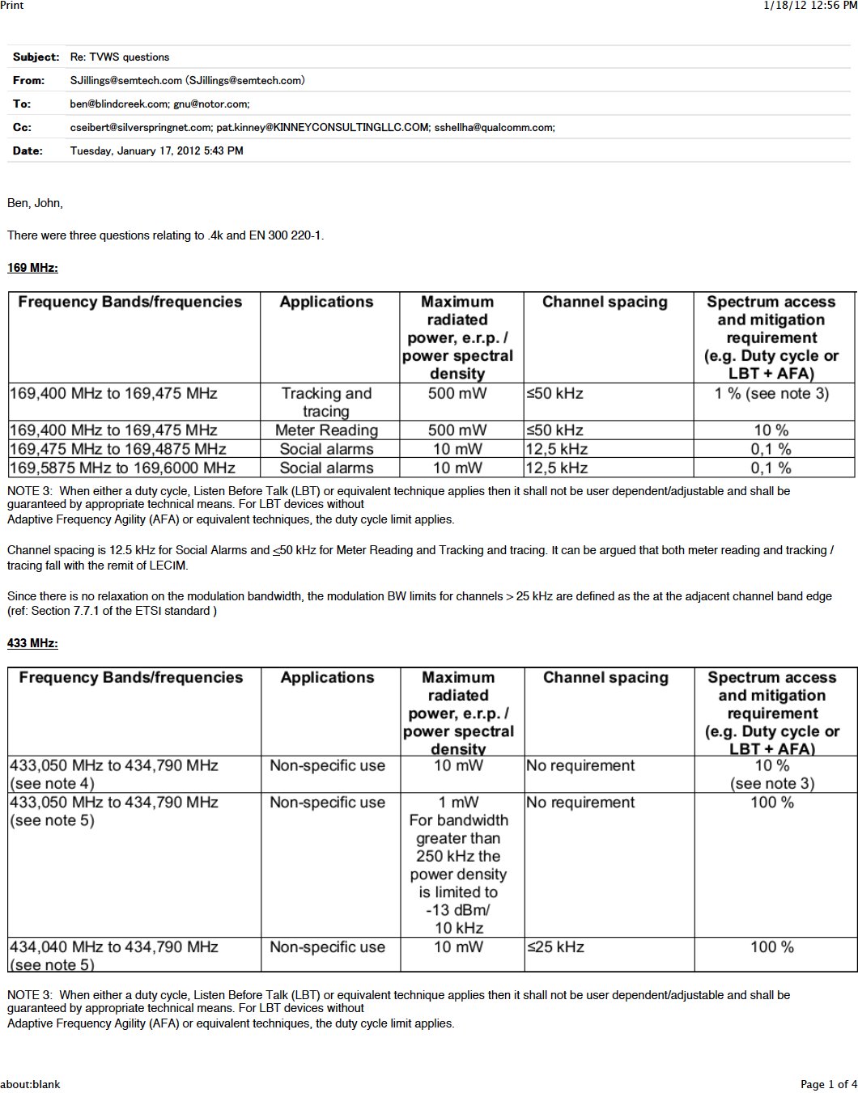

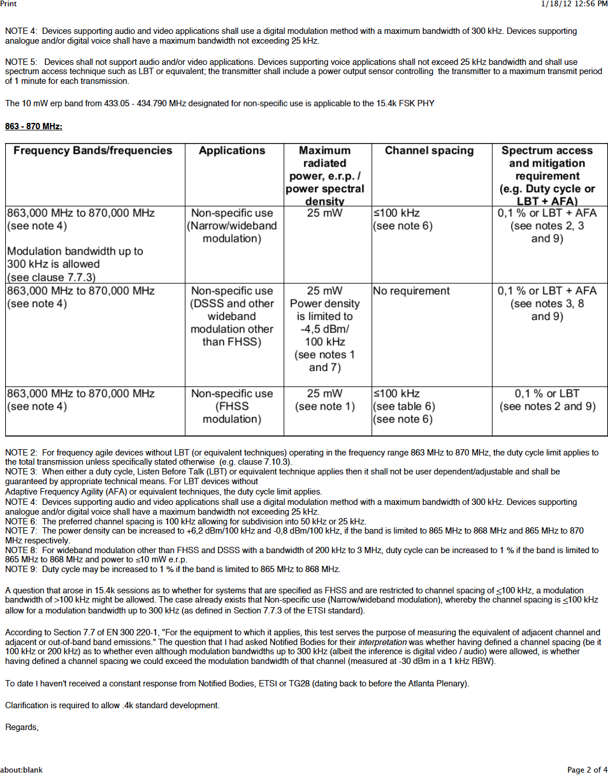

From Steve Jillings

Hi John,

While the tables and notes are a cut and paste from EN 300 220-1, my comments and observations on modulation bandwidth and channel spacing are purely my interpretation.

I strongly recommend that .4k seek guidance and advice from .18 with regards to this regulatory matter and will attend the PM2 .18 session should this topic be discussed.

Regards,

Steve

