Before the
FEDERAL COMMUNICATIONS COMMISSION
Washington, D.C. 20554

In the Matter of  Petition for Rulemaking by Lockheed Martin Corporation regarding Amendment of Part 15 to Enable More Flexible RFID Use in the 433 MHz  Band |  | RM-11651

Via the ECFS

Comments Of IEEE 802.18
- IEEE 802.18, the Radio Regulatory Technical Advisory Group (“RR-TAG”) within IEEE 802 hereby submits its Comments in the above-captioned Proceeding. This document was prepared and approved by the RR-TAG, and also was reviewed by the IEEE 802 Executive Committee.
- The members of the RR-TAG that participate in the IEEE 802 standards process are interested parties in this proceeding. We appreciate the opportunity to provide these comments to the Commission.

Introduction
- On December 14, 2011, the Commission opened the above-captioned proceeding, setting a 30 day period as the closing date for comments.
- We have a particular interest in the 433-435 MHz band, since the IEEE 802.15 Working Group for Wireless Personal Area Networks (“WPANs”) has developed an Active Radio Frequency Identification (“RFID”) physical layer amendment to the IEEE 802.15.4 (“IEEE 802.15.4”) base standard for Low-Rate WPANs called IEEE 802.15.4f (“802.15.4f”) which includes operation in the 433 MHz band.
- In addition, the IEEE 802.15.4k (“802.15.4k”) Task Group is currently considering a different amendment to 802.15.4 specifically targeted at Low Energy Critical Infrastructure Monitoring in the 433 MHz band.

Ieee 802.18 believes that updating the commission’s rules for RFID in the 433 MHz band to harmonize with international spectrum rules would bring benefits to the us marketplace
- The frequency band ranging from 433.05 MHz – 434.79 MHz (“433 MHz Band”) in most of the world is considered a license free band in which coexistence of low power RF devices is assured through:
- Limited transmit power.
- Limited duty cycle of allowed transmissions.
- A Listen Before Talk mechanism.

- The following table provides a snapshot of some international radio regulations in this band:

Table 1: Summary of a Sampling of International Regulations in the 433 MHz Band
Region | Regulation | Transmit Power (ERP) | Max Signal Bandwidth
USA  Canada | FCC 15.231(5)(b) / RSS-210  FCC 15.231(e) / RSS-210  FCC15.240 / RS-210 | 23 uW  4 uW  0.57 mW | 1,000 kHz
Europe, Africa | ETSI EN 300 220 | 10 mW  (10% duty cycle) | 500 kHz
China | SRRC Regulation Oct 2005 | 2.2 mW | 200 kHz
Japan | ARIB T92 | 1 mW | 200 kHz
Korea | MIC Notice No. 2005-29 | 3.6 mW | 500 kHz
Australia, New Zealand | AS/NZS 4268:2003 | 15 mW | 1,740 kHz

- When compared to the other countries listed in the Table 1, the regulations in the US are more restrictive with respect to transmit power and duty cycle in this band.
- RFID equipment in the 433 MHz Band is presently deployed by many companies to provide active RFID and Real Time Location Service (“RTLS”) equipment and systems throughout the world. Presently, the US market does not benefit from the full capabilities available in RFID technology deployed in other parts of the world because of the limitations imposed by the Commission’s rules in Part 15.231 and Part 15.240.

433 MHz spectrum offers superior propagation
characteristics when compared with the 2.4 GHZ ISM band
- Figures 1 and 2 plot path gain at 430 MHz relative to path gain at 2.35 GHz in two different environments.
15 dB
15 dB

Figure 1: Industrial LOS Environment Figure 2: Office LOS/NLOS Environment

- As predicted by RF propagation theory, experimental results show 15 dB less signal loss at 430 MHz when compared to signal loss at 2.35 GHz.
- This improved propagation characteristic in the 433 MHz band makes RFID operation particularly effective in global applications.
- In order to provide appropriate utilization of the 433 MHz Band, the 802.15.4f standard divides 1.74 MHz of available bandwidth into multiple channels and data rates:
  - 250 kb/s (3 channels, 580 kHz channel width)
  - 100 kb/s (5 channels, 348 kHz channel width)
  - 31.25 kb/s (15 channels, 108 kHz channel width)
- Figure 3 shows a graphical illustration of these data rates and the 802.15.4f channel plan.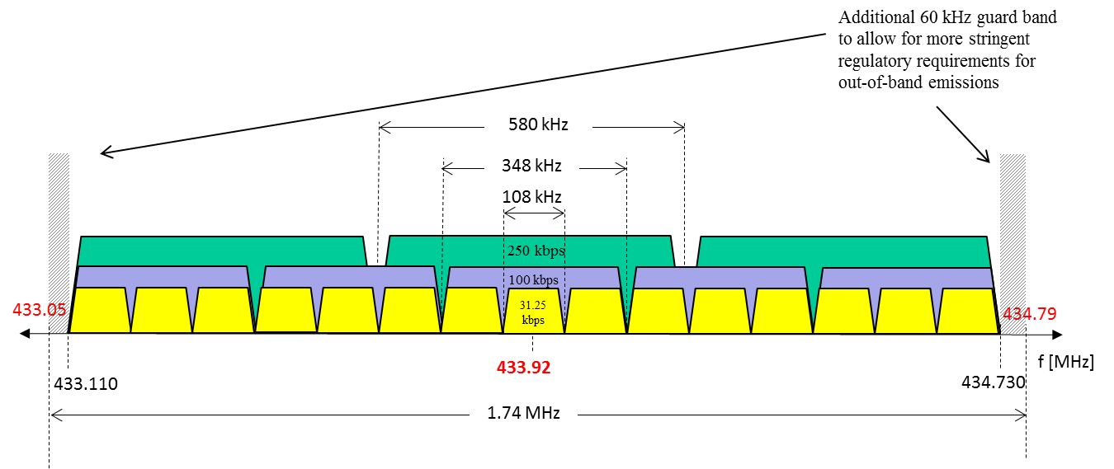
Figure 3: IEEE 802.15.4f Channel Plan for the 433 MHz Band

- 802.15.4 provides mechanisms needed to assure coexistence within the band, primarily through a Carrier Sense Multiple Access (“CSMA”) mechanism, sometimes referred to as “Listen Before Talk”.
- MSK modulation assures appropriate adjacent channel attenuation as well as out of band attenuation to protect other devices which are not compliant with the 802.15.4f air interface.
- Accepting the Lockheed Martin Petition in RM-11651 would permit devices conforming to the 802.15.4f amendment to coexist gracefully with other devices presently operating in the US 433 MHz band under Part 15 rules.
- The 802.15.4k amendment is in the early stages of development, but will also benefit from the proposed changes to the Part 15 rules.

CONCLUSION
- IEEE 802.18 encourages the Commission to accept the Lockheed Martin petition for rulemaking in the 433 MHz band.

Respectfully submitted,

/s/

Michael Lynch
Chair, IEEE 802.18 Radio Regulatory Technical Advisory Group
108 Brentwood Court
Allen, TX 75013
972.814.4901
freqmgr@ieee.org

The IEEE Local and Metropolitan Area Networks Standards Committee (“IEEE 802” or the “LMSC”)
2 This document represents the views of IEEE 802.18. It does not necessarily represent the views of the IEEE as a whole or the IEEE Standards Association as a whole.

