 Electronic Communications Committee (ECC)
within the European Conference of Postal and Telecommunications Administrations (CEPT)
ECC Report on Compatibility between WAS/RLAN on board aircraft and radars in the bands 5250-5350 MHz and 5470-5725 MHz

Place, Month, Year

executive summary
This report addresses the issue of compatibility between RLAN on-board aircraft and radars in the bands 5250-5350 MHz and 5470-5725 MHz and concludes on:
- Based on the new RLAN DFS specifications as in EN 310 893 V1.5.1, RLAN on-board aircraft are not compatible with Meteorological radars in the 5600-5650 MHz band and should hence not be authorized in this band.
- RLAN on-board aircraft compatibility with radars, mainly military radars, in the other bands, i.e. 5250-5350 MHz, 5470-5600 MHz and 5650-5725 MHz is theoretically feasible but should be carefully considered, in the light of the mobile nature of the vector as well as the sensitive missions related to air surveillance of military radars. In such case, it would be highly beneficial that preceding testing be performed to verify this compatibility.
- Should RLAN on-board aircraft be considered in the bands given in 2) above, it should be assumed that applications requiring great number of simultaneous RLAN channels could see their nominal operational conditions constrained over large areas due to high number of DFS triggers produced by radars operated at visibility distances from the plane (about 400 km).

Table of contents

0 executive summary 2
List of abbreviations 4
1 introduction 5
2 Characteristics of RLAN on board aircraft 5
2.1 General Characteristics 5
2.2 Spectrum requirement 5
2.3 Propagation model 6
2.4 Attenuation from the plane 6
2.5 General scenario 7
3 Radar detection DFS capabilities in the band 5 250-5350 MHz and 5470-5725 MHz bands 7
3.1 DFS principles and details 7
3.2 Meteorological radars case 10
3.2.1 Visibility distance 10
3.2.2 Interference distance 10
3.2.3 DFS application to RLAN on board aircraft 11
3.2.4 Conclusion for meteorological radars 12
3.3 Military radars case 13
3.3.1 Military radars characteristics 13
3.3.2 Theoretical analysis 13
3.3.3 Coexistence scenarios and operational impact 14
3.3.4 Conclusions for military radars 16
4 Conclusions 17
ANNEX 1: LIST OF REFERENCES 18

List of abbreviations

Abbreviation | Explanation
CEPT | European Conference of Postal and Telecommunications
e.i.r.p | Equivalent isotropically radiated power
ITU | International Telecommunication Union
EUMETNET | European Meteorological Network
RLAN | Radio Local Area Networks
WLAN IFE | Wireless Local Area Networks – In-Fight Entertainment system
DFS | Dynamic Frequency Selection

ECC Report on Compatibility between WAS/RLAN on board aircraft and radars in the bands 5250-5350 MHz and 5470-5725 MHz

introduction
WAS/RLAN in the 5 GHz range are covered by EC Decision 2005/513/EC (11 July 2005) and ECC Decision (04)08 that, in particular, impose the implementation of Dynamic Frequency selection (DFS) in the 5250-5350 MHz and 5470-5725 MHz frequency bands to ensure protection of radars.
These regulations were primarily considering non-mobile RLAN for which DFS algorithm were developed but implicitly authorise RLAN use on-board aircraft, although no specific analysis were performed at that time, based on the statement that “Use of RLAN inside an aircraft is also considered to be an indoor use, due to the strong attenuation offered by the aircraft, their operational conditions, and taking account of the fact that the installation and use of RLAN equipment inside an aircraft is regulated by administrations due to the specific certification required from the relevant aviation authorities” (Footnote 2 in the background section of ECC Decision (04)08)
Since adoption of ECC Decision (04)08, use of RLAN on board aircraft has been considered on a more specific basis, allowing in particular to get more detailed information about potential attenuation offered by aircraft and, following recent RLAN interference cases to meteorological radars in Europe, DFS specification as in ETSI standard EN 301893 have considerably evolved.
In the light of these new elements, this ECC Report presents a specific compatibility analysis between WAS/RLAN on board aircraft and radars (military and meteorological) in the 5250-5350 MHz and 5470-5725 MHz bands.

Characteristics of RLAN on board aircraft

General Characteristics
RLAN on-board aircraft could be used to provide different types of applications:
1) wireless distribution of streaming audio and/or video in airborne platforms
- Access point to connect passengers devices (laptop, ..)
- avionics intra-communications
Based on some previous projects, such as In-Flight-Entertainment system, one can expect that such RLAN use on-board aircraft, irrespective of the application, would not make use of maximum authorized RLAN eirp (30 dBm) but would more likely be limited to a maximum EIRP of 200 mW (+23 dBm) if TPC (Transmit Power Control) is used or 100 mW (+20 dBm) if no TPC is used.
If one can expect that applications 1) and 2) operations would be likely limited during the flight phase of the plane (i.e. with a minimum altitude restriction of 3000m), application 3) would more than likely relate to operations down to the ground.

Spectrum requirement
Table 1 below provides the frequency bands, number of channels and operational restrictions related that would apply to RLAN use on board aircraft.
Frequency Band | Channel Count | Total Capacity | DFS Requirements
5 150 to 5 250 MHz | 4 | 80 Mbit/s | None
5 250 to 5 350 MHz | 4 | 80 Mbit/s | DFS Required
5 470 to 5 725 MHz | 11 | 220 Mbit/s | DFS Required
Table 1: Frequency bands, number of channels, total capacity and DFS requirements

Depending on the applications, the number of required channels may vary from few channels to almost all of the channels.
Applications requiring less than 4 channels would be able to be accommodated in the 5150-5250 MHz band, hence without DFS requirements, but it is more than likely that that a number of applications would require more than 4 channels, up to almost all channels if considering applications type 1 and 2 (previous information provided to ECC for entertainment applications were based on a total maximum throughput requirement of 330 Mbit/s and a minimum of 17 available channels, see [9]).
Since most of these channels present DFS requirement, it should thus be considered that a number of these channels could become unavailable at any point in time during a flight. In particular, the current deployment of meteorological radars, fixed by nature, would make the 3 channels covering the 5600-5650 MHz band constantly unavailable over Europe, hence leaving a maximum of 16 available channels for RLAN operation, in which anyway there would be a high probability that simultaneous DFS trigger due to other radars (in particular in vicinity of airports) would drastically limit the number of channels finally available to RLAN operation.

Propagation model
Considering the RLAN on-board aircraft operation Altitude, and in particular the regular airplanes flight altitude of 10000 m, it is obvious that the use of RLAN on-board aircrafts relates to a free-space propagation model with regards to other radio services stations.

Attenuation from the plane
A Boeing measurement campaign has been realised in 2004 (see document in reference [8]) to determine the attenuation fuselage of a B747 air-plane within the 5150-5250MHz.
Results of attenuation measurement can be summarized as following:

List of fuselage attenuation values (dB)at each measurement point of a 747 airplane.
 | Measurement point number
Measurement point height | 1 | 2 | 3 | 4 | 5 | 6 | 7 | 8 | 9
H3 | 36.1 | 21.1 | 0 | 18.8 | 6.3 | 19.3 | 22.8 | 21 | 19.5
H2 | 42 | 7.5 | 6.3 | 0.6 | (2) | 25 | 7.7 | 28.1 | 7.3
H1 | 24.1 | 17.3 | 10.6 | 8.1 | 11.6 | 27.6 | 24.3 | 23.6 | 21
Table 2: Fuselage Attenuation

Although these results present a quite large variation from 0 to 42 dB attenuation, Boeing calculated at that time a mean value of 17,3 dB.
It is hence proposed to consider an average attenuation from the plane of 17dB but to consider corresponding results with cautious, taking into account the following elements that could induce variation of the fuselage attenuation :

- The fuselage attenuation measurement is dependent of the accuracy of the measurements means and methods.
- In document [8], it has been shown that significant increases of fuselage attenuation are visible in the axial directions (nose-on and tail-on orientations). Attenuation is smaller in the other orientations and that calculated probability of aircraft illumination shows that nose-on and tail-on orientations are the most likely.
- It would be interesting to not only rely on measurements made on a single airplane but to get additional elements for a set of similar planes and different planes
- Some tests have been realised on new materials, as composite materials. A single measurement has shown that RF attenuation at 5GHz on a composite door is better than on an aluminium door. New materials may need a characterization to evaluate the corresponding attenuation.
- When a structure becomes dated, attenuation decreases. It means that the reference attenuation value would not be relevant for the whole equipment life long.
- The influence of the aircraft flight conditions has not been developed since aircraft movements could induce extra variations of fuselage attenuation

General scenario

Radar detection DFS capabilities in the band 5 250-5350 MHz and 5470-5725 MHz bands

DFS principles and details
RLAN Dynamic Frequency Selection (DFS) specifications are provided in ETSI standard EN 301 893.
Following interference cases to meteorological radars, a new version V1.5.1 of EN 301893 has been released, that should be followed by a subsequent version V.1.6.1. The following table provides a summary of modifications introduced in these new versions.
On a general basis, these new specifications recognize the specificities of meteorological radars in the band 5600-5650 MHz, requiring a DFS relying on an efficient Channel Availability Check (CAC) process, whereas other radars would more require an efficient in-service monitoring process.
To this respect, one can also note that, as such, the DFS specifications in the 5600-5650 MHz band are not sufficient on their own to ensure protection of meteorological radars but are part of a “package” including also requirement for meteorological radars first, to only operate in the 5600-5650 MHz band and secondly, to transmit a minimum of 2 detectable signals over their scanning strategy (typically lasting around 15 minutes) (minimum detectable signal concept).

 | EN 301 893  V1.3.1/  V1.4.1 | EN 301 893  V1.5.1 |  | EN 301 893  V.1.6.1
Parameter | All Channels | 5600-5650 MHz | Other channels
Date of Withdraw (DOW) | 1 July 2010 (April 09 for 5600-5650 MHz band) | 1 January 2013 |  | N/A
Minimum pulse width (see detailed test signals in table below) | 1 μs | 0.8 μs |  | 0.5 μs
PRF (see detailed test signals in table below) | Fixed | Fixed, Staggered and Interleaved |  | V1.5.1
Channel Availability Check (CAC) time | 1 minute | 10 minutes | 1 minute | V1.5.1
Off-Channel CAC (Note 1) | No | Yes |  | V1.5.1
CAC and Off-Channel CAC detection probability (Note 2) | 60% | 99.99% | 60% | V1.5.1
In-service monitoring detection probability | 60% | 60% |  | V1.5.1
CAC for slave devices with power above 200 mW (after initial detection by In-service) | No | Yes |  | V1.5.1
Detection Threshold | -64 dBm (>200 mW)  -62 dBm (<200 mW) | -62 +10 -EIRP Spectral Density (dBm/MHz) + G (dBi), however the DFS threshold level shall not be lower than -64 dBm assuming a 0 dBi receive antenna gain |  | V1.5.1
Channel Move time | 10s | 10s |  | V1.5.1
Channel closing time | 260 ms | 1s |  | V1.5.1
Non-occupancy period | 30 minutes | 30 minutes |  | V1.5.1
Possibility to exclude 5600-5650 MHz band from the channel plan or to exclude these channels from the list of usable channels | No | Yes |  | V1.5.1
Note 1: The alternative “Off-Channel” CAC process consists of an RLAN operating in another channel that will verify on a non-continuous and statistical basis possible meteorological radar signal detection. This process is based on short-time slots detection periods (down to few ms) over a sufficiently long period of time (several hours)
Note 2: The corresponding probability relates to the detection of one single radar burst (18 pulses for the 5600-5650 MHz band) over the CAC time period.
Table 3

Radar test signal #  (see notes 1 to 3) | Pulse width  W [µs] |  | Pulse repetition frequency PRF (PPS) |  | Number of different PRFs | Pulses per burst for each PRF (PPB)  (see note 5)
Radar test signal #  (see notes 1 to 3) | Min | Max | Min | Max | Number of different PRFs | Pulses per burst for each PRF (PPB)  (see note 5)
1 | 0.8 | 5 | 200 | 1000 | 1 | 10  (see note 6)
2 | 0.8 | 15 | 200 | 1600 | 1 | 15  (see note 6)
3 | 0.8 | 15 | 2 300 | 4000 | 1 | 25
4 | 20 | 30 | 2 000 | 4000 | 1 | 20
5 | 0.8 | 2 | 300 | 400 | 2/3 | 10  (see note 6)
6 | 0.8 | 2 | 400 | 1200 | 2/3 | 15  (see note 6)
NOTE 1: Radar test signals 1 to 4 are constant PRF based signals. See figure D.1. These radar test signals are intended to simulate also radars using a packet based Staggered PRF. See figure D.2.
NOTE 2: Radar test signal 4 is a modulated radar test signal. The modulation to be used is a chirp modulation with a ±2,5MHz frequency deviation which is described below.
NOTE 3: Radar test signals 5 and 6 are single pulse based Staggered PRF radar test signals using 2 or 3 different PRF values. For radar test signal 5, the difference between the PRF values chosen shall be between 20 and 50 pps. For radar test signal 6, the difference between the PRF values chosen shall be between 80 and 400 pps. See figure D.3
NOTE 4: Apart for the Off-Channel CAC testing, the radar test signals above shall only contain a single burst of pulses. See figure D.1, D.2 and D.3.
For the Off-Channel CAC testing, repetitive bursts shall be used for the total duration of the test. See figure D.4. See also clause 4.7.2.2.
NOTE 5: The total number of pulses in a burst is equal to the number of pulses for a single PRF multiplied by the number of different PRFs used.
NOTE 6: For the CAC and Off-Channel CAC requirements, the minimum number of pulses (for each PRF) for any of the radar test signals to be detected in the band 5600 to 5650 MHz shall be 18.
Table 4: Parameters of radar test signals

Meteorological radars case

Visibility distance
Being on-board aircraft, RLAN would obviously operate at location presenting quite high visibility distance from radars without taking advantage of any shielding, unlike for “terrestrial” RLAN. Such distances are given in the following table, for radar typical antenna height range (7 to 30 m) and RLAN operating altitude of 3000 and 10000m.

Radar height | Visibility distance for an airplane at 3000 m altitude | Visibility distance for an airplane at 10000 m altitude
7 m | 205 km | 366 km
30 m | 215 km | 376 km
Table 5: Visibility of RLAN

Interference distance
The following calculations are made under the following assumptions:
For RLAN:
EIRP: 20 dBm (0 dBi antenna assumed)
Plane attenuation: 17 dB
Bandwidth: 20 MHz

For Meteorological Radar
Antenna gain: 44 dBi
Noise figure : 3 dB
Protection criteria : I/N = -10 dB
The following table provides, for the typical radar pulses cases (0.5 and 2 μs), the analysis of necessary EIRP discrimination between RLAN emissions and radar protection threshold taking into account bandwidth factors.

 | 0.5 μs pulses | 2 μs pulses
Necessary bandwidth | 2 MHz | 0.5 MHz
Interference threshold | -118 dBm/2 MHz | -124 dBm/0.5 MHz
Relative RLAN EIRP density | 10 dBm/2 MHz | 4 dBm/0.5 MHz
EIRP discrimination | 128 dB | 128 dB
Table 6: e.i.r.p discrimination

It is interesting to note that, irrespective of the radar pulse width, the necessary EIRP discrimination is constant, i.e 128 dB.
Finally, the necessary free space attenuation between RLAN and radars is given by:

L_{nec} = EIRP_{disc} – A_{plane} + G
Where
L_{nec} =Necessary free space attenuation (dB)
EIRP_{disc} = EIRP discrimination
A_{plane} = Plane attenuation
G = Radar antenna gain
Leading to : L_{nec} = 128 – 17 + 44 = 155 dB and corresponding to a free space distance of 238 kms.
RLAN on board aircraft will hence present an interference potential at distances up to 238 kms from any meteorological radars, noting in particular that such distance is well beyond the typical distance between meteorological radars to ensure efficient territory coverage.
To this respect, it can be seen on the figure below that there is roughly no location over Europe at a distance below 238 kms from any meteorological radars, in particular taking into account regular aeronautical routes that are crossing over western Europe.

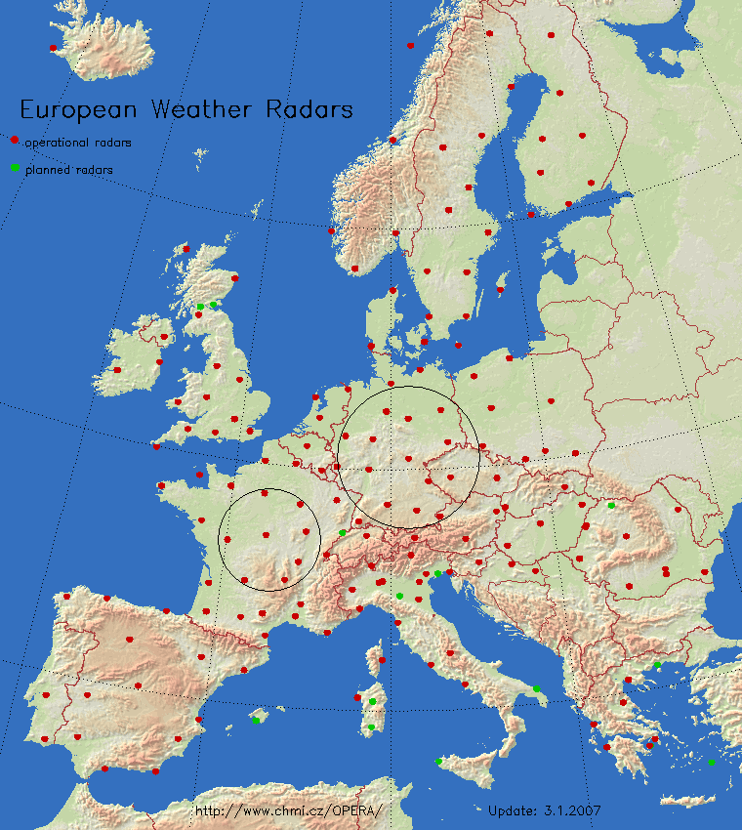
Meteorological radars in European countries members of EUMETNET (note that some radars in the south of Europe are S-Band and that, far east, the existing radars are not plotted since the corresponding countries are currently not part of EUMETNET)

In the light of this map, one can obviously note that, within an interference distance of 238 kms (small circle over France) from a given radar, the corresponding RLAN will also be at interference distance from a large number of radars (5 to 8) that could hence represent a risk of interference not only to a single radar but the whole network.
This is in particular exacerbated by the fact that some RLAN on board aircraft applications would lead to the simultaneous use of a large number of RLAN channels.
It is hence obvious that, to ensure protection of meteorological radars in the 5600-5650 MHz band, an efficient DFS mechanism would be necessary.

DFS application to RLAN on board aircraft
Compared to the RLAN-to-radar link budget, the radar-to-RLAN link budget (controlling the DFS threshold detection) presents roughly a 5 to 7 dB difference (depending on the threshold), leading to a 424 to 534 km detection distance. Recognising that such detection would likely occur only in case of visibility means that RLAN on board aircraft would detect Radars at about 380 km.
One can note that this is consistent with information initially provided within the ETSI SRDoc on WLAN IFE [9]:
“In an airborne platform, the situation is somewhat different. At altitude, the radio horizon is approximately 400 km in radius – a much larger radio horizon than a terrestrial installation. As a result, the RLAN has the potential of detecting a substantially larger number of radars at any given point in time.”
At such distance, a RLAN on-board an aircraft would simultaneously detect signals from a large number of radars (more than 2/3 of networks for large countries such as UK, France or Germany).
These radars (13 in example case of Germany as shown on the map above) will obviously operate on different frequencies within the 5600-5650 MHz band and hence are likely to already override any use of the relevant channels over the whole Europe, taking into account the fixed and 24/7 operation nature of meteorological radars.
In addition, even though successful “in-service monitoring” have been performed during testing in the US and Canada, it is necessary to consider up-to-date DFS development in ETSI (see section 3.1 above) that shows that for meteorological radars in the 5600-5650 MHz band, “in-service monitoring” is much less important than Channel availability Check (CAC).
Indeed, for meteorological radars, a 10 minutes CAC with a 99.99% detection probability is the main tool allowing successful DFS monitoring and radar protection, building upon such specificities (including noise calibration without emission) as well as the necessity to ensure a long term coexistence between RLAN and radars (under the minimum detectable signal concept).
However, due to the mobile nature of RLAN on board aircraft, the aircraft speed of about 800 km/h would make the corresponding RLAN access point “move” by about 130 km during the possible 10 minutes CAC. It is hence obvious that such CAC process will not be efficient to ensure adequate detection of meteorological radars since such RLAN “move” would lead, during the 10 min CAC process, to radars “sorting-out” or “entering” from the detection zone. The new “entering” radars during the CAC process would hence not benefit from a whole 10 min CAC, hence leading to affecting the capability to detect with 99.99% probability the absence of any radar on the corresponding channel.
It is hence obvious that mobile RLAN, and in particular RLAN on-board aircraft are not compatible with a DFS mechanism relying on CAC process. To this respect, it is interesting to note the following abstract from document [8] in its section 2.2, that confirms such statement :
“All DFS algorithms approved to-date have assumed a non-mobile RLAN infrastructure. While the 802.11 clients were expected to be mobile, the access points (APs), which serve as the connection point to a wired infrastructure, were expected to be fixed in location. As such, the architects of the DFS algorithm did not explicitly consider the case of RLANs installed within mobile platforms, such as trains, watercraft, or aircraft. Specifically, the notion of a Channel Availability Check, a test that is run by the AP to ensure the channel is clear of radars before the channel is used by the RLAN (discussed further in Section 3.2.1), is compromised if the AP is mobile. As RLAN equipment has become more popular for mobile installations, additional questions arise concerning the applicability and efficacy of DFS to a mobile platform.”
One can finally stress the fact that, unlike for typical RLANs that target using 1 channel at a location where it is more than likely that only 1 meteorological radar would be operating, the IFE, by principle, would operate in visibility of multiple radars more than likely operating over the 3 channels in the 5600-5650 MHz band and for which 3 simultaneous CAC would have to be performed.
Acknowledging that 1 single RLAN is able to produce severe interference to radar (referring to current interference cases from “terrestrial” RLAN), it would then have made no sense to work toward finding solutions to solve interference cases from “terrestrial” RLAN if, in the same time, no global solutions are found for RLAN on-board aircraft (or all type of mobile RLANs).

Conclusion for meteorological radars
Taking into account that :

- RLAN on-board aircraft present high potential of interference to meteorological radars (up to 238 km),
- RLAN on-board aircraft appears only capable of performing “in-service monitoring” DFS
- In the 5600-5650 MHz band, RLAN on-board aircraft would not be able to perform an efficient DFS process and in particular the required 10 minutes CAC with 99.99% detection probability as specified in EN 301893 V.1.5.1
- RLAN on-board aircraft would always operate over Europe at location in detection range (up to 380 km) of a large number of meteorological radars, hence presenting obviously no channel availability in the 5600-5650 MHz band,
it can be concluded that RLAN on-board aircraft operation are not compatible with meteorological radars and hence should not be authorised in the band 5600-5650 MHz.

Military radars case

Military radars characteristics
5250-5850MHz frequency band
Mode: fixed frequency
frequency agility
EIRP : 98.5dBm to 148.5dBm (Rec. UIT-R M.1638)
Antenna Gain: 28 to 54 dBi
Receiver IF 3dB bandwidth: 0,1MHz to 10MHz

Theoretical analysis
3.3.2.1 Background on DFS
Coexistence between radar and RLAN in the 5 GHz range and work on the efficiency of DFS have been studied in several working groups. In France practical testing campaigns have been performed with military radars in 2004. The situation can be summarized as below:
- Studies within CEPT (JPT5G, SE38, JPT BWA, SE41…): see ERC Report 72, ECC Report 68 and ECC Report 110,
- ETSI 301893 standard v 1.2.3 (for RLAN in the 5150-5350 and 5470-5725MHz bands) has been published in 2003,
- Tests have shown that DFS characteristics in compliance with EN 301893 V1.2.3 were not sufficient to protect military radars,
- ETSI 301893 standard have been improved (but frequency hopping signals are not taken into account) in versions 1.3.1 and 1.4.1,
- ETSI 301893 standard has been further improved in version 1.5.1 and future version 1.6.1 but frequency hopping signals are still not taken into account.

3.3.2.2 Mutual link budget analysis
Regarding the impact on radars, some uncertainties are related to the mobile nature of RLAN on-board aircraft whereas all previous studies and analysis were performed so far on DFS applied to fixed or nomadic scenarios.
This difference creates additional difficulties in the coexistence with radars, especially for those which have a function of air surveillance.
A first analysis is based on a mutual link budget calculation. This is based on the assumption of a symmetrical propagation path between the RLAN and the radar.

“RLAN → radar” link budget
RLAN IFE eirp | 200mW | 23 | dBm
Aircraft Attenuation | 17dB | -17 | dB
Radar Antenna gain | 34 to 50 dBi | 35 | dBi
10log(BWLAN/BRADAR) | 10log (20/4) | -7 | dB
Radar Sensitivity | -105 dBm | -(-105) | dBm
Radar protection criteria (I/N) | -6 dB | - 6
 | Necessary Attenuation loss | 145 | dB
 | Distance (free space) | 73 | Km

“Radar → RLAN” link budget
Radar eirp |  | 105 | dBm
Aircraft attenuation |  | -17 | dB
Antenna gain |  | 2 | dB
DFS threshold |  | -62 | dBm
 | Necessary attenuation loss | 152 | dB
 | Distance (free space) | 164 | km
Table 7: Distances (free space)

This analysis shows that, in theory, with the DFS detection threshold considered in EN 301893, the DFS mechanism detects this radar before the radar ‘sees’ RLAN interference.
However, the experience from terrestrial RLAN has shown the difficulties for proper implementation of DFS. As a consequence, the following section highlights some practical scenarios that can lead to coexistence difficulties between RLAN on-board aircraft and radars.

Coexistence scenarios and operational impact
 | Scenario 1: radar near an airport
Usually air traffic surveillance is realised with radar in L or S band; but sometimes, a C band radar can replace the fixed radar in case of failure
As well, protection of an area near an airport can be realised by a C band radar.

1.1 | Aircraft traffic detection: X aircrafts | 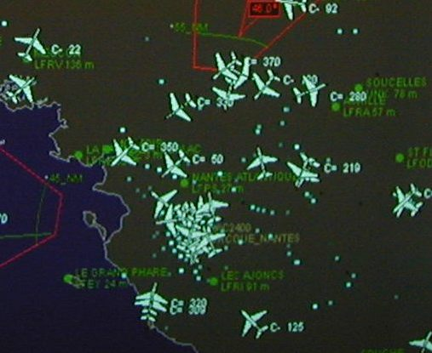
1.2 | RLAN without DFS (or with DFS not detecting frequency hopping radar signals, for example)  Radar detects RLAN signals that create false detections  Radar creates false tracks or identifies a threat  Saturation of the radar screen, and use of process time which induces:  - loss of range in the direction of each RLAN  - time computer strongly reduced for real threat  - jamming and false track

Without DFS or with an inefficient DFS mechanism, radar functioning is not realistic (figure 1.2). Each aircraft fitted with RLANs will be equivalent to a jammer.
With DFS, some delay in the detection of radar by DFS would lead to an interference situation for the radar. Delay could be due to difficulties for the DFS to detect specific radar signal or frequency hopping radar signal. This stresses the need for an efficient DFS mechanism.

Scenario 2: Example of peace keeping scenario
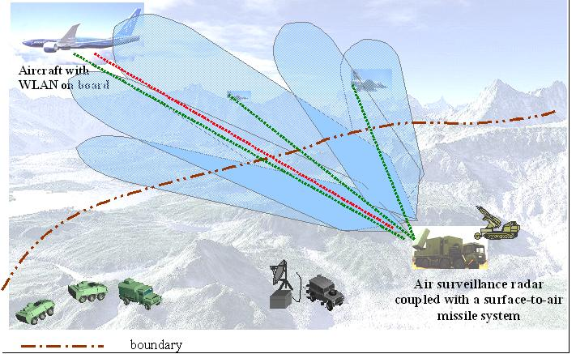
Possible evolution of the scenario in a ‘worst case’ situation
(in a short time, < a few seconds) :
Detection of aircrafts
Detection of a jamming signal (RLAN) co-located with one aircraft
RLAN signal is considered as a jamming signal
Radar identifies aircraft as a target
Target information is provided to the missile firing unit
Target may be engaged or not……..

A situation where radar detects an aircraft, and in the same time a 5GHz signal coming from RLAN, can be seen as a target with ECCM (Electronic Counter Counter Measure). This may have very detrimental impact in ‘peace keeping’ scenarios.

Scenario 3: airspace and maritime space check
Example of intentional and no-intentional jamming on aircraft
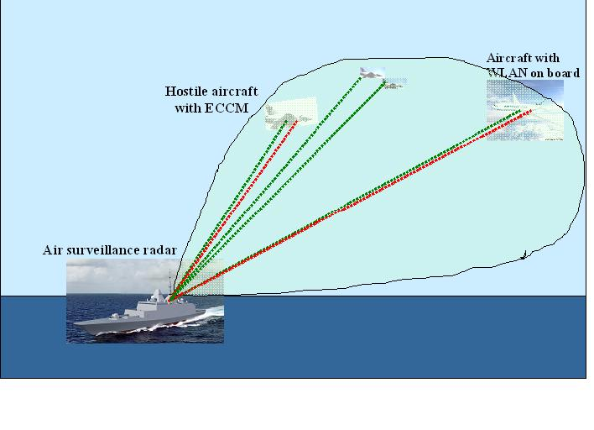
4 aircrafts detected
Detection of jamming signal (or supposed jamming) collocated with two aircrafts
Radar identifies two aircrafts as targets, but nevertheless one of them is a “friend”

These situations can be more or less critical, according to the DFS efficiency. The EN301893 standard (RLAN) was designed for terrestrial RLAN systems in a stationary environment or with a limited speed compared to the speed of an aircraft.
On this basis, and although some satisfactory “in-service monitoring” detection testing have already been performed (Testing in US and Canada) with meteorological radars, it would be beneficial to perform specific testing with RLANs on-board aircraft to know their DFS ability to detect military radars when RLAN move with high speed.
This would complement the testing campaign performed with weather radars and reported in R[3].

Conclusions for military radars
Coexistence between military radars and RLAN on-board aircraft systems (WLAN on-board aircraft) in the C band can be summarized as follows:

- Without DFS, coexistence is impossible.
- With DFS, coexistence is theoretically possible but should be carefully considered. Indeed, the experience on terrestrial RLAN has shown that the practical implementation of DFS is complex and that, interference into radars could still be observed due to the difficulty to take into account every possible radar signals (e;g. frequency hopping signals).
In any case, should RLAN on-board aircraft usage be considered in the future in the 5 GHz range, it would be highly beneficial that preceding testing be performed to verify the full efficiency of detection capabilities of RLAN operated on high speed vector and the absence of any detrimental wrong detection that could lead to potentially tragic consequences.

Conclusions
This ECC Report presents a specific compatibility analysis between RLAN on board aircraft and radars (military and meteorological) in the 5250-5350 MHz and 5470-5725 MHz that allow to draw the following conclusions:

- Based on the new RLAN DFS specifications as in EN 310 893 V1.5.1, RLAN on-board aircraft are not compatible with Meteorological radars in the 5600-5650 MHz band and should hence not be authorized in this band.
- RLAN on-board aircraft compatibility with radars, mainly military radars, in the other bands, i.e. 5250-5350 MHz, 5470-5600 MHz and 5650-5725 MHz is theoretically feasible but should be carefully considered, in the light of the mobile nature of the vector as well as the sensitive missions related to air surveillance of military radars. In such case, it would be highly beneficial that preceding testing be performed to verify this compatibility.
- Should RLAN on-board aircraft be considered in the bands given in 2) above, it should be assumed that applications requiring great number of simultaneous RLAN channels could see their nominal operational conditions constrained over large areas due to high number of DFS triggers produced by radars operated at visibility distances from the plane (about 400 km).
- LIST OF REFERENCES

- ETSI EN 301 893: “Broadband Radio Access Networks; 5 GHz High Performance RLAN. Harmonized EN covering essential requirements of article 3.2 of the R&TTE Directive”.
- IEEE 802.11: “IEEE Standard for Information Technology - Telecommunications and information exchange between systems - Local and Metropolitan area networks - Specific requirements - Part 11: Wireless LAN Medium Access Control (MAC) and Physical Layer (PHY) specifications".
- IEEE 802.11a-1999 [ISO/IEC 8802-11:1999/Amd 1:2000(E)] (Supplement to IEEE Std 802.11, 1999 Edition): "Part 11: Wireless LAN Medium Access Control (MAC) and Physical Layer (PHY) specifications: High-speed Physical Layer in the 5 GHz Band".
- IEEE 802.11n: “Wireless LAN Medium Access Control (MAC) and Physical Layer (PHY) Specifications: Enhancements for Higher Throughput”
- ECC Decision (04)08: “ECC Decision of 12 November 2004 on the harmonised use of the 5 GHz frequency bands for the implementation of Wireless Access Systems including Radio Local Area Networks (WAS/RLANs)”
- Commission Decision 2005/513/EC of 11 July 2005 on the harmonised use of radio spectrum in the 5 GHz frequency band for the implementation of wireless access systems including radio local area networks (WAS/RLANs).
- Commission Decision 2007/90/EC of 12 February 2007 amending Decision 2005/513/EC on the harmonised use of radio spectrum in the 5 GHz frequency band for the implementation of Wireless Access Systems including Radio Local Area Networks (WAS/RLANs).
- Dynamic Frequency Selection (DFS) Functionality with airborne radio local Area networks (RLAN’s) Flight Tests, Results, and Conclusions.(Document Number D6-83753, 19April 2007)
- ETSI System Reference Document TR 102 631 (Airborne In-flight entertainment systems).

