 | INTERNATIONAL TELECOMMUNICATION UNION
 | RADIOCOMMUNICATION  STUDY GROUPS | Document 6E/XXX-E
 | RADIOCOMMUNICATION  STUDY GROUPS | XX August 2005
 | RADIOCOMMUNICATION  STUDY GROUPS | English only
Received: XX September 2005
United States of America
Information paper on the reallocation of the 698-806 MHz frequency band in the United States
At the April 2005 meeting of WP 8A Document 8A/160 provided information on the reallocation of the 698-806 MHz frequency band in the United States. The purpose of this document is to provide WP 6E with a high-level description of the rules that the FCC has implemented for the new services in the band.
Resolution 228 (Rev.WRC-03) has recognized that many developing countries and countries with large areas of low population density, could benefit from the propagation characteristics of these frequency bands for the cost-effective implementation of IMT-2000, the future development of IMT-2000 and systems beyond IMT-2000.
In addition these propagation characteristics would also benefit developing countries in the deployment of advanced wireless services in these bands.
Accordingly this information may be of use to some administrations. The agenda of the April 2005 CITEL PCC.II meeting included a discussion on the refarming of the 700 MHz band. PCC.II will continue work on that topic at their October 2005 meeting. In WP 8F, this band has been included among those to be considered for IMT-2000 and beyond. It may also be of interest to those participating in the work of the Regional Radiocommunication Conference to be held in 2006.

1 Spectrum recovery process
In 1997, the United States Congress recognized that the transition to digital television (DTV) would enable the same number of TV stations that aired analogue signals to use less aggregate spectrum to air DTV signals. As a result, Congress passed a law mandating that the stations airing analogue signals on Channels 52 to 69 be moved off that spectrum at the end of the transition and instead moved into Channels 2 to 51 for DTV, thereby clearing a total of 108 MHz in the 700 MHz band for other uses. Congress required the United States Federal Communications Commission (FCC) to reallocate 24 MHz of the upper 700 MHz band (746-806 MHz) for public safety services and to auction the remaining 84 MHz.
Consistent with this statutory mandate, the FCC conducted reallocation proceedings and adopted band plans for the lower (698-746 MHz, UHF broadcasting channels 52-59) and upper 700 MHz (746-806 MHz, UHF broadcasting channels 60-69) bands. Diagrams of the United States upper and lower 700 MHz bands can be found in the Annex.
The FCC has implemented the Congressional directive. For example, each State, Puerto Rico and US Virgin Islands, has received 2.6 MHz of spectrum in the upper 700 MHz public safety band for State interoperability initiatives. Likewise, to date, the FCC has conducted auctions for 24 MHz of the spectrum to be vacated by the TV stations.
Congress established a target of 31 December 2006 for the end of the DTV transition. Section 309(j)(14) of the Communications Act sets forth the conditions under which analogue television broadcasting will end in the United States. Those conditions could be met as early as 31 December 2006, although the statute provides for extensions of that date if certain marketplace criteria have not been satisfied. As contemplated by Section 309(j)(14), up to 15 per cent of television households in a given market could lose television service altogether if they rely exclusively on over-the-air broadcasting and have analogue-only sets when the transition ends. In the remaining households, analogue sets that are not connected to a pay television service could lose service as well. The FCC is working on options to minimize the disruption to consumers when the switch-over to digital broadcasting occurs.
2 Permitted services and operating rules
The FCC implemented its flexible use policy in fashioning rules to govern the 84 MHz of 700 MHz spectrum to be recovered from the broadcasters and auctioned for commercial use. Accordingly, the FCC adopted rules to permit fixed, mobile, and/or broadcast services to be deployed on the spectrum.
2.1 Upper 700 MHz band
The upper 700 MHz band consists of 36 MHz allocated for commercial use,746-794 MHz. The permitted uses include fixed, mobile, and broadcast services. The remaining 24 MHz is allocated for public safety use. The law passed by Congress in 1997 established this division of the spectrum between commercial and public safety use.
Six of the 36 MHz allocated for commercial use was identified as guard bands to provide protection to public safety users operating in the adjacent bands. Guard band equipment must meet more stringent criteria and guard band users must comply with frequency coordination procedures. Cellular system architectures are prohibited from operating in the guard bands.
In the sub-bands of 746-764 MHz and 777-792 MHz fixed and base stations are limited to an effective radiated power (ERP) of 1,000 watts and an antenna height of 305 m. Control and mobile stations in the 747-762 MHz and 776-794 MHz sub-bands and fixed stations transmitting in the 776-777 MHz and 792-794 MHz sub-bands are limited to 30 watts ERP. Hand-held devices in the 747-762 MHz and 776-794 MHz sub-bands are limited to 3 watts ERP
2.2 Lower 700 MHz band
In the 698-746 MHz band fixed and base stations are limited to an ERP of 50 kW. Control and mobile stations are limited to an ERP of 30 watts while hand-held devices are limited to 3 watts. There are antenna height restrictions.
More details of the FCC Part 27 rules for the 700 MHz band can be found at:
http://ecfr.gpoaccess.gov/cgi/t/text/text-idx?&c=ecfr&tpl=/ecfrbrowse/Title47/47tab_02.tpl

3 DTV build-out status
The DTV transition is a complex undertaking, and for many years now, the FCC has been dealing with many difficult regulatory issues relating to the transition. After creating an advisory committee composed of representatives from television networks, station licensee, receiver manufacturers, and other interested parties, the FCC adopted a standard for DTV. Similarly, the FCC has created a Table of Allotments for DTV and established a complex process by which DTV stations will select their final channel allotment. After the FCC adopted build-out requirements for DTV stations and dealt with numerous requests for extensions of time, most television stations in the United States are now airing a digital signal. In all, as of 3 February 2005 1,488 stations are on air. For further details see http://www.fcc.gov/mb/video/files/dtvonairsum.html.

4 Status of licensing of new services in the 700 MHz bands
Since the time that Document 8A/94 was written in August 2004 there has been very little licensing activity. Resolution of matters impacting the “date certain” for the end of the DTV transition may allow further licensing of this band. It is expected that some form of date certain may be decided in 2005.
Some of the companies that have acquired licenses for the 18 MHz of lower 700 MHz that the FCC auctioned in 2002 and 2003 have begun to launch services on the spectrum. One licensee that owns licences covering the entire United States on Channel 55, 716-722 MHz, has announced plans to deploy a nationwide “mediacast” network on the spectrum to deliver multimedia content to mobile phones.

4.1 Upper 700 MHz guard bands
These bands, which comprise a total of 6 MHz, were auctioned in 2000 and 2001. One United States wireless carrier owns a number of licences for this spectrum, but has agreed to return the licences to the FCC as part of the reconfiguration of the 800 MHz band. The FCC has not yet decided what to do with this returned guard band spectrum.
4.2 Upper 700 MHz band
The FCC has not yet auctioned any of this spectrum.

4.3 Lower 700 MHz band
As already noted, the FCC has auctioned 18 MHz of this spectrum – Blocks C (710-716/ 740-746 MHz) and D (716-722 MHz). The FCC has not yet set a date for auctions of the remaining 30 MHz in this band.
A more detailed report of the 700 MHz reallocation process can be found at:
http://hraunfoss.fcc.gov/edocs_public/attachmatch/FCC-03-138A2.doc
Details of completed auctions 33, 38, 44 and 49 and the recently completed auction 60 for the remaining “C” block licenses can be found at:
http://wireless.fcc.gov/auctions/

5 Technologies available for the 700 MHz band
There are a number of technologies/standards either already available or being developed that can be used in or interoperate with the public safety and commercial portions of the reallocated 700 MHz band.

5.1 Public safety
Update on status of P25 Phase 2 and other standards – Currently Project 25 (P25) Phase 1 as defined in the TIA-102 series standard has been adopted by the FCC as the interoperable standard for the new nationwide 700 MHz public safety narrowband interoperability channels, including voice and low/moderate-speed data interoperability. Every radio certified for operation in these channels must include P25 Phase 1 capability.
The P25 Phase 1 suite of open standards was developed and completed by a partnership of public safety representatives and equipment manufacturers and is applicable to multiple public safety bands.
TIA and the public safety community are currently developing a P25 Phase 2 suite of standards to meet future FCC channel efficiency requirements (6.25 kHz efficiency) for the VHF and lower UHF bands. Once completed, the P25 Phase 2 suite of standards may also be considered for the 700 MHz and other bands. In addition to the development of the P25 Phase 2 suite of standards, the P25 Steering Committee notes that the Inter RF Subsystem Interface (ISSI) suite of standards is in development and initial documents are in the process of being published. Key P25 Phase 2 operational requirements identified to date are:
– compliance with the FCC emission masks;
– increased spectrum efficiency;
– interoperability with P25 Phase 1 and other complementary standards;
– end-to-end encryption.
For the wideband public safety channels, the industry and public safety partnered to complete the ANSI/TIA-902 data series. The 902 suite of standards offers the capability for approximately 100 kbps data rates in a 50 kHz channel up to approximately 500 kbps in a 150 kHz channel. The public safety community has requested that the FCC adopt TIA-902 as the interoperability standard for the wideband 700 MHz public safety interoperability channels.
Regarding broadband data communications standardization, it can be noted that the TIA and European Telecommunications Standards Institute (ETSI) Project MESA capabilities and output involves backward-compatible features and capability enhancements (i.e. P25, TETRA, other), that involve varied technologies and spectrum allocation scenarios.
There have been contributions into MESA to also consider other solutions such as, inter alia those used for IMT-2000 and IEEE 802, for enhancing public safety applications in various frequency bands, including the 700 MHz band.

5.2 Commercial operations
The FCC does not require the use of any specific technology in the commercial segments of the 700 MHz band. However, activity is underway in the industry to define technology options. As already noted, one licensee is launching a nationwide network on its lower 700 MHz spectrum to deliver high quality multimedia content to mobile devices. The network is based on technology called FLO (forward link only). This technology, when deployed in the lower 700 MHz band with its superior propagation characteristics, enables the one-way delivery of video, audio, and data in a very cost-efficient manner.
Standards that provide choices for commercial operators in the band vary from PAMR-type systems to broadband.
Among the cellular standards 3GPP has defined GSM750 for the 747–762/777–792 MHz segments of the upper 700 MHz band. Work began in the fall of 2004 to specify GSM requirements for the lower 700 MHz band. 3GPP2 has identified the 746–794 MHz band for cdma2000 in Band Class 7.
Various technologies (e.g. CDMA, GSM and OFDM) will be experiencing technology growth through standardization bodies with evaluation of the capabilities demonstrated in trial systems. The groups doing this standardization work include IEEE, 3GPP, 3GPP2, ETSI and TIA. None of these technologies have yet been commercially deployed in the 700 MHz band in the United States
Contact:
Michael Lynch
Tel: 972-684-7518
Fax: 972-684-3775
E-mail: mjlynch@nortelnetworks.com

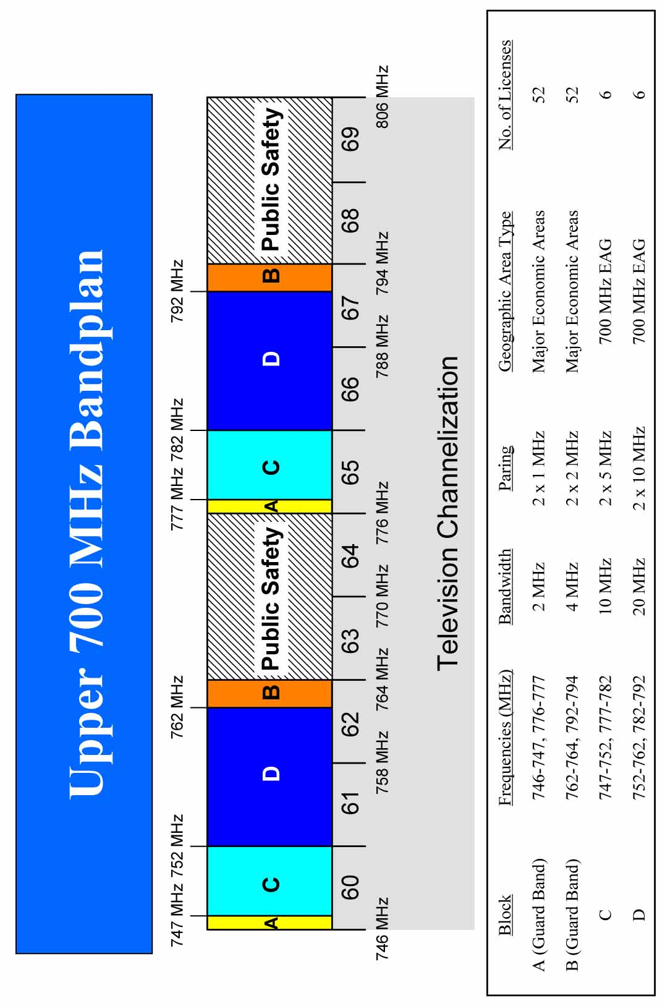

_____________

See FCC Media Bureau Docket No. 04-210, “Media Bureau Seeks Comment on Over-the-Air Broadcast Television Viewers”.
TIA is an American National Standards Institute (ANSI)-accredited Standards Development Organization.
cdma2000® is a registered trademark and certification mark of the Telecommunications Industry Association (TIA-USA).

