Project | IEEE 802.16 Broadband Wireless Access Working Group <http://ieee802.org/16>
Title | Small Cell Cross Industry Meeting Summary
Date Submitted | July 14, 2013
Source(s) | Ching-Tarng Hsish  Industrial Technology Research Institute (ITRI)  195,Sec. 4, Chung Hsing Rd.  Chutung, Hsinchu, Taiwan 310, R.O.C. | chsieh@itri.org.tw
Re: | [If this is a proposed revision, cite the original document.]  [If this is a response to a Call for Contributions, cite the name and date of the Call for Contributions to which this document responds, as well as the relevant item number in the Call for Contributions. Contributions that are not responsive to this section of the template, and contributions which do not address the topic under which they are submitted, may be refused or consigned to the “General Contributions” area.]
Abstract | This document is a summary of the Small Cell Cross Industry Meeting held in London on June 7, 2013.
Purpose | This contribution shares information about the Small Cell Cross Industry meeting organized by Small Cell Forum.
Notice | This document does not represent the agreed views of the IEEE 802.16 Working Group or any of its subgroups. It represents only the views of the participants listed in the “Source(s)” field above. It is offered as a basis for discussion. It is not binding on the contributor(s), who reserve(s) the right to add, amend or withdraw material contained herein.
Copyright Policy | The contributor is familiar with the IEEE-SA Copyright Policy <http://standards.ieee.org/IPR/copyrightpolicy.html>.
Patent Policy | The contributor is familiar with the IEEE-SA Patent Policy and Procedures:  <http://standards.ieee.org/guides/bylaws/sect6-7.html#6> and <http://standards.ieee.org/guides/opman/sect6.html#6.3>.  Further information is located at <http://standards.ieee.org/board/pat/pat-material.html> and <http://standards.ieee.org/board/pat>.

Introduction

The small cell cross industry meeting, which was organized by the Small Cell Forum, took place at Hilton London Metropole in London on June 7, 2013 immediately following the Small Cell World Summit 2013. There was an open plenary release plan workshop in the morning and the cross industry meeting was held in the afternoon.

Small Cell Forum Open Plenary Release Plan Workshop

The open plenary session shared SCF release plan with attendees of the Small Cell World Summit, members of the SCF, and industry partners. The topics include Small Cell Forum’s Release Program and working group updates. Gordon Mansfield, Chairman of SCF, gave opening remarks. He said that the scope of SCF did not change even though the name of the organization was changed from Femto Cell Forum to SCF. The newly created Backhaul SIG held its first meeting during the Small Cell World Summit 2013.

Caroline Gabriel of Maravedis gave an industrial perspective of small cells from an analyst point of view. She helped set the stage and led the discussions at the end of the session. The objectives of the meeting are describing scope of work of the SCF, highlighting release 1 and, engaging members and industry in release 2 and release 3 with the goal of creating a consensus among members of the releases. She analyzed mobile operator strategies on small cells. There is considerable progress and growth but challenges remain in achieving critical mass. The current focus is on a few cutting edge carriers. There are perceived challenges on standards, volumes, and architecture. Many carriers cautioned about risk level and business cases. Caroline thinks that we will see real volume in 2015-2016 and there will be more outdoor than indoor units. Most operators want to deal with small cell in a safer and standardized way. They don’t see enough effort on standards and they need best practices. Early adopters can be admired but not emulated.

SCF Release Plan

Simon Saunders, former chairman of Small Cell Forum, gave a presentation on SCF releases. SCF’s market segmentations include home, enterprise, urban, and rural. SCF releases are formulated according to these market segmentations. Release 1 on the Home segment was published in Barcelona at MWC 2013 last February. Release 2 on the Enterprise segment will be published in December 2013 and Release 3 on the Urban segment will be published in MWC 2014. Figure 1 depicts an overview of SCF releases.

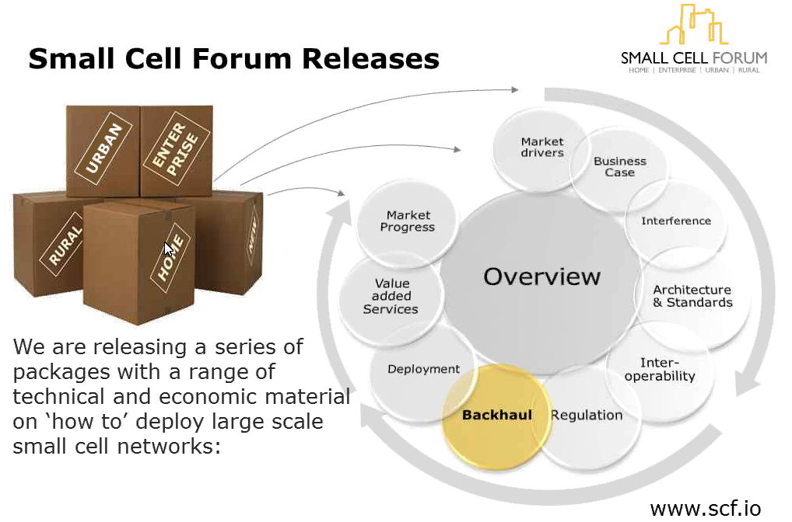
Figure 1. Small Cell Forum Releases

Simon described two challenges in coming up the release documents. The first one is finding the answers to members’ questions. He felt that SCF had answers to almost all the frequently asked questions. Forum insiders usually can find the answers quickly. But without support external parties found the material hard to locate. They need clear guidance and support to navigate the web and to be aware of the scope and scale of the SCF work. SCF addressed the first challenge by providing an easy-to-navigate web page and clearly articulated structure and contents with overview documents. Consistency and unified terms are essential for solving this problem.

The second challenge is to make the work meet the market needs. Simon mentioned that SCF was responding to rapidly changing market conditions. SCF took a top down/bottom up approach in dealing with the situation. The top down approach is a set of annual priorities published by the executive board as guidance for the working group. The bottom up approach is for the WGs and SIGs to initiate work items above and beyond the priorities set by the executive board. Simon feels that the SCF releases are industry best practices but the views from other industry bodies may be different in various ways. SCF discussed and shaped the release architecture with several industry bodies to keep the balance of technical and commercial activities. SCF tries to get members and partners buy-in to the whole release. There is a question whether it is time for a consumer focused information source.

In summary, Simon feels that the SCF release initiative provides a means to identify two major challenges across the diverse interest of the small cell community and the scope and breadth of the SCF work is impressive. It is quite an ambition to produce 3 releases in 13 months. Challenges remain in ensuring the work is fully represented and appreciated.

There were some discussions about the definition and differentiation of the 4 market segments. Even though operators want small cells their expectation might be different from that discussed in the meeting.

SCF is conducting a plugfest to test the interface between AP and the gateway. Currently the certification is done by other organizations such as OMA but is thinking about providing its own certification. There was discussion on the definition of market segmentation and the overlap among them. Operators are defining indoor coverage and indoor capacity. They don’t look at it from market segmentation point of view. In conclusion, Gordon thanked everybody for attending the SCF release workshop and participating in the discussion.

Small Cell Cross Industry Meeting

The afternoon session is a cross industry meeting attended by SCF officers, WG and SIG chairs, and representatives of invited industry organizations. About 15 people (see Figure 2) attended the meeting in person and 10 attended by conference call. A little more details about SCF plans for deliverables over the coming 12 months was presented. The industry meeting included SCF WG and SIG status report and sharing of small cell related work activities from invited industry organizations. The objective of the meeting is for SCF to better understand where the industry organizations can cooperate with in order to meet the needs of SCF members and the industry.

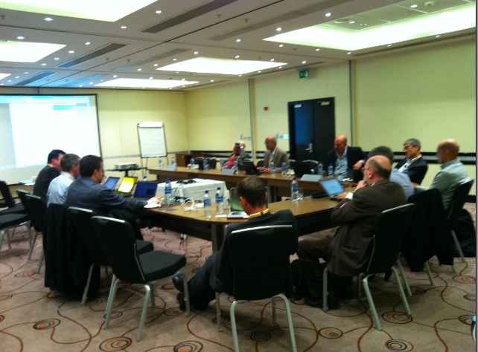

Figure 2. Small Cell Cross Industry Meeting.

SCF Working Group Status

SCF has 6 working groups and 4 SIGs including the recently initiated Backhaul SIG that held its first meeting on June 6 in London. Figure 3 shows all SCF WGs and SIGs.

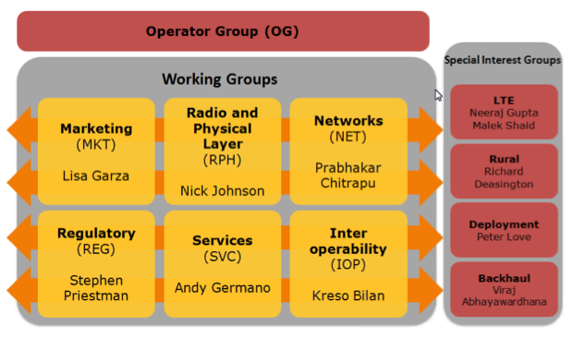
Figure 3. Small Cell Forum Groups.

The services WG is working on Enterprise, Metro Services, Connected Home (LIPA), LTE services, and API evolution. It will publish API's via the OMA liaison. The Rural SIG is working on LI implications of SIPTO to allow for optimization of data backhaul. SCF has issued a Backhaul White Paper. Its approach is to apply Use Cases to derive backhaul requirements and solutions. The approach of the SCF Backhaul SIG is to introduce use cases to derive requirements for backhaul including wired and wireless backhaul. They use the NGMN requirements for small cell as a basis. The SCF backhaul SIG will develop backhaul business case and address deployment issues. They also plan to investigate end-to-end transport network, e.g., SDN and Carrier Ethernet Standards for small cell backhaul. The SCF backhaul approach is similar to that of IEEE 802.16r and IEEE 802.16r will liaison with SCF Backhaul SIG on its Architecture and Requirements.

The Regulatory WG reported that the key principles are Licensing,
Interference & Safety concerns, Security, LBS applications, and impact of LTE cells. The group has been working with regulatory bodies of Japan, USA, Brazil, Thailand, etc. Release 1 contains an updated Regulatory White Paper. Release 2 will also refresh the Regulatory White Paper.

The Networking WG is currently working on E2E SCN architecture, Wi-Fi integration, multi-technology Small Cell Networks, Small Cell RAN & Core Network Interconnection Architecture, local signaling, Provisioning & OAM, and multi-operator SCN. The IOP SIG has conducted 3 plugfests in technology cities in France focusing on 3GPP Iuh and BBF TR-196. The fourth plugest is an LTE plugfest focusing on 3GPP S1 interface. The LTE SIG is working on Multi-technology Small Cell Networks White Paper, Enterprise LTE Services White Paper, and LTE Small Cell IOT Test Specifications. The deployment SIG will obtain consensus and create best practice pertaining to the deployment of scalable Small Cell Networks. Figure 4 shows the internal functioning and external relationships of the Networking WG.

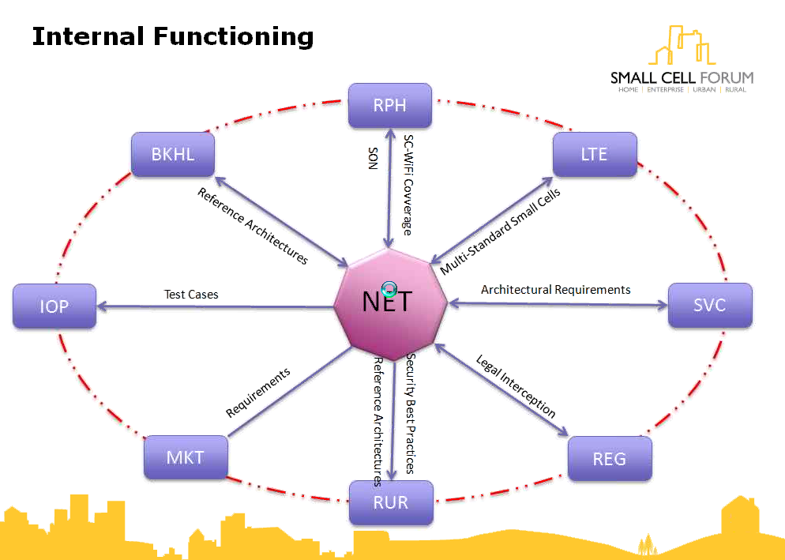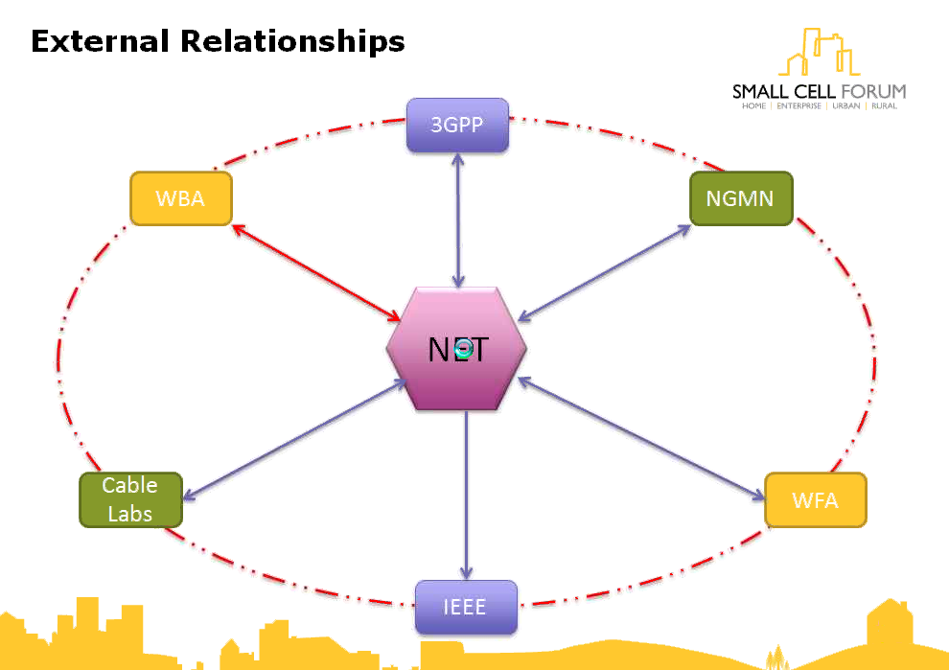

Figure 4. Internal functioning and external relationships of Networking WG.

The LTE SIG is working on Multi technology Small Cell Networks White Paper and the Enterprise LTE Services White Paper. The LTE SIG also plans to work on multi-vendor HetNet and specific challenges for small cell in carrier aggregation. The Deployment SIG started to scope activities for the SIG and plans to make the documents useful in small cell deployment and scalable in the release 2 timeframe.

Partners Presentation

The organizations participated in the cross industry meeting are Cable Labs, GVF, IWPC, MEF, NGMN, WMF, and BBF. Cable Labs is a consortium of cable operators. The representative of Cable Labs gave an oral description about its interest in small cell in which cable operators see opportunities. There is a variety of differences in regulation from region to region. How cable operators can help mobile operators by providing backhaul.

The representative from GVS reported that the new HTS (High Throughput Satellite) is more cost effective and can allocate capacity in an area more efficiently. The satellite industry is excited about the wireless trend in coordination with the SCF. GVF is working with SCF on regulatory matters and will also work with SCF on business models. The GVF representative described a high-speed and low-cost Satellite System O3b Networks, with support from Google, Liberty Global and HSBC, to provide communications access for billions of people worldwide. Small cell industry went to GVF several years ago. There could be synergy between small cell (or femto) and VSAT by leveraging small cell with satellite.

The HetNet Forum is dedicated to the advancement of heterogeneous wireless networks. The IWPC presentation was done by Dan Picker, SCWG (Small Cell and Backhaul Deployment and Reliability Working Group) chair and CTO of Purewave Networks. IWPC need to look at their areas that overlap with those of the SCF. Small cell is incompatible with traditional macro base stations. For example, how do we preserve network reliability with small cells. Operators join multiple industry organizations. They want the industry organizations to make it work.
The MEF presentation was done by Bill Rembert of AT&T. He described the Ethernet 2.0 Mobile Backhaul initiative and MEF 22.1 – The Mobile Backhaul Implementation Agreement. The next phase of the agreement will be documented in MEF 22.2. Carrier Ethernet provides consistent services delivered to users connected over a wide variety of access networks as shown in Figure 5. Carrier Ethernet is ideal for shared mobile backhaul and wireless/wire-line convergence.

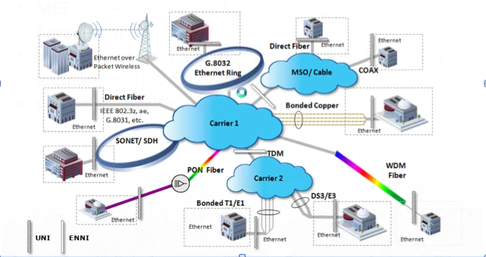

Figure 5. Carrier Ethernet over variety of access networks.

NGMN described areas of common interests including policy, ANDSF, integration with Wi-Fi, etc. They mentioned real Wi-Fi and small cell environment and LBS over Wi-Fi network. Integration with small cell and IP preservation between Wi-Fi and other technologies were mentioned.

The meeting was significantly delayed due to lengthy discussions at the beginning of the meeting. The Webex stopped working after a short break and had to switch to a voice only NSN bridge. Graham gracious offered to let me present WiMAX Forum’s small cell work. I described that WMF is investigating small cell backhaul issue at member request and is working on the topic with IEEE 802.16r. IEEE 802.16r already has liaison with several industry organizations and will expand liaison relationship to other organizations. Graham will get back to participating industry organizations on next steps.

Small Cell World Summit 2013 Exhibition

The Small Cell World Summit 2013 included an exhibition that showcase chipset, components, system, and applications. Companies participated in the exhibition include Intel, Qualcomm, NEC, Alcatel-Lucent, Cisco, ipaccess, Radisys, ZTE, Broadcom, Airspan, etc. Figure 6 is a glimpse of the exhibition floor.

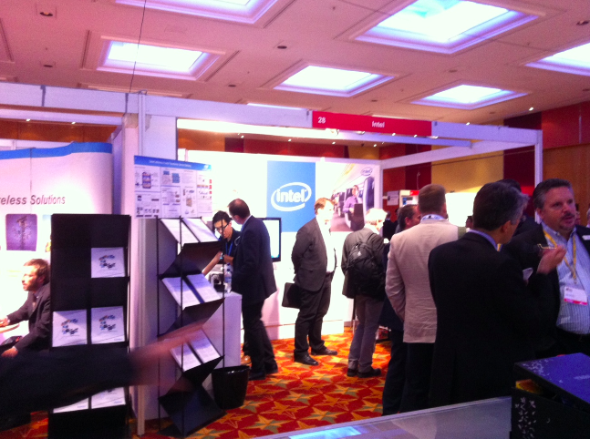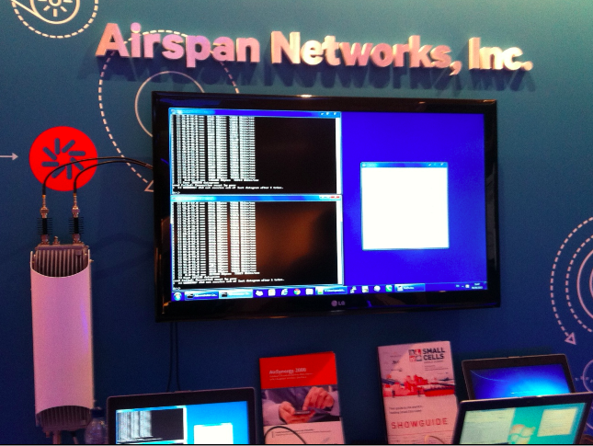

Figure 6. Small Cell World Summit 2013 Exhibition.

Conclusions

Small cell deployment involved many issues that require the collaboration of multiple industry organizations to present a complete solution to the operators and end users. The cross industry meeting was well received by the organizations attended the meeting. The CEO of SCF Gordon will distribute meeting material and follow up with participating industry organizations on next steps.

