Project | IEEE 802.16 Broadband Wireless Access Working Group <http://ieee802.org/16>
Title | Comment on procedure of multicast communication in IEEE 802.16n
Date Submitted | 2012-11-05
Source(s) | Eunkyung Kim, Jaesun Cha, Anseok Lee, Wooram Shin, Kwangjae Lim  ETRI | E-mail: ekkim@etri.re.kr  *<http://standards.ieee.org/faqs/affiliationFAQ.html>
Re: | In response to Sponsor Ballot Recirculation #1 on P802.16n
Abstract | Comment regarding procedure of multicast communication in GRIDMAN Draft Stnadard
Purpose | To discuss and adopt the proposed text in the draft amendment document on GRIDMAN
Notice | This document does not represent the agreed views of the IEEE 802.16 Working Group or any of its subgroups. It represents only the views of the participants listed in the “Source(s)” field above. It is offered as a basis for discussion. It is not binding on the contributor(s), who reserve(s) the right to add, amend or withdraw material contained herein.
Release | The contributor grants a free, irrevocable license to the IEEE to incorporate material contained in this contribution, and any modifications thereof, in the creation of an IEEE Standards publication; to copyright in the IEEE’s name any IEEE Standards publication even though it may include portions of this contribution; and at the IEEE’s sole discretion to permit others to reproduce in whole or in part the resulting IEEE Standards publication. The contributor also acknowledges and accepts that this contribution may be made public by IEEE 802.16.
Patent Policy | The contributor is familiar with the IEEE-SA Patent Policy and Procedures:  <http://standards.ieee.org/guides/bylaws/sect6-7.html#6> and <http://standards.ieee.org/guides/opman/sect6.html#6.3>.  Further information is located at <http://standards.ieee.org/board/pat/pat-material.html> and <http://standards.ieee.org/board/pat>.

Comment on the procedure of multicast communication in IEEE 802.16n
Eunkyung Kim, Jaesun Cha, Anseok Lee, Wooram Shin, Kwangjae Lim
ETRI

Instructions
According to the IEEE 802.16n, procedure of multicast communication is provided with Figure 16-7. However, it does not include proper arrow. Thus, Figre 16-7 shall be re-drawn properly.

References
- IEEE P802.16TM-2012, IEEE Standard for Air Interface for Broadband Wireless Access Systems, August 2012.
- IEEE P802.16nTM/D6, Air Interface for Broadband Wireless Access Systems - Draft Amendment: Higher Reliability Networks, November 2012.

Proposed Text on IEEE 802.16n Amendment Draft Standard
[-------------------------------------Start of Text Proposal---------------------------------------------------]
[Remedy: Change Figure 16-7 (line#1-line#35, page 115) as follows:]

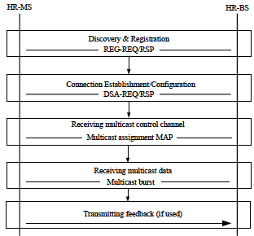
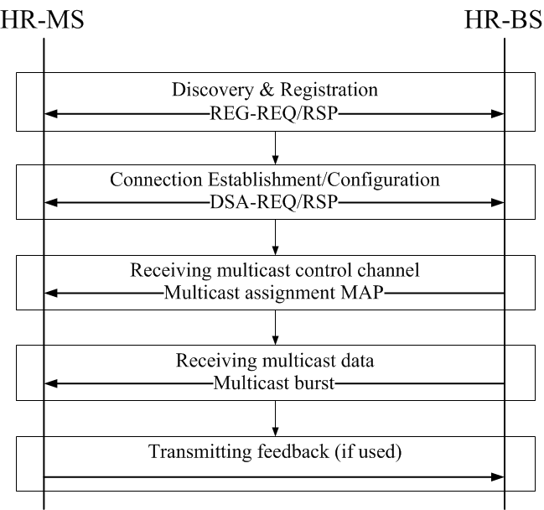

Figure 16-7 – Procedure of multicast communication establishment
[-------------------------------------End of Text Proposal---------------------------------------------------]

