Project | IEEE 802.16 Broadband Wireless Access Working Group <http://ieee802.org/16>
Title | Comments on the Consolidated System Requirements on P802.16q
Date Submitted | 2012-11-07
Source(s) | Jaesun Cha, Eunkyung Kim, Anseok Lee, Wooram Shin, Kwangjae Lim  ETRI | E-mail: jscha@etri.re.kr  *<http://standards.ieee.org/faqs/affiliationFAQ.html>
Re: | Multi-tier Networks Call for Contributions (16-12-0617-00-Shet)
Abstract | Comments on IEEE 802.16-12-0615-01-000q (Consolidated Proposed Text towards an Initial Draft System Requirements on IEEE 802.16q Multi-tier Networks)
Purpose | To discuss and adopt the proposed text in a new consolidated draft System Requirement Document (SRD) on IEEE P802.16q Multi-tier Networks
Notice | This document does not represent the agreed views of the IEEE 802.16 Working Group or any of its subgroups. It represents only the views of the participants listed in the “Source(s)” field above. It is offered as a basis for discussion. It is not binding on the contributor(s), who reserve(s) the right to add, amend or withdraw material contained herein.
Release | The contributor grants a free, irrevocable license to the IEEE to incorporate material contained in this contribution, and any modifications thereof, in the creation of an IEEE Standards publication; to copyright in the IEEE’s name any IEEE Standards publication even though it may include portions of this contribution; and at the IEEE’s sole discretion to permit others to reproduce in whole or in part the resulting IEEE Standards publication. The contributor also acknowledges and accepts that this contribution may be made public by IEEE 802.16.
Patent Policy | The contributor is familiar with the IEEE-SA Patent Policy and Procedures:  <http://standards.ieee.org/guides/bylaws/sect6-7.html#6> and <http://standards.ieee.org/guides/opman/sect6.html#6.3>.  Further information is located at <http://standards.ieee.org/board/pat/pat-material.html> and <http://standards.ieee.org/board/pat>.

Comments on the Consolidated System Requirements
Jaesun Cha, Eunkyung Kim, Anseok Lee, Wooram Shin, Kwangjae Lim
ETRI

Proposed Texts

----------------- Start of the text proposal --------------------------------------------------------------------------------------
The 802.16q amendment shall be developed in accordance with the P802.16q project authorization request (PAR) with its accompanying Five Criteria Statement[1]. The scope of the resulting project shall be as follows:

“This amendment specifies MAC/PHY protocol enhancements for cooperation among base stations in multi-tier networks to enhance interference mitigation, mobility management, and base station power management. Enhanced base stations shall support legacy mobile stations. PHY changes to any mobile stations are out of scope. In addition, these protocol enhancements include management messaging between base stations, and between base stations and mobile stations. This amendment shall comply with IEEE Std 802, IEEE Std 802.1D, and IEEE Std 802.1Q.”

This document represents the high-level system architecture functional structure and requirements for the 802.16q amendment. All contents included in any draft of the 802.16q amendment shall meet these requirements. This document, however, shall be maintained and may evolve. These system requirements embodied herein are defined to ensure competitiveness of the amended standard against other mobile broadband radio access technologies in those areas defined by the PAR and Five Criteria Statement. These system requirements also call for significant gains and improvements relative to the preexisting IEEE 802.16 system that would justify the creation of the amendment. To accelerate the completion and evaluation of the standard, to improve the clarity and reduce complexity of the standard specification, and to further facilitate the deployment of new systems, the number of optional features should be minimized.

References
- IEEE 802.16-12-0394-0506-Gdoc, PAR and Five CriterisCriteria for P802.16q on a Multi-tier (Amendment to IEEE Std 802.16 for Multi-tier Networks), July 2012.
- IEEE 802.16-12-0136-00-Gdoc, Hierarchical Network Study Report, January 2012.

Definitions
Multi-tier Network (MN) | A network of small base statios controlled by either macro base stations or an ASN gateway, where the cell coverage of the small base stations is within the interference range of at least one macro base station. A network comprising base stations of varying cell coverage and roles, from small base stations to macro base stations. The multi-tier network is typically controlled by the same operator.
Macro base station | A base station that may control small base stations that provides connectivity, management, and control of the mobile station, compliant with the IEEE 802.16 WirelessMAN OFDMA specification specified by IEEE 802.16-2012 and amended by IEEE 802.16q.
Small base station | A base station controlled by at least one macro base station or an ASN gateway, with smaller transmission power/cell size than that of the macro base station.

Abbreviations and Acronyms
ASN | access service network
MN | Multi-tier Network
BS | base station
MIMO | multiple input multiple output
MS | mobile station

General Requirement

Compatibility with other 802.16 equipment
IEEE 802.16q shall support provide continuing support and interoperability for WirelessMAN equipment, including MSs and BSs.

Complexity
IEEE 802.16q provides IEEE Std 802.16 medium access control (MAC) enhancements and PHY modifications to provide functionalities for Multi-tier Network, but PHY modifications of mobile stations is not included.

802.16q Protocol and Functional Structure
Figure 1 shows the functional entities within the protocol structure defined in IEEE Std 802.16-2012 and amended by IEEE 802.16q (Note: The MS may not utilize all the blocks shown in Figure 1)
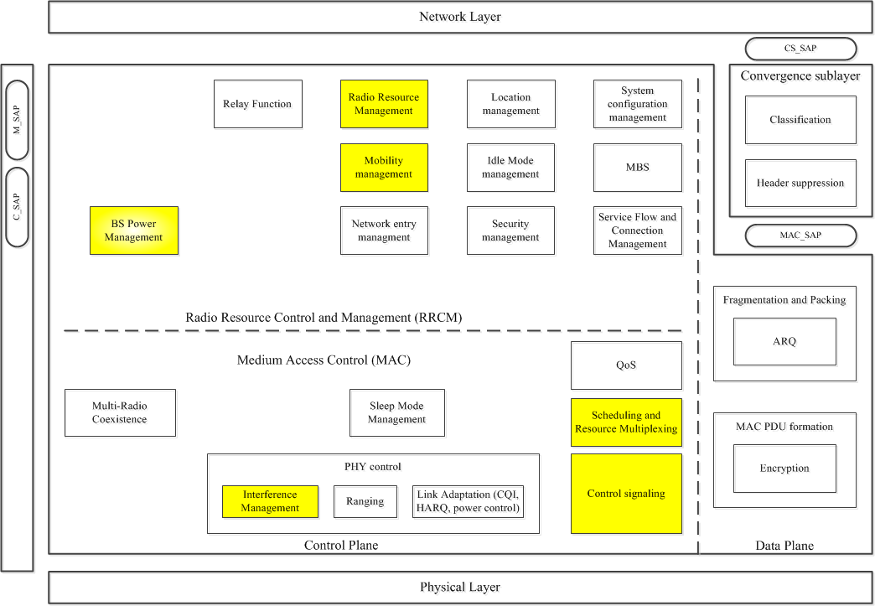
Figure 1 – IEEE 802.16q Functional decompositions within the Protocol Structure
In order to support the IEEE 802.16q Multi-tier Network operations, following functions shall be enhanced.
- Radio Resource Management
- Mobility management
- Interference Management
- Scheduling and Resource Multiplexing
- Control Signaling
In order to support the IEEE 802.16q Multi-tier Network operations, following function shall be included over existing IEEE 802.16 protocol.
- BS Power Management

“Radio resource management” and “Scheduling and resource multiplexing” are the functions that help to utilize the resources in views of time/frequency/space/power allocation and help to mitigate the interference and/or coordinate transmission among base stations of multi-tiers.
“Mobility management” function assists MS to search for the cells not in the advertized or configured neighboring list without significant searching overhead.
“Interference management” function controls severe inter-cell interference in the present of multiple cells in a multi-tier network and enhances the user throughput.
“Control signal” may be enhanced to support DL/ULdownlink control and uplink control and measurement feedback handling used by base stations of multi-tiers.
“BS Power management” is a fuction that supports energy saving of base stations by cooperation among base stations of mulit-tiers of adjacent base stations.

Functional Requirement
This section provides requirements related to features in Multi-tier Networks, which are in accordance with included in the scope of 802.16q PAR[1].

Interference Management in Multi-tier Networks

The 802.16q system shall support interference management by coordination and cooperation among BSs for multi-tier networks.

The 802.16q system shall provide mechanisms for coordinated resource (time, frequency, power) management to mitigate inter-cell interference between macro cells, between small cells, and between macro cells and small cells.

The 802.16q system shall provide mechanisms for resource(time, frequency) multiplexing, which limits reuse of resource by overlaying/adjacent cells and exclusively dedicates resource to a specific cell among overlaying/adjacent cells.

The 802.16q system shall provide mechanisms for fractional frequency reuse (FFR) with support of varied settings on the number of frequency partition, size of each partition, and (maximum) power of each partition.

The 802.16q system shall provide mechanisms for dynamic coordinated scheduling to alleviate small-scale interference variation.

The 802.16q system shall provide mechanisms for downlink transmit power setting/control of small BS to suppress interference to MSs connected to overlaid/adjacent cells.

The 802.16q system shall provide mechanisms for uplink power control of MSs to suppress interference to BSs in overlaid/adjacent cells.

The 802.16q system shall provide mechanisms for cooperative transmission by multiple macro BSs, by multiple small BSs, or by macro BS(s) and small BS(s) to enhance cell-edge performance such as cell-edge throughput and client quality of service (QoS) (e.g., coordinated beamforming, collaborative MIMO).

The 802.16q system shall provide mechanisms for synchronization of frames operated by a macro BS and its overlaid small BS(s) to prevent from being impaired by inter-symbol/carrier interference.

The 802.16q system shall provide mechanisms for inter-cell interference channel measurement and report to support interference management with coordination and cooperation among BSs.

The 802.16q system shall provide mechanisms for management information exchange among BSs to support interference management with coordination and cooperation among BSs.

Mobility Management in Multi-tier Networks

Efficient cell discovery shall be supported

Efficient detection of cell ID, cell type and subscription type shall be supported.

Energy efficient and optimized cell search for neighboring small cells on different frequencies shall be supported.

Energy efficient and optimized cell search for neighboring small cells not broadcast by a Macro cell shall be supported.

Efficient cell selection/reselection to a preferred type of cells shall be supported.

Cell selection/reselection based on various factors shall be supported. (e.g., cell type preference, cell load, mobility of a mobile station, etc)

Cell selection/reselection shall differentiate triggering conditions for each cell type

Base Station Power Management

The 802.16q system shall support cooperation of adjacent base stations for energy saving of base stations.

The 802.16q system shall support mangement information exchange among adjacent base stations for power saving.

The 802.16q system shall support coordinated association of users for power saving operation of base stations

The 802.16q system shall support additional operation mode of base stations for power saving of base stations.

The 802 .16q system shall support additional operational mode with minimum impact on operations of mobile stations.

The 802 .16q system shall support duty-cycled operation of base stations.

The 802 .16q system shall support transition to/from inactive period in duty-cycled operation, triggered by adjacent BSs.

The 802.16q system shall support adaptive configuration of power saving operation according to various metric (e.g. number of users).

MIMO support in Multi-tier Networks

This section provides requirements for supporting MIMO in the link between a macro BS and a small BS in multi-tier networks.

MIMO support through integrated antennas in a small BS

The 802.16q system shall support MIMO with integrated antennas in a small BS. For the macro BS and the small BS, minimum [TBD] number of transmit and [TBD] number of receive antennas shall be supported.

Antennas in a small BS shall be integrated with low inter-antenna interference.

Integrated antennas shall support MIMO or beamforming/pre-coding operation.

A small BS shall support antenna selection operation with low complexity.

----------------- End of the text proposal ---------------------------------------------------------------------------------------

