Project | IEEE 802.16 Broadband Wireless Access Working Group <http://ieee802.org/16>
Title | Overall System Requirements on IEEE 802.16q Multi-tier Networks
Date Submitted | 2012-09-12
Source(s) | Eunkyung Kim, Jaesun Cha, Anseok Lee, Wooram Shin, Kwangjae Lim  ETRI | E-mail: ekkim@etri.re.kr  *<http://standards.ieee.org/faqs/affiliationFAQ.html>
Re: | “IEEE 802.16-12-0507-02-Shet,” in response to Call for Contributions: Multi-Tier Networks IEEE 802.16 Working Group on System Requirmeent of Multi-tier Networks
Abstract | Proposal regarding System Requirement on Multi-tier Networks, focusing on ToC and general requirement
Purpose | To discuss and adopt the proposed text in the System Requirement Document (SRD) on IEEE P802.16q Multi-tier Networks
Notice | This document does not represent the agreed views of the IEEE 802.16 Working Group or any of its subgroups. It represents only the views of the participants listed in the “Source(s)” field above. It is offered as a basis for discussion. It is not binding on the contributor(s), who reserve(s) the right to add, amend or withdraw material contained herein.
Release | The contributor grants a free, irrevocable license to the IEEE to incorporate material contained in this contribution, and any modifications thereof, in the creation of an IEEE Standards publication; to copyright in the IEEE’s name any IEEE Standards publication even though it may include portions of this contribution; and at the IEEE’s sole discretion to permit others to reproduce in whole or in part the resulting IEEE Standards publication. The contributor also acknowledges and accepts that this contribution may be made public by IEEE 802.16.
Patent Policy | The contributor is familiar with the IEEE-SA Patent Policy and Procedures:  <http://standards.ieee.org/guides/bylaws/sect6-7.html#6> and <http://standards.ieee.org/guides/opman/sect6.html#6.3>.  Further information is located at <http://standards.ieee.org/board/pat/pat-material.html> and <http://standards.ieee.org/board/pat>.

Overall System Requirments on IEEE 802.16q Multi-tier Networks
Eunkyung Kim, Jaesun Cha, Anseok Lee, Wooram Shin, Kwangjae Lim
ETRI

Instructions
According to the IEEE 802.16q PAR and 5 Crieteria[1] and the study report of Hierarchical Network by IEEE 802.16 PPC[2], multi-tier network is promised as a main approch to further improve network capacity and efficiently manage radio resource. Multi-tier access network architecture consisting of macrocells and a variety of overlaid smaller cells also allows low cost per bit and efficiently utilizing all spectral resources in the system.
To achieve the enhancement to network capacity and efficient management radio resources in multi-tier access network, the main issues to be required in multi-tier access network include:
- interference mitigation between macro cells and small cells, and between small cells (see details in [5])
- mobility mangement (see details in [3])
- base station power management (see details in [4])
Herein, we propose the SRD structure and contents to be considered as general requirements and technical requirements for IEEE 802.16q project.

Proposed ToC on SRD of IEEE 802.16q

- Overview
- References
- Definitions
- Abbreviations and Acronyms
- General Requirement
  - Compatibility with other 802.16 equipment
  - Complixity
  - 802.16q Protocl and Functional Structure
- Functional Requirement
[Note: Detailed text is not provided in this document]
  - Interference Mitigation in Multi-tier Networks
  - Mobility Management in Multi-tier Networks
  - Base Station Power Management

References
- IEEE 802.16-12-0394-05-Gdoc, Approved PAR and Five Criteris for P802.16q on a Multi-tier Amendment to IEEE Std 802.16, July 2012.
- IEEE 802.16-12-0136-00-Gdoc, Hierarchical Network Study Report, January 2012.
- 16-12-0531-00-000q, Proposed System Requirements on Mobility Management, September 2012.
- 16-12-0533-00-000q, Proposed System Requirements on Base Station Power Management for IEEE 802.16q Networks, September 2012.
- 16-12-0534-00-000q, System Requirements on Interference Management for IEEE 802.16q Multi-tier Networks, September 2012.

Proposed Text on SRD of IEEE 802.16q
[-------------------------------------Start of Text Proposal---------------------------------------------------]

Overview
The 802.16q amendment shall be developed in accordane with the P802.16q project authorization request (PAR) with its accompanying Five Criteria Statement[1]. The scope of the resulting project shall be as follows:

“This amendment specifies MAC/PHY protocol enhancements for cooperation among base stations in multi-tier networks to enhance interference mitigation, mobility management, and base station power management. Enhanced base stations shall support legacy mobile stations. PHY changes to any mobile stations are out of scope. In addition, these protocol enhancements include management messaging between base stations, and between base stations and mobile stations. This amendment shall comply with IEEE Std 802, IEEE Std 802.1D, and IEEE Std 802.1Q.”

This document represents the high-level system architecture and requirements for the 802.16q amendment. All contents included in any draft of the 802.16q amendment shall meet these requirements. This document, however, shall be maintained and may evolve. These system requirements embodied herein are defined to ensure competitiveness of the amended standard against other mobile broadband radio access technologies in those areas defined by the PAR and Five Criteria Statement. These system requirements also call for significant gains and improvements relative to the preexisting IEEE 802.16 system that would justify the creation of the amendment. To accelerate the completion and evaluation of the standard, to improve the clarity and reduce complexity of the standard specification, and to further facilitate the deployment of new systems, the number of optional features should be minimized.

References
- IEEE 802.16-12-0394-05-Gdoc, PAR and Five Criteris for P802.16q on a Multi-tier Amendment to IEEE Std 802.16, July 2012.
- IEEE 802.16-12-0136-00-Gdoc, Hierarchical Network Study Report, January 2012.

Definitions
Multi-tier Network (MN) | A network compliant with wireless Metropolitan Area Network (MAN) comprised of macro cells, micro cells, pico cells, and femto cells, typically controlled by the same operator.
Small base station | A base station with smaller transmission power/cell size than that of macro base station, including micro, pico, and femto base stations.
Enhanced small base station | A small base station implementing the functionality defined in IEEE 802.16q.

Abbreviations and Acronyms
MN | Multi-tier Network

General Requirement

Compatibility with other 802.16 equipment
IEEE 802.16q Multi-tier Network shall support provide continuing support and interoperability for WirelessMAN-OFDMA equipment, including MSs and BSs.

Complexity
IEEE 802.16q provides IEEE Std 802.16 medium access control (MAC) enhancements and OFDMA PHY modifications to provide functionalities for Multi-tier Network, but PHY modifications of mobile stations is not included.

802.16q Protocol and Functional Structure
Figure 1 shows the functional entities within the protocol structure of the IEEE 802.16q Multi-tier Networks.
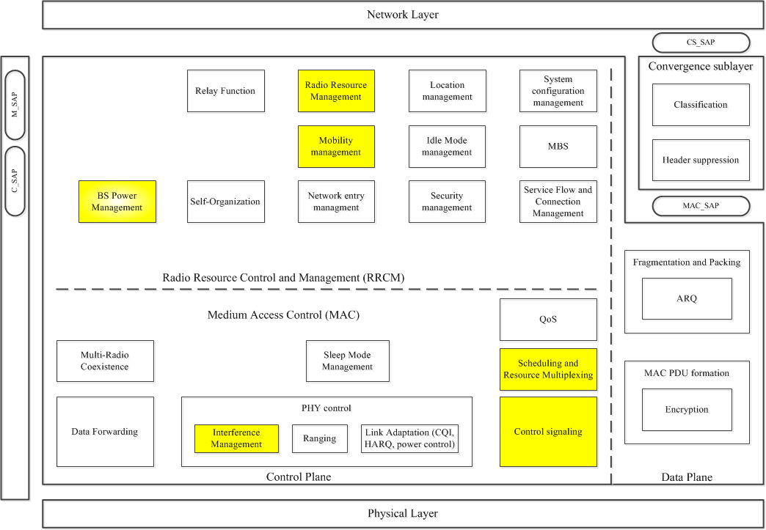
Figure 1 – IEEE 802.16q Functional decompositions withing the Protocol Structure
In order to support the IEEE 802.16q Multi-tier Network operations, following functions shall be enhanced.
- Radio Resource Management
- Mobility management
- Interference Management
- Scheduling and Resource Multiplexing
- Control Signaling
In order to support the IEEE 802.16q Multi-tier Network operations, following function shall be included over existing IEEE 802.16 protocol.
- BS Power Management

“Radio resource management” and “Scheduling and resource multiplexing” are the functions that help to utilize the resources in views of time/frequency/space/power allocation and help to mitigate the interference and/or coordinate transmission among multi-tiers.
“Mobility management” function assists MS to search for the cells not in the advertized or configured neighboring list without significant searching overhead.
“Interference management” function controls severe inter-cell interference in the present of multiple cells in a multi-tier network and enhances the user throughput.
“Control signal” may be enhanced to support downlink control and uplink control and measurement feedback handling used by multi-tiers.
“BS Power management” is a fuction that supports energy saving of base stations by cooperation of adjacent base stations.

Functional Requirement
This section provides requirements related to features in Multi-tiner Networks, which are included in the scope of 802.16q PAR[1].

Interference Mitigation in Multi-tier Networks

Mobility Management in Multi-tier Networks

Base Station Power Management

[-------------------------------------End of Text Proposal---------------------------------------------------]

