Project | IEEE 802.16 Broadband Wireless Access Working Group <http://ieee802.org/16>
Title | Number of ACID in Multicarrier
Date Submitted | 2012-3-13
Source(s) | Zheng Yan-Xiu,  Maintenance Task Group | zhengyanxiu@itri.org.tw
Re: | IEEE 802.16-12-0218-00-WGLS, Liaison Statement to IEEE 802.16 WG on modifications to the IEEE Std 802.16 needed to support WiMAX certification.
Abstract | Changes are provided to accommodate Number of ACID in Multicarrier
Purpose | As basis of maintenance data base for IEEE 802.16.1
Notice | This document does not represent the agreed views of the IEEE 802.16 Working Group or any of its subgroups. It represents only the views of the participants listed in the “Source(s)” field above. It is offered as a basis for discussion. It is not binding on the contributor(s), who reserve(s) the right to add, amend or withdraw material contained herein.
Release | The contributor grants a free, irrevocable license to the IEEE to incorporate material contained in this contribution, and any modifications thereof, in the creation of an IEEE Standards publication; to copyright in the IEEE’s name any IEEE Standards publication even though it may include portions of this contribution; and at the IEEE’s sole discretion to permit others to reproduce in whole or in part the resulting IEEE Standards publication. The contributor also acknowledges and accepts that this contribution may be made public by IEEE 802.16.
Patent Policy | The contributor is familiar with the IEEE-SA Patent Policy and Procedures:  <http://standards.ieee.org/guides/bylaws/sect6-7.html#6> and <http://standards.ieee.org/guides/opman/sect6.html#6.3>.  Further information is located at <http://standards.ieee.org/board/pat/pat-material.html> and <http://standards.ieee.org/board/pat>.
Number of ACID in Multicarrier
Zheng Yan-Xiu
Maintenance Task Group

Introduction
This contribution is intended to incorporate changes agreed based on the liaison IEEE 802.16-12-0218-00-WGLS.

Due to the feedback delay in TDD mode, RTT(round trip time) is increased in some subframes.
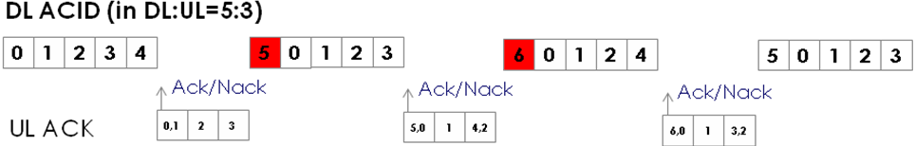
When it comes to DL:UL=6:2, 10 ACIDs are required in DL as follows.

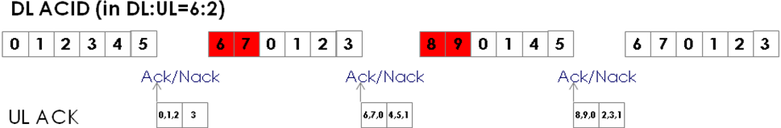
W

In general, 16m systems operate with two LRU types such as DLRU and CLRU for control and traffic channels. In order to maximize throughout, it needs to allocate bursts in both DLRU and CLRU. If two burst are allocated in every DL subframe, at least 14 ACIDs are required in case of DL:UL=5:3.
For an AMS operating over carriers with sum of FFT size that is 2048 subcarriers or less, in DL or UL, the maximum number of total HARQ channel per AMS is 16. In multicarrier mode, at least two bursts per carrier need to be allocated in every DL subframe to maximize throughput. Hence, the required number of ACIDs is increased in twice in multicarrier mode than in single carrier mode. If number of ACID in system is less than the required number of ACID, DL throughput will be decreased. Following Table shows DL throughput between in 10MHz single carrier and in 10MHz carrier of multicarrier.
 | 10MHz BW  (40 SLRU,  8 DLSRU) | 10MHz (in 10+10 MHz MC)  (40 SLRU,  8 DLSRU  per 10MHz) | 10MHz BW  (36 SLRU,  12 DLSRU) | 10MHz (in 10+10 MHz MC)  (36 SLRU,  12 DLSRU  per 10MHz) | 10MHz BW  (32 SLRU,  16 DLSRU) | 10MHz (in 10+10 MHz MC)  (32 SLRU,  16 DLSRU  per 10MHz)
DL:UL=5:3 | 76.2 Mbps | 73.1 Mbps | 66.3 Mbps | 59.6 Mbps | 65.5 Mbps | 55.1 Mbps
DL:UL=6:2 | 93.0 Mbps | 76.8 Mbps | 78.5 Mbps | 61.5 Mbps | 75.7 Mbps | 57.0 Mbps

In order to maximize throughput in multicarrier, the maximum number of HARQ channel per AMS needs to be 16 in a carrier. For an AMS operating over carrier, the maximum number of total HARQ channel per AMS needs to be increased with number of used carriers as (16 x number of used carrier).

Proposed Text
[Adopt the following change in line 35 on page 437 in section 6.2.14.2.1.1 in IEEE P802.16.1/D4:]

<insert>The maximum number of HARQ channels per AMS in a carrier, in DL, is 16. For an AMS operating over carriers in DL, the maximum number of total HARQ channels per AMS, N_{DL_HARQ_CH}, is (16 × number of used carriers). If the i-th physical carrier is assigned to an AMS, the ACID in the physical carrier index i is calculated as (16 × i + n) mod N_{DL_HARQ_CH}, where n is the 4-bit ACID value signaled in DL assignment A-MAP IE, and i is indexed from 0 to i.</insert>
<delete>For an AMS operating over carriers with a sum of FFT sizes that is 2048 subcarriers or less, in DL, the maximum number of total HARQ channels per AMS is 16. For an AMS operating over carriers with the sum of FFT sizes that is larger than 2048 subcarriers, in DL, the maximum number of total HARQ channels per AMS, N_{DL_HARQ_CH}, is floor(16 × sum of FFT sizes of all used carriers / 2048). If the i-th physical carrier is assigned to an AMS, the ACID in the physical carrier index i is calculated as (16 × ri + n) mod N_{DL_HARQ_CH}, where n is the 4-bit ACID value signaled in DL assignment A-MAP IE, and ri = ceil(Si / 2048) – 1. Si is the sum of FFT sizes of active carriers that are assigned to an AMS among the carriers indexed from 0 to i.</delete>

[Adopt the following change in line 17 on page 438 in section 6.2.14.2.1.2 in IEEE P802.16.1/D4:]

<insert>The maximum number of HARQ channels per AMS in a carrier, in UL, is 16. For an AMS operating over carriers in UL, the maximum number of total HARQ channels per AMS, N_{UL_HARQ_CH}, is (16 × number of used carriers). If the i-th physical carrier is assigned to an AMS, the ACID in the physical carrier index i is calculated as (16 × i + n) mod N_{UL_HARQ_CH}, where n is the 4-bit ACID value signaled in UL assignment A-MAP IE, and i is indexed from 0 to i.</insert>
<delete>For an AMS operating over carriers with a sum of FFT sizes that is 2048 subcarriers or less, in UL, the maximum number of total HARQ channels per AMS is 16. For an AMS operating over carriers with a sum of FFT sizes that is larger than 2048 subcarriers, in UL, the maximum number of total HARQ channels per AMS, NUL_HARQ_CH, is floor(16 × sum of FFT sizes of all used carrier / 2048). If the i-th physical carrier is assigned to an AMS, the ACID in the physical carrier index i is calculated as (16 × ri + n) mod NUL_HARQ_CH, where n is the 4-bit ACID value signaled in DL assignment A-MAP IE, and ri = ceil(Si / 2048) – 1. Si is the sum of FFT sizes of active carriers that are assigned to an AMS among the carriers indexed from 0 to i.</delete>

