Project | IEEE 802.16 Broadband Wireless Access Working Group <http://ieee802.org/16>
Title | Text Proposal for MAC-layer Support for BS-controlled HR-MS FTN in 802.16.1a
Date Submitted | 2012-01-09
Source(s) | Anh Tuan Hoang, Haiguang Wang, Jaya Shankar, Wai Leong Yeow,  Shoukang Zheng, Joseph Teo Chee Ming  Institute for Infocomm Research  1 Fusionopolis Way, #21-01, Connexis (South Tower)  Singapore 138632  Eldad Zeira  InterDigital | Voice: +65 6408-2271  E-mail: athoang@i2r.a-star.edu.sg
Re: | In response to the 802.16n (GRIDMAN) Call for Comments to 802.16.1a AWD in 802.16n-11/0033
Abstract
Purpose | To discuss and adopt the proposed text in the 802.16.1a AWD
Notice | This document does not represent the agreed views of the IEEE 802.16 Working Group or any of its subgroups. It represents only the views of the participants listed in the “Source(s)” field above. It is offered as a basis for discussion. It is not binding on the contributor(s), who reserve(s) the right to add, amend or withdraw material contained herein.
Copyright Policy | The contributor is familiar with the IEEE-SA Copyright Policy <http://standards.ieee.org/IPR/copyrightpolicy.html>.
Patent Policy | The contributor is familiar with the IEEE-SA Patent Policy and Procedures:  <http://standards.ieee.org/guides/bylaws/sect6-7.html#6> and <http://standards.ieee.org/guides/opman/sect6.html#6.3>.  Further information is located at <http://standards.ieee.org/board/pat/pat-material.html> and <http://standards.ieee.org/board/pat>.

Text Proposal for MAC-layer Support for BS-controlled HR-MS FTN in 802.16.1a

Anh Tuan Hoang, Wai Leong Yeow, Haiguang Wang, Jaya Shankar,
Shoukang Zheng, Joseph Teo Chee Ming
Institute for Infocomm Research (I2R)

Introduction
In the current AWD, the operation of BS-controlled HR-MS FTN has been specified. In this contribution, we further provide details on MAC-layer support for the FTN operation. Particularly, we focus on:
- HARQ operation involving forwarding HR-MS;

References
- IEEE 802.16.1a Amendment Working Draft, IEEE 802.16n-11/0033.

Text Proposal for the 802.16n Amendment Working Document (AWD)
Note:
The text in BLACK color: the existing text in the 802.16n Amendment Draft Standard
The text in YELLOW-HIGHLIGHTED RED color: the removal of existing 802.16n Amendment Draft Standard Text
The text in YELLOW-HIGHLIGHTED BLUE color: the new text added to the 802.16n Amendment Draft Standard Text

[-----------------------------------------------Start of Text Proposal---------------------------------------------------]
{Remedy 1: Modify Section 6.12.3.2.1 as indicated}

6.12.3.2 BS-controlled HR-MF forwarding to network

The general operation of BS-controlled HR-MS forwarding to network (FTN) can be described as follows:
- At the beginning of the process, the serving HR-BS/RS instructs one or a group of its associated HR-MS to broadcast discoverable signals so that an out-of-coverage HR-MS can start network entry and get associated to the HR-BS/RS. This is described in 6.12.3.2.1.1.
- After the out-of-coverage HR-MS has completed network entry and become an attached forwarded HR-MS, the forwarding HR-MS helps forward control and data messages between the forwarded HR-MS and the serving HR-BS/RS. MAC-layer support for this process is described in 6.12.3.2.1 while PHY-layer support for this is described in 6.12.3.2.2.

6.12.3.2.1 Medium access control

6.12.3.2.1.1 Network entry involving forwarding HR-MS

For an HR-MS that is inside-of-coverage of an HR-BS/RS, the network entry process is as described in 6.2.15 and 6.6.2.10.

For an HR-MS that is out-of-coverage of any HR-BS/RS but within reach of a forwarding HR-MS, the process of network entry can be described as follows.

To enable coverage extension, a serving HR-BS/HR-RS shall schedule some of its directly-associated HR-MSs to transmit PA/SA-Preamble signals so that an outside-of-coverage HR-MS can detect and start network entry.
Any new HR-MS scanning for DL preambles for possible network entry shall be able to differentiate between preambles transmitted by normal infrastructure stations (HR-BS/HR-RS) and those transmitted by a coverage-extending HR-MS. For that, the last [TBD] SA-Preamble sequences in each segment are reserved for transmission by coverage-extending HR-MS.

The HR-BS may instruct HR-MS that are associated with it to transmit network configuration information (NCI) at pre-defined resources relative to the preambles transmitted by the HR-MS. The NCI, when transmitted, defines resources for access by the HR-MS that is not under HR-BS coverage. This corresponds to the coverage extension procedure defined in 6.12.3.2.1.1.1. If NCI is omitted then access resources are defined by the index and the sub-carrier set index of the SA-Preamble. This corresponds to the coverage extension procedure defined in 6.12.3.2.1.1.2.

6.12.3.2.1.1.1 Coverage Extension with NCI Preceding Initial Ranging
The procedure starts when serving HR-BS/RS transmits an AAI-FN-CONFIG-CMD message to instruct one or a group of its directly-associated HR-MS to carry out a coverage-extending process. The format of AAI-FN-CONFIG-CMD message is defined in Table 780763fn1 and includes , among other fields, the following information:

- Idx and nIDCell corresponding to the SA-Preamble the index of the SA-Preamble and index of SA-Preamble carrier set, respectively, to be transmitted by the scheduled HR-MS (or group of HR-MS). These two parameters are indicated through the IDCell field. The SA-Preamble shall be selected from the last 10 sequences in each subcarrier segment. The scheduled HR-MS shall also transmit PA-Preamble, however this preamble is the same as that transmitted by serving HR-BS and therefore need not be specified.

- t_{adv}: the timing advance that should be used by the scheduled HR-MS (or group of HR-MS) when transmitting PA/SA-Preambles. This offset is with respect to the DL frame timing as seen by the scheduled HR-MS.

- n_{start} : the superframe number in which the new coverage-extending process should be started.

- m_{prep}: the number of superframes, counting from the superframe with number n_{start}, that the scheduled HR-MS (or group of HR-MS) shall transmit PA/SA-Preambles without transmitting Network Configuration Information (NCI). The value of m_{prep} shall not be greater than a system parameter N_{prep_max}.

- m_{nci}: the number of superframes in which NCI is to be transmitted, i.e., the NCI shall be transmitted in superframes (n_{start} + m_{prep}) to (n_{start} + m_{prep} + m_{nci} -1).

- m_{rng}: the number of opportunities, together with their particular configurations.

- The number of ranging opportunities per superframe, this value can be one (ranging opportunity is allocated in 2nd frame) or two (ranging opportunities are allocated in 2nd and 4th frames).

- The location of the channel used to feedback to the new HR-MS (if pre-allocated).

- The power setting to be used by scheduled HR-MS (or group of HR-MS) when transmitting preambles and NCI.

- Other information to be transmitted in NCI (see Error: Reference source not found and Error: Reference source not found).

Upon receiving the AAI-FN-CONFIG-CMD message, the scheduled HR-MS (or group of HR-MS), from now on simply referred to as forwarding HR-MS, shall start transmitting the specified PA/SA-Preambles in superframe n_{start.} The forwarding HR-MS transmits PA-Preamble in the first symbol of the 2nd frame and SA-Preamble in the first symbol of the 3rd frame of every superframe with superframe number from n_{start.} to (n_{start} + m_{prep.} - 1).

Next, the forwarding HR-MS transmits NCI in superframes with number from (n_{start} + m_{prep}) to (n_{start} + m_{prep} + m_{nci} – 1). During these m_{nci} superframes, the forwarding HR-MS continues to transmit PA/SA-Preambles as specified above. The transmission of NCI can be described as follows:

- NCI partitioning: The NCI is divided into two subpackets, i.e., Initial Network Configuration Information (I-NCI) and Supplementing Network Configuration Information (S-NCI). I-NCI is transmitted first, with its location determinable from the SA-Preamble index, Idx, and subcarrier set index, n, of the SA-Preamble transmitted by the forwarding HR-MS, as specified in 6.12.3.2.2.2.2. The content of I-NCI is described in Error: Reference source not found. The content of S-NCI is described in Error: Reference source not found. The location of S-NCI is specified in the I-NCI. The physical structure of I-NCI and S-NCI are described in 6.12.3.2.2.2.

- Transmission of I-NCI: The I-NCI shall be transmitted in the N_{I-NCI} Distirubted LRUs (DLRUs) in the first subframe of a superframe, with the particular resource index being determinable from the SA-Preamble transmitted by the forwarding HR-MS. Within the selected subframe, the I-NCI shall occupy the last 5 OFDM symbols, i.e., effectively forming a Type-3 subframe.

- Transmission of S-NCI: the resource allocated for S-NCI shall be defined in I-NCI (see Error: Reference source not found). In general, this allocation depends on the IDCell and the frame configuration of the serving HR-BS/RS.

When a new HR-MS detects the PA/SA-Preambles and I/S-NCI transmitted by the forwarding HR-MS and decides to start initial ranging through the forwarding HR-MS, the following process shall be carried out:

- The new HR-MS, after acquiring downlink synchronization and uplink transmission parameters through PA/SA-Preambles and I/S-NCI, shall pick one of the ranging codes specified in S-NCI using a uniform random process. The HR-MS shall send the selected ranging code on the first allocated ranging opportunity specified in S-NCI.

- Upon receiving the ranging code from the new HR-MS, the forwarding HR-MS is supposed to respond with an AAI-FN-RNG-ACK message. As specified in S-NCI, m_{rng} ranging opportunities shall be allocated. If the new HR-MS has previously transmitted a ranging code in a ranging opportunity which is not the last opportunity, the new HR-MS shall expect to receive an AAI-FN-RNG-ACK message from the forwarding HR-MS before the next ranging opportunity. If the new HR-MS does not receive such an AAI-FN-RNG-ACK message, it shall pick another ranging code using a uniform random process and transmit on the coming ranging opportunity. The new HR-MS may ramp-up its transmit power as specified in S-NCI. If the new HR-MS transmits a ranging code in the last ranging opportunity specified in S-NCI, it shall expect to receive an AAI-FN-RNG-ACK message within T31 Tx1 Timer. The number of ranging opportunity allocated is specified by the field “Number of ranging opportunities” in S-NCI.

- The AAI-FN-RNG-ACK message provides responses to all the successfully received ranging preamble codes in the ranging opportunity preceding its transmission. There are four possible ranging status responses from the forwarding HR-MS to the new HR-MS in the AAI-FN-RNG-ACK message, i.e.,
  - Continue: The forwarding HR-MS informs the new HR-MS of needed adjustments (e.g., time, power, and possibly frequency corrections) and a status notification of “continue”.
  - Success: The forwarding HR-MS informs the new HR-MS of status “success”, but may have adjustment suggestions to the new HR-MS if necessary. With status success, the forwarding HR-MS shall inform the new HR-MS of a BW allocation in the uplink for the new HR-MS to send AAI-RNG-REQ message.
  - Abort: The forwarding HR-MS informs the new HR-MS to abort the current initial ranging process.
  - Continue with 2nd Second Phase: This status notification is only applicable if the current coverage extension process follows the Two-Phase approach, as specified in AAI-FN-CONFIG-CMD message. The forwarding HR-MS informs the new HR-MS to prepare to receive post-access preambles and post-access S-NCI. This status shall only be sent once, i.e., it shall not be given when the new HR-MS has already been carrying out ranging using post-access preambles and post-access S-NCI from forwarding HR-MS.

- Based on the received response of ranging status, the new HR-MS performs the following:
  - Upon receiving a Continue status notification and parameter adjustments in AAI-FN-RNG-ACK message, the new HR-MS shall adjust its parameters accordingly and continue the ranging process by randomly selecting one ranging code and transmitting in the next available ranging opportunity, or as instructed in the AAI-FN-RNG-ACK message.
  - Upon receiving a Success status notification, the new HR-MS shall wait for the forwarding HR-MS to inform it of a BW allocation in the UL to send AAI-RNG-REQ message. The forwarding HR-MS forwards the corresponding request to the serving HR-BS, and subsequently acts on behalf of the HR-BS in sending an AAI-RNG-RSP message to the new HR-MS. If the new HR-MS does not receive BW allocation for AAI-RNG-REQ within Tx T3 or the AAI-RNG-REQ/RSP is not completed in [TBD] 128 frames, it stops the process and try to associate with another HR-MS or a HR-BS/RS.
  - Upon receiving an Abort status notification, the new HR-MS shall stop the ranging process. It shall not attempt to restart initial ranging with a forwarding HR-MS transmitting the same SA-Preamble in the next n_{closed} coverage extending process.
  - Upon receiving Continue with 2nd Second Phase status notification, the new HR-MS waits for post-access PA/SA-Preambles and post-access S-NCI to be transmitted by forwarding HR-MS. Upon receiving post-access PA/SA-Preambles and S-NCI, the new HR-MS start a new round of initial ranging as follows steps as described above. and carries out ranging process as described above. The initial transmission power for the ranging is determined based on the last ranging prior to detection of post-access SA-Preamble and S-NCI.

- HR-BS assigns and transfers a TSTID by AAI-RNG-RSP message when ranging status is Success. Initial ranging process is over after receiving the AAI-RNG-RSP message. The TSTID is used until STID is newly assigned and received at successful registration.

In the above procedure, the transmission of initial ranging code by the new HR-MS shall follow:
- For frame configuration without FDM-based UL PUSC zone support:
  - In the time domain, the S-RCH allocation is specified by the subframe offset O_{SF} transmitted in S-NCI, i.e., ranging opportunity is located at mod(O_{SF} + 1, NUL)^{th} uplink AAI subframe of a particular frame. The information for ranging frequency resource allocation, i.e., the subband index for ranging resource allocation is determined by the IDcell of the superordinate HR-BS (transmitted in I-NCI) and the allocated number of subbands R_{SB} according to the following equation, where IDcell is defined in 6.3.5.1.2 and R_{SB} is L_{SB-CRU,FPi}/4, where L_{SBCRU, FPi} is the number of allocated subband CRUs as defined in 6.3.7.3 for FP_{i} corresponding to reuse 1 partition or power-boosted reuse 3 partition only if there is no reuse 1 partition.
I_{SB,s} = mod(IDcell + 1, R_{SB}),
where I_{SB, s} denotes the subband index (0, …, R_{SB}– 1) for ranging resource allocation among R_{SB} subbands.

- For frame configuration with FDM-based UL PUSC zone support:
  - The un-associated HR-MS shall transmit ranging preamble in a similar way to what specified in 6.3.8.2.4.3.
After a successful initial ranging, the forwarding HR-MS shall assist HR-BS and the new HR-MS to exchange control messages to complete basic capability negotiation, HR-MS authorization and key exchange, and registration.

The behavior of the forwarding HR-MS and serving HR-BS/RS during initial ranging of the new HR-MS shall be as follows.
- After transmitting NCI (i.e., in I/S-NCI messages), the forwarding HR-MS shall monitor the specified ranging opportunities for any initial-ranging attempt by new HR-MS. If no such ranging attempt is detected, the coverage extension process terminates.

- When the forwarding HR-MS detects one or more ranging codes transmitted on the allocated ranging opportunities, it shall calculate signal strength and necessary adjustments (time, power, frequency corrections). An AAI-FN-RNG-ACK message shall be transmitted to the new HR-MS.

- If resource in the uplink area has been pre-allocated by HR-BS for the forwarding HR-MS to transmit AAI-FN-RNG-ACK message, the forwarding HR-MS shall transmit an AAI-FN-RNG-ACK message to the new HR-MS, with corresponding status and adjustments (if necessary). The HR-BS shall also monitor the pre-allocated resource for the AAI-FN-RNG-ACK in order to carry out any further proactive resource allocation for the coverage extending process.

- If resource has not been pre-allocated for the forwarding HR-MS to transmit AAI-FN-RNG-ACK message, the forwarding HR-MS shall transmit an AAI-HR-RNG-REPAAI-FN-RNG-REP report to the HR-BS. The AAI-HR-RNG-REPAAI-FN-RNG-REP message contains signal strength and possibly necessary adjustments for the new HR-MS. The HR-BS may receive AAI-HR-RNG-REPAAI-FN-RNG-REP messages from multiple scheduled forwarding HR-MS. The HR-BS is supposed to follow up with an AAI-FN-RNG-FLU message before the next allocated ranging opportunity of the coverage extending process if there is any. Otherwise, if this is the last ranging opportunity as specified in S-NCI, the AAI-FN-RNG-FLU message is supposed to be transmitted within Tx2 Timer, where Tx2 < Tx1. The AAI-FN-RNG-FLU message specifies the forwarding HR-MS that shall transmit an AAI-FN-RNG-ACK message to the new HR-MS, if such a message needs to be transmitted. The resource to transmit such an AAI-FN-RNG-ACK message has been pre-specified in the original AAI-FN-CONFIG-CMD message, and has been made known to the new HR-MS through the S-NCI.

- After the ranging status has become Success, HR-BS shall allocate bandwidth in the uplink to allow the new HR-MS to transmit AAI-RNG-REQ message. The forwarding HR-MS shall recognize this allocation IE in the A-MAP and inform the new HR-MS accordingly (using a CDMA Allocation IE).

- The HR-BS may request the forwarding HR-MS to report any ranging attempt, whether they have crossed the response threshold or not, for management purposes.

The above FTN operation is illustrated in Fig. xyz. Note that after the new HR-MS has been associated as an forwarded HR-MS, the forwarding HR-MS periodically transmit Periodic NCI (P-NCI). The transmission of P-NCI is described in 6.12.3.2.2.2.4.

Fig. xyz FTN operation to support an out-of-coverage HR-MS

{Remedy 2: Modify Tables 763fn1and Table 763fn2 as indicated}

Table 763fn1 – AAI-FN-CONFIG-CMD message field description
Field | Size (bits) | Value/Description | Condition
Superframe Number Action (n_{start}) | 4 | LSBs of the superframe number in which the coverage-extending cycle should be started. | Mandatory
IDCell | 10 | IDCell (SA-Preamble index Idx and subcarrier set index n) to be used by the scheduled HR-MS  (If Two-Phase Discovery is used, the HR-BS should assign pre-access SA-Preamble to groups of HR-MS based on their service characteristics.) | Mandatory
Number of Preamble-only Superframes (m_{prep}) | 4 | Indicates the number of superframes (starting from superframe with number n_{start}) in which the scheduled HR-MS should broadcast PA/SA-Preambles. No NCI shall be transmitted during these superframes. | Mandatory
Number of Superframes with I/S-NCI (m_{nci} ) | 2 | Indicates the number of superframes (starting from superframe with number n_{start} + m_{prep}) that the scheduled HR-MS transmits I/S-NCI. | Mandatory
Subframe index for S-NCI | 3 | The 2 LSB bits indicate the index of the UL subframe in which S-NCI is transmitted.  The MSB bit indicates the frame in which S-NCI is transmitted. MSB bit == 0 indicate the 1st frame while MSB bit = 1 indicate the 3rd frame. | Mandatory
LRU starting index for S-NCI | 6 | Indicates the starting index of the LRUs allocated for S-NCI | Mandatory
Start RP code information of the  S-RCH | 4
Frame containing the ranging opportunity | 1 | 0b0: The ranging opportunity is located at 2nd frame within a superframe  0b1: The ranging opportunity is located at 4th frame within a superframe | Mandatory
Number of Ranging Opportunities (m_{rng}) | 2 | Indicates the number of ranging opportunities given to outside-of-coverage HR-MS  The number of ranging opportunities that are allocated after each S-NCI. | Mandatory
Indicator of ranging opportunities per superframe | 1 | 0b0: 1 ranging opportunity per superframe, and located at 2nd frame  0b1: 2 ranging opportunities per superframe, and located at 2nd and 4th frames
If (Support of WirelessMANOFDMA with FDM-based UL PUSC Zone){
Subframe offset of the RCH | 2 | Indicates the subframe offset (O_{SF}) of the RCH allocation.  The range of values is 0 ≤ O_{SF} ≤ 3
Start RP code information of the RCH | 4 | Indicates the k_{ns}, which is the parameter for start of the RP code group (r_{ns0}).  r_{ns0}(k_{ns}) = 16 × k_{ns} + 1, k_{ns} = 0,1, ...,15
Number of RP codes allocated for coverage extension ranging | 2 | Indicates the number of RP codes and the particular codes that can be used for ranging with the forwarding HR-MS.
}else{
Subframe offset of the S-RCH | 2 | Indicates the subframe offset (O_{SF}) of the S-RCH allocation
Start RP code information of the  S-RCH |  | Indicates the ks that is the parameter controlling the start root index of the RP codes (r_{s0}).  r_{s0} = 6 × k_{s} + 1  The range of values is 0 ≤ k_{s} ≤ 15
Transmission timing offset of SRCH | 3 | Indicates N_{RTO}, which is the parameter used for the calculation of the sample number, T_{RTO}, which is applied to advance the ranging signal transmission timing relative to the defined uplink transmission timing point based on the frame structure from AMS perspective when AMS conducts initial or handover ranging in a femtocell.  T_{RTO} = floor(N_{RTO} × (T_{g} – 2) × F_{S})(samples)  where N_{RTO} = min( RTD ⁄ (T_{g}–2) , 7), and RTD is the round trip delay from the femto-ABS to the overlay macro-ABS.  The range of values is 0 ≤ N_{RTO} ≤ 7.
}
HR-MS Preamble Timing Advance (t_{adv}) | [TBD] | Timing advanced that should be used by scheduled HR-MS when transmitting PA/SA-Preamble, relative to the beginning of each frame as seen by the scheduled HR-MS. | Optional
HR-MS EIRP | 5 | Unsigned integer from 1 to 64 in units of 1 dBm, where 0b00000 = 0dBm and 0b11111 = 31dBm | Mandatory
HR-MS to HR-MS Feedback Resource Index | 11 | 512 FFT size: 0 in first2 MSB bits + 9 bits for resource index  1024 FFT size: 11 bits for resource index  2048 FFT size: 11 bits for resource index  Resource index includes location and allocation size. | Optional
HR-MS to HR-BS Report Resource Index | 11 | 512 FFT size: 0 in first2 MSB bits + 9 bits for resource index  1024 FFT size: 11 bits for resource index  2048 FFT size: 11 bits for resource index  Resource index includes location and allocation size. | Optional
If(Two-Phase Discovery){
Threshold | [TBD]
If(Post-access parameters to be pre-assigned){
Post IDCell | 10 | IDCell (SA-Preamble index Idx and subcarrier set index n) to be used by the scheduled HR-MS after detecting ranging signal above a specified threshold.  (The HR-BS should assign post-access SA-Preamble such that they will be unique within physical proximity.)
Number of Superframes with NCI (m_{nci} ) | 2 | Indicates the number of superframes (starting from superframe with number n_{start} + m_{prep}) that the scheduled HR-MS transmits NCI. | Mandatory
Start RP code information of the  S-RCH | 4
Number of Ranging Opportunities (m_{rng}) | 2 | Indicates the number of ranging opportunities given to outside-of-coverage HR-MS | Mandatory
Subframe offset of Ranging Channel | 2 | Indicates the subframe offset (O_{SF}) of the RCH allocation.  The range of values is 0 ≤ O_{SF} ≤ 3 | Mandatory
}
}

Table 763fn2 – AAI-FN-RNG-ACK message field description
Field | Size (bits) | Value/Description | Condition
For (j = 0; j < N_Received_Codes; j++) {
Ranging Preamble Code Index | 2 | Ranging preamble code index  received in this ranging opportunity.
Ranging Status | 2 | Indicate whether ranging preamble  code or UL burst is received within  acceptable limits by forwarding HR-MS.  0b00 = success  0b01 = continue  0b10 = abort  0b11 = continue with 2nd second phase
… | … | … | …
}

{Remedy 3: Remove section 6.2.3.65.44 and modify section 6.2.3.65.45 as indicated}

6.2.3.65.44 AAI-FN-RNG-REP
Forwarding HR-MS transmits AAI-FN-RNG-REP message to report to serving HR-BS/RS those ranging signals it can receive from new HR-MS, as part of the coverage extension process.

6.2.3.65.45 AAI-FN-RNG-FLU
Serving HR-BS/RS transmits AAI-FN-RNG-FLU to instruct one or a group of an HR-MS to follow-up with the ranging process of a new HR-MS, as part of the coverage extension process.

Table 763fnx – AAI-FN-RNG-FLU message format

Field | Size (bits) | Value/Description | Condition
For (j = 0; j < Number_of_ranging_codes; j++) {
Ranging Code Index | 2 | Ranging preamble code index to be followed up. | Mandatory
Frame number | 4 | 4 LSBs of the frame number in which the ranging code was received | Mandatory
Subframe offset of the received ranging preamble | 2 | Indicates the subframe offset (O_{SF}) where the ranging code was received | Mandatory
}

{Remedy 4: Removing the entire section 6.12.3.2.1.1.2 Coverage Extension with Initial Ranging Preceding NCI}

{Remedy 5: Modify sections 6.12.3.2.1.2 and 6.12.3.2.1.3 as indicated}

6.12.3.2.1.2 Connection management involving HR-MS
[TBD]
Management and transport connections between a forwarded HR-MS and serving HR-BS/RS are defined in the same way as specified in 6.3.1.1. Each forwarding HR-MS keeps track of all STIDs allocated to all of its associated HR-MSs.

6.12.3.2.1.3 Construction and transmission of MAC PDUs by forwarding HR-MS
Forwarding and forwarded HR-MS shall construct and transmit MAC PDUs in the same way as described in 6.2.4.

{Remedy 6: Insert the following new sections}

6.12.3.2.1.x HARQ functions under FTN
HARQ functions are supported for unicast transmissions to/from forwarded HR-MS. The detailed HARQ operation depends on whether the forwarded HR-MS is inside or outside of HR-BS/RS coverage and is described in 6.12.3.2.1.x.1 and 6.12.3.2.1.x.2.

6.12.3.2.1.x.1 HARQ operation for inside-of-coverage forwarded HR-MS

The procedure for HARQ transmissions from an inside-of-coverage forwarded HR-MS toward the serving HR-BS/RS can be described as follows.

- HR-BS/RS initiates the process by transmitting a UL assignment A-MAP IE corresponding to the STID of the forwarded HR-MS.
- Forwarding HR-MS, by decoding the UL assignment A-MAP IE using STID of its associated forwarded HR-MS, recognizes the scheduled UL transmission and shall attempt to receive the scheduled transmission. For the forwarded HR-MS, the UL HARQ transmission follows the same specifications for UL HARQ in 6.2.14.
- Based on the UL HARQ specifications in 6.2.14, serving HR-BS/RS transmits the corresponding HARQ ACK/NACK toward the forwarded HR-MS. The forwarding HR-MS shall also attempt to receive the DL HARQ feedback from serving HR-BS/RS.
- If the feedback from serving HR-BS/RS is an NACK while the forwarding HR-MS was able to successfully decode the UL transmission from the forwarded HR-MS, the forwarding HR-MS shall transmit an ACK in an UL HARQ feedback channel and wait for the UL resource to be assigned by serving HR-BS/RS to forward the successfully decoded packet. Here, the UL HARQ feedback channel used by the forwarding HR-MS shall be specified by the same “HFA” field in the original UL assignment IE (that is used to specify the DL HARQ feedback channel for the serving HR-BS/RS). HR-BS allocated UL resource to the forwarding HR-MS using an UL assignment A-MAP IE with the STID of the forwarding HR-MS. The forwarding HR-MS recognizes that the UL assignment A-MAP IE is for forwarding the packet received from forwarded HR-MS by comparing the ACID field of the first UL assignment A-MAP (for forwarded HR-MS and with forwarded HR-MS’s STID) and the second US assignment A-MAP (for forwarding HR-MS and with forwarding HR-MS’s STID).

The operation is illustrated in Fig. xx1.
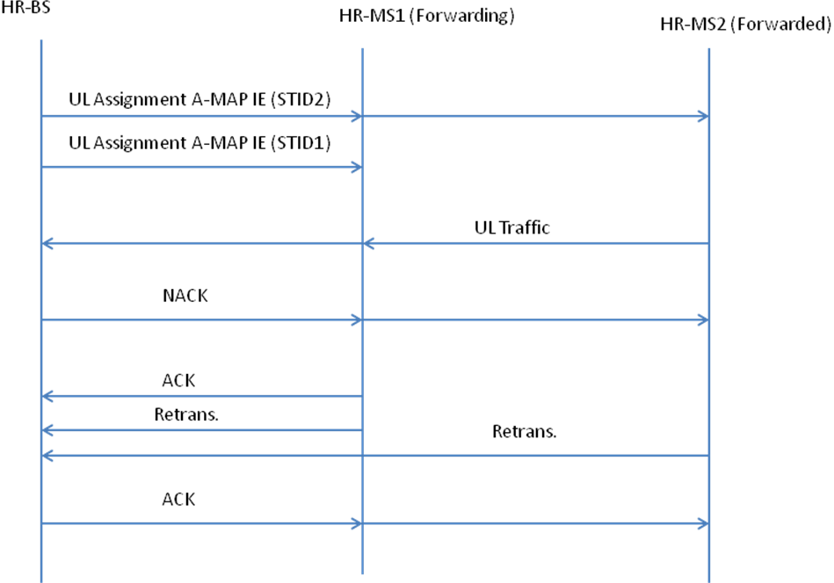

Fig. xx1 – HARQ procedure for HR-MS FTN for User Case 1, uplink transmission

6.12.3.2.1.x.2 HARQ operation for outside-of-coverage forwarded HR-MS
For the case when forwarded HR-MS is outside of coverage of HR-BS/RS, HARQ is carried out in a hop-by-hop/stop-and-wait manner. In the DL (UL), the forwarding HR-MS follows HARQ operation as specified in 6.2.14 to receive (transmit) unicast data traffic and unicast MAC control messages from (to) the serving HR-BS/RS on behalf of its associated forwarded HR-MS. In the DL (UL), the forwarding HR-MS only forwards successfully decoded packets toward forwarded HR-MS (HR-BS/RS). The HARQ procedures for transmissions between HR-BS/RS and forwarded HR-MS are described in 6.12.3.2.1.x.2.1 and 6.12.3.2.1.x.2.2.

6.12.3.2.1.x.2.1 Transmissions from HR-BS/RS toward forwarded HR-MS
The procedure for HARQ transmissions from HR-BS/RS toward an outside-of-coverage forwarded HR-MS can be described as follows.
- HR-BS/RS initiates the process by transmitting a DL assignment A-MAP IE corresponding to the STID of the forwarded HR-MS.
- Forwarding HR-MS, by decoding the DL assignment A-MAP IE using STID of its forwarded HR-MS, recognizes the scheduled DL transmission and proceeds to receive according to the HARQ procedure described in 6.2.14. Following that procedure, upon successfully decoding the DL packet (destined for its forwarded HR-MS), the forwarding HR-MS transmits an ACK toward the HR-BS/RS.
- HR-BS/RS allocates resource in the UL for the forwarding HR-MS to forward the received packet toward its forwarded HR-MS. This allocation is conveyed through an FTN Assignment A-MAP IE corresponding to the STID of the forwarded HR-MS, with the same value of ACID as specified in the original DL assignment A-MAP IE. By matching the ACID field of the DL assignment A-MAP IE and FTN Assignment A-MAP IE, the forwarding HR-MS can recognize the resource allocated for the HARQ forwarding operation. This assignment IE can be transmitted before or after HR-BS/RS receives the ACK from forwarding HR-MS. In either case, the resource allocation only becomes valid from the forwarding frame that follows the frame in which forwarding HR-MS transmits ACK toward the HR-BS/RS. The resource allocation will be valid for a number of consecutive forwarding frames specified by the field “Number of valid frames” of the FTN Assignment A-MAP IE.
- After successfully decoding the packet from HR-BS/RS, forwarding HR-MS transmits F-MAP IE and the corresponding HARQ subpacket toward the forwarded HR-MS. The location of the F-MAP block to be used is specified in the original FTN Assignment A-MAP IE. The fields Resource Index, HFA, and ACID are copied from the original FTN Assignment A-MAP IE to the F-MAP IE. The HARQ operation between forwarding and forwarded HR-MSs follows a synchronous procedure as specified bellow:
  - HARQ subpackets are generated and transmitted as specified in 6.2.14.1, with the forwarding HR-MS behaves like an ABS.
  - HARQ subpacket is transmitted toward the forwarded HR-MS in the subframe that is specified by the “Allocation offset” field in the F-MAP IE.
  - The forwarded HR-MS shall attempt to decode the burst. If the decoding is successful, the forwarded HR-MS sends an ACK toward the forwarding HR-MS in the frame that follows the HARQ transmission, i.e., in the next reversed frame. Otherwise, the forwarded HR-MS sends an NACK in the frame that follows the HARQ transmission. The HARQ feedback channel used to convey ACK/NACK is specified by the HFA field of the F-MAP IE.
  - If the HARQ feedback from the forwarded HR-MS is an ACK, the forwarding HR-MS transmits an ACK toward the HR-BS/RS.
  - If the HARQ feedback from the forwarded HR-MS is an NACK and the resource allocated for forwarding the packet is still valid (based on the field “Number of valid frames” of the original FTN Assignment A-MAP IE), the forwarding HR-MS shall carry out retransmission in the same allocated resource in the next forwarding frame. Otherwise, the forwarding HR-MS may request for extra resource from HR-BS/RS by sending a NACK toward HR-BS/RS. Whether or not a request for extra resource should be sent is specified by the field “Extra Resource Indicator” in the original FTN Assignment A-MAP IE.
  - In the previous steps, when forwarding HR-MS sends ACK/NACK toward HR-BS/RS, it shall do so using the same HARQ feedback channel specified by the HFA field of the FTN Assignment A-MAP IE. This means that such a HARQ feedback channel is used by forwarding HR-MS during forwarding frames (to transmit to HR-BS/RS) and by forwarded HR-MS during reversed frames (to feedback to forwarding HR-MS).
The above procedure is illustrated in Fig. xx2.

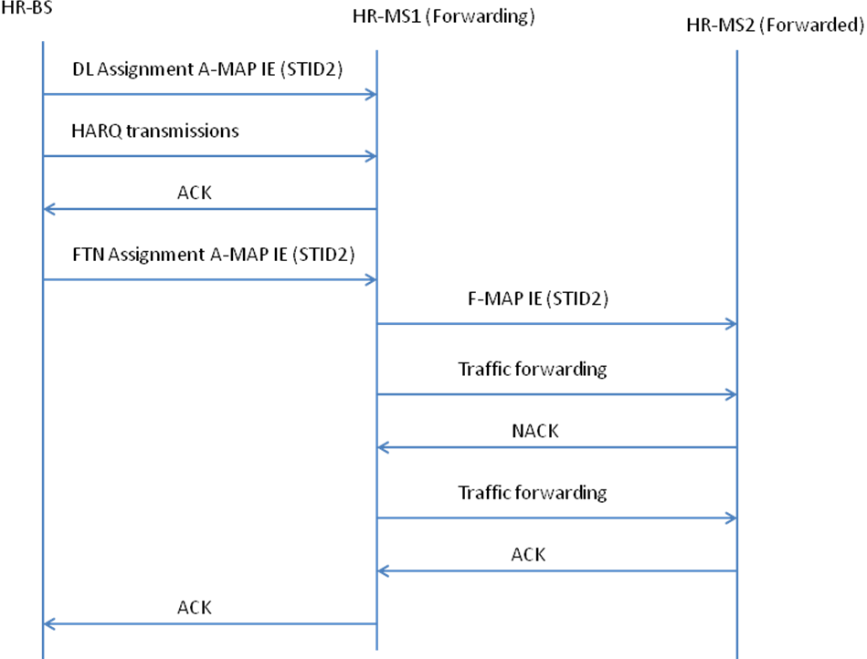
Fig. xx2 – HARQ procedure for HR-MS FTN for User Case 2, downlink transmission

6.12.3.2.1.x.2.2 Transmissions from forwarded HR-MS toward HR-BS/RS
The procedure for HARQ transmissions from a outside-of-coverage HR-MS toward HR-BS/RS can be described as follows.
- HR-BS initiates the process by transmitting an FTN Assignment A-MAP IE corresponding to the STID of the forwarded HR-MS.
- Forwarding HR-MS, by decoding the FTN Assignment A-MAP IE using STID of its forwarded HR-MS, recognizes the scheduled FTN transmission. Forwarding HR-MS then translates the FTN Assignment A-MAP IE into an F-MAP IE and transmits toward the corresponding forwarded HR-MS in the coming forwarding frame. The location of the F-MAP block to be used for the transmission is specified in the FTN Assignment A-MAP IE. The fields Resource Index, HFA, and ACID are copied from the Forwarding Assignment A-MAP IE to the F-MAP IE.
- Based on the received F-MAP IE, the forwarded HR-MS starts transmission toward forwarding HR-MS. The HARQ operation between forwarded and forwarding HR-MSs follows a synchronous procedure as specified bellow:
  - HARQ subpackets are generated and transmitted as specified in 6.2.14.1, with the forwarded HR-MS behaves like an AMS.
  - HARQ subpacket is transmitted toward the forwarding HR-MS in the subframe that is specified by the “Allocation offset” field in the F-MAP IE. In particular, if the F-MAP IE is transmitted in an F-MAP block within a particular subframe with index “n” within a forwarding frame, then the corresponding HARQ transmission shall be located in the subframe with index equal “Allocation offset + n” within the next reversed frame.
  - The forwarding HR-MS shall attempt to decode the burst. If the decoding is successful, the forwarding HR-MS sends an ACK toward the forwarded HR-MS in the frame that follows the HARQ transmission, i.e., in the next forwarding frame. Otherwise, the forwarding HR-MS sends an NACK in the frame that follows the HARQ transmission. The HARQ feedback channel used to convey ACK/NACK is specified by the HFA field of the F-MAP IE.
  - If the HARQ feedback from the forwarding HR-MS is an NACK and the resource allocated for HARQ transmission from forwarded HR-MS is still valid (based on the field “Number of valid frames” of the original FTN Assignment A-MAP IE), the forwarded HR-MS shall carry out retransmission in the same allocated resource in the next forwarding frame.
- Upon successfully decoding the packet from the forwarded HR-MS, the forwarding HR-MS shall proceed to forward the received packet to the HR-BS/RS. The UL resource for the forwarding HR-MS to forward such a packet is allocated through an UL assignment A-MAP IE. This UL assignment A-MAP IE corresponds to the STID of the forwarding HR-MS with the same ACID field as in the original FTN Assignment A-MAP IE. By matching the ACID field of the UL assignment A-MAP IE and FTN Assignment A-MAP IE, the forwarding HR-MS can recognize the resource allocated for the HARQ forwarding operation. The UL assignment A-MAP IE can be sent in either of the following ways:
  - It is transmitted when forwarding HR-MS, upon successfully decoding the packet from forwarded HR-MS, transmits an ACK to the HR-BS/RS on the same HARQ feedback channel specified by the HFA field in the original FTN Assignment A-MAP IE.
  - It is transmitted when forwarding HR-BS/RS, upon monitoring the HARQ feedback channel specified by the HFA field in the original FTN Assignment A-MAP IE, detects an ACK transmitted by forwarding HR-MS toward forwarded HR-MS.

The above procedure is illustrated in Fig. xx3.

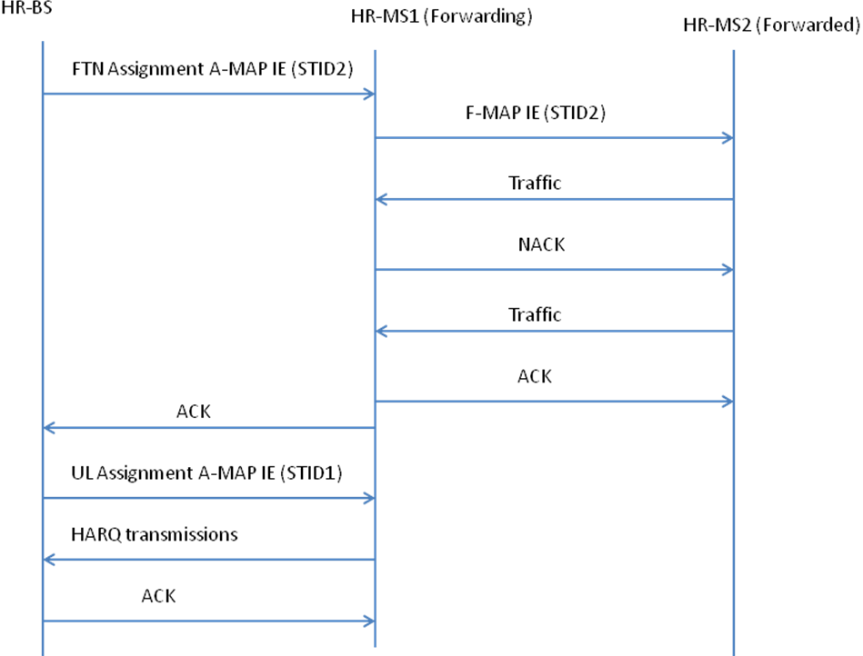
Fig. xx3 – HARQ procedure for HR-MS FTN for User Case 2, uplink transmission

{Remedy 7: Modify the paragraph on page 571, Section 6.3.5.1.2, lines 5-15, as indicated}

SA-Preamble sequences are partitioned and each partition is dedicated to a specific base station type such as Macrocell ABS, Macro Hot-zone ABS, Femto ABS, or TTR Relay ABS. STR Relay ABS can be included in either the macro ABS partition or the Macro Hot-zone partition based on deployment. The base station types are categorized into macro ABS and non-macro ABS cells by hard partition with 258 sequences (86 sequences per segment x 3 segments) dedicated for macro ABS. The non-macro ABS information is broadcasted in a hierarchical structure, which composes of S-SFH SP3 and AAI-SCD message. In S-SFH SP3, non-macro ABS cell type is partitioned as public and CSG femto base stations. Total 16 cases of IDcell partition for public and CSG-femto ABS are shown in Table 167, which is composed of IDcell partitions based on 30 sequence (10 sequences per segmentation) granularity. For an HR-MS acting as forwarding HR-MS and transmits SA-Preamble (specified in 6.12.3.2), the preamble is taken from the last 10 sequences in each segment.
[-----------------------------------------------End of Text Proposal---------------------------------------------------]

Use of IEEE-Copyrighted Conference and Journal Papers
The IEEE 802.16 Working Group has obtained permission to post IEEE-copyrighted material from IEEE conferences and publications when received in an official contribution to the Working Group. IEEE requires two conditions:
- A full copyright and credit notice must be posted at the top of the paper in the following format:
Copyright ©2002 Institute of Electrical and Electronics Engineers, Inc. Reprinted, with permission, from [all relevant journal info].
This material is posted here with permission of the IEEE. Internal or personal use of this material is permitted. However, permission to reprint/republish this material for advertising or promotional purposes or for creating new collective works for resale or redistribution must be obtained from the IEEE (contact pubs–permissions@ieee.org).
By choosing to view this document, you agree to all provisions of the copyright laws protecting it.
- If the author is not the submitter of the contribution, the author’s written approval for the reuse of the material must be attached.

