Project | IEEE 802.16 Broadband Wireless Access Working Group <http://ieee802.org/16>
Title | Text Proposal for MAC Management Messages to Support BS-controlled HR-MS DC in 802.16.1a
Date Submitted | 2012-01-09
Source(s) | Anh Tuan Hoang, Haiguang Wang, Jaya Shankar, Wai Leong Yeow,  Shoukang Zheng, Joseph Teo Chee Ming  Institute for Infocomm Research  1 Fusionopolis Way, #21-01, Connexis (South Tower)  Singapore 138632 | Voice: +65 6408-2271  E-mail: athoang@i2r.a-star.edu.sg
Re: | In response to the 802.16n (GRIDMAN) Call for Comments to 802.16.1a AWD in 802.16n-11/0033
Abstract | In this contribution, we propose modifications/clarifications for some of these MAC Management messages used for BS-controlled DC.
Purpose | To discuss and adopt the proposed text in the 802.16.1a AWD
Notice | This document does not represent the agreed views of the IEEE 802.16 Working Group or any of its subgroups. It represents only the views of the participants listed in the “Source(s)” field above. It is offered as a basis for discussion. It is not binding on the contributor(s), who reserve(s) the right to add, amend or withdraw material contained herein.
Copyright Policy | The contributor is familiar with the IEEE-SA Copyright Policy <http://standards.ieee.org/IPR/copyrightpolicy.html>.
Patent Policy | The contributor is familiar with the IEEE-SA Patent Policy and Procedures:  <http://standards.ieee.org/guides/bylaws/sect6-7.html#6> and <http://standards.ieee.org/guides/opman/sect6.html#6.3>.  Further information is located at <http://standards.ieee.org/board/pat/pat-material.html> and <http://standards.ieee.org/board/pat>.

Text Proposal for MAC Management Messages to Support BS-controlled HR-MS DC in 802.16.1a

Anh Tuan Hoang, Haiguang Wang, Jaya Shankar,
Wai Leong Yeow, Shoukang Zheng, Joseph Teo Chee Ming
Institute for Infocomm Research (I2R)

Introduction
In the current AWD, the operation of BS-controlled HR-MS direct communication (DC) has been specified. In this contribution, we further provide details on MAC-layer support for the DC operation. Particularly, we focus on:
- Assignment A-MAP IE used to allocate resource for BS-controlled DC.
- HARQ operation of BS-controlled DC.

References
- IEEE 802.16.1a Amendment Working Draft, IEEE 802.16n-11/0033.

Text Proposal for the 802.16n Amendment Working Document (AWD)
Note:
The text in BLACK color: the existing text in the 802.16n Amendment Draft Standard
The text in YELLOW-HIGHLIGHTED RED color: the removal of existing 802.16n Amendment Draft Standard Text
The text in YELLOW-HIGHLIGHTED BLUE color: the new text added to the 802.16n Amendment Draft Standard Text

[-----------------------------------------------Start of Text Proposal---------------------------------------------------]
{Remedy 1: Insert the following new section under 6.12.2.2.1}

6.12.2.2.1.x HARQ operation for HR-MS direct communication
HARQ operation for HR-MS direct communication follows the procedure described bellows.
- HR-BS/RS initiates the process by transmitting a DC Assignment A-MAP IE, with the field “Direct Link A-MAP IE Type” set to “0b0000”. The Direct Link Assignment A-MAP IE is CRC masked using the TWDC address of the transmitting HR-MS. Both transmitting and receiving HR-MS will be able to recognize this allocation and prepare to transmit/receive accordingly.
- Upon receiving the DC Assignment A-MAP IE, the HR-MS scheduled for transmitting shall calculate the transmission timing based on the same specification in 6.2.14.2.2.2.2.
- After receiving the DC Assignment A-MAP IE, the HR-MS scheduled for receiving shall attempt to receive subsequent transmission from the transmitting HR-MS. If the decoding is successful, the receiving HR-MS sends an ACK toward HR-BS/RS in the next frame, in the HARQ feedback channel specified by the field “HFA UL” in the DC Assignment A-MAP IE. Otherwise, if the decoding fails, the receiving HR-MS sends an NACK toward HR-BS/RS.
- Based on the feedback from the receiving HR-MS, the HR-BSs shall carry out one of the following actions:
  - If the feedback from the receiving HR-MS is an ACK: HR-BS/RS sends an ACK in the DL HARQ feedback channel specified by the field “HFA DL” in the original DC Assignment A-MAP IE.
  - If the feedback from the receiving HR-MS is an NACK: HR-BS/RS sends an NACK in the DL HARQ feedback channel specified by the field “HFA DL” in the original DC Assignment A-MAP IE. The HR-BS may schedule a retransmission by sending another Direct Link Assignment A-MAP IE with the same ACID and AI-SN.
- Together with sending ACK/NACK, the HR-BS may or may not transmit a new DC Assignment A-MAP IE.
  - Upon receiving ACK from the HR-BS/RS, if there is no new DC Assignment A-MAP IE from HR-BS/RS while the resource allocation in the original DC Assignment A-MAP IE still applies to the next frame, the transmitting and receiving HR-MSs proceed with a new HARQ attempt. Whether or not the resource allocation still applies to the next frame is determined by the field “Number of valid frames” in the original DC Assignment A-MAP IE.
  - Upon receiving NACK from HR-BS, if there is no new DC Assignment A-MAP IE from the HR-BS and the resource allocation in the original DC Assignment A-MAP IE still applies to the next frames, the transmitting HR-MS proceeds to re-transmit the HARQ subpacket in the allocated resource.
  - If there is a new DC Assignment A-MAP IE from the HR-BS, the new assignment IE shall supersede the original DC Assignment A-MAP IE and the transmitting and receiving HR-MSs shall follow the new allocation accordingly.

DC Assignment A-MAP IE is described in Table xx1. The above HARQ procedure is illustrated in Fig. xx1.
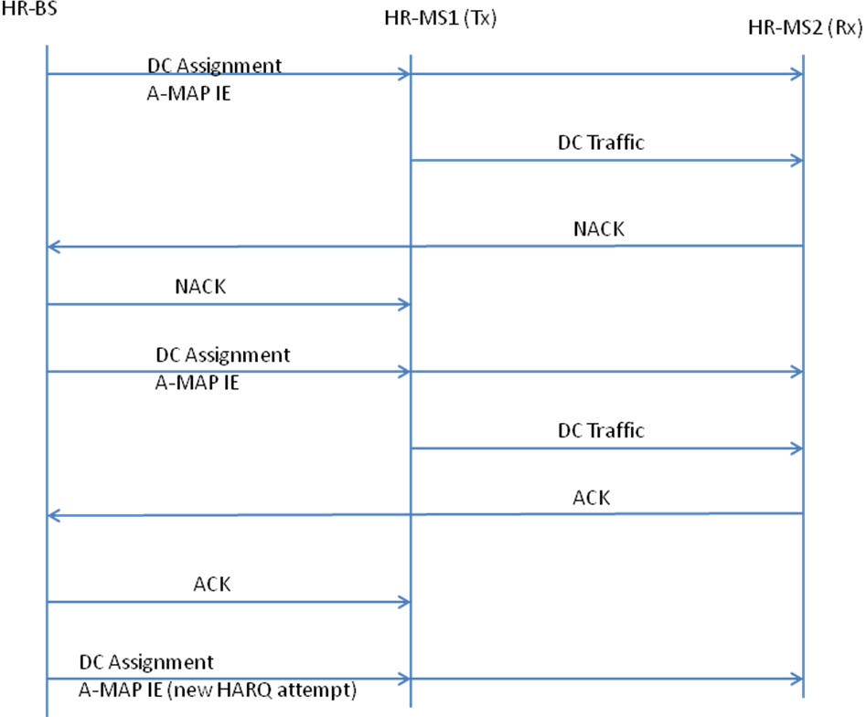

Fig. xx1 HARQ procedure over the direct communication link

{Remedy 2: Insert the following new section under 6.12.2.2.2}

6.12.2.2.2.2.x A-MAP IE for HR-MS direct communication

6.12.2.2.2.2.x.1 Direct Communication Assignment A-MAP IE

Table xx1 describes the fields in a Direct Communication Assignment A-MAP IE used for resource assignment to the direct link between two HR-MSs involving in BS-controlled HR-MS direct communications.

DC Assignment A-MAP IE is CRC masked according to Table 192, with the Type Indicator set to 0b011. This value of Type Indicator distinguishes DC Assignment A-MAP IE from DL/UL assignments.

Table xx1 – Direct Communication Assignment A-MAP IE format
Syntax | Size (bits) | Notes
Direct Communication Assignment A-MAP_IE{
Direct Link A-MAP IE Type | 4 | Set to 0b0000
I_{SizeOffset} | 5 | Offset use to compute burst size index
MEF | 1 | MIMO encoder format  0b0: SFBC  0b1: Vertical Encoding with only 1 stream
Resource Index | 11 | 512 FFT size: 0 in first 2 MSB bits + 9 bits for resource index  1024 FFT size: 11 bits for resource index  2048 FFT size: 11 bits for resource index  Resource index includes location and allocation size
HFA DL | 3 | HARQ Feedback Allocation in the DL
HFA UL | 3 | HARQ Feedback Allocation in the UL
ACID | 4 | HARQ channel identifier
AI_SN | 1 | HARQ identifier sequence number
Number of valid frames | 5 | Number of frames that this allocation applies to; when equal 0b0000, indicate the de-allocation of the defined resource.
Reserved | 3 | To make the size equal 40 bits
}
ª A 16-bit CRC is generated based on the randomized contents of the Direct Communication Assignment A-MAP IE. The CRC is masked by the 16-bit CRC mask generated according to Table 192, i.e., with Type Indicator set to “0b011”.
[-----------------------------------------------End of Text Proposal---------------------------------------------------]

Use of IEEE-Copyrighted Conference and Journal Papers
The IEEE 802.16 Working Group has obtained permission to post IEEE-copyrighted material from IEEE conferences and publications when received in an official contribution to the Working Group. IEEE requires two conditions:
- A full copyright and credit notice must be posted at the top of the paper in the following format:
Copyright ©2002 Institute of Electrical and Electronics Engineers, Inc. Reprinted, with permission, from [all relevant journal info].
This material is posted here with permission of the IEEE. Internal or personal use of this material is permitted. However, permission to reprint/republish this material for advertising or promotional purposes or for creating new collective works for resale or redistribution must be obtained from the IEEE (contact pubs–permissions@ieee.org).
By choosing to view this document, you agree to all provisions of the copyright laws protecting it.
- If the author is not the submitter of the contribution, the author’s written approval for the reuse of the material must be attached.

