**IEEE P802.15**

**Wireless Personal Area Networks**

|  |  |  |
| --- | --- | --- |
| Project | IEEE P802.15 Working Group for Wireless Personal Area Networks (WPANs) | |
| Title | D02 Miscellaneous Comment Resolutions I | |
| Date Submitted | 10 April 2025 | |
| Source | Billy Verso (Qorvo), | billy.verso at qorvo.com |
| Re: | IEEE P802.15.4ab | |
| Abstract | Comment Resolutions for selected comments on the LB213 / P802.15.4ab D02. | |
| Purpose | This document provides text changes intended to be part of the final IEEE Std 802.15.4ab (amendment to IEEE Std 802.15.4), as part of resolving selected comments from the consolidated spreadsheet (DCN 15-25-0174) that have been assigned to the author to resolve. | |
| Notice | This document does not represent the agreed views of the IEEE 802.15 Working Group or IEEE 802.15.4ab Task Group. It represents only the views of the participants listed in the “Source(s)” field above. It is offered as a basis for discussion and is not binding on the contributing individual(s) or organization(s). The material in this document is subject to change in form and content after further study. The contributor(s) reserve(s) the right to add, amend or withdraw material contained herein. | |
| Release | The contributor acknowledges and accepts that this contribution becomes the property of IEEE and may be made publicly available by P802.15. | |
| Patent Policy | The contributor is familiar with the IEEE-SA Patent Policy and Procedures.  <https://standards.ieee.org/about/sasb/patcom/materials/> | |

|  |
| --- |
| Comments addressed here: |

1 Comment Index # 262 2

2 Comment Index # 264 3

3 Comment Index # 493 4

# Comment Index # 262

|  |  |  |  |  |  |
| --- | --- | --- | --- | --- | --- |
| **Index** | **page** | **clause** | **line** | **Comment** | **Proposed Change** |
| 262 (Panpan) | 41 | 10.21.6.1.5 | 5 | I guess "TRUE" should be changed to "FALSE"? | As in comment |

**Discussion:**

This relates to following lines:

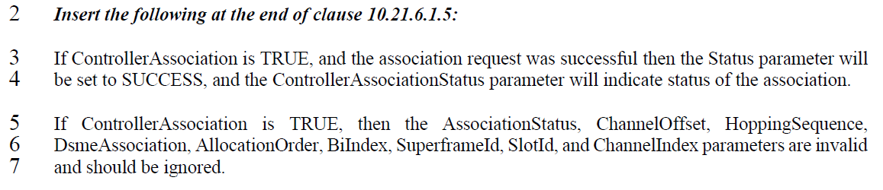

The commenter is thinking that the second statement should perhaps be a “FALSE”, however this is not the case….

For controller association, (when ControllerAssociation is TRUE), the result of the controller association will be reflected in both the Status parameter and the ControllerAssociationStatus parameter, which is what the statement on line #3 is saying.

Also, for controller association, (when ControllerAssociation is TRUE), the parameters listed on lines #5 and #6 are not applicable to controller association: AssociationStatus applies to PAN coordinator association, while ChannelOffset, DsmeAssociation, HoppingSequence, AllocationOrder, BiIndex, SuperframeId, SlotId, and ChannelIndex (apply to DSME and TSCH).

Both statements are correctly using the TRUE condition.

**Proposed Disposition:** Rejected.

**Disposition Detail:** “TRUE” is correct here, since the listed parameters are not applicable to controller association.

# Comment Index # 264

|  |  |  |  |  |  |
| --- | --- | --- | --- | --- | --- |
| **Index** | **page** | **clause** | **line** | **Comment** | **Proposed Change** |
| 264 (Panpan) | 46 | 10.32.2 | 3 | Change "a whole number of ranging rounds" to "a number of whole ranging rounds" | As in comment |

**Discussion:**

This relates to following lines:

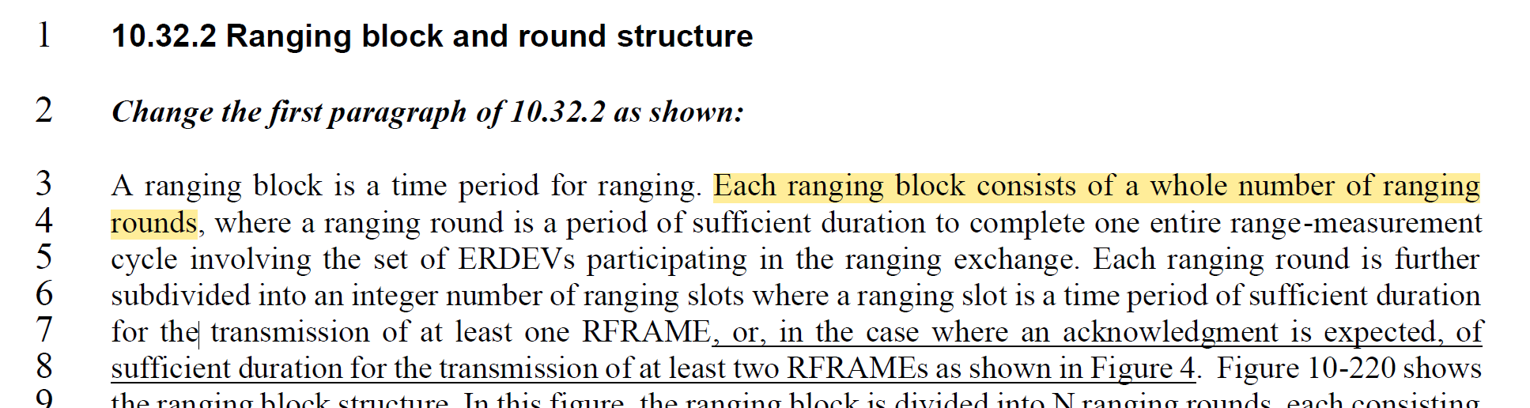

This comment was originally classified as Editorial but was changed to Technical to give group oversight of the potential change in meaning being proposed, however with further review, it seems that the meaning of “a whole number of ranging rounds" is really the same as the meaning of "a number of whole ranging rounds”, so there is no reason to change it.

Another reason not to change is that this is baseline text, (as can be inferred from line 2).

This text was in the approved IEEE Std 802.15.4z-2020 amendment (p.38) and was integrated into the IEEE Std 802.15.4-2024 revision (p.470). It has already had much review and balloting during those projects.

Since the proposed change does not alter the meaning, and, since the text in question is pre-existing text in baseline standard, we should leave it alone.

**Proposed Disposition:** Rejected.

**Disposition Detail:** This is baseline text with clear meaning – no change is necessary.

# Comment Index # 493

|  |  |  |  |  |  |
| --- | --- | --- | --- | --- | --- |
| **Index** | **page** | **clause** | **line** | **Comment** | **Proposed Change** |
| 493 (Billy) | 95 | 10.39.10.2 | 12 | Could add about clock offset correction for the SS-TWR calculation | Add at end of line, ", with the clock offset from the MCPS-DATA.indication that delivered the O-QPSK response frame" |

**Discussion:**

This relates to the final paragraph in the clause giving the MSC and primitive interactions for an NBA MMS UWB ranging exchange:



Earlier in this clause (10.39.10.2) the text describes (on p.93 line#7) how in the initiator the MAC issues MCPS-DATA.indication primitive to report the arrival of the response Compact frame including RangingTrackingInterval and RangingOffset parameters to report the clock offset measurement.

Noting that the SS-TWR calculation in 10.29.1.2.2 includes a formula that uses the clock offset to improve the accuracy of the TOF estimate, the suggestion is to extend the final paragraph (which is already informative) with a phrase informing that the clock offset measurement can also be used in this calculation.

This is a useful addition but to help in readability and understanding let’s do it as a separate “*can also use*” sentence rather than extending the current one, as follows…

**Proposed Disposition:** Revised.

**Disposition Detail:**

Add the following new sentence at the end of this paragraph:

“The initiator can also use the clock offset information from the reception of the O‑QPSK response frame in this calculation as described in 10.29.1.2.2.”

*<END>*