**IEEE P802.15**

**Wireless Personal Area Networks**

|  |  |  |
| --- | --- | --- |
| Project | IEEE P802.15 Working Group for Wireless Personal Area Networks (WPANs) | |
| Title | **Proposed Resolution for MMS – Advertising Data** | |
| Date Submitted | Jan. 2025 | |
| Sources | Hong Won Lee (LG Electronics)  [hongwon.lee@lge.com](mailto:hongwon.lee@lge.com) |  |
| Re: |  | |
| Abstract |  | |
| Purpose | To propose resolution for “P802.15.4ab™/D01 Draft Standard for Low-Rate Wireless Networks” . | |
| Notice | This document does not represent the agreed views of the IEEE 802.15 Working Group or IEEE 802.15.4ab Task Group. It represents only the views of the participants listed in the “Sources” field above.It is offered as a basis for discussion and is not binding on the contributing individuals. The material in this document is subject to change in form and content after further study. The contributors reserve the right to add, amend or withdraw material contained herein. | |

This submission contains the proposed comment resolutions for the CID 1363

Rev 0: Initial version.

***Comment index #1363 in 15-24-0371-01-04ab-consolidated-comments-draft-1-0.xlsx***

|  |  |  |  |  |  |  |  |
| --- | --- | --- | --- | --- | --- | --- | --- |
| **Name** | **Index#** | **Pg** | **Sub-Clause** | **Ln** | **Comment** | **Proposed Change** | **Disposition** |
| Pooria Pakrooh | 1363 | 89 | 10.38.9.3.22 | 3 | This newly added field can cause unnecessary overhead, how long can this be? | Limit the maximum duration. | Revised |

**Discussion**：To clarify the maximum length of the Advertising Data, the maximum value of the Advertising Data length subfield can be inferred from the frame length. Regarding the overhead, the maximum duration does not need to be limited because it is naturally determined by the frame length. The overhead can be derived not only from the duration of the compact frame but also from other aspects, such as the interval between compact frames. Therefore, the overhead should be addressed from an implementation perspective to accommodate various environments. For implementation, the recommendation to use default channel and default slot duration is added.

**Disposition: Revised**

**Disposition Detail:**

**Proposed text changes on P802.15.4ab™/D01:**

**10.38.3.6 UWB MMS ranging session initialization using public addresses**

**- Original Text**

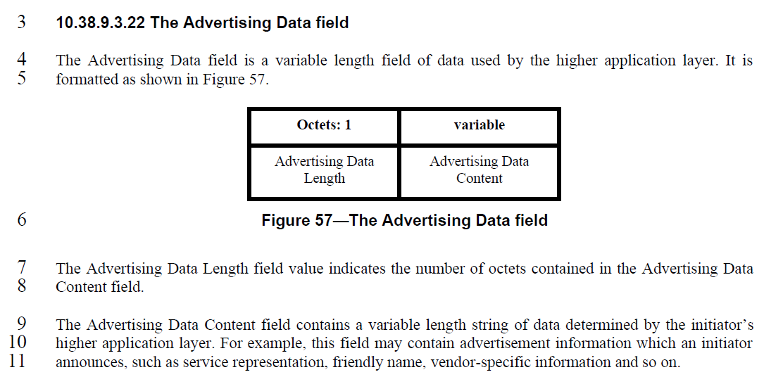

**- Proposed change**

***Change the sub-clause as follows (Track changes ON)***

**(*pp. 89 line #11*)**

The Advertising Data Content field contains a variable length string of data determined by the initiator’s higher application layer. For example, this field may contain advertisement information which an initiator announces, such as service representation, friendly name, vendor-specific information and so on. The default values of *macMmsNbInitChannel, macMmsNbInitSlotDuration in Table 20* should be used if the Public Advertising Poll Compact frame includes the Advertising Data field.