**IEEE 802.15**

**Wireless Personal Area Networks**

|  |  |  |
| --- | --- | --- |
| Project | IEEE P802.15 Working Group for Wireless Personal Area Networks (WPANs) | |
| Title | **Proposed Text for Draft 1.0 Comment Resolution – Part 3** | |
| Date Submitted | January 15, 2025 | |
| Sources | Youngwan So (SAMSUNG Electronics)  [youngwan.so@samsung.com](mailto:youngwan.so@samsung.com) |  |
| Re: |  | |
| Abstract |  | |
| Purpose | To propose resolution for miscellaneous hyper block related comments for “P802.15.4ab™/D1.0 Draft Standard for Low-Rate Wireless Networks” . | |
| Notice | This document does not represent the agreed views of the IEEE 802.15 Working Group or IEEE 802.15.4ab Task Group. It represents only the views of the participants listed in the “Sources” field above.It is offered as a basis for discussion and is not binding on the contributing individuals. The material in this document is subject to change in form and content after further study. The contributors reserve the right to add, amend or withdraw material contained herein. | |

Rev 0: Initial version.

***Comment Indices in 15-24-0371-01-04ab-consolidated-comments-draft-1.0:***

|  |  |  |  |  |  |  |  |
| --- | --- | --- | --- | --- | --- | --- | --- |
| **Name** | **Index#** | **Pg** | **Sub-Clause** | **line** | **Comment** | **Proposed Change** | **Disposition** |
| Billy Verso | 1069 | 42 | 10.32.2 | 22 | Here and line 26, are those "other devices" controllers? YES, I believe so since by definition a controller is a device that sends an RCM (base standard definition). So call them that. | Change "other devices" to "other controllers", line 22 and line 27. | Accepted |
| Alex Krebs | 1384 | 42 | 10.32.2 | 22,23 | Do we need a more clear definition of RCMs? It seems here as if anybody, not only the initiator/controller, are allowed to send RCMs not only for sync, but also with ranging config params. This may be in conflict with the initiator=controller paradigm. | Change lines 21-23 to:  - Ranging Control Message (RCM): A message transmitted during ranging control phase, to configure or to synchronize an upcoming ranging phase. | Accepted |

**Disposition Detail: 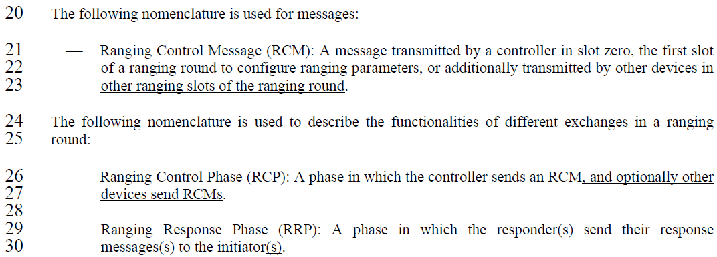 CID#1069 & 1384**

Accepted.

**Proposed text changes on P802.15.4ab™/Draft 1.0 :**

***Change 10.32.2 P42L22 as below ;***

20 The following nomenclature is used for messages:

21 ⎯ Ranging Control Message (RCM): A message transmitted during ranging control phase, to configure or to synchronize an upcoming ranging phase.

24 The following nomenclature is used to describe the functionalities of different exchanges in a ranging

25 round:

26 ⎯ Ranging Control Phase (RCP): A phase in which the controller sends an RCM, and optionally other

27 controllers send RCMs.

28

29 Ranging Response Phase (RRP): A phase in which the responder(s) send their response

30 messages(s) to the initiator(s).

***Comment Indices in 15-24-0371-01-04ab-consolidated-comments-draft-1.0:***

|  |  |  |  |  |  |  |  |
| --- | --- | --- | --- | --- | --- | --- | --- |
| **Name** | **Index#** | **Pg** | **Sub-Clause** | **line** | **Comment** | **Proposed Change** | **Disposition** |
| Hong Won Lee | 1407 | 47 | 10.32.9.10 | 27 | There is no description of bitmap-based block scheduling for block-based mode, which can be used. Bitmap-based block scheduling should be described for both hyper block mode and block-based mode, respectively | Change from "element represents the pattern of scheduled blocks to a single device" to "element represents the pattern of scheduled blocks in hyper block mode defined in 10.x.x.x.x or represents the current scheduled block in block-based mode to a single device" | Revised |

**Disposition Detail:**





**CID#1407**

Revised as suggested

**Proposed text changes on P802.15.4ab™**

***Change 10.32.9.10 P47L27 as below ;***

25 When bitmap-based block scheduling is used, one or multiple ranging blocks may be assigned to a device

26 for transmissions using a single Scheduling List field element. A bitmap in each Scheduling List field

27 element represents the pattern of scheduled blocks in hyper block mode defined in 10.32.3.5 or represents the current scheduled block in block-based mode to a single device. For example, a Scheduling IE with

1 Scheduling List Type field value of five can be transmitted in the same ranging round as an HBS IE for

2 block scheduling in hyper block mode, as described in 10.32.3.5. The Block Scheduling Bitmap field

3 represents one or multiple ranging blocks assigned to a device for transmission using a single Scheduling

4 List field element in a hyper block.***Comment Indices in 15-24-0371-01-04ab-consolidated-comments-draft-1.0:***

|  |  |  |  |  |  |  |  |
| --- | --- | --- | --- | --- | --- | --- | --- |
| **Name** | **Index#** | **Pg** | **Sub-Clause** | **line** | **Comment** | **Proposed Change** | **Disposition** |
| Billy Verso | 1111 | 53 | 10.32.9.12 | 10 | "It is recommended that the three values giving block, round and slot duration are all included in the HBS IE at the same time." Rather than recommending, could just define the format so that they all have to be included. | Specify a single presence bit to cover the inclusion/exclusion of all three fields. |  |
| B. Rolfe | 1332 | 53 | 10.32.9.12 | 10 | Note sure what "The controller may choose the units to suit its needs." means in the context of an optional behavior (without specifying conditions for "needs"). Are we saying this is determined by some process outside the scope of this standard? (seems likely). | The controller chooses the units as needed based on criteria outside the scope of this standard. |  |

**Disposition Detail:**

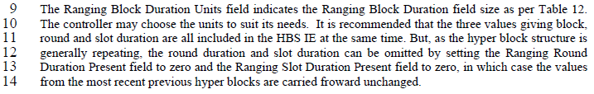

**CID#1111**

Revised. Added one bit presence flag and description about it as suggested.

**CID#1332**

Accepted. Intended the controller chooses the units as needed based on criteria outside the scope of this standard.

**Proposed text changes on P802.15.4ab™/Draft 1.0 :**

***Change the chapter 10.32.9.12 P53L10 as follows:***

The Content Control field is formatted as per Figure 21 and indicates the presence of duration fields in the

7 Ranging Block Description List, which is structured as per Figure 22.

|  |  |  |  |  |
| --- | --- | --- | --- | --- |
| Bits: 0-1 | 2 | 3 | 4 | 5-7 |
| Ranging Block Duration Unit | Ranging Block Duration Present | Ranging Round Duration Present | Ranging Slot Duration Present | reserved |

**Figure 21— Content Control field format**

The Ranging Bloc1k Duration Units field indicates the Ranging Block Duration field size as per Table 12.

The controller chooses the units as needed based on criteria outside the scope of this standard. It is recommended that the three values giving block, round and slot duration are all included in the HBS IE at the same time. But, as the hyper block structure is generally repeating, the round duration and slot duration can be omitted by setting the Ranging Round Duration Present field to zero and the Ranging Slot Duration Present field to zero, in which case the values from the most recent previous hyper blocks are carried froward unchanged.

………….

***Change the chapter 10.32.9.12 P54L1 as follows:***

The Ranging Block Duration Present field indicates the presence or absence of the Ranging Block Duration field in the elements of the Ranging Block Description List which is formatted as per Figure 22. When the Ranging Block Duration Present field value is one, the Ranging Block Duration field is included in the Ranging Block Description List elements. When the Ranging Block Duration Present field value is zero, the Ranging Block Duration field is not included in the Ranging Block Description List elements.

The Ranging Round Duration Present field indicates the presence or absence of the Ranging Round Duration field in the elements of the Ranging Block Description List which is formatted as per Figure 22. When the Ranging Round Duration Present field value is one, the Ranging Round Duration field is included in the Ranging Block Description List elements. When the Ranging Round Duration Present field value is zero, the Ranging Round Duration field is not included in the Ranging Block Description List elements.

The Ranging Slot Duration Present field indicates the presence or absence of the Ranging Slot Duration field in the elements of the Ranging Block Description List which is formatted as per Figure 22. When the Ranging Slot Duration Present field value is one, the Ranging Slot Duration field is included in the Ranging Block Description List elements. When the Ranging Slot Duration Present field value is zero, the Ranging Slot Duration field is not included in the Ranging Block Description List elements.

Ranging Block Description List Length field specifies the number of elements in the Ranging Block Description List field. The number of elements shall be set equal to the number of ranging blocks in the hyper block. The Ranging Block Description List field contains Ranging Block Description List elements each of which is structured as per Figure 22.

|  |  |  |  |
| --- | --- | --- | --- |
| Octets: 1 | 0/1/2/3 | 0/1 | 0/2 |
| Relative Block Index | Ranging Block Duration | Ranging Round Duration | Ranging Slot Duration |

**Figure 22— Format of Elements in the Ranging Block Description List Field**