IEEE P802.15
Wireless Personal Area Networks

Project | IEEE P802.15 Working Group for Wireless Personal Area Networks (WPANs)
Title | CID 11 resolution
Date Submitted | 13 January 2025
Source | Billy Verso (Qorvo),  Carl Murray (Qorvo) | billy.verso at qorvo.com
Re: | IEEE P802.15.4ab
Abstract | Comment Resolutions for selected comments on the LB207 / P802.15.4ab D01.
Purpose | This document provides text changes intended to be part of the final IEEE Std 802.15.4ab (amendment to IEEE Std 802.15.4), as part of resolving selected comments from the consolidated spreadsheet (doc 15-24-0371) that have been assigned to the author to resolve.
Notice | This document does not represent the agreed views of the IEEE 802.15 Working Group or IEEE 802.15.4ab Task Group. It represents only the views of the participants listed in the “Source(s)” field above. It is offered as a basis for discussion and is not binding on the contributing individual(s) or organization(s). The material in this document is subject to change in form and content after further study. The contributor(s) reserve(s) the right to add, amend or withdraw material contained herein.
Release | The contributor acknowledges and accepts that this contribution becomes the property of IEEE and may be made publicly available by P802.15.
Patent Policy | The contributor is familiar with the IEEE-SA Patent Policy and Procedures.  <https://standards.ieee.org/about/sasb/patcom/materials/>

CIDs addressed here:

1 Comment Index # 11 2

d

Comment Index # 11
Index | page | clause | line | Comment | Proposed Change
11  (Xiliang) | 192 | 16.2.11.1 | 8 | We should include the clarification texts we have approved in doc#: 15-24-0139-05-04ab for CID #878. | Add the following paragraph between line 8 and line 9:  In the case of NBA UWB MMS, another narrowband PHY packet precedes the RSF/RIFs and assists the MMS to provide this initial synchronization.  In the case of UWB-driven UWB MMS, the RSFs or RIFs are preceded by a fragment consisting of SYNC and SFD that is used to obtain initial timing and frequency synchronization.
Discussion:
The referenced doc 15-24-0139-05 and CID #878 relates to the “Pre-ballot-C” draft. The resolution in 139r5 (which with no discussion bears little relationship to the comment) provides text to replace the two lines highlighted in the screenshot graphic below, from p.160 of the “Pre-ballot-C” draft, “General” sub-clause of 16.2.11 “Multi-millisecond ranging packet format”.
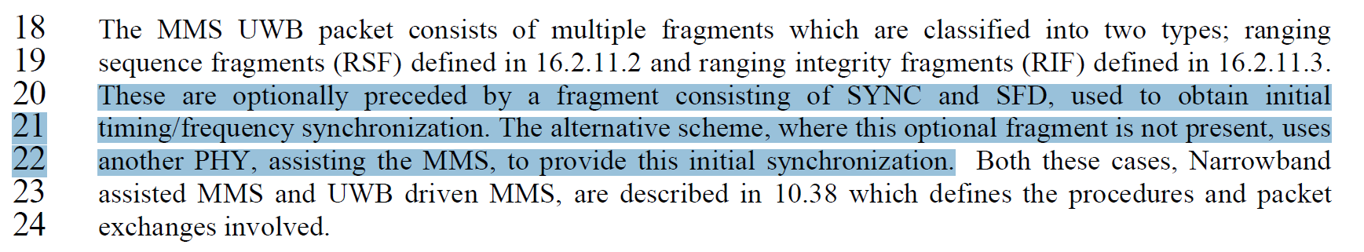
The change being asked for now, in D01 CID 11 is essentially re-applying the original change, inserting the lines the commenter originally provided in 0139r5.
How come these lines don’t appear in the D01 draft?
The answer is that the group decided that they should not be there!
These lines were deleted by the 15-24-0221-04 resolution to CID 296 on the “Pre-ballot-C” draft.
15-24-0139-05 was uploaded and agreed on 14-Mar-2024 during the Denver Plenary.
15-24-0221-04 was uploaded and agreed on 30-May-2024 during the 6 PM ET call.
So, the lines were initially changed by 139r5 and then later removed completely by 221r4.
What is the reasoning here? Is it covered elsewhere?
The original issues were somewhat hurriedly resolved to complete the “Pre-ballot-C” comment resolution and get D01 out for ballot. At the time, it was said that it would need to be revisited.
We can thank the commenter for CID #11 which prompts that discussion to be continued.

One of the discussion points is that the SYNC+SFD fragment in the UWB Driven mode is sub-optimum (see commentary in 15-24-0021-02), i.e., the constraints on its content and pulse amplitude, means that it is weaker (lower energy) than subsequent RSF/RIF.
If we don’t fix that then it can be mitigated for by using the preceding (UWB) Poll/Response Compact Frame to get an initial estimate of the clock offset for the MMS packet, which is why we opted to remove the statement saying that initial synchronization comes from the SYNC+SFD fragment.
The draft has a sentence in the Control Phase text that says: “The poll Compact frame (10.38.9.7) is used by the responder to estimate the clock frequency offset for the reception of the initiator's subsequent MMS UWB transmissions serves to enable carrier coherent transmissions from the initiator to the responder device.”, (Ref: P#67 L#35 amended by 15-24-0648-01 to resolve CID#1168), and a similar sentence for the other direction in the succeeding paragraph.
The understanding is that this can apply in both NBA and UWB Driven cases, since these control packets, (poll and response Compact frames), are required both modes, as per page 55 of D01:
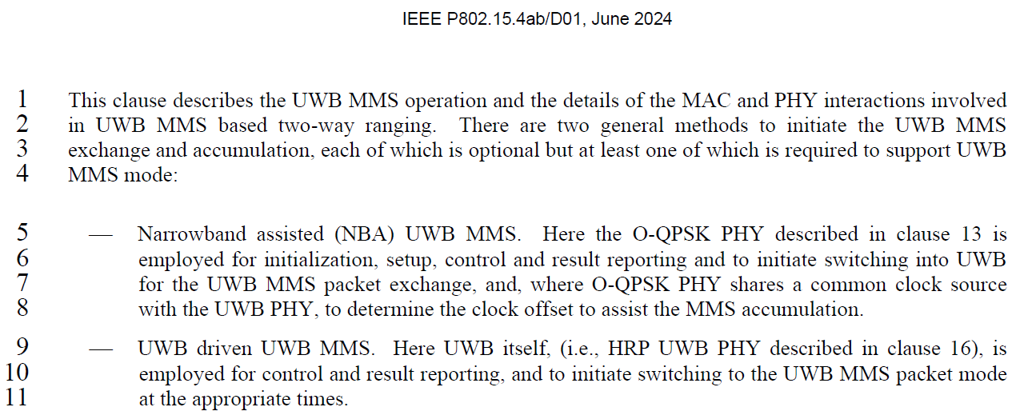
These reasons still hold:
The text already provides for the control phase poll and response messages (SP0 style packets in UWB-driven mode) to be used to get an initial estimation of timing offset. The SYNC+SFD fragment in the UWB-driven case can also be used for this purpose or to augment an estimate from the SP0 packet, so this fragment is not necessarily the source of the initial estimate, (except perhaps in the OOB case).
So, the proposed resolution is as follows:
Proposed Disposition: Rejected.
Disposition Detail: Although these lines were changed by 15-24-0139-05 the group later decided to apply 15-24-0221-04 to remove these lines, and the changes to P#67 L#35 for CID#1168 provide text that clarifies the role of the control phase packets in estimating the timing offset.
<END >

