**IEEE P802.15**

**Wireless Personal Area Networks**

|  |  |  |
| --- | --- | --- |
| Project | IEEE P802.15 Working Group for Wireless Personal Area Networks (WPANs) | |
| Title | **Proposed Resolution for CIR Report** | |
| Date Submitted | January 2025 | |
| Sources | Rojan Chitrakar, Lei Huang (Huawei)  [rojan.chitrakar@huawei.com](mailto:rojan.chitrakar@huawei.com) |  |
| Re: |  | |
| Abstract |  | |
| Purpose | To propose resolution for “P802.15.4ab™/D01 Draft Standard for Low-Rate Wireless Networks” | |
| Notice | This document does not represent the agreed views of the IEEE 802.15 Working Group or IEEE 802.15.4ab Task Group. It represents only the views of the participants listed in the “Sources” field above.It is offered as a basis for discussion and is not binding on the contributing individuals. The material in this document is subject to change in form and content after further study. The contributors reserve the right to add, amend or withdraw material contained herein. | |

Rev 0: Initial version: 11 CIDs

Rev 1: Disposition of CID 137 changed to REVISE (from Accept). Changed resolution for 266 to Revise (from Reject). Replaced figures 140, 141, 142.

|  |  |  |  |  |  |  |  |
| --- | --- | --- | --- | --- | --- | --- | --- |
| **Name** | **Index#** | **Pg** | **Sub-Clause** | **Ln** | **Comment** | **Proposed Change** | **Disposition** |
| Li-Hsiang Sun | 247 | 133 | 10.39.4.6.3 | 10 | Where the measurement ID is assigned? | Add in 10.39.4.2 that measurement ID is assigned in session setup phase | Revise |
| Li Ma | 203 | 133 | 10.39.4.6.3 | 22 | If Receive Report (RR) is compressed, and the RRD field only be present in the first part of Receive Report and not the second part , how does a receiver which only receives the second part knows what it receives contains a whole RR or just a second part of a RR | Add in Report Identity Ctrl, or Receive Report Ctrl an indication whether the RR is complete,a 1st part or a 2nd part.  Alternatively, move the reserved bits of Receive Report Description (RRD) can be moved to the front, and 1 bit can be used for the indication whether the RR is complete, a 1st part or a 2nd part, and RRD is included in each part of a receive report | Revise  A presence bit is added in the Receive Report Control field to indicate the presence/absence of the Receive Report Description field. |
| Li-Hsiang Sun | 248 | 133 | 10.39.4.6.3 | 22 | If Report is compressed, and the RRD field only is present in the first part of Receive Report and not the second part , how does a receiver who only receives the second part knows what it receives contains a whole RR or just a second part of a RR | Add in Report Identity Ctrl, or Receive Report Ctrl an indication whether the RR is complete,a 1st part or a 2nd part.  Alternatively, move the reserved bits of Receive Report Description (RRD) to the front, and 2 bits can be used for the indication whether the RR is complete, a 1st part or a 2nd part, and RRD is included in each part of a receive report | Revise  A presence bit is added in the Receive Report Control field to indicate the presence/absence of the Receive Report Description field. |
| Billy Verso | 1243 | 133 | 10.39.4.6.3 | 22 | "shall only" is not good, and second "present" is not needed either. | Change to "shall be present in the first part of the receive report and not in the second part." | Accept |
| Rojan Chitrakar | 137 | 134 | 10.39.4.6.3 | 6 | "… frame, the v is fragmented as described above." v should be "Receive Report Lists field" | replace "v" with "Receive Report Lists field " | Revise |
| Bin Qian | 175 | 134 | 10.39.4.6.3 | 6 | What is the meaning of v? | Specify the meaning of v | Revise  Resolved by resolution of CID 137. |

**Proposed text changes on P802.15.4ab™/D01:**

**10.39.4.6.3** **CIR measurement report Fragmentation**

***Modify the subclause as follows (Track changes ON)***

…

⎯ The Report Identity Control field shall be present in all CIR Report IE. Except the First Report

Fragment field and the Remaining Report Fragments field, each of the rest of the fields of the

Report Control field shall be set to the same value in all fragments. The Measurement ID field is assigned during session setup (10.39.4.2) and helps to identify all the fragments that belong to the same CIR measurement report. The First Report Fragment field and the Remaining Report Fragments field is used to keep track of the fragment order and is set as described in 10.39.6.2.

⎯ The Receive Report Lists field carry one or more receive reports that are arranged as described in in

10.39.6.2. Even when the receive reports are carried in multiple CIR Report IEs, the reports shall

follow the order described in 10.39.6.2 across all the fragments. The sub-fields of each receive

report are included as follows:

⎯ The Receive Report Description field shall be present in all receive reports except when a

receive report is divided into two parts and carried in two different CIR Report IEs. In that

case the Receive Report Description field shall be present in the first part of the receive

report and not present in the second part.

…

If compression is enabled (as indicated by the Compression field in the Report Parameters Control field of

the CIR Report IE), the CIR Taps field of each receive report shall be compressed individually using the

DEFLATE compressed data format described in IETF RFC 1951. If the size of the CIR Report IE still

exceeds the available space in the Payload field of the host frame, the Receive Report Lists field of the

CIR Report IE is fragmented as described above. An example fragmentation procedure when compression is enabled is illustrated in Figure 141.

***Replace Figure 140 with below:***

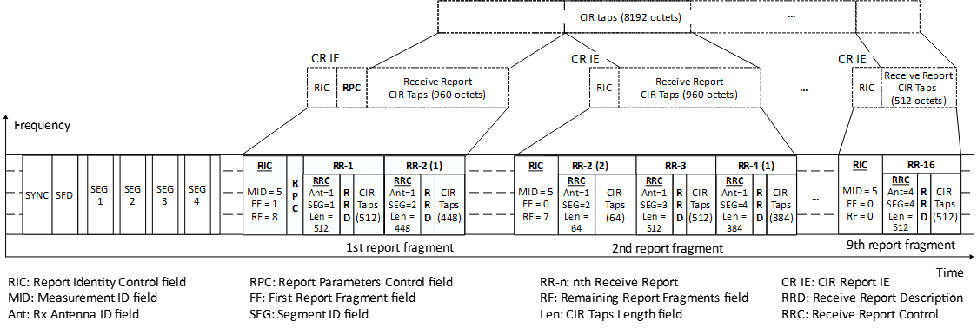

***Replace Figure 141 with below:***

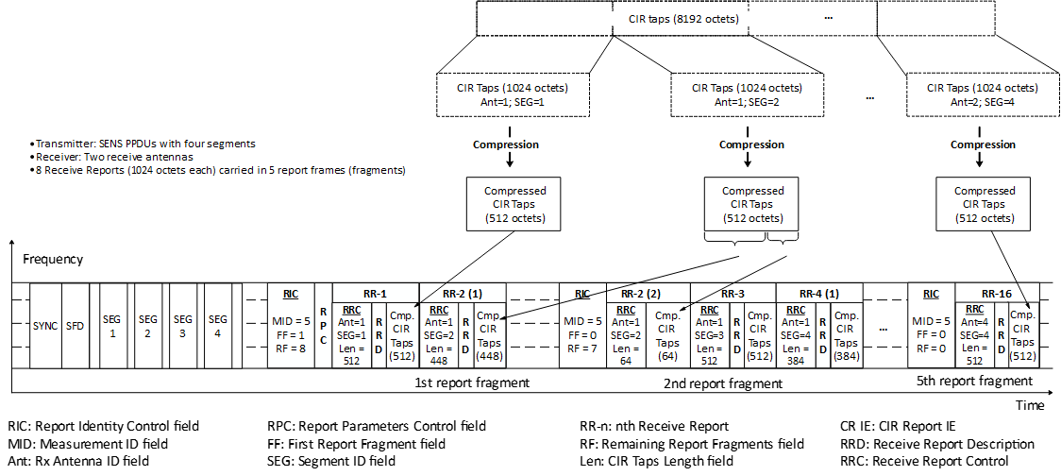

***Replace Figure 142 with below:***

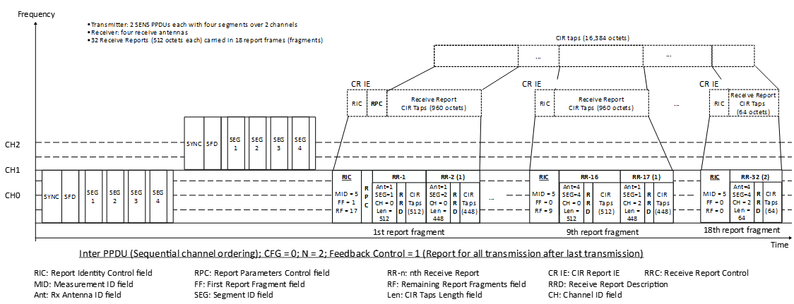

|  |  |  |  |  |  |  |  |
| --- | --- | --- | --- | --- | --- | --- | --- |
| **Name** | **Index#** | **Pg** | **Sub-Clause** | **Ln** | **Comment** | **Proposed Change** | **Disposition** |
| Li-Hsiang Sun | 266 | 153 | 10.39.6.2 | 13 | “The Responder Address field, when present, identifies the SDEV that generated the CIR report.” does not cover the case that responder is sensing transmitter and this is a SBP CIR report | add “or identifies the sensing transmitter when the initiator generated the CIR report” | Revise |
| Pablo Corbalán Pelegrín | 1317 | 153 | 10.39.6.2 | 13 | The Responder address may also be included in the MAC Header of the message. If this report is sent to the application together with the sender of the message, is the responder address field then needed? | Verify if the Responder Address field is indeed needed. If not, we may reconsider whether the addressing fields should be added or not. In any case, setting the Responder Address Mode to 00 means that no responder address is added. | Reject  The Responder Address field identifies the SDEV that generated the CIR report the Sensing by Proxy case, which may be different from the SDEV identified by the MAC header. |
| Mickael Maman | 87 | 155 | 10.39.6.2 | 16 | the channel ID of the receive report control field is currently limited to the 16 legacy channels. It should be extended to extended channels | update size of channel ID to 1 octet in figure 168 and add "The Channel ID field indicates the channel corresponding to the CIR taps when frequency stitching is enabled. Values in the range 0 to 15 refer to channels defined in Table 16-27 (HRP UWB PHY band allocation), while values 16 to 113 refer to the extended channel numbering as specified in 16.4.1.2" | Revise |
| Li-Hsiang Sun | 269 | 155 | 10.39.6.2 | 16 | How does Receive Report Control identify an aggregated CIR report? i.e. feedback ctrl value 2 | Please clarify | Revise  A bit “Report for aggregated Channel” is added in the RRC to identify report for aggregated channel |
| Carl Murray | 905 | 155 | 10.39.6.2 | 16 | The 'Channel ID' field only has 4 bits which is not sufficient to indicated the channel for frequency stitching as they can be aligned to 128.8 MHz offsets. | Change the 'Channel ID' field so that it incorporated the channels in section 16.4.1.2 and 11.1.3.5. | Revise |

**Proposed text changes on P802.15.4ab™/D01:**

**10.39.6.2 CIR Report IE**

***Modify the subclause as follows (Track changes ON)***

…

The Measurement ID field carries a unique ID that identifies a particular sensing measurement instance.

The Measurement ID may be used by the sensing initiator to identify reports corresponding to a particular

sensing measurement instance.

In SBP reporting, if the CIR report is generated by the sensing initiator, the Responder Address field, when present, identifies the sensing transmitter. Otherwise, the Responder Address field, when present, identifies the SDEV that generated the CIR report.

The Report Parameters Control field shall be formatted as shown in Figure 164.

…

Each receiver report in the Receive Report Lists field shall be formatted as shown in Figure 166.

|  |  |  |
| --- | --- | --- |
| Octets: 1, 2, 3 or 4 | 0 or 3 | Variable |
| Receive Report Control | Receive Report Description | CIR Taps |

**Figure 166—Format of an individual Receive Report field**

…

The Receive Report Control field shall be formatted as shown in Figure 168.

|  |  |  |  |  |  |  |  |
| --- | --- | --- | --- | --- | --- | --- | --- |
| Bits: 0-1 | 2-3 | 4 | 5 | 6 | 7 | Octets: 0 or 1 | 0 or 2 |
| Rx Antenna ID | Segment ID | Receive Report Description Present | Channel ID Present | Report for aggregated Channel | CIR Taps Length Present | Channel ID | CIR Taps Length |

**Figure 168—Receive Report Control field format**

The Rx Antenna ID field identifies the receive antenna corresponding to the CIR taps.

The Segment ID field identifies the Sensing PPDU SENS segment corresponding to the CIR taps.

The Receive Report Description Present field when one indicates that the Receive Report Description field is

present in the Receive Report field, or when zero that it is not present.

The Channel ID Present field when one indicates that the Channel ID field is present in the Receive Report Control field, or when zero that it is not present.

The Report for aggregated Channel field when one indicates the Receive Report field carries CIR taps for the aggregated channels using frequency stitching, or when zero that the Receive Report field carries CIR taps for a single channel.

The CIR Taps Length Present field when one indicates that the CIR Taps Length field is present in the Receive Report Control field, or when zero that it is not present.

The Channel ID field indicates the channel corresponding to the CIR taps when frequency stitching is

enabled and the receive report is not an aggregated report. Values in the range 0 to 15 refer to channels defined in Table 16-27 (HRP UWB PHY band allocation), values 16 to 113 refer to the extended channel numbering as specified in 16.4.1.2, while values 114 to 255 are reserved. The Channel ID field is not present when frequency stitching is not enabled or when frequency stitching is enabled but the receive report is an aggregated report.