**IEEE P802.15**

**Wireless Personal Area Networks**

|  |  |  |
| --- | --- | --- |
| Project | IEEE P802.15 Working Group for Wireless Personal Area Networks (WPANs) | |
| Title | **Proposed Resolution for MMS – Public part3** | |
| Date Submitted | Jan. 2025 | |
| Sources | Hong Won Lee (LG Electronics)  [hongwon.lee@lge.com](mailto:hongwon.lee@lge.com) |  |
| Re: |  | |
| Abstract |  | |
| Purpose | To propose resolution for “P802.15.4ab™/D01 Draft Standard for Low-Rate Wireless Networks” . | |
| Notice | This document does not represent the agreed views of the IEEE 802.15 Working Group or IEEE 802.15.4ab Task Group. It represents only the views of the participants listed in the “Sources” field above.It is offered as a basis for discussion and is not binding on the contributing individuals. The material in this document is subject to change in form and content after further study. The contributors reserve the right to add, amend or withdraw material contained herein. | |

This submission contains the proposed comment resolutions for the CIDs 58, 1363 and 1434

Rev 0: Initial version.

Rev 1: The resolution proposal for the CID 1363 is removed for offline discussion.

***Comment index #58 and #1434 in 15-24-0371-30-04ab-consolidated-comments-draft-1-0.xlsx***

|  |  |  |  |  |  |  |  |
| --- | --- | --- | --- | --- | --- | --- | --- |
| **Name** | **Index#** | **Pg** | **Sub-Clause** | **Ln** | **Comment** | **Proposed Change** | **Disposition** |
| Mickael Maman | 58 | 87 | 10.38.9.3.15 | 28 | SOR Time offset is between ADV conf and not ADV Poll | This is a four-octet, 32-bit field that specifies the time offset in 1/499.2 MHz resolution between the start of the Advertising Confirmation Compact frame, or the Public Advertising Confirmation Compact frame, and the start of the Start of Ranging Compact frame. | Revised |
| Lei HUANG | 1434 | 87 | 10.38.9.3.15 | 28 | The SOR Time Offset field indicates the time offset between the start of the Advertising Confirmation Compact frame and the start of the Start of Ranging Compact frame. | Change "the start of the Advertising Poll Compact frame, or the Public Advertising Poll Compact frame" to "the start of the Advertising Confirmation Compact frame". | Revised |

**Discussion**：Agree with commenters. The SOR Time Offset field is the start time between (Public) Advertising Confirmation Compact frame and (Public) Start of Ranging Compact frame. Additionally, regarding Time Offset defined in 10.38.9.3.14, the Public Start of Ranging Compact frame is missed

**Disposition: Revised**

**Disposition Detail:**

**Proposed text changes on P802.15.4ab™/D01:**

**- Original Text**

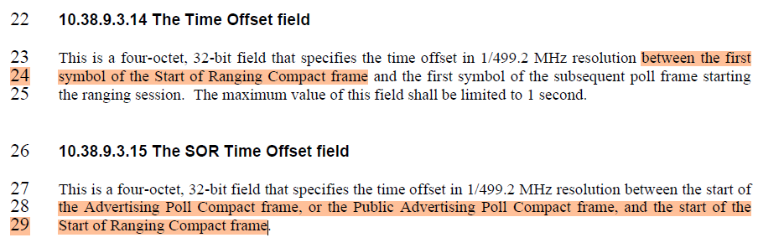

**- Proposed change**

***Change the sub-clause as follows (Track changes ON)***

**(*pp. 87 line #24*)**

This is a four-octet, 32-bit field that specifies the time offset in 1/499.2 MHz resolution between the first symbol of the Start of Ranging Compact frame, or the Public Start of Ranging Compact frame, and the first symbol of the subsequent poll frame starting the ranging session. The maximum value of this field shall be limited to 1 second.

**(*pp. 87 line #28*)**

This is a four-octet, 32-bit field that specifies the time offset in 1/499.2 MHz resolution between the start of the Advertising Confirmation Compact frame, or the Public Advertising Confirmation Compact frame, and the start of the Start of Ranging Compact frame.