**IEEE P802.15**

**Wireless Personal Area Networks**

|  |  |  |
| --- | --- | --- |
| Project | IEEE P802.15 Working Group for Wireless Personal Area Networks (WPANs) | |
| Title | **Proposed resolution for comment ID 417-420-421-424-444 on message sequence charts** | |
| Date Submitted | January 2025 | |
| Sources | Mickael Maman (STMicroelectronics) |  |
| Re: |  | |
| Abstract |  | |
| Purpose | To propose comments resolution for “P802.15.4ab™/D01 Draft Standard for Low-Rate Wireless Networks” | |
| Notice | This document does not represent the agreed views of the IEEE 802.15 Working Group or IEEE 802.15.4ab Task Group. It represents only the views of the participants listed in the “Sources” field above.It is offered as a basis for discussion and is not binding on the contributing individuals. The material in this document is subject to change in form and content after further study. The contributors reserve the right to add, amend or withdraw material contained herein. | |

***Comment Index #417-420-421-424 in 15-24-0371-31-04ab-consolidated-comments-draft-1-0***

|  |  |  |  |  |  |  |
| --- | --- | --- | --- | --- | --- | --- |
| **Name** | **Index #** | **Page** | **Sub-clause** | **Line #** | **Comment** | **Proposed Change** |
| Tero Kivinen | 417 | 61 | 10.38.3.5 | 7 | The figure 28 is good, but message sequence chart is also needed. | Add MSC for the one-to-one ranging exchange showing the MLME-calls done, i.e., how does the initiator higher layer indicate to which device it want to start the exchange with, and how do the initiator receive those ADV RESP packets. |
| Tero Kivinen | 420 | 62 | 10.38.3.5 | 2 | Message sequence chart is missing. | Add message sequence chart. |
| Tero Kivinen | 421 | 62 | 10.38.3.5 | 14 | Message sequence chart is missing. | Add message sequence chart. |
| Tero Kivinen | 424 | 62 | 10.38.3.5 | 22 | Message sequence chart is missing. | Add message sequence chart. |

**Discussion of comment ID 417-420-421-424:**

The reviewers requested several message sequence charts for contention-based initialization setup handshake:

* Example sessions initialization for one-to-one, coordination inactive,
* Example sessions initialization for one-to-one, coordination active,
* Example sessions initialization for multiple one-to-one ranging,
* Example sessions initialization for one-to-many ranging.

Fo the sake of simplicity, we provide a message sequence chart only for the first example.

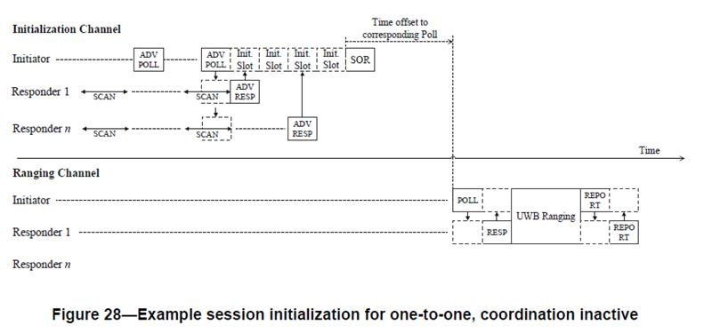

**Proposed resolution:**

**revised**

**Proposed text changes on P802.15.4ab™/D01 for comment ID 417-420-421-424:**

**Insert after Figure 28 page 61 line 10**

Figure XXX shows the message sequence chart for the contention-based initialization setup handshake for one to one ranging with coordination inactive as illustrated in Figure 28. The advertising Poll compact frame may include the Initialization Slot Duration field and/or the CAP Duration field specifying the duration of an initialization slot and the number of initialization slot of the contention access period respectively. After the reception of the advertising Poll compact frame, the higher layer may update these two parameters with MLME-SET primitives. In this example, the CAP duration is 4 initialization slots. Similarly, the long term PHY and MAC operating parameters may be updated after Start of Ranging compact frame reception.

**Figure XXX: Message sequence charts for the contention-based initialization setup handshake for one-to-one ranging with coordination inactive as illustrated in Figure 28**

***Comment Index #417-420-421-424-444 in 15-24-0371-31-04ab-consolidated-comments-draft-1-0***

|  |  |  |  |  |  |  |
| --- | --- | --- | --- | --- | --- | --- |
| **Name** | **Index #** | **Page** | **Sub-clause** | **Line #** | **Comment** | **Proposed Change** |
| Tero Kivinen | 444 | 67 | 10.38.4.1 | 35 | How is this short term operating parameter update done inside the device? | Provide message sequence chart that shows what MLME calls are needed to set things up. |

**Discussion of comment ID 444:**

When the responder receives a poll Compact frame from the initiator including short-term operating parameters, the device updates the corresponding PIB with MLME-SET primitive as defined in DCN552 and DCN0444.

**Proposed resolution:**

**Rejected**

**Proposed text changes on P802.15.4ab™/D01 for comment ID 444:**

**None**