**IEEE P802.15**

**Wireless Personal Area Networks**

|  |  |  |
| --- | --- | --- |
| Project | IEEE P802.15 Working Group for Wireless Personal Area Networks (WPANs) | |
| Title | **Proposed Text for Draft 1.0 Comment Resolution – Hyper block related comments resolutions proposal** | |
| Date Submitted | November 12, 2024 | |
| Sources | Youngwan So (SAMSUNG Electronics)  [youngwan.so@samsung.com](mailto:youngwan.so@samsung.com) |  |
| Re: |  | |
| Abstract |  | |
| Purpose | To propose resolution for miscellaneous hyper block related comments for “P802.15.4ab™/D1.0 Draft Standard for Low-Rate Wireless Networks” . | |
| Notice | This document does not represent the agreed views of the IEEE 802.15 Working Group or IEEE 802.15.4ab Task Group. It represents only the views of the participants listed in the “Sources” field above.It is offered as a basis for discussion and is not binding on the contributing individuals. The material in this document is subject to change in form and content after further study. The contributors reserve the right to add, amend or withdraw material contained herein. | |

Rev 0: Initial version. Addressed below comments (in numerical order : Totally 25)

* 3, 4, 5, 185, 217, 366, 940, 1072, 1073, 1074,
* 1077, 1078, 1079, 1081, 1082, 1083, 1088, 1089, 1090, 1091,
* 1092, 1093, 1331, 1385, 1440

Rev 1: Rev 0 was uploaded as broken. Rev 1 is recovered version.

Rev 2: Minor updates.

***Comment Indices in 15-24-0371-01-04ab-consolidated-comments-draft-1.0:***

|  |  |  |  |  |  |  |  |
| --- | --- | --- | --- | --- | --- | --- | --- |
| **Disposition Detail:** | **Index#** | **Pg** | **Sub-Clause** | **Ln** | **Comment** | **Proposed Change** | **Disposition** |
| Alex Krebs | 1385 | 42 | 10.32.2 | 26-30 | RCP and RRP definitions are valid for O2O ranging only, O2M ranging does generally not follow these conventions. | Change page 56, line 8-9 to:  For one-to-one ranging with one initiator and one responder a UWB MMS ranging exchange consists of consecutive control phase, ranging phase, and a report phase, as illustrated in Figure 25. | Accepted |

**Disposition Detail:**

Accepted. The following is the relevant section captured. Multiple responders bring multiple rangings and multiple reportings. So it’s not true if we say “a UWB MMS ranging exchange consists of a control phase, a ranging phase and a report phase.”

***P42L26-30***

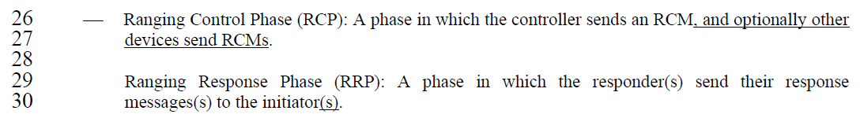

***P56L8-9***

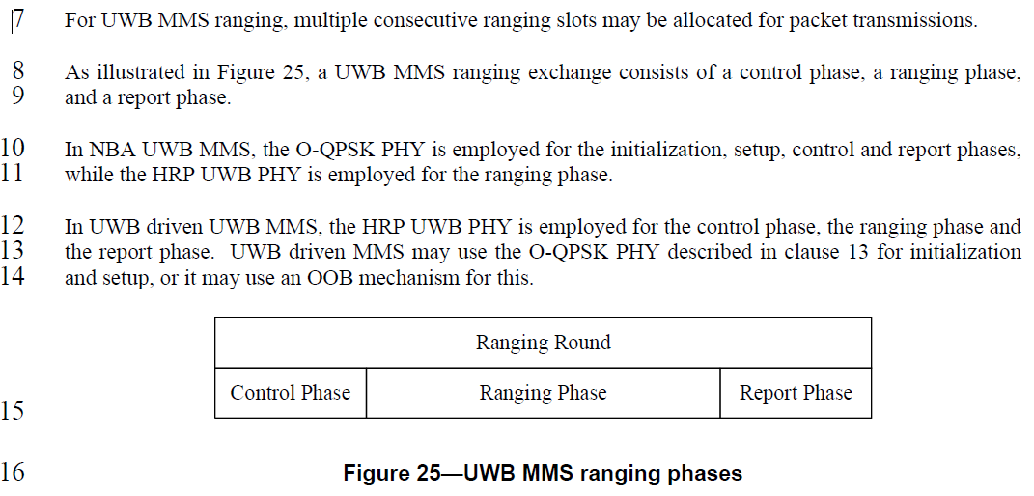

**Proposed text changes on P802.15.4ab™/Draft 1.0 :**

***Change the chapter 10.32.2 P56L8 as follows:***

, For one-to-one ranging with one initiator and one responder, a UWB MMS ranging exchange consists of consecutive a control phase, a ranging phase, and a report phase as illustrated in Figure 25.

***Comment Indices in 15-24-0371-01-04ab-consolidated-comments-draft-1.0:***

|  |  |  |  |  |  |  |  |
| --- | --- | --- | --- | --- | --- | --- | --- |
| **Name** | **Index#** | **Pg** | **Sub-Clause** | **Ln** | **Comment** | **Proposed Change** | **Disposition** |
| Billy Verso | 1074 | 43 | 10.32.3.5 | 16 | "The HBS IE takes effects from the corresponding hyper block where HBS IE exists." is strange language. "Effects" should be singular, but I think the intent could be conveyed more clearly, something like the proposed change. | Change to: "The RCM with the HBS IE is sent at the start of the hyper block, and this immediately conveys the hyper block structure configuration for current hyper block, i.e., the hyper block beginning with the slot carrying the RCM." | Accepted |
| Srivathsa Masthi Parthasarathi | 217 | 43 | 10.32.3.5 | 16, 17 | inconsistent implementation can happen with the statement - The HBS IE takes effects from the corresponding hyper block where HBS IE exists | The specification can keep it simple if the statement is - The Controlee shall follow the hyperblock structure when HBS IE is transmitted | Revised |

**Disposition Detail:**

The following is the corresponding section (FYI).

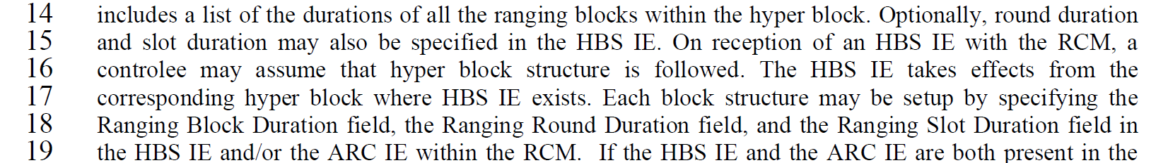

Accepted. The effects should be singular and I agree the proposed text is simple and is more likely to avoid confusion.

**Proposed text changes on P802.15.4ab™/Draft 1.0 :**

***Change the chapter 10.32.3.5 P43L16 as follows:***

includes a list of the durations of all the ranging blocks within the hyper block. Optionally, round duration and slot duration may also be specified in the HBS IE. On reception of an HBS IE with the RCM, a controlee may assume that hyper block structure is followed. The RCM with the HBS IE is sent at the start of the hyper block, and this immediately conveys the hyper block structure configuration for current hyper block, i.e., the hyper block beginning with the slot carrying the RCM. Each block structure may be setup by specifying the Ranging Block Duration field, the Ranging Round Duration field, and the Ranging Slot Duration field in the HBS IE and/or the ARC IE within the RCM.

***Comment Indices in 15-24-0371-01-04ab-consolidated-comments-draft-1.0:***

|  |  |  |  |  |  |  |  |
| --- | --- | --- | --- | --- | --- | --- | --- |
| **Name** | **Index#** | **Pg** | **Sub-Clause** | **Ln** | **Comment** | **Proposed Change** | **Disposition** |
| Billy Verso | 1072 | 43 | 10.32.3.5 | 12 | It is difficult to interpret "may be" in terms of what is required or not for hyper block mode. Alternatives that could be permitted is sending RCM in first slot without the HBS IE, not sending RCM at all, or sending it in other slots, or ff the first slot is defined by the presence of the HBS IE | Rewrite paragraph/clause be more definite in specifying what constitutes a hyper block. For instance, if it is the RCM with HBS IE, in slot 0 then say that. | Revised |
| Billy Verso | 1077 | 43 | 10.32.3.5 | 23 | This paragraph suggests that HBS IE is sent in every hyper block (so the "may" in the first line of precious paragraph should be a shall. | If I am right make it a "Shall", i.e., "In hyper block mode the RCM with HSB IE shall be sent …." | Revised |

**Disposition Detail:**

The following is the corresponding section captured for convenience.

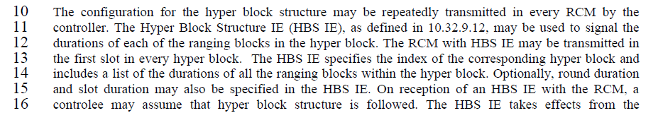

Agree with both comments in that there are excessive number of “MAY” expression, not being definite. I know it is not good for standard document as it increases ambiguity if we allow too many “MAY”. I just intended not to be much constraning in this initial phase but document progress was quite fast than expected. Rewrote the paragraph with more definite terms regarding what is required or not. And it seems CID#1077 is pointing P43L10 NOT P43L23. If this is correct, proposed text is as below.

**Proposed text changes on P802.15.4ab™/Draft 1.0 :**

***Change the chapter 10.32.3.5 P43L12 as follows:***

In hyper block mode, the Hyper Block Structure IE (HBS IE), shall be transmitted in RCM that shall be sent at the very first slot of each hyper block by the controller. The HBS IE, as defined in 10.32.9.12, is used to configure the hyper block structure by signaling the durations of each of the ranging blocks, rounds and slots in the hyper block. The HBS IE specifies the index of the corresponding hyper block and includes a list of the durations of all the ranging blocks round duration and slot durations The HBS IE takes effects from the first hyper block where HBS IE begin to exist. Each block structure shall be setup by specifying the Ranging Block Duration field, the Ranging Round Duration field, and the Ranging Slot Duration field in the HBS IE and/or the ARC IE within the RCM. If the HBS IE and the ARC IE are both present in the same RCM, the ranging parameters are jointly configured by the HBS IE and the ARC IE.And if there are common parameters in both ARC IE and HBS IE, these corresponding overlapping parameter values shall be the same. The hyper block structure is determined by the next higher layer or out of band.

***Comment Indices in 15-24-0371-01-04ab-consolidated-comments-draft-1.0:***

|  |  |  |  |  |  |  |  |
| --- | --- | --- | --- | --- | --- | --- | --- |
| **Name** | **Index#** | **Pg** | **Sub-Clause** | **Ln** | **Comment** | **Proposed Change** | **Disposition** |
| Billy Verso | 1073 | 43 | 10.32.3.5 | 15 | Not really sure what the purpose of this sentence "On reception of an HBS IE with the RCM, a controlee may assume that hyper block structure is followed.", it does not read well, and is hard to understand. Is the "with the RCM" needed, I think HSB IE is included in the RCM so this "with" is strange. "May assume" is also strange. Is it defining receiver behaviour. Better to specify the transmitter controller behaviour using "SHALL" and not have the receiver assuming something | Rewrite the sentence to address the points of the comment or if it is not necessary then delete it. | Revised |

**Disposition Detail:**

The following is the corresponding section captured for convenience.

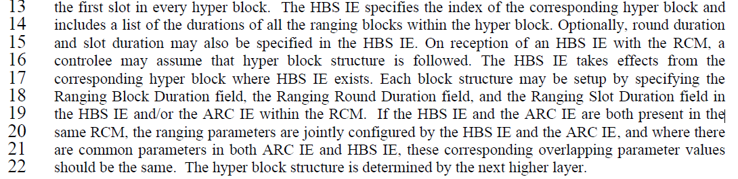

Revised. The original intention of the sentence “*On reception of an HBS IE with the RCM, a controlee may assume that hyper block structure is followed."* was to describe how the controlees know the hyper block mode starts. The answer is controlee can know beginning of hyper block mode by identifying the presence of HBS IE within RCM. Once hyper block mode starts and HBS IE is sent, the controller should keep to send it at the very first slot of every hyper block. But it seems my expression brought confusion. So I revised the text so to make it rather clearer and to make it as more transmitter-side behaviour, as was also commented in other CIDs.

**Proposed text changes on P802.15.4ab™/Draft 1.0 :**

***Change the chapter 10.32.3.5 P43L15 as follows:***

The configuration for the hyper block structure may be repeatedly transmitted in every RCM by the controller. The Hyper Block Structure IE (HBS IE), as defined in 10.32.9.12, may be used to signal the durations of each of the ranging blocks in the hyper block. The RCM with HBS IE may be transmitted in the first slot in every hyper block. The HBS IE specifies the index of the corresponding hyper block and includes a list of the durations of all the ranging blocks within the hyper block. Optionally, round duration and slot duration may also be specified in the HBS IE. To announce the start of hyper block mode, the controller shall send an HBS IE and keep transmitting HBS IE at the very first slot of every hyper block till the hyper block mode finishes. The HBS IE takes effects from the corresponding hyper block where HBS IE exists.

***Comment Indices in 15-24-0371-01-04ab-consolidated-comments-draft-1.0:***

|  |  |  |  |  |  |  |  |
| --- | --- | --- | --- | --- | --- | --- | --- |
| **Name** | **Index#** | **Pg** | **Sub-Clause** | **Ln** | **Comment** | **Proposed Change** | **Disposition** |
| Billy Verso | 1078 | 43 | 10.32.3.5 | 26 | Now as I read this it seems there could be an HBS IE in each sub-block of the hyper-block, which perhaps modifies some of my earlier comments. I guess the "block index" referred to on this line what is referenced by the "Relative Block Index" in the Ranging Block Description List. This is complex, maybe a worked example would make it clearer. | Add an annex (referred to from this clause) with a detailed worked example showing where RCM and HBS IE may be sent and the content of the various fields of the HBS IE that are relevant to defining the hyper block scheduling operation | Revised |

**Disposition Detail:**

The following is the corresponding section captured for convenience.

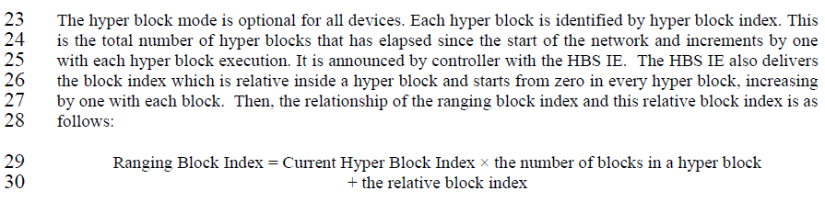

Revised. Again, I also agree with the comments in principle. HBS IE is sent in the very first slot of every hyper block. The example can be as below.

**Proposed text changes on P802.15.4ab™/Draft 1.0 :**

***Change the chapter 10.32.3.5 P43L23 as follows:***

The hyper block mode is optional for all devices. Each hyper block is identified by hyper block index. This is the total number of hyper blocks that has elapsed since the start of the hyper block mode and increments by one with a hyper block execution. It is announced by controller with the HBS IE. The HBS IE also delivers the block index which is relative inside a hyper block and starts from zero in every hyper block, increasing by one with each block. Then, the relationship of the ranging block index and this relative block index is as follows:

Ranging Block Index = Current Hyper Block Index × the number of blocks in a hyper block

+ the Relative Block Index

***Add below paragraph after the chapter 10.32.3.5 P43L30 or as Annex :***

The Figure 7-a shows an example of Hyper Block structure and its indexing instance. This example shows a case that a Hyper Block is comprised of three blocks, where each of which block is comprised of three, six and one rounds in order, respectively. The very first round (round 0) of the Hyper Block 0 has five slots as an example and RCM having HBS IE shall be sent in the very first slot (slot 0) of the round 0 of each Hyper Block at least once.

Basically this hyper block structure repeats even though example in Figure 7-a shows just three Hyper Blocks only. The Relative Block Index is indicating the index of a certain block within a Hyper Block. That value resets to zero whenever the next Hyper Block starts and the index value increases again by one as the next block comes.

The Figure 7-a shows an example that the Relative Block Index increase from zero to two till it meets end of the Hyper Block. On the other hand, Block Index is an index value counting the number of Blocks passed from the very first Block of the Hyper Block 0, so it does not reset even when the next Hyper Block appears. Figure 7-a example shows the Block Index increases from zero to eight, while Relative Block Index resets to zero every time it meets start of the next Hyper Block.

The Relative Block Index is to identify the order of a certain block inside a hyper block, whereas Block Index is to identify the absolute order of a certain block.

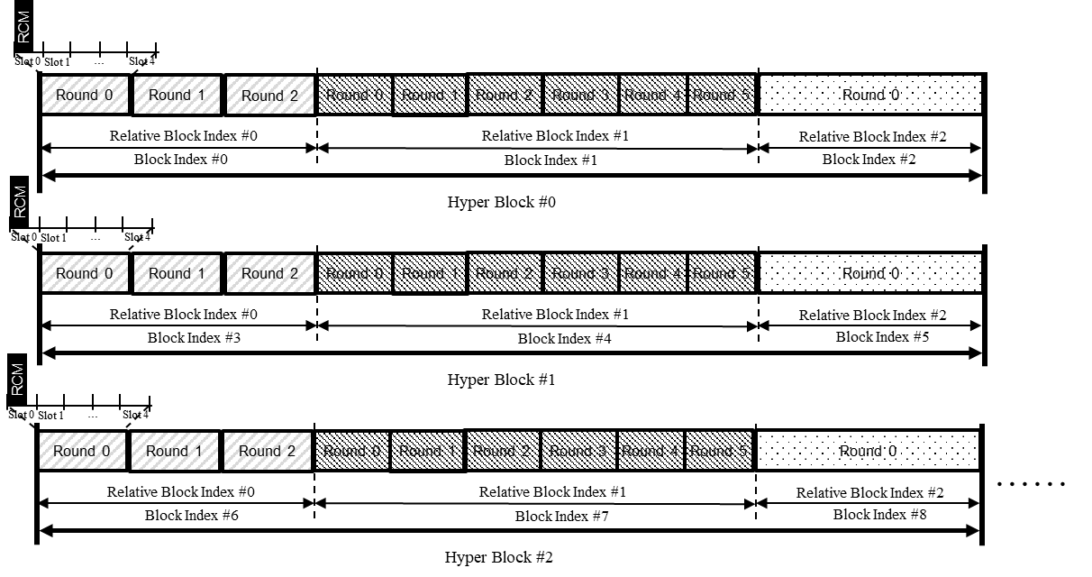

Figure 7-a- Example of Hyper Block structure and block indexing

The Figure 7-b shows an example of HBS IE content for Hyper Block Structure instance in Figure 7-a. This example shows a HBS IE sent just for Hyper Block 0 case. Therefore, it has Hyper Block Index value of zero (0x0000).

This HBS IE carries round duration and slot duration as well inside the Ranging Block Description List Fields, so both of Ranging Round/Slot Duration Present flags are set one. And RSTU is used as Block duration field unit, so Ranging Block Duration Units field is set to two (0b10) based on Table 12..

Hyper Block 0 is comprised of three Blocks as an example, so Ranging Block Description List Length field value is three (0x03). And each Block is assumed to have the round which is five (0x05) slots long (Block 0 case), fifteen (0x0F) slots long (Block 1 case) and fifty (0x32) slots long (Block 2 case) respectively. Then, Duration of Block 0 is 18,000 RSTU (= 1200 RSTU/slot × 5 slot/round × 3 round/block) and Duration of Block 1 is 108,000 RSTU (= 1200 RSTU/slot × 15 slot/round × 6 round/block) and finally Duration of Block 2 is 60,000 RSTU (= 1200 RSTU/slot × 50 slot/round × 1 round/block)

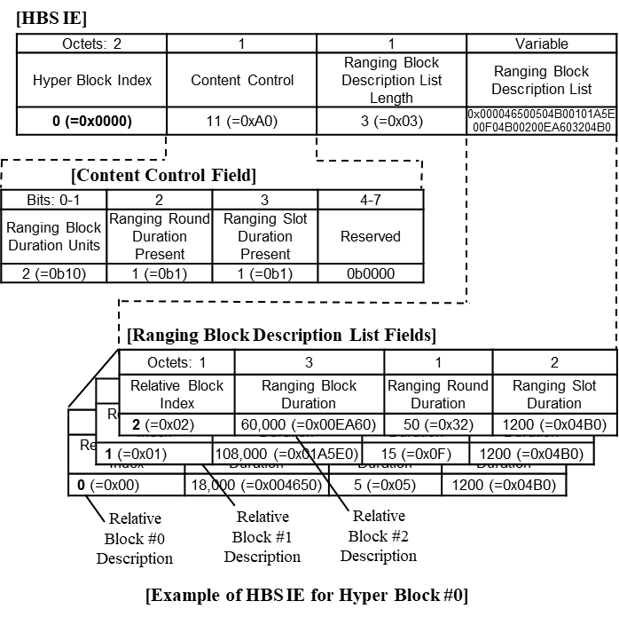

Figure 7-b- Example of HBS IE content

***Comment Indices in 15-24-0371-01-04ab-consolidated-comments-draft-1.0:***

|  |  |  |  |  |  |  |  |
| --- | --- | --- | --- | --- | --- | --- | --- |
| **Name** | **Index#** | **Pg** | **Sub-Clause** | **Ln** | **Comment** | **Proposed Change** | **Disposition** |
| Zhenzhen Ye | 3 | 43 | 10.32.3.5 | 8 | Is it mandtory to require successive hyper blocks to have the same configuration? With HBS IE, the configuration can be changed. | change to "while successive hyper blocks may employ the same configuration" | Rejected |
| Zhenzhen Ye | 4 | 43 | 10.32.3.5 | 27-30 | The formulation of the (absolute) ranging block index doesn't work if there is a hyper block configuration change |  | Rejected |
| Zhenzhen Ye | 5 | 44 | 10.32.3.5 | 5 | hyper block doesn't have to keep the same structure in every hyper block if HBS IE specify a new hyper block configuration. | change to "The hyper block may keep the same structure repeated in every hyper block." | Rejected |

**Disposition Detail:**

The following is the corresponding section captured for conveniences.

**[P43L8]**

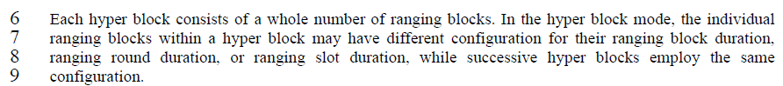

**[P43L27-30]**

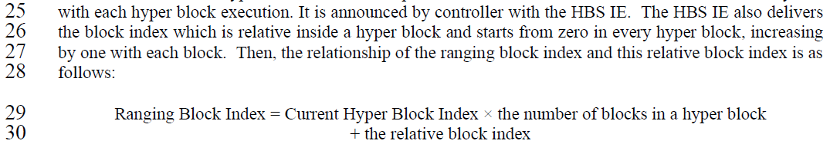

**[P44L5]**



Rejected. Comments concerning that hyper block configuration change will make the indexing formulation invalid. The successive hyper blocks have the same configuration to make this mode simple. It’s possible the hyper block configuration can be changed by changing field values in HBS IE. But, that is a creation of new session rather than a configuration change.

**Proposed text changes on P802.15.4ab™/Draft 1.0 :**

**None**

***Comment Indices in 15-24-0371-01-04ab-consolidated-comments-draft-1.0:***

|  |  |  |  |  |  |  |  |
| --- | --- | --- | --- | --- | --- | --- | --- |
| **Name** | **Index#** | **Pg** | **Sub-Clause** | **Ln** | **Comment** | **Proposed Change** | **Disposition** |
| Billy Verso | 1079 | 44 | 10.32.3.5 | 3 | Sentence "Different blocks within a hyper block may be allocated for different applications such as ranging or sensing or data communications." seems to be saying it is block level allocation, is there a real allocation mechanism defined that only requests/grants blocks to different devices, a reference to this scheme would be good to include here. However, if it is a more informal method and not block level, then more informal language would be appropriate, and indeed perhaps mentioning that the allocation methods are not defined. | Change to: "Different parts of the hyper block may be used for different applications such as ranging or sensing or data communications. The mechanisms for assigning these are not defined within this standard." | Agreed |

**Disposition Detail:**

The following is the corresponding text captured for convenience.

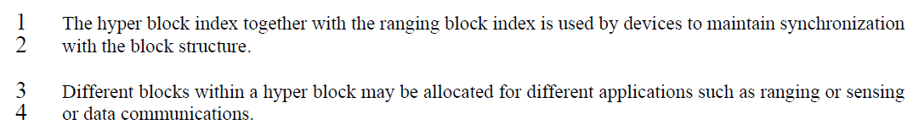

It may look like block-level assignment in some cases, but didn’t intend block-level assignment is a sole way. How to assign is not defined here.

**Proposed text changes on P802.15.4ab™/Draft 1.0 :**

***Change the chapter 10.32.3.5 P44L3 as follows:***

The hyper block index together with the ranging block index is used by devices to maintain synchronization with the block structure.

Different parts of the hyper block may be used for different applications such as ranging or sensing or data communications. The mechanisms for assigning these are not defined within this standard.

***Comment Indices in 15-24-0371-01-04ab-consolidated-comments-draft-1.0:***

|  |  |  |  |  |  |  |  |
| --- | --- | --- | --- | --- | --- | --- | --- |
| **Name** | **Index#** | **Pg** | **Sub-Clause** | **Ln** | **Comment** | **Proposed Change** | **Disposition** |
| Billy Verso | 1081 | 44 | 10.32.3.5 | 8 | The methods defined here are a little confusing saying the controlee "may" do something. A "shall" would be more appropriate, except it is probably actually the next higher layer that is taking the decision and we should not be mandating its behaviour. Perhaps the text be reduced a lot or made clearer if it was defined from the transmitter's perspective. | Rewrite the behaviours to describe transmitter operation not receivers. The controller may set field xxx to value yyy to request that the controller hops into ….." | Revised |
| Billy Verso | 1082 | 44 | 10.32.3.5 | 8 | If hyper block is really something to be used and understood by the layers above the MAC, then perhaps the body of the text here could be much shorter, and just say something like the HBS IE is defined to allow next-higher layers coordinate the used of the medium.... it has fields that allow request of xxxx, and yyyy, etc. Could give specific examples in an informative annex, rather than a normative clause with non-normative "may" which are hard to understand the behaviour. | Consider much simpler specification, with examples of use referenced and placed in an annex or an separate mentor document.. | Revised |
| Billy Verso | 1083 | 44 | 10.32.3.5 | 13 | Again use of "may"…. Should it be "should"? I think this is really next higher layer behaviour being specified in the wrong place. Another one on line 16 | Consider much simpler specification, with examples of use referenced and placed in an annex or an separate mentor document.. | Revised |
| Huan-Bang Li | 1440 | 44 | 10.32.3.5 | 22 | replace 'm not equal to p' by 'm does not equal to p'. | make change. | Agreed |

**Disposition Detail:**

The following is the corresponding text captured for conveniences.

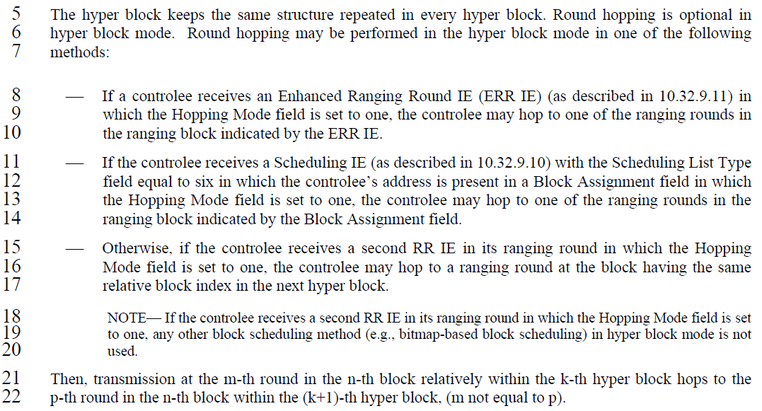

Agree with all the comments above. Revised the text as suggested.

Mostly change from MAY to SHALL; and Receiver behaviour to Transmitter behaviour;

**Proposed text changes on P802.15.4ab™/Draft 1.0 :**

***Change the chapter 10.32.3.5 P44L8-22 as follows:***

The hyper block keeps the same structure repeated in every hyper block. Round hopping is optional in hyper block mode. Round hopping can be performed in the hyper block mode in one of the following methods:

⎯ The controller may set field Hopping Mode in an Enhanced Ranging Round IE (ERR IE) (as described in 10.32.9.11) to value one to request that the controlee hop into one of the ranging rounds in the ranging block indicated by the ERR IE.

⎯ The controller may set Scheduling List Type field in a Scheduling IE (as described in 10.32.9.10) to value six in which the controlee’s address is present in a Block Assignment field in which the Hopping Mode field is set to one, to request the controlee hop into one of the ranging rounds in the ranging block indicated by the Block Assignment field.

⎯ Otherwise, The controller may set the Hopping Mode field at a second RR IE in its ranging round to value one to request the controlee hop into a ranging round at the block having the same relative block index in the next hyper block.

.

NOTE— If the controlee receives a second RR IE in its ranging round in which the Hopping Mode field is set to one, any other block scheduling method (e.g., bitmap-based block scheduling) in hyper block mode is not used.

Then, transmission at the m-th round in the n-th block relatively within the k-th hyper block hops to the p-th round in the n-th block within the (k+1)-th hyper block, (m does not equal to p).

***Comment Indices in 15-24-0371-01-04ab-consolidated-comments-draft-1.0:***

|  |  |  |  |  |  |  |  |
| --- | --- | --- | --- | --- | --- | --- | --- |
| **Name** | **Index#** | **Pg** | **Sub-Clause** | **Ln** | **Comment** | **Proposed Change** | **Disposition** |
| Youngwan So | 940 | 45 | 10.32.3.5 | 1 | The Hyper Block Advertisement (HBA) round is optional feature. However "at least once" looks to give an impression that HBA is mandatory. | Remove "at least once" | Agreed |

**Disposition Detail:**

The following is the corresponding section (FYI).

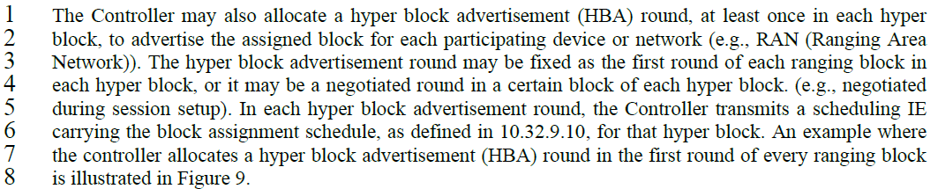

**Proposed text changes on P802.15.4ab™/Draft 1.0 :**

***Change the chapter 10.32.3.5 P43L12 as follows:***

The Controller may also allocate a hyper block advertisement (HBA) round, in each hyper block, to advertise the assigned block for each participating device or network (e.g., RAN (Ranging Area Network)). The hyper block advertisement round may be fixed as the first round of each ranging block in each hyper block, or it may be a negotiated round in a certain block of each hyper block. (e.g., negotiated during session setup). In each hyper block advertisement round, the Controller transmits a scheduling IE carrying the block assignment schedule, as defined in 10.32.9.10, for that hyper block. An example where the controller allocates a hyper block advertisement (HBA) round in the first round of every ranging block is illustrated in Figure 9.

***Comment Indices in 15-24-0371-01-04ab-consolidated-comments-draft-1.0:***

|  |  |  |  |  |  |  |  |
| --- | --- | --- | --- | --- | --- | --- | --- |
| **Name** | **Index#** | **Pg** | **Sub-Clause** | **Ln** | **Comment** | **Proposed Change** | **Disposition** |
| Tero Kivinen | 366 | 46 | 10.32.9.3 | 2 | The section 10.38.9.3.20 defines round index as 8-bit field and the security restricts it to 8-bit field. Here the round index is 14 bit field. | Change Round Index to 8-bit field. | Revised |
| Billy Verso | 1089 | 46 | 10.32.9.3 | 7 | "Hyper Block Index" (if it is not a field name) should be lower case. | If it is a field add "field" otherwise make it lower case. | Accepted |
| Wenzheng Li | 185 | 46 | 10.32.9.3 | 8 | "the Ranging Block Index field is assumed to specify Hyper Block Index for the  ranging hyper block and controlee may assume the block index will be the same with previous hyper block"  the last block index in this sentence should be relative block index | the Ranging Block Index field is assumed to specify Hyper Block Index for the  ranging hyper block and controlee may assume the relative block index will be the same with previous hyper block | Revised |
| Billy Verso | 1088 | 46 | 10.32.9.3 | 7 | The sentence beginning "In hyper block mode …" says defines a particular case where, "Ranging Block Index field is assumed to specify Hyper Block Index" which is strange, can we not specify the behaviour. | Change to say "the Ranging Block Index field shall specify the hyper block index"" | Accepted |
| Billy Verso | 1090 | 46 | 10.32.9.3 | 7 | "the Ranging Block Index field is assumed to specify Hyper Block Index", (I assume by the receiver), maybe could be more definite and specify it from the transmitter perspective | Change to the "Ranging Block Index field specifies the Hyper Block Index" | Accepted |
| Billy Verso | 1091 | 46 | 10.32.9.3 | 8 | "controlee may assume" is strange…can we turn int into controller/transmitter perspective, or otherwise make a more definitive statement.. | Unless explicitly rescheduled the controlee block index assignments are the same in each hyper block" | Accepted |
| B. Rolfe | 1331 | 46 | 10.32.9.3 | 8 | " may assume" might be read wrong. DO we mean unless the information is updated for the current hyperblock,use the values from the prior hyperblock? | In hyper block mode when neither block assignment scheduling nor Bitmap-based block scheduling is used, the Ranging Block Index field is specifies the Hyper Block Index for the ranging hyper block. Unless updated for the current Hyper Block, the controlee shall use the block index from the previous hyper block | Accepted |
| Billy Verso | 1092 | 46 | 10.32.9.3 | 9 | Should define how hyper block index is conveyed in those other two hyper block modes, where either block assignment scheduling or bitmap-based block scheduling is used, (or reference where the details are specified). | Add description as per comment, or reference where it is. | Accepted |

**Disposition Detail:**

The following is the corresponding texts.

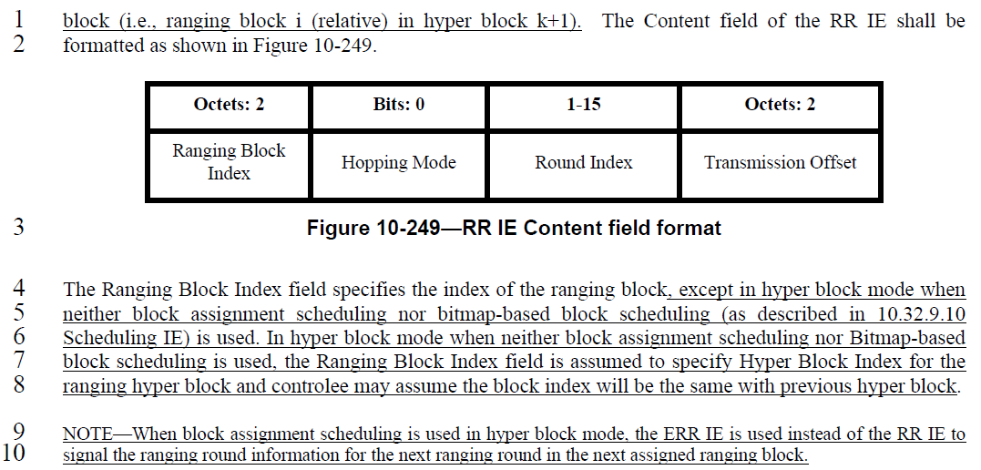

**CID #366**

Revised. RR IE was originally defined in 4z amendment and Round Index was assigned with 15 bits (see below captured from 4z spec.). So if we change Round Index into 8-bits field, we violate backward compatibility. It’s true that Round Index in hyper block mode just uses 8 bits, so we can allocate and use just lower 8 bits only from 15 bits-long Round Index field of RR IE in case of hyper block mode.



**[RR IE Captured from 4z amendment]**

**CID #1089, 185**

Accepted and revised. Technical editorial. The “Hyper Block Index” is a field name.

**CID #1088, 1090, 1091, 1331**

Accepted. Changed text into transmitter perspective operation. And changed “May” into “Shall” operation.

**CID #1092**

Accepted. In “Block Assignment Scheduling”, the hyper block index is signalled by “HBS IE or ERR IE”, and in case of “Bitmap-based block scheduling, the hyper block index is conveyed by “HBS IE”.

**Proposed text changes on P802.15.4ab™/Draft 1.0 :**

***Change the chapter 10.32.9.3 P46L7 & P46L13 as follows:***

The Content field of the RR IE shall be formatted as shown in Figure 10-249.

|  |  |  |  |
| --- | --- | --- | --- |
| Octets:2 | Bits: 0 | 1-15 | Octets: 2 |
| Ranging Block Index | Hopping Mode | Round Index | Transmission Offset |

**Figure 10-249—RR IE Content field format**

The Ranging Block Index field specifies the index of the ranging block, except in hyper block mode with hopping enabled when neither block assignment scheduling nor bitmap-based block scheduling (as described in 10.32.9.10 Scheduling IE) is used. In hyper block mode with hopping, when neither block assignment scheduling nor Bitmap-based block scheduling is used, the Ranging Block Index field specifies Hyper Block Index field for the ranging hyper block Unless explicitly rescheduled, the controlee block index assignments are the same in each hyper block.

NOTE—When block assignment scheduling is used in hyper block mode, the ERR IE is used instead of the RR IE to signal the ranging round information for the next ranging round in the next assigned ranging block. In “Block Assignment Scheduling”, the hyper block index is signalled by “HBS IE or ERR IE”, and in case of “Bitmap-based block scheduling, the hyper block index is conveyed by “HBS IE”

***……..***

The Round Index field specifies the ranging round index for the ranging block. In case of hyper block mode, only lower 8 bits are used to specify the block index.

***Comment Indices in 15-24-0371-01-04ab-consolidated-comments-draft-1.0:***

|  |  |  |  |  |  |  |  |
| --- | --- | --- | --- | --- | --- | --- | --- |
| **Name** | **Index#** | **Pg** | **Sub-Clause** | **Ln** | **Comment** | **Proposed Change** | **Disposition** |
| Billy Verso | 1093 | 46 | 10.32.9.10 | 22 | "schedule blocks or slots to be used by intended device" I am assuming an assignment is for the purpose of transmission only , but worth saying if this IE is also scheduling reception if that is the case add "and receptions" to my proposed change. | "assign ranging blocks or ranging slots to selected devices for scheduled transmissions" | Accepted |

**Disposition Detail:**

The following is the corresponding texts.

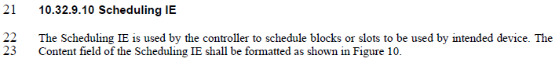

Agreed. Fundamentally, the same thought with commenter.

**Proposed text changes on P802.15.4ab™/Draft 1.0 :**

***Change the chapter 10.32.9.10 P46L22 as follows:***

**10.32.9.10 Scheduling IE**

The Scheduling IE is used by the controller to assign ranging blocks or ranging slots to selected devices for scheduled transmissions. The Content field of the Scheduling IE shall be formatted as shown in Figure 10.