**IEEE P802.15**

**Wireless Personal Area Networks**

|  |  |  |
| --- | --- | --- |
| Project | IEEE P802.15 Working Group for Wireless Personal Area Networks (WPANs) | |
| Title | **Draft 1.0 Comment Resolution CIDs 1000, 929, 1395, 514, 546** | |
| Date Submitted | October 2024 | |
| Sources | Panpan Li, Bin Qian, Lei Huang, Rojan Chitrakar, David Xun Yang (Huawei) |  |
| Re: |  | |
| Abstract |  | |
| Purpose | To propose comments resolution for “P802.15.4ab™/D1.0 Draft Standard for Low-Rate Wireless Networks” | |
| Notice | This document does not represent the agreed views of the IEEE 802.15 Working Group or IEEE 802.15.4ab Task Group. It represents only the views of the participants listed in the “Sources” field above.It is offered as a basis for discussion and is not binding on the contributing individuals. The material in this document is subject to change in form and content after further study. The contributors reserve the right to add, amend or withdraw material contained herein. | |

**R0: 1000, 929, 1395, 514, 546**

|  |  |  |  |  |  |  |  |
| --- | --- | --- | --- | --- | --- | --- | --- |
| **Index #** | **Commenter** | **Sub-Clause** | **Page** | **Line** | **Comment** | **Proposed Change** | **Proposed resolution** |
| 1000 | Carlos Aldana | 10.38.9.3.12 | 87 | 5 | The concept of MrpThirdSlots seems to work for 2 responders. What happens where there are more than 2 responders? Do we need to define MrpFourthSlots, MrpFifthSlots,etc? We probably need a more scalable solution. | Please clarify | Revised |
| 929 | Youngwan So | 10.38.9.3.12 | 85 | 13 | The management MAC Configuration Field seems to be 8 octets long, not 7 octets. And reference is wrong. | Change from "This seven-octet field is formatted as shown in Figure 53." To "This eight-octet field is formatted as shown in Figure 54." | Revised |
| 1395 | Alex Krebs | 10.38.9.3.12 | 85 | 13 | This says its a seven octet field, but Figure 54 shows a 8 octet field, newly carrying a one-to-many configuration field. This field can never be used for one-to-one ranging hence unnecessarily prolonging OTA configuration, and the 400 RSTU slots required for time efficient O2M cannot be configured using the O2O definitions hence depicted configuration does not work for O2M anyways. So this change from DraftC is a lose/lose situation. If the proponents of time-efficient O2M desire OTA configuration, a separate O2M MAC management config field should be specified (e.g. via a different message id and/or message control). | Revert this change to preballot-C state by removing bits 56-63 again, and delete p87 lines 3-5. | Revised |
| 514 | Tero Kivinen | 10.38.9.3.12 | 85 | 13 | The Management MAC Configuration field is eight octets long, not seven. | Change seven to eight. | Revised |
| 546 | Tero Kivinen | 10.38.9.5 | 94 | 1 | The Management MAC Configuration field is 8 octets long. | Change 0/7 to 0/8. |  |

**Discussion:**

It has been restricted that there are at most two responders per ranging sub-round for time efficient one-to-many ranging. Thus, there is no need to define MrpFourthSlots and MrpFifthSlots.

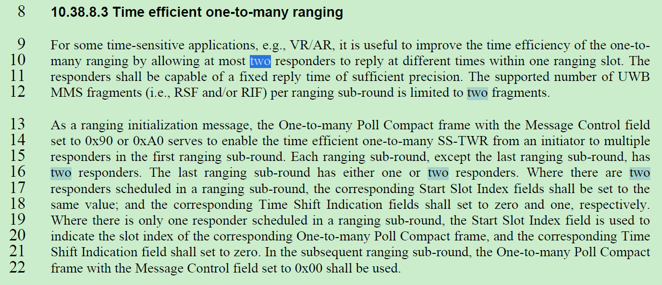

In time efficient one-to-many ranging, the interval between two adjacent RSFs transmitted by initiator or responder is 1200 RSTUs, which is same as one to one ranging.

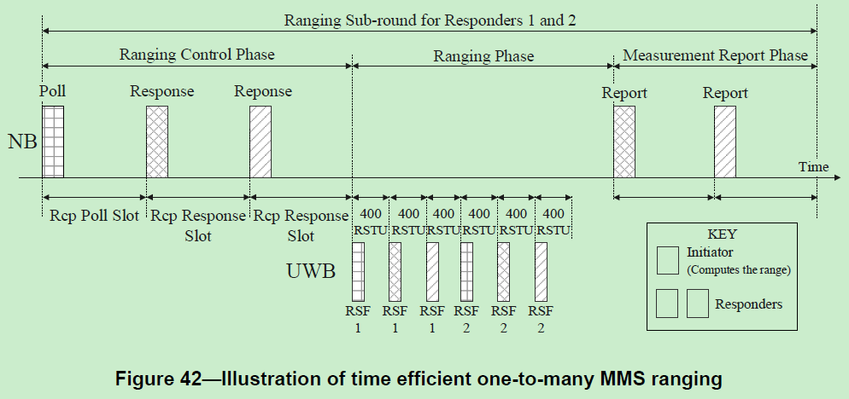

To make the Management MAC Configuration field applicable to time efficient one-to-many ranging, we also need to keep the Measurement Report Request fields of the two responders same, which means either both or neither of the two responders request the initiator to send the report, and either both or neither of the two responders send report to the initiator.

**Resolution: Revised**

*Proposed text changes on P802.15.4ab™-D01:*

**10.38.9.3.12 The Management MAC Configuration field**

*Change Line 13 on page 85 as follows*

This seven-octet field is formatted as shown in Figure 54.

*Change Line 1 on page 86 as follows*

|  |  |  |  |  |  |  |  |  |  |  |  |  |  |
| --- | --- | --- | --- | --- | --- | --- | --- | --- | --- | --- | --- | --- | --- |
| Bits: 0-2 | 3-10 | 11-18 | 19 | 20 |  | 21-24 | 25-28 | 29-40 |  | 41-44 | 45-48 | 49-52 | 53-55 |
| Ranging Slot  Duration | Ranging Round  Duration | Ranging Block  Duration | Channel Switching | Measurement  Report Request |  | RcpPollSlots | RcpResponseSlots | RpDuration |  | MrpFirstSlots | MrpSecondSlots | MrpThirdSlots | Reserved |

Figure 54—The Management MAC Configuration field

**10.38.8.3 Time efficient one-to-many ranging**

*Change Line 13-29 on page 74 as follows*

As a ranging initialization message, the One-to-many Poll Compact frame with the Message Control field set to 0x90 or 0xA0 serves to enable the time efficient one-to-many SS-TWR from an initiator to multiple responders in the first ranging sub-round. Each ranging sub-round, except the last ranging sub-round, has two responders. The last ranging sub-round has either one or two responders. Where there are two responders scheduled in a ranging sub-round, the corresponding Start Slot Index fields and the Measurement Report Request fields shall be set to the same value; and the corresponding Time Shift Indication fields shall set to zero and one, respectively. Where there is only one responder scheduled in a ranging sub-round, the Start Slot Index field is used to indicate the slot index of the corresponding One-to-many Poll Compact frame, and the corresponding Time Shift Indication field shall set to zero. In the subsequent ranging sub-round, the One-to-many Poll Compact frame with the Message Control field set to 0x00 shall be used.

In each ranging sub-round shown in Figure 42, during the ranging control phase, the responder with Time Shift Indication field set to zero may transmit a One-to-many Response Compact frame back to the initiator at the beginning of the ranging slot following the poll period. The responder with Time Shift Indication field set to one may transmit a One-to-many Response Compact frame back to the initiator at the beginning of the ranging slot following the first One-to-many Response Compact frame. When there is one responder scheduled in the last ranging sub-round, the ranging control phase is same as the basic operation of one-to-many MMS ranging. Where there are two responders scheduled in a ranging sub-round, the Measurement Report Request fields shall be set to the same value.

*Change Line 17-36 on page 75 as follows*

When there are two responders involved in ranging in the same ranging sub-round, the report phase consists of one, two, or three periods for transmission of a report packet. The durations of the three reporting periods are specified by the macMms1stReportNSlots, macMms2ndReportNSlots, and macMms3rdReportNSlots attributes. If the report phase has only a single transmission, the initiator shall transmit the One-to-many Initiator Report Compact frame with the Message Control field set to 0x10 or the One-to-many Initiator Secure Report Compact frame with the Message Control field set to 0x10 to the two responders in the first reporting period. This message indicates the round-trip time with respect to each of the two responders in the Round-trip Time One and the Round-trip Time Two fields, respectively. If the report phase has two transmissions, the responder with Time Shift Indication field set to zero shall transmit the One-to-many Responder Report Compact frame or the One-to-many Responder Secure Report Compact frame in the first reporting period, and the responder with Time Shift Indication field set to one shall transmit the One-to-many Responder Report Compact frame or the One-to-many Responder Secure Report Compact frame in the second reporting period. If the report phase has three transmissions, the responder with Time Shift Indication field set to zero shall transmit the One-to-many Responder Report Compact frame or the One-to-many Responder Secure Report Compact frame in the first reporting period, the responder with Time Shift Indication field set to one shall transmit the One-to-many Responder Report Compact frame or the One-to-many Responder Secure Report Compact frame in the second reporting period, and the initiator shall transmit the One-to-many Initiator Report Compact frame or the One-to-many Initiator Secure Report Compact frame with the Message Control field set to 0x10 in the third reporting period. Figure 43 shows the possible report packet positions in the report phase. During the initialization phase and control phase, the Measurement Report Request fields of two responders scheduled in a ranging sub-round shall be set to the same value.