**IEEE P802.15**

**Wireless Personal Area Networks**

|  |  |  |
| --- | --- | --- |
| Project | IEEE P802.15 Working Group for Wireless Personal Area Networks (WPANs) | |
| Title | UWB Packet Format Configuration | |
| Date Submitted | 26 September 2024 | |
| Source | Billy Verso (Qorvo), | billy.verso at qorvo.com |
| Re: | IEEE P802.15.4ab Comment Resolutions | |
| Abstract | Comment Resolutions for selected comments on the LB207 / P802.15.4ab D01. | |
| Purpose | This document provides text changes intended to be part of the final IEEE Std 802.15.4ab (amendment to IEEE Std 802.15.4), as part of resolving selected comments from the consolidated spreadsheet (doc 15-24-0371) that have been assigned to the author to resolve. | |
| Notice | This document does not represent the agreed views of the IEEE 802.15 Working Group or IEEE 802.15.8 Task Group. It represents only the views of the participants listed in the “Source(s)” field above. It is offered as a basis for discussion and is not binding on the contributing individual(s) or organization(s). The material in this document is subject to change in form and content after further study. The contributor(s) reserve(s) the right to add, amend or withdraw material contained herein. | |
| Release | The contributor acknowledges and accepts that this contribution becomes the property of IEEE and may be made publicly available by P802.15. | |
| Patent Policy | The contributor is familiar with the IEEE-SA Patent Policy and Procedures.  <https://standards.ieee.org/about/sasb/patcom/materials/> | |

|  |
| --- |
| **Comments addressed here:** |

1 Comment Index #’s: 108, 182, 1346, 1063, 28, 29, 1064, 1325, 183 2

# Comment Index #’s: 108, 182, 1346, 1063, 28, 29, 1064, 1325, 183

|  |  |  |  |  |  |
| --- | --- | --- | --- | --- | --- |
| **Index** | **page** | **clause** | **line** | **Comment** | **Proposed Change** |
| 108 (Rojan) | 40 | 10.29.9.5.1 | 20 | FormatSpecificParameters Type should not be Enuration, also the details of the parameters seem to be missing. | Correct the FormatSpecificParameters Type and add details of the packet parameters. |
| 182 (Wenzheng) | 40 | 10.29.9.5.1 | 20 | For the Table 7, FormatSpecificParameters shall be defined | FormatSpecificParameters shall include: active segment lengths preamble code(91 or 127) support active segments number(1,2,3,4) |
| 1346  (Pooria) | 40 | 10.29.9.5.1 | 20 | Does "PacketFormat" parameter only specify SENS packets, or ranging packets too? If so, why is it called UWB-PACKET? | Use a more descriptive name, or generalize to STS packets as well as other 4ab packets. |
| 1063 (Billy) | 40 | 10.29.9.5.1 | 10 | MLME-UWB-PACKET.request seems like a good way to configure not just sensing packets but all the UWB packet formats: Normal, STS, SENS, MMS, etc. | Unify HRP UWB PHY packet mode configuration into one place… I will prepare a submission to cover this. |
| 28 (Mickael) | 40 | 10.29.9.5.1 | 20 | PacketFormat is missing for default STS_PACKET | add STS_PACKET in valid range and add phyHrpUwbPacketFormat: SENS_PACKET_0, SENS_PACKET_1, SENS_PACKET_2, STS_PACKET (default) in Table 12-8 |
| 29 (Mickael) | 40 | 10.29.9.5.1 | 20 | FormatSpecificParameters for SENS_PACKET | TxSensPacketStructure: 0-2 TxSensSegmentLength: 16/32/64/128/256/512 TxSensNumberSegments: 0-4 RxSensPacketStructure: 0-2 RxSensSegmentLength: 16/32/64/128/256/512 RxSensNumberSegments: 0-4 |
| 1064 (Billy) | 40 | 10.29.9.5.1 | 21 | If the FormatSpecificParameters parameter is not use, it should be removed. I am thinking that simple PIB values should be used for configuring such items. | Delete the FormatSpecificParameters parameter. And the INVALID_PARAMETER return value in MLME-UWB-PACKET.confirm if there are no other parameters to be invalid. |
| 1325 (Ben) | 40 | 10.29.9.5.1 | 21 | "This may provide specific parameters associated with the selected packet format." can be more clear and avoid misuse of "may". | Provides lparameters specific to the selected packet format. |
| 183 (Wenzheng) | 41 | 10.29.9.5.2 | 10 | For the Table 8, specific indication for not supported parameter may be introduced with respective to FormatSpecificParameters in Table 7 | NOT_SUPPORTED_SENS_LENGTH NOT_SUPPORTED_PREAMBLE_CODE NOT_SUPPORTED_SEGMENTS_NUMBER |

**Discussion:**

These comments, all relate to the MLME-UWB-PACKET (format) primitive. When this primitive was conceived the idea was to use it to select the packet format for all UWB packet types not just sensing packets, (hence the name), although this was not captured in the text prepared for D01 which was prepared under time pressure to begin the ballot. CI#1063 is proposing to unify HRP UWB PHY packet mode configuration using this primitive. A different commenter in CI#1346 has this as a proposed resolution also. Another commenter in CI#28 is saying this primitive is missing a way to return to the base packet format, and while the STS primitive could be used for this, including all packet formats into this one primitive makes this cleaner and address that comment. The changes below show how this may be done.

Comments, (CI#108, CI#182, and CI#29), relate to the “FormatSpecificParameters” parameter which was left empty as a place holder in D01, and upon reflection, as suggested in CI#1064, rather than filling it up, it is proposed to keep this primitive simple by removing this parameter and then using PIB attributes to configure such items. These PIB attributes (mostly) exist already so there is no need to duplicate them in the primitive. The removal of the FormatSpecificParameters parameter is also captured in the proposed changes below. Doing this also resolves CI#1325 and CI#183.

Proposed resolution for all the listed CID is then: **Revised**

The changes as required given the following two pages.

***Changes with respect to P802.15.4ab D01 – Modify clause 10.29.9.5 as shown:***

**10.29.9.5 Primitives for specifying UWB Packet format**

**10.29.9.5 1 MLME-UWB-PACKET-FORMAT.request**

The MLME-UWB-PACKET-FORMAT.request primitive allows the next higher layer to request that a device with HRP UWB PHY capabilities uses a selected UWB packet format for its transmissions and receptions, if it is supported.

The semantics of this primitive are:

MLME-UWB-PACKET-FORMAT.request (

PacketFormat

)

The primitive parameters are defined in Table 7.

**Table 7—MLME-UWB-PACKET-FORMAT.request parameters**

| **Name** | **Type** | **Valid range** | **Description** |
| --- | --- | --- | --- |
| PacketFormat | Enumeration | BASIC_PACKET, STS_PACKET_1, STS_PACKET_2, STS_PACKET_3, SENS_PACKET_0, SENS_PACKET_1, SENS_PACKET_2, MMS_PACKET_1, MMS_PACKET_2 | This parameter selects the HRP UWB PHY PPDU format. |
|  |  |  |  |

The PacketFormat parameter value determines the UWB packet format to use in the transmitter and expected by the receiver. The PacketFormat parameter value of BASIC_PACKET specifies the basic PPDU format shown in Figure 16-2 which is the same as the STS packet configuration zero shown in Figure 16-3. PacketFormat parameter values of STS_PACKET_1, STS_PACKET_2 and STS_PACKET_3 each specify one of the STS packet configuration formats one, two and three shown in Figure 16-3. PacketFormat parameter values of SENS_PACKET_0, SENS_PACKET_1 and SENS_PACKET_2 each specify one of the sensing packet configuration formats shown in Figure 194. PacketFormat parameter values of MMS_PACKET_1 and MMS_PACKET_2 each specify one of the MMS packet formats shown in Figure 198.

The result of the UWB packet format configuration attempt is reported by the MLME-UWB-PACKET-FORMAT.confirm primitive.

**10.29.9.5 1 MLME-UWB-PACKET-FORMAT.****confirm**

The MLME-UWB-PACKET-FORMAT.confirm primitive reports the result of the attempt to configure the UWB packet format via the MLME-UWB-PACKET-FORMAT.request primitive.

The semantics of this primitive are:

MLME-UWB-PACKET-FORMAT.confirm (

Status

)

The primitive parameters are defined in Table 8.

**Table 8—MLME-UWB-PACKET-FORMAT.confirm parameters**

| **Name** | **Type** | **Valid range** | **Description** |
| --- | --- | --- | --- |
| Status | Enumeration | SUCCESS,  NOT_SUPPORTED | This parameter reports the result of the MLME-UWB-PACKET.request. |

The MLME-UWB-PACKET-FORMAT.confirm primitive is generated by the MLME and issued to its next higher layer in response to an MLME-UWB-PACKET-FORMAT.request primitive.

If the selected packet format is not supported by the device, a Status of NOT_SUPPORTED is returned.

If the request was successful, the MLME issues the MLME-UWB-PACKET-FORMAT.confirm primitive with a Status of SUCCESS.

…

**16.2.11 Multi-millisecond ranging packet format**

**16.2.11.1 General**

***Replace current figure 198***

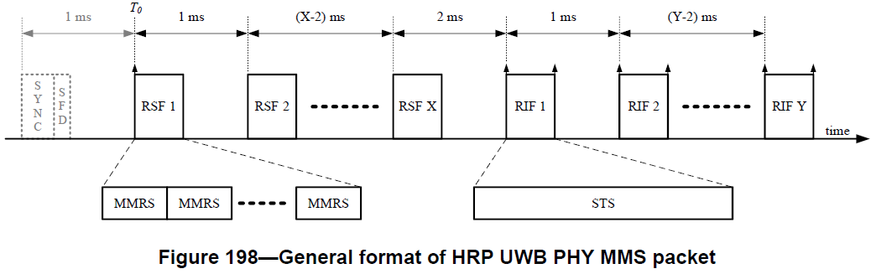

***with the following:***



**Figure 198—HRP-ARDEV MMS packet formats**

***<END >***