**IEEE P802.15**

**Wireless Personal Area Networks**

|  |  |  |
| --- | --- | --- |
| Project | IEEE P802.15 Working Group for Wireless Personal Area Networks (WPANs) | |
| Title | **Proposed Resolutions for CID 192, 198** | |
| Date Submitted | January 2025 | |
| Sources | Wenzheng Li(Calterah Semiconductor)  [wenzheng.li@calterah.com](mailto:wenzheng.li@calterah.com); |  |
| Re: |  | |
| Abstract |  | |
| Purpose | To propose resolution for “P802.15.4ab™/D01 Draft Standard for Low-Rate Wireless Networks” . | |
| Notice | This document does not represent the agreed views of the IEEE 802.15 Working Group or IEEE 802.15.4ab Task Group. It represents only the views of the participants listed in the “Sources” field above.It is offered as a basis for discussion and is not binding on the contributing individuals. The material in this document is subject to change in form and content after further study. The contributors reserve the right to add, amend or withdraw material contained herein. | |

Rev 1: Initial version.

***Comment Indices in 15-24-0371-12-04ab-consolidated-comments-draft-1-0:***

|  |  |  |  |  |  |  |  |
| --- | --- | --- | --- | --- | --- | --- | --- |
| Name | Index # | Category | Page | Sub-clause | Line # | Comment | Proposed Change |
| Zhongxing Yu | 198 | Technical | 74 | 10.38.8.3 | 8 | In Chapter 10.38.8.3 Time Efficient one-to-many ranging, it says about time efficient MMS for SS-TWR ranging. But in most scenario ,DS-TWR is more popular than SS-TWR. Time efficient MMS for one-to-many DS-TWR ranging is recommended to be introduced. | <https://mentor.ieee.org/802.15/dcn/24/15-24-0313-01-04ab-time-efficient-mms-for-one-to-many-ds-twr-ranging.docx> |
| Wenzheng Li | 192 | Technical | 74 | 10.38.8.3 | 12 | Since the initial SYNC+SFD fragment shall be exchanged in UWB driven UWB MMS, the type of SYNC+SFD should be introduced in the MMS fragment exchange in the time efficient one to many ranging | The supported number of UWB  MMS fragments (i.e., RSF and/or RIF or SYNC+SFD) per ranging sub-round is limited to two fragments |

**Discussion**：

**For CID 192::**

It is not clear that whether the time efficient one to many ranging can only be used in the case of NBA MMS, or it can also be used in the UWB driven MMS?

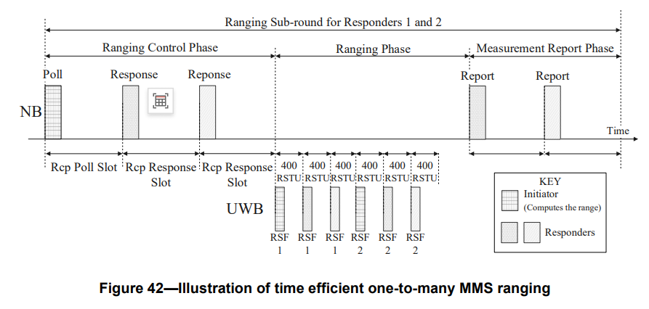

Only NBA MMS is stated in the sub-clause 10.38.8.3. Since we have two kinds of MMS defined in the 4ab, it is recommended to support both UWB-driven MMS and NBA MMS in the time efficient one to many ranging.

it is also recommended to support time efficient one to many ranging in case of another PHY is employed for control and reporting phase.

**For CID 198:**

In the current context of time efficient one to many ranging in clause 10.38.8.3, the time efficient one to many ranging is only targeted for SS-TWR

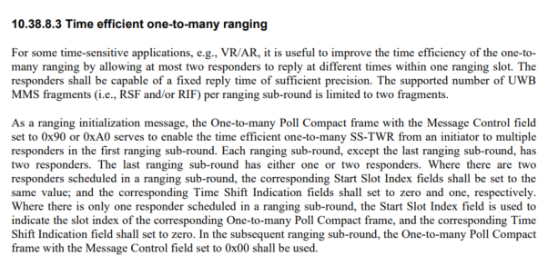

However, DS-TWR is much common in the practice useage,

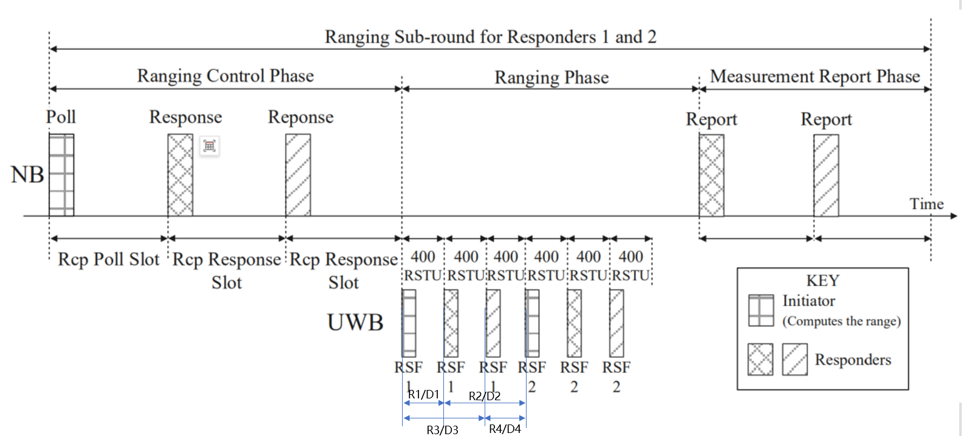

If:

R1: Round trip time of the initiator, from first RSF send and first RSF received from 1st responder(One-to-many Initiator Report Compact frame)

D1: Reply time of the 1st responder, from first RSF received from initiator and first RSF send(One-to-many Responder Report Compact frame)

R2: Round trip time of the 1st responder, from first RSF send and second RSF received from initiator(OOB)

D2: Reply time of initiator, from first RSF received from 1st responder and second RSF send(OOB)

So, ToF between initiator and 1st responder can ben calculated by using DS-TWR,

TOF=(R1*R2-D1*D2)/(R1+R2+D1+D2)

The similar method can be applied for 2nd responder in this case.

So, in the case of OOB assisted time-efficient one to many MMS ranging or some other ways, DS-TWR may be implemented, it is recommended that do not restrict time-efficient one to many ranging only for SS-TWR.

**Disposition: Revised**

**Disposition Detail:**

**Proposed text changes on P802.15.4ab™/D01:**

**10.38.8.3 Time efficient one-to-many ranging**

For some time-sensitive applications, e.g., virtual reality/augmented reality, it is useful to improve the time efficiency of the one-to-many ranging by allowing at most two responders to reply at different times within one ranging slot. The responders shall be capable of a fixed reply time of sufficient precision. The supported number of UWB MMS fragments (i.e., RSF and/or RIF and/or SYNC+SFD) per ranging sub-round is limited to two fragments. Support of time efficient one-to-many ranging is optional for both NBA MMS or UWB driven UWB MMS.

As a ranging initialization message, the One-to-many Poll Compact frame with the Message Control field set to 0x90 or 0xA0 serves to enable the time efficient one-to-many MMS ranging from an initiator to multiple responders in the first ranging sub-round. Each ranging sub-round, except the last ranging sub-round, has two responders. The last ranging sub-round has either one or two responders. Where there are two responders scheduled in a ranging sub-round, the corresponding Start Slot Index fields shall be set to the same value; and the corresponding Time Shift Indication fields shall set to zero and one, respectively. Where there is only one responder scheduled in a ranging sub-round, the Start Slot Index field is used to indicate the slot index of the corresponding One-to-many Poll Compact frame, and the corresponding Time Shift Indication field shall set to zero. In the subsequent ranging sub-round, the One-to-many Poll Compact frame with the Message Control field set to 0x00 shall be used.

In each ranging sub-round shown in Figure 42 and Figure 43, during the ranging control phase, the responder with Time Shift Indication field set to zero may transmit a One-to-many Response Compact frame back to the initiator at the beginning of the ranging slot following the poll period. The responder with Time Shift Indication field set to one may transmit a One-to-many Response Compact frame back to the initiator at the beginning of the ranging slot following the first One-to-many Response Compact frame. When there is one responder scheduled in the last ranging sub-round, the ranging control phase is same as the basic operation of one-to-many MMS ranging.

The UWB MMS packet format shall be as specified in clause 16.2.11 with fragments from responder one and responder two offset from the initiator's fragments by 400 and 800 RSTU respectively.

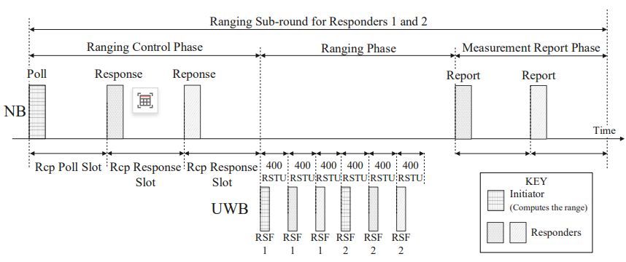

**Figure 42—Illustration of time efficient one-to-many NBA MMS ranging**

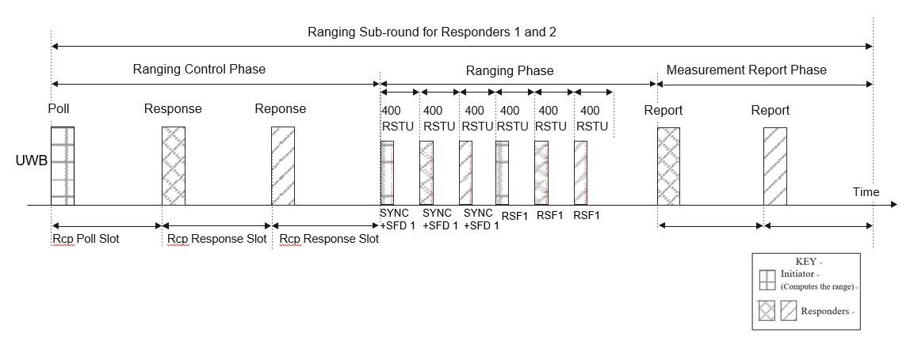

**Figure 43—Illustration of time efficient one-to-many UWB driven UWB MMS ranging**

If another PHY is employed for control and reporting, the HRP UWB PHY MMS packet is recommended to include the initial SYNC and SFD fragment as specified in 16.2.11.

When there are two responders involved in ranging in the same ranging sub-round, the report phase consists of one, two, or three periods for transmission of a report packet. The durations of the three reporting periods are specified by the macMms1stReportNSlots, macMms2ndReportNSlots, and macMms3rdReportNSlots attributes. If the report phase has only a single transmission, the initiator shall transmit the One-to-many Initiator Report Compact frame with the Message Control field set to 0x10 or the One-to-many Initiator Secure Report Compact frame with the Message Control field set to 0x10 to the two responders in the first reporting period. This message indicates the round-trip time with respect to each of the two responders in the Round-trip Time One and the Round-trip Time Two fields, respectively. If the report phase has two transmissions, the responder with Time Shift Indication field set to zero shall transmit the One-to-many Responder Report Compact frame or the One-to-many Responder Secure Report Compact frame in the first reporting period, and the responder with Time Shift Indication field set to one shall transmit the One-to-many Responder Report Compact frame or the One-to-many Responder Secure Report Compact frame in the second reporting period. If the report phase has three transmissions, the responder with Time Shift Indication field set to zero shall transmit the One-to-many Responder Report Compact frame or the One-to-many Responder Secure Report Compact frame in the first reporting period, the responder with Time Shift Indication field set to one shall transmit the One-to-many Responder Report Compact frame or the One-to-many Responder Secure Report Compact frame in the second reporting period, and the initiator shall transmit the One-to-many Initiator Report Compact frame or the One-to-many Initiator Secure Report Compact frame with the Message Control field set to 0x10 in the third reporting period. Figure 43 shows the possible report packet positions in the report phase.

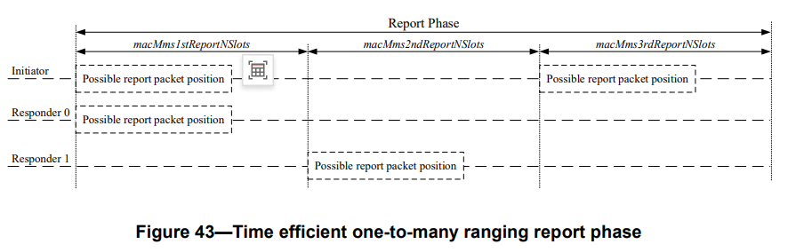

When there is one responder involved in ranging in a ranging sub-round, the report phase is same as the basic operation of one-to-many MMS ranging.