**IEEE P802.15**

**Wireless Personal Area Networks**

|  |  |  |
| --- | --- | --- |
| Project | IEEE P802.15 Working Group for Wireless Personal Area Networks (WPANs) | |
| Title | **Proposed Resolutions for CID 192, 198** | |
| Date Submitted | September 2024 | |
| Sources | Wenzheng Li(Calterah Semiconductor)  [wenzheng.li@calterah.com](mailto:wenzheng.li@calterah.com); |  |
| Re: |  | |
| Abstract |  | |
| Purpose | To propose resolution for “P802.15.4ab™/D01 Draft Standard for Low-Rate Wireless Networks” . | |
| Notice | This document does not represent the agreed views of the IEEE 802.15 Working Group or IEEE 802.15.4ab Task Group. It represents only the views of the participants listed in the “Sources” field above.It is offered as a basis for discussion and is not binding on the contributing individuals. The material in this document is subject to change in form and content after further study. The contributors reserve the right to add, amend or withdraw material contained herein. | |

Rev 0: Initial version.

***Comment Indices in 15-24-0371-12-04ab-consolidated-comments-draft-1-0:***

|  |  |  |  |  |  |  |  |
| --- | --- | --- | --- | --- | --- | --- | --- |
| Name | Index # | Category | Page | Sub-clause | Line # | Comment | Proposed Change |
| Zhongxing Yu | 198 | Technical | 74 | 10.38.8.3 | 8 | In Chapter 10.38.8.3 Time Efficient one-to-many ranging, it says about time efficient MMS for SS-TWR ranging. But in most scenario ,DS-TWR is more popular than SS-TWR. Time efficient MMS for one-to-many DS-TWR ranging is recommended to be introduced. | <https://mentor.ieee.org/802.15/dcn/24/15-24-0313-01-04ab-time-efficient-mms-for-one-to-many-ds-twr-ranging.docx> |
| Wenzheng Li | 192 | Technical | 74 | 10.38.8.3 | 12 | Since the initial SYNC+SFD fragment shall be exchanged in UWB driven UWB MMS, the type of SYNC+SFD should be introduced in the MMS fragment exchange in the time efficient one to many ranging | The supported number of UWB  MMS fragments (i.e., RSF and/or RIF or SYNC+SFD) per ranging sub-round is limited to two fragments |

**Discussion**：

**For CID 192::**

It is not clear that whether the time efficient one to many ranging can only be used in the case of NBA MMS, or it can also be used in the UWB driven MMS?

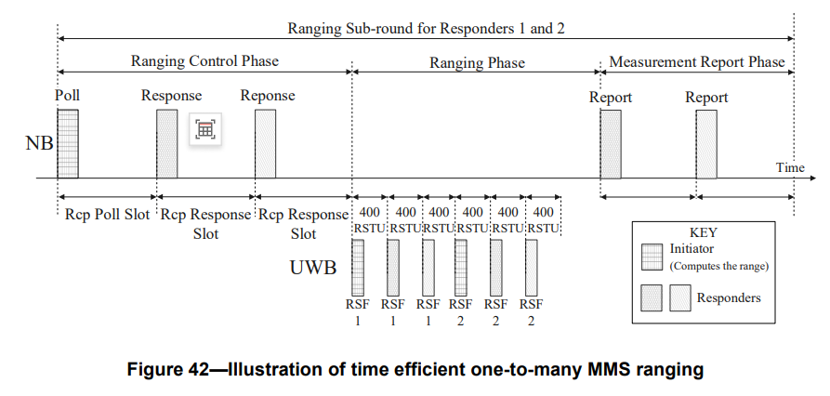

Only NBA MMS is stated in the sub-clause 10.38.8.3

According to the previous discussion and contributions,

1. we have two kinds of MMS defined in the 4ab: UWB-driven MMS and NBA MMS
2. the spectrum policy is not clear for NBA MMS in some regions
3. NBA MMS may have coexistence problems with other wireless technology
4. OOB assisted MMS is important in achieving link budget gain before NBA MMS comes to the market.

it is recommended to support both MMS mechanisms for the case of time-efficient one to many ranging, and the OOB assisted MMS should follow the mechanism of UWB-driven MMS..

**For CID 198:**

In the current context of time efficient one to many ranging in clause 10.38.8.3, the time efficient one to many ranging is only targeted for SS-TWR

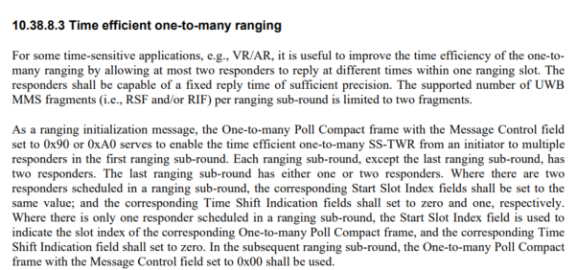

However, according to the current RSF/RIF transmission scheme in time efficient one to many ranging, OOB mechanism may help to apply DS-TWR method, if the reply times and the round-trip times of the initiator and two responders can be exchanged by OOB mechanism in one sub-round:

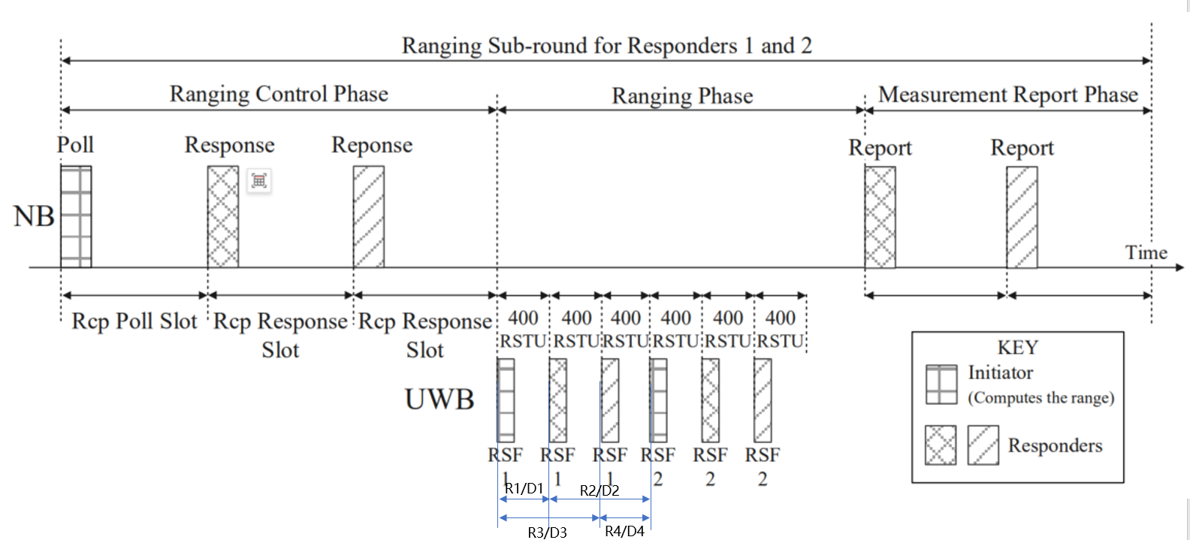

If:

R1: Round trip time of the initiator, from first RSF send and first RSF received from 1st responder

D1: Reply time of the 1st responder, from first RSF received from initiator and first RSF send

R2: Round trip time of the 1st responder, from first RSF send and second RSF received from initiator

D2: Reply time of initiator, from first RSF received from 1st responder and second RSF send

So, ToF between initiator and 1st responder can ben calculated by using DS-TWR, if R1/D1/R2/D2 can be measured and exchanged in OOB way.

The similar method can be applied for 2nd responder in this case.

In fact, we can also apply ESS-TWR with two RSF fragments from initiator and second RSF fragments from each two responder in a sub-round.

So, in the case of OOB assisted time-efficient one to many MMS ranging , it should not be restricted only for SS-TWR.

**Disposition: Revised**

**Disposition Detail:**

**Proposed text changes on P802.15.4ab™/D01:**

**10.38.8.3 Time efficient one-to-many ranging**

For some time-sensitive applications, e.g., VR/AR, it is useful to improve the time efficiency of the one-to-many ranging by allowing at most two responders to reply at different times within one ranging slot. The responders shall be capable of a fixed reply time of sufficient precision. The supported number of UWB MMS fragments (i.e., RSF and/or RIF and/or SYNC+SFD) per ranging sub-round is limited to two fragments.

As a ranging initialization message, the One-to-many Poll Compact frame with the Message Control field set to 0x90 or 0xA0 serves to enable the time efficient one-to-many MMS ranging from an initiator to multiple responders in the first ranging sub-round. Each ranging sub-round, except the last ranging sub-round, has two responders. The last ranging sub-round has either one or two responders. Where there are two responders scheduled in a ranging sub-round, the corresponding Start Slot Index fields shall be set to the same value; and the corresponding Time Shift Indication fields shall set to zero and one, respectively. Where there is only one responder scheduled in a ranging sub-round, the Start Slot Index field is used to indicate the slot index of the corresponding One-to-many Poll Compact frame, and the corresponding Time Shift Indication field shall set to zero. In the subsequent ranging sub-round, the One-to-many Poll Compact frame with the Message Control field set to 0x00 shall be used.

In each ranging sub-round shown in Figure 42 and Figure 43, during the ranging control phase, the responder with Time Shift Indication field set to zero may transmit a One-to-many Response Compact frame back to the initiator at the beginning of the ranging slot following the poll period. The responder with Time Shift Indication field set to one may transmit a One-to-many Response Compact frame back to the initiator at the beginning of the ranging slot following the first One-to-many Response Compact frame. When there is one responder scheduled in the last ranging sub-round, the ranging control phase is same as the basic operation of one-to-many MMS ranging.

For the NBA MMS, during the ranging phase, the initiator may start transmitting the first RSF fragment at the start of the ranging phase and continue to send subsequent RSF fragments at regular intervals of 1200 RSTU if the RSF only MMS packet is used. The initiator may start transmitting the first RIF fragment at the start of the ranging phase and continue to send the second RIF fragment at a regular interval of 1200 RSTU if the RIF only MMS packet is used. The initiator may start transmitting the first RSF fragment at the start of the ranging phase and continue to send the RIF fragment 2 ms after the start of its first RSF fragment transmission if the mixed RSF/RIF packet is used.

The responder with Time Shift Indication field set to zero may start transmitting the first RSF fragment at 400 RSTU into the ranging phase and continue to send subsequent RSF fragments at regular intervals of 1200 RSTU, if the RSF only MMS packet is used. This responder may start transmitting the first RIF fragment at 400 RSTU into the ranging phase and continue to subsequent RIF fragments at a regular intervals of 1200 RSTU if the RIF only MMS packet is used. This responder may start transmitting the first RSF fragment at 400 RSTU into the ranging phase and continue to send the first RIF fragment 2 ms after the start of its last RSF fragment transmission if the mixed RSF/RIF packet is used.

The responder with Time Shift Indication field set to one may start transmitting the first RSF fragment at 800 RSTU into the ranging phase and continue to send subsequent RSF fragments at regular intervals of 1200 RSTU, if the RSF only MMS packet is used. This responder may start transmitting the first RIF fragment at 800 RSTU into the ranging phase and continue to subsequent RIF fragments at a regular intervals of 1200 RSTU if the RIF only MMS packet is used. This responder may start transmitting the first RSF fragment at 800 RSTU into the ranging phase and continue to send the first RIF fragment 2 ms after the start of its last RSF fragment transmission if the mixed RSF/RIF packet is used.

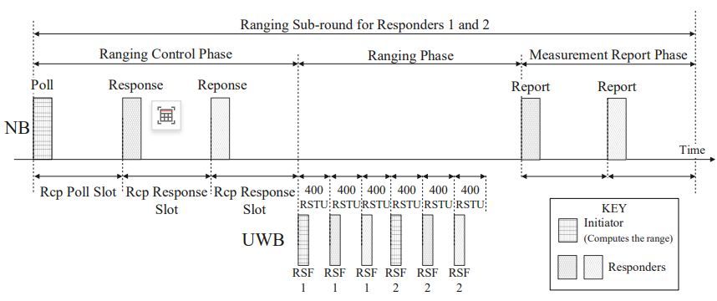

**Figure 42—Illustration of time efficient one-to-many NBA MMS ranging**

For the UWB driven UWB MMS, during the ranging phase, the initiator may start transmitting the first SYNC+SFD fragment at the start of the ranging phase and continue to send subsequent RSF fragments at regular intervals of 1200 RSTU if the RSF only MMS packet is used. The initiator may start transmitting the first SYNC+SFD fragment at the start of the ranging phase and continue to send the subsequent RIF fragment at a regular interval of 1200 RSTU if the RIF only MMS packet is used.

The responder with Time Shift Indication field set to zero may start transmitting the first SYNC+SFD fragment at 400 RSTU into the ranging phase and continue to send subsequent RSF fragments at regular intervals of 1200 RSTU, if the RSF only MMS packet is used. This responder may start transmitting the first SYNC+SFD fragment at 400 RSTU into the ranging phase and continue to subsequent RIF fragments at a regular intervals of 1200 RSTU if the RIF only MMS packet is used.

The responder with Time Shift Indication field set to one may start transmitting the first SYNC+SFD fragment at 800 RSTU into the ranging phase and continue to send subsequent RSF fragments at regular intervals of 1200 RSTU, if the RSF only MMS packet is used. This responder may start transmitting the first SYNC+SFD fragment at 800 RSTU into the ranging phase and continue to subsequent RIF fragments at a regular intervals of 1200 RSTU if the RIF only MMS packet is used.

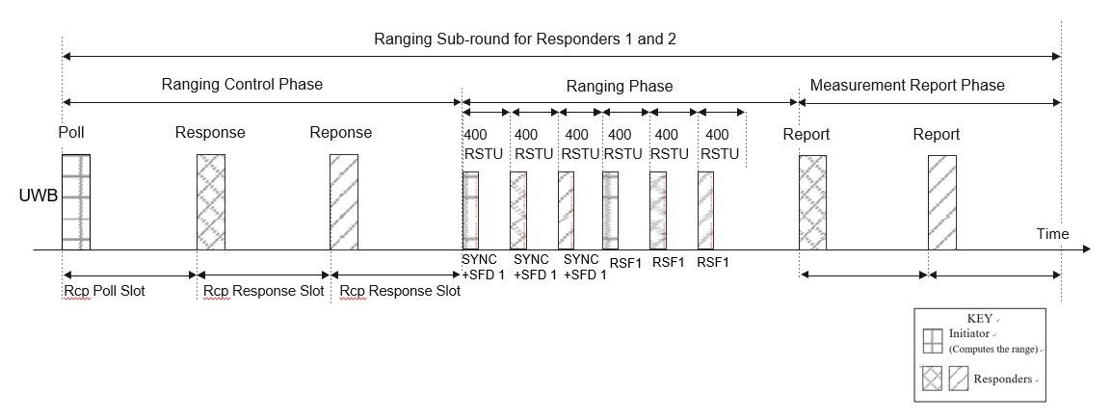

**Figure 43—Illustration of time efficient one-to-many UWB driven UWB MMS ranging**

The OOB mechanism should follow the time efficient one to many UWB driven UWB MMS ranging phase, when the time synchronization is needed between initiator and responder

When there are two responders involved in ranging in the same ranging sub-round, the report phase consists of one, two, or three periods for transmission of a report packet. The durations of the three reporting periods are specified by the macMms1stReportNSlots, macMms2ndReportNSlots, and macMms3rdReportNSlots attributes. If the report phase has only a single transmission, the initiator shall transmit the One-to-many Initiator Report Compact frame with the Message Control field set to 0x10 or the One-to-many Initiator Secure Report Compact frame with the Message Control field set to 0x10 to the two responders in the first reporting period. This message indicates the round-trip time with respect to each of the two responders in the Round-trip Time One and the Round-trip Time Two fields, respectively. If the report phase has two transmissions, the responder with Time Shift Indication field set to zero shall transmit the One-to-many Responder Report Compact frame or the One-to-many Responder Secure Report Compact frame in the first reporting period, and the responder with Time Shift Indication field set to one shall transmit the One-to-many Responder Report Compact frame or the One-to-many Responder Secure Report Compact frame in the second reporting period. If the report phase has three transmissions, the responder with Time Shift Indication field set to zero shall transmit the One-to-many Responder Report Compact frame or the One-to-many Responder Secure Report Compact frame in the first reporting period, the responder with Time Shift Indication field set to one shall transmit the One-to-many Responder Report Compact frame or the One-to-many Responder Secure Report Compact frame in the second reporting period, and the initiator shall transmit the One-to-many Initiator Report Compact frame or the One-to-many Initiator Secure Report Compact frame with the Message Control field set to 0x10 in the third reporting period. Figure 43 shows the possible report packet positions in the report phase.

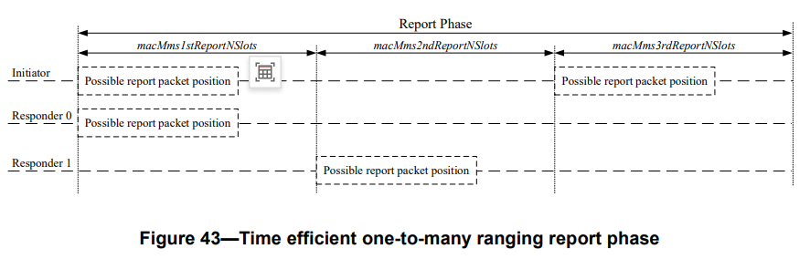

When there is one responder involved in ranging in a ranging sub-round, the report phase is same as the basic operation of one-to-many MMS ranging.