IEEE P802.15
Wireless Personal Area Networks

Project | IEEE P802.15 Working Group for Wireless Personal Area Networks (WPANs)
Title | Proposed Resolution for Discovery
Date Submitted | July 2024
Sources | Kangjin Yoon (Spark Microsystems)  Yoons.2k15@gmail.com
Re:
Abstract
Purpose | To propose resolution for “P802.15.4ab™/D01 Draft Standard for Low-Rate Wireless Networks”
Notice | This document does not represent the agreed views of the IEEE 802.15 Working Group or IEEE 802.15.4ab Task Group. It represents only the views of the participants listed in the “Sources” field above. It is offered as a basis for discussion and is not binding on the contributing individuals. The material in this document is subject to change in form and content after further study. The contributors reserve the right to add, amend or withdraw material contained herein.

Name | Index# | Pg | Sub-Clause | Ln | Comment | Proposed Change | Disposition
Billy Verso | 1261 | 162 | 10.40.3 | 9 | In the sentence "may be sent in any unscheduled slot in the round slot in the round" would "unoccupied" be a better word than "unscheduled" | Change "unscheduled" to "unoccupied". | Reject
Disposition details:
What controlees can know is which slots are unscheduled, not actual occupancy of slots.

Billy Verso | 1262 | 162 | 10.40.3 | 9 | UWB reception is expensive, so the initiator device is unlikely to have its receiver on in any slot that it is not expecting a packet. Better to develop a protocol, with a slot dedicated to association, and perhaps that association scheme would be better being defined in the higher layer protocol and not in 4ab. | Consider modification / deletion of this mode of association, to address this issue or explain what the initiator should be doing for an energy efficient scheme. | Reject
Disposition details:
There is another option of specifying and using Contention slots. If the Contention Slots Info field exists in the AC IE, receiver may monitor the contention slots only to save energy.
And when the number of unscheduled slots is not big, it would be better not to have Contention Slots Info field in AC IE to reduce the size of the AC IE and use all unscheduled slots.

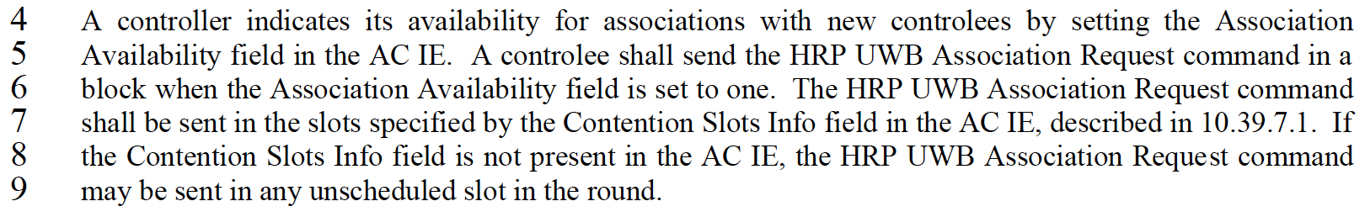

Billy Verso | 1263 | 163 | 10.40.3 | 2 | This figure (Figure 178) is not referenced in the text, if it is not referenced then it is probably not needed? | Either delete the figure, or write some text to refer to it and explain what it is showing, (and perhaps the figure caption could be shortened, if the descriptive text is carrying the same info) | Revise
Disposition details:
Add "Figure 178 shows the example of frame exchange when the block contains a single ranging round." at the end of the line 20 of the page 162.
Change the title of Figure 178 to from "Example of frame exchange for HRP UWB association when the block contains a single ranging round" to "Example of frame exchange for HRP UWB association"

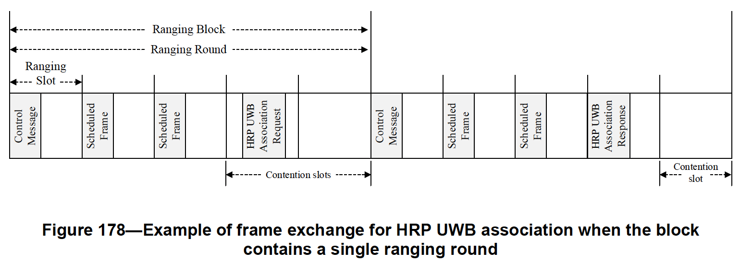

Billy Verso | 1264 | 163 | 10.40.4.1 | 5 | I think this is wrongly named HRP UWB association command suggest a more application (rather than PHY) related name, like perhaps "ranging controller association". HRP can associate to a normal 15.4 PAN coordinator, and no reason why other phy may not use this scheme in a ranging/slotted network, | Rename to "ranging controller association" | Revise
Disposition details:
We agreed to change to “controller association” in comment #1028.
Change “HRP UWB association” to “controller association”.

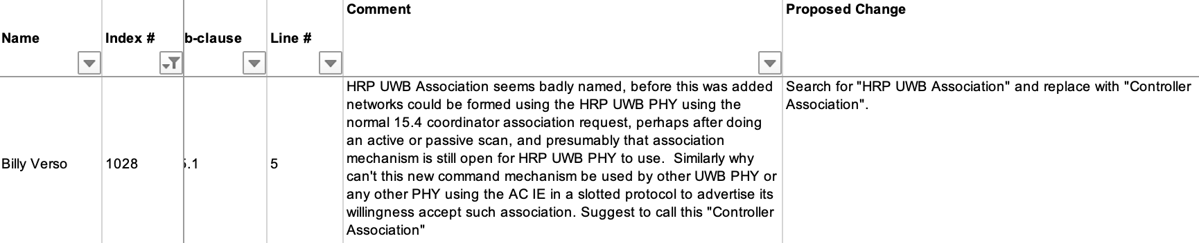

Tero Kivinen | 745 | 163 | 10.40.4.1 | 9 | The text "Addressing Mode field shall be set to same mode as indicated by the AC IE" does not make sense. AC IE does not have modes indicating the address mode fields, and if it is trying to say that use same source and destination addressing modes than what was used to AC IE then that does not work, as the if the AC IE is using short address then the device transmitting association request can't use short address, as it has not yet been given short address. | Specify how the source and destination addressing fields are to be used in association request command. | Revise
Disposition details:
Change "set to the same mode as indicated by the AC IE in the control message" to "set to match the mode used for the control message" in line 9.

When Controlees use short addresses for association request message, they should generate the short address. The procedure is well described in the second paragraph of 10.40.3.

Tero Kivinen | 746 | 163 | 10.40.4.1 | 17 | The macShortAddress cannot be used before device has been associated and given a short address, using this mac command. | Source address needs to be extended address always as device do not yet have short address. | Reject
Tero Kivinen | 752 | 165 | 10.40.4.2 | 11 | Status value 2 does not make any sense, as this is association request, thus by definition device does not yet have short address, that could be updated. | Remove status value 2. | Reject
Tero Kivinen | 753 | 165 | 10.40.4.2 | 11 | Status value 3 does not make any sense, as this is association request, thus by definition device does not yet have short address, that could be duplicate as the request does not provide short address request. | Remove status value 3. | Reject
Disposition details:
When Controlees use short addresses for association request message, they should generate the short address. The procedure is well described in the second paragraph of 10.40.3.

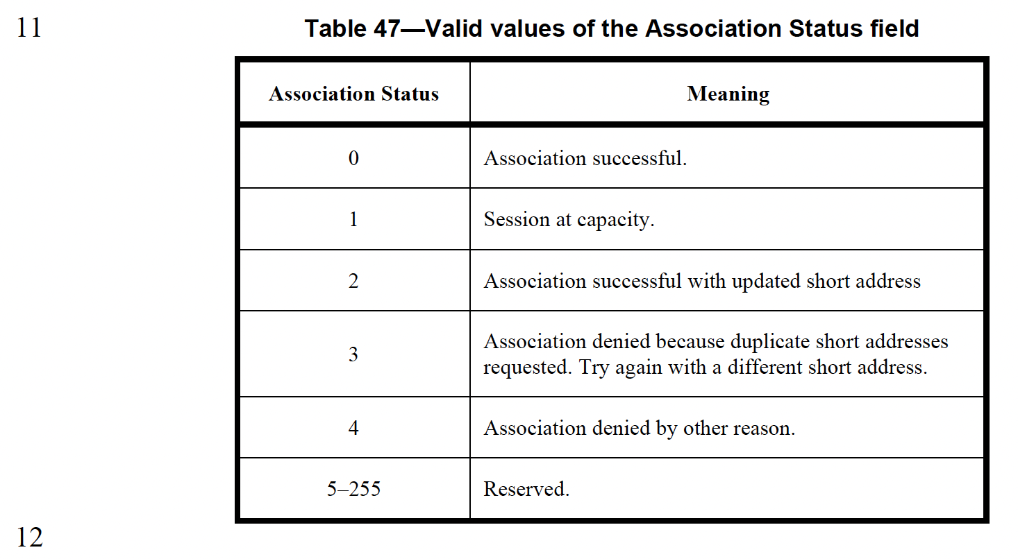

[2nd paragraph of 10.40.3]
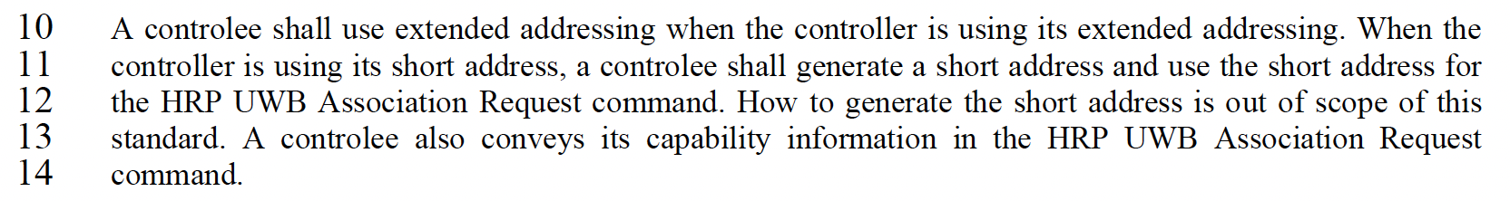

Tero Kivinen | 744 | 163 | 10.40.4.1 | 21 | Where does the device wanting to send association request get this session id? | is this Session Id same as AC IE, if so add reference to there. | Revise
Disposition details:
Add "Controlees can learn the Session ID by observing the AC IE." at the end of line 21.

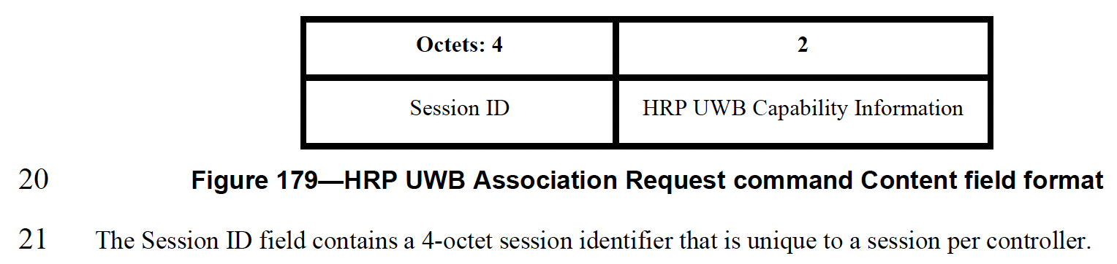

Li-Hsiang Sun | 258 | 164 | 10.40.4.1 | 1 | compression/decompression of CIR report should be added in capability | as in comment | Revise
Disposition details:
I asked commentor for proposed change.
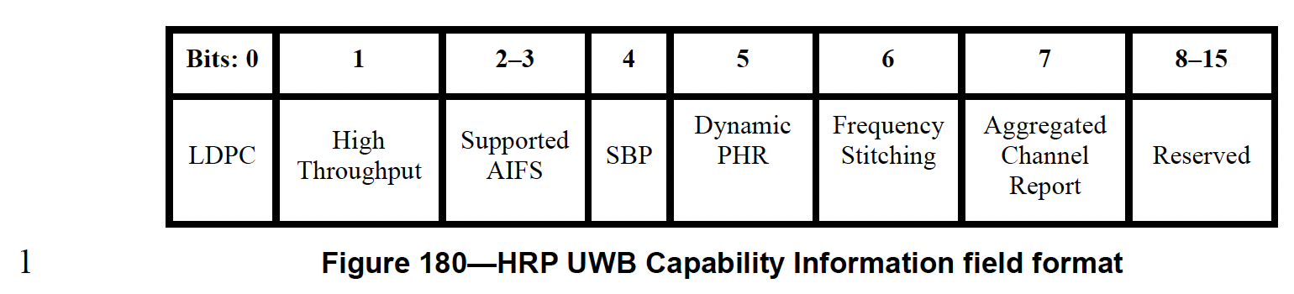

Billy Verso | 1265 | 164 | 10.40.4.2 | 17 | I think this is wrongly stated since we cannot know what the remote controlee is trying to do. And the SHALL here is dependent on next higher layer activity. | Change to: "This command shall be sent as a result of the MLME-ASSOCIATE.response primitive being issued by the next higher layer. | Revise
Disposition details:
Change "shall be sent" to "shall only be sent"

This line does not mean the controller should send response command always. What this line says is that the response command should not be sent by a controlee.

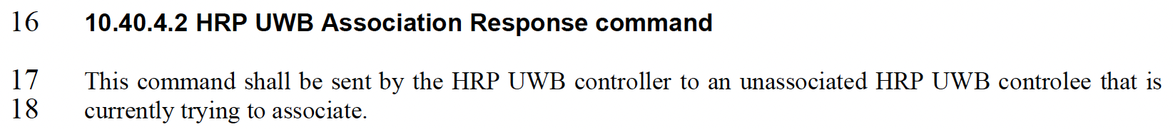

Tero Kivinen | 754 | 165 | 10.40.4.2 | 9 | The response command should include the short address the controller assigned to the controlee not just updated short address. | Change "Updated Short Address" to "Short Address". | Reject
Disposition details:
Controller already uses short address in MAC header. There is no reason to repeat.

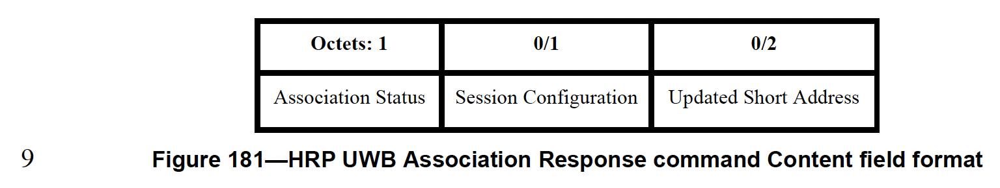

Tero Kivinen | 756 | 166 | 10.40.4.2 | 3 | There is no macHrpUwbAifsPeriod pib variable. | Fix it to macEmdevImmAckAifsPeriod, | Accept
Disposition details:
Simple error

