**IEEE P802.15**

**Wireless Personal Area Networks**

|  |  |  |
| --- | --- | --- |
| Project | IEEE P802.15 Working Group for Wireless Personal Area Networks (WPANs) | |
| Title | **Proposed Resolution for Presence Bitmap** | |
| Date Submitted | May 2024 | |
| Sources | Rojan Chitrakar, Lei Huang (Huawei)  [rojan.chitrakar@huawei.com](mailto:rojan.chitrakar@huawei.com) |  |
| Re: |  | |
| Abstract |  | |
| Purpose | To propose resolution for Presence Bitmap related comments for “P802.15.4ab™/D (pre-ballot) C Draft Standard for Low-Rate Wireless Networks” . | |
| Notice | This document does not represent the agreed views of the IEEE 802.15 Working Group or IEEE 802.15.4ab Task Group. It represents only the views of the participants listed in the “Sources” field above.It is offered as a basis for discussion and is not binding on the contributing individuals. The material in this document is subject to change in form and content after further study. The contributors reserve the right to add, amend or withdraw material contained herein. | |

Rev 0: Initial version.

***Comment Indices in 15-24-0010-00-04ab-consolidated-comments-draft-c:***

|  |  |  |  |  |  |  |
| --- | --- | --- | --- | --- | --- | --- |
| **Name** | **Idx** | **Pg** | **L.** | **Comment** | **Proposed Change** | **Resolution** |
| Carl Murray | 743 | 72 | 15 | Would it be better to get rid of message control 0x00 as 0x01 provides the same functionality but is more flexible at the cost of 1 octet | Should discuss | Revise. message control 0x00 is retained but the rest (0x10, 0x20 and 0x30) are combined. |
| Rojan Chitrakar | 639 | 72 | 15 | The 3 message control version are almost the same and can be easily unified by adopting the presence bitmap in all versions. | Unify the 3 message control versions by adopting the presence bitmap field in all versions. | Revise. message control 0x10, 0x20 and 0x30 are combined. |

**Discussion**：

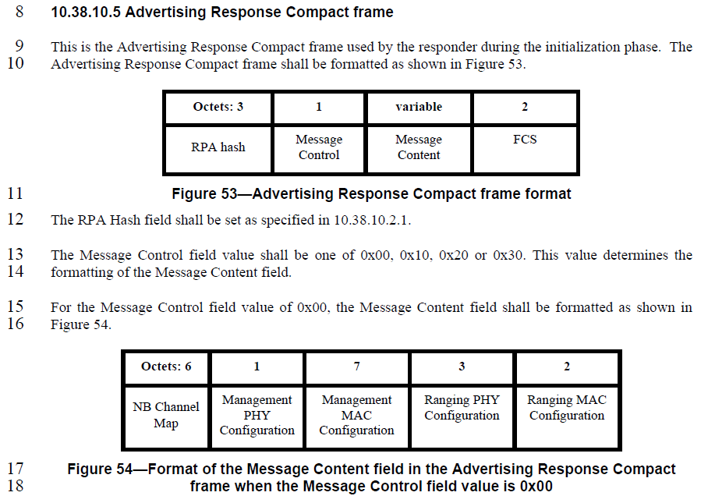

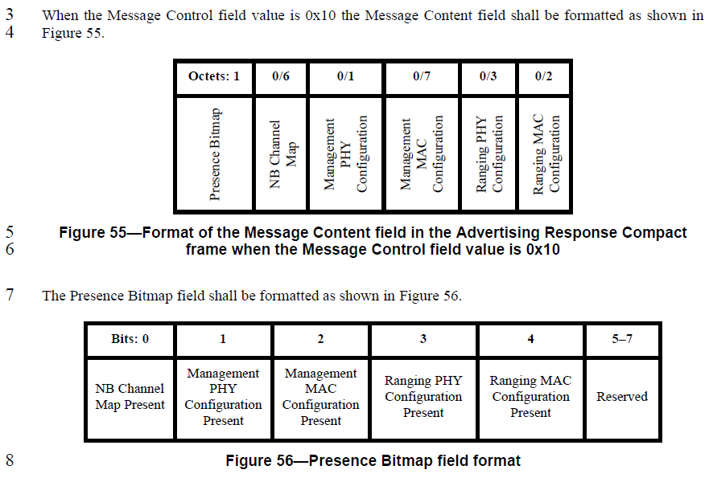

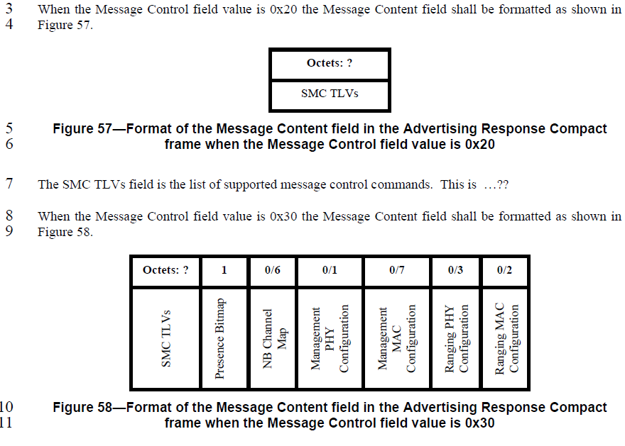

**Disposition: Revised**

**Disposition Detail:**

**Proposed text changes on P802.15.4ab™/D (pre-ballot) C:**

**10.38.10.5 Advertising Response Compact frame**

***Change the subfield as follows (Track changes ON)***

…

The RPA Hash field shall be set as specified in 10.38.10.2.1. 12

The Message Control field value shall be one of 0x00 or 0x10. This value determines the formatting of the Message Content field.

…

|  |  |  |  |  |  |  |
| --- | --- | --- | --- | --- | --- | --- |
| **Octets: 1/2** | **0/6** | **0/1** | **0/7** | **0/1** | **0/2** | 0/variable |
| Presence Bitmap | NB Channel Map | Management PHY Configuration | Management MAC Configuration | Ranging PHY Configuration | Ranging MAC Configuration | SMC_TLVs |

**Figure 55—Format of the Message Content field in the Advertising Response Compact frame when the Message Control field value is 0x10**

The Presence Bitmap field is set as specified in 10.38.10.3.xx.

***Delete Figure 56 and lines 8 to 22 in page 72***

The NB Channel Map field if present shall be set as per 10.38.10.3.7

The Management MAC Configuration field if present shall be set as per 10.38.10.3.10

The Management PHY Configuration field if present shall be set as per 10.38.10.3.15

The SMC TLVs field is the list of supported message control commands and if present shall be set as per 10.38.10.3.x. This is used by the initiator to signal to responders which compact frames and which message control values it supports.

***Delete lines 3 to 15 in page 74***

**10.38.10.17 Public Advertising Response Compact frame**

***Change the subfield as follows (Track changes ON)***

…

The Message Control field value shall be 0x00..

The Message Content is formatted the same as for the Advertising Response Compact frame Message Content field with Message Control field value 0x10, as shown in Figure 55, with the same function and meaning for each of the fields.

***Delete lines 12 to 17 in page 92***

**10.38.10.3 Common message fields**

***Note to editor: Add the following to the end of the subclause***

**10.38.10.3.xx The Presence Bitmap field**

The Presence Bitmap field shall be formatted as shown in Figure xx1.

|  |  |  |  |  |  |  |  |
| --- | --- | --- | --- | --- | --- | --- | --- |
| Bits: 0-1 | 2 | 3 | 4 | 5 | 6 | 7 | Octets: 0/1 |
| NB Channel Map Present | Management  PHY  Configuration  Present | Management  MAC  Configuration  Present | Ranging PHY  Configuration  Present | Ranging MAC  Configuration  Present | Block and Round Index Present | Extended Presence Bitmap  Present | Extended Presence Bitmap |

**Figure xx1—****Presence Bitmap format**

The NB Channel Map Present field set to a value 0 indicates absence of a NB Channel Map in the Message Content field, a value of 1 indicates the presence in the Message Content field of a 2-byte NB Lower Channel Map as shown in Figure 44, a value of 2 indicates the presence in the Message Content field of a 5-byte NB Higher Channel Map as shown in Figure 44, and a value of 3 indicates the presence in the Message Content field of a 6-byte NB Channel Map as shown in Figure 43.

The Management PHY Configuration Present field when one indicates that the Management PHY Configuration field is included in the Responder Detail List elements or is not included when the Management PHY Configuration Present field value is zero.

The Management MAC Configuration Present field when one indicates that the Management MAC Configuration field is included in the Responder Detail List elements or is not included when the Management MAC Configuration Present field value is zero.

The Ranging PHY Configuration Present field when one indicates that the Ranging PHY Configuration field is included in the Responder Detail List elements or is not included when the Ranging PHY Configuration Present field value is zero.

The Ranging MAC Configuration Present field when one indicates that the Ranging MAC Configuration field is included in the Responder Detail List elements or is not included when the Ranging MAC Configuration Present field value is zero.

The Block and Round Index Present field when one indicates that both the Block index field and the Round Index field are included in the Message Content field or are not included when the Block and Round Index Present field value is zero.

The Extended Presence Bitmap Present field when one indicates that the Extended Presence Bitmap is included in the Presence Bitmap field or is not included when the Extended Presence Bitmap Present field is zero.

The Extended Presence Bitmap field shall be formatted as shown in Figure xx2.

|  |  |  |
| --- | --- | --- |
| Bits: 0 | 1 | 2 - 7 |
| SMC_TLVs  Present | Start and End Slot Indices Present | Reserved |

**Figure xx2—Extended Presence Bitmap format**

The SMC_TLVs Present field when set to value 1 in indicates that the SMC_TLVs field is present in the Message Content field. A value of zero indicates absence of the SMC_TLVs field in the Message Content field.

The Start and End Slot Indexes Present field when one indicates that both the Block index field and the Round Index field are included in the Responder Detail List elements or are not included when the Block and Round Index Present field value is zero.