PAPR OF QPSK IN OFDM SINGLE CARRIER SYTEM

Introduction
This document describes the waveform generation for QPSK modulation using the OFDM single carrier system and PAPR (Peak to average power ratio) computation.

QPSK Modulation
The QPSK modulation symbols are 0.7071 + 0.7071i, -0.7071 + 0.7071i, 0.7071-0.7071i, -0.7071-0.7071i all of which have unit magnitude. Below figure shows the constellation of QPSK modulation.
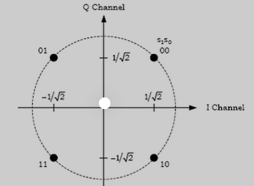
Figure 1 QPSK constellation plot

Waveform
The time-domain signal is generated by populating the appropriate subchannels, followed by IFFT (Inverse Fast Fourier Transform) and CP (Cyclic Prefix) addition.
Since we are populating a single tone/subcarrier only, there is a single modulation symbol in one subchannel and upon taking the IFFT of this, it results in the time domain signal given below.
s(n) = (1/N) *a(k)e^(j*2pi*k*n/N), n= 1 to N
We can see that the absolute value of s(n) is the same for all values of n and is equal to the absolute value of a(k)/N (where a(k) is the QPSK symbol having unit magnitude and N is the FFT size) since the magnitude of e^(j*2pi*k*n/N) is 1. Hence the peak and average value are the same, and PAPR is 0 dB.
The below figure shows the OFDM subcarriers out of which only a single subcarrier is used.
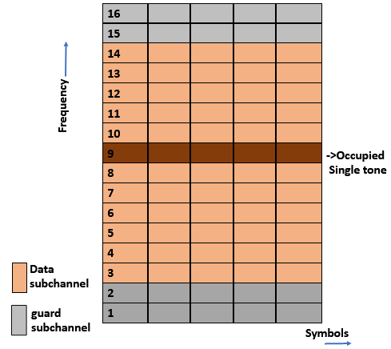
Figure 2 OFDM with Single carrier used.

STEPS FOR SIGNAL GENERATION AND PAPR COMPUTATION
- Generate the time domain signal by populating the appropriate subcarriers, followed by IFFT (Inverse Fast Fourier Transform) and CP(Cyclic Prefix) addition for a total of 10 slots. 1 slot corresponds to 54 symbols for the single carrier system.
- Obtain the PAPR of the above-generated signal using the formula:
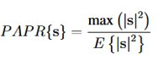
- The above two steps are repeated for a total of 1000 iterations and the PAPR value corresponding to each iteration is stored.
- From the 1000 PAPR values, generate the Complementary Cumulative Distribution Function (CCDF) plot.
- Note the PAPR value (say x) at which the CCDF takes the value of 0.01. This means 1% of the time or 10 out of the 1000 obtained PAPR values (corresponding to each iteration) is greater than the value x.
This probabilistic value x is considered as the final PAPR.
*In case of the single carrier system with single subchannel enabled, since the PAPR value is 1 or 0 dB for all the iterations, that itself is the PAPR value. We do not depend on the above general steps of obtaining the PAPR based on CCDF.

