IEEE 802.15
Wireless Specialty Networks

Project | IEEE 802.15 Working Group for Wireless Specialty Networks
Title | Use Cases document
Date Submitted | January 25th, 2022
Source
  Marco Hernandez¹, Ryuji Kohno^{1,2}, Takumi Kobayashi^{1,2}, Minsoo Kim²  ¹YRP-IAI, ²YNU, Japan | Marco.Hernandez@ieee.org  Kohno@ynu.ac.jp  Kobayashi-Takumi-ch@ynu.ac.jp  Minsoo@minsookim.com
Response | To call for contributions
Abstract | This document contains uses cases for P802.15.6a specification.
Purpose | For contributions to P802.15.6a
Notice | This document has been prepared to assist the IEEE P802.15.6a. It is offered as a basis for discussion and is not binding on the contributing individual(s) or organization(s). The material in this document is subject to change in form and content after further study. The contributor(s) reserve(s) the right to add, amend or withdraw material contained herein.

Contributors
Name & affiliation | Email
Marco Hernandez, YRP-IAI Japan | Marco.Hernandez@ieee.org
Ryuji Kohno, YRP-IAI, YNU, Japan | Kohno@ynu.ac.jp
Takumi Kobayashi, YRP-IAI, YNU, Japan | Kobayashi-Takumi-ch@ynu.ac.jp
Minsoo Kim, YRP-IAI Japan | Minsoo@minsookim.com
Kamran Sayrafian, NIST USA | Kamran.Sayrafian@nist.gov

Revision history
Revision | Date | Notes
0 | 1/19/2022

Contents
1. Introduction 1
1.1 Enhanced dependability for IEEE 802.15.6TM−2012 Std 1
1.2 Vehicle Area Networks 1
1.3 Computer Brain Interface 1
1.4 Coexistence 2
2. Use cases 3
2.1 Radio channel and environmental models 3
2.2 Vehicle BAN and Human BANs use cases 3
2.3 Computer Brain Interface 6
2.4 Support for infrastructure protocols 7
2.5 C2C communications 7
Annex A Bibliography 8

- Introduction
The standard IEEE 802.15.6TM−2012 Wireless BANs aimed to solve the issues related to Human Body Area Networks (HBAN). While the amendment IEEE 802.15.6a addresses higher reliability of HBANs and adds Vehicle Area Networks (VBAN) support.
The amendment enhances the Ultra-Wideband (UWB) physical layer (PHY) and medium access control (MAC) to support dependability to human body area networks (HBAN), and it adds support for vehicle body area networks (VBAN). VBAN operates under strict compliance to standards and limits for electromagnetic interference (EMI) from the vehicle's electric and electronic systems.
Areas of enhancement include operation with multiple PANs (Personal Area Networks) coexisting. Protection against interference from other BANs or other wireless systems operating in the UWB band. Also, a simple and more reliable MAC protocol compared to IEEE 802.15.6.
Other areas of enhancement include support of higher performance, security, coexistence, and efficiency in the operation and maintenance of HBAN and VBAN. P802.15.6a incorporates support for infrastructure protocols via an access point. The amendment provides safeguards so that high throughput data use cases will not cause significant disruption to low duty-cycle ranging use cases. Technical features offer to satisfy an evolutionary set of entertainment and healthcare services.
  - Enhanced dependability for IEEE 802.15.6TM−2012 Std
As the use of personal devices and gadgets in modern societies increases, BANs must coexist with other wireless systems operating in the UWB band. IEEE 802.15.6TM−2012 was not designed to cope with a plurality of devices and congested environments. It is necessary to introduce mechanisms to mitigate interference and performance degradation.
The new case of coexistence with other wireless systems includes other UWB systems and narrowband devices operating in the UWB band. For enhanced dependability, new mechanisms in the UWB PHY and MAC of IEEE 802.15.6-2012 must be introduced.
In addition, new use-cases appeared throughout the years. Such as wireless interfaces in vehicles, autonomous vehicles, not just infotainment, but control of sensors around a vehicle, integration to human BANs and infrastructure to offer stable and dependable communication flows via 5G for example.
  - Vehicle Area Networks
Usability in new vehicle use cases: The BAN paradigm extends to land vehicles. Indeed, BAN is specifically designed for vehicles with sensors and actuators in the vehicle’s cabin, engine compartment, trunk. The idea is to interact with an HBAN to monitor vital signs and other health indicators in the vehicle's control system. Hence, HBAN is another input to vehicle control for navigation, cruise control, and emergency situations. Moreover, VBAN provides a hub for the connection to other networks such as Wi-Fi or Cellular with the possibility to connect Time-Sensitive Networking domains to support highly dependable communication flows.
New business opportunities by the adoption of wireless technologies to vehicles like a smart-key, wireless harness, infotainment, monitoring drivers’ health conditions, etc.
  - Computer Brain Interface
Brain-computer interface (BCI) acquires brain signals, analyze them, and translate them into commands relayed to devices and actuators that carry out desired actions. BCI was originally conceived to replace neuromuscular disorders in disabled people. However, BCI has the potential to be a key element in virtual and augmented reality applications. Indeed, until recently, the dream of controlling one's environment through thoughts had been in the realm of science fiction. However, the advance of technology has brought a new reality.
We can use the electrical signals from brain activity to interact with the user's environment. CBI interface requires collecting signals from the brain; sending them to a control unit from which those are transmitted wirelessly to an Access Point (AP). Such AP supports a 15.6a interface. The reason to use UWB signaling in such an interface is the requirement to use a 64 Mb/s information data rate to support the CBI interface from NICT [].
  - Coexistence
The proliferation of wireless systems has produced scenarios in which multiple BANs must coexist as well as with other wireless systems operating in the UWB band. The Std IEEE802.15.6-2012 was not designed to manage such levels of interference that ultimately causes performance degradation. IEEE 802.15.6a aims to solve coexistence with BANs and other wireless systems operating in the UWB band.
Interference mitigation mechanisms are required at the PHY and MAC levels to deal with the coexistence of multiple BANs and other wireless systems.

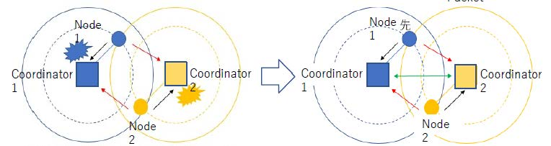
- —Concept of coordinator-to-coordinator interference mitigation.

An innovation of the amendment is to coordinate interference and collisions among coordinators within communication range. Conventional 802.15.6 BAN coordinators operate independently of one another. The amendment aims to increase dependability and performance. Hence, 15.6a BAN coordinators may interact to mitigate interference and collisions. Coordinator-to-coordinator (C2C) communication performs via a dedicated link between BAN coordinators.

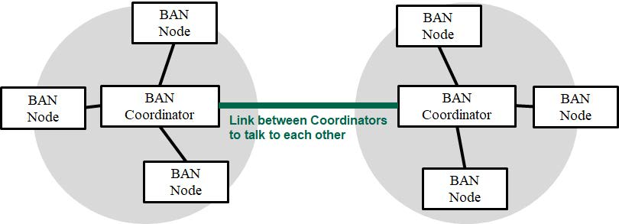
- —Coordinator-to-coordinator communications.
- Use cases
  - Radio channel and environmental models
The new VBAN use cases require the characterization of UWB propagation on vehicles and the interaction between HBAN and VBAN. The different use cases of channel characterization are named environmental models.

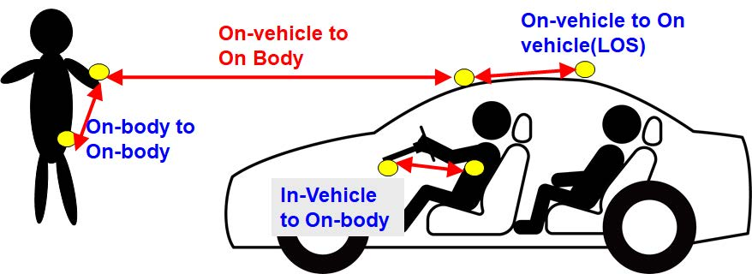
- —Concept of channel models for HBAN and VBAN.

Such environmental models include interference from other wireless systems operating in the UWB band. Also, EMI is produced by the electric and electronic systems of vehicles.
  - Vehicle BAN and Human BANs use cases
The interaction between HBAN and VBAN creates an environment, which may experience significant interference and collisions. A solution for coexistence is coordinating access to the medium between BAN coordinators: coordinator-to-coordinator communication (C2C). It enables various use cases.
    - Vehicle BAN and Human BANs inside the vehicle
Considering a star topology, the VBAN's coordinator is a super-coordinator, and other HBAN coordinators are super-nodes.
A VBAN coordinator may support up to 5 HBAN coordinators for a passenger vehicle, such as sedan, pickup, SUV, utility vehicle.
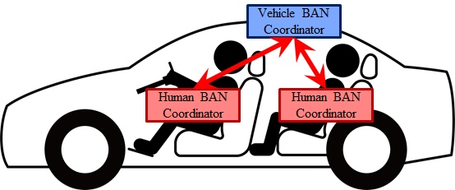
- —C2C passenger vehicle use case I.

Another use case for passenger vehicles includes an HBAN approaching the vehicle.

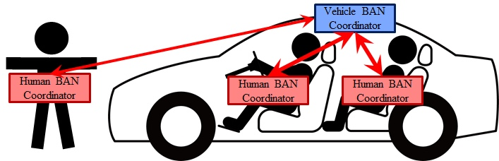
- — C2C passenger vehicle use case II.

An interesting use case is for a passenger bus with one or more VBAN coordinators coexisting with HBANs from passengers.

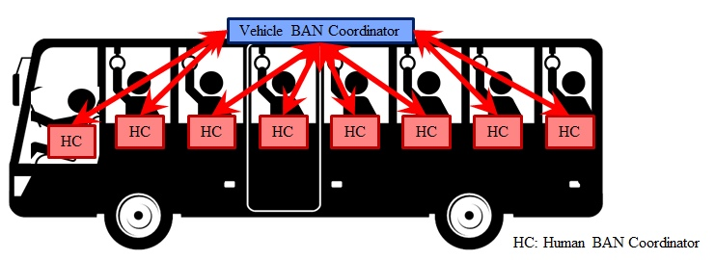
- —C2C passenger bus use case I.

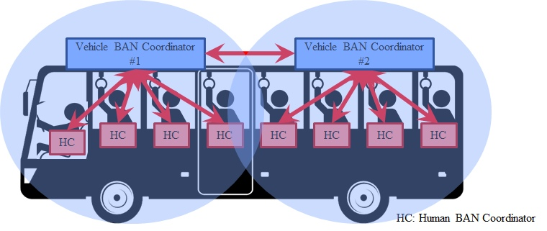
- — C2C passenger bus use case II.
    - Multiple HBANs
C2C communication links seem to follow a peer-to-peer topology.
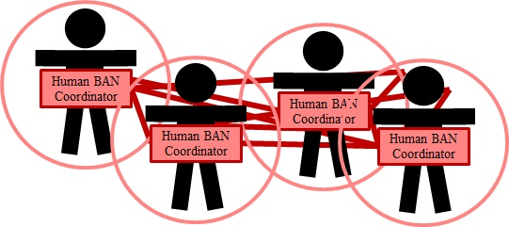
- —C2C multiple BANs use case.

    - Handover use case
An interesting use case includes an HBAN approaching a VBAN. The control of a given HBAN node may be handed over to the VBAN coordinator.

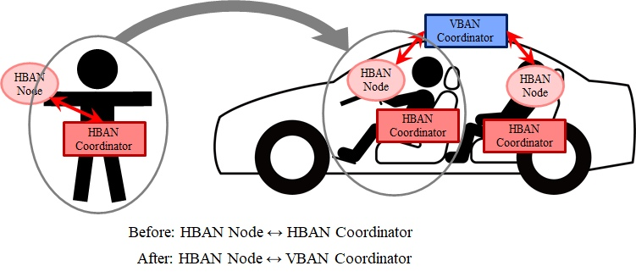
- —Handover use case I.

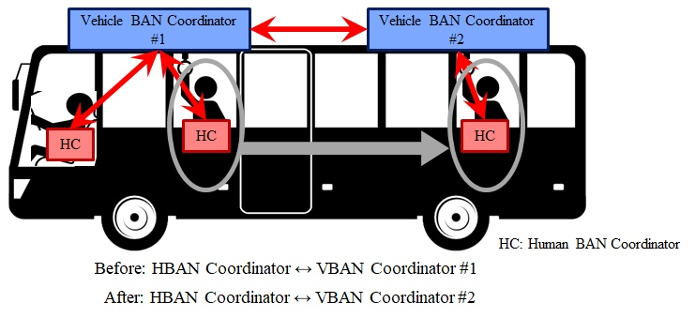
- — Handover use case II.
  - Computer Brain Interface
Brain-computer interface (BCI) acquires brain signals, analyze them, and translate them into commands relayed to devices and actuators that carry out desired actions. BCI was originally conceived to replace neuromuscular disorders in disabled people. However, BCI has the potential to be a key element in virtual and augmented reality applications.
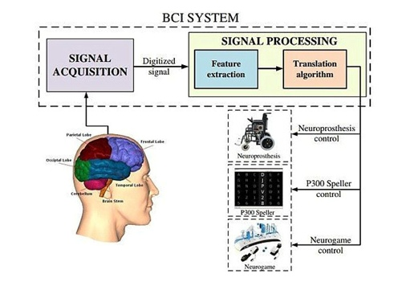
- —Concept of BCI use cases.

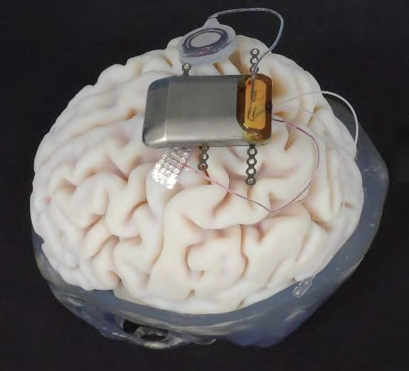
- —UWB radio interface outside the skull.
  - Support for infrastructure protocols
This use case looks for HBAN, VBAN to interconnect to other networks, such as Wi-Fi, Cellular, LAN (Ethernet).
A possibility for such interconnection (at the MAC/LLC layer) is to reuse the mechanisms of 802.1 Stds (TSN).

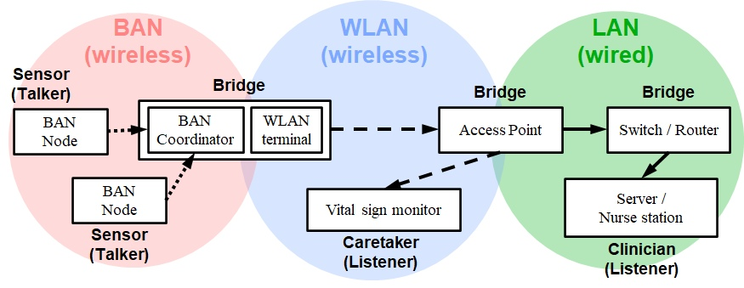
- —Interconnection to other networks use case.

  - C2C communications
Another use case would be the same interconnection for C2C communication of BAN networks, see Figure 2.

Bibliography
- Project Authorization Request P802.15.6a. Online: 15-21-0259-04-006a
- Criteria for Standards Development P802.15.6a. Online: 15-21-0260-03-006a
- Draft Technical Requirement of P802.15.6a. Online: 15-21-0493-01-006a

