IEEE P802.15
Wireless Specialty Networks
IEEE P802.15.13
Text for Adaptive MIMO Communication Comment Resolutions
Date: 2021-06-28
Source: Tuncer Baykas (Kadir Has University), Murat Uysal (Ozyegin University), Refik Kizilirmak (Nazarbayev University),
Address: Kadir Has University, Istanbul, Turkey E-Mail: tbaykas@ieee.org

Abstract

This document contains proposed text for IEEE P802.15.13 Draft Comment Resolutions of I-10, I 357

…. In the repetition coding, the same information is transmitted from all OFEs as shown in Figure 25. Solid lines indicate wires to the transmitter and dashed lines indicate wireless communication.
…

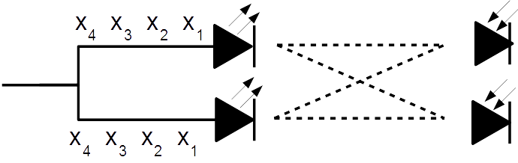
Figure 25 Repetition coding for adaptive MIMO communication

…

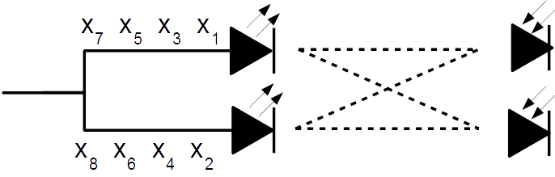
Figure 26 Spatial Multiplexing for Adaptive MIMO Communication

