IEEE P802.15
Wireless Specialty Networks
IEEE P802.15.13
Text for Adaptive MIMO Communication
Date: 2019-05-13
Source: Tuncer Baykas (Vestel, Istanbul Medipol University), Murat Uysal (Ozyegin University), Omer Narmanlioglu (Ozyegin University), Refik Kizilirmak (Nazarbayev University), Cihat Aytac (Vestel)
Address: Istanbul Medipol University, Istanbul, Turkey E-Mail: tbaykas@ieee.org

Abstract

This document contains proposed text for IEEE P802.15.13 Draft

Overview

Normative References

Definitions, acronyms, and abbreviations

General description

MAC functional description

(5.8.5) Adaptive MIMO transmission
Coordinators supporting capMultiOfeEstimation capability, can use the CSI information for adaptive MIMO transmission. In adaptive MIMO transmission two main modes are available.
1) Repetition Coding:
In the repetition coding, the same information is transmitted from all OFEs .Only one MCS information is provided.
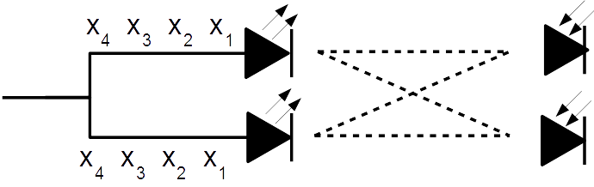
Figure 27 Repetition Coding for Adaptive MIMO Communication

2) Spatial Multiplexing
In the spatial multipexing case every OFE sends independent information. The MCS of each OFE is provided separately.
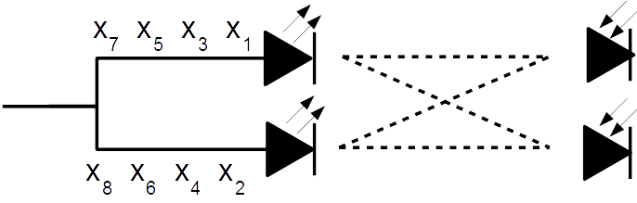
Figure 28 Spatial Multiplexing for Adaptive MIMO Communication

Change Table 52 and its explanation accordingly…
The advanced modulation header defines the fields given in Table 1Error: Reference source not found.
Field | Octet | Bits | Description
Adaptive | 0 | [0] | Whether carriers are to be allocated dynamically
CQI | 0 | [1] | Indicate if CQIs should be calculated in the PHY for the current transmission frame
eU-OFDM | 0 | [2] | Indicate if payload is encoded using eU-OFDM
STR | 0 | [3] | Indicate the number of eU-OFDM streams superimposed in the signal encoding procedure
Reserved | 0 | [9:4] | Reserved for future use
Relaying enabled | 1 | [10] | Indicate if relaying should be performed for the current PHY frame
Relaying mode | 1 | [12:11] | Specify the mode of relaying operation to be performed
MIMO enabled | 1 | [13] | Indicate if a MIMO mode is enabled for the current PHY frame
MIMO reference symbol | 1 | [14] | Indicate format of the reference symbols used for CQI estimation
MIMO mode | 1 | [15] | Indicate MIMO uses repetition coding or spatial multiplexing
Reserved bits | 2 | [16:15] | Reserved for future use
Parity | 2 | [17] | An even parity check bit for the information in bits 0 - 16
Tail | 2 | [23:18] | 6 zero bits

- Fields in the advanced modulation header
The individual fields of the basic header are described as follows.
Adaptive bit indicates whether adaptive bit loading is used to encode the subsequent payload:
“1” indicates: Adaptive bit loading is used. In this case, the subsequent payload is encoded with the loading scheme which the receiving device has estimated and suggested to the transmitter using the feedback channels and negotiation procedures on the MAC sub-layer.
“0” indicates: Adaptive bit loading is not used. In this case, the subsequent payload is encoded with the default loading scheme and the rate specified in the basic PHY header.
LB-PHY does not support adaptive bit loading. If any PHY which does not support bit loading receives a packet with a “1” in this bit, it ignores the packet as it will not be able to demodulate.
CQI bit indicates whether the CQIs should be calculated in the PHY for the current transmission frame.
“1” indicates: the CQIs should be estimated
“0” indicates: the CQIs should not be estimated
The channel estimation symbols preceding the PHY header are used for the estimation of the CQIs if the MIMO mode is not enabled. If MIMO mode is enabled, the MIMO reference symbols used for CQI estimation is further defined in MIMO RS field in the advanced modulation header.
Upon estimation of the CQIs, the PHY conveys the results to the MAC using a predefined PHY service primitive. The calculation of the bit and power allocation scheme as well as the necessary exchange for updating the bit and power allocation scheme at the transmitter and receiver are handled at the MAC sublayer.
eU-OFDM indicates whether the payload field is encoded using eU-OFDM.
“1” indicates: the payload is encoded using eU-OFDM.
“0” indicates: the payload is not encoded using eU-OFDM.
Note that the use of this waveform can be negotiated in advance using control/management frames. Furthermore, the use of eU-OFDM encoding does not prohibit the use of any other waveforms such as RPO-OFDM.
STR bit indicates the number of eU-OFDM streams superimposed in the signal encoding procedure.
“0” indicates: the number of eU-OFDM streams superimposed in the signal encoding procedure is 1.
“1” indicates: the number of eU-OFDM streams superimposed in the signal encoding procedure is 4.
Reserved bits are reserved for future use.
Relaying mode specifies the type of relaying mode that should be performed.
“00” specifies: Relaying and duplexing mode is FD-AF.
“01” specifies: Relaying and duplexing mode is FD-DF.
“10” specifies: Relaying and duplexing mode is HD-AF.
“11” specifies: Relaying and duplexing mode is HD-DF.
MIMO enabled bit indicates whether a MIMO mode is enabled for the current PHY frame.
“1” indicates: MIMO mode is enabled and the subsequent payload is encoded using the MIMO scheme already negotiated between the transmitter and the receiver.
“0” indicates: MIMO mode is not enabled and the subsequent payload is encoded using the SISO scheme specified by the parameters in the basic PHY header and the advanced modulation header.
MIMO Reference Symbols Format bit indicates the format of the reference symbols used for CQI estimation.
“0” indicates: MIMO Reference Symbols Format I is used.
“1”: indicates: MIMO Reference Symbols Format II is use
The two MIMO reference symbols formats are specified in Error: Reference source not found.
MIMO mode bit indicates which MIMO mode will be used.
“1” indicates: MIMO mode is enabled and the subsequent payload is spatially multiplexed.
“0” indicates: MIMO mode is enabled for repetition coding and the subsequent payload is encoded using the SISO scheme specified by the parameters in the basic PHY header and the advanced modulation header.
Reserved bit is reserved for future use.
Parity bit does an even parity check for the information in bits 0 - 16.
Tail consists of 6 bits which are set to 0 to complete the advanced modulation header.

