IEEE P802.15
Wireless Specialty Networks
IEEE P802.15.13
Text for Adaptive MIMO Communication
Date: 2019-05-13
Source: Tuncer Baykas (Vestel, Istanbul Medipol University), Murat Uysal (Ozyegin University), Omer Narmanlioglu (Ozyegin University), Refik Kizilirmak (Nazarbayev University), Cihat Aytac (Vestel)
Address: Istanbul Medipol University, Istanbul, Turkey E-Mail: tbaykas@ieee.org

Abstract

This document contains proposed text for IEEE P802.15.13 Draft

Overview

Normative References

Definitions, acronyms, and abbreviations

General description

MAC functional description

Adaptive MIMO transmission
Coordinators supporting capMultiOfeEstimation capability, can use the CSI information for adaptive MIMO transmission. In adaptive MIMO transmission two main modes are available.
1) Repetition Coding:
In the repetition coding, the same information is transmitted from all OFEs .Only one MCS information is provided.
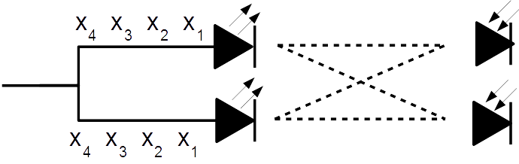
Figure 27 Repetition Coding for Adaptive MIMO Communication

2) Spatial Multiplexing
In the spatial multipexing case every OFE sends independent information. The MCS of each OFE is provided separately.
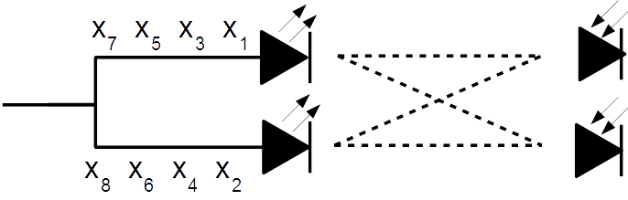
Figure 28 Spatial Multiplexing for Adaptive MIMO Communication

