IEEE P802.15
Wireless Specialty Networks
IEEE P802.15.13
Text for MIMO Communication in Chapter 5
Date: 2019-05-13
Author:
Name | Affiliation | Address | Phone | Email
Tuncer Baykas | Vestel, Medipol Uni. |  |  | tbaykas@ieee.org

Abstract

This document contains proposed text for IEEE P802.15.13 draft.

5 MAC functional description

5.9 MIMO Communication
The use of adaptive multiple input multiple output (MIMO) communication for High rate PD is optional. Figure 1 illustrates the general overview of the MIMO communication.
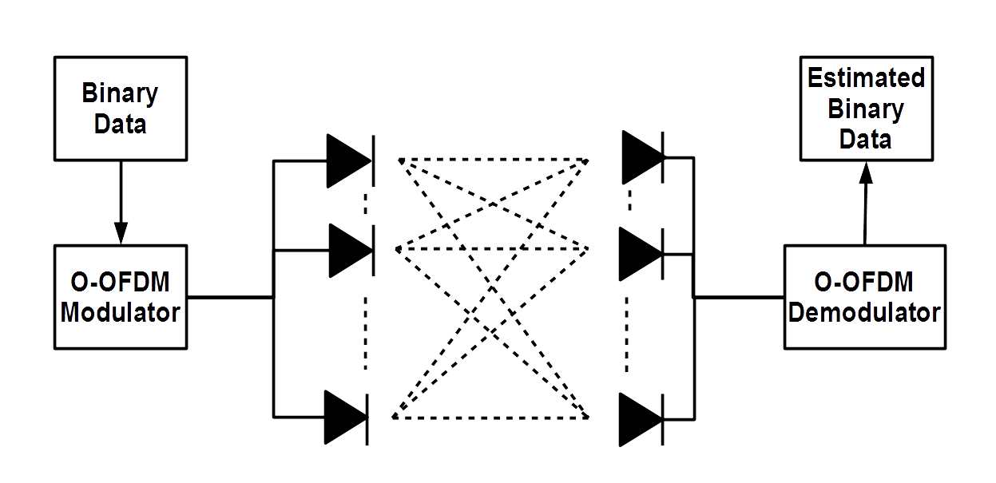
Figure 1 General Overview of High-Rate PD MIMO Communication

The information is transmitted from multiple LEDs to multiple PDs through optical wireless channels. The maximum number of LED arrays and PD arrays, which can be supported by the High rate PD is set to 16.

MIMO Communication Setup

To setup the MIMO communication, it is assumed that the association is realized in SISO mode. Afterwards VLC receiver sends MIMO info request the start the setup. Transmitter provides the number of Transmit elements and its MIMO capabilities. The receiver sends channel info request to start the channel estimation process. The transmitter sends in SISO mode information elements, which include the channel estimation sequence. The channel state information (i.e., channel coefficients, channel correlation, signal-to-noise ratio etc.) is estimated by the receiver. Based on channel conditions, the receiver selects the optimal transmission mode, which includes modulation type, modulation order, MIMO configuration and MIMO type. The selected transmission mode is provided to the transmitter via a feedback channel.

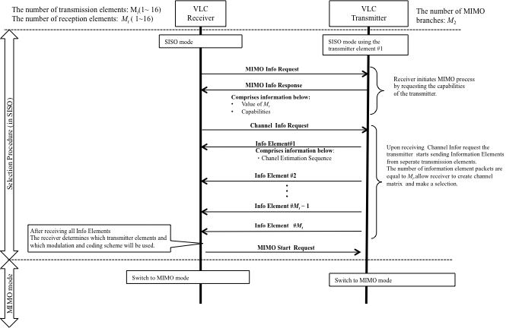
Figure 2 MIMO Communication Setup

All possible communication modes should be set on a lookup table for selection.
The selection algorithm is provided below. The performance metric is pre-determined values according to the quality-of-service (QoS) requirements for targeted applications, such as highest date rate under a specific BER threshold.
/
Two main MIMO schemes can be supported.
1) Repetition Coding:
In the repetition coding, the same information is transmitted from all transmit elements.
2) Spatial Multiplexing
In the spatial multipexing case every transmit element sends independent information.

/

