IEEE P802.15
Wireless Specialty Networks
IEEE P802.15.13
Text for MIMO and Relay Communication
Date: 2019-05-13
Author:
Name | Affiliation | Address | Phone | Email
Tuncer Baykas | Vestel |  |  | tbaykas@ieee.org

Abstract

This document contains proposed text for IEEE P802.15.13.

Overview

Normative References

Definitions, acronyms, and abbreviations

General description

Introduction

Components of an IEEE 802.15.13 OWPAN

Add to the end of the last paragraph…

Coordinators and devices may have multiple optical frontends for transmission and reception to support MIMO communication.

Network service

Add after 4.3.1.5

Relay functionality

With the relay functionality, an intermediate relay is used to assist a transmission via a direct optical wireless
link. With the relay functionality, each relay supports different duplexing and relay modes. For full duplex (FD), the relay receives and transmits data simultaneously, while in half duplex (HD), the relay receives the
data in one time slot and retransmits it in another transmission slot. The relay supports two modes; amplify and-
forward (AF), and decode-and-forward (DF).
a) In AF mode, the RD receives the data from the coordinator, which are then retransmitted after
amplification.
b) In DF mode, the received data is decoded by the relay and then retransmitted to the destination
device.
In case the device is disconnected from the coordinator, a relay search request is conducted, including the
relay capabilities. The coordinator broadcasts a relay search request frame. Each relay replies back on the
control channel with its own capabilities including duplexing and relaying modes. The coordinator selects
the relay that provides the best connectivity. The coordinator sets up a relay link between itself and the
device through the selected relay. A connection remains active until the direct link between the coordinator
and the device is reinitiated and the coordinator requires a termination of the link between the coordinator
and the relay.

Network Integration

Coexistence

MAC functional description

5.9 MIMO Communication
The use of adaptive multiple input multiple output (MIMO) communication for High rate PD is optional. Figure 1 illustrates the general overview of the MIMO communication.
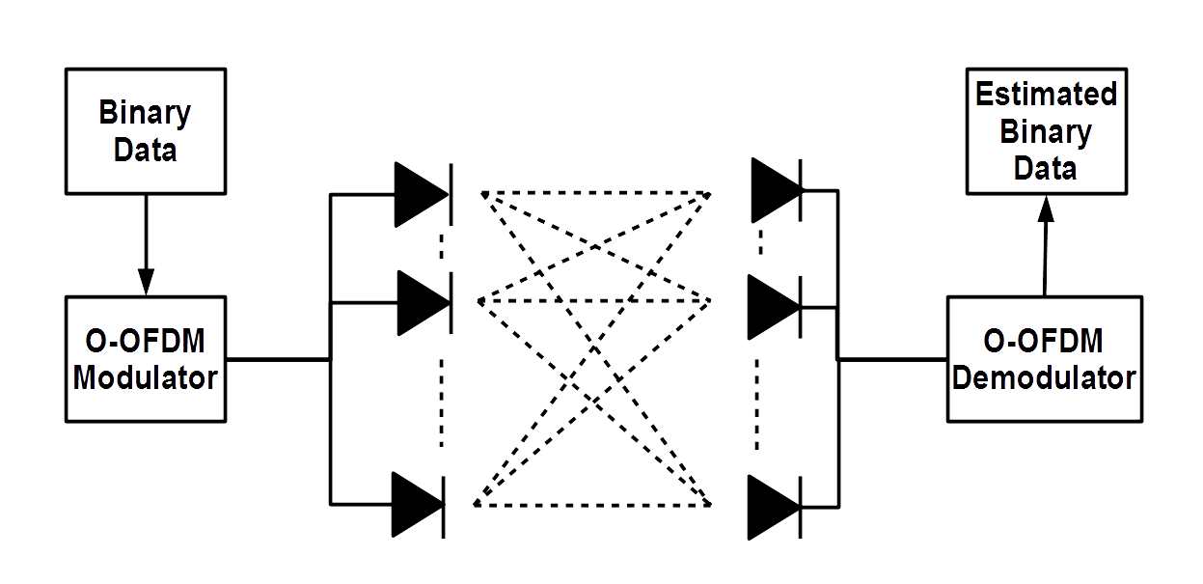
Figure 1 General Overview of High-Rate PD MIMO Communication

The information is transmitted from multiple LEDs to multiple PDs through optical wireless channels. The maximum number of LED arrays and PD arrays, which can be supported by the High rate PD is set to 16.

MIMO Communication Setup

To setup the MIMO communication, it is assumed that the association is realized in SISO mode. Afterwards VLC receiver sends MIMO info request the start the setup. Transmitter provides the number of Transmit elements and its MIMO capabilities. The receiver sends channel info request to start the channel estimation process. The transmitter sends in SISO mode information elements, which include the channel estimation sequence. The channel state information (i.e., channel coefficients, channel correlation, signal-to-noise ratio etc.) is estimated by the receiver. Based on channel conditions, the receiver selects the optimal transmission mode, which includes modulation type, modulation order, MIMO configuration and MIMO type. The selected transmission mode is provided to the transmitter via a feedback channel.

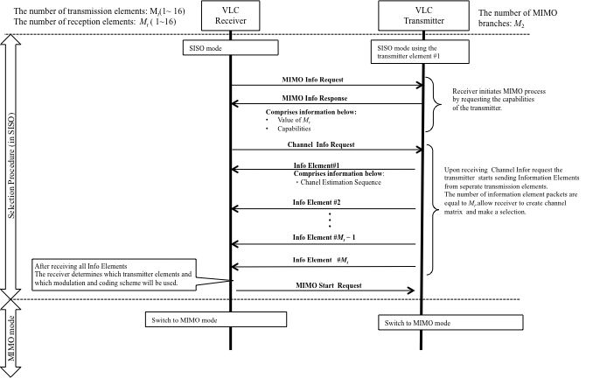
Figure 2 MIMO Communication Setup

All possible communication modes should be set on a lookup table for selection.
The selection algorithm is provided below. The performance metric is pre-determined values according to the quality-of-service (QoS) requirements for targeted applications, such as highest date rate under a specific BER threshold.

/

Two main MIMO schemes can be supported.
1) Repetition Coding:
In the repetition coding, the same information is transmitted from all transmit elements.
2) Spatial Multiplexing
In the spatial multipexing case every transmit element sends independent information.

/

MAC frame formats

Management frames

Add below text

Advanced Modulation Control Element

Advanced modulation control frame indicates the advanced modulation capabilities of a communication node.

1 bit | 4 | 1 | 4 | 1 | 4
Adaptive  Loading | eU | RPO | Relaying | MIMO | MIMO Channel Number
Figure 6-3: Advanced Modulation Control element
Adaptive Loading: A single bit indicates whether the communication node transmitting the advanced modulation control frame supports adaptive bit and energy loading:

“1” indicates: Adaptive bit and energy loading is supported.
“0” indicates: Adaptive bit and energy loading is not supported.

eU: The 4 bits indicate if the node supports eU-OFDM. The bit value at a given position out of the four positions
indicates whether eU-OFDM implementation with the same number of streams as the bit position is supported. Positions are counted from left to right. For example:

“1000” indicates eU-OFDM with one stream only is supported.
“1100” indicates eU-OFDM with one and two streams only is supported.
“1010” indicates eU-OFDM with one and three streams only is supported.
“1111” indicates eU-OFDM with all possible streams is supported.
“0000” indicates eU-OFDM is not supported.

RPO: A single bit indicates whether the communication node transmitting the advanced modulation control frame supports RPO-OFDM:
“1” indicates: RPO-OFDM is supported.
“0” indicates: RPO-OFDM is not supported.

Relaying: The 4 bits indicate the types of relaying operations the communication node transmitting the advanced modulation control frame supports.

The first bit indicates whether relaying in FD is supported:
“1” indicates: Relaying in FD is supported.
“0” indicates: Relaying in FD is not supported.

The second bit indicates whether relaying in HD is supported:
“1” indicates: Relaying in HD is supported.
“0” indicates: Relaying in HD is not supported.

The third bit indicates whether AF relaying is supported:
“1” indicates: AF relaying is supported.
“0” indicates: AF relaying is not supported.

The fourth bit indicates whether DF relaying is supported:
“1” indicates: DF relaying is supported.
“0” indicates: DF relaying is not supported.

MIMO: A single bit indicates whether the communication node transmitting the advanced modulation control frame supports MIMO communication:

“1” indicates: MIMO is supported.
“0” indicates: MIMO is not supported.

MIMO Channel Number: The 4 bits indicate the maximum number of MIMO communication channels which the communication node transmitting the advanced modulation control frame supports.

A value of '0000' corresponds to 1 channel, and a value of '1111' corresponds to 16 channels.

Acknowledgements

Tuncer Baykas acknowledges the support TUBA-Gebip award program.

