IEEE P802.15
Wireless Personal Area Networks

Project | IEEE P802.15 Working Group for Wireless Personal Area Networks (WPANs)
Title | P2p-list reuse proposal for RMA corrections to 802.15.10-2017
Date Submitted | [May 7th, 2018]
Source | [Kiyoshi Fukui]  [OKI]  [Charlie Perkins]  [Futurewei]  [Noriyuki Sato]  [OKI] | Voice: [+81-6-6260-0700]  Fax: [ ]  E-mail: [fukui535@oki.com]  Voice: [+1-408-330-4586]  E-mail: [charliep@computer.org]  Voice: [+81-6-6260-0700]  Fax: [ ]  E-mail: [sato652@oki.com]
Re: | [TG 802.15.10a (RMA) corrections to 802.15.10-2017]
Abstract | Proposal for re-use of P2P list to enable correction
Purpose | [Economical method to satisfy 802.15.10a correction requirements]
Notice | This document has been prepared to assist the IEEE P802.15. It is offered as a basis for discussion and is not binding on the contributing individual(s) or organization(s). The material in this document is subject to change in form and content after further study. The contributor(s) reserve(s) the right to add, amend or withdraw material contained herein.
Release

5. L2R functional description

5.2 L2R mesh formation and route establishment

5.2.1 L2R mesh construction

Change the following entry in Table 5-1 as indicated:

Name | Type | Valid range | Description | Retrieved from IE | Condition to record
P2P path list Route table entry | List of P2P paths reachable destination information | List of the elements of a P2P path Route table entry as defined in Table 5-3 | List of P2P paths available through the current neighbor. Omitted if ondemand P2P route discovery or storing mode are disabled.  Information needed to route a frame to each reachable destination | P2P-RP IE, P2P-RQ IE | P

Change the title of Table 5-3 as indicated:

Table 5-3—Elements of a P2P path route table entry in storing mode

Modify Table 5-2—Elements of a local NT entry:

List of devices that are reachable through the neighbor by DS routing (only used in storing mode)

Modify Figure 5-12—L2R mesh construction as described: (p.47)

Candidate PQM on node C by the link from node F should be 15, since F’s PQM is 10 and LQM between C and F is 5.

5.2.2 L2R route metrics

Delete words from second list item as described: (line 8 on p.48)

If the content of the Link Quality Metric ID and the Mesh Root Address fields match the corresponding parameters in the MT of an L2R mesh the device has joined, the content of the Value field is recorded as the announced link metric of the neighbor in the global NT.

5.2.2.3 Expected airtime metric

Both BO and SO are exponent of 2, 'r' multiplied by 'BO/SO' is really correct? Should they be represented with BI and SD instead: (line 6 on p.51)

5.2.4.2 DS source route establishment

Add new specification after the following text and include xref (p.54):

When the mesh root receives the RA IE or the SRA IE, it delivers the path and the source address therein to the next higher layer with the L2LME-INTERMEDIATE-ADDR-LIST.indication primitive, and stores them as the pair of the address list and the destination address into the ‘Route Table’ in the MT (Table 5-1).

5.2.6 Multicast route establishment

Change the first paragraph of 5.2.7.1 as indicated: (line 2 on p.57)

the multicast address retrieved from the Multicast Subscription field of the RA IE into the list of reachable destinations multicast groups of the neighbor from which they received the RA IE.

5.2.7.1 Storing mode

Change the first paragraph of 5.2.7.1 as indicated:

When a device receives a P2P-RQ IE, if it has no existing path to the source of the P2P-RQ IE, it stores the information retrieved from the P2P-RQ IE into a new entry in the P2P path list Route Table in the MT. The address of the neighbor from which the P2P-RQ IE is received is recorded in the Next hop of the P2P path Route Table. The device calculates or measures the LQM between itself and the neighbor from the previous hop and adds the result to the PQM value found in the IE. The device then stores the result into the PQM Value of the P2P path Route Table entry.

Change the 5th paragraph of 5.2.7.1 as indicated:

If the PSN of new P2P-RQ IE is newer than the recorded PSN, the device calculates the PQM between the device and the source of the P2P-RQ IE. All elements of the P2P path Route Table are updated with the information from the latest P2P-RQ IE and with the newly calculated PQM value.

Change the 8th to 11th paragraphs of 5.2.7.1 as indicated:

If the Request Intermediate Response field in the P2P-RQ IE is set to 1 and if an intermediate device has a path Route Table entry to the requested destination, it does not propagate the P2P-RQ IE but replies with a P2P-RP IE where the PSN and the PQM Value fields are set to the PSN and PQM value recorded for the path Route Table entry of interest in the P2P path list Route Table.

If the device is the desired destination, it replies with a P2P-RP IE. The TTL field of the P2P-RP IE is set to (l2rDefaultTTL - ttl), where ttl is the value of the TTL field in the received P2P-RQ IE. The PQM Value is set to 0. The PSN field is set to the device's current PSN. The P2P-RP IE is forwarded to the neighbor whose address is recorded in Next hop in the current P2P path Route Table entry.

When a device receives a P2P-RP IE, it processes the information in the IE in the same way as it processes the information in a P2P-RQ IE as described above in 5.2.7.1. A P2P path Route Table entry is created or updated accordingly.

If the address of the device receiving the P2P-RP IE does not match the address found in the P2P SA field, the device forwards the P2P-RP IE through the Next hop recorded for the corresponding P2P path Route Table entry with the Destination address matching the address in the P2P SA field.

Change the 13th paragraph of 5.2.7.1 as indicated:

The original source device may start routing data frames as soon as it receives a P2P-RP IE. When a device receives a new P2P-RP IE for the same destination, if the PQM value therein is lower than the PQM value provided by the current next hop, the P2P path Route Table is updated with the information of the new P2P-RP IE. Otherwise the P2P-RP IE is discarded.

5.2.7.2 Non-storing mode

Change the 2nd paragraph of 5.2.7.2 (pg. 64) as indicated:

If the device is the desired destination, it delivers the path and the source address therein to the next higher layer with the L2RLME-INTERMEDIATE-ADDR-LIST.indication primitive. The device also creates a new entry in the P2P path list Route Table of the MT where the Destination address is set to the address retrieved from the P2P SA field of the P2P-RQ IE, the PSN is set to the value retrieved from the corresponding field in the IE, the PQM value is set to the sum of the value of the PQM field and the LQM on the latest hop. The Intermediate address list is set to the inverted list of addresses found in the Intermediate Address List field. The device generates a P2P-RP IE and copies the Intermediate Address List field of the P2P-RQ IE into the corresponding field in the P2P-RP IE and sets the PSN to its own current PSN. The PQM Value is set to the value of the PQM recorded in the Route Table entry for the P2P path of interest. The P2P-RP IE is then carried forwarded to the source through the path indicated.

When the P2P-RP IE reaches the device with the address found in the P2P SA field, the device delivers the path and the source address therein to the next higher layer with the L2RLME-INTERMEDIATE-ADDRLIST.indication primitive. The device also creates a new entry in the P2P path list Route Table of the MT where the Destination address is set to the address retrieved from the P2P DA field of the P2P-RP IE, the PSN, the PQM value and the Intermediate Address List are set to the values retrieved from the corresponding fields in the IE.

5.3.1 L2R US route maintenance:

Change the 6th paragraph of 5.3.1 as indicated: (p.65)

If a device misses does not receive any RAs or SRAs within the time interval l2rRaIeInterval, or any TC IEs within the time interval l2rTcInterval, or l2rMaxMissedTcIe TC IEs, from a neighbor, the corresponding entry in the NT is erased. Route Table entries in the Mesh Table (MT) using that neighbor are also erased.

5.4 L2R routing capabilities

5.4.1.1 Source routing (p.67)

Insert this sentence top of the clause 5.4.1.1
Source routing is used in DS routing and non on-demand P2P routing by mesh root and in On-demand P2P by source node with intermediate nodes indicated when non storing mode is used.

Insert the following as a new paragraph in 5.4.1.1 (p.67):
If the frame is an incoming frame from the PHY layer and if the frame passes the filtering at the MAC layer, the frame is delivered to the L2R sublayer. If the DA matches the device’s address, the frame is delivered to the next higher layer. If the DA does not match the device’s address, the frame is forwarded again.

Change the 1st paragraph of 5.4.1.1 as indicated:

If the L2R mesh is in non-storing mode, devices other than mesh root only store information about their neighbors but do not store DS routing information received with RA or SRA IEs. The mesh root stores all information received from the TC IEs and the RA IEs or SRA IEs. If on-demand P2P routing is enabled in non-storing mode, only the end to end source and destination devices of a P2P path store routing information. In either case, source routing is used. The path to the destination received from the IntermediateAddrList parameter of L2R-DATA.request primitive is included in the Intermediate Addresses List of the L2R Routing IE or the SLR IE and data frames are routed on the path indicated. An L2R mesh working in non-storing mode is indicated by Storing Mode set to FALSE in the MT.

Replace Figure 5-23 with following figure (changing caption as well) (pg.67):
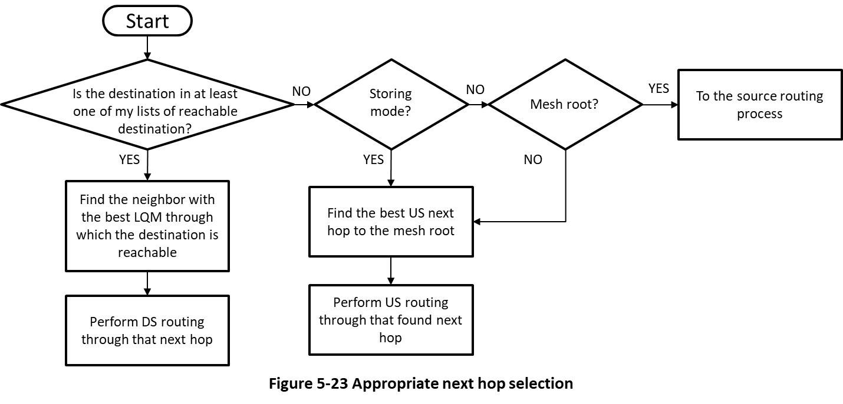

5.4.1.2 Hop-by-hop routing

Change the 3rd paragraph of 5.4.1.2 as indicated:

If on-demand P2P routing is allowed in the L2R mesh, a source device may establish a route to the destination through the procedure described in 5.2.7. If the route is established, the next hop is selected according to the newly found path. If a path has already been established, i.e., there is a path to the desired destination information exists in the P2P path list Route Table, the transmitting device forwards the frame to the device with the address recorded in Next hop in the corresponding P2P path Route Table entry. If there is no existing route recorded and no route is found within l2rP2pRouteDiscoveryTimeout, the frame is forwarded US until the first common ancestor between the source and the destination, and is then forwarded DS to the destination. This algorithm is illustrated in Figure 5-24.

5. 5.2 Securing frames

Change the 2nd paragraph of 5.5.2 as indicated:

For a broadcast transmission, the L2R sublayer refers to l2rBCSecurityLevel, l2rBCSecKeyIdMode, l2rBCSecKeySource, and l2rBCSecKeyIndex found in Table 7-40.
6.2 L2R Long nested IE (LLIE)

6.2.2 L2R Routing IE

6.2.2.1 Descriptor field

Change the last paragraph of 6.2.2.1 as indicated:

If P2P is set to 1, the current data frame is a P2P data frame and the forwarding device searches the P2P path list Route Table in the MT to find a next hop. Otherwise, the current data frame is sent US or DS and the forwarding device searches among its neighbors or their list of reachable destinations to find a next hop.

7.2.1.1 L2R-DATA.request

Add to IntermediateAddrList description in Table 7-32—L2R-DATA.request parameters (p.127):

Addresses to be inserted in the IntermediateAddressList of the L2R Routing IE. When IntermediateAddrList is ‘NULL’, the ‘Address List’ in the Route Table in the MT is used, where the destination address matches to the one in this primitive. Omitted if source routing is not used.

