IEEE P802.15
Wireless Personal Area Networks

Project | IEEE P802.15 Working Group for Wireless Personal Area Networks (WPANs)
Title | Required revisions to 802.15.10-2017
Date Submitted | [March 4th, 2018]
Source | [Noriyuki Sato]  [OKI] | Voice: [+81-6-6260-0700]  Fax: [ ]  E-mail: [sato652@oki.com]
Re: | [TG 802.15.10a (RMA) corrections to 802.15.10-2017]
Abstract | Additional potential areas for correction have been identified
Purpose | [Further details about the 802.15.10a correction draft requirements]
Notice | This document has been prepared to assist the IEEE P802.15. It is offered as a basis for discussion and is not binding on the contributing individual(s) or organization(s). The material in this document is subject to change in form and content after further study. The contributor(s) reserve(s) the right to add, amend or withdraw material contained herein.
Release | The contributor acknowledges and accepts that this contribution becomes the property of IEEE and may be made publicly available by P802.15.
Design of (and questions about) correct specification for non-storing mode packet handling in 802.15.10.

The purpose of this document is to collect together some discussion items which have been raised as relevant corrections for non-storing mode operations. The first three have been adapted from 15-17-0517-02-0mag.

- Add an entry to the mesh table 5-1 (MT) (pp. 40-42)
  - Path List
    - Consists of ‘Destination Address’ and ‘Address List’ pair
    - Enabled only when non-storing mode

- Add new specification after the following text in 5.2.4.2 (p.54) and include xref
  - When the mesh root receives the RA IE or the SRA IE, it delivers the path and the source address therein to the next higher layer with the L2LME-INTERMEDIATE-ADDR-LIST.indication primitive, and stores them as the pair of the address list and the destination address into the ‘Path List’ in the MT (Table 5-1).

- Add to IntermediateAddrList description of L2RDATA.request (7.2.1.1) (p.127):
  - Addresses to be inserted in the IntermediateAddressList of the L2R Routing IE. When IntermediateAddrList is ‘NULL’, the ‘Address List’ in the ‘Path List’ in the MT is used, where the destination address matches to the one in this primitive. Omitted if source routing is not used.

- If a neighbor disappears, then the Path List table in the MT needs to be cleaned up.

  - In clause 5.3.1 (L2R US route maintenance) (p.65):

    - If a device misses l2rMaxMissedTcIe TC IEs from a neighbor, the corresponding entry in the NT is erased. Path Lists in the Mesh Table (MT) using that neighbor are also erased.

- In Table 5-2—Elements of a local NT entry (clause 5.2.2) (p.43):

  - List of devices that are reachable through the neighbor by DS routing.
    - this should be "by DS routing or by source routing"?

- Clause 5.4.1.1 Source routing (p.67):
  - If the L2R mesh is in non-storing mode, devices only store information about their neighbors but do not otherwise store DS routing information received with RA or SRA IEs. The mesh root stores all information received from the TC IEs and the RA IEs or SRA IEs. If on-demand P2P routing is enabled, only the end to end source and destination devices of a P2P path store routing information. In either case, source routing is used. The path to the destination received from the IntermediateAddrList parameter of L2R-DATA.request primitive is included in the Intermediate Addresses List of the L2R Routing IE or the SLR IE and data frames are routed on the path indicated. An L2R mesh working in non-storing mode is indicated by Storing Mode set to FALSE in the MT. Source routing is not used for US routing.
  - Source routing is used in DS routing and non on-demand P2P routing by mesh root and in On-demand P2P by source node with intermediate nodes indicated when non storing mode is used. – insert this sentence top of the clause 5.4.1.1
  - Change ‘devices’ to ‘devices other than mesh root’
  - Change “If on-demand P2P routing is enabled” to “if on-dmand P2P routing is enabled in non-storing mode”
  - Replace Figure 5-23 with following figure (changing caption as well):
  - 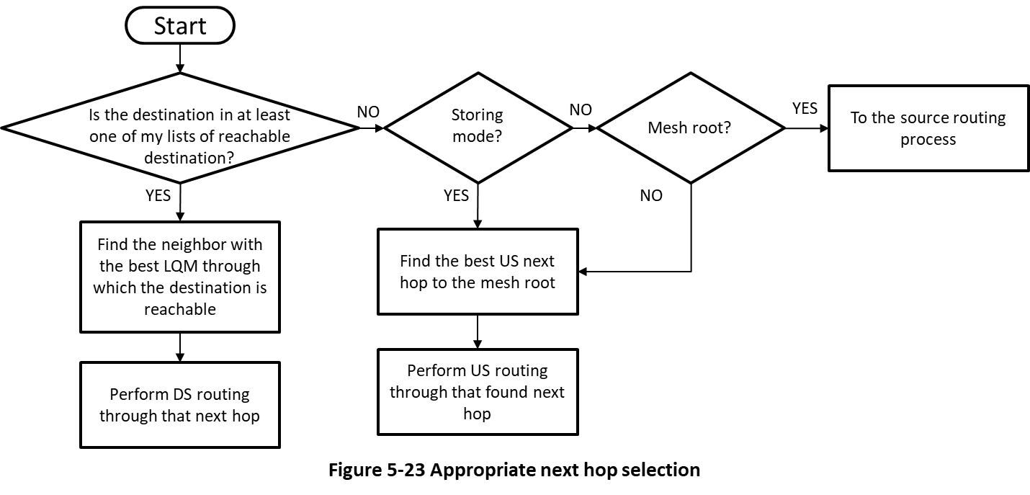

- Ensure that the mesh root can insert AddressList in a Path List without invoking DataRequest primitive

  - Language from 5.4.1.2 Hop-by-hop routing (p.68) would serve this purpose if mesh-root DS routing were "included" for non-storing mode. Insert the following as a new paragraph in 5.4.1.1 (p.67):
    - “If the frame is an incoming frame from the PHY layer and if the frame passes the filtering at the MAC layer, the frame is delivered to the L2R sublayer. If the DA matches the device’s address, the frame is delivered to the next higher layer. If the DA does not match the device’s address, the frame is forwarded again.”

- Additional modification needed for section 5.4.1.1(p.67)
  - The mesh root stores all information received from the TC IEs and the RA IEs or SRA IEs in the Path List structure of the MT (Table 5-1).

- In Figure 5-25 (p.69), "Select Appropriate NH" procedure box requires creative interpretation. Suggested to "expand" the box as needed for various modes. This could be done by a new diagram resembling Figure 5-29, having a "non-storing" mode:
  - If IntermediateAddressList is present, use it.
  - Otherwise, if mesh root, insert AddressList and send downstream to destination.
  - Otherwise, send packet upstream to mesh root.

- Check at section 5.2.7.2 for accuracy (done)
  - Might require root to take note of previously unknown source routes.
  - “carried to the source” → “forwarded to the source”
  - Is otherwise O.K. because it’s about Request/Reply, not data

- Other editorial error need to be fixed:
  - Figure 5-12 in Clause 5.2.1 (p.47)
    - Candidate PQM on node C by the link from node F should be 15. Since F’s PQM is 10 and LQM between C and F is 5.
  - Clause 5.2.2 (l.8 on p.48)
    - Delete “and the Mesh Root Address field” since NLM IE doesn’t have it anymore. It was used to have but changed.
  - Clause 5.2.2.3 (l.6 on p.51)
    - Both BO and SO are exponent of 2, 'r' mutipied by 'BO/SO' is really correct? Should they be represented with BI and SD instead? Need to check.
  - Clause 5.2.2.3 (l.7 on p.51)
    - IEEE80215.14 s/b IEEE802.15.4.
  - Clause 5.2.6 (l.2 on p.57)
    - "the list of reachable destinations" s/b "the list of multicast groups"
  - Clause 5.5.2 (In second paragraph on p.80)
    - "l2rBCSecLevel" s/b "l2rBCSecSecurityLevel"

