IEEE P802.15
Wireless Personal Area Networks

Project | IEEE P802.15 Working Group for Wireless Personal Area Networks (WPANs)
Title | Revised draft of Cyclic-superframe structure
Date Submitted | Nov. 1, 2017
Source | Seong-Soon Joo (ETRI) | E-Mail:[ssjoo@etri.re.kr]
Re:
Abstract | This document is a revised draft of Cyclic-superframe structure.
Purpose | This document provides the input for the TG8 RevCom draft.
Notice | This document does not represent the agreed views of the IEEE 802.15 Working Group or IEEE 802.15.8 Task Group. It represents only the views of the participants listed in the “Source(s)” field above. It is offered as a basis for discussion and is not binding on the contributing individual(s) or organization(s). The material in this document is subject to change in form and content after further study. The contributor(s) reserve(s) the right to add, amend or withdraw material contained herein.
Release | The contributor acknowledges and accepts that this contribution becomes the property of IEEE and may be made publicly available by P802.15.
Patent Policy | The contributor is familiar with the IEEE-SA Patent Policy and Procedures:  <http://standards.ieee.org/guides/bylaws/sect6-7.html#6> and  <http://standards.ieee.org/guides/opman/sect6.html#6.3>.  Further information is located at <http://standards.ieee.org/board/pat/pat-material.html> and  <http://standards.ieee.org/board/pat>.

- Overview
- Normative references
- Definitions, acronyms, abbreviations, and word usage
  - Definitions
3.1.8 cyclic-superframe: A periodic time interval comprised of multiple superframes with defined active and inactive periods repeated in a defined sequence.
  - Acronyms and abbreviations
DP discovery period
PP peering period
SP synchronization period

- Format conventions

- General description
  - General
  - Components of IEEE 802.15.8 PAC network
  - Network Topologies
  - Architecture

  - Functional Overview
    - Superframe structure

    - Cyclic-superframe
For efficient synchronized group communication, the PAC MAC superframe uses a period of fixed length. For the application to choose a duty-cycle of activity to suit the particular traffic needs of its peer group and to reduce interference between adjacent PDs or PAC groups, the cyclic-superframe is specified. The cyclic-superframe is a periodic time interval comprised of multiple superframes with defined active and inactive periods repeated in a defined sequence. During inactive periods, a PD may turn off its receiver etc. to conserve power. The cyclic superframe shall be overridden when the next higher layer requests to use a given period of the superframe in the current and subsequent superframes if required (the MAC layer does not need to wait until the change of cyclic-superframe configuration is completed). Once the cyclic-superframe configuration is completed, the MAC layer shall resume operation with the new cyclic superframe configuration. The details of the cyclic-superframe structure are specified in clause 6.2.1.
The support of cyclic superframe is mandatory for the OFDM PHY (clause Error: Reference source not found), and optional for the UWB PHY (clause Error: Reference source not found).

- MAC functional description
  - Superframe

  - Cyclic-superframe
    - Cyclic-superframe structure
A cyclic-superframe is a periodic time interval comprised of superframes. A cyclic-superframe contains multiple superframes with active and inactive periods. During an inactive period, a PD may turn off its transceiver etc. in order to conserve power and reduce interference. Each period of every superframe, except the synchronization period, may be configured to be either active or inactive. A superframe of a cyclic-superframe shall use one of sixteen possible combinations of active and inactive periods, which are illustrated in A cyclic-superframe shall be formed with the superframes using two patterns of active and inactive periods: pattern A and pattern B, each of which can be one of sixteen types. The cyclic-superframe consists of a number of repetitions of pattern A superframe, followed by a number of repetitions of pattern B superframe, as shown in Error: Reference source not found. The maximum cyclic-superframe size is 4096 superframes. If a cyclic-superframe size is one, the cyclic-superframe is formed only with the pattern A superframe..
A cyclic-superframe shall be formed with the superframes using two patterns of active and inactive periods: pattern A and pattern B, each of which can be one of sixteen types. The cyclic-superframe consists of a number of repetitions of pattern A superframe, followed by a number of repetitions of pattern B superframe, as shown in Error: Reference source not found. The maximum cyclic-superframe size is 4096 superframes. If a cyclic-superframe size is one, the cyclic-superframe is formed only with the pattern A superframe.
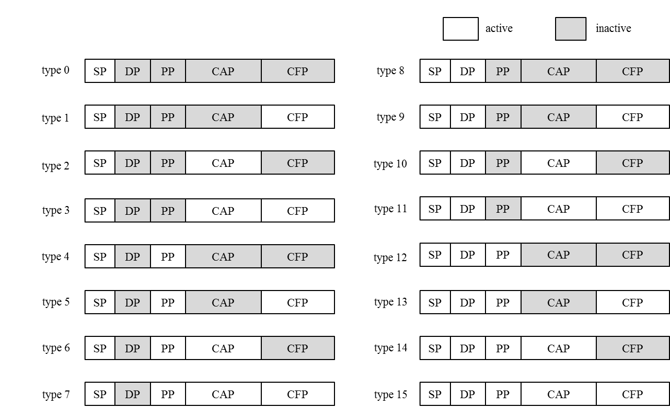
Figure 6—Combinations of active and inactive periods of a superframe
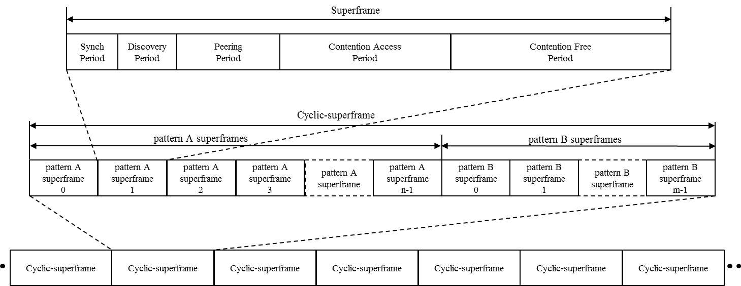
Figure 7—The cyclic-superframe structure

The next higher layer is responsible for configuring the appropriate cyclic-superframe structure for its application(s) usage, via the cyclic-superframe descriptors present in the macCyclicSuperframeStructureList PIB attribute.
Several examples of a cyclic-superframe structure are shown in Figure 8. Figure 8 a) shows a cyclic-superframe with two pattern A superframes each with the SP active (0b0000), followed by two pattern B superframes, each with the SP active (0b0000). This example cyclic-superframe could be used during synchronization.
Figure 8 b) shows a cyclic-superframe with three pattern A superframes each with the SP active (0b0000), followed by one pattern B superframe with SP, DP, PP and CAP active (0b1110). This example cyclic-superframe could be used for supporting discovery every four superframes.
Figure 8 c) shows a cyclic-superframe with five pattern A superframes, each with SP and DP active (0b1000), followed by one pattern B superframe with SP, DP and CAP active (0b1010). This example cyclic-superframe could be used for supporting energy efficient data transmission by transmitting a data frame over the CAP every six superframes.
Figure 8 d) shows a cyclic-superframe with three pattern A superframes each with SP, DP, PP and CFP active (0b1101), followed by six pattern B superframes with SP active (0b0000). This example cyclic-superframe could be used for supporting reliable data transmission by using three consecutive data frames transmissions over the CFP, before sleeping for the duration of six superframes.
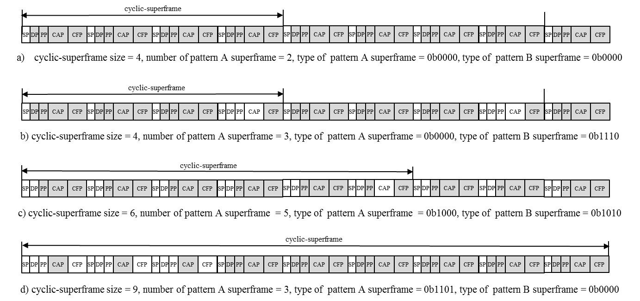
Figure 8—Example cyclic-superframe structures
    - Maintaining cyclic-superframe structure
If the PIB macCyclicSuperframeEnabled is set to TRUE, the MAC layer shall maintain the cyclic-superframe structure and manage the reception and transmission frames accordingly. The MAC layer may operate the multiple cyclic-superframes concurrently. The next higher layer configures a cyclic-superframe for providing an application service. The next higher layer configures the background cyclic-superframe that instructs the MAC layer to turn the transceiver on periodically for providing active periods to receive or transmit Cyclic-superframe Advertise Request command frames. The background cyclic-superframe is always present and may be updated when adding or deleting a cyclic-superframe for an application service.
The cyclic-superframe configuration is stored in the Cyclic-Superframe Descriptor of the PIB macCyclicSuperframeStructureList. The cyclic-superframe configuration is identified with the MAC address of a PD starting the cyclic-superframe and the cyclic-superframe identifier selected by the PD’s MAC layer. The cyclic-superframe identifier of the background cyclic-superframe is zero.
At any time it wishes, the next higher layer may modify the cyclic-superframe structure using the MLME-CYCLICSUPERFRAME.request primitive to add, update, or delete any of cyclic-superframe descriptors in the macCyclicSuperframeStructureList.

      - Maintaining cyclic-superframe structure after starting a PD
After starting a PD, the MAC layer maintains the cyclic-superframe structure as shown in Figure 9.
- After synchronization, the MAC layer shall reset macCyclicSuperframeCount and start to control the PHY according to the background cyclic-superframe. The background cyclic-superframe has default value defined in the macCyclicSuperframeStructureList of Table 87.
- Irrespective of the cyclic superframe configuration, the MAC layer listens during the peering period for aCyclicSuperframeAdvWindow consecutive superframes to collect neighbor PAC groups’ cyclic-superframe structures by receiving the Cyclic-superframe Advertise Request command frames. The received cyclic-superframe configurations of neighbor PAC groups are added to the macCyclicSuperframeNeighborList. Based on macCyclicSuperframeNeighborList, the next higher layer may select a start time of a cyclic-superframe avoiding interference with neighbor running PAC groups when starting a new PAC group.
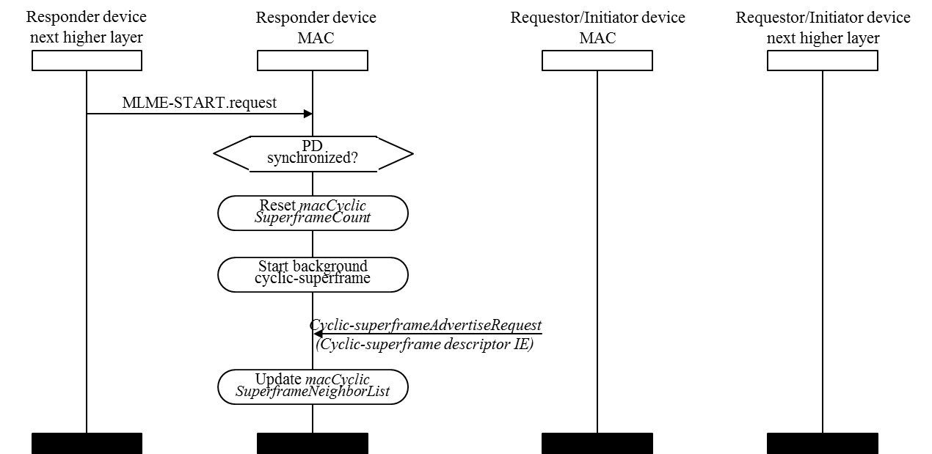
Figure 9—Sequence chart for maintaining cyclic-superframe after starting a PD
      - Maintaining cyclic-superframe structure for discovery
For discovery or for being discovered, the MAC layer maintains the cyclic-superframe structure as shown in Figure 10.
- If a PD intends to be discovered, the next higher layer may select the cyclic-superframe configuration adequate to support being discovered procedure. The new cyclic-superframe for being discovered is added by the MLME-CYCLICSUPERFRAME.request primitive with the Manipulation Type parameter set to ADD and the Cyclic-superframe Descriptor parameters: Initiator PD address set to the PD MAC address, Cyclic-superframe Identifier selected by the next higher layer for registering the cyclic-superframe descriptor to the PIB macCyclicSuperframeStructureList, Cyclic-superframe size, Number of pattern A superframes, Number of pattern B superframes, Type of pattern A superframe, Type of pattern B superframe, and Start time of cyclic-superframe. The MAC layer shall add a cyclic-superframe descriptor to macCyclicSuperframeStructureList and start the operation of the new cyclic-superframe for being discovered at the Start time of cyclic-superframe of the Cyclic-superframe Descriptor parameter.
- The next higher layer may update the background cyclic-superframe to adapt to the changing cyclic-superframe structure by the MLME-CYCLICSUPERFRAME.request primitive with the Manipulation Type parameter set to UPDATE and the Cyclic-superframe Descriptor parameters: Initiator PD address set to the PD MAC address, Cyclic-superframe Identifier set to zero, modified Cyclic-superframe structure configuration, and Start time of cyclic-superframe set to the Start time of the Cyclic-superframe Descriptor parameter of MLME-CYCLICSUPERFRAME.request primitive requested for adding a new cyclic-superframe for being discovered procedure.
- If multiple cyclic-superframes are already operated, newly added cyclic-superframe structure is merged over the currently operating cyclic-superframes, as described in clause 6.2.3.
- When the next higher layer wants to initiate two-way untargeted discovery or two-way targeted discovery, or many-to-many group discovery, it may do so by first issuing MLME-CYCLICSUPERFRAME.request primitive to add a new cyclic-superframe for the discovery procedure and peering procedure, and then using the MLME-DISCOVER.request primitive with Discovery Type, Discovery Resource, Discovery Range Min, Discovery Range Max, Destination Address, Multicast Address, Address Mode, and Cyclic-Superframe Descriptor parameter, where the Cyclic-Superframe Descriptor are identical in both primitives. The Cyclic-Superframe Descriptor parameter of the MLME-DISCOVER.request primitive is copied into the content field of a Cyclic-superframe descriptor IE included in the Discovery Request command, as described in clause 7.4.3.1.
- As shown in Figure 10, the MAC layer of responder PD receiving the Discovery Request command shall report its reception via the MLME-DISCOVERY.indication primitive with Discovery Type and Cyclic-superframe Descriptor parameters. The Cyclic-superframe Descriptor parameter is copied from Cyclic-superframe descriptor IE content field of the received Discovery Request command.
- If the next higher layer of the responder PD wishes to be discovered, it responds using the MLME-DISCOVERY.response primitive, as described in clause 8.3.3.4.
- The next higher layer of the responder PD may then instruct the MAC layer to use the cyclic-superframe of the requestor PD by deleting the cyclic-superframe structure used for being discovered and adding the cyclic-superframe structure provided by the requestor PD. The deletion is achieved by issuing an MLME-CYCLICSUPERFRAME.request with the Manipulation Type parameter set to DELETE and the Cyclic-superframe Descriptor parameters: Initiator PD address set to the PD MAC address, Cyclic-superframe Identifier set to the registered cyclic-superframe identifier, and Start time of cyclic-superframe selected by the next higher layer. The addition the cyclic-superframe for peering by the MLME-CYCLICSUPERFRAME.request primitive with the Manipulation Type parameter set to ADD and the Cyclic-superframe Descriptor parameter that is identical with the Cyclic-superframe Descriptor parameter of MLME-DISCOVERY.indication primitive. The MAC layer shall update the cyclic-superframe descriptor of the macCyclicSuperframeStructureList. The MAC layer shall start the operation of the updated cyclic-superframe structure at the Start time of cyclic-superframe of the Cyclic-superframe Descriptor parameter of the MLME-CYCLICSUPERFRAME.request primitive.
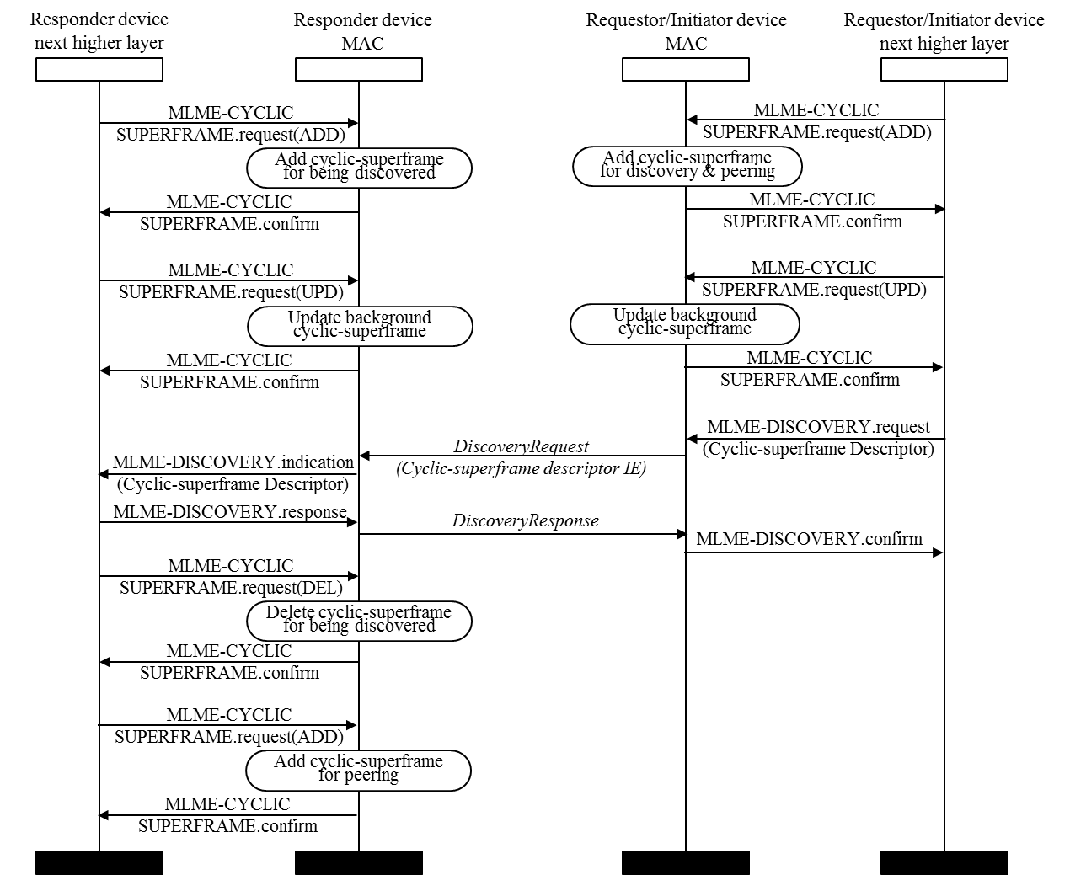
Figure 10—Sequence chart for maintaining cyclic-superframe for discovery or for being discovered
      - Maintaining cyclic-superframe structure for peering
For peering, the MAC layer maintains the cyclic-superframe structure as shown in Figure 11.
- If the next higher layer of initiator PD intends to configure the cyclic-superframe structure for data communication, it may provide the cyclic-superframe configuration in the MLME-PEERING.request primitive with the Request Type, Channel Page, Channel Number, Group ID, Application ID, Destination Address, Multicast Address, PD List, PHY Capability List, Elliptic Curve, Key Descriptor, and Cyclic-Superframe Descriptor. The Cyclic-Superframe Descriptor parameter of the MLME-PEERING.request primitive is copied into Cyclic-superframe descriptor IE content field of the Peering Request command, as described in clause 7.4.3.1.
- After completing the peering procedure, the upper layer of the initiator PD may start the new cyclic-superframe structure for data communication (i.e. with the Cyclic-superframe Descriptor it used for the MLME-PEERING.request) by issuing a MLME-CYCLICSUPERFRAME.request primitive with the Manipulation Type parameter set to ADD and the Cyclic-superframe Descriptor parameters, which causes the MAC layer to update the cyclic-superframe descriptor of the macCyclicSuperframeStructureList. If multiple cyclic-superframes are operating, the newly requested cyclic-superframe is merged into the currently operating cyclic-superframe structures. The MAC layer shall start the operation of the updated cyclic-superframe at the Start time specified by the Cyclic-superframe Descriptor parameter.
- If the next higher layer of the initiator PD intends not to continue the discovery and peering procedure, the next higher layer may delete the cyclic-superframe structure for discovery and peering procedure by MLME-CYCLICSUPERFRAME.request primitive with the Manipulation Type parameter set to DELETE and the Cyclic-superframe Descriptor parameters: Initiator PD address set to the PD MAC address, Cyclic-superframe Identifier set to the registered cyclic-superframe identifier, and Start time of cyclic-superframe selected by the next higher layer.
- As shown in Figure12, the MAC layer of responder PD receiving the Peering Request command shall report the reception by the MLME-PEERING.indication primitive with Request Type, Source Address, Channel Page, Channel Number, Group ID, Application ID, PHY Capability List, and Cyclic-superframe Descriptor parameters. The Cyclic-superframe Descriptor parameter is copied from Cyclic-superframe descriptor IE content field of the Peering Request command. If the next higher layer of the responder PD wishes to be peered, the next higher layer may respond to the requester PD by the MLME-PEERING.response primitive.
- The next higher layer of the responder PD may then instruct its MAC layer to use the cyclic-superframe of the requestor PD by deleting the cyclic-superframe structure for peering and adding the cyclic-superframe for data communication. The deletion is achieved by issuing an MLME-CYCLICSUPERFRAME.request primitive with the Manipulation Type parameter set to DELETE and the Cyclic-superframe Descriptor parameters: Initiator PD address set to the requestor PD MAC address, Cyclic-superframe Identifier set to the registered cyclic-superframe identifier, and Start time of cyclic-superframe selected by the next higher layer. The addition the cyclic-superframe for data communication is achieved using the MLME-CYCLICSUPERFRAME.request primitive with the Manipulation Type parameter set to ADD and the Cyclic-superframe Descriptor parameter matching the Cyclic-superframe Descriptor parameter of MLME-PEERING.indication primitive. The MAC layer shall update the cyclic-superframe descriptor of the macCyclicSuperframeStructureList. If multiple cyclic-superframe are operating, newly added cyclic-superframe is merged with the currently operating cyclic-superframe structures. The MAC layer shall start the operation of the updated cyclic-superframes at the Start time specified in the Cyclic-superframe Descriptor parameter of the MLME-CYCLICSUPERFRAME.request primitive.
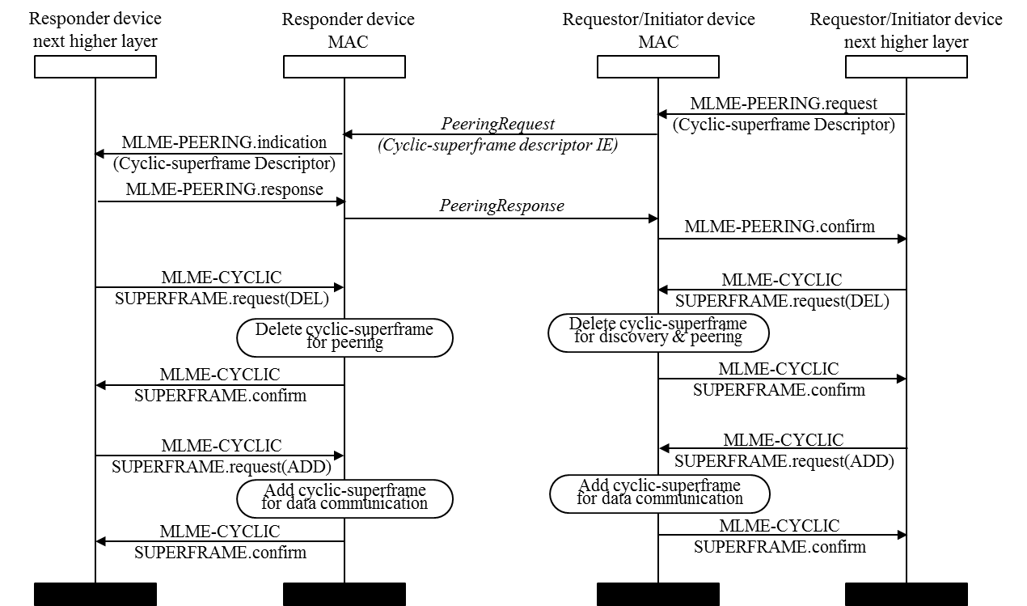
Figure 12—Sequence chart for maintaining cyclic-superframe during peering

      - Advertising and deleting cyclic-superframe structure
The cyclic-superframe configuration of a PAC group is advertised by a requestor PD or an initiator PD of discovery or peering. The cyclic-superframe configuration of a PAC group is shared with PDs of neighbor PAC groups as follows:
- The MAC layer of a requestor PD or an initiator PD shall send the Cyclic-superframe Advertise Request command frame periodically every aCyclicSuperframeAdvWindow superframes, in the peering period of the superframe, starting at a randomly selected superframe within the period of the aCyclicSuperframeAdvWindow. The Cyclic-superframe Advertise Request command frame shall be transmitted, irrespective of whether the selected peering periods are marked as inactive in the cyclic superframe structure. The Cyclic-superframe Advertise Request command frame contains a single cyclic-superframe configuration. Where an initiator PD is initiating multiple groups and has multiple cyclic-superframe configurations, it shall send a separate Advertise Request command for each of these cyclic-superframe configurations, such that all are advertised during every aCyclicSuperframeAdvWindow superframes period.
- The MAC layer of a PD listens during the peering period for duration of aCyclicSuperframeAdvWindow superframes to collect neighbor PAC groups’ cyclic-superframe structures by receiving the Cyclic-superframe Advertise Request command frames. The received cyclic-superframe descriptor of a neighbor PAC group updates the macCyclicSuperframeNeighborList. If the Cyclic-superframe Advertise Request command frame for any particular PAC group is not heard for five consecutive aCyclicSuperframeAdvWindow periods, the MAC layer shall remove the cyclic-superframe descriptor from the macCyclicSuperframeNeighborList.
The cyclic-superframe descriptor is deleted from the macCyclicSuperframeStructureList as follows:
- When the discovery procedure or peering procedure, or data communication is terminated, the next higher layer may delete the cyclic-superframe structure by the MLME-CYCLICSUPERFRAME.request primitive with the Manipulation Type parameter set to DELETE and the Cyclic-superframe Descriptor parameter. The cyclic-superframe descriptor identified with the Initiator PD MAC address and Cyclic-superframe identifier is deleted from the macCyclicSuperframeStructureList. The currently operating cyclic-superframe structure is reconfigured at Start time specified by the Cyclic-superframe Descriptor parameter of the MLME-CYCLICSUPERFRAME.request primitive.
    - Access control with cyclic-superframe structure
The cyclic-superframe specifies when a PAC group is able to communicate. Each PD in a PAC group maintains the start time of its cyclic-superframe as follows:
- With reference to the macCyclicSuperframeNeighborList, the next higher layer of an initiator PD selects the start time of cyclic-superframe to minimize the likelihood that the new PAC group interferes with its neighbor PAC groups. The macCyclicSuperframeNeighborList is obtained using the MLME-GET.request primitive.
- The MAC layer maintains the macCyclicSuperframeCount, which is a modulo-4096 counter of the number superframes since synchronization. When receiving the Cyclic-superframe descriptor IE, the start time of the cyclic-superframe is given by the expression:
{( macCyclicSuperframeCount - Superframe Sequence Number) + n*Cyclic-superframe Size},.
where n is the smallest integer that lets {( macCyclicSuperframeCount - Superframe Sequence Number) + n*Cyclic-superframe Size} be larger than zero.
- A PD can join multiple PAC groups having different cyclic-superframe configurations. Different cyclic-superframe size and different start time of cyclic-superframes cause cyclic-superframes overlapping and some period may be shared with multiple PAC groups. To know which period of a superframe is active for receiving and transmitting a frame, all active cyclic-superframe configurations are considered together, and a period is only considered inactive, when it is inactive in all configurations.
The frames transmitted are scheduled for accessing medium as follows:
- Before requesting to receive or transmit a frame, the appropriate period of the cyclic-superframe should be activated. The next higher layer is responsible for selecting a cyclic-superframe structure to satisfy its applications’ requirements.
- The MAC layer transmits the Cyclic-superframe Advertise Request command frame at the selected PP.
- The Discovery Request command frame or the Discovery Response command frame is transmitted in the active CAP of the cyclic-superframe configured by the Requestor PD or the Initiator PD.
- The Peering Request command frame or the Peering Response command frame is transmitted in the active PP of the cyclic-superframe configured by the Requestor PD or the Initiator PD.
- The Data frame is transmitted in the active CFP of the cyclic-superframe of the destination PAC group, if the CFPTx parameter of MLME-DATA.request primitive is set. Otherwise, the Data frame is transmitted in the nearest active CAP of the destination PAC group.

  - IFS
  - Channel access
  - Starting and maintaining PAC networks
  - Transmission, reception, and acknowledgment
  - Synchronization procedure
  - Discovery procedure
  - Peering procedure
  - De-peering procedure
  - Communication period
  - Link-ID
- MAC frame formats
  - PD addresses
  - General MAC frame format
  - Format of individual frame types
  - Information Elements (IEs)
    - General IE format
    - IE list termination
    - Header IEs
      - Cyclic-superframe descriptor IE
The Cyclic-superframe descriptor IE Content field shall be formatted as illustrated in Figure .
Octets: 2 | 2 | 2 | 2 | 1
Cyclic-superframe Identifier | Superframe Sequence Number | Cyclic-superframe Size | Number of  Pattern A Superframe | Superframe Pattern Type
Figure 51—The Cyclic-superframe descriptor IE Content field format

The Cyclic-superframe Identifier field contains the identifier of the cyclic-superframe structure being defined by this IE.
The Superframe Sequence Number field contains the sequence number of the superframe sending Cyclic-superframe descriptor IE counting from the start of the cyclic-superframe being defined by this IE. It is calculated by (macCyclicSuperframeCount - Start time of cyclic-superframe) modulo Cyclic-superframe size. The MAC layer fills this field when transmitting the frame.
The Cyclic-superframe Size field contains the number of superframes in the cyclic-superframe being defined by this IE.
The Number of Pattern A Superframe field contains the number of pattern A superframe in the cyclic-superframe being defined by this IE.
The Superframe Pattern Type field contains the type of pattern A superframe and the type of pattern B superframe, as indicated in Figure .

Bit : 0 | 1 | 2 | 3 | 4 | 5 | 6 | 7
CFP State | CAP State | Peering Period State | Discovery  Period State | CFP State | CAP State | Peering Period State | Discovery  Period State
Type of Pattern A Superframe |  |  |  | Type of Pattern B Superframe
Figure 52—Superframe pattern type field format

The Discovery Period State field shall be set to 1 if the discovery period is active, and to 0 if inactive.
The Peering Period State field shall be set to 1 if the peering period is active, and to 0 if inactive.
The CAP State field shall be set to 1 if the contention period is active, and to 0 if inactive.
The CFP State field shall be set to 1 when the contention free period is active, and to 0 if inactive.
  - MAC commands
This clause defines the MAC command identifier (ID), MAC command Content field and relevant MAC Header fields. The MAC command frame format is defined in Error: Reference source not found and the MAC Header fields are defined in 7.2.
The MAC command identifiers are listed in 23.
Table 1—MAC command IDs
Command ID | Command name | Clause
0 | Reserved | ⎯
1 | Discovery Request | 7.5.1
2 | Discovery Response | Error: Reference source not found
3 | Peering Request | 7.5.3
4 | Peering Response | 7.5.3
5 | De-peering Notification | 7.5.3
6 | Reassignment | 7.5.3
7 | RE Request | 7.5.3
8 | RE Response | 7.5.3
9 | RE Notification | 7.5.3
10 | Public Key Request | Error: Reference source not found
11 | Public Key Response | 7.5.3
12 | Cyclic-superframe Advertise Request | Error: Reference source not found
13 − 255 | Reserved | ⎯
    - Discovery Request command frame
This command shall be sent by the MLME upon reception of a MLME-DISCOVERY.request primitive in order to obtain the discovery information of other PDs.

      - Relevant MHR fields
The DAM field shall be set to MAC address, multicast address or broadcast. The SAM field shall be set to MAC address. The AR/SNS field shall be set to Immediate Ack if the DAM field is set to MAC address. The Destination Address field shall contain the MAC address of the Responder PD, multicast address of a PAC group or an empty address (broadcast). The Source Address field shall contain the MAC address of the Requestor PD. If the Responder PD has a secured communication with the Requestor PD, the SEC field shall be to 1; otherwise to 0. The Cyclic-superframe descriptor IE field shall be set to the Cyclic-Superframe Descriptor parameter of the MLME-DISCOVERY.request primitive, if present.
    - Discovery Response command frame
This command shall be sent by the Responder PD(s) in response to a MLME-DISCOVERY.response service primitive in order to send the requested discovery information to the Requestor PD.
    - Peering Request command frame
This command shall be sent by a Requestor PD’s MLME upon reception of the MLME-PEERING.request primitive in order to request to peer with another PD(s).
      - Relevant MHR fields
The DAM field shall be set to MAC address in case of one-to-one peering, broadcast address in case of one-to-many or many-to-many peering, or multicast address in case of re-peering to a PAC group. The SAM field shall be set to MAC address. The AR/SNS field shall be set to Immediate Ack only in case of one-to-one peering; otherwise, it shall be set to SNS=0, AR=0. The SEC field shall be set to 1 if the Requestor PD has the public key of Responder PD or targeted PDs; otherwise, it shall be set to 0. The Destination address field shall contain the MAC address of the Responder PD in case of one-to-one peering or shall be empty in case of one-to-many peering, or shall contain the Multicast Address of a PAC group in case of re-peering to such PAC group. The Source Address field shall contain the MAC address of the Requestor PD. The Cyclic-superframe descriptor IE field shall be set to the Cyclic-Superframe Descriptor parameter of the MLME-PEERING.request primitive, if present.

    - Peering Response command frame
The Peering Response command frame reports the result of a peering request to the Requestor PD. It shall be sent by the Responder PD’s MLME after receiving the MLME-PEERING.reponse primitive.
      - Relevant MHR fields
The DAM field shall be set to MAC address. The SAM field shall be set to MAC address. The AR/SNS field shall be set to Immediate Ack. The SEC field shall be set to 1 if the Responder PD has the public key of Requestor PD; otherwise, it shall be set to 0. The Destination address field shall contain the MAC address of the Requestor PD. The Source address field shall contain the MAC address of the Responder PD.

    - De-peering Notification command frame
    - Reassignment command
    - RE Request command
    - RE Response command
    - RE Notification command
    - Cyclic-superframe Advertise Request command frame
This command shall be sent by the MLME of the PD configuring a cyclic-superframe in order to advertise the cyclic-superframe configuration. This command shall be sent during peering period every aCyclicSuperframeAdvWindow superframes, as described in clause 6.2.2.
      - Relevant MHR fields
The DAM field shall be set to broadcast. The SAM field shall be set to MAC address. The AR/SNS field shall be set to b’00. The HIEP field set to 1. The SEC field shall be set to 0. The PIEP field set to 0.
The Destination Address field shall be not present. The Source Address field shall be present.
The Cyclic-superframe descriptor IE shall contain the Cyclic-superframe descriptor of the macCyclicSuperframeStructureList identified by the Initiator PD address and the Cyclic-superframe Identifier. The Superframe Sequence Number field of the Cyclic-superframe descriptor IE content field is set to the value calculated with the Start time of cyclic-superframe parameter of the Cyclic-superframe descriptor and the macCyclicSuperframeCount, as described in clause 6.2.3. The Cyclic-superframe Size field of the Cyclic-superframe descriptor IE content field is set to the Cyclic-superframe size parameter of the Cyclic-superframe descriptor. The Number of Pattern A Superframe Size field of the Cyclic-superframe descriptor IE content field is set to the Number of pattern A superframes parameter of the Cyclic-superframe descriptor. The Type of Pattern A Superframe field of the Cyclic-superframe descriptor IE content field is set to the Type of pattern A superframe parameter of the Cyclic-superframe descriptor. The Type of Pattern B Superframe field of the Cyclic-superframe descriptor IE content field is set to the Type of pattern B superframe parameter of the Cyclic-superframe descriptor.
      - Relevant MAC Payload fields
The Content field shall be empty.

- MAC services
  - Overview
  - Generic service primitives
  - MLME-SAP interface
    - PIB access

    - Cyclic superframe configuration
These primitives set the cyclic-superframe configuration and instruct the MAC layer to operate the cyclic-superframe structure.

      - MLME-CYCLICSUPERFRAME.request
This primitive allows the next higher layer to request the MAC layer to manipulate the macCyclicSuperframeStructureList of the PIB, and consecuently to operate the transceiver activity according to the resultant cyclic-superframe structure. The parameters of this primitive are:

MLME-CYCLICSUPERFRAME.request (

Manipulation Type;

Cyclic-Superframe Descriptor;

)

Table 27—MLME-CYCLICSUPERFRAME.request parameters
Name | Type | Valid range | Description
Manipulation Type | Enumeration | ADD,  UPDATE,  DELETE | Indicates the type of cyclic-superframe structure manipulation. ADD for adding a cyclic-superframe descriptor to the macCyclicSuperframeStructureList. UPDATE for replacing a cyclic-superframe descriptor.  DELETE for deleting a cyclic-superframe descriptor from the macCyclicSuperframeStructureList.
Cyclic-Superframe Descriptor | As defined in Table 37 | As defined in Table 37 | Indicates the structure of cyclic-superframe.

The Cyclic Superframe Descriptor parameters are defined in Table 38.
Table 38—Cyclic-superframe Descriptor parameters
Name | Type | Valid range | Description
Initiator PD address | 48-bit integer | 48-bits IEEE MAC address | MAC address of the PD specifying the cyclic-superframe structure.
Cyclic-superframe Identifier | 16-bit integer | 0 to 2¹⁶−1 | Identifier of the cyclic-superframe structure.  Zero is reserved for the background cyclic-superframe structure.
Cyclic-superframe size | 12-bit integer | 1 to 2¹²−1 | Number of superframes in a cyclic-superframe.
Number of pattern A superframe | 12-bit integer | 1 to 2¹²−1 | Number of pattern A superframes in a cyclic-superframe
Type of pattern A superframe | Integer | As specified in  Error: Reference source not found | State indicator of periods of pattern A superframe
Type of pattern B superframe | Integer | As specified in Error: Reference source not found | State indicator of periods of pattern B superframe
Start time of cyclic-superframe | 12-bit integer | 0 to 2¹²−1 | Superframe sequence number starting the cyclic-superframe, as defined in clause 6.2.3.

        - When generated
This primitive is generated by the next higher layer to request the MLME to set a cyclic superframe configuration and to start the cyclic-superframe structure operation.

        - Effect on receipt
The MLME sets the PIB with the value of the cyclic-superframe descriptor.
- The macCyclicSuperframeStructureList attribute of the PIB stores a list of cyclic-superframe structure configurations operating in the MAC layer. Each configuration is uniquely identified by the Initiator PD address and the Cyclic-superframe Identifier. The cyclic-superframe descriptor of the macCyclicSuperframeStructureList, which the Initiator PD address is the MAC address of the PD and the Cyclic-superframe Identifier is zero, stores the background cyclic-superframe structure configuration. The default value is stored initially as a background cyclic-superframe structure configuration and may be updated.
- If Manipulation Type is set to ADD, the MAC layer adds a cyclic-superframe descriptor to the macCyclicSuperframeStructureList.
- If Manipulation Type is set to UPDATE, the MAC layer replaces the cyclic-superframe descriptor of the macCyclicSuperframeStructureList with the Cyclic-Superframe Descriptor parameter of the MLME-CYCLICSUPERFRAME.request primitive.
- If Manipulation Type is set to DELETE, the MAC layer deletes a cyclic-superframe descriptor identified by the Initiator PD address and the Cyclic-superframe Identifier of Cyclic-Superframe Descriptor parameter of the MLME-CYCLICSUPERFRAME.request primitive from the macCyclicSuperframeStructureList.
The MLME starts the updated cyclic-superframe operation at the Start time of the Cyclic-superframe Descriptor parameter of the MLME-CYCLICSUPERFRAME.request primitive.
      - MLME-CYCLICSUPERFRAME.confirm
This primitive reports the setting of a new cyclic-superframe configuration requested by MLME-CYCLICSUPERFRAME.request primitive. The parameters of this primitive are:
MLME-CYCLICSUPERFRAME.confirm (

Status;
)

Table 49—MLME-CYCLICSUPERFRAME.confirm parameters
Name | Type | Valid range | Description
Status | Enumeration | SUCCESS,  INVALID_PARAMETER,  UNKNOWN,  MAX_LIST_EXCEEDED,  UNSUPPORTED | Result of the request operation.

The Status of the primitive shall indicate SUCCESS if the operation completed successfully. If any of the arguments fail a range check, the Status shall be INVALID_PARAMETER. If a cyclic-superframe descriptor is being added and the macCyclicSuperframeStructureList is already full, the Status shall be MAX_LIST_EXCEEDED. The maximum length of macCyclicSuperframeStructureList is implementation dependent, but a minimum length of ten is recommended. If an update or deletion is being requested and the corresponding cyclic-superframe descriptor cannot be found, the Status shall be UNKNOWN. The status of UNSUPPORTED indicates that Cyclic-Superframe is not supported.
        - When generated
This primitive is generated by the MLME in response to MLME-CYCLICSUPERFRAME.request primitive.
        - Effect on receipt
The MLME confirms the setting of the cyclic-superframe configuration for a PAC group.
    - Discovery
These primitives are used to obtain the discovery information of targeted PDs using the CAP, or untargeted PDs using the discovery period (typically at start up). Also, the primitives indicate if the MLME shall indicate the transmission of the local discovery information during the discovery period.
      - MLME-DISCOVERY.request
Depending on the parameters of this primitive:
⎯ This primitive instructs the MLME to request for the discovery information of a targeted PD or PDs in a PAC group during the CAP.
⎯ This primitive instructs the MLME either to transmit the PD’s discovery information or to detect other PDs discovery information during the discovery period.
The parameters of this primitive are:
MLME-DISCOVERY.request(
Discovery Type;
Discovery Resource;
Discovery Range Min;
Discovery Range Max;
Destination Address;
Multicast Address;
Address mode;
Cyclic-Superframe Descriptor;
)
Table 40—MLME-DISCOVERY.request parameters
Name | Type | Valid range | Description
Discovery Type | Enumeration | ONE-WAY-TX, ONE-WAY-RX, TWO-WAY-UNTARGETED, TWO-WAY-TARGETED | Indicates whether targeted/untargeted discovery during the CAP, or the transmission/ reception of discovery information during the discovery period.
Discovery Resource | Integer | 1 – Number of discovery resource blocks | This parameter is only present when the Discovery Type parameter is set to ONE-WAY-TX. It indicates the discovery resource block to transmit the discovery information during the discovery period.
Discovery Range Min | Integer | 1 – Number of discovery resource blocks | This parameter is only present when the Discovery Type parameter is set to ONE-WAY-RX. It indicates the minimum discovery resource block to scan for discovery information during the discovery period.
Discovery Range Max | Integer | 1 – Number of discovery resource blocks | This parameter is only present when the Discovery Type parameter is set to ONE-WAY-RX. It indicates the maximum discovery resource block to scan for discovery information during the discovery period.
Destination Address | MAC address | IEEE 48 bit MAC address | This parameter is only present when the Discovery Type parameter is set to TWO-WAY-TARGETED. It indicates the MAC address of the targeted PD to request its discovery information.
Multicast Address | Unsigned integer | 0 to 2¹⁶ −1 | This parameter is only present when the Discovery Type parameter is set to TWO-WAY-TARGETED. It indicates the multicast address of the targeted PAC group to request their discovery information.
Address Mode | Enumeration | PD, Group | Indicates if the discovery request is for a targeted PD or PAC group.
Cyclic-Superframe Descriptor | As defined in Error: Reference source not found | As specified in Error: Reference source not found | This parameter shall be included only if cyclic-superframe is supported.  Specifies a cyclic-superframe structure.

        - When generated
Depending on the parameters of this primitive:
⎯ This primitive is generated by the next higher to request for the discovery information of another PD or other PDs in the PAC group during the CAP.
⎯ This primitive indicates if the local MLME transmits the PD’s discovery information or detects the discovery information of other PDs during the discovery period.
        - Effect on receipt
Depending on the parameters of this primitive:
⎯ On receipt of this primitive, if the Discovery Type parameter is set to TWO-WAY-TARGETED, the MLME shall send a Discovery Request command frame with Destination Address field of either the MAC address indicated in the Destination Address parameter, if Address Mode parameter is set to PD, or the multicast address indicated in the Multicast Address parameter, if the Address Mode parameter is set to Group. If the MLME-DISCOVERY.request primitive includes a Cyclic-Superframe Descriptor and Cyclic-Superframes are supported, then a Cyclic-superframe Descriptor IE shall be included in the Discovery Request command frame to convey this information, as described in clause 7.4.3.1.
⎯ On receipt of this primitive, if the Discovery Type parameter is set to MANY2MANY, the MLME shall send a Discovery Request command frame with the multicast address indicated in the Multicast Address parameter and the Address Mode parameter is set to Group
⎯ On receipt of this primitive, if the Discovery Type parameter is set to TWO-WAY-UNTARGETED, the MLME shall broadcasts a Discovery Request command frame as described in clause 6.8.3.2.
⎯ On receipt of this primitive, if the Discovery Type parameter is set to ONE-WAY-TX, the MLME shall indicate to the local PHY to transmit the PD’s discovery information over the discovery resource block indicated in the Discovery Resource parameter during the discovery period.
⎯ On receipt of this primitive, if the Discovery Type parameter is set to ONE-WAY-RX, the MLME shall indicate to the local PHY to scan for discovery information between the range indicated by the Discovery Range Min parameter and Discovery Range Max parameter during the discovery period.
      - MLME-DISCOVERY.confirm
Depending on the parameters of this primitive:
⎯ The primitive reports the result of a request for targeted or untargeted discovery information to a Responder PD or PDs in a PAC group during the CAP, and in response to the MLME-DISCOVERY.request primitive.
⎯ This primitive reports the status for either transmission or reception of discovery information during the discovery period, and in response to MLME-DISCOVERY.request primitive to the local PHY.
MLME-DISCOVERY.confirm(
Discovery Type;
Discovery Info;
Discovery List;
Status;
)
Table 41—MLME-DISCOVERY.confirm parameters
Name | Type | Valid range | Description
Discovery Type | Enumeration | ONE-WAY-TX, ONE-WAY-RX, TWO-WAY-UNTARGETED, TWO-WAY-TARGETED | Indicates whether targeted/untargeted discovery during the CAP, or the transmission/reception of discovery information during the discovery period.
Discovery Info | As defined in Error: Reference source not found | As defined in Error: Reference source not found | This parameter is only present when the Discovery Type is set to TWO-WAY-TARGETED or TWO-WAY-UNTARGETED.
Discovery List | List PDs’ discovery information | As defined in Error: Reference source not found | This parameter is only present when the Discovery Type is set to ONE-WAY-RX. It indicates the discovery information captured during the discovery period.
Status | Enumeration | SUCCESS, DENIED, CHANNEL_ACCESS_FAILURE, NO_ACTIVE_PERIOD | Status of the discovery request.

        - When generated
Depending on the parameters of this primitive:
⎯ This primitive is generated by the MLME upon reception of a Discovery Response command frame from the Responder PD(s) during the CAP to the next higher layer.
⎯ This primitive is generated by the MLME to report the result to the issue of MLME-DISCOVERY-request primitive, to the local PHY, to the next higher layer.
        - Effect on receipt
Depending on the parameters of this primitive:
⎯ The PD’s next higher layer is informed of the result of a request for targeted discovery information of Responder PD(s) during the CAP. If the Status parameter is SUCCESS and the Discovery Type parameter is either TWO-WAY-UNTARGETED or TWO-WAY-TARGETED, the discovery information is contained in the Discovery Info parameter; otherwise, the corresponding error code of DENIED or CHANNEL_ACCESS_FAILURE is generated.
⎯ The PD’s next higher layer is informed of the status to the issue of MLME-DISCOVERY-request primitive to the local PHY. If the Status parameter is SUCCESS and the Discovery Type parameter is ONE-WAY-RX, the discovery information is contained in the Discovery List parameter; otherwise, the corresponding error code of CHANNEL_ACCESS_FAILURE is generated. If the Status parameter is SUCCESS and the Discovery Type parameter is ONE-WAY-TX, the PD’s discovery information was transmitted successfully; otherwise, the corresponding error code of CHANNEL_ACCESS_FAILURE is generated.
⎯ If an active period for transmitting the Discovery request frame could not be found, it shall discard the Data frame and set the Status parameter to NO_ACTIVE_PERIOD.

      - MLME-DISCOVERY.indication
This primitive indicates the reception of a Discovery Request command frame to the next higher layer of a Responder PD or PDs of a PAC group during the CAP. The parameters of this primitive are:
MLME-DISCOVERY.indication(
Discovery Type;
Source Address;
Multicast Address;
Cyclic-Superframe Descriptor;
)

Table 42—MLME-DISCOVERY.indication parameters
Name | Type | Valid range | Description
Discovery Type | Enumeration | ONE-WAY-TX, ONE-WAY-RX, TWO-WAY-UNTARGETED, TWO-WAY-TARGETED | Indicates whether targeted/untargeted discovery during the CAP, or the transmission/ reception of discovery information during the discovery period.
Source Address | MAC address | IEEE 48 bit MAC address | This parameter is only present when the Discovery Type parameter is set to TWO-WAY-UNTARGETED or TWO-WAY-TARGETED. It indicates the MAC address of the PD to request its discovery information.
Multicast Address | Unsigned integer | 0 to 2¹⁶ −1 | This parameter is only present when the Discovery Type parameter is set to TWO-WAY-UNTARGETED or TWO-WAY-TARGETED. It indicates the multicast address of the PAC group to request their discovery information.
Cyclic-Superframe Descriptor | As defined in Error: Reference source not found | As defined in Error: Reference source not found | This parameter shall be included only if cyclic-superframe is supported. Specifies a cyclic-superframe structure

        - When generated
This primitive is generated by the MLME of the PD receiving a Discovery Request command frame from a Requestor PD during the CAP.
        - Effect on receipt
The PD’s higher layer is notified of the receipt of a Discovery Request command frame, and the cyclic superframe structure used by the Requestor PD.

      - MLME-DISCOVERY.response
The primitive is used to send a response command frame to the MLME of the PD requesting for discovery information. The parameters of this primitive are:

MLME-DISCOVERY.response(
Discovery Type;
Discovery Info;
Status;
Destination Address;
Multicast Address;
)

Table 5—MLME-DISCOVERY.response parameters
Name | Type | Valid range | Description
Discovery Type | Enumeration | ONE-WAY-TX, ONE-WAY-RX, TWO-WAY-UNTARGETED, TWO-WAY-TARGETED | Indicates whether targeted/untargeted discovery during the CAP, or the transmission/ reception of discovery information during the discovery period.
Discovery Info | As defined in Error: Reference source not found | As defined in Error: Reference source not found | Indicates the PD’s discovery information.
Status | Enumeration | SUCCESS, DENIED | Status of the discovery request.
Destination Address | MAC address | IEEE 48 bit MAC address | This parameter is only present when the Discovery Type parameter is set to TWO-WAY-UNTARGETED or TWO-WAY-TARGETED. It indicates the MAC address of the PD to request its discovery information.
Multicast Address | Unsigned integer | 0 to 2¹⁶ −1 | This parameter is only present when the Discovery Type parameter is set to TWO-WAY-UNTARGETED or TWO-WAY-TARGETED. It indicates the multicast address of the PAC group to request their discovery information.

        - When generated
This primitive is generated by a Responder PD’s next higher layer in response to the reception of MLME-DISCOVERY.indication primitive.
        - Effect on receipt
On receipt of this primitive, the MLME initiates the transmission of a Discovery Response command frame to the Requestor PD that requested the discovery information, if the Status parameter is set to SUCCESS. If the Status parameter is set to DENIED, the MLME shall set the Discovery Information field of the Discovery Response command frame to be empty.
    - Peering primitives
The following primitives describe how a Requestor PD becomes peered with other Responder PD(s).
      - MLME-PEERING.request
This primitive initiates a request for peering between a Requestor PD and a Responder PD or targeted Responder PDs.
The parameters of this primitive are:
MLME-PEERING.request(
Peering Type;
Channel Page;
Channel Number;
Group ID;
Application ID;
Destination Address;
Multicast Address;
PD List;
PHY Capability List;
Elliptic Curve;
Key Descriptor;
Cyclic-Superframe Descriptor;
)

Table 6—MLME-PEERING.request parameters
Name | Type | Valid range | Description
Peering Type | Enumeration | ONE2ONE, ONE2MANY, ONE2GROUP | Indicates whether one-to-one or one-to-many peering operation.
Channel Number | Integer | As defined in Error: Reference source not found | This parameter is only present if there is a new proposed channel number on which to attempt to peer.
Channel Page | Integer | As defined in Error: Reference source not found | This parameter is only present if there is a new proposed page on which to attempt to peer.
Group ID | Octet | 2 octets | Desired Group ID of Responder PD to request association.
Application ID | Octet | 13 octets | Desired Application ID of Responder PD to request association.
Destination Address | MAC address | IEEE 48 bit MAC address | MAC address of Responder PD.
Multicast Address | Octet | 2 octets | This parameter is only present if Peering Type is set to ONE2GROUP.
PD List | List of PDs’ discovery information | As defined in Table 3 | This parameter is only present if Peering Type is set to ONE2MANY. List of targeted PDs’ discovery information
PHY Capability List | Enumeration list | LOW_MOBILITY, HIGH_MOBILITY, GFSK, UWB_BPM_BPSK, UWB_OOK | List of PHYs supported by the Requestor PD.
Elliptic Curve | Integer | 0: Curve 25519  1: Curve 256  2⎯255: reserved | The standard elliptic curve used to derive the public key.
Key Descriptor | As defined in Error: Reference source not found | As defined in Error: Reference source not found | Key descriptor parameters.
Cyclic-Superframe Descriptor | As defined in Error: Reference source not found | As defined in Error: Reference source not found | This parameter shall be included only if cyclic-superframe is supported. Indicates the structure of cyclic-superframe of Requestor PD.

        - When generated
Depending on the parameters of this primitive:
⎯ This primitive is generated by the Requestor PD’s next higher layer to request peering with a Responder PD in case of one-to-one peering. The Request Type parameter is set to UNICAST.
⎯ This primitive is generated by the Requestor PD’s next higher layer to request peering with Responder PDs in case of one-to-many peering. The Request Type parameter is set to BROADCAST.
⎯ This primitive is generated by the Requestor PD’s next higher layer to request peering with PDs of a PAC group (for instance when a PD request re-peering to a PAC group). The Request Type parameter is set to MULTICAST.
⎯ Cyclic-Superframe Descriptor parameter shall be included only if cyclic-superframe is supported.

        - Effect on receipt
Depending on the parameters of this primitive:
⎯ On receipt of this primitive, if the Peering Type parameter is set to ONE2ONE, the MLME shall send a Peering Request command frame to the Responder PD with the Destination Address field containing the value of the Destination Address parameter.
⎯ If the Peering Type parameter is set to ONE2MANY, the MLME shall broadcast the Peering Request command frame with a list of targeted PDs’ discovery information in the Content field. That may require several Peering Request command frames to send (the Peering Request command format has a provision to indicate that another Peering Request command follows).
⎯ If the Peering Type parameter is set to ONE2GROUP, the MLME shall send a Peering Request command frame to the PDs of a PAC group with Destination Address field containing the value of the Multicast Address parameter.
In all of the above cases, the MLME shall append the PD’s public key in the Content field.
If the primitive includes a Cyclic-Superframe Descriptor parameter and Cyclic-Superframes are supported, then a Cyclic-superframe Descriptor IE shall be included in the Peering Request command frame to convey this information.
The MLME shall insert the desired Group ID and/or Application ID to request peering.
The MLME shall insert a new channel number and/or new channel page, if available. The MLME shall insert if the PD supports extra PHYs in the PHY Capability List parameter.
      - MLME-PEERING.indication
This primitive is used to indicate the reception of a Peering Request command frame. The parameters of this primitive are:
MLME-PEERING.indication(
Peering Type;
Source Address;
Channel Page;
Channel Number;
Group ID;
Application ID;
PHY Capability List;
Cyclic-Superframe Descriptor;
)

Table 7—MLME-PEERING.indication parameters
Name | Type | Valid range | Description
Peering Type | Enumeration | ONE2ONE, ONE2MANY, ONE2GROUP | Indicates whether one-to-one or one-to-many peering operation.
Source Address | MAC address | IEEE 48 bit MAC address | MAC address of Requestor PD.
Channel Page | Integer | As defined in Error: Reference source not found | This parameter is only present if there is a new proposed channel number on which to attempt to peer.
Channel Number | Integer | As defined in Error: Reference source not found | This parameter is only present if there is a new proposed page on which to attempt to peer.
Group ID | Octet | 2 octets | Desired Group ID on which to attempt to peer.
Application ID | Octet | 13 octets | Desired Application ID on which to attempt to peer.
PHY Capability List | Enumeration list | LOW_MOBILITY, HIGH_MOBILITY, GFSK, UWB_BPM_BPSK, UWB_OOK | List of PHYs supported by the Requestor PD.
Cyclic-Superframe Descriptor | As defined in Error: Reference source not found | As defined in Error: Reference source not found | Indicates the structure of cyclic-superframe of Requestor PD. It shall only be included if cyclic-superframe is supported and a Cyclic-superframe Descriptor IE was present in the received Peering Request command frame.

        - When generated
Depending on the parameters of this primitive:
⎯ If the Peering Type field in the Peering Request command frame is set to either ONE2ONE or ONE2GROUP, this primitive is generated by the Responder PD’s MLME to inform the next higher layer of a request to peer with a Requestor PD with MAC address in the Source Address parameter.
⎯ If the Peering Type field in the Peering Request command frame is set to ONE2MANY, the MLME shall verify that the Responder PD’s MAC address matches a PD-MAC address on the PD List contained in the Content field of the Peering Request command frame(s). If it is so, this primitive is generated by the Responder PD’s MLME to inform the next higher layer of a request to peer with a Requestor PD with MAC address in the Source Address parameter. Otherwise, the MLME shall ignore the Peering Request command frame(s).
⎯ Cyclic-Superframe Descriptor parameter shall be included only if cyclic-superframe is supported and a Cyclic-superframe Descriptor IE was present in the received Peering Request command frame.

        - Effect on receipt
The next higher layer of Responder PD is notified of the receipt of a peering request from the MAC layer of a Requestor PD with the following information.:
⎯ The Group ID and/or Application ID desired to be peered.
⎯ The ephemeral public key used by the Requestor PD.
⎯ If available, a request to use a new channel number and/or new channel page.
⎯ If available, indication supported extra PHYs by the Requestor PD.
⎯ If available, the cyclic-superframe configuration provided by the Requestor PD.
Based on these parameters, the Responder’s PD next higher layer will issue an appropriate response.
      - MLME-PEERING.response
This primitive is used to send a response to the MLME of the Requestor PD requesting peering. The parameters of this primitive are:
MLME-PEERING.response(
Peering Type;
Destination Address;
Multicast Address;
Channel Number;
Status;
Elliptic Curve;
Key Descriptor;
)

Table 8—MLME-PEERING.response parameters
Name | Type | Valid range | Description
Peering Type | Enumeration | ONE2ONE, ONE2MANY, ONE2GROUP | Indicates whether one-to-one or one-to-many peering operation.
Destination Address | MAC address | IEEE 48 bit MAC address | Requestor PD’s MAC address.
Multicast Address | Octet | 0 to 2¹⁶−1 | This parameter is only present if the Status parameter is SUCCESS. Indicates the multicast address of the requested Group ID and/or Application ID.
Channel Number | Integer | As defined in Error: Reference source not found | This parameter is only present if the requested channel number is different from an available channel number.
Status | Enumeration | SUCCES, OUT_OF_CAPACITY, ACCESS_DENIED, CHANNEL_NUM_DENIED, CHANNEL_PAGE_DENIED | Status of the peering attempt.
Elliptic Curve | Integer | 0: Curve 25519  1: Curve 256  2⎯255: reserved | The standard elliptic curve used to derive the key.
Key Descriptor | As defined in Table x | As defined in Error: Reference source not found | Key descriptor parameters as defined in Table x.

        - When generated
This primitive is generated by the Responder PD’s next higher layer in response to the reception of a MLME-PEERING.indication primitive.
        - Effect on receipt
On receipt of this primitive, the MLME initiates the transmission of a Peering Response command frame to the Requestor PD that requested peering.
If the Status parameter is set to SUCCESS, the MLME shall append the multicast address of the requested PAC group (Group ID and/or Application ID), the Responder PD’s public key parameters, and its cyclic superframe structure.
In case the Status parameter is set to either OUT_OF_CAPACITY or ACCESS_DENIED, the MLME shall not include a multicast group address in the Peering Response command frame.
If the Status parameter is set to either CHANNEL_NUM_DENIED or CHANNEL_PAGE_DENIED, the MLME shall include the Channel Number parameter in the Peering Response command frame, if the available channel number in the Responder PD is different from the requested channel number by the Requestor PD. The intention of this parameter is to help the Requestor PD to identify an available channel number in the Responder PD.
      - MLME-PEERING.confirm
This primitive reports the result of a request for association or peering to the Requestor PD. The parameters of this primitive are:
MLME-PEERING.confirm(
Peering Type;
Source Address;
Multicast Address;
Channel Number;
Status;
Elliptic Curve;
Key Descriptor;
P;
P_{W;}
)

Table 9—MLME-PEERING.confirm parameters
Name | Type | Valid range | Description
Peering Type | Enumeration | ONE2ONE, ONE2MANY, ONE2GROUP | Indicates whether one-to-one or one-to-many peering operation.
Source Address | MAC address | IEEE 48 bit MAC address | Responder PD’s MAC addresses.
Multicast Address | Octet | 2 octets | Multicast address of the desired Group ID and/or Application ID to associate
Channel Number | Integer | As defined Error: Reference source not found | This parameter is only present if the requested channel number is different from an available channel number.
Status | Enumeration | SUCCESS, OUT_OF_CAPACITY, ACCESS_DENIED, CHANNEL_NUM_DENIED, CHANNEL_PAGE_DENIED, NO_ACTIVE_PERIOD | The status of the peering attempt.
Elliptic Curve | Integer | 0: Curve 25519  1: Curve 256  2⎯255: reserved | The standard elliptic curve used to derive the key.
Key Descriptor | As defined in Error: Reference source not found | As defined in Error: Reference source not found | Key descriptor parameters as defined in Table x.
P | Single precision float number | dB | The received power measured at the antenna input corresponding to Responder PD signal. This parameter is only present if Peering Type is set to ONE2ONE.
P_{W} | Single precision float numbers | dB | The AWGN plus interference measured at the antenna input of Requestor PD. This parameter is only present if Peering Type is set to ONE2ONE.

        - When generated
This primitive is generated by the MLME upon reception of a Peering Response command frame from a Responder PD.
        - Effect on receipt
The Requestor PD’s next higher layer is informed of the result of a request for peering.
If the Status parameter is set to SUCCESS, the MLME shall continue the security procedure as defined in clause Error: Reference source not found, and shall change to the agreed channel page and/or channel page, if available.
If the Status parameter is set to either CHANNEL_NUM_DENIED or CHANNEL_PAGE_DENIED, the Responder PD accepts to peer just not in the proposed new channel number and/or channel page and gives an available channel number to peer in the Channel Number parameter.
If the Peering Type is set to ONE2ONE, the PD shall store P in the PiList, Pw in the PwiList and PDR in the PDRList of the PIB. The PDR is assigned by the next higher layer if power control is enabled.
If an active period for transmitting the Peering request frame could not be found in the current cyclic-superframe, it shall discard the frame and set the Status parameter to NO_ACTIVE_PERIOD.

    - De-peering primitives
    - RE primitives
    - Communication status
    - Reset MAC layer
    - Receiver enable
    - Channel scanning
    - Start PAC network
    - Synchronization
    - Dynamic preamble selection
    - Ranging calibration

  - MLDE-SAP interface
The MLDE-SAP supports the transport of data information for the MAC data plane architecture as shown in Error: Reference source not found. Table summarizes the primitives supported by the MLDE-SAP.

Table 10—MLDE-SAP primitives
Name | Request | Confirm | Indication | Response
MLDE.Data | Error: Reference source not found | Error: Reference source not found | Error: Reference source not found | ⎯
    - Data primitives
The Data primitives let provide for the transfer MSDUs from a MAC entity to another MAC entity for unicast sessions or MAC entities in case of broadcast or multicast group communications.

  - PAC information base (PIB)
The PAC information base (PIB) consists of variables and constants required to manage the MAC and PHY layers. MAC related PIB variables have the prefix “mac”, e.g., macImmAckWaitDuration. PHY related PIB variables have the prefix “phy”, e.g., phyCurrentChannel. The “mac” and “phy” PIB variables can be read or written by the next higher layer using the MLME-GET.request or MLME-SET.request primitives. However, some “mac” and “phy” PIB variables (indicated by a dagger †) can be set only by vendors or MAC layer, and consecuently those can be read-only by the next higher layer by using the MLME-GET.request primitive. Constants specified by this standard have the prefix “a”, e.g., aSuperframeDuration with non applicable values in the “Range” column of Error: Reference source not found.

Table 11—PIB variables and constants set by vendors (†)
Field | Type | Range | Default | Description
macCyclicSuperframeStructureList | List of cyclic-superframe descriptors | As specified in Table 38 | The default background cyclic-superframe descriptor: Initiator PD address is the PD address, Cyclic-superframe Identifier is zero, Cyclic-superframe size is 1, Number of patter A superframe is 1, Type of patter A superframe is 0b1110, and Start time of cyclic-superframe is 0. | This attribute shall be included only if cyclic-superframe is supported.  The list of the cyclic-superframe descriptors running in a PD, which are the background cyclic-superframe and cyclic-superframes for being discovered, discovery, peering, or data communication.
macCyclicSuperframeNeighborList | List of cyclic-superframe descriptors | As specified in Table 38 | Implementation specific | This attribute shall be included only if cyclic-superframe is supported.  The list of the cyclic-superframe descriptor of discovered neighbor PAC groups.
macCyclicSuperframeEnabled | Boolean | TRUE, FALSE | Implementation specific | This attribute shall be included only if cyclic-superframe is supported.  This attribute enables or disables the cyclic-superframe structure.
macCyclicSuperframeCount | 12-bit integer | 0 to 4095 | 0 | This attribute shall be included only if cyclic-superframe is supported.  Counter, Modulo-4096, of superframes after synchronization.

Table 12— PIB constants set by the standard
Field | Type | Value | Description
aCyclicSuperframeAdvWindow | Integer | 64 | The window size in number of superframe for transmitting Cyclic-superframe Advertise Request command frame

(Normative)
QC-LDPC prototype matrices

(Normative)
Modulation mapping

(informative)

(informative)

The mathematics of two-way ranging

(informative)

Design procedure of a primitive (n,k,t) BCH code

(informative)
Use of a cyclic-superframe

General
The radio channel is shared with adjacent multiple PAC groups. For efficient synchronized group communication, the PAC MAC superframe is defined. Since the PAC MAC superframe uses a period of fixed length for each use, it is difficult to satisfy the following requirements.
- configure which periods in a superframe are active or inactive for each communication steps: discovery, peering, and data transmission.
- select combination of superframe periods to be active or inactive that can reduce interference between adjacent PDs or PAC groups
- allocate some number of superframe periods for maintaining the quality of transmission for an application service.

The cyclic-superframe structure is specified to handle the active and inactive periods of multiple superframes.

Application usage
To show how cyclic-superframe structure operates on peer services, we consider that three different peer service groups are operating within communication range as shown in Figure 127.
The service of peer group A is on-line game;
- initiator invites on-line gamers and waits for 10 minutes
- initiator forms a peer group and starts a game
- game control messages are exchanged among gamers every 500 ms
The service of peer group B is advertisement;
- advertiser sends advertisement to customers in the shopping mall every 1 sec
- customer starts to search advertisement for 30 minutes while locating in the mall
The service of peer group C is equipment control;
- equipment controller discovers sensing and actuation devices all the times
- sensing device sends data every 10 sec
- equipment controller sends control data every 10 sec
- sensing device should send urgent signal no later than 100 ms

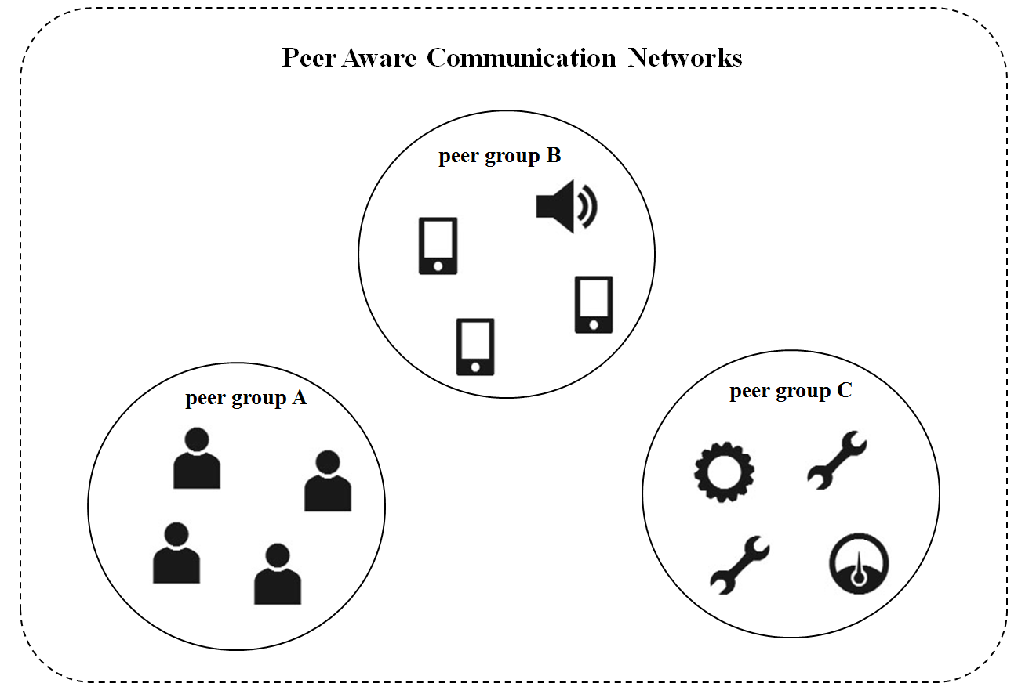
Figure 127—Scenario illustrating multiple peer group services.

Each peer group has different discovery procedure and data transmission pattern, as shown in Figure 128. The peer group A starts data transmission phase after discovering game partners and peering with all participants. Any participating device can leave from the game PAC group, but no new device is expected to join the PAC group after commencing the game. For the peer group B, advertiser continues to discover a peer. Any peer device can join a peer group by responding to an advertiser. After transmitting advertisement data, peering between the advertiser and the customer is released. For the peer group C, equipment controller continues to discover a peer device. After peering, the device will remain in data transmission phase.
Those requirements on discovery, peering and data transmission phase of each service are considered in usage of the cyclic-superframe; selecting the start and stop time of discovery phase, the frequency of discovery request, the duration of peering phase, and the duration of data transmission phase. Each peer group can select the cyclic-superframe structure adequate for the traffic characteristics of the application at each communication phase; active periods of pattern A and B superframe, the size of the cyclic-superframe, and ratio of pattern A superframes and pattern B superframes.
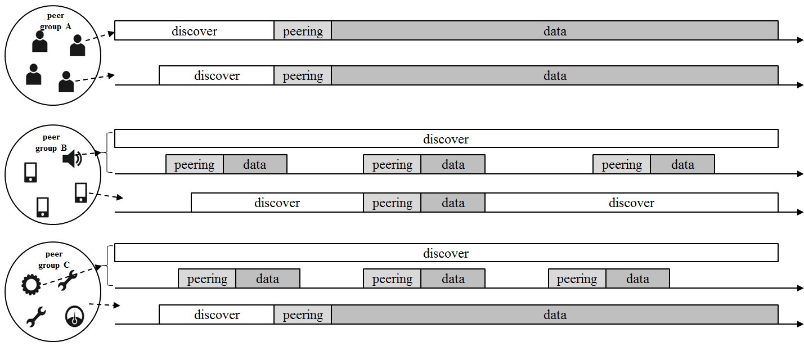
Figure 128— Cyclic-superframe structures for variety of PAC group services.

If a peer device joins multiple peer groups, the device manages the access according to the active periods combined multiple cyclic-superframe of peer groups, as shown in Figure 129. The peer device can identify in which period of the superframe contention will be high. The peer device can increase the transmission success rate of a high priority device by regulating the low priority devices access.
The newly formed peer group listens for Cyclic-superframe Advertise Request command frames broadcasting from the neighbor peer groups and collects information of cyclic-superframe structure. In order to avoid the interference among the neighbor PAC groups implicitly, the peer group calculates the contention probability of each period of a superframe by projecting new cyclic-superframe structure over combined multiple cyclic-superframe of peer groups. The peer group selects the start time of peer group communication to let newly joined cyclic-superframe induce the lowest contention.
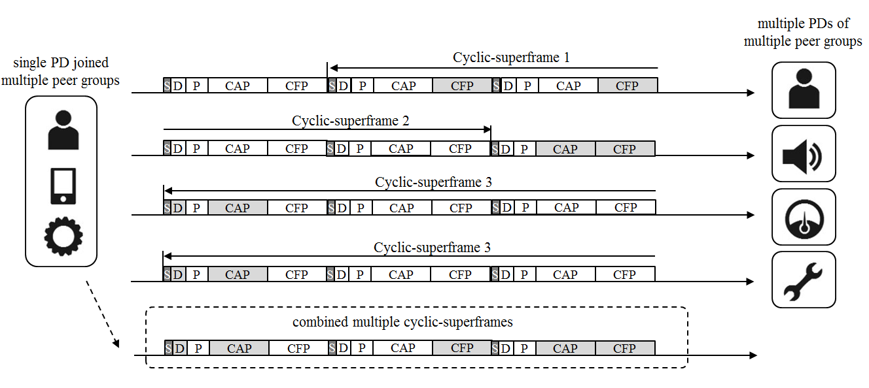
Figure 129— Combined multiple cyclic-superframes for a PD joined multiple peer groups

Operation of cyclic-superframe
A PD starts with the default cyclic-superframe structure, which sets discovery period of a superframe to be active: the cyclic-superframe size is one and the type of pattern A superframe is 0b1000. After synchronization, the MAC layer starts to count a superframe with modulo-4096. The combined multiple cyclic-superframe configuration initialized with the default background cyclic-superframe configuration. The MAC layer activates the transceiver for a period set to be active of the combined multiple cyclic-superframe configuration.
The combined multiple cyclic-superframe configuration is updated when receiving the MLME-CYCLICSUPERFRAME.request from the next higher layer. The next higher layer requests the MAC layer to start a new cyclic-superframe when receiving the discovery request or peering request from an application service, or when responding to a Discovery Request command or Peering Request command frame received from a PD.
The cyclic-superframe structure is set according to an application service. The application service can have single cyclic-superframe configuration or two different configurations which are the cyclic-superframe structure for discovery and peering and the cyclic-superframe structure for data transmission. The cyclic-superframe configuration of an application service can be predetermined and shared among the peer groups before starting a service.

Configuration of cyclic-superframe
The configuration of a cyclic-superframe depends on frequency of message transmission or data rate.
If a Discovery Request command frame needs to be transmitted every X ms, Cyclic-superframe size will be set as nearest integer of X divided by aSuperframeDuration and Number of pattern A superframe will be set as 1, and the PP and CAP of pattern A superframe are set to active.
If one-to-one peer needs a best effort Y bps data rate link with a data frame arrived every Z ms and the average transmission rate in a CAP of a superframe is AvgRateCAP, Cyclic-superframe size will be set as nearest integer of Z divided by aSuperframeDuration and Number of pattern A superframe will be set as nearest integer of Y divided by AvgRateCAP, and the CAP of pattern A superframe is set to active.

