IEEE P802.15
Wireless Personal Area Networks

Project | IEEE P802.15 Working Group for Wireless Personal Area Networks (WPANs)
Title | Revised draft of Cyclic-superframe structure for sponsor ballot recirculation
Date Submitted | July 10, 2017
Source | Seong-Soon Joo (ETRI) | E-Mail:[ssjoo@etri.re.kr]
Re:
Abstract | This document is a revised draft of Cyclic-superframe structure.
Purpose | This document provides the input for the TG8 recirculation sponsor ballot draft.
Notice | This document does not represent the agreed views of the IEEE 802.15 Working Group or IEEE 802.15.8 Task Group. It represents only the views of the participants listed in the “Source(s)” field above. It is offered as a basis for discussion and is not binding on the contributing individual(s) or organization(s). The material in this document is subject to change in form and content after further study. The contributor(s) reserve(s) the right to add, amend or withdraw material contained herein.
Release | The contributor acknowledges and accepts that this contribution becomes the property of IEEE and may be made publicly available by P802.15.
Patent Policy | The contributor is familiar with the IEEE-SA Patent Policy and Procedures:  <http://standards.ieee.org/guides/bylaws/sect6-7.html#6> and  <http://standards.ieee.org/guides/opman/sect6.html#6.3>.  Further information is located at <http://standards.ieee.org/board/pat/pat-material.html> and  <http://standards.ieee.org/board/pat>.

- Overview
- Normative references
- Definitions, acronyms, abbreviations, and word usage
  - Definitions
3.1.8 cyclic-superframe: A periodic time interval comprised of multiple superframes with defined active and inactive periods repeated in a defined sequence.
  - Acronyms and abbreviations
DP discovery period
PP peering period
SP synchronization period

- Format conventions

- General description
  - General
  - Components of IEEE 802.15.8 PAC network
  - Network Topologies
  - Architecture

  - Functional Overview
    - Superframe structure

    - Cyclic-superframe
For efficient synchronized group communication, the PAC MAC superframe uses a period of fixed length. For the application to choose a duty-cycle of activity to suit the particular traffic needs of its peer group and to reduce interference between adjacent PDs or PAC groups, the cyclic-superframe is specified. The cyclic-superframe is a periodic time interval comprised of multiple superframes with defined active and inactive periods repeated in a defined sequence. During inactive periods, a PD may turn off its receiver etc. to conserve power. The details of the cyclic-superframe structure is defined in clause 6.1.2.
The support of cyclic superframe is mandatory for the OFDM PHY (clause 10), and optional for the OFDMA and UWB PHYs (clauses 11 and 12).

- MAC functional description
  - Channel access
    - Superframe

    - Cyclic-superframe
      - Cyclic-superframe structure
A cyclic-superframe is a periodic time interval comprised of superframes. A cyclic-superframe contains multiple superframes with active and inactive periods. During an inactive period, a PD may turn off its transceiver etc. in order to conserve power and reduce interference. Each period of every superframe, except the synchronization period, may be configured to be either active or inactive. A superframe of a cyclic-superframe shall use one of sixteen possible combinations of active and inactive periods, which are illustrated in .
A cyclic-superframe shall be formed with the superframes using two patterns of active and inactive periods: pattern A and pattern B, each of which can be one of sixteen types. The cyclic-superframe consists of a number of repetitions of pattern A superframe, followed by a number of repetitions of pattern B superframe, as shown in . The cyclic-superframe structure shall be described by the cyclic-superframe size, the number of pattern A superframe, the number of pattern B superframe, the type of pattern A superframe, and the type of pattern B superframe. The maximum cyclic-superframe size is 4,096 superframes. If a cyclic-superframe size is one, the cyclic-superframe is formed only with the pattern A superframe.

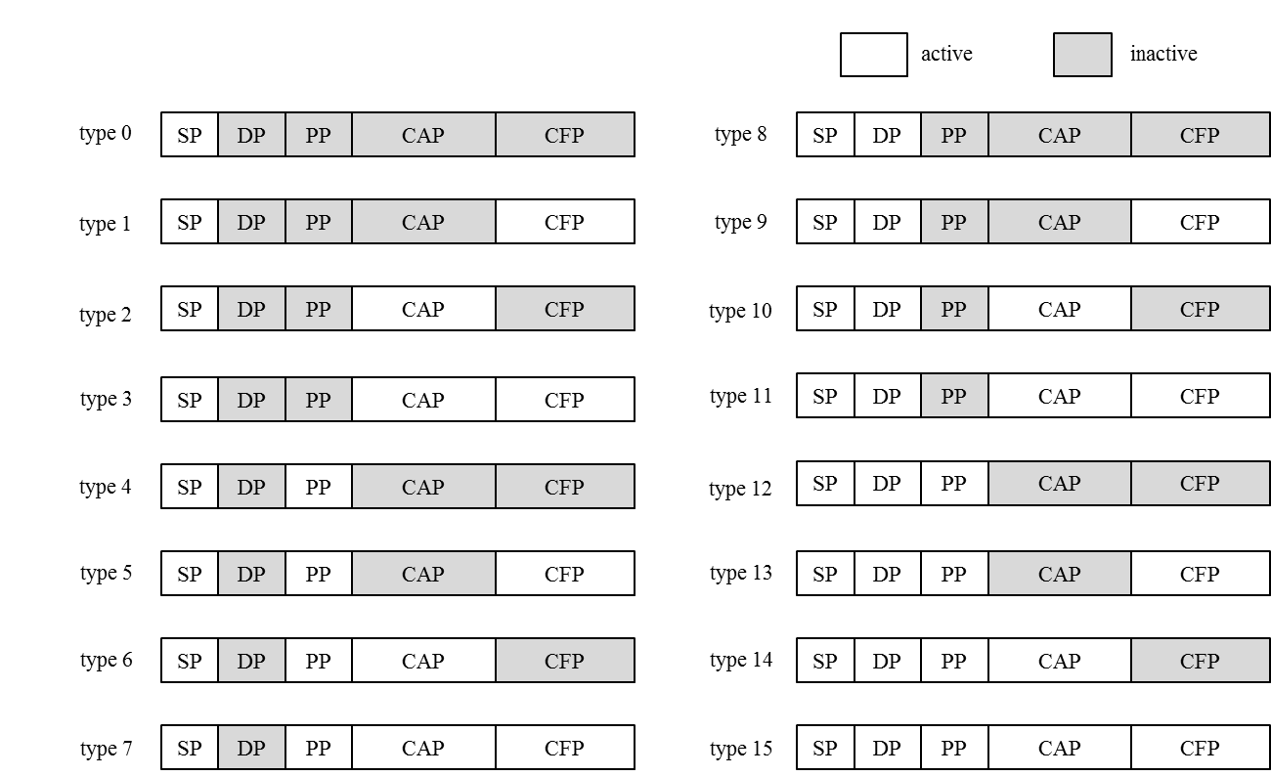
Figure 7—Combinations of active and inactive periods of a superframe

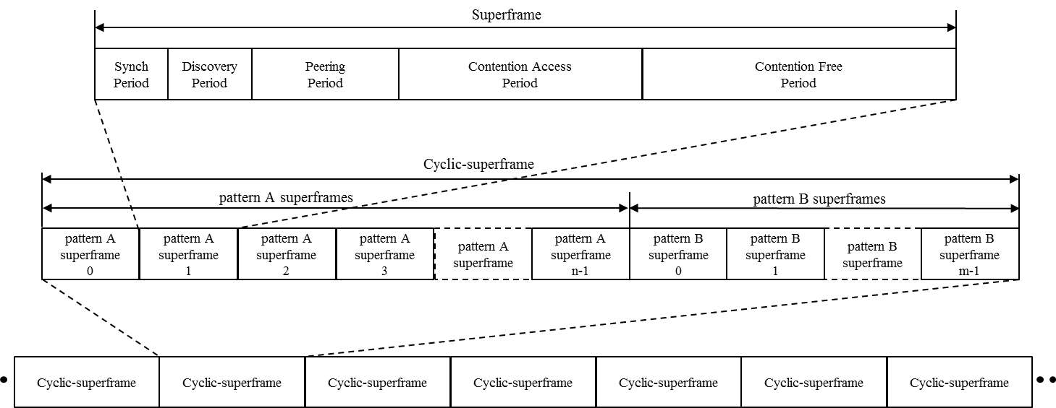
Figure 8—The cyclic-superframe structure

The upper layer is responsible for configuring the appropriate cyclic-superframe structure for its application(s) use.
The cyclic-superframe configured in the PIB is used to define the superframe structure for all communications defined in the standard, until the configuration of the cyclic-superframe structure is changed by the upper layer.
Several examples of a cyclic-superframe structure are shown in Figure 9. Figure 9 a) shows a cyclic-superframe with two pattern A superframes each with the SP active (0b0000), followed by two pattern B superframes, each with the SP active (0b0000). This example cyclic-superframe could be used during synchronization.
Figure 9 b) shows a cyclic-superframe with three pattern A superframes each with the SP active (0b0000), followed by one pattern B superframe with SP, DP, PP and CAP active (0b1110). This example cyclic-superframe could be used for supporting discovery every four superframes.
Figure 9 c) shows a cyclic-superframe with five pattern A superframes, each with SP and DP active (0b1000), followed by one pattern B superframe with SP, DP and CAP active (0b1010). This example cyclic-superframe could be used for supporting energy efficient data transmission by transmitting a data frame over the CAP every six superframes.
Figure 9 d) shows a cyclic-superframe with three pattern A superframes each with SP, DP, PP and CFP active (0b1101), followed by six pattern B superframes with SP active (0b0000). This example cyclic-superframe could be used for supporting reliable data transmission by using three consecutive data frames transmissions over the CFP, before sleeping for the duration of six superframes.

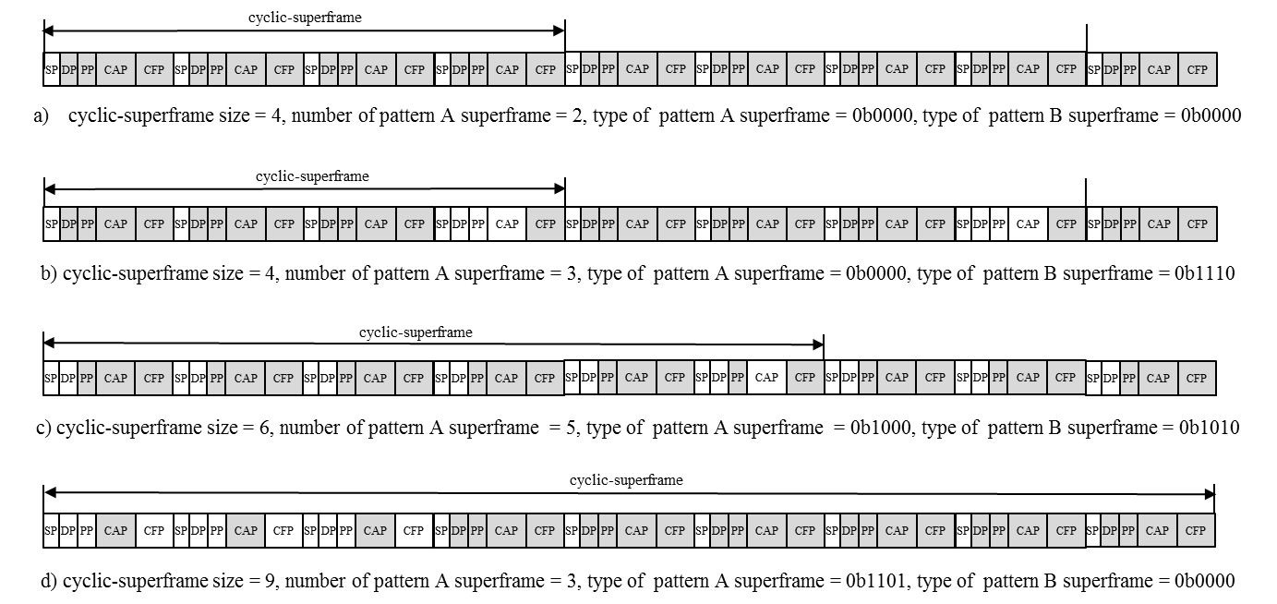
Figure 9—Example cyclic-superframe structures
      - Maintaining cyclic-superframe structure
If the macCyclicSuperframeEnabled is set to TRUE, the MAC layer shall maintain cyclic-superframe structure as follows:
- As shown in Figure xx (a), after synchronization, the MAC layer shall reset macCyclicSuperframeCount and start to control the access of PHY according to the default cyclic-superframe structure, as specified in the first element of macCyclicSuperframeStructureList of Table 82. The next higher layer may set the default cyclic-superframe structure by the MLME-CYCLICSUPERFRAME.request primitive with the Manipulation Type parameter set to DEFAULT and the Cyclic-superframe Descriptor parameter defined in Error: Reference source not found. Irrespective of the cyclic superframe configuration, The MAC layer listens peering period of aCyclicSuperframeAdvWindow superframes to collect neighbor PAC groups’ cyclic-superframe structure by receiving the Cyclic-superframe Advertise Request command frames. The received cyclic-superframe structure of a neighbor PAC group is added to the macCyclicSuperframeNeighborList,
- As shown in Figure xx (b), if the PD intends to start a PAC group, the next higher layer may select the cyclic-superframe configuration and start a new cyclic-superframe structure for the PAC group by the MLME-CYCLICSUPERFRAME.request primitive with the Manipulation Type parameter set to ADD and the Cyclic-superframe Descriptor parameter, which has the PD MAC address, Multicast address of a PAC group, selected Cyclic-superframe size, Number of pattern A superframes, Number of pattern B superframes, Type of pattern A superframe, Type of pattern B superframe, and assigned Start time of cyclic-superframe. The MAC layer shall add a cyclic-superframe descriptor to the macCyclicSuperframeStructureList. If the default cyclic-superframe is operated only in the PD, the MAC layer shall stop the default cyclic-superframe operation and start the operation of the requested cyclic-superframe for the PAC group at the Start time of cyclic-superframe of the Cyclic-superframe Descriptor parameter. If multiple cyclic-superframes are already operated, newly requested cyclic-superframe configuration is merged over the running cyclic-superframe structures, defined in clause 6.1.2.3.
- If the PD intends to join the selected PAC group, the next higher layer may set the cyclic-superframe configuration and start a new cyclic-superframe structure for detecting discovery information by the MLME-CYCLICSUPERFRAME.request primitive with the Manipulation Type parameter set to ADD and the Cyclic-superframe Descriptor parameter, which is same as the cyclic-superframe structure of the selected PAC. The MAC layer shall add the cyclic-superframe descriptor to the macCyclicSuperframeStructureList. If the default cyclic-superframe is operated only in the PD, the MAC layer shall stop the default cyclic-superframe operation and start the operation of the requested cyclic-superframe for the PAC group at the Start time of cyclic-superframe of the Cyclic-superframe Descriptor parameter. If multiple cyclic-superframe are operated already, newly requested cyclic-superframe is merged over the running cyclic-superframe structures.
- As shown in Figure xx (c), if the PD intends to update the cyclic-superframe configuration for data communication after peering, the next higher layer may select the cyclic-superframe configuration and start a new cyclic-superframe structure by the MLME-CYCLICSUPERFRAME.request primitive with the Manipulation Type parameter set to UPDATE and the Cyclic-superframe Descriptor parameter, which has the PD MAC address, Multicast address of a PAC group, selected Cyclic-superframe size, Number of pattern A superframes, Number of pattern B superframes, Type of pattern A superframe, Type of pattern B superframe, and assigned Start time of cyclic-superframe. The MAC layer updates the cyclic-superframe descriptor of the macCyclicSuperframeStructureList.
- The next higher layer selects t
- he Start time of cyclic-superframe such that new PAC group does not interfere with neighbor running PAC groups. The cyclic-superframe configuration of the neighbor PAC groups is collected by using the MLME-GET.request primitive with the PIB Name parameter set to macCyclicSuperframeNeighborList.
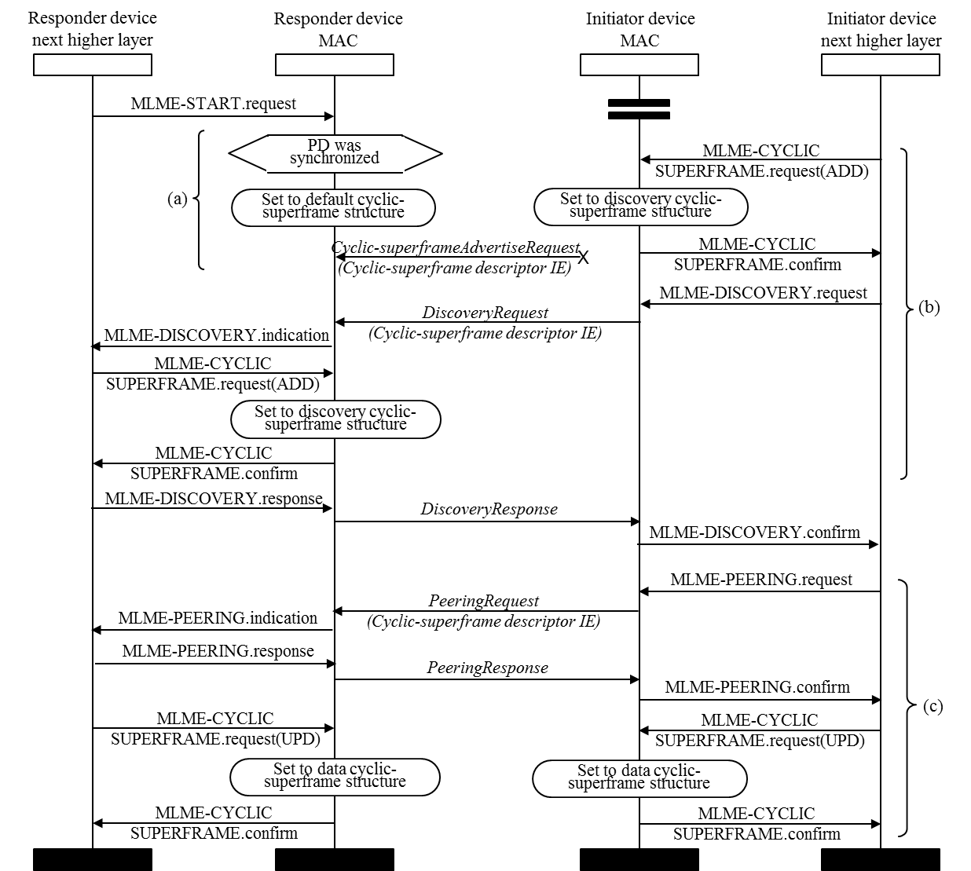
Figure 10—Sequence chart for maintaining cyclic-superframe structures

The cyclic-superframe configuration of a PAC group is selected by an initiator PD, which starts discovery or peering. The cyclic-superframe configuration of a PAC group is shared with PDs of a PAC group as follows:
- As shown in Figure xx (b), the initiator PD of discovery shall convey the cyclic-superframe configuration to a PD by inserting Cyclic-superframe Descriptor IE to the Discovery Request command frame. The Cyclic-superframe Descriptor parameter of MLME-DISCOVERY.request primitive is copied into Cyclic-superframe descriptor content IE field, as described in clause 6.10.4.3.1. When a PD receives Discovery Request command frame, the MAC layer shall report the Cyclic-superframe descriptor of a PAC group to the next higher layer with the MLME-DISCOVERY.indication primitive. If the upper layer determines to be discovered, the upper layer may request to add the cyclic-superframe descriptor by the MLME-CYCLICSUPERFRAME.request primitive with the Manipulation Type parameter set to ADD and the Cyclic-superframe Descriptor parameter same as the Cyclic-superframe Descriptor parameter of the MLME-DISCOVERY.indication primitive. The MAC layer shall add the cyclic-superframe descriptor to the macCyclicSuperframeStructureList. If the default cyclic-superframe is operated only in the PD, the MAC layer shall stop the default cyclic-superframe operation and start the operation of the requested cyclic-superframe for the PAC group at the Start time of cyclic-superframe of the Cyclic-superframe Descriptor parameter. If multiple cyclic-superframe are operated already, newly requested cyclic-superframe is merged over the running cyclic-superframe structures.
- As shown in Figure xx (c), the initiator PD of peering shall convey the cyclic-superframe configuration to a PD by inserting Cyclic-superframe Descriptor IE of the Peering Request command frame. The Cyclic-superframe Descriptor parameter of MLME-PEERING.request primitive is copied into Cyclic-superframe descriptor content IE field, as described in clause 6.10.4.3.1. When a PD receives Peering Request command frame, the MAC layer shall report the Cyclic-superframe descriptor of a PAC group to the next higher layer with the MLME-PEERING.indication primitive. If the next higher layer determines to join the PAC group, the next higher layer may request to update the cyclic-superframe descriptor by the MLME-CYCLICSUPERFRAME.request primitive with the Manipulation Type parameter set to UPDATE and the Cyclic-superframe Descriptor parameter same as the Cyclic-superframe Descriptor parameter of the MLME-PEERING.indication primitive. The MAC layer shall update the cyclic-superframe descriptor of the macCyclicSuperframeStructureList. If multiple cyclic-superframe are operated already, newly requested cyclic-superframe is merged over the running cyclic-superframe structures.
The cyclic-superframe configuration of a PAC group is advertised by an initiator PD, which starts discovery or peering. The cyclic-superframe configuration of a PAC group is shared with PDs of neighbor PAC groups as follows:
- The MAC layer of initiator PD shall send the Cyclic-superframe Advertise Request command frame periodically every aCyclicSuperframeAdvWindow superframes. The command frame is sent in the peering period of the superframe which is chosen at the first advertisement randomly from aCyclicSuperframeAdvWindow superframes. Even though selected peering period of the superframe is inactive period of the running cyclic-superframe structures, the Cyclic-superframe Advertise Request command frame shall be transmitted.
- The MAC layer of a PD listens the peering period for duration of aCyclicSuperframeAdvWindow superframes to collect neighbor PAC groups’ cyclic-superframe structure by receiving the Cyclic-superframe Advertise Request command frames. The received cyclic-superframe descriptor of a neighbor PAC group renews the macCyclicSuperframeNeighborList.
The cyclic-superframe configuration of a PAC group is deleted from the macCyclicSuperframeStructureList as follows:
- When the next higher layer of the initiator PD decides to finish the discovery procedure or the peering procedure, the next higher layer deletes cyclic-superframe structure of the PAC group by the MLME-CYCLICSUPERFRAME.request primitive with the Manipulation Type parameter set to DELETE and the Cyclic-superframe Descriptor parameter with the initiator PD MAC address, Multicast address of the PAC group, and assigned Start time of cyclic-superframe. The indexed cyclic-superframe descriptor is deleted from the macCyclicSuperframeStructureList. The running cyclic-superframe structure is reconfigured at the assigned Start time of the cyclic-superframe.
- After transmitting or receiving the Depeering Notification command frame, the next higher layer may request to delete the cyclic-superframe configuration by the MLME-CYCLICSUPERFRAME.request primitive with the Manipulation Type parameter set to DELETE and the Cyclic-superframe Descriptor parameter with the initiator PD MAC address, Multicast address of the PAC group, and assigned Start time of cyclic-superframe. The indexed cyclic-superframe descriptor is deleted from the macCyclicSuperframeStructureList. The running cyclic-superframe structure is reconfigured at the assigned Start time of the cyclic-superframe.

      - Access control with cyclic-superframe structure
The cyclic-superframe tells when a PAC group is able to communicate. The PD of a PAC group maintains the start time of cyclic-superframe as follows:
- The MAC layer shall keep macCyclicSuperframeCount. The macCyclicSuperframeCount is the number of past superframes counted after synchronization or resetting, and is presented with superframe numbers modulo 4,096. The macCyclicSuperframeCount is the reference to delimitate the cyclic-superframe. The start time of the cyclic-superframe is calculated with {(value of macCyclicSuperframeCount - superframe sequence) + n*cyclic-superframe size} modulo 4096.
- A PD can join multiple PAC groups having different cyclic-superframe configurations. Different cyclic-superframe size and different start time of cyclic-superframes cause cyclic-superframes overlapping and some period may be shared with multiple PAC groups. To know which period of a superframe is active for receiving and transmitting a frame, the cyclic-superframe configurations are merged on 4,096 superframes period state map.
The frames transmitted are scheduled for accessing medium as follows:
- When the Discovery Request command frame or the Discovery Response command frame is requested to transmit, the MAC layer waits for the nearest active CAP of the cyclic-superframe of the PAC group.
- When the Peering Request command frame or the Peering Response command frame is requested to transmit, the MAC layer waits for the nearest active PP of the cyclic-superframe of the PAC group.
- When the Data frame is requested to transmit in the CFP, the MAC layer waits for the nearest active CFP of the cyclic-superframe of the PAC group.
- When the Cyclic-superframe Advertise Request command frame is requested to transmit in the selected PP, the MAC layer transmits the command frame at the PP.
- Before requesting to transmit a frame, the appropriate period of the cyclic-superframe should be activated. When selecting a configuration of the cyclic-superframe, be sure to satisfy the transmitting requirements. At least one more active CAP in a cyclic-superframe is recommended.

  - Starting and maintaining PAC networks
  - Transmission, reception, and acknowledgment
  - Synchronization procedure
  - Discovery procedure
  - Peering procedure
  - De-peering procedure

  - Communication period
  - Link-ID
  - MAC frame formats
    - PD addresses
    - General MAC frame format
The general MAC frame shall be formatted as illustrated in Figure 36. The fields of the MAC frame appear in a fixed order; however, some fields may not be included in all frames.
Octets: 2 | 0/1 | 0/2/6/8 | 0/1/2/6 | variable | variable | variable | 2
Frame Control | Sequence Number | Destination Address | Source Address or Link-ID | Information Elements |  | Payload | FCS
Frame Control | Sequence Number | Addressing fields |  | Header Information Elements | Payload Information Elements | Payload | FCS
MAC Header |  |  |  |  | MAC Payload |  | MAC Footer
Figure 36—General MAC frame format
      - Frame control field
        - Frame Type field
        - Destination Addressing Mode (DAM) field
The DAM field shall be set to one of the values listed in Table 10.
Table 10—Values of the Destination Addressing Mode field
DAM value  b1 b0 | Description
00 | The destination address is not present [broadcast]
01 | The destination address is an IEEE 48-bit MAC address.
10 | The destination address is a 16-bit multicast group address.
11 | The destination address is combined address of a 16-bit multicast group address and an IEEE 48-bit MAC address

      - Sequence Number field
      - Destination Address field
The Destination Address field, when present, is either a 2-octet multicast group address, or a 6-octet IEEE MAC address, or an 8-octet combined address of a multicast group address and an IEEE MAC address according to the value specified in the Destination Addressing Mode field of the Frame Control field (see 6.10.2.1.2). This field shall be included in the MAC frame only if the DAM field is set to 01, or 10, or 11. When the Destination Address field is not present, this shall represent the broadcast address.
    - Format of individual frame types
      - Data frame format
The Data frame shall be formatted as illustrated in Figure 39.
Octets: 2 | 0/1 | 0/2/6/8 | 0/1/2/6 | variable | variable | variable | 2
Frame Control | Sequence Number | DA | SA or L-ID | Header IEs | Payload IEs | Payload | FCS
MAC Header |  |  |  |  | MAC Payload |  | MAC Footer
Figure 39—Data frame format
      - Acknowledgement frame formats
There are two types of acknowledgement frames: the Immediate Acknowledgment frame and the Enhanced Acknowledgment frame. The type to send is defined by the Ack Type parameter specified in the AR/SNS field (see 6.10.2.1.4).
The Frame Type field shall contain the value indicating an Acknowledgment frame (see Table 12). All other fields in the Frame Control field shall be set accordingly to the description of the Ack frame format.
        - Immediate Acknowledgment frame format
The Immediate Acknowledgment frame shall be formatted as shown in Figure 40.
Octets: 2 | 1 | 6/8 | 6/1/2 | 2
Frame Control | Sequence Number | DA | SA/L-ID | FCS
MAC Header |  | MAC Payload |  | MAC Footer
Figure 40—Immediate Acknowledgment frame format
The MHR of the Immediate Ack frame shall contain only the Frame Control and Sequence Number fields. The Sequence number field shall be copied from the frame being acknowledged. The payload of the Immediate Ack frame shall contain a copy of the Destination Address and Source Address/Link-ID fields from the frame being acknowledged.
        - Enhanced Acknowledgment frame format
The Enhanced Acknowledgment frame shall be formatted as shown in Figure 41.
Octets: 2 | 1 | 6/8 | 6 | variable | variable | variable | 2
Frame Control | Sequence Number | DA | SA | Header IEs | Payload IEs | Payload | FCS
MAC Header |  |  |  |  | MAC Payload |  | MAC Footer
Figure 41—Enhanced Acknowledgment frame format
In the MAC Header, the Frame Control field shall be set accordingly to the intended use of the Enhanced Ack frame. The Sequence number field shall be copied from the frame being acknowledged. The Addressing fields shall contain full source and destination addresses. The MAC Payload shall contain only Payload IEs that may be included.
      - MAC command frame format
MAC command frames shall be formatted as illustrated in Figure 42.
Octets: 2 | 0/1 | 0/2/6/8 | 0/6/1/2 | variable | variable | 1 | variable | 2
Frame Control | Sequence Number | DA | SA/L-ID | Header IEs | Payload IEs | Command ID | Content | FCS
MAC Header |  |  |  |  | MAC Payload |  |  | MAC Footer
Figure 42—MAC command frame format
    - Information Elements (IEs)
      - General IE format
      - IE list termination
      - Header IEs
        - Cyclic-superframe descriptor IE
The Cyclic-superframe descriptor IE Content field shall be formatted as illustrated in Figure .
Octets: 2 | 2 | 2 | 1
Superframe Sequence Number | Cyclic-superframe Size | Number of  Pattern A Superframe | Superframe Pattern Type
Figure 48—The Cyclic-superframe descriptor IE Content field format

The Superframe Sequence Number field contains the sequence number of the superframe sending Cyclic-superframe descriptor IE counting from the start of a cyclic-superframe.
The Cyclic-superframe Size field contains the number of superframes in a cyclic-superframe.
The Number of Pattern A Superframe field contains the number of pattern A superframe in a cyclic-superframe.
The Superframe Pattern Type field contains the type of pattern A superframe and the type of pattern B superframe, as indicated in Figure .

Bit : 0 | 1 | 2 | 3 | 4 | 5 | 6 | 7
Discovery  Period State | Peering Period State | CAP State | CFP State | Discovery  Period State | Peering Period State | CAP State | CFP State
Type of Pattern A Superframe |  |  |  | Type of Pattern B Superframe
Figure 49—Superframe pattern type field format

The Discovery Period State field shall be set to 1 if the discovery period is active, and to 0 if inactive.
The Peering Period State field shall be set to 1 if the peering period is active, and to 0 if inactive.
The CAP State field shall be set to 1 if the contention period is active, and to 0 if inactive.
The CFP State field shall be set to 1 when the contention free period is active, and to 0 if inactive.
  - MAC commands
This clause defines the MAC command identifier (ID), MAC command Content field and relevant MAC Header fields. The MAC command frame format is defined in Error: Reference source not found and the MAC Header fields are defined in Error: Reference source not found.
The MAC command identifiers are listed in Table 1.
Table 1—MAC command IDs
Command ID | Command name | Clause
0 | Reserved | ⎯
1 | Discovery Request | 6.11.1
2 | Discovery Response | Error: Reference source not found
3 | Peering Request | 6.11.3
4 | Peering Response | 6.11.3
5 | De-peering Notification | 6.11.3
6 | Reassignment | 6.11.3
7 | RE Request | 6.11.3
8 | RE Response | 6.11.3
9 | RE Notification | 6.11.3
10 | Public Key Request | 6.11.3
11 | Public Key Response | Error: Reference source not found
12 | Cyclic-superframe Advertise Request | 6.11.12
13 − 255 | Reserved | ⎯
    - Discovery Request command frame
    - Discovery Response command frame
    - Peering Request command frame
    - Peering Response command frame
    - De-peering Notification command frame
    - Reassignment command
    - RE Request command
    - RE Response command
    - RE Notification command
    - Cyclic-superframe Advertise Request command frame
This command shall be sent by the MLME in order to advertise the cyclic-superframe configuration of a PAC group.
      - Relevant MHR fields
The DAM field shall be set to broadcast. The SAM field shall be set to MAC address. The AR/SNS field shall be set to b’00. The HIEP field set to 1. The SEC field shall be set to 1. The PIEP field set to 0.
The Destination Address field shall be not present. The Source Address field shall contain the Initiator PD address parameter of the Cyclic-superframe descriptor.
The Cyclic-superframe descriptor IE shall contain the Cyclic-superframe descriptor of the macCyclicSuperframeStructureList indexed by the Initiator PD address. The Superframe Sequence Number field of the Cyclic-superframe descriptor IE content field is set to the value calculated with the Start time of cyclic-superframe parameter of the Cyclic-superframe descriptor and the macCyclicSuperframeCount, as described in clause 6.1.2.3. The Cyclic-superframe Size field of the Cyclic-superframe descriptor IE content field is set to the Cyclic-superframe size parameter of the Cyclic-superframe descriptor. The Number of Pattern A Superframe Size field of the Cyclic-superframe descriptor IE content field is set to the Number of pattern A superframes parameter of the Cyclic-superframe descriptor. The Type of Pattern A Superframe field of the Cyclic-superframe descriptor IE content field is set to the Type of pattern A superframe parameter of the Cyclic-superframe descriptor. The Type of Pattern B Superframe field of the Cyclic-superframe descriptor IE content field is set to the Type of pattern B superframe parameter of the Cyclic-superframe descriptor.

- MAC services
  - Overview
  - Generic service primitives
  - MLME-SAP interface
    - PIB access

    - Cyclic superframe configuration
These primitives set the cyclic-superframe configuration in a PD.

      - MLME-CYCLICSUPERFRAME.request
This primitive allows the next higher layer to request that the MLME manipulates the cyclic-superframe structure of a PAC group of the PIB. The parameters of this primitive are:

MLME-CYCLICSUPERFRAME.request (

Handle;

Manipulation Type;

Cyclic-Superframe Descriptor;

)

Table 2—MLME-CYCLICSUPERFRAME.request parameters
Name | Type | Valid range | Description
Handle | Integer | 0x00-0xff | Unique identifier of the cyclic-superframe structure manipulation request.
Manipulation Type | Enumeration | DEFAULT,  ADD,  UPDATE,  DELETE | Indicates the type of cyclic-superframe structure manipulation. DEFAULT for inserting default cyclic-superframe configuration. ADD for adding a cyclic-superframe descriptor of a PAC group to the macCyclicSuperframeStructureList. UPDATE for replacing a cyclic-superframe descriptor of a PAC group.  DELETE for deleting a cyclic-superframe descriptor of a PAC group from the macCyclicSuperframeStructureList.
Cyclic-Superframe Descriptor | As defined in Table 37 | As defined in Table 37 | Indicates the structure of cyclic-superframe for a PAC group.

The Cyclic Superframe Descriptor parameters are defined in Table 37.
Table 37—Cyclic-superframe Descriptor parameters
Name | Type | Valid range | Description
Initiator PD address | 48-bit  Integer | 6 octets | MAC address of the initiator of the PAC group.
Multicast group address | 16-bit  Integer | 2 octets | Multicast group address of the PAC group.
Cyclic-superframe size | 16-bit  Integer | 1-4096 | Number of superframes in a cyclic-superframe.
Number of pattern A superframe | 16-bit  Integer | 1-4096 | Number of pattern A superframes in a cyclic-superframe
Type of pattern A superframe | Integer | As defined in Figure | State indicator of periods of pattern A superframe
Type of pattern B superframe | Integer | As defined in Figure 7 | State indicator of periods of pattern B superframe
Start time of cyclic-superframe | 16-bit  Integer | 0-4095 | Superframe sequence number starting the cyclic-superframe, as defined in clause 6.1.2.3.

        - When generated
This primitive is generated by the next higher layer to request the MLME to set a cyclic superframe configuration in the local PD.

        - Effect on receipt
The MLME sets the PIB with the value of the cyclic-superframe descriptor for a PAC group.
- If Manipulation Type is set to DEFAULT, the MAC layer inserts default cyclic-superframe configuration to the first element of the macCyclicSuperframeStructureList.
- If Manipulation Type is set to ADD, the MAC layer adds a cyclic-superframe descriptor of a PAC group to the macCyclicSuperframeStructureList.
- If Manipulation Type is set to UPDATE, the MAC layer replaces the cyclic-superframe descriptor of a PAC group of the macCyclicSuperframeStructureList with the Cyclic-Superframe Descriptor parameter of the primitive.
- If Manipulation Type is set to DELETE, the MAC layer deletes a cyclic-superframe descriptor of a PAC group from the macCyclicSuperframeStructureList.
      - MLME-CYCLICSUPERFRAME.confirm
This primitive reports the setting of a new cyclic-superframe configuration requested by MLME-CYCLICSUPERFRAME.request primitive. The parameters of this primitive are:
MLME-CYCLICSUPERFRAME.confirm (

Handle;

Status;
)

Table 48—MLME-CYCLICSUPERFRAME.confirm parameters
Name | Type | Valid range | Description
Handle | Integer | 0x00-0xff | Unique identifier of the cyclic-superframe structure manipulation request.
Status | Enumeration | SUCCESS,  INVALID_PARAMETER,  UNKNOWN,  MAX_LIST_EXCEEDED | Result of the request operation.

The Status of the primitive shall indicate SUCCESS if the operation completed successfully. If any of the arguments fail a range check, the Status shall be INVALID_PARAMETER. If a cyclic-superframe descriptor is being added and the macCyclicSuperframeStructureList is already full, the Status shall be MAX_LIST_EXCEEDED. If an update or deletion is being requested and the corresponding cyclic-superframe descriptor cannot be found, the Status shall be UNKNOWN.
        - When generated
This primitive is generated by the MLME in response to MLME-CYCLICSUPERFRAME.request primitive.
        - Effect on receipt
The MLME confirms the setting of the cyclic-superframe configuration for a PAC group.
    - Discovery
These primitives are used to obtain the discovery information of targeted PDs using the CAP, or untargeted PDs using the discovery period (typically at start up). Also, the primitives indicate if the MLME shall indicate the transmission of the local discovery information during the discovery period.
      - MLME-DISCOVERY.request
Depending on the parameters of this primitive:
⎯ This primitive instructs the MLME to request for the discovery information of a targeted PD or PDs in a PAC group during the CAP.
⎯ This primitive instructs the MLME either to transmit the PD’s discovery information or to detect other PDs discovery information during the discovery period.
The parameters of this primitive are:
MLME-DISCOVERY.request(
Discovery Type;
Discovery Resource;
Discovery Range Min;
Discovery Range Max;
Destination Address;
Multicast Address;
Address mode;
Cyclic-Superframe Descriptor;
)
Table 5—MLME-DISCOVERY.request parameters
Name | Type | Valid range | Description
Discovery Type | Enumeration | ONE-WAY-TX, ONE-WAY-RX, TWO-WAY-UNTARGETED, TWO-WAY-TARGETED | Indicates whether targeted/untargeted discovery during the CAP, or the transmission/ reception of discovery information during the discovery period.
Discovery Resource | Integer | 1 – Number of discovery resource blocks | This parameter is only present when the Discovery Type parameter is set to ONE-WAY-TX. It indicates the discovery resource block to transmit the discovery information during the discovery period.
Discovery Range Min | Integer | 1 – Number of discovery resource blocks | This parameter is only present when the Discovery Type parameter is set to ONE-WAY-RX. It indicates the minimum discovery resource block to scan for discovery information during the discovery period.
Discovery Range Max | Integer | 1 – Number of discovery resource blocks | This parameter is only present when the Discovery Type parameter is set to ONE-WAY-RX. It indicates the maximum discovery resource block to scan for discovery information during the discovery period.
Destination Address | MAC address | IEEE 48 bit MAC address | This parameter is only present when the Discovery Type parameter is set to TWO-WAY-TARGETED. It indicates the MAC address of the targeted PD to request its discovery information.
Multicast Address | Unsigned integer | 0 to 2¹⁶ −1 | This parameter is only present when the Discovery Type parameter is set to TWO-WAY-TARGETED. It indicates the multicast address of the targeted PAC group to request their discovery information.
Address Mode | Enumeration | PD, Group | Indicates if the discovery request is for a targeted PD or PAC group.
Cyclic-Superframe Descriptor | As defined in Error: Reference source not found | As defined in Error: Reference source not found | Indicates the structure of cyclic-superframe for PAC group with identifier in Group ID

        - When generated
Depending on the parameters of this primitive:
⎯ This primitive is generated by the next higher to request for the discovery information of another PD or other PDs in the PAC group during the CAP.
⎯ This primitive indicates if the local MLME transmits the PD’s discovery information or detects the discovery information of other PDs during the discovery period.
        - Effect on receipt
Depending on the parameters of this primitive:
⎯ On receipt of this primitive, if the Discovery Type parameter is set to TWO-WAY-TARGETED, the MLME shall send a Discovery Request command frame with Destination Address field of either the MAC address indicated in the Destination Address parameter, if Address Mode parameter is set to PD, or the multicast address indicated in the Multicast Address parameter, if the Address Mode parameter is set to Group. The MLME shall insert the Cyclic-Superframe Descriptor parameter in the Cyclic-superframe descriptor IE of the MAC header of the Discovery Request command frame, as described in clause 6.11.12.1.
⎯ On receipt of this primitive, if the Discovery Type parameter is set to ONE-WAY-TX, the MLME shall indicate to the local PHY to transmit the PD’s discovery information over the discovery resource block indicated in the Discovery Resource parameter during the discovery period.
⎯ On receipt of this primitive, if the Discovery Type parameter is set to ONE-WAY-RX, the MLME shall indicate to the local PHY to scan for discovery information between the range indicated by the Discovery Range Min parameter and Discovery Range Max parameter during the discovery period.
      - MLME-DISCOVERY.confirm
Depending on the parameters of this primitive:
⎯ The primitive reports the result of a request for targeted discovery information to a Responder PD or PDs in a PAC group during the CAP, and in response to the MLME-DISCOVERY-request primitive.
⎯ This primitive reports the status for either transmission or reception of discovery information during the discovery period, and in response to MLME-DISCOVERY-request primitive to the local PHY.
MLME-DISCOVERY.confirm(
Discovery Type;
Discovery Info;
Discovery List;
Status;
Cyclic-Superframe Descriptor;
)
Table 6—MLME-DISCOVERY.confirm parameters
Name | Type | Valid range | Description
Discovery Type | Enumeration | ONE-WAY-TX, ONE-WAY-RX, TWO-WAY-UNTARGETED, TWO-WAY-TARGETED | Indicates whether targeted/untargeted discovery during the CAP, or the transmission/reception of discovery information during the discovery period.
Discovery Info | As defined in Error: Reference source not found | As defined in Error: Reference source not found | This parameter is only present when the Discovery Type is set to TWO-WAY-TARGETED or TWO-WAY-UNTARGETED.
Discovery List | List PDs’ discovery information | As defined in Error: Reference source not found | This parameter is only present when the Discovery Type is set to ONE-WAY-RX. It indicates the discovery information captured during the discovery period.
Status | Enumeration | SUCCESS, DENIED, CHANNEL_ACCESS_FAILURE | Status of the discovery request.
Cyclic-Superframe Descriptor | As defined in Error: Reference source not found | As defined in Error: Reference source not found | This parameter is only present when the Discovery Type is set to TWO-WAY-TARGETED or TWO-WAY-UNTARGETED. Indicates the structure of the cyclic-superframe of Responder PD(s).

        - When generated
Depending on the parameters of this primitive:
⎯ This primitive is generated by the MLME upon reception of a Discovery Response command frame from the Responder PD(s) during the CAP to the next higher layer.
⎯ This primitive is generated by the MLME to report the result to the issue of MLME-DISCOVERY-request primitive, to the local PHY, to the next higher layer.
        - Effect on receipt
Depending on the parameters of this primitive:
⎯ The PD’s next higher layer is informed of the result of a request for targeted discovery information of Responder PD(s) during the CAP. If the Status parameter is SUCCESS and the Discovery Type parameter is either TWO-WAY-UNTARGETED or TWO-WAY-TARGETED, the discovery information is contained in the Discovery Info parameter; otherwise, the corresponding error code of DENIED or CHANNEL_ACCESS_FAILURE is generated.
⎯ The PD’s next higher layer is informed of the status to the issue of MLME-DISCOVERY-request primitive to the local PHY. If the Status parameter is SUCCESS and the Discovery Type parameter is ONE-WAY-RX, the discovery information is contained in the Discovery List parameter; otherwise, the corresponding error code of CHANNEL_ACCESS_FAILURE is generated. If the Status parameter is SUCCESS and the Discovery Type parameter is ONE-WAY-TX, the PD’s discovery information was transmitted successfully; otherwise, the corresponding error code of CHANNEL_ACCESS_FAILURE is generated.
      - MLME-DISCOVERY.indication
This primitive indicates the reception of a Discovery Request command frame to the next higher layer of a Responder PD or PDs of a PAC group during the CAP. The parameters of this primitive are:
MLME-DISCOVERY.indication(
Discovery Type;
Cyclic-Superframe Descriptor;
)

Table 7—MLME-DISCOVERY.indication parameters
Name | Type | Valid range | Description
Discovery Type | Enumeration | ONE-WAY-TX, ONE-WAY-RX, TWO-WAY-UNTARGETED, TWO-WAY-TARGETED | Indicates whether targeted/untargeted discovery during the CAP, or the transmission/ reception of discovery information during the discovery period.
Cyclic-Superframe Descriptor | As defined in Error: Reference source not found | As defined in Error: Reference source not found | Indicates the structure of cyclic-superframe

        - When generated
This primitive is generated by the MLME of the PD receiving a Discovery Request command frame from a Requestor PD during the CAP.
        - Effect on receipt
The PD’s higher layer is notified of the receipt of a Discovery Request command frame, and the cyclic superframe structure used by the Requestor PD.

      - MLME-DISCOVERY.response
The primitive is used to send a response command frame to the MLME of the PD requesting for discovery information. The parameters of this primitive are:

MLME-DISCOVERY.response(
Discovery Type;
Discovery Info;
Status;
Cyclic-Superframe Descriptor;
)

Table 8—MLME-DISCOVERY.response parameters
Name | Type | Valid range | Description
Discovery Type | Enumeration | ONE-WAY-TX, ONE-WAY-RX, TWO-WAY-UNTARGETED, TWO-WAY-TARGETED | Indicates whether targeted/untargeted discovery during the CAP, or the transmission/ reception of discovery information during the discovery period.
Discovery Info | As defined in Error: Reference source not found | As defined in Error: Reference source not found | Indicates the PD’s discovery information.
Status | Enumeration | SUCCESS, DENIED | Status of the discovery request.
Cyclic-Superframe Descriptor | As defined in Error: Reference source not found | As defined in Error: Reference source not found | Indicates the structure of cyclic-superframe.

        - When generated
This primitive is generated by a Responder PD’s next higher layer in response to the reception of MLME-DISCOVERY.indication primitive.
        - Effect on receipt
On receipt of this primitive, the MLME initiates the transmission of a Discovery Response command frame to the Requestor PD that requested the discovery information, and inserts the cyclic superframe structure used by the Responder PD, if the Status parameter is set to SUCCESS. If the Status parameter is set to DENIED, the MLME shall set the Discovery Information field of the Discovery Response command frame to be empty.
    - Peering primitives
The following primitives describe how a Requestor PD becomes peered with other Responder PD(s).
      - MLME-PEERING.request
This primitive initiates a request for peering between a Requestor PD and a Responder PD or targeted Responder PDs.
The parameters of this primitive are:
MLME-PEERING.request(
Peering Type;
Channel Page;
Channel Number;
Group ID;
Application ID;
Destination Address;
Multicast Address;
PD List;
PHY Capability List;
Elliptic Curve;
Key Descriptor;
Cyclic-Superframe Descriptor;
)

Table 9—MLME-PEERING.request parameters
Name | Type | Valid range | Description
Peering Type | Enumeration | ONE2ONE, ONE2MANY, ONE2GROUP | Indicates whether one-to-one or one-to-many peering operation.
Channel Number | Integer | As defined in Error: Reference source not found | This parameter is only present if there is a new proposed channel number on which to attempt to peer.
Channel Page | Integer | As defined in Error: Reference source not found | This parameter is only present if there is a new proposed page on which to attempt to peer.
Group ID | Octet | 2 octets | Desired Group ID of Responder PD to request association.
Application ID | Octet | 13 octets | Desired Application ID of Responder PD to request association.
Destination Address | MAC address | IEEE 48 bit MAC address | MAC address of Responder PD.
Multicast Address | Octet | 2 octets | This parameter is only present if Peering Type is set to ONE2GROUP.
PD List | List of PDs’ discovery information | As defined in Table 3 | This parameter is only present if Peering Type is set to ONE2MANY. List of targeted PDs’ discovery information
PHY Capability List | Enumeration list | LOW_MOBILITY, HIGH_MOBILITY, GFSK, UWB_BPM_BPSK, UWB_OOK | List of PHYs supported by the Requestor PD.
Elliptic Curve | Integer | 0: Curve 25519  1: Curve 256  2⎯255: reserved | The standard elliptic curve used to derive the public key.
Key Descriptor | As defined in Error: Reference source not found | As defined in Error: Reference source not found | Key descriptor parameters.
Cyclic-Superframe Descriptor | As defined in Error: Reference source not found | As defined in Error: Reference source not found | Indicates the structure of cyclic-superframe of Requestor PD

        - When generated
Depending on the parameters of this primitive:
⎯ This primitive is generated by the Requestor PD’s next higher layer to request peering with a Responder PD in case of one-to-one peering. The Peering Type parameter is set to ONE2ONE.
⎯ This primitive is generated by the Requestor PD’s next higher layer to request peering with Responder PDs in case of one-to-many peering. The Peering Type parameter is set to ONE2MANY.
⎯ This primitive is generated by the Requestor PD’s next higher layer to request peering with PDs of a PAC group (for instance when a PD request re-peering to a PAC group). The Peering Type parameter is set to ONE2GROUP.
        - Effect on receipt
Depending on the parameters of this primitive:
⎯ On receipt of this primitive, if the Peering Type parameter is set to ONE2ONE, the MLME shall send a Peering Request command frame to the Responder PD with the Destination Address field containing the value of the Destination Address parameter.
⎯ If the Peering Type parameter is set to ONE2MANY, the MLME shall broadcast the Peering Request command frame with a list of targeted PDs’ discovery information in the Content field. That may require several Peering Request command frames to send (the Peering Request command format has a provision to indicate that another Peering Request command follows).
⎯ If the Peering Type parameter is set to ONE2GROUP, the MLME shall send a Peering Request command frame to the PDs of a PAC group with Destination Address field containing the value of the Multicast Address parameter.
In all of the above cases, the MLME shall append the PD’s public key in the Content field, and the MLME shall insert the Cyclic-Superframe Descriptor parameter in the Cyclic-superframe descriptor IE of the MAC Header, as described in clause 6.11.12.1. The MLME shall insert the desired Group ID and/or Application ID to request an association or peering. Also, the MLME shall insert a new channel number and/or new channel page, if available. The MLME shall insert if the PD supports extra PHYs in the PHY Capability List parameter.
      - MLME-PEERING.indication
This primitive is used to indicate the reception of a Peering Request command frame. The parameters of this primitive are:
MLME-PEERING.indication(
Peering Type;
Source Address;
Channel Page;
Channel Number;
Group ID;
Application ID;
PHY Capability List;
Cyclic-Superframe Descriptor;
)

Table 10—MLME-PEERING.indication parameters
Name | Type | Valid range | Description
Peering Type | Enumeration | ONE2ONE, ONE2MANY, ONE2GROUP | Indicates whether one-to-one or one-to-many peering operation.
Source Address | MAC address | IEEE 48 bit MAC address | MAC address of Requestor PD.
Channel Page | Integer | As defined in Error: Reference source not found | This parameter is only present if there is a new proposed channel number on which to attempt to peer.
Channel Number | Integer | As defined in Error: Reference source not found | This parameter is only present if there is a new proposed page on which to attempt to peer.
Group ID | Octet | 2 octets | Desired Group ID on which to attempt to peer.
Application ID | Octet | 13 octets | Desired Application ID on which to attempt to peer.
PHY Capability List | Enumeration list | LOW_MOBILITY, HIGH_MOBILITY, GFSK, UWB_BPM_BPSK, UWB_OOK | List of PHYs supported by the Requestor PD.
Cyclic-Superframe Descriptor | As defined in Error: Reference source not found | As defined in Error: Reference source not found | Indicates the structure of cyclic-superframe of Requestor PD.

        - When generated
Depending on the parameters of this primitive:
⎯ If the Peering Type field in the Peering Request command frame is set to either ONE2ONE or ONE2GROUP, this primitive is generated by the Responder PD’s MLME to inform the next higher layer of a request to peer with a Requestor PD with MAC address in the Source Address parameter.
⎯ If the Peering Type field in the Peering Request command frame is set to ONE2MANY, the MLME shall verify that the Responder PD’s MAC address matches a PD-MAC address on the PD List contained in the Content field of the Peering Request command frame(s). If it is so, this primitive is generated by the Responder PD’s MLME to inform the next higher layer of a request to peer with a Requestor PD with MAC address in the Source Address parameter. Otherwise, the MLME shall ignore the Peering Request command frame(s).
        - Effect on receipt
The Responder PD is notified of the receipt of a peering request by a Requestor PD and its cyclic superframe structure with the following information:
⎯ The Group ID and/or Application ID desired to be peered.
⎯ The ephemeral public key used by the Requestor PD.
⎯ If available, a request to use a new channel number and/or new channel page.
⎯ If available, indication supported extra PHYs by the Requestor PD.
⎯ The cyclic-superframe configuration used by the Requestor PD.
Based on these parameters, the Responder’s PD next higher layer will issue an appropriate response.
      - MLME-PEERING.response
This primitive is used to send a response to the MLME of the Requestor PD requesting peering. The parameters of this primitive are:
MLME-PEERING.response(
Peering Type;
Destination Address;
Multicast Address;
Channel Number;
Status;
Elliptic Curve;
Key Descriptor;
Cyclic-Superframe Descriptor;
)

Table 11—MLME-PEERING.response parameters
Name | Type | Valid range | Description
Peering Type | Enumeration | ONE2ONE, ONE2MANY, ONE2GROUP | Indicates whether one-to-one or one-to-many peering operation.
Destination Address | MAC address | IEEE 48 bit MAC address | Requestor PD’s MAC address.
Multicast Address | Octet | 2 octets | This parameter is only present if the Status parameter is SUCCESS. Indicates the multicast address of the requested Group ID and/or Application ID.
Channel Number | Integer | As defined in Error: Reference source not found | This parameter is only present if the requested channel number is different from an available channel number.
Status | Enumeration | SUCCES, OUT_OF_CAPACITY, ACCESS_DENIED, CHANNEL_NUM_DENIED, CHANNEL_PAGE_DENIED | Status of the peering attempt.
Elliptic Curve | Integer | 0: Curve 25519  1: Curve 256  2⎯255: reserved | The standard elliptic curve used to derive the key.
Key Descriptor | As defined in Table x | As defined in Error: Reference source not found | Key descriptor parameters as defined in Table x.
Cyclic-Superframe Descriptor | As defined in Error: Reference source not found | As defined in Error: Reference source not found | Indicates the structure of cyclic-superframe of Responder PD
PhySecuritySupport | Enumeration | TRUE, FALSE | Indicates whether the PD supports PHY layer security

        - When generated
This primitive is generated by the Responder PD’s next higher layer in response to the reception of a MLME-PEERING.indication primitive.
        - Effect on receipt
On receipt of this primitive, the MLME initiates the transmission of a Peering Response command frame to the Requestor PD that requested peering.
If the Status parameter is set to SUCCESS, the MLME shall append the multicast address of the requested PAC group (Group ID and/or Application ID), the Responder PD’s public key parameters, and its cyclic superframe structure.
In case the Status parameter is set to either OUT_OF_CAPACITY or ACCESS_DENIED, the MLME shall not include a multicast group address in the Peering Response command frame.
If the Status parameter is set to either CHANNEL_NUM_DENIED or CHANNEL_PAGE_DENIED, the MLME shall include the Channel Number parameter in the Peering Response command frame, if the available channel number in the Responder PD is different from the requested channel number by the Requestor PD. The intention of this parameter is to help the Requestor PD to identify an available channel number in the Responder PD.
      - MLME-PEERING.confirm
This primitive reports the result of a request for association or peering to the Requestor PD. The parameters of this primitive are:
MLME-PEERING.confirm(
Peering Type;
Source Address;
Multicast Address;
Channel Number;
Status;
Elliptic Curve;
Key Descriptor;
Cyclic-Superframe Descriptor;
P;
P_{W;}
)

Table 12—MLME-PEERING.confirm parameters
Name | Type | Valid range | Description
Peering Type | Enumeration | ONE2ONE, ONE2MANY, ONE2GROUP | Indicates whether one-to-one or one-to-many peering operation.
Source Address | MAC address | IEEE 48 bit MAC address | Responder PD’s MAC addresses.
Multicast Address | Octet | 2 octets | Multicast address of the desired Group ID and/or Application ID to associate
Channel Number | Integer | As defined Error: Reference source not found | This parameter is only present if the requested channel number is different from an available channel number.
Status | Enumeration | SUCCESS, OUT_OF_CAPACITY, ACCESS_DENIED, CHANNEL_NUM_DENIED, CHANNEL_PAGE_DENIED | The status of the peering attempt.
Elliptic Curve | Integer | 0: Curve 25519  1: Curve 256  2⎯255: reserved | The standard elliptic curve used to derive the key.
Key Descriptor | As defined in Error: Reference source not found | As defined in Error: Reference source not found | Key descriptor parameters as defined in Table x.
Cyclic-Superframe Descriptor | As defined in Error: Reference source not found | As defined in Error: Reference source not found | Indicates the structure of cyclic-superframe of Responder PD
P | Single precision float number | dB | The received power measured at the antenna input corresponding to Responder PD signal. This parameter is only present if Peering Type is set to ONE2ONE.
P_{W} | Single precision float numbers | dB | The AWGN plus interference measured at the antenna input of Requestor PD. This parameter is only present if Peering Type is set to ONE2ONE.

        - When generated
This primitive is generated by the MLME upon reception of a Peering Response command frame from a Responder PD.
        - Effect on receipt
The Requestor PD’s next higher layer is informed of the result of a request for peering.
If the Status parameter is set to SUCCESS, the MLME shall continue the security procedure as defined in clause Error: Reference source not found, and shall change to the agreed channel page and/or channel page, if available.
If the Status parameter is set to either CHANNEL_NUM_DENIED or CHANNEL_PAGE_DENIED, the Responder PD accepts to peer just not in the proposed new channel number and/or channel page and gives an available channel number to peer in the Channel Number parameter.
If the Peering Type is set to ONE2ONE, the PD shall store P in the PiList, Pw in the PwiList and PDR in the PDRList of the PIB. The PDR is assigned by the next higher layer if power control is enabled.
    - De-peering primitives
    - RE primitives
    - Communication status
    - Reset MAC layer
    - Receiver enable
    - Channel scanning
    - Start PAC network
    - Synchronization
    - Dynamic preamble selection
    - Ranging calibration

  - MLDE-SAP interface
The MLDE-SAP supports the transport of data information for the MAC data plane architecture as shown in Error: Reference source not found. Table 13 summarizes the primitives supported by the MLDE-SAP.

Table 13—MLDE-SAP primitives
Name | Request | Confirm | Indication | Response
MLDE.Data | Error: Reference source not found | Error: Reference source not found | Error: Reference source not found | ⎯
    - Data primitives
The Data primitives let transfer MSDUs from a MAC entity to another MAC entity for unicast sessions or MAC entities in case of multicast group communications.
      - MLDE-DATA.request
This primitive instructs a transfer of an MSDU from a local MAC entity to another MAC entity (unicast session), or MAC entities in case of multicast group communications. The parameters of this primitive are:

MLDE-DATA.request (
Msdu Handle;
DestinationAddressType;
Multicast Address;
Destination Address;
Protocol ID;
Msdu;
DataRate;
AckTx;
CFPTx;
Priority;
Ranging;
IeList;
RequestRriTx;
)
Table 79—MLDE-DATA.request parameters
Name | Type | Valid Range | Description
Msdu Handle | Integer | 0x00-0xff | The handle associated with the MSDU being requested
Destination Address Type | Enumeration | MAC48, MULTICAST, BROADCAST, COMBINED | Specifies the type of address to be used by the Destination Address parameter.
Multicast Address | Unsigned integer | 0 to 2¹⁶ −1 | The multicast address of the PAC group to which the MSDU is being transferred.
Destination Address | PAC address | IEEE 48 bits MAC address (unicast). 2 octet address (multicast). Empty address (broadcast). | PAC address to which the MSDU is being transferred.
Protocol ID | Octet | 2 octets | IEEE Ethertype value used to encapsulate MAC frames.
…

        - When generated
The next higher layer requests the MAC layer to send a Data frame.

        - Effect on receipt
On receipt of this primitive, the MLDE determines whether it is able to fulfill the request according to the requested parameters. A request that cannot be fulfilled according to the requested parameters is discarded, and this action is indicated to the next higher layer using MLDE-DATA.confirm primitive, which describes why the MAC layer was unable to fulfill the request. If the request can be fulfilled according to the requested parameters, the MAC layer properly formats a Data frame and passes it to the local PHY for transfer to the PD with destination address indicated in the Destination Address parameter.

If the CFPTx parameter is set to TRUE, the MLDE will determine whether it has a valid LinkIndex parameter for the intended PD or PAC group as described in clause 6.1.5. If a valid LinkIndex could not be found, the MLDE will discard the MSDU. If a valid LinkIndex was found, the MLDE will defer, if necessary, until REStartIndex parameter in the CFP. If the CFPTx parameter is set to FALSE, the MLDE will transmit the MSDU using CSMA-CA during the CAP as described in clause 6.1.4.1.

      - MLDE-DATA.confirm
This primitive reports the results of a request to transfer data to another PD or PAC group, and as a response to the issue of a MLDE-DATA.request primitive. The parameters of this primitive are:

MLDE-DATA.confirm (
Msdu Handle;
Status;
TxRangingCounter;
RxRangingCounter;
AckIeList;
TxRrtiValue;
AoaAzimuth;
AoaElevation;
AoaPresent;
Rssi;
)
Table 80—MLDE-DATA.confirm parameters
Name | Type | Valid Range | Description
Msdu Handle | Integer | 0x00-0xff | The handle associated with the MSDU being confirmed.
Status | Enumeration | SUCCESS, INVALID_CFP, NO_ACK, INVALID_PARAMETER FRAME_TOO_LONG, INSUFICIENT_RESOURCES, CHANNEL_ACCESS_FAILURE | The status of the last MSDU transmission.
TxRangingCounter
…

        - When generated
This primitive is generated by local MAC as a response to the issue of a MLDE-DATA.request primitive to report the status of such Data frame transmission request.

        - Effect on receipt
The MLDE-DATA.confirm primitive returns the Status parameter of either SUCCESS, indicating that the request to transmit the Data frame was successful, or the appropriate error code as follows:

If a valid LinkIndex parameter for the CFP could not be found, it shall discard the Data frame and set the Status parameter to INVALID_CFP.

In case of acknowledged data transmission, if the MLDE does not receive an Acknowledgment frame from the recipient or recipients after macMaxFrameRetries retransmissions, it shall discard the Data frame and set the Status parameter to NO_ACK.

If the requested transaction is too large to fit in either the scheduled REs in the CFP or CAP, the MLDE shall discard the Data frame and set the Status parameter to INSUFICIENT_RESOURCES.

If the Data frame is too large to fit into the PHY frame, the MLDE shall discard the Data frame and set the 15 Status parameter to FRAME_TOO_LONG.

If the CSMA-CA algorithm fails due to adverse conditions on the channel, the MLDE shall discard the Data frame and set the Status parameter to CHANNEL_ACCESS_FAILURE.

      - MLDE-DATA.indication
This primitive indicates to the next higher layer, the reception of a Data frame from another PD. The parameters of this primitive are:

MLDE-DATA.indication(
Source Address;
Destination Address Type;
Multicast Address;
Destination Address;
Protocol ID;
Msdu;
CQI;
Data Sequence Number;
DataRate;
TxRangingCounter;
RxRangingCounter;
IeList;
AoaAzimuth;
AoaElevation;
AoaPresent;
Rssi;
)

Table 81—MLDE-DATA.indication parameters
Name | Type | Valid Range | Description
Source Address | MAC address | IEEE 48 bits MAC address | The address of the PD from which the frame originated.
Destination Address Type | Enumeration | MAC48, MULTICAST, BROADCAST,  COMBINED | Specifies the type of address to be used by the Destination Address parameter.
Multicast Address | Unsigned integer | 0 to 216 −1 | The multicast address of the PAC group to which the MSDU is being received.
Destination Address | PAC address | IEEE 48 bits MAC address (unicast). 2 octet address (multicast). Empty address (broadcast). | The destination address of the delivered Data frame.
Protocol ID | Octet | 2 octets | IEEE Ethertype value used to encapsulate MAC frames.
…

        - When generated
This primitive is generated by the MLDE upon successful reception of a Data frame to the next higher layer. Such successful reception is reported only if the received Data frame passed the MAC filtering defined in clause 6.3.2.

        - Effect on receipt
The next higher layer gets a MSDU, and may be IEs, from the received Data frame.

Further effects on receipt of this primitive may be dependent on the content of the MSDU.

  - PAC information base (PIB)
Table 14—PIB attributes
Field | Type | Range | Default | Description
macCyclicSuperframeStructureList | List of cyclic-superframe descriptors | As defined in Table 37 | The default cyclic-superframe descriptor: Initiator PD address is the PD address, Multicast group address is 0, Cyclic-superframe size is 1, Number of patter A superframe is 1, Type of patter A superframe is 0b1110, and Start time of cyclic-superframe is 0. | The list of the cyclic-superframe descriptor of PAC groups which the PD is joining. The first element of the list is reserved for default cyclic-superframe descriptor of the PD.
macCyclicSuperframeNeighborList | List of cyclic-superframe descriptors | As defined in Table 37 | Implementation specific | The list of the cyclic-superframe descriptor of discovered neighbor PAC groups.
macCyclicSuperframeEnabled | Boolean | TRUE, FALSE | Implementation specific | This attribute enables or disables the cyclic-superframe structure.
macCyclicSuperframeCount | Enumeration | 0-4095 | 0 | The 4,096 modulo operated count of past superframes showed after synchronization.

Table 15—PAC constants
Field | Type | Value | Description
aCyclicSuperframeAdvWindow | Octet | 64 | The window size in number of superframe for transmitting Cyclic-superframe Advertise Request command frame

(Normative)
QC-LDPC prototype matrices

(Normative)
Modulation mapping

(informative)

(informative)

The mathematics of two-way ranging

(informative)

Design procedure of a primitive (n,k,t) BCH code

(informative)
Use of a cyclic-superframe

General
The radio channel is shared with adjacent multiple PAC groups. For efficient synchronized group communication, the PAC MAC superframe is defined. Since the PAC MAC superframe uses a period of fixed length for each use, it is difficult to satisfy the following requirements.
- configure which periods in a superframe are active or inactive for each communication steps: discovery, peering, and data transmission.
- select combination of superframe periods to be active or inactive that can reduce interference between adjacent PDs or PAC groups
- reserve some number of superframe periods for maintaining the quality of transmission for an application service.

The cyclic-superframe structure is specified to handle the active and inactive periods of multiple superframes.

Application usage
To show how cyclic-superframe structure operates on peer services, we consider that three different peer service groups are operating within communication range as shown in Figure 127.
The service of peer group A is on-line game;
- initiator invites on-line gamers and waits for 10 minutes
- initiator forms a peer group and starts a game
- game control messages are exchanged among gamers every 500 ms
The service of peer group B is advertisement;
- advertiser sends advertisement to customers in the shopping mall every 1 sec
- customer starts to search advertisement for 30 minutes while locating in the mall
The service of peer group C is equipment control;
- equipment controller discovers sensing and actuation devices all the times
- sensing device sends data every 10 sec
- equipment controller sends control data every 10 sec
- sensing device should send urgent signal no later than 100 ms

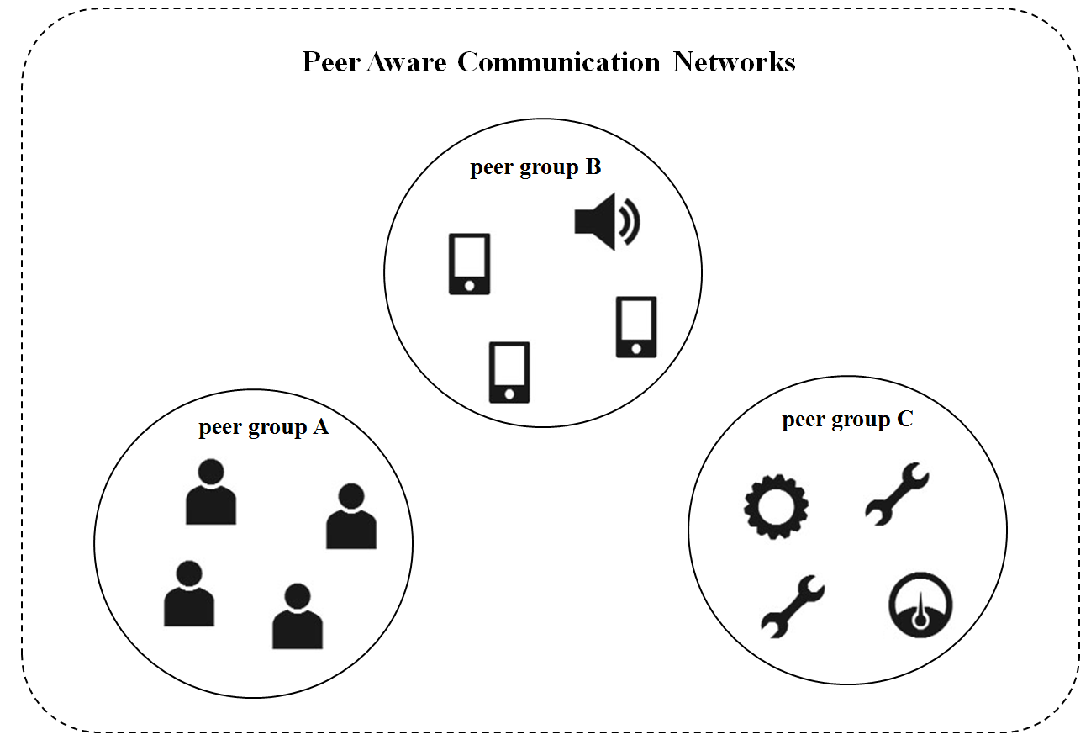
Figure 127—Scenario illustrating multiple peer group services.

Each peer group has different discovery procedure and data transmission pattern, as shown in Figure 128. The peer group A starts data transmission phase after discovering game partners and peering with all participants. Any participating device can leave from the game PAC group, but no new device is expected to join the PAC group after commencing the game. For the peer group B, advertiser continues to discover a peer. Any peer device can join a peer group by responding to an advertiser. After transmitting advertisement data, peering between the advertiser and the customer is released. For the peer group C, equipment controller continues to discover a peer device. After peering, the device will remain in data transmission phase.
Those requirements on discovery, peering and data transmission phase of each service are considered in usage of the cyclic-superframe; selecting the start and stop time of discovery phase, the frequency of discovery request, the duration of peering phase, and the duration of data transmission phase. Each peer group can select the cyclic-superframe structure adequate for the traffic characteristics of the application at each communication phase; active periods of pattern A and B superframe, the size of the cyclic-superframe, and ratio of pattern A superframes and pattern B superframes.
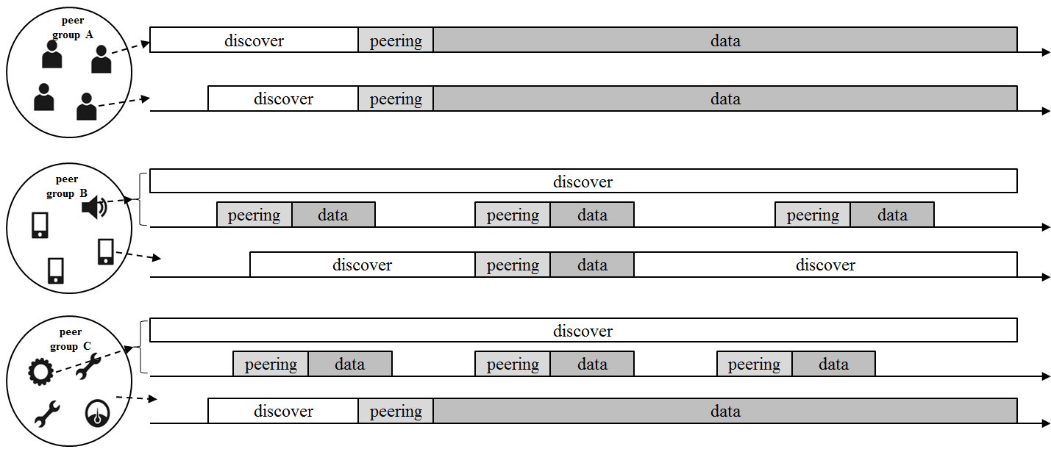
Figure 128— Cyclic-superframe structures for variety of PAC group services.

If a peer device joins multiple peer groups, the device manages the access to the MAC link according to the active periods combined multiple cyclic-superframe of peer groups, as shown in Figure 129. The peer device can identify in which period of the superframe contention will be high. The peer device can increase the transmission success rate of a high priority device by regulating the low priority devices access.
The newly formed peer group listens he Cyclic-superframe Advertise Request command frames broadcasting from the neighbor peer groups and collects information of cyclic-superframe structure. In order to avoid the interference among the neighbor PAC groups implicitly, the peer group calculates the contention probability of each period of a superframe by projecting new cyclic-superframe structure over combined multiple cyclic-superframe of peer groups. The peer group selects the start time of peer group communication to let newly joined cyclic-superframe induce the lowest contention.
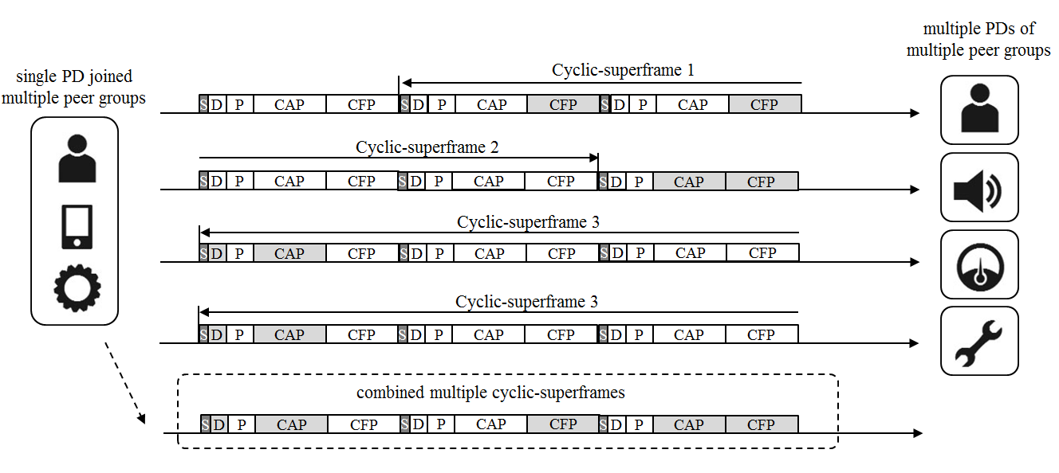
Figure 129— Combined multiple cyclic-superframes for a PD joined multiple peer groups

Operation of cyclic-superframe
A PD starts with the default cyclic-superframe structure, which sets discovery period of a superframe to be active: the cyclic-superframe size is one and the type of pattern A superframe is 0b1000. After synchronization, the MAC layer starts to count a superframe with modulo 4096. The combined multiple cyclic-superframe configuration map, which is 4 by 4096 bits, is initialized with the default cyclic-superframe configuration. The MAC layer activates the transceiver for a period set to be active of the combined multiple cyclic-superframe configuration map.
The combined multiple cyclic-superframe configuration map is updated when receiving the MLME-CYCLICSUPERFRAME.request from the next higher layer. The next higher layer requests the MAC layer to start a new cyclic-superframe when receiving the discovery request or peering request from an application service, or when responding to a Discovery Request command or Peering Request command frame received from a PD.
The cyclic-superframe structure is set according to an application service. The application service can have single cyclic-superframe configuration or two different configurations which are the cyclic-superframe structure for discovery and peering and the cyclic-superframe structure for data transmission. The cyclic-superframe configuration of an application service can be predetermined and shared among the peer groups before starting a service.

Configuration of cyclic-superframe
The configuration of a cyclic-superframe depends on frequency of message transmission or data rate.
If a Discovery Request command frame needs to be transmitted every X ms, Cyclic-superframe size will be set as nearest integer to X divided by aSuperframeDuration and Number of pattern A superframe will be set as 1, and the PP and CAP of pattern A superframe are set to active.
If one-to-one peer needs a best effort Y bps data rate link with a data frame arrived every Z ms and the average transmission rate in a CAP of a superframe is AvgRateCAP, Cyclic-superframe size will be set as nearest integer to Z divided by aSuperframeDuration and Number of pattern A superframe will be set as nearest integer to Y divided by AvgRateCAP, and the CAP of pattern A superframe is set to active.

