IEEE P802.15
Wireless Personal Area Networks

Project | IEEE P802.15 Working Group for Wireless Personal Area Networks (WPANs)
Title | WOLA windowing for the OFDMA PHY
Date Submitted | May 9th, 2017
Source | Marco Hernandez, Huan-Bang Li (NICT)
Response | In response to Call for Contributions to TG8
Abstract
Purpose | For discussion in TG8
Notice | This document has been prepared to assist the IEEE P802.15. It is offered as a basis for discussion and is not binding on the contributing individual(s) or organization(s). The material in this document is subject to change in form and content after further study. The contributor(s) reserve(s) the right to add, amend or withdraw material contained herein.
Release | The contributor acknowledges and accepts that this contribution becomes the property of IEEE and may be made publicly available by P802.15.

Contents
1.1 OFDM-based multi-carrier waveforms 2
1.2 CP-OFDM with WOLA 3

  - OFDM-based multi-carrier waveforms
Multi-carrier waveforms can be represented by the following expression
$y(n)=\sum_{k=0}^{∞}{\sum_{m=0}^{N_{\text{FFT}}−1}{d_{k,m}}}p(n−kN_{\text{FFT}})e^{j2πmF(n−{\text{kN}}_{\text{FFT}})}$
where $p(n)$ is the prototype filter, $F(n−kN_{\text{FFT}})$ represents the frequency shifter corresponding to the m-th sub-carrier, k is the data symbol index per sub-carrier, and n is discrete time index in the discrete time domain. A general implementation is illustrated in Figure 1, where b(n) is band-pass filter to further suppress out-of-band (OOB) leakage.

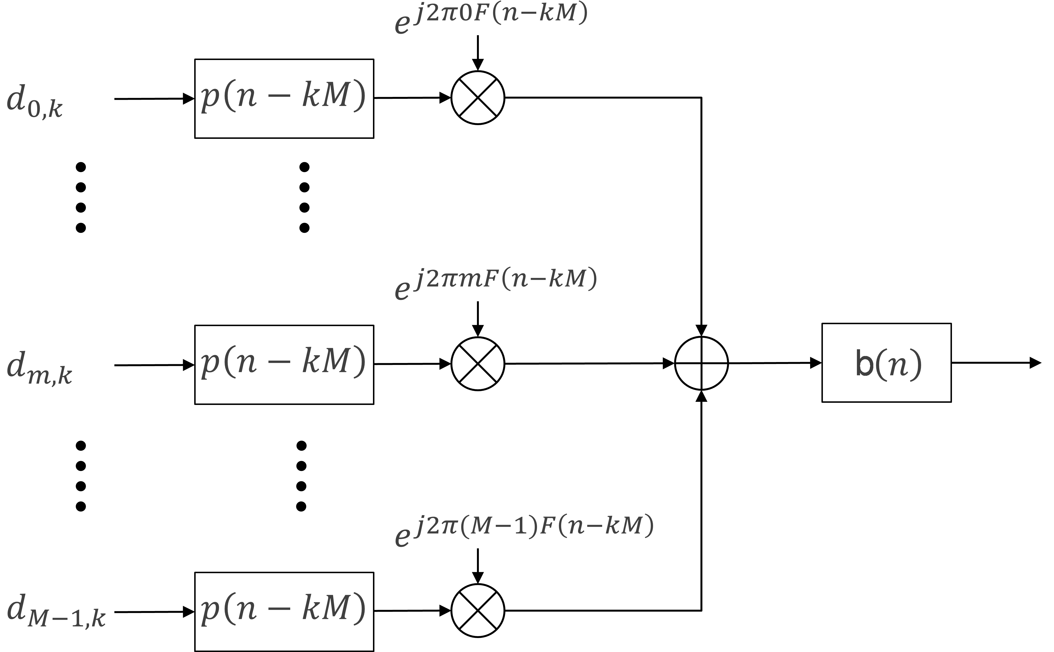
Figure 1—Multi-carrier waveform synthesis

The various OFDM-based multi-carrier waveforms are obtained based on the optimization differences of the two filters p(n) and b(n). Specifically,
- p(n) is typically implemented through time domain windowing, which corresponds to manipulating the pulse shaping of each sub-carrier in frequency domain.
- b(n) is typically implemented through time domain filtering, which corresponds to apply a frequency domain band-pass window over a block of contiguous sub-carriers.
The CP-OFDM waveform for the OFDM PHY and OFDMA PHY can be synthesized as a simple special case of Figure 1 by setting the prototype filter p(n) as a rectangular pulse and bypassing b(n). Such simplifications allow efficient implementation of the modulator and demodulator using FFT and IFFT.
One drawback of the CP-OFDM waveform is the rather poor frequency localization due to the rectangular prototype filter p(n). The slowly decaying OOB leakage could potentially cause interference to the adjacent band. It also leads to in-band interference whenever there is frequency offset between users.
  - CP-OFDM with WOLA
In CP-OFDM with weighted overlap and add (WOLA), the rectangular prototype filter p(n) is replaced by a pulse shape with soft edges at both sides of a CP-OFDM symbol, which results in much sharper side-lope decay in the frequency domain, and bypassing b(n).
In practice, the better contained frequency response is achieved by using a time domain window, which adds soft edges to the cyclic extension of the OFDM symbol, as shown in Figure 2. Although the edges further expand each symbol, the overhead is still the same as the CP-OFDM waveform, since adjacent symbols are overlapped in the edge transition region as shown in Figure 2.
Figure 2—WOLA processing at transmitter

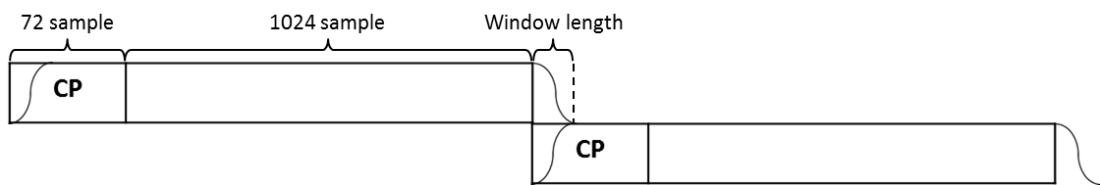
Figure 3—Edge effect for overlap and add

The weighting window in the time domain determines the frequency response of the prototype filter. Several types of windowing have been evaluated with different tradeoffs between the width of the main lobe and suppression of the side lobes. In general, a cosine-based edge seems to offer a good compromise between OOB suppression with straightforward implementation.
The weighting window shall be a tapered cosine (Tukey) window given by
$w(n)=\left\{\begin{matrix}\frac{1}{2}\left[1+\text{cos}\left(π\left(\frac{2n}{α(N−1)}\right)\right)\right] & 0≤n<\frac{α(N−1)}{2} \\ 1 & \frac{α(N−1)}{2}≤n≤(N−1)(1−α/2) \\ \frac{1}{2}\left[1+\text{cos}\left(π\left(\frac{2n}{α(N−1)}−\frac{2}{α}+1\right)\right)\right] & (N−1)(1−α/2)<n≤(N−1)\end{matrix}\right.$
where $N=N_{\text{FFT}}+\text{CP}+W$ is the size of the window, $α=2W/{N_{\text{FFT}}}$, W is the length of the extension (taper region), and it is implementation dependent.
An optional window with raised-cosine edges is given by
$w(n)=\left\{\begin{matrix}\frac{1}{2}\left[1+\text{cos}\left(π\frac{n−W+1/2}{W}\right)\right] & 0≤n<W \\ 1 & W≤n<N−W \\ \frac{1}{2}\left[1+\text{cos}\left(π\frac{n−N+W−1/2}{W}\right)\right] & N−W≤n≤N\end{matrix}\right.$
In this case $α=W/{N_{\text{FFT}}}$.

The windowed OFDM symbols are then overlapped by commencing transmission of each windowed OFDM symbol W samples before the end of the previous OFDM symbol. This overlapping ensures that the time between OFDM symbols is maintained as CP-OFDM as illustrated in Figure 4. The taper at the start of the first OFDM symbol for transmission is removed and is overlapped with the taper at the end of the last OFDM symbol.

Figure 4—WOLA processing at transmitter for CP-OFDM

Figure 5 illustrates the PSD of CP-OFDM with WOLA at the transmitter. The OOB suppression is substantially better than the CP-OFDM.
Figure 5—PSD CP-OFDM with WOLA at transmitter

In addition to applying WOLA at the transmitter to reduce the OOB leakage from the signal, WOLA can be similarly applied at the receiver to suppress other users’ interference as well. When users are asynchronous, the soft edges applied at the receiver help to reduce other user interference resulting from the mismatched FFT capture window. The receiver WOLA processing is illustrated in Figure 6.

Figure 6—WOLA processing at the receiver for CP-OFDM

To illustrate the effect of suppressing interference from asynchronous users by using WOLA at the receiver, OOB leakage is compared from an adjacent interferer with random offset in Figure 6. The FFT capture window is aligned to the desired user’s signal. As shown in Figure 7, the interference from the asynchronous neighboring user is noticeably lower when there is WOLA at the receiver.

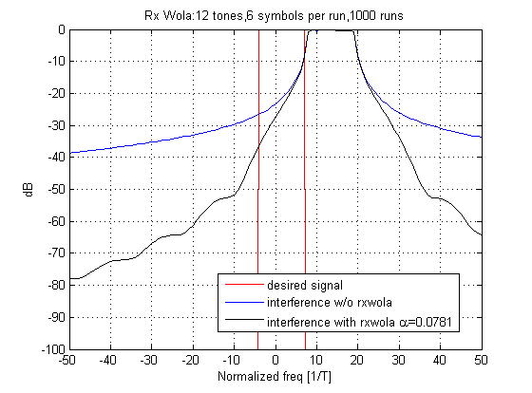
Figure 7—PSD at the receiver with WOLA

In summary, WOLA is a very attractive pulse shaping technique for CP-OFDM waveforms as it better suppresses OOB leakage; it better suppresses asynchronous user interference, easy integration with MIMO, and very simple implementation.

