IEEE P802.15
Wireless Personal Area Networks

Project | IEEE P802.15 Working Group for Wireless Personal Area Networks (WPANs)
Title | Correction of blurred equations in clause 12 of LB draft 1
Date Submitted | November 2016
Source | Billy Verso (DecaWave), | billy.verso (at) decawave.com
Re: | Improvement of UWB text readability 802.15.8 draft
Abstract | This document contains a reworking of selected equations that appear blurred in clause 12 of the first letter ballot circulation of the IEEE 802.15.8 draft standard.
Purpose | This document provides the details text for the IEEE 802.15.8 draft
Notice | This document does not represent the agreed views of the IEEE 802.15 Working Group or IEEE 802.15.8 Task Group. It represents only the views of the participants listed in the “Source(s)” field above. It is offered as a basis for discussion and is not binding on the contributing individual(s) or organization(s). The material in this document is subject to change in form and content after further study. The contributor(s) reserve(s) the right to add, amend or withdraw material contained herein.
Release | The contributor acknowledges and accepts that this contribution becomes the property of IEEE and may be made publicly available by P802.15.
Patent Policy | The contributor is familiar with the IEEE-SA Patent Policy and Procedures:  <http://standards.ieee.org/guides/bylaws/sect6-7.html#6> and  <http://standards.ieee.org/guides/opman/sect6.html#6.3>.  Further information is located at <http://standards.ieee.org/board/pat/pat-material.html> and  <http://standards.ieee.org/board/pat>.

There are only two equations blurred in clause 12 so rather than reproduce all the text of clause 12 the approach here is to present the two corrections as a table from wich the editor copy into the corrected position in the revised draft.

Correction #1:
Blurred image | 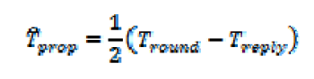
Position in 1st draft  P802.15.8-D1.0.pdf | Clause: 12.3.2 Single-sided two-way ranging  Page number: 216 (is page 231 in pdf)  Line number: 7
Corrected  Equation 3.0 object | $${\hat{T}}_{\text{prop}}=\frac{1}{2}\left(T_{\text{round}}−T_{\text{reply}}\right)$$

Correction # 2:
Blurred image | 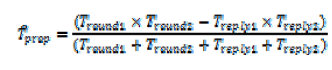
Position in 1st draft  P802.15.8-D1.0.pdf | Clause: 12.3.3 Double-sided two-way ranging  Page number: 217 (is page 232 in pdf)  Line number: 3
Corrected  Equation 3.0 object | $${\hat{T}}_{\text{prop}}=\frac{(T_{\text{round}1}×T_{\text{round}2}−T_{\text{reply}1}×T_{\text{reply}2})}{(T_{\text{round}1}+T_{\text{round}2}+T_{\text{reply}1}+T_{\text{reply}2})}$$

