IEEE P802.15
Wireless Personal Area Networks

Project | IEEE P802.15 Working Group for Wireless Personal Area Networks (WPANs)
Title | Resolution for comment r01-58, header formation
Date Submitted | 27, Oct. 2016
Source | [ Kondou, Keitarou]  [Sony Semiconductor Solutions Corp.]  [1-7-1 Konan, Minato-ku, Tokyo Japan] | Voice: [+81-50-3140-1435]  Fax: [ +81-3-6748-4268]  E-mail: [Keitarou.Kondo@sony.com]
Re: | In response to r01-58 from Consolidated Sponsor Ballot recirculation-1 comments (15-16-0726-01-003e)
Abstract | Defines the chip rate in the case channel bonding is used and provide the data processing procedure in the case channel aggregation is used.
Purpose | Resolve the comment r01-58
Notice | This document has been prepared to assist the IEEE P802.15. It is offered as a basis for discussion and is not binding on the contributing individual(s) or organization(s). The material in this document is subject to change in form and content after further study. The contributor(s) reserve(s) the right to add, amend or withdraw material contained herein.
Release | The contributor acknowledges and accepts that this contribution becomes the property of IEEE and may be made publicly available by P802.15.

Comment

# | Page | Subclause | Line | Comment | Must Be Satisfied | Proposed Change
r01-58 | 121 | 11a.2.3.2 | 25 | Delete the sentense "The frame header consists of a base frame header followed by an optional frame header".  Refer the i-88 of SB comment. | Yes | As commented

Resolution:
Revised to clarify the header-formation process.
Following texts and changes are applied to the current draft of 15.3e

11a.2.2.7 Stuff bits

Insert the following text at the end of the subclause:
For the stuff bits in the frame headers, the values are given in Table 11a-7.The bit pattern of the header stuff bits shall be set to 01.

11a.2.3.2 Frame Header
Chamge the first paragraph as follows:
A frame header shall be added after the PHY preamble. The frame header conveys information in the PHY and MAC headers necessary for successfully decoding the frame. The frame header consists of a base frame header followed by an optional frame header.

Chamge the text for construction process a)-6 as follows:

6) Form the base frame header by concatenating the coded PHY header, coded scrambled MAC header, coded scrambled HCS, and scrambled header stuff bits

Chamge Figure 11a-6 as follows:

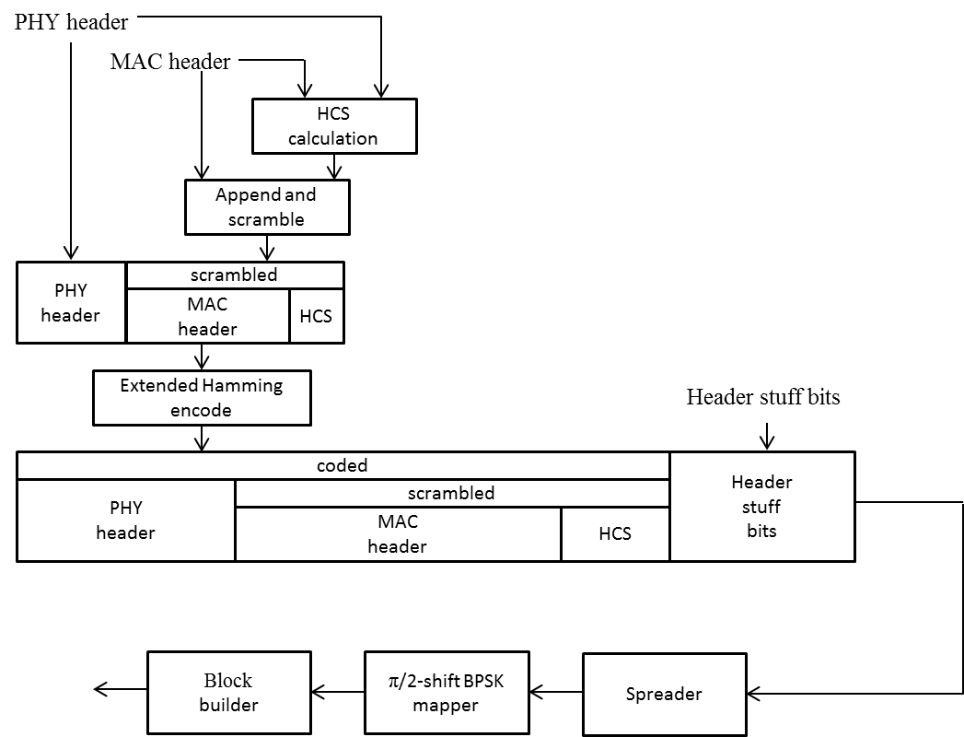

Figure 11a-6—Frame header construction process

